**DEWAGEDARA D.M.E.S. (E/21/087)**

**PERERA W.S.S. (E/21/302)**

**Group 06**

**1.load 4 0x025 (Miss)**

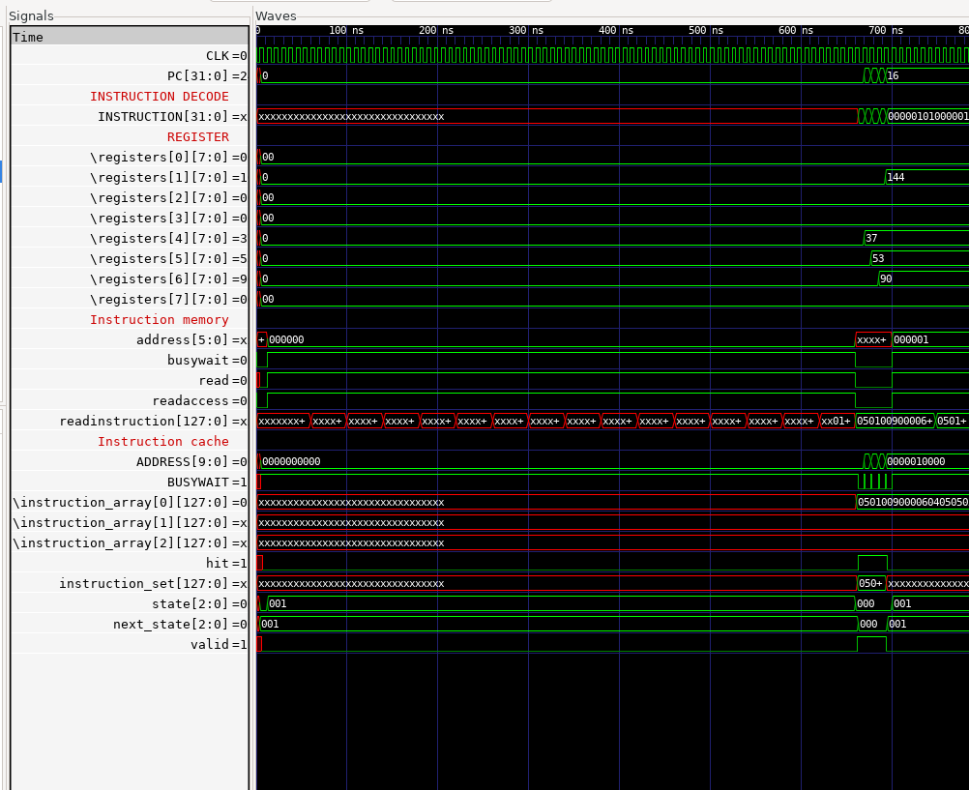

1. **loadi 5 0x35 (Hit)**
2. **add 6 4 5 (Hit)**
3. **loadi 1 0x90 (Hit)**

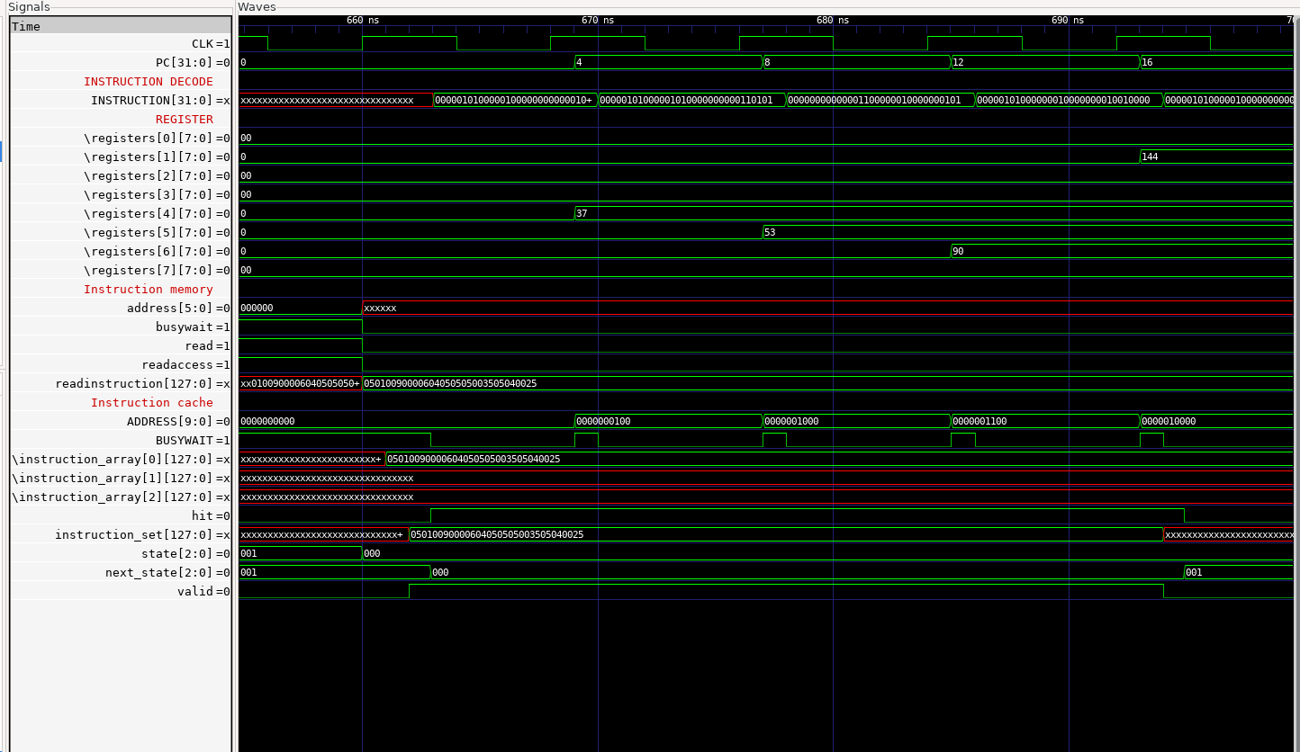

1. **sub 1 1 4 (Miss)**

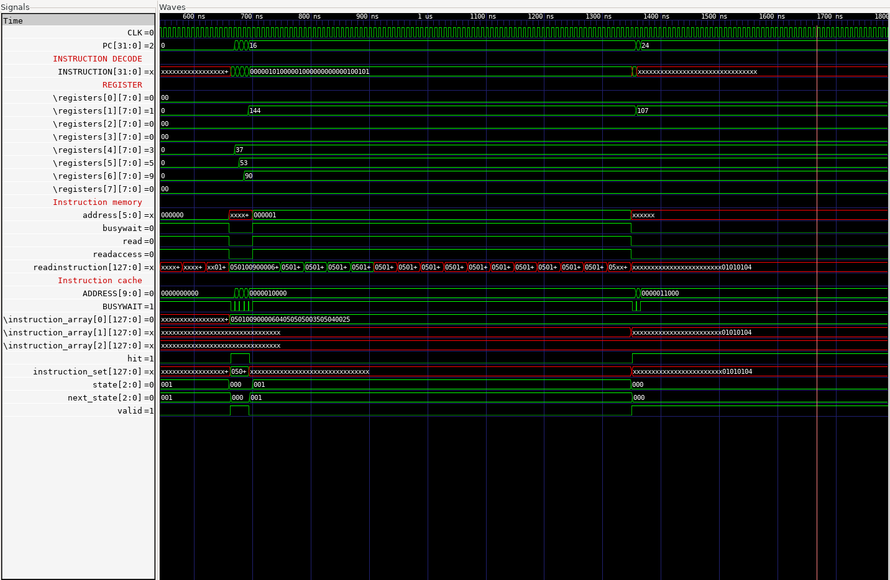

Screenshot 2025-07-16 093058