Software Requirements

Specification

for

75th Anniversary Exhibition Crowd Management System

version 1.0

Prepared by DEWAGEDARA D.M.E.S.
(E/21/087)

Faculty of Engineering,

University of Peradeniya

Due Date: 23rd May 2025

Table of Contents

Revision History
1. Introduction
1.1 Purpose
1.2 Document Conventions
1.3 Intended Audience and Reading Suggestions
1.4 Product Scope
1.5 References

2. Overall Description
2.1 Product Perspective
2.2 Product Functions
2.3 User Classes and Characteristics
2.4 Operating Environment
2.5 Design and Implementation Constraints
2.6 User Documentation
2.7 Assumptions and Dependencies

3. External Interface Requirements
3.1 User Interfaces
3.2 Hardware Interfaces
3.3 Software Interfaces
3.4 Communications Interfaces

4. System Features
4.1 Real-time Crowd Monitoring
4.2 Interactive Exhibition Navigation
4.3 RFID-Based Visitor Tracking
4.4 Dynamic Content Management
4.5 Analytics Dashboard
4.6 Emergency Management

5. Other Nonfunctional Requirements
5.1 Performance Requirements
5.2 Safety Requirements
5.3 Security Requirements
5.4 Software Quality Attributes
5.5 Business Rules
6. Other Requirements
Appendix A: Glossary
Appendix B: Analysis Models
Appendix C: To Be Determined List

Revision History

Version | Date | Description | Author
1.0 | May 23, 2025 | Initial SRS document creation | Dewagedara D.M.E.S.

1. Introduction

Purpose
This Software Requirements Specification (SRS) document defines the functional and non-functional requirements for the 75Exhibition Crowd Management System, a comprehensive digital twin platform designed for the Faculty of Engineering's 75th anniversary exhibition (EngEx 2025). The system aims to provide real-time crowd monitoring, intelligent navigation, and enhanced visitor engagement through integrated IoT sensors, RFID technology, and data analytics.
The document serves as the primary reference for system developers, project stakeholders, and quality assurance teams involved in the development and deployment of the 75Exhibition platform.

Document Conventions

This document follows the IEEE 830-1998 standard for Software Requirements Specifications. The following conventions are used throughout:
- Bold text indicates system components, user interface elements, or important technical terms
- Italic text represents document references or emphasis
- Code formatting is used for technical specifications, file names, and system parameters
- Requirements are uniquely identified using the format [REQ-XXX] where XXX is a sequential number
- Priority levels are indicated as: High (H), Medium (M), Low (L)

Intended Audience and Reading Suggestions

This document is intended for ,
Primary Audience :
- Software developers and system architects
- Project managers and technical leads
- Quality assurance and testing teams
- Database administrators

Secondary Audience :
- EngEx 2025 organizing committee members
- Faculty administrators and decision makers
- External stakeholders and collaborating departments

Reading Suggestions :
- Readers unfamiliar with crowd management systems should begin with Section 2
- Technical implementers should focus on Sections 3 and 4 for detailed specifications
- Project managers should prioritize Sections 1, 2, and 5 for scope and requirements
overview
- End users should refer to Section 3.1 for user interface specifications

1.4 Product Scope
The 75Exhibition Crowd Management System is a comprehensive real-time digital twin platform that transforms the traditional exhibition experience into an intelligent, data-driven environment. The system encompasses:
Core Capabilities :
- Real-time crowd density monitoring and heat map generation
- Interactive digital navigation with personalized pathways
- RFID-integrated visitor tracking and analytics
- Dynamic content management and scheduling
- Multi-platform accessibility (web, mobile, kiosk interfaces)
- Comprehensive analytics dashboard for organizers

Strategic Benefits:
- Enhanced visitor safety through proactive crowd management
- Improved visitor engagement via personalized recommendations
- Operational efficiency for exhibition organizers
- Long-term infrastructure value for future campus events
- Educational showcase of engineering systems integration

Scope Limitations:
- The system is designed specifically for indoor exhibition environments
- Integration with external payment systems is not included in this phase
- Advanced AI-based predictive analytics are planned for future iteratio

References

- IEEE Std 830-1998, "IEEE Recommended Practice for Software Requirements Specifications"
- ISO/IEC 25010:2011, "Systems and software engineering — Systems and software Quality Requirements and Evaluation (SQuaRE)"
- EngEx 2025 Event Planning Documentation, University of Peradeniya
- RFID Technology Standards and Implementation Guidelines
- Web Content Accessibility Guidelines (WCAG) 2.1

2. Overall Description

2.1 Product Perspective
The 75Exhibition system operates as an independent, self-contained platform while integrating with existing university infrastructure. The system architecture consists of several interconnected components:
System Architecture Overview:
- Frontend Layer : Web applications, mobile apps, and kiosk interfaces
- Backend Services: Real-time data processing, API gateway, and business logic
- Data Layer: Time-series databases, visitor analytics, and content management
- IoT Integration: RFID readers, crowd sensors, and smart display systems
- External Interfaces: University authentication systems and network infrastructure

Relationship to Existing Systems:
- Integrates with university LDAP for authentication
- Utilizes existing WiFi infrastructure for connectivity
- Interfaces with campus digital signage systems
- Connects to university data services through secure APIs

2.2 Product Functions

The 75Exhibition platform delivers the following core functions:
- Real-time Monitoring and Analytics:
- Continuous crowd density tracking across exhibition zones
- Heat map generation and visualization
- Visitor flow pattern analysis
- Capacity threshold monitoring and alerting
- Interactive Navigation and Engagement:
- Dynamic exhibition map with real-time updates
- Personalized visitor pathways and recommendations
- Interactive booth information and multimedia content
- Social features including ratings and reviews
- Content and Schedule Management:
- Auto-updating event schedules and session information
- Dynamic content delivery based on visitor preferences
- Push notifications for relevant events and activities
- Multi-language content support
- Administrative and Reporting Functions:
- Comprehensive organizer dashboard
- Real-time operational metrics and KPIs
- Post-event analytics and reporting
- System health monitoring and maintenance tools

2.3 User Classes and Characteristics
Primary User Classes:
1. Exhibition Visitors (General Public)
- Characteristics: Diverse age groups (12-70 years), varying technical expertise
- Primary Goals: Navigate efficiently, discover relevant content, engage with exhibits
- Technical Proficiency: Basic to intermediate smartphone/web usage
- Access Methods: Mobile app, web browser, information kiosks
2. Exhibition Organizers
- Characteristics : Event management professionals, faculty members
- Primary Goals : Monitor crowd flow, manage content, ensure safety compliance
- Technical Proficiency : Intermediate to advanced computer skills
- Access Methods : Administrative web dashboard, mobile monitoring app
3. Booth Representatives/Exhibitors
- Characteristics : Students, faculty, industry representatives
- Primary Goals : Attract visitors, share information, collect engagement data
- Technical Proficiency : Basic to intermediate technical skills
- Access Methods : Exhibitor portal, mobile interface
4. System Administrators
- Characteristics: IT professionals, engineering students
- Primary Goals: Maintain system operation, monitor performance, troubleshoot issues
- Technical Proficiency: Advanced technical and programming skills
- Access Methods: Administrative console, system monitoring tools

2.4 Operating Environment
Hardware Environment:
- Servers : Cloud-based infrastructure (minimum 8 cores, 32GB RAM)
- Client Devices : Smartphones (iOS 12+, Android 8+), tablets, desktop computers
- IoT Hardware : RFID readers, crowd sensors, digital display screens
- Network Infrastructure : University WiFi , ethernet backbone

Software Environment:
- Operating Systems : Windows 10+, macOS 10.14+, iOS 12+, Android 8+, Linux (Ubuntu)
- Web Browsers : Chrome 80+, Firefox 75+, Safari 13+, Edge 80+
- Database Systems : PostgreSQL 12+, Redis 6+, InfluxDB 2.0+
- Development Frameworks : React 18+, Node.js 16+, Python 3.8+

Compliance Requirements:
- University data protection policies
- Accessibility standards (WCAG 2.1 AA)
- Sri Lankan data privacy regulations
- IEEE wireless communication standards

2.5 Design and Implementation Constraints
Technical Constraints:
- Must integrate with existing university WiFi infrastructure
- RFID system limited to 13.56 MHz frequency band
- Real-time data processing latency must not exceed 500ms
- System must handle concurrent access from 2500+ users

Regulatory Constraints:
- Compliance with university IT security policies
- Adherence to data privacy and protection regulations
- Accessibility requirements for disabled users
- Safety standards for IoT device deployment

Business Constraints:
- Development timeline limited to 2 months
- Budget restrictions for hardware procurement
- Limited access to third-party APIs and services
- Requirement for open-source technology where possible

Environmental Constraints:
- Indoor deployment with limited power access points
- Potential interference from other wireless devices
- Physical space limitations for sensor placement
- Weather protection requirements for outdoor displays

2.6 User Documentation
End User Documentation:
- Interactive user guide accessible through the application
- Quick start guides for mobile and web interfaces
- Video tutorials for key features and navigation
- FAQ section with common questions and solutions
- Multilingual support (English, Sinhala, Tamil)

Administrator Documentation:
- System administration manual
- API documentation for integrators
- Troubleshooting guides and error code references
- Database schema and data dictionary
- Deployment and configuration guides

Developer Documentation:
- Technical architecture documentation
- Code documentation and style guides
- Testing procedures and quality assurance protocols
- Version control and release management procedures

2.7 Assumptions and Dependencies
Assumptions:
- University WiFi infrastructure will remain stable during the exhibition
- Visitors will have access to smartphones or can use provided kiosks
- RFID tags will be distributed to all exhibition attendees
- Exhibition layout and booth assignments will be finalized 2 weeks before the event
- Adequate power supply will be available for all IoT devices

Dependencies:
- University IT department cooperation for network access and authentication
- Collaboration with engineering departments for hardware installation
- Third-party RFID hardware vendor support and delivery schedules
- Availability of student development teams from participating departments
- Approval from university administration for data collection and usage

3. External Interface Requirements

3.1 User Interfaces
Mobile Application Interface:
- Design Principles : Material Design 3.0 (Android), Human Interface Guidelines (iOS)
- Screen Resolutions : Support for 360x640 to 1440x3200 pixels
- Navigation : Bottom tab navigation with 5 primary sections
- Key Screens:
- Interactive map with real-time crowd indicators
- Personal schedule and bookmarked exhibits
- Live notifications and alerts panel
- Settings and profile management
- Help and emergency contact information

Web Application Interface:
- Design Framework : Responsive design supporting desktop, tablet, and mobile viewports
- Browser Compatibility : Chrome 80+, Firefox 75+, Safari 13+, Edge 80+
- Layout : Header navigation with sidebar menu for desktop, collapsible menu for mobile
- Key Components:
- Dashboard with crowd metrics and system status
- Interactive floor plan with zoom and pan functionality
- Content management interface for organizers
- Real-time analytics and reporting tools

Information Kiosk Interface:
- Display Specifications : 32-inch touchscreen displays (1920x1080 resolution)
- Interaction Method : Multi-touch gestures with haptic feedback
- Accessibility Features : Voice narration, high contrast mode, large text options
- Content Areas:
- Welcome screen with event overview
- Interactive map and wayfinding
- Current events and schedules
- Emergency information and contacts

3.2 Hardware Interfaces
RFID Reader Integration:
- Frequency : 13.56 MHz (ISO 14443 Type A)
- Read Range : 10-15 cm for visitor tags
- Data Protocol : NFC Data Exchange Format (NDEF)
- Installation : Mounted at entry points and key transition areas
- Power Requirements : 12V DC, maximum 15W per unit

Crowd Sensing Hardware:
- Technology : Computer vision cameras with people counting algorithms
- Resolution : Minimum 1080p for accurate detection
- Field of View : 120-degree wide-angle lens coverage
- Data Output : Real-time visitor count and movement vectors
- Privacy Compliance : No facial recognition or personal identification

Digital Display Systems:
- Type : LED displays for information kiosks and directional signage
- Connectivity : Ethernet connection for content updates
- Resolution : 4K capability for detailed maps and graphics
- Mounting : Wall-mounted or freestanding kiosk enclosures
- Environmental : Indoor rated with anti-glare coating

3.3 Software Interfaces
University Authentication System:
- Protocol : LDAP v3 over SSL/TLS
- Authentication Method : Username/password with optional 2FA
- User Attributes : Name, email, department, role classification
- Session Management : JWT tokens with 24-hour expiration
- Authorization : Role-based access control (RBAC)

Database Management Systems:
- Primary Database : PostgreSQL 12+ for transactional data
- Time-Series Database : InfluxDB 2.0+ for sensor data and analytics
- Caching Layer : Redis 6+ for session management and real-time data
- Connection Pooling : pgBouncer for PostgreSQL connections
- Backup Strategy : Daily automated backups with 30-day retention

Third-Party APIs:
- Mapping Services : OpenStreetMap API for outdoor navigation context
- Push Notifications : Firebase Cloud Messaging (FCM) for mobile alerts
- Analytics Platform : Custom analytics engine with REST API endpoints
- Weather Services : OpenWeatherMap API for environmental context

3.4 Communications Interfaces
Network Protocols:
- HTTP/HTTPS : RESTful API communication with TLS 1.3 encryption
- WebSocket : Real-time bidirectional communication for live updates
- MQTT : IoT device communication with QoS level 1 reliability
- WiFi : 802.11n/ac for mobile device connectivity
Data Exchange Formats:
- JSON : Primary format for API requests and responses
- XML : Legacy system integration where required
- CSV : Data export functionality for reporting
- Binary Protocols : Optimized formats for high-frequency sensor data
Security Protocols:
- TLS 1.3 : Encryption for all external communications
- OAuth 2.0 : Authorization framework for third-party integrations
- API Keys : Authentication for internal service communications
- Rate Limiting : Protection against API abuse and DDoS attacks

4. System Features

4.1 Real-time Crowd Monitoring
Description and Priority: This feature provides continuous monitoring of visitor density across all exhibition zones, generating real-time heat maps and crowd flow analytics. Priority: High
Stimulus/Response Sequences:
- Crowd Density Detection:
  - Stimulus : Visitor enters monitored zone
  - Response : System updates crowd count within 2 seconds
  - Data Flow : Sensor → Processing Engine → Database → Dashboard

- Threshold Alert Generation:
  - Stimulus: Crowd density exceeds 80% capacity
  - Response: Automated alert sent to organizers and visitors
  - Escalation: Emergency protocols activated at 95% capacity

Functional Requirements:
[REQ-001] The system shall detect and count visitors in real-time across all monitored zones with 95% accuracy.
[REQ-002] The system shall generate visual heat maps showing crowd density with color-coded indicators (green: low, yellow: medium, red: high).
[REQ-003] The system shall send automated alerts when any zone reaches 80% of maximum capacity.
[REQ-004] The system shall maintain historical crowd data for post-event analysis and future planning.
[REQ-005] The system shall provide predictive crowd flow recommendations based on current trends and historical patterns.

4.2 Interactive Exhibition Navigation
Description and Priority: An intelligent navigation system that provides personalized pathways, real-time directions, and contextual information about exhibits and events. Priority: High
Stimulus/Response Sequences:
- Route Planning:
  - Stimulus: User requests directions to specific exhibit
  - Response: System calculates optimal route considering crowd density
  - Updates: Dynamic rerouting based on real-time conditions

- Personalized Recommendations:
  - Stimulus: User profile analysis and current location
  - Response: Suggested exhibits and events based on interests
  - Feedback Loop: Recommendations refined based on user interactions

Functional Requirements:
[REQ-006] The system shall provide interactive maps with real-time navigation to any exhibit or facility.
[REQ-007] The system shall generate personalized recommendations based on user preferences and historical behavior.
[REQ-008] The system shall offer alternative routes when primary paths are congested.
[REQ-009] The system shall provide estimated walking times and distances between locations.
[REQ-010] The system shall support offline map functionality for areas with limited connectivity.

4.3 Real-Time Alerts and Notifications (FR3)

Description and Priority: Integration of RFID technology for seamless visitor identification, location tracking, and personalized experience delivery. Priority: High
Stimulus/Response Sequences:
- Visitor Check-in:
  - Stimulus: RFID tag scanned at entry point
  - Response: Visitor profile activated and location logged
  - Integration: Personal preferences loaded and recommendations generated

- Location-Based Services:
  - Stimulus: RFID tag detected at exhibit location
  - Response: Contextual information delivered to user device
  - Analytics: Visitor journey and engagement data collected

Functional Requirements:
[REQ-011] The system shall register and authenticate visitors using RFID tags at entry points.
[REQ-012] The system shall track visitor location and movement patterns while maintaining privacy compliance.
[REQ-013] The system shall deliver location-specific content and notifications based on RFID proximity detection.
[REQ-014] The system shall collect anonymized analytics data for visitor behavior analysis.
[REQ-015] The system shall support RFID tag deactivation and data purging upon visitor departure.

4.4 Dynamic Content Management
Description and Priority: A flexible content management system that allows real-time updates to schedules, announcements, and exhibit information across all platform interfaces. Priority: Medium
Stimulus/Response Sequences:
- Content Update:
  - Stimulus: Organizer publishes schedule change
  - Response: Updates propagated to all interfaces within 30 seconds
  - Notification: Affected users receive push notifications

- Emergency Announcements:
  - Stimulus: Emergency announcement initiated
  - Response: High-priority message displayed across all platforms
  - Persistence: Message remains visible until manually cleared

Functional Requirements:
[REQ-016] The system shall support real-time content updates across all user interfaces.
[REQ-017] The system shall provide multilingual content management (English, Sinhala, Tamil).
[REQ-018] The system shall support multimedia content including images, videos, and audio.
[REQ-019] The system shall maintain content version control and rollback capabilities.
[REQ-020] The system shall support scheduled content publication and expiration.

4.5 Analytics Dashboard
Description and Priority: A comprehensive analytics platform providing real-time metrics, historical analysis, and actionable insights for exhibition organizers and stakeholders. Priority: Medium
Stimulus/Response Sequences:
- Real-time Metrics:
  - Stimulus: Dashboard access by authorized user
  - Response: Current visitor counts, popular exhibits, and system status displayed
  - Refresh: Data updated every 10 seconds for real-time insights

- Report Generation:
  - Stimulus: User requests custom analytics report
  - Response: Report generated and available for download
  - Formats: PDF, Excel, and CSV export options

Functional Requirements:
[REQ-021] The system shall provide real-time dashboard with key performance indicators and system metrics.
[REQ-022] The system shall generate detailed analytics reports on visitor behavior and exhibition performance.
[REQ-023] The system shall support custom query building and data visualization tools.
[REQ-024] The system shall maintain data retention policies and automated archiving.
[REQ-025] The system shall provide API access for third-party analytics integration.

4.6 Emergency Management
Description and Priority: Critical safety features including emergency notifications, evacuation guidance, and crisis communication tools. Priority: High
Stimulus/Response Sequences:
- Emergency Detection:
  - Stimulus: Emergency button activated or automatic trigger
  - Response: Immediate notification to all users and emergency services
  - Guidance: Evacuation routes displayed on all interfaces

- Crisis Communication:
  - Stimulus: Emergency coordinator broadcasts announcement
  - Response: Message delivered via all communication channels
  - Tracking: Visitor location data used for emergency response coordination

Functional Requirements:
[REQ-026] The system shall provide emergency notification capabilities with immediate delivery to all users.
[REQ-027] The system shall display evacuation routes and emergency procedures on all interfaces.
[REQ-028] The system shall integrate with university emergency response systems.
[REQ-029] The system shall maintain emergency contact directories and automated notification lists.
[REQ-030] The system shall provide location data to emergency responders while maintaining privacy compliance.

5. Other Nonfunctional Requirements

5.1 Performance Requirements
Response Time Requirements:
- [REQ-031] Web interface response time shall not exceed 2 seconds for standard operations under normal load conditions.
- [REQ-032] Mobile application response time shall not exceed 1.5 seconds for navigation and content retrieval.
- [REQ-033] Real-time crowd data updates shall be processed and displayed within 3 seconds of sensor input.
- [REQ-034] Database query response time shall not exceed 500ms for 95% of all requests.
Throughput Requirements:
- [REQ-035] The system shall support concurrent access by up to 5,000 active users without performance degradation.
- [REQ-036] The system shall process up to 4000 RFID tag reads per minute across all readers.
- [REQ-037] The system shall handle up to 1,000 API requests per second during peak usage periods.
Capacity Requirements:
- [REQ-038] The system shall store visitor data for up to 4000 simultaneous active users.
- [REQ-039] The system shall maintain historical analytics data for reporting purposes.
- [REQ-040] The system shall support exhibition layouts with up to 100 individual booth locations.

5.2 Safety Requirements
Visitor Safety:
- [REQ-041] The system shall provide immediate emergency notifications with automatic escalation procedures.
- [REQ-042] The system shall maintain real-time capacity monitoring to prevent overcrowding and unsafe conditions.
- [REQ-043] The system shall include fail-safe mechanisms that default to safe operational states during system failures.
Data Safety:
- [REQ-044] The system shall implement automated data backup procedures with 99.9% reliability.
- [REQ-045] The system shall provide data recovery capabilities with maximum 4-hour recovery time objectives.
- [REQ-046] The system shall maintain data integrity through transaction logging and validation checks.

5.3 Security Requirements
Authentication and Authorization:
- [REQ-047] The system shall enforce strong password policies and support multi-factor authentication for administrative accounts.
- [REQ-048] The system shall implement role-based access control with least privilege principles.
- [REQ-049] The system shall maintain audit logs of all security-related events and access attempts.

Data Protection:
- [REQ-050] The system shall encrypt all data in transit using TLS 1.3 or higher encryption standards.
- [REQ-051] The system shall encrypt sensitive data at rest using AES-256 encryption.
- [REQ-052] The system shall implement data anonymization for analytics and reporting functions.
Network Security:
- [REQ-053] The system shall include intrusion detection and prevention capabilities.
- [REQ-054] The system shall implement API rate limiting and DDoS protection mechanisms.
- [REQ-055] The system shall maintain network segmentation between public and administrative interfaces.

5.4 Software Quality Attributes
Reliability:
- [REQ-056] The system shall maintain 99.5% uptime during exhibition operating hours.
- [REQ-057] The system shall include automatic failover capabilities for critical components.
- [REQ-058] The system shall provide graceful degradation of non-critical features during partial system failures.
Scalability:
- [REQ-059] The system architecture shall support horizontal scaling of web and application servers.
- [REQ-060] The system shall accommodate 50% increase in concurrent users without major architectural changes.
- [REQ-061] The system shall support addition of new exhibition zones and IoT devices without system downtime.
Maintainability:
- [REQ-062] The system shall include comprehensive logging and monitoring capabilities.
- [REQ-063] The system shall support remote diagnostics and troubleshooting tools.
- [REQ-064] The system code shall maintain minimum 80% test coverage with automated testing suites.
Usability:
- [REQ-065] The system interfaces shall be intuitive and require minimal training for basic operations.
- [REQ-066] The system shall comply with WCAG 2.1 AA accessibility standards.
- [REQ-067] The system shall provide multilingual support with seamless language switching.

5.5 Business Rules
Operational Rules:
- [REQ-068] Visitor data collection shall comply with university privacy policies and require explicit consent.
- [REQ-069] System access shall be restricted to authorized personnel with appropriate clearance levels.
- [REQ-070] All system modifications during exhibition hours shall require approval from the event coordinator.

Data Governance Rules:
- [REQ-071] Personal visitor data shall be automatically purged 30 days after exhibition conclusion.
- [REQ-072] Analytics data shall be anonymized before sharing with external research partners.
- [REQ-073] System audit logs shall be maintained for minimum 12 months for compliance purposes.

6. Other Requirements
Legal and Regulatory Requirements:
- Compliance with Sri Lankan data protection and privacy laws
- Adherence to University of Peradeniya IT governance policies
- Implementation of accessibility standards for disabled users
- Compliance with local wireless communication regulations
Cultural and Localization Requirements:
- Support for Sinhala and Tamil languages in addition to English
- Cultural sensitivity in user interface design and content presentation
- Accommodation of local customs and behavioral patterns in system design
- Integration with local emergency response protocols and procedures
Environmental Requirements:
- Energy-efficient operation of IoT devices and display systems
- Minimal environmental impact from hardware deployment
- Sustainable technology choices and responsible disposal planning
- Integration with university sustainability initiatives
Training Requirements:
- Comprehensive training program for system administrators and organizers
- User orientation materials for exhibition staff and volunteers
- Technical documentation for maintenance and support personnel
- Knowledge transfer sessions for future system enhancement projects

Appendix A: Glossary
API (Application Programming Interface): A set of protocols and tools for building software applications and enabling communication between different software components.
Digital Twin: A digital replica of physical assets, processes, or systems that can be used for various purposes such as monitoring, analysis, and optimization.
Heat Map: A graphical representation of data where individual values are represented as colors, commonly used to show crowd density distributions.
IoT (Internet of Things): A network of interconnected devices that can collect and exchange data using embedded sensors and connectivity.
KPI (Key Performance Indicator): Quantifiable measures used to evaluate the success of an organization or particular activity.
LDAP (Lightweight Directory Access Protocol): An application protocol for accessing and maintaining distributed directory information services.
MQTT (Message Queuing Telemetry Transport): A lightweight messaging protocol designed for small sensors and mobile devices.
RFID (Radio Frequency Identification): Technology that uses electromagnetic fields to automatically identify and track tags attached to objects.
SRS (Software Requirements Specification): A document that describes the functionality and behavior of a software system.
TLS (Transport Layer Security): Cryptographic protocols designed to provide communications security over a computer network

Appendix B: Analysis Models

System Context Diagram,

[External Users] → [75Exhibition System] ← [University Systems]
↓ ↓ ↓
[Mobile Apps] [IoT Sensors] [Authentication]
[Web Interface] [RFID Readers] [Network Services]
[Info Kiosks] [Displays] [Data Services]

Data Flow Diagram - Level 0,

Visitors → Registration/Authentication → User Management
↓
User Interactions → Content Delivery ← Content Management
↓
Location Data → Analytics Engine → Reporting Dashboard
↓
Sensor Data → Crowd Monitoring → Alert System

Entity Relationship Model
Key Entities:
- User (UserID, Name, Email, Role, Preferences)
- Location (LocationID, Name, Coordinates, Capacity, Type)
- Event (EventID, Title, Description, StartTime, EndTime, LocationID)
- Analytics (RecordID, UserID, LocationID, Timestamp, Action)
- Alert (AlertID, Type, Message, Timestamp, Status)

Use Case Diagram
Primary Actors: Visitor, Organizer, System Administrator
Key Use Cases:
- Navigate Exhibition
- View Real-time Crowd Data
- Manage Content
- Generate Reports
- Monitor System Health
- Handle Emergencies

Appendix C: To Be Determined List
The following items require further clarification and will be addressed in future document revisions:
- Integration Specifications:
  - TBD-001: Exact API specifications for university LDAP integration
  - TBD-002: Data exchange formats with existing campus management systems
  - TBD-003: Integration requirements with university emergency alert systems
  - TBD-004: Specifications for third-party analytics platform connections

- Hardware Specifications:
  - TBD-005: Final RFID reader placement locations and coverage areas
  - TBD-006: Exact sensor specifications for crowd monitoring cameras
  - TBD-007: Power consumption requirements and electrical infrastructure needs
  - TBD-008: Environmental protection specifications for outdoor equipment

- Performance Benchmarks:
  - TBD-009: Detailed load testing parameters and acceptance criteria
  - TBD-010: Specific latency requirements for different system components
  - TBD-011: Database performance optimization strategies and indexing requirements
  - TBD-012: Network bandwidth requirements during peak usage scenarios

- Security Implementation Details:
  - TBD-013: Specific encryption key management procedures
  - TBD-014: Detailed penetration testing requirements and schedules
  - TBD-015: Incident response procedures for security breach scenarios
  - TBD-016: Data retention and purging automation specifications

- User Experience Design:
  - TBD-017: Detailed accessibility testing procedures and compliance verification
  - TBD-018: Specific multilingual content translation and localization requirements
  - TBD-019: User interface design specifications for different screen sizes
  - TBD-020: Usability testing protocols and user acceptance criteria

- Operational Procedures:
  - TBD-021: Detailed backup and disaster recovery testing procedures
  - TBD-022: System maintenance windows and update deployment strategies
  - TBD-023: Training curriculum details for different user groups
  - TBD-024: Post-exhibition system decommissioning procedures

- Legal and Compliance:
  - TBD-025: Specific data privacy consent mechanisms and user opt-out procedures
  - TBD-026: Compliance audit schedules and reporting requirements
  - TBD-027: Terms of service and privacy policy content specifications
  - TBD-028: International student data handling requirements

Visual System Architecture Overview
Presentation Layer

75 Exhibition system Architecture

Web Appliaction
Kiosk Interface
Mobile app
User Journey Flow Diagram
Digital
Displays
RFID
Readers
Crowd
Sensors
IOT Integration Layer

Redis
(cahe)
InfluxDB
(Time Series)
PostgreSQl
(Primary)
Data Access Layer

RFID service
Emergency Management
Content Management
Navigation Service
Crowd Managementma
Analytics Engine
Business Logic Layer

RESTful APIs and websocket services
API Gateway and Load Balancer

User Journey Fllow Diagram
Visitor Journey Flow
Start: Visitor Arrives at Exhibiton

- Registration and RFID Tag Assignment
- Scan QR code or use Kiosk
- Creat profile with preferences
-Receive RFID-enabled entry tag

- Interactive Map and Navigation
- View real-time exhibition layout
-Get personalized recommendations

- Exhibition Exploration
- Navigation using optimal routes
- Receive location-based notifications
-Access multimedia content at booths

- Engagement and Feedback
- Rate and review exhibits
- Participate in interactive activities
-Share experiences on social features

End: Exit and Data Analytics Collection
Securith Architecture Diagram
Security Architecture
External Security Layer

Firewall and DDos Protection
- rate Limiting
-Intrusion Detection
-SSL/TLS Termination

Application Security Layer

Authentication and Authorization
-OAuth 2.0/JWT Tokens
-Role-Based Access Control
-Multi-factor Authentication

Data Security Layer

Encryption and data Protection
- AES-256 Encryption at Rest
-TLS 1.3 Encryption in Transit
-Data Anonymization and Privacy

Monitoring and Compliance Layer

Audir Logging and Compliance
- Security Event Monitoring
-Compliance Reporting
-Incident Response Authomation

Database Schema Overview
Database Schema Design

Loaction Table
Loaction_ID
Name
Coordinates
Capacity
Type
description
User Table
User_id
Username
Email
Role
Preferences
Created_at

Event Table
Event_id
Title
Description
Start_time
End_time
Location_ID
capacity
Analytics Table
record_id
user_id
location_id
Timestamp
Action_type
Duration
metadata

RFID_Tracking Table
Tracking_id
Rfid_tag_id
User_id
Location_id
Timestamp
duration
Alert Table
Alert_id
Type
Message
Timestamp
Severity
status

User interface
- Admine Pannel
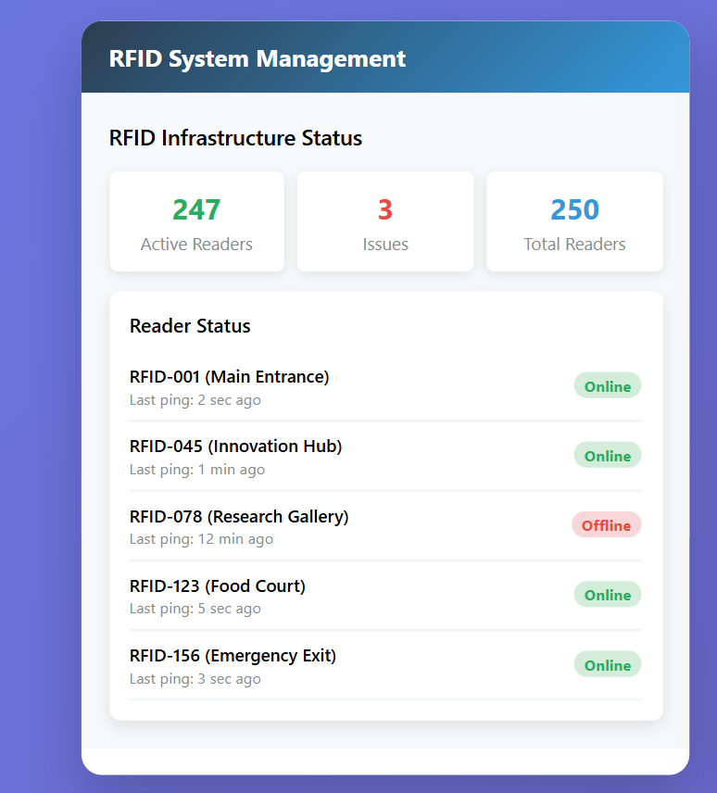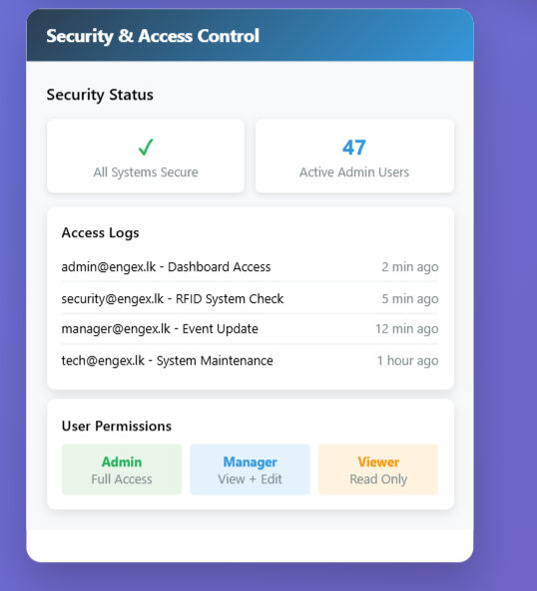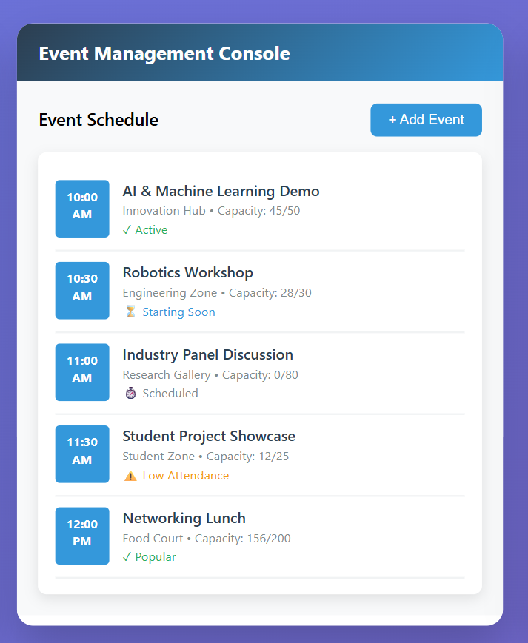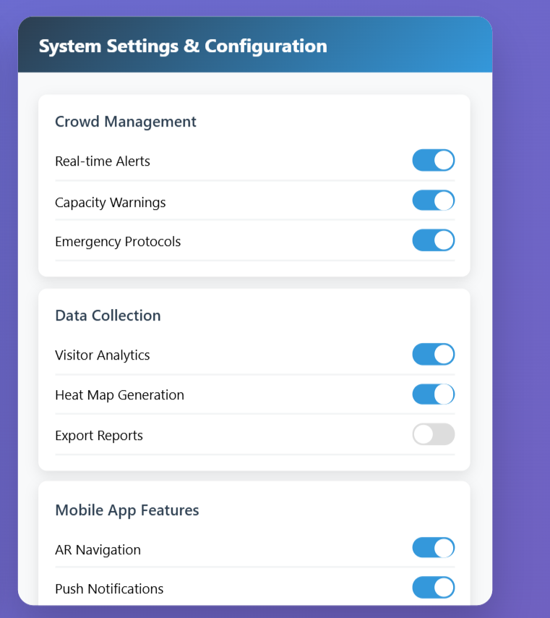

- Overview
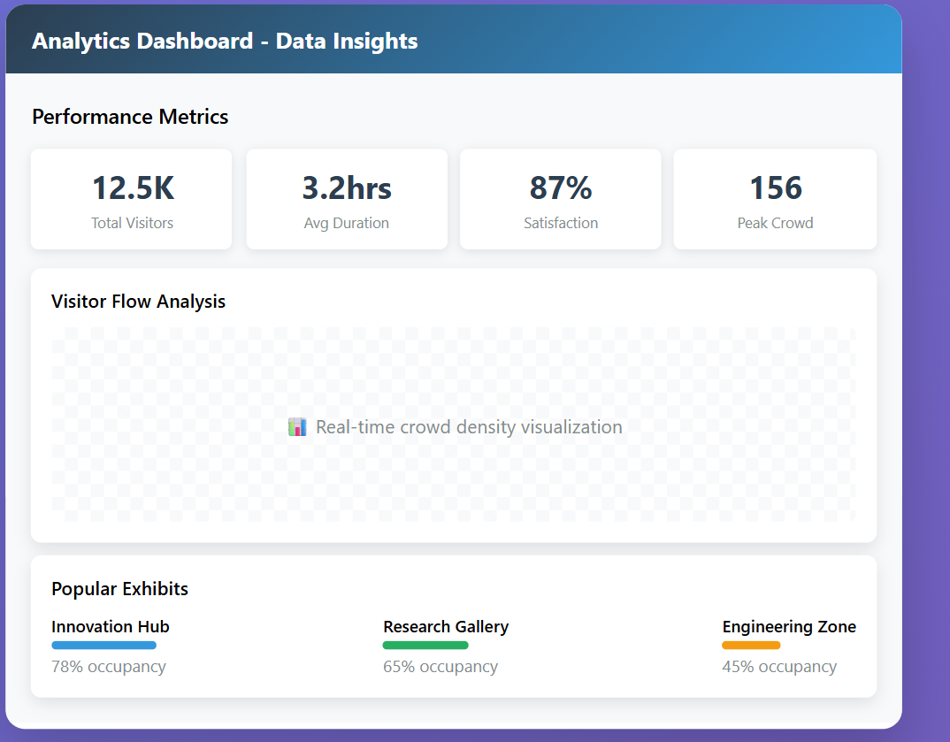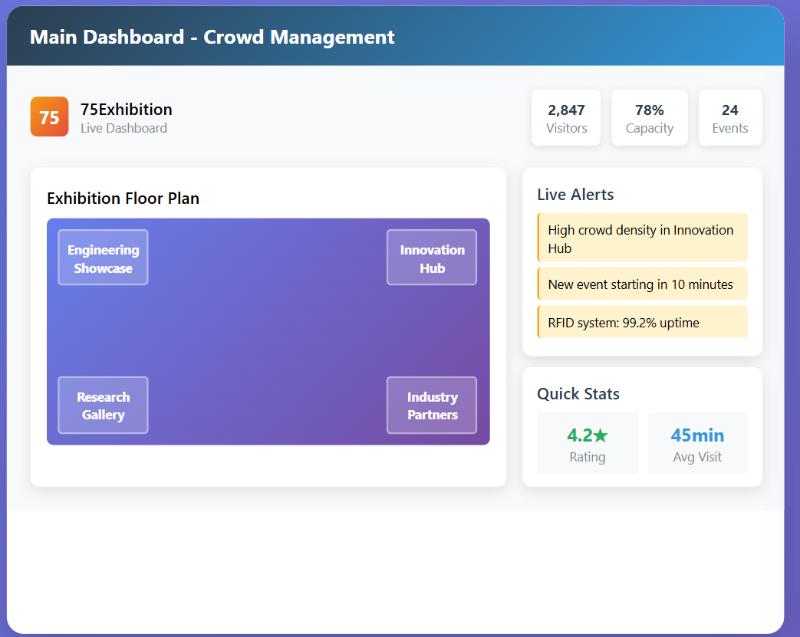

- Mobile App Interface
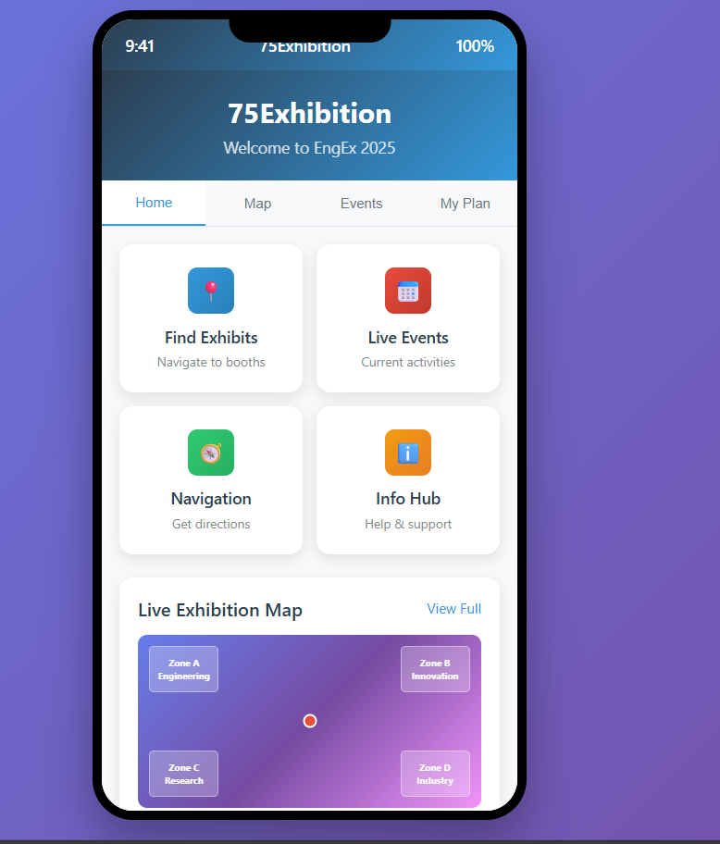

This Software Requirements Specification document has been prepared in accordance with IEEE 830-1998 standards for the 75Exhibition Crowd Management System. The document serves as the authoritative reference for all development, testing, and deployment activities related to the project

Role | Name | Signature | Date
Project Manager
Technical Lead
Quality Assurance
Lead
Client Representative
.

Distribution List;
- Development Team Member
- Project Stakeholders
- Quality Assurance Team
- System Administrators
- EngEx2025 Committe

