LAB 02 - WRITING MYSQL QUERIES 1
DEWAGEDARA D.M.E.S.
E/21/087

1.Recreate the following tables with relationships using MySQL syntaxes.

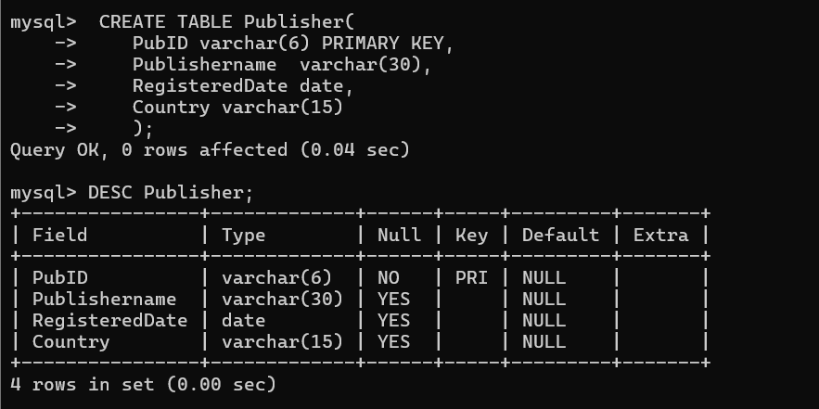

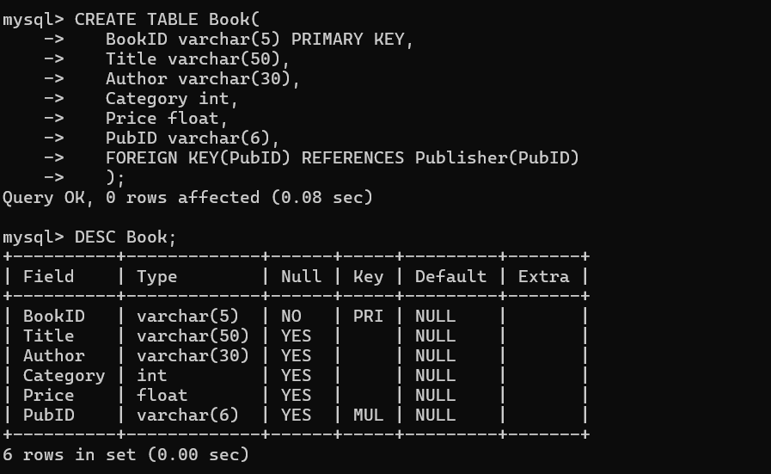

- Insert following records to Publisher table and Book.

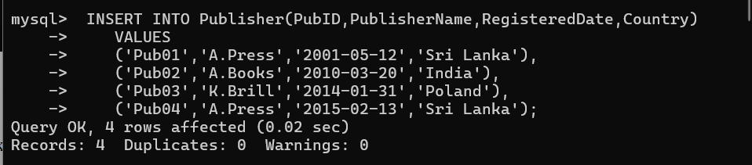

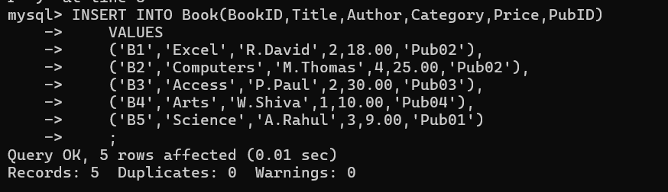

RESULTS,

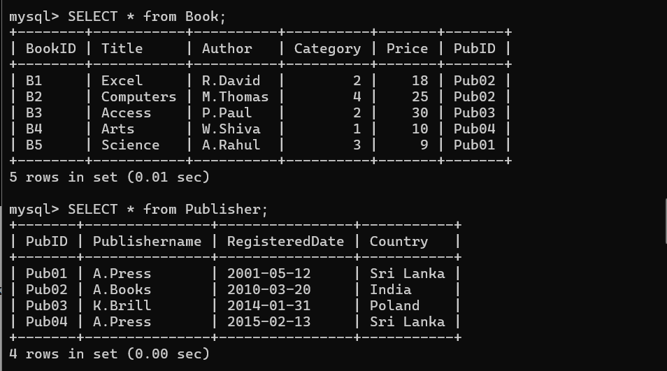

- Write SQL queries/statements considering the following table. Table Name: Book

- Display all the details in the Book table.

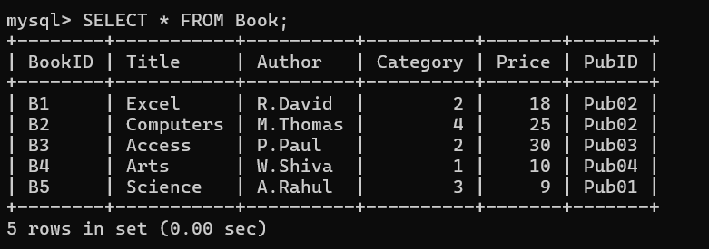

- Display all the titles of the books.

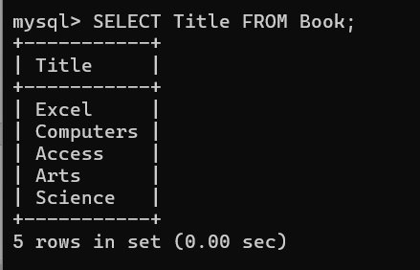

- Display all the titles of the books with prices.

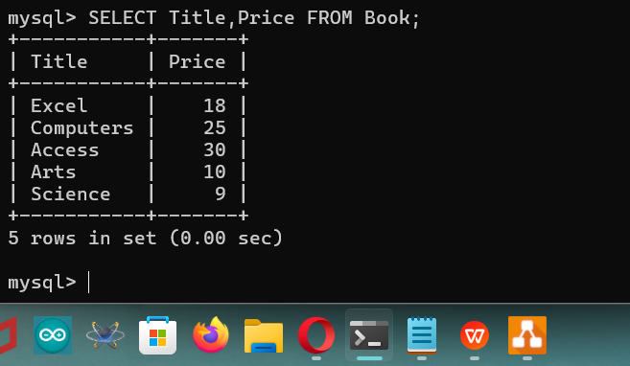

- Display the Book ID, the Title and the Author.

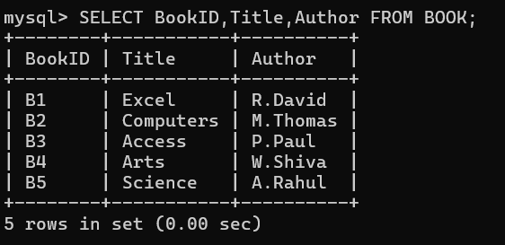

e. Display the details of the book with the Book ID B2.

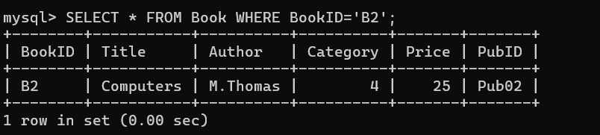

f. Display the titles of the books with the prices less than 20.00.

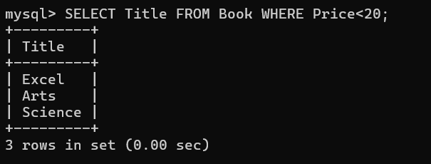

g. Display the details of the books in category 2.

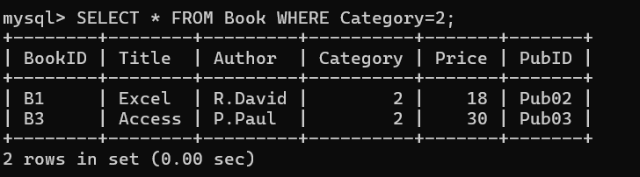

- Write queries

- Display all the Titles in the Book table in ascending order.

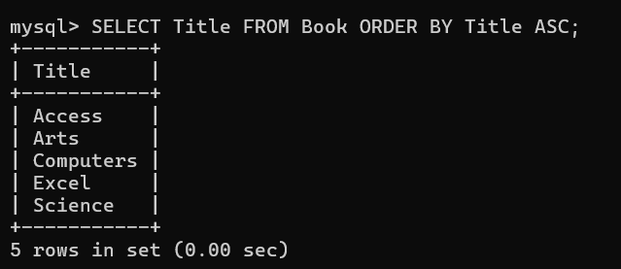

- Display all the details in the Book table in descending order by Price.

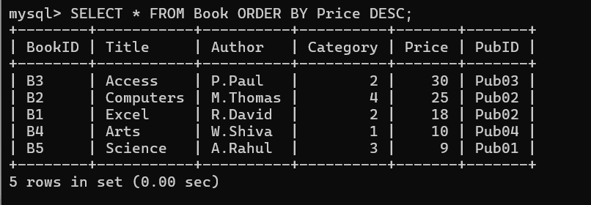

- Display all the details in the Book table in ascending order by Price and Title.

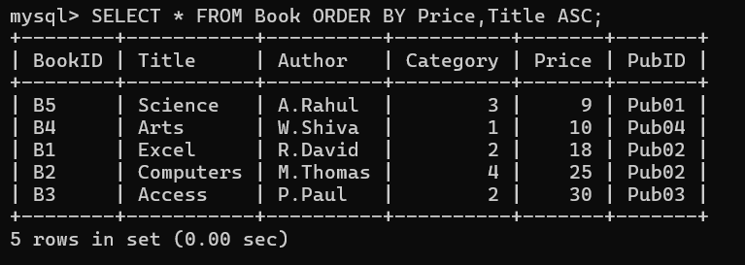

- Write SQL queries/statements considering the ‘Book’ table

- Change the category as 3 of the book with the BookID ‘B3’.

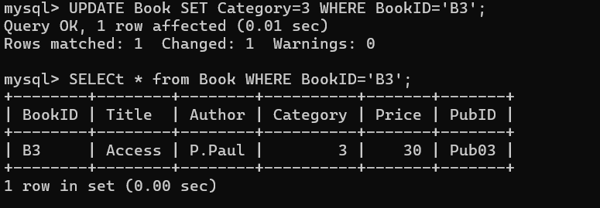

- Change the price of the book with the BookID ‘B3’ by adding 10.00 to the current price.

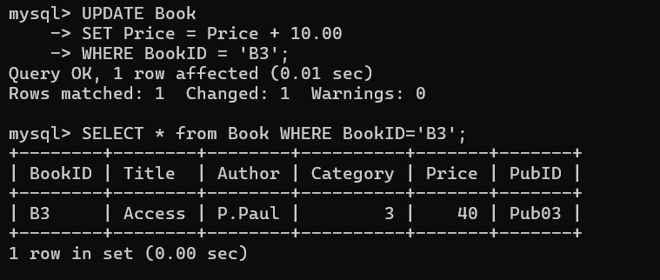

- Delete the details of the book with the BookID ‘B3’.

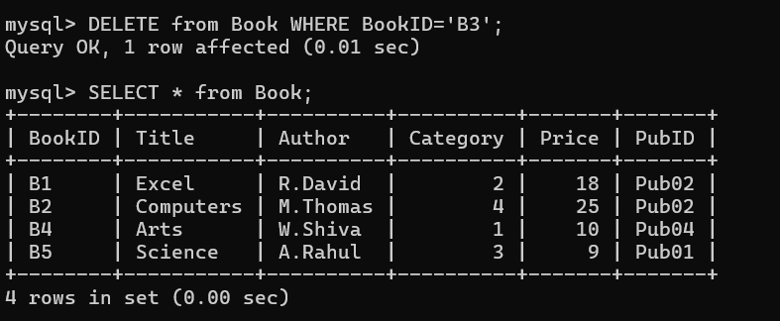

- Delete all the books in category 2.

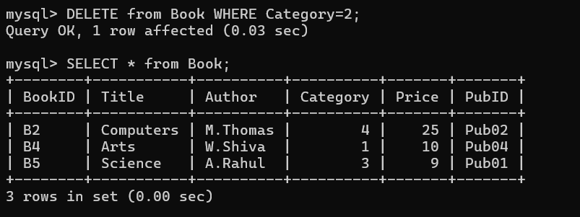

- Remove all the data in the Book table.
