LAB-04
DEWAGEDARA D.M.E.S.
E/21/087

- Write a nested query to list the details of the movies directed by a director

A. who is also a reviewer.

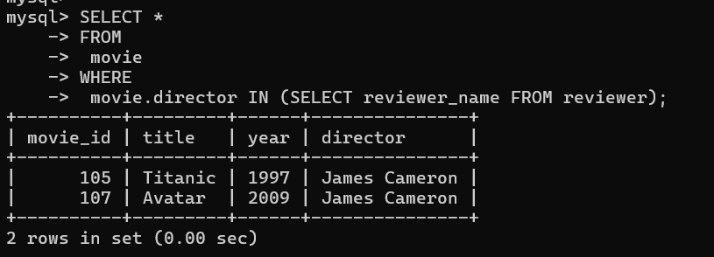

B. who is not a reviewer.

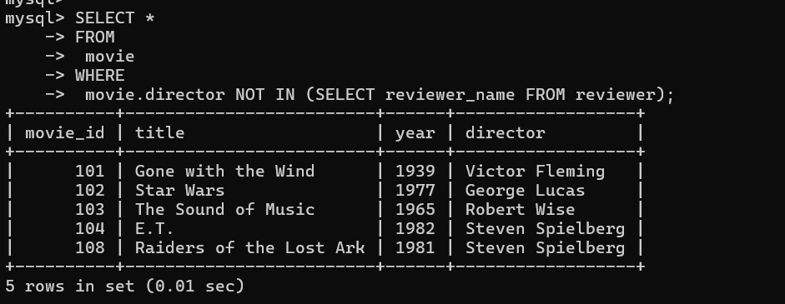

- Write a nested query to list the details of the movie ratings,

A. reviewed by the reviewer ‘Sarah Martinez’.

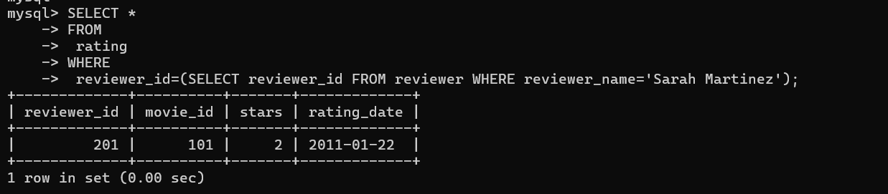

- not reviewed by the reviewer ‘Sarah Martinez’.

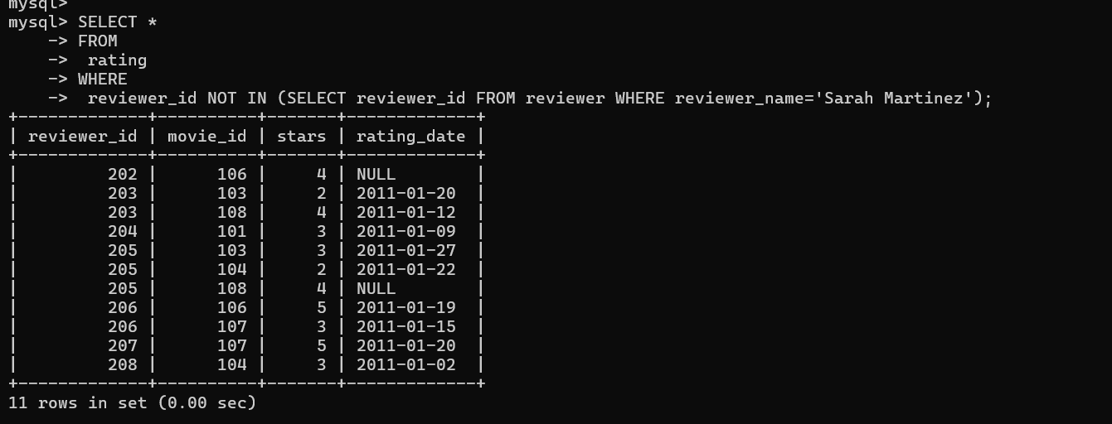

- Find all the years that have a movie that received a rating of 4 or 5 and sort them in increasing order of the year. Write,

A.non-nested query.
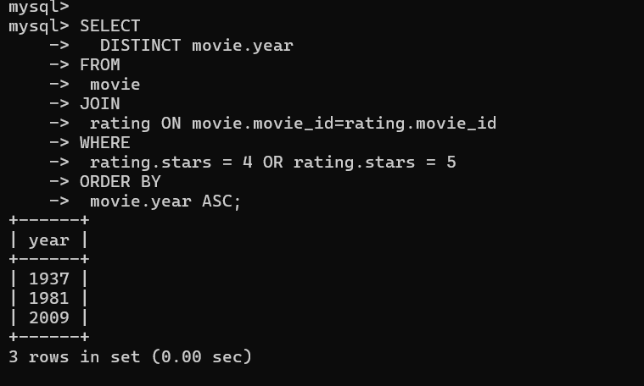

B.a nested query

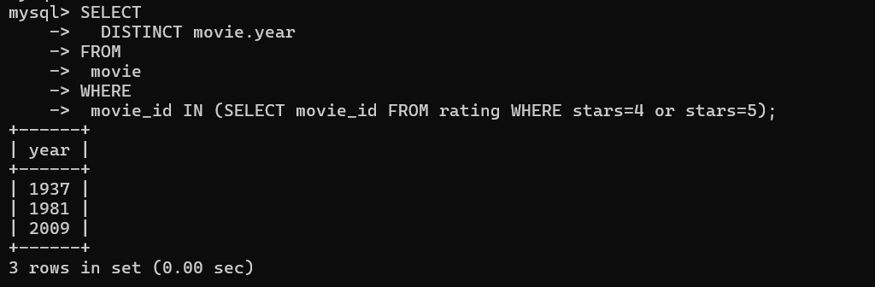

14) Some reviewers did not provide a date with their rating. Find the names of all reviewers who have a NULL value for the date. Write a nested query

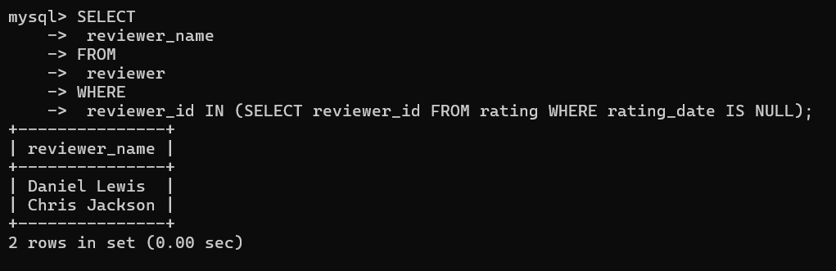

15)List the movie titles and average ratings, from the highest-rated to lowest-rated. If two or more movies have the same average rating, list them in alphabetical order.

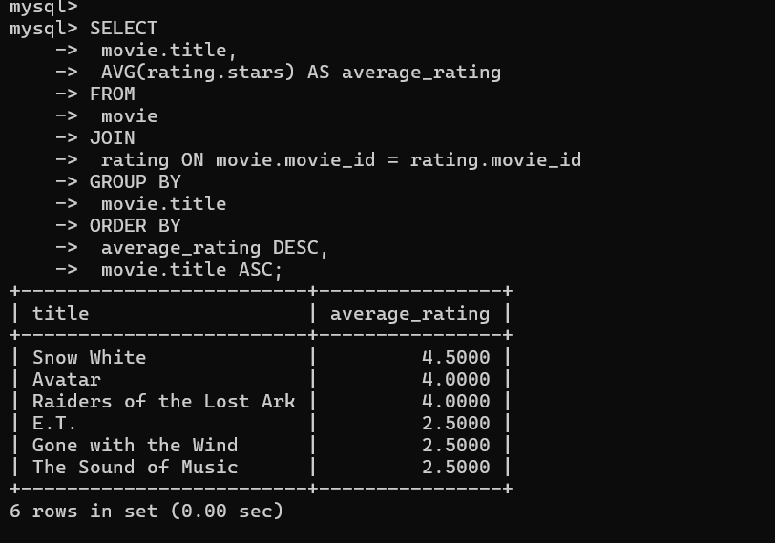

- Remove all ratings where the movie's year is before 1970 or after 2000

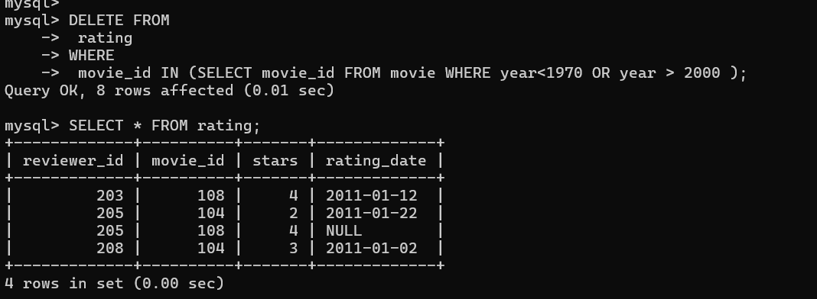

- Remove all ratings where the rating date is NULL

