DEWAGEDARA D.M.E.S.
E/21/087

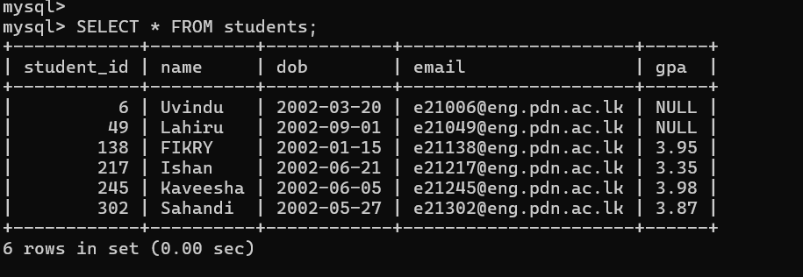

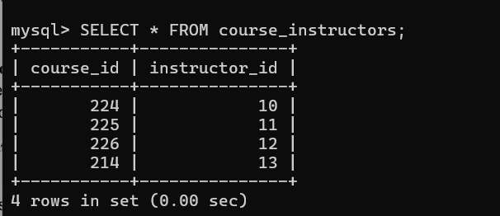

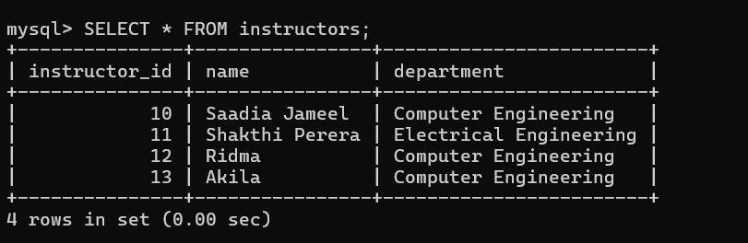

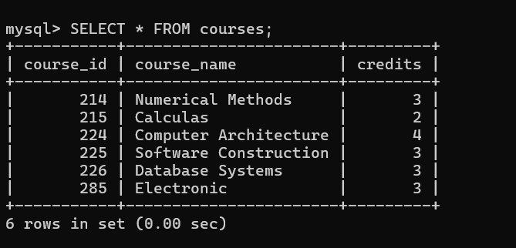

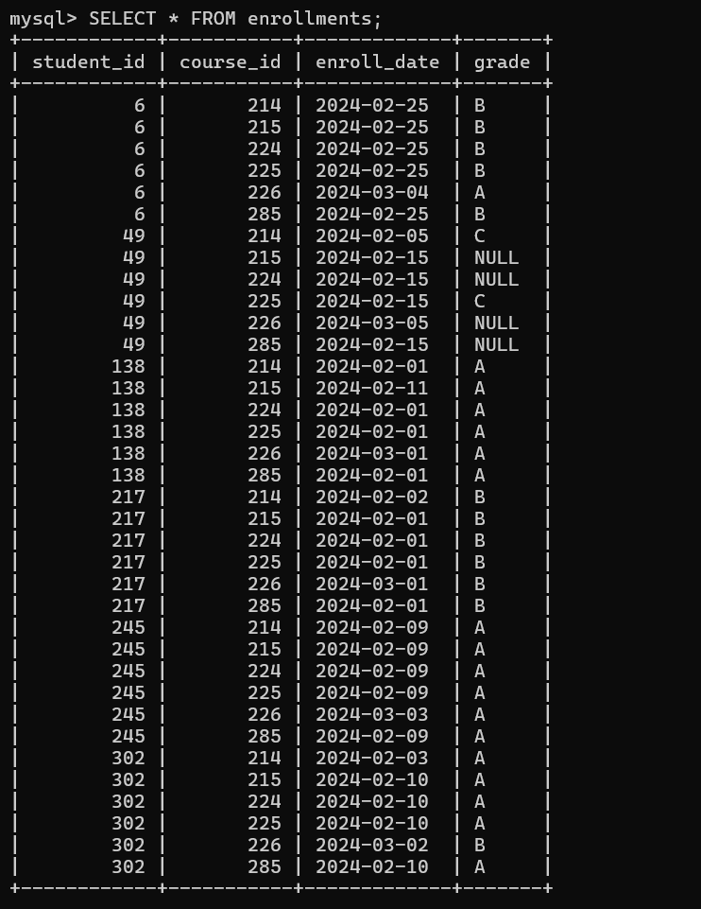

Lab Tasks

1)
- List all students details.

Use the SELECT to show all information about the students stored in the table.

- Display all courses that offer more than 3 credits.
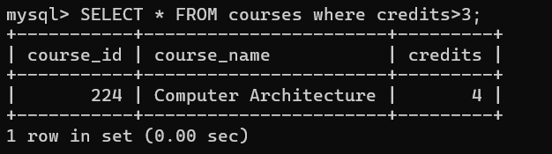
Use WHERE clause to filter and display only the courses that have more than 3 credits.

- Show all enrollments with student name, course name, and grade.
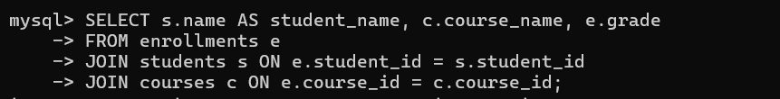
Use JOIN to combine data from students, enrollments, and courses tables and display student name, course name, and grade together using SELECT.

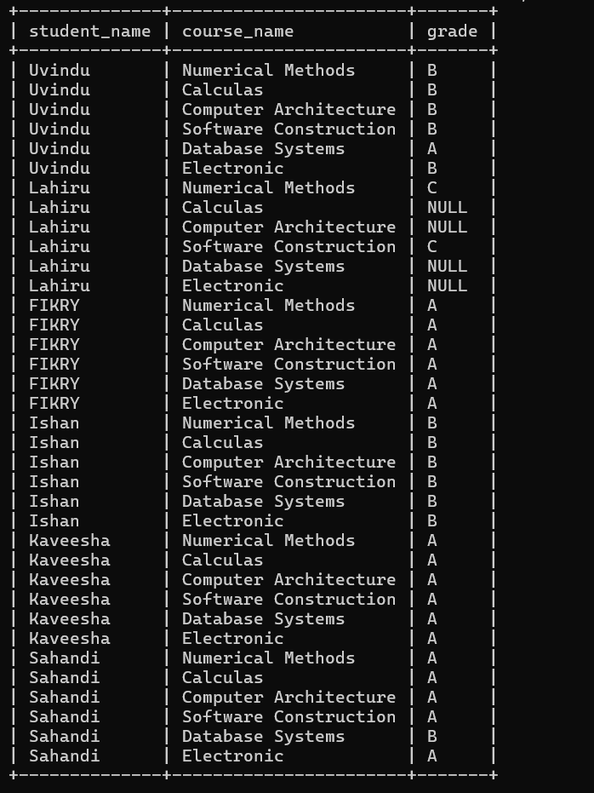

a.Show each course with the number of enrolled students.

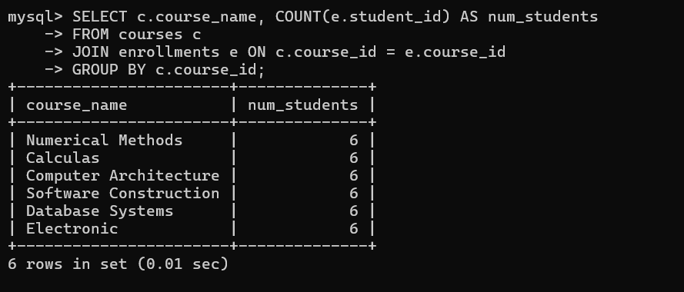
First group the students by course_id from the enrollments table using GROUP BY. Then use COUNT() to find how many students are enrolled in each course.

3)
- Find students who enrolled after '2024-02-10'.
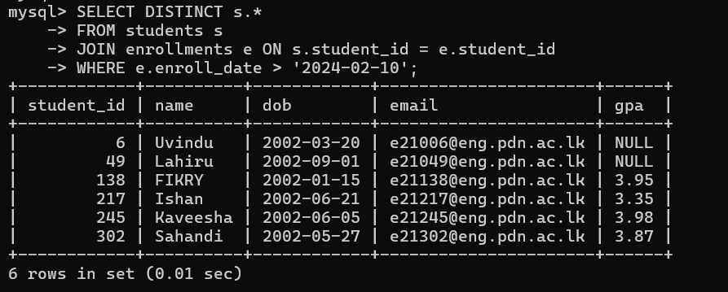
Use WHERE to check if the student's enroll_date is after '2024-02-10' and show only the distinct student details using SELECT DISTINCT.

- Retrieve names of students who got the highest GPA.

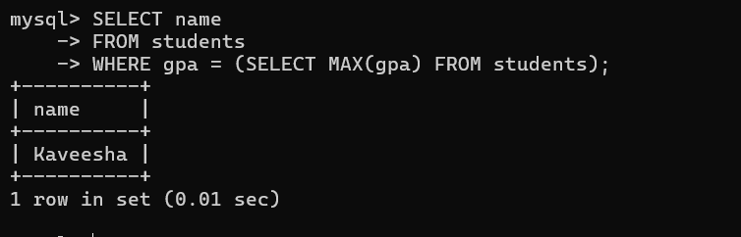

Use a subquery to find the highest GPA in the students table, and then retrieve the names of students who have that GPA.

4)
a.Update Lahiru’s GPA to 3.2.
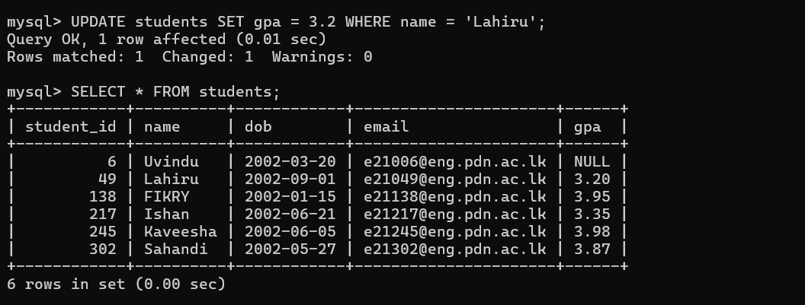 Use UPDATE to change the GPA of the student named 'Lahiru' to 3.2 in the students table if the name matches.

b.Delete enrollments where the grade is NULL
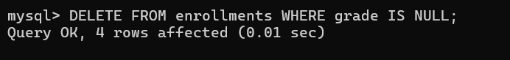

Use DELETE with WHERE grade IS NULL to remove any enrollment records where the grade is not yet assigned.

5)
a. Create a view named student_course_view showing student name, course
name, and grade.
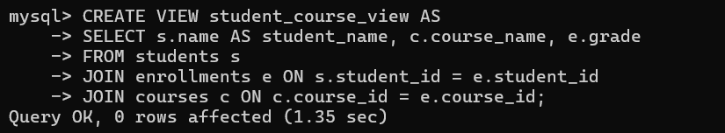

Create a VIEW named student_course_view to simplify access to student names, course names, and grades by using JOIN and SELECT.
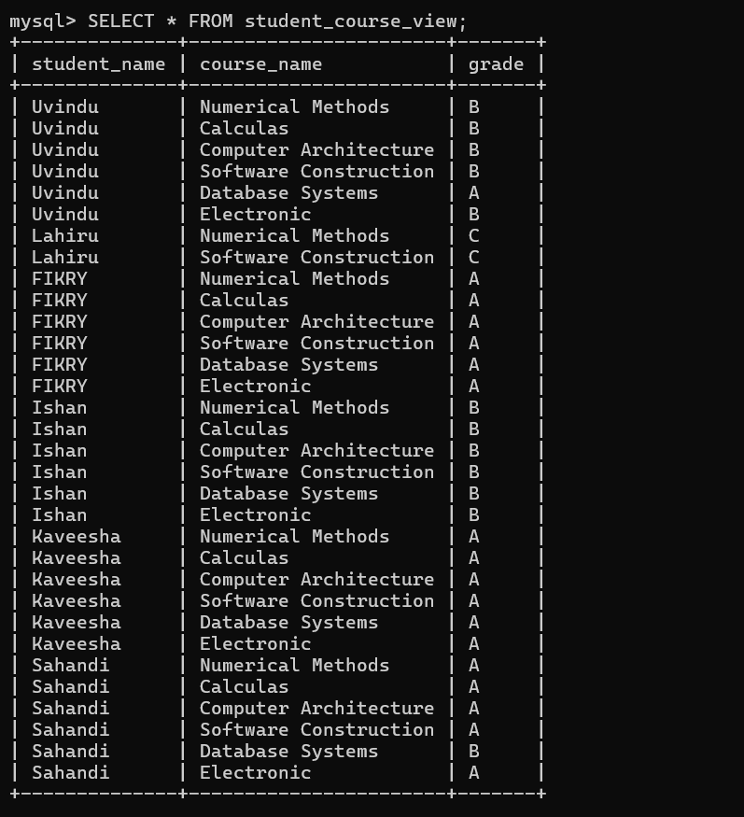

b. Create a stored procedure enroll_student to insert a record into
enrollments with student_id, course_id, enroll_date, grade.

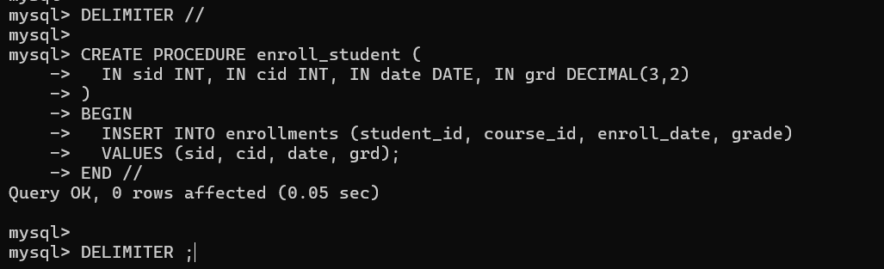
Create a stored procedure called enroll_student that accepts inputs like student_id, course_id, enroll_date, and grade, and inserts a new record into the enrollments table.

