DEWAGEDARA D.M.E.S.
E/21/087
LAB 08

TASK 01

A.
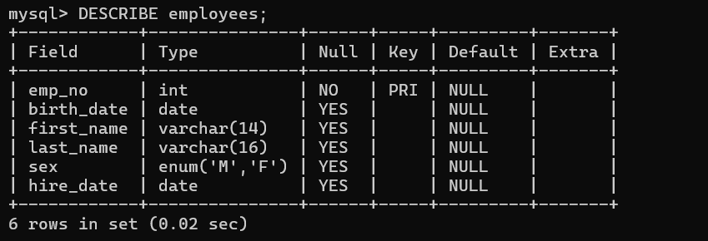

B.

C.

- The DESCRIBE command shows the table structure, data types, and constraints.
- SHOW INDEX reveals what indexes currently exist (only PRIMARY KEY on emp_no).
- Most columns don't have indexes initially, which affects query performance.

D.
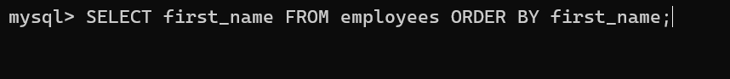

E.
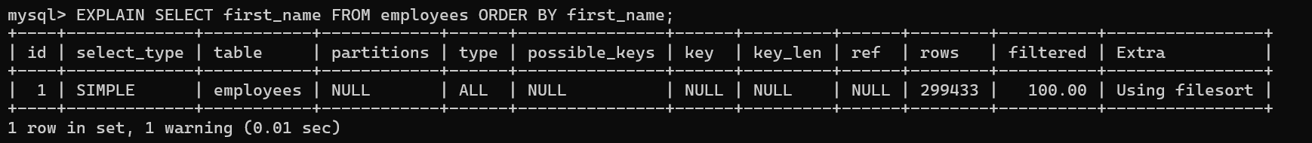

F.

- The EXPLAIN output shows how MySQL executes the query.
- Without an index on first_name, MySQL must:
- Scan the entire table (type: ALL)
- Sort all results (Using filesort)
- This is inefficient for large tables

G.


H.


I.
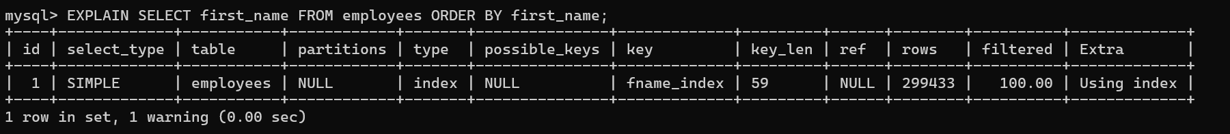

J.

- The query now uses the index (type: index)
- No filesort needed since data is already sorted in the index
- Significant performance improvement

K.

- Before Index: Full table scan + filesort
- After Index: Direct index access, pre-sorted data
- Improvement: Faster execution, especially noticeable with large datasets

Task 02

A composite (multi-column) index is an index that includes multiple columns from a table, allowing
efficient queries that filter or sort by multiple columns simultaneously.

A.
Difference from Multiple Single-Column Indexes,
- Composite Index: Single index structure covering multiple columns
- Multiple Single Indexes: Separate index structures for each column
- Advantage: Composite indexes can satisfy queries involving multiple columns in one lookup

B.
Column Order Impact,
- Left-most prefix rule: Index can only be used if query includes leftmost columns
Example: Index on (last_name, first_name) can help:
WHERE last_name = 'Smith'
WHERE last_name = 'Smith' AND first_name = 'John'
But NOT: WHERE first_name = 'John' (without last_name)

C.
- Queries frequently filter by multiple columns together
- Sorting by multiple columns
- When query selectivity improves with multiple columns
- Covering indexes (index contains all needed columns)

TASK 03

A.



B.

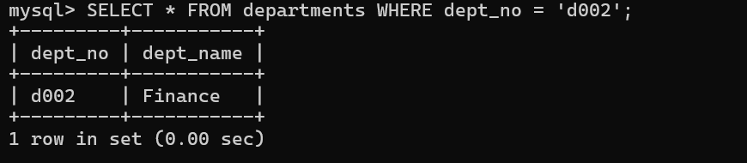
Conclusions,

- If dept_no is PRIMARY KEY: Very fast lookup (type: const)
- If dept_name has no index: Full table scan (type: ALL)
- Primary keys provide the fastest access method
- Non-indexed columns require full table scans

TASK 04
A.

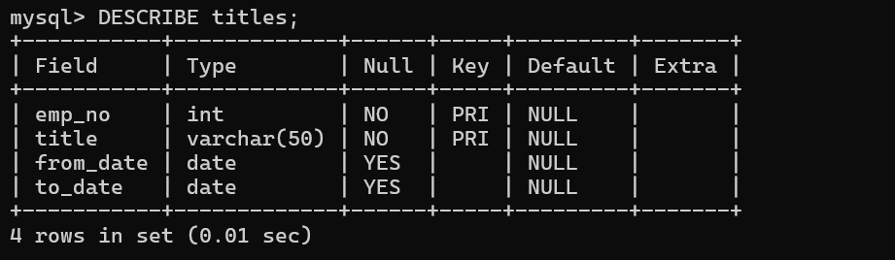

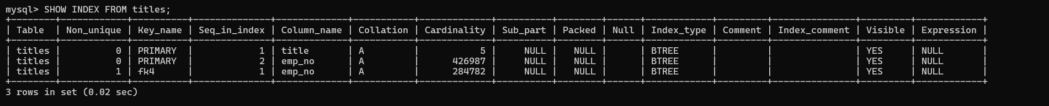

2.
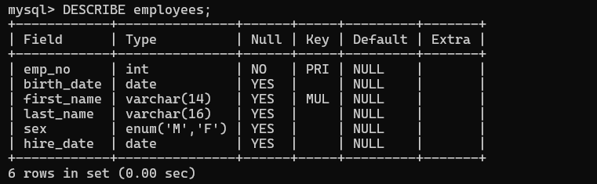

B.
Creat emplist table,


Creat titleperiod table,

- Analyze the table,
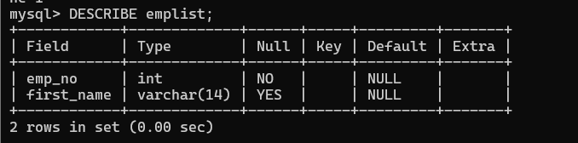



2.
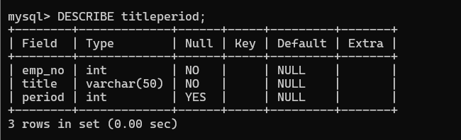



C.

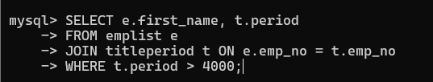

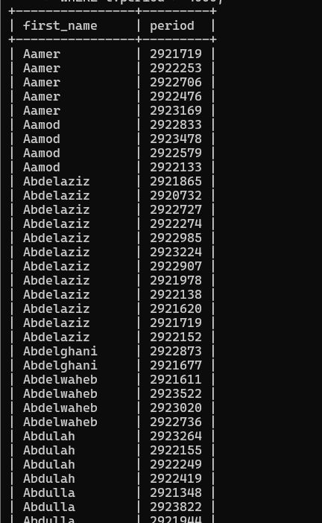

D.Explain without index,

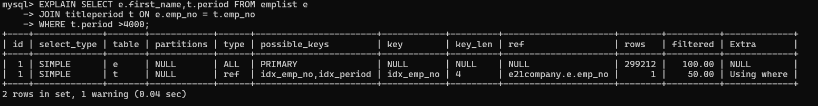

- type: ALL - Full table scans on both tables
- rows: High number of rows examined
- Extra: Using where - filtering after reading all rows
- Performance: Poor due to nested loop joins without indexes

E.
Creat primary key on emplist,


Creat index on titleperiod,

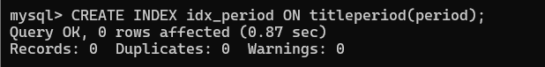

3.
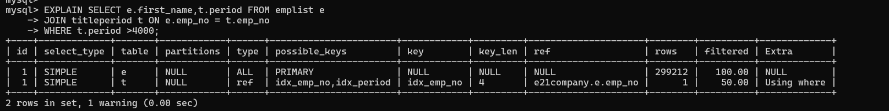

Improved Analysis:
- type: eq_ref/ref - Index-based joins
- rows: Fewer rows examined
- key: Shows which indexes are used
- Performance: Significantly better

4.YES,
- Covering Index: Create composite index including all needed columns
- Query Rewriting: Consider different join orders
- Partitioning: For very large tables
- Statistics Update: Ensure MySQL has current table statistics

TASK 05

Query 1: Engineers per Department
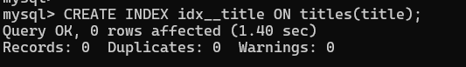



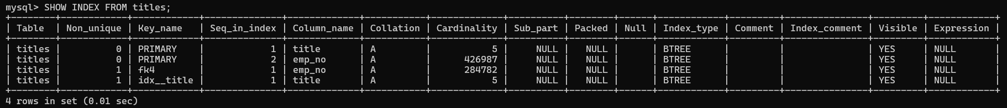

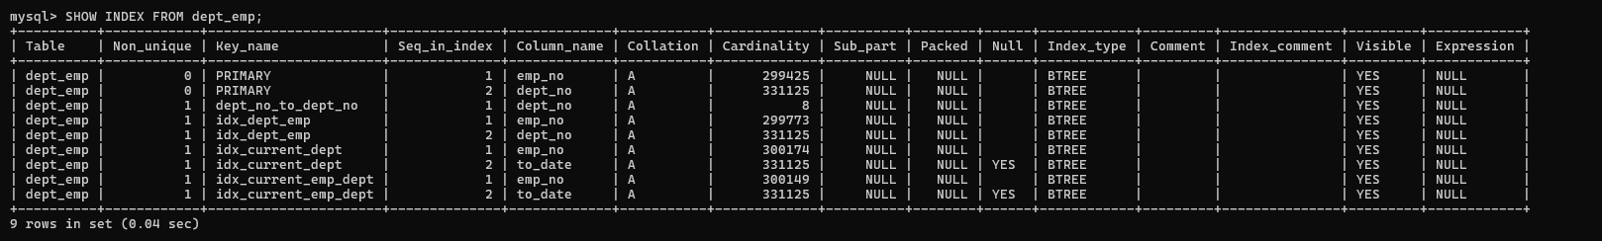

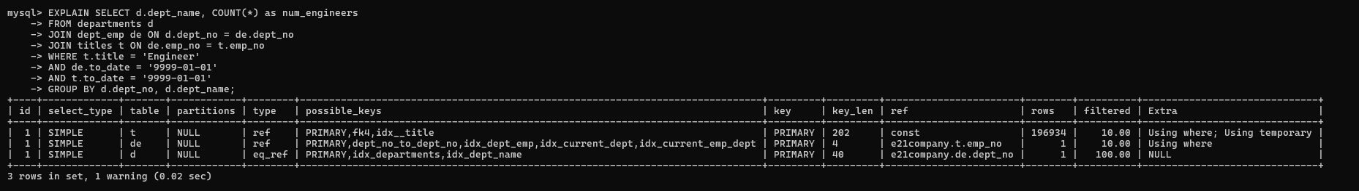
Expected Improvements:
- type: Changes from ALL to ref/eq_ref
- key: Shows which indexes are being used
- rows: Significant reduction in rows examined
- Extra: More efficient join algorithms

Query 3: High Salary Employees by Department
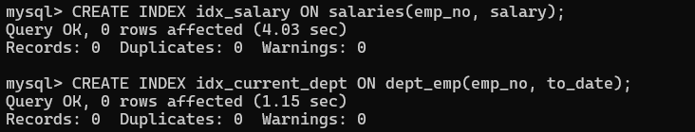

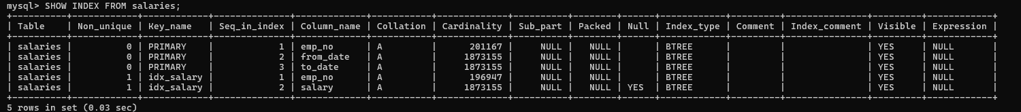

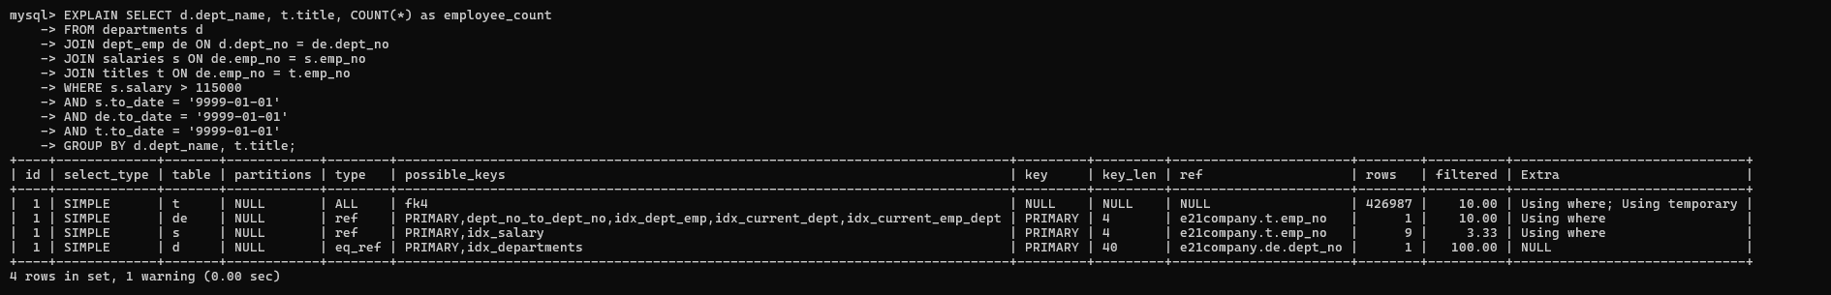

Expected Improvements:

- Range scan on salary index instead of full table scan
- Efficient joins using emp_no indexes
- Reduced rows examined due to early filtering

Query 5: Non-HR Employees
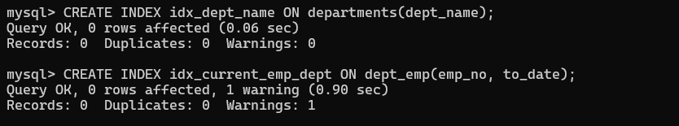

TASK 06

- Negative Impacts:
- Slower INSERT: Each insert must update all relevant indexes
- Slower UPDATE: Updates to indexed columns require index maintenance
- Slower DELETE: Must remove entries from all indexes
- Storage Overhead: Indexes consume additional disk space

- Performance:
- Read-Heavy Workload: Indexes provide significant benefits
- Write-Heavy Workload: Indexes can degrade performance
- Mixed Workload: Balance between read and write performance

