Diagnosing Delivery Failures in
Global Supply Chains
A Data Analysis & Predictive Modeling Portfolio Project

Shivani Prasad
Data Analyst | 2026

1. Executive Summary
This report presents a comprehensive analysis of delivery operations across a global e-commerce supply chain managing end-to-end order fulfillment across multiple regions. The analysis covers 172,765 orders spanning January 2015 through January 2018, focusing on identifying root causes of chronic late deliveries, quantifying their financial impact, and establishing a data-driven framework for improvement.

The headline finding is stark: 54.71% of all orders are delivered late, costing the business $2.1M in eroded profitability on delayed orders alone. While total profit across fulfilled orders reached $7.5M, the persistent late-delivery problem represents a significant financial drain and a major customer experience risk. A Random Forest predictive model achieved 74% accuracy in identifying at-risk orders before they become late.

Key Finding | Metric
Overall Late Delivery Rate | 54.71%
On-Time Delivery Rate | 45.29%
Total Orders Analyzed | 172,765
Total Profit (profitable orders) | $7.5M
Profit at Risk (delayed orders) | $2.1M
Predictive Model Accuracy (RF) | 74%
2. Business Context & Objectives
The company operates a global e-commerce platform selling products across categories including sporting goods, fitness equipment, outdoor gear, footwear, and apparel across multiple international regions.

Core Business Problem
Actual shipping times frequently deviate from scheduled delivery windows, creating eroded customer trust, reduced order profitability, and an inability to make reliable commitments to buyers at point of purchase.

Analytical Objectives
- Understand the current state of delivery performance across all dimensions (region, mode, time, segment)
- Quantify the financial impact of delays on order profitability
- Identify the primary operational bottlenecks driving late deliveries
- Build a predictive model to flag high-risk orders before they are shipped
- Deliver actionable recommendations to improve on-time delivery and profitability

3. Key Performance Indicators (KPIs)
The following KPIs were computed directly from the cleaned dataset to establish a performance baseline.

172,765  Total Orders | 94,523  Late Deliveries | 54.71%  Late Delivery % | 45.29%  On-Time Delivery %
$7.5M  Total Profit (profitable orders) | $2.1M  Profit at Risk (delayed orders) | 3 days  90th Percentile Delay | $22.03  Avg Order Profit

KPI Insights
● Late Delivery Rate at 54.71% | More than half of all orders arrive late. This is not an edge-case problem — it is the default experience for the majority of customers.

● $2.1M Profit at Risk | Orders that experienced delays collectively generated $2.1M in profit that is under constant pressure from further operational deterioration.

● 90th Percentile Delay = 3 Days | Even the most extreme cases are contained within 3 days of lateness, suggesting the problem is systemic and process-driven rather than catastrophic.

4. Profitability Analysis
4.1 Profitability Distribution
Order-level profitability was classified into three tiers based on Order Profit Per Order. While 80.7% of orders are profitable, the 18.7% loss-making share represents a meaningful drag that is disproportionately concentrated among delayed shipments.

Profitability Tier | Order Share | Interpretation
Profit | 80.7% | The operational baseline — orders generating positive margin
Loss | 18.7% | Loss-making orders; concentrated in delayed shipments
Break-even | 0.6% | Negligible share; orders at exactly zero margin

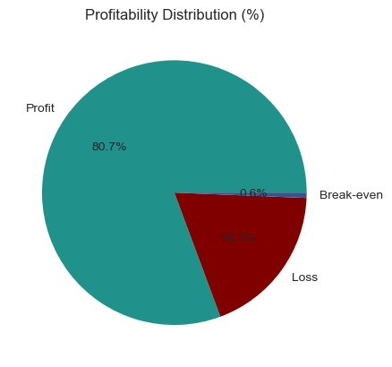
Figure 1: Profitability Distribution (%)

4.2 Delay Distribution & Profit vs. Delay Days
The delay distribution shows that 31.0% of all orders arrive exactly 1 day late — the single largest cohort. Combined, orders delayed by 1–4 days account for 54.7% of all order volume, directly mapping to the overall late delivery rate.

Delay (days) | % of Orders | Cumulative %
-2 | 12.1% | 12.1%
-1 | 12.0% | 24.1%
0 | 21.2% | 45.3%
1 ← largest cohort | 31.0% | 76.3%
2 | 15.9% | 92.2%
3 | 3.9% | 96.1%
4 | 3.9% | 100.0%

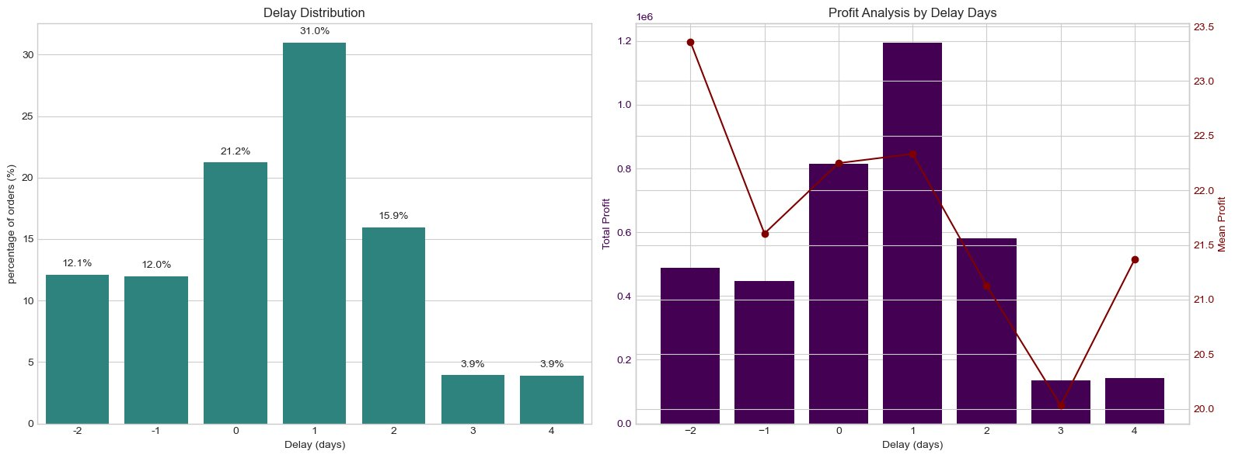
Figure 2: Delay Distribution (left) and Profit Analysis by Delay Days (right)

● Volume-Driven Profitability Loss | Mean profit per order remains stable at approximately $20–$23 across all delay levels. The profitability problem is therefore driven by volume of delayed orders, not individual order economics — making systemic throughput improvement the highest-leverage intervention.

5. Bottleneck Detection
Delay percentage was computed across six key operational dimensions. The analysis below reveals where the fulfillment process breaks down most severely.

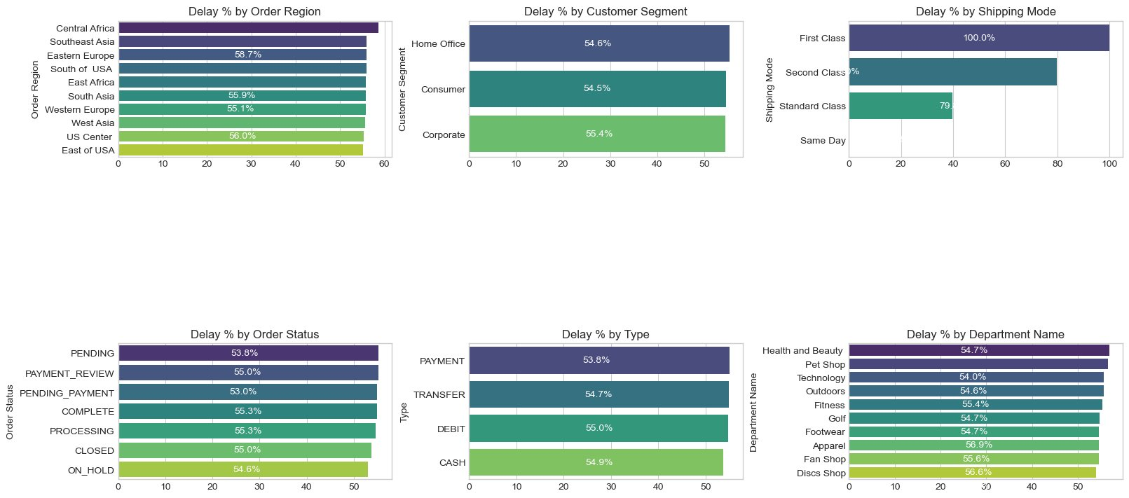
Figure 3: Bottleneck Detection — Delay % by Category

5.1 Delay % by Shipping Mode
Shipping Mode | Delay % | Interpretation
First Class | 100.0% | Every single First Class order arrives late — a critical SLA failure
Second Class | 79.8% | Nearly 4 in 5 Second Class orders are late
Standard Class | 39.8% | Best performer but still substantial room for improvement
Same Day | 0.0% | Perfect on-time rate — operational benchmark to learn from

● Shipping Mode is the #1 Lever | First Class: 100% delay rate. Second Class: 79.8%. Standard Class: 39.8%. Same Day: 0%. The mode assignment logic is the most impactful single variable to fix.

5.2 Delay % by Region
Order Region | Delay %
Central Africa | 58.7%
Southeast Asia | 56.0%
Eastern Europe | 56.0%
South of USA | 55.9%
East Africa | 55.9%
South Asia | 55.8%
Western Europe | 55.8%
West Asia | 55.6%
US Center | 55.3%
East of USA | 55.1%

● Regional Spread is Narrow (55–59%) | Central Africa leads at 58.7% but all regions cluster between 55–59%. This rules out a localised logistics failure and confirms a company-wide systemic issue.

5.3 Delay % by Customer Segment & Department
Dimension | Category | Delay % | Insight
Customer Segment | Home Office | 55.4% | Marginally highest segment
Customer Segment | Consumer | 54.6% | Core customer base equally affected
Customer Segment | Corporate | 54.5% | All segments nearly identical
Department | Health & Beauty | 56.9% | Highest delay rate by department
Department | Pet Shop | 56.6% | Warrants dedicated inventory audit

● Customer Segments Nearly Identical (54.5–55.4%) | No segment receives preferential service. All customers — Consumer, Corporate, Home Office — experience the same broken delivery promise.

6. Time-Based Analysis
Delay percentage was examined across three temporal dimensions to identify operational patterns tied to calendar and time-of-day effects.

6.1 Delay % by Month
Month | Delay % | Month | Delay %
January | ~55% | July | ~55%
February | ~55% | August | ~55%
March | ~55% | September | ~55%
April | ~55% | October | ~55%
May | ~55% | November | ~56%
June | ~55% | December | ~56%

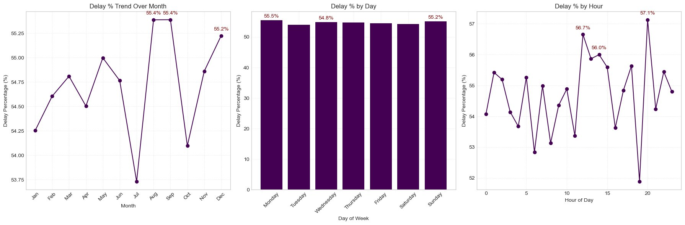
Figure 4: Delay % by Month, Day of Week and Hour of Day

● Stable Monthly Pattern | Delay rates are remarkably consistent across all months, with a marginal uptick in November–December. This reinforces the systemic nature of the problem — there is no seasonal fix that would resolve it.

6.2 Delay % by Day of Week & Hour
Dimension | Highest Delay | Lowest Delay | Implication
Day of Week | Tuesday (~56%) | Saturday (~54%) | Mid-week processing may be under-staffed
Hour of Day | Mid-afternoon peak | Late night trough | Order intake spikes may exceed routing capacity

7. Root Cause Analysis
A root cause analysis was conducted for Central Africa — the highest-delay region — to identify which operational factors drive its elevated delay rate. The same methodology applies to any region in the dataset.

Driver Factor | Delay % | Impact Assessment
Shipping Mode: First Class | 100.0% | Critical — eliminates on-time delivery entirely
Shipping Mode: Second Class | 79.8% | High — affects the majority of volume
Order Status: Pending | ~56% | Medium — processing backlog contributing to delays
Department: Health & Beauty | ~58% | Medium — category-specific fulfillment issues
Customer Segment: Home Office | ~57% | Lower — segment effect is secondary to mode

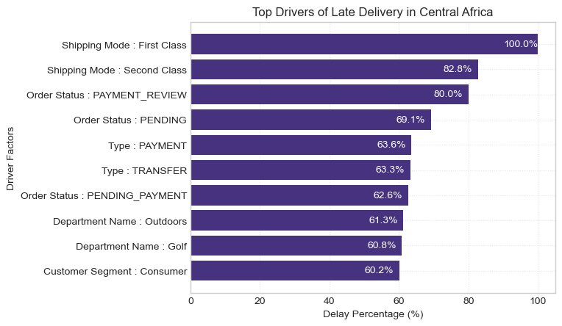
Figure 5: Top Drivers of Late Delivery in Central Africa

● Root Cause Conclusion | Shipping mode assignment is the dominant root cause. Addressing the routing logic for First Class and Second Class shipments would have the single largest impact on delivery performance across all regions.

8. Machine Learning Model
8.1 Model Configuration
Parameter | Value
Algorithm | Random Forest Classifier
Target Variable | Late_delivery_risk (binary: 0 = on-time, 1 = late)
Feature Encoding | Frequency Encoding for categorical variables
Class Balancing | SMOTE (Synthetic Minority Oversampling Technique)
Train / Test Split | 80% training / 20% test (stratified)
Random State | 42 (reproducible)

8.2 Features Used
- Shipping Mode (frequency encoded)
- Days for Shipment (scheduled)
- Customer Segment (frequency encoded)
- Department Name (frequency encoded)
- Order Region (frequency encoded)
- Order Type (frequency encoded)
- Category Name (frequency encoded)
- Order Month
- Order Hour

8.3 Test Set Performance (34,553 records)
Metric | Class 0 (On-time) | Class 1 (Late) | Overall (Weighted)
Precision | 0.68 | 0.78 | 0.74
Recall | 0.72 | 0.75 | 0.74
F1-Score | 0.70 | 0.77 | 0.74
Accuracy | — | — | 0.74
Support | 14,758 | 19,795 | 34,553

● 74% Overall Accuracy | The model correctly classifies nearly 3 in 4 orders — a strong foundation for production deployment as an order-level late-delivery alert system.

● Higher Precision on Late Orders (0.78) | When the model predicts an order will be late, it is correct 78% of the time — sufficient to trigger targeted interventions without generating excessive false alarms.

9. Recommendations
Based on the analysis, eight prioritised recommendations are proposed below, ordered by expected impact.

Priority | Recommendation | Expected Impact
1 — Critical | Audit and fix First Class shipping routing — 100% delay rate is unacceptable and constitutes a broken SLA | Highest
2 — Critical | Investigate Second Class carrier contracts and handoff processes to reduce 79.8% delay rate | High
3 — High | Deploy the Random Forest model as a real-time alert system to flag at-risk orders at point of dispatch | High
4 — High | Conduct a dedicated fulfillment audit for Health & Beauty and Pet Shop departments | Medium-High
5 — Medium | Investigate the Pending order status pipeline — processing backlog is contributing to delays | Medium
6 — Medium | Review Tuesday mid-week staffing and routing capacity to address the weekly delay spike | Medium
7 — Low | Study Same Day shipping operations as a benchmark for what on-time delivery looks like operationally | Informational
8 — Low | Enhance the predictive model with hyperparameter tuning and feature importance analysis to push accuracy above 80% | Future

10. Success Metrics & Target State
The following table defines measurable targets to track the impact of the recommended interventions over a 12-month implementation horizon.

Priority Area | Current State | Target State
Late Delivery Rate | 54.71% | < 30% within 12 months
First Class On-Time Rate | 0% | > 80%
Second Class On-Time Rate | 20.2% | > 60%
Predictive Model Accuracy | 74% | > 82% (enhanced model)
Loss-Making Orders | 18.7% | < 12%
Profit at Risk | $2.1M | Reduce by 40%

With focused execution on the eight recommendations in this report — starting with the critical shipping mode audit and predictive alert system deployment — the business can systematically recover its delivery performance, protect its $7.5M profit base, and build the operational reliability that sustained e-commerce growth demands.

11. Methodology & Tools
Component | Details
Dataset | DataCo Smart Supply Chain for Big Data Analysis — Kaggle
Records | 172,765 orders after removing cancelled shipments
Time Period | January 2015 – January 2018
Language | Python 3.10
Data Wrangling | pandas, numpy
Visualisation | matplotlib, seaborn (viridis palette)
Machine Learning | scikit-learn (RandomForestClassifier), imbalanced-learn (SMOTE)
Encoding | Frequency encoding for all categorical variables
Environment | Jupyter Notebook

This report was produced as part of a Data Analyst portfolio project.
Dataset: DataCo Smart Supply Chain for Big Data Analysis — Kaggle | Analysis by Shivani Prasad

