# Capstone Project – Battle of the Neighborhoods (Week 1)

By Shiju George

Rev. 0 (initial issue)

January 31, 2021

## Introduction / Business Problem:

My Client wishes to open a specific type of tea shop in New Orleans that will provide traditional teas in a space which promotes and supports social communities interested in mind and body wellness. He believes that there are synergies between these types of tea houses and places like yoga studios. In this regard, he would like to know which areas in New Orleans have yoga studios, and in particular which of these areas have the fewest number of tea houses. This information is important to my Client as he would like to know which area in New Orleans would potentially be suitable for a successful tea house.

## Description of the Data and how it will be used to solve the Business Problem:

Locations of the neighborhoods in New Orleans as defined by their respective latitudes and longitudes are shown on the following Wikipedia page:

<https://en.wikipedia.org/wiki/Neighborhoods_in_New_Orleans>

Using a python based Jupyter notebook, this information was extracted and transformed into a Pandas DataFrame, for example here are the first 5 rows of this data:

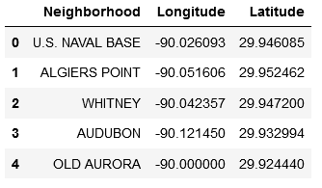

The following general steps were then applied, and they show how the New Orleans neighborhood location data was used to solve the Problem.

1. Create a map of New Orleans that shows each neighborhood.
2. Use Foursquare to find the top 100 venues and associated venue categories in each neighborhood. Following are the first 5 rows of this Foursquare data for the New Orleans neighborhoods:

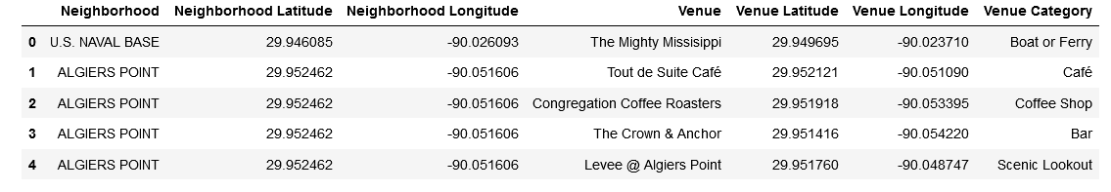

1. Use ‘one hot encoding’ on the venue categories of the venues in each neighborhood, e.g.:

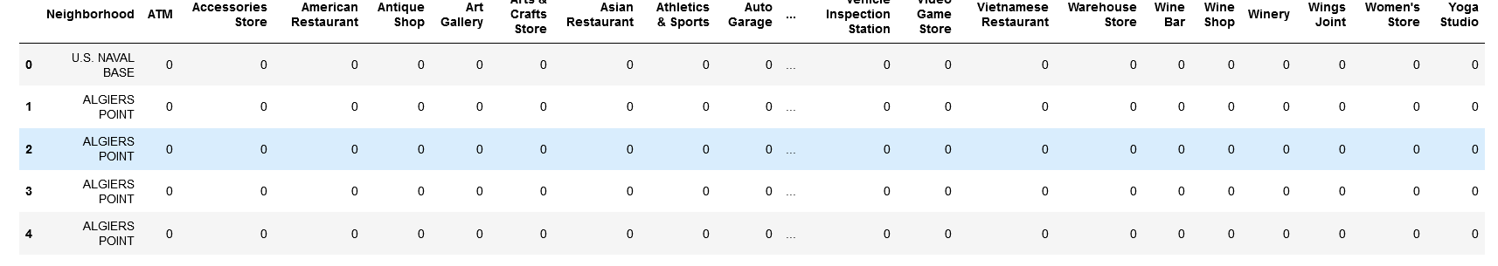

1. Determine a frequency grouping of the venue categories in each neighborhood, e.g.:

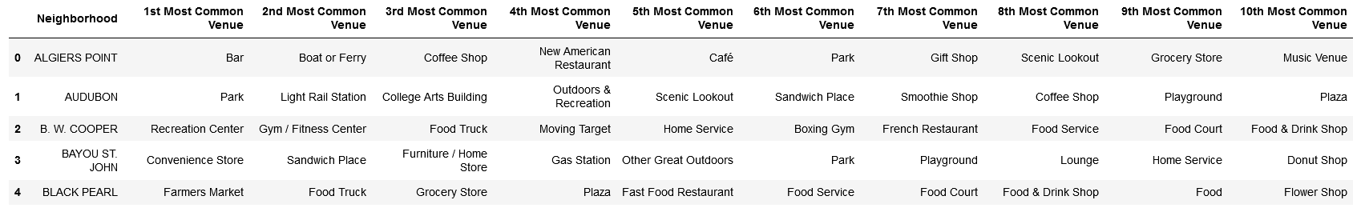

1. Cluster the neighborhoods using the K-Means method.
2. Show where the clusters are on a map of New Orleans.
3. Present plots that show which neighborhoods have both yoga studios and tea or coffee shops.
4. Using these plots determine which neighborhoods have the lowest number of coffee shops.