AutoR Studio — UI Progress Report
Snapshot of the AutoR Studio frontend on branch `kunlun/ui-initial-design` as of 2026-04-18. This document summarizes what is shipping, the NotebookLM-style view that was just added, and the concrete TODOs left for the next contributor.

1. Where the UI stands
The Studio now ships a working local shell served by `python studio.py --repo-root . --port 8765`. It runs against real runs on disk — no mocked data. The top-level structure is:
- Hub — projects grid with live run status.
- Workspace — per-run view with a page nav.
- Workspace pages: Overview, Human Review, Versions, Notebook. (The old Files and Paper pages were folded into Notebook.)
Every page reads live state from `runs/<run_id>/*` so the two views (existing 6-stage pipeline UI and the new Notebook view) stay in sync without a new event bus — the 3-second poll on the workspace view already catches cross-view changes.

2. Project Hub
Starting surface: list of research projects with latest-run status and a `New Project` form that seeds both the project record and an initial run in one click.
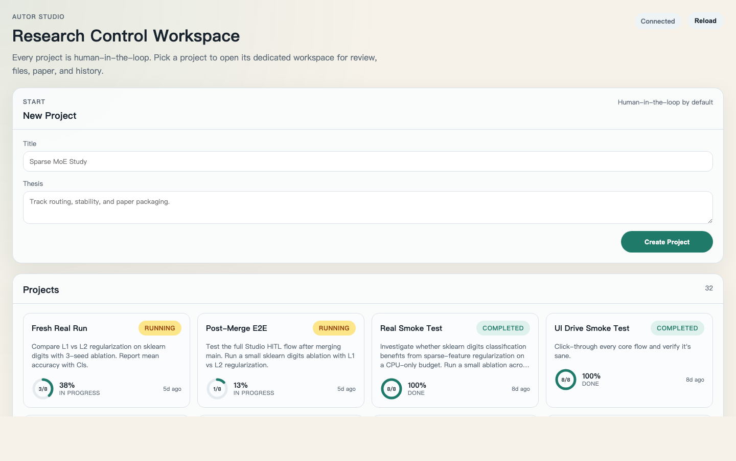
Figure. Project Hub with live run chips and the New Project form.

3. Workspace — Overview
Overview is the pipeline snapshot: stage strip, run progress, activity feed, and artifact counts. This is the human-friendly supervisor view of the current run.
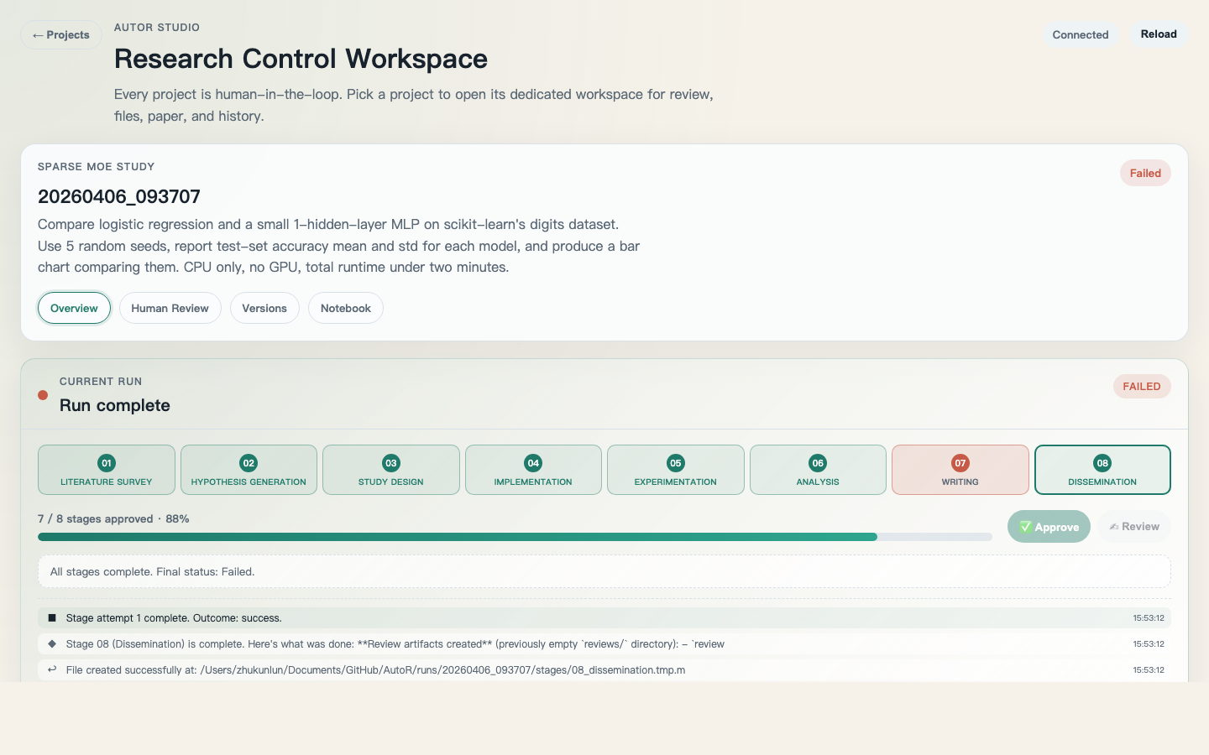
Figure. Workspace Overview with live stage strip and run progress.

4. Workspace — Human Review
The review page drives the human-in-the-loop gate: a hero block calls out the stage being reviewed, an inline feedback field + `Approve` / `Send Feedback & Re-run` buttons are the two primary actions, and a live Progress Monitor panel shows runner events as they stream in.
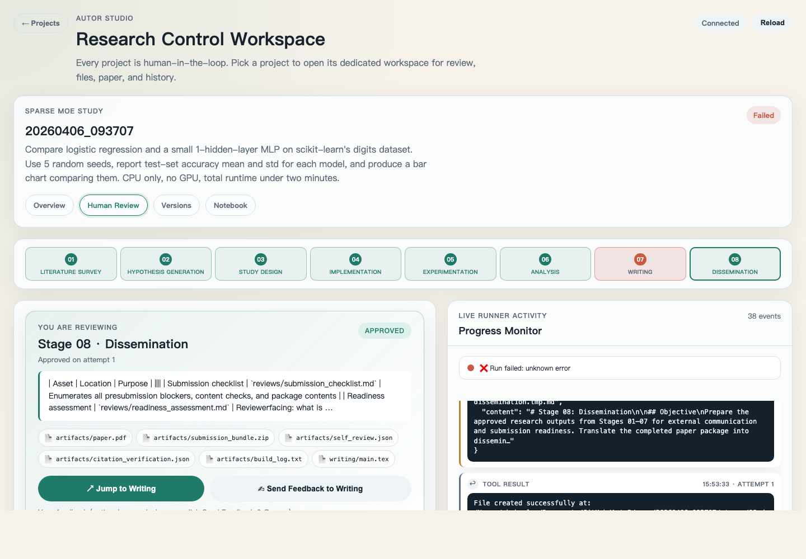
Figure. Human Review with hero, feedback, and live runner activity.

5. Workspace — Notebook (new)
The Notebook is a NotebookLM-inspired 3-column surface built around a real Claude Code instance running inside the run's working directory. It exists alongside the 6-stage pipeline UI — the two views share the same on-disk state.
Columns, left to right:
- Sources (left): project thesis, run metadata, stage status, workspace file tree, paper artifacts.
- Claude Code (center): conversation with the coordinator, streaming tool calls and thinking events inline.
- Viewer (right): clicking anything on the left (or any file-targeted tool chip in the middle) opens that file here. Markdown is rendered, PDFs are embedded, everything else falls back to monospace.
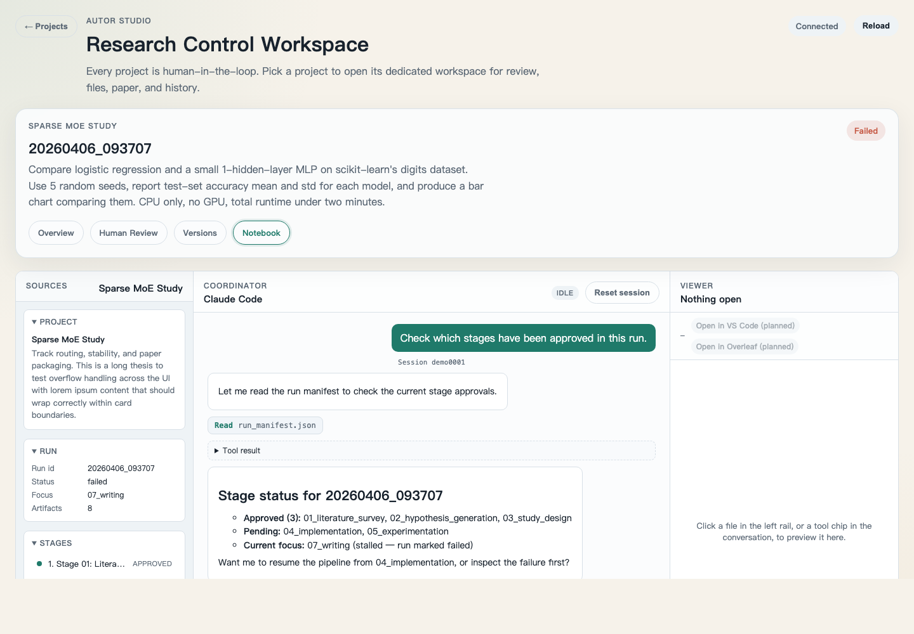
Figure. Notebook view with sources, CC conversation, and viewer.

5.1 How the center panel works
Each user message spawns a one-shot `claude -p --output-format stream-json --resume <session_id>` subprocess with the run directory as cwd. The backend streams each stream-json event over SSE to the browser, appends everything to `runs/<run_id>/notebook/transcript.jsonl`, and on the very first message captures the session id into `runs/<run_id>/notebook/session.json` so subsequent messages resume the same CC conversation.
Events render as: user bubbles, assistant markdown blocks, collapsible `Thinking…` disclosures, tool-use chips with clickable file targets, and a final `result` footer. System hook spam is dropped from the visible chat (still kept in the transcript).

5.2 Versions
Read-only derived checkpoints based on the run manifest + approved stages. Named milestones, restore, and branch actions are not yet implemented.
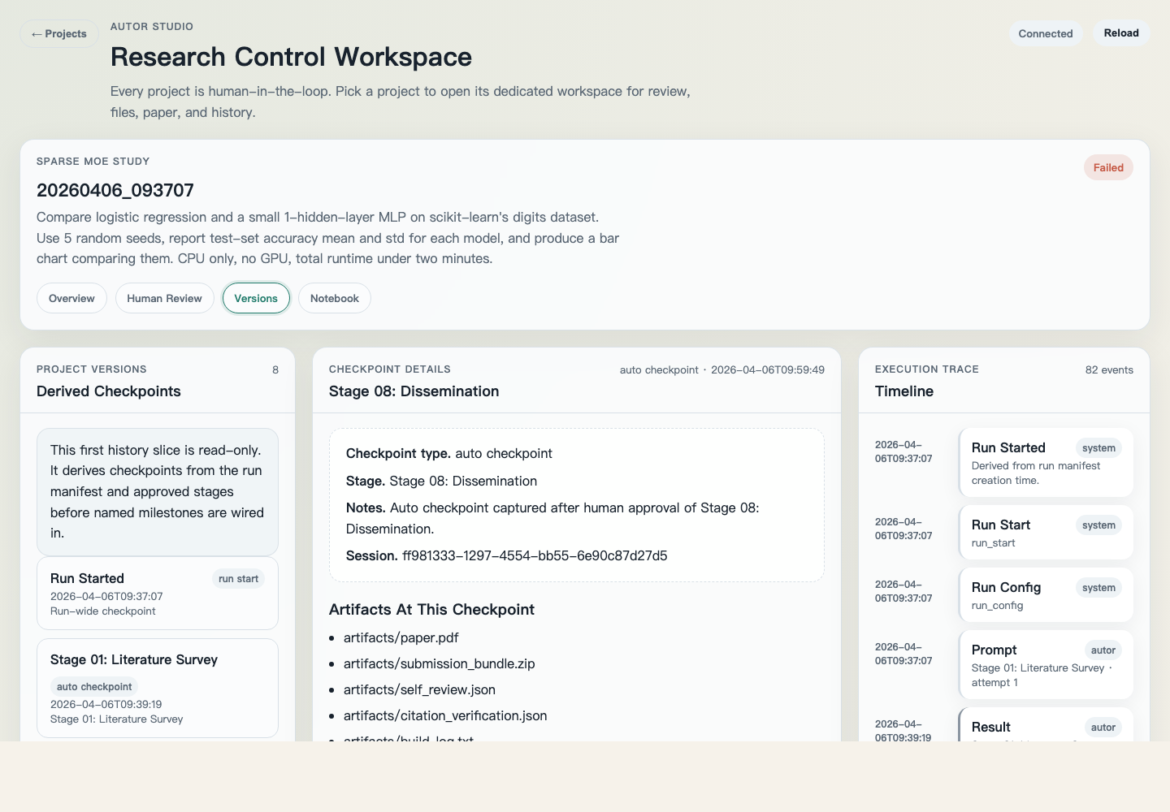
Figure. Versions page — derived checkpoints, details, and trace timeline.

6. Backend endpoints used by the UI
Endpoint | Purpose
GET /api/projects/overview | Project grid with live-run status
POST /api/projects | Create project
POST /api/projects/{id}/runs/start | Start a new run
GET /api/runs/{id} | Run summary + stages
GET /api/runs/{id}/stages/{slug} | Stage markdown
POST /api/runs/{id}/stages/{slug}/approve | Approve stage
POST /api/runs/{id}/stages/{slug}/feedback | Re-run with feedback
GET /api/runs/{id}/files/tree | Workspace file tree
GET /api/runs/{id}/files/content | Read-only file preview
GET /api/runs/{id}/paper | Manuscript summary + sections
GET /api/runs/{id}/paper/pdf | Compiled PDF bytes
GET /api/runs/{id}/history | Derived checkpoints + trace
POST /api/notebook/stream | SSE stream of Claude Code events (new)
GET /api/notebook/transcript | Persisted notebook transcript (new)
POST /api/notebook/reset | Clear notebook session for a run (new)

7. Open TODOs for the next contributor
Pick any of these off; each one is sized for a single PR.

7.1 Notebook view polish
- Resizable columns: drag handles between the three panels, width persisted to localStorage.
- Inline file links in assistant markdown (`[method.tex](...)`) that open in the right-pane viewer via `data-notebook-rel` (scaffold already in notebook.js).
- Input affordances: slash-command palette for common AutoR actions (`/approve`, `/rerun-stage`, `/compile`).
- Ctrl/Cmd+K shortcut to focus the input from anywhere in the workspace.
- Toggle to show/hide hook events in the chat (currently hidden by default — keeps transcript readable).

7.2 Sync & robustness
- SSE keepalive ping every 15s so Chrome/proxies don't kill idle connections mid-tool-use.
- When CC edits files, have the Overview page auto-bump its stage strip so the user can see the effect without a manual refresh (currently arrives at the next 3s poll).
- Race guard: if the user approves a stage from the 6-stage view while CC is holding a reference to that stage, explicitly note it in the next assistant turn.
- Browser hard-refresh during a running stream: on reconnect, resume from the transcript and mark the interrupted turn visibly.

7.3 Safety & permissions
- Current default is `--permission-mode bypassPermissions`. Offer an `acceptEdits`-only mode behind a toggle for users who want CC to stop at destructive file/bash actions.
- Add a configurable allowlist / denylist for Bash commands CC can issue from the Notebook (e.g. deny `rm -rf`, allow `python main.py`, `latex`).
- Audit log: keep a per-run summary of the commands CC executed on behalf of the user, surfaced in the Versions timeline.

7.4 Write actions missing from the 6-stage UI
- Named milestone persistence (currently `Versions` is read-only).
- Restore / branch write actions from the browser.
- In-browser file editing (the Notebook viewer is still read-only).
- Compile actions on the manuscript artifacts (trigger a LaTeX build from the UI).
- VS Code / Overleaf handoff buttons (the Notebook viewer currently shows them disabled as planned pills).

7.5 Tests
- Unit tests for `src/backend/notebook.py` session+transcript round-trip against a tmp run dir.
- Integration test: stub `claude` binary that echoes predetermined stream-json events, assert SSE event ordering and `done` framing.
- UI smoke via Playwright: open hub → open workspace → switch to Notebook → verify the three columns render for a seeded run.

8. Running locally
From the repo root:
python studio.py --repo-root . --port 8765
# then open http://127.0.0.1:8765 in a browser
The Notebook view needs the `claude` CLI on PATH (verified with `claude --version`). Session state for a run lives at `runs/<run_id>/notebook/`; delete that directory to start fresh.

9. Further reading
- docs/ui-design/README.md — original design pass.
- docs/superpowers/specs/2026-04-18-notebook-view-design.md — this session's Notebook design spec.
- src/backend/notebook.py — subprocess wrapper + transcript I/O.
- src/frontend/static/notebook.js — Notebook client.

