MySQL DATABASE TABLES:  
  
Tables:  
  
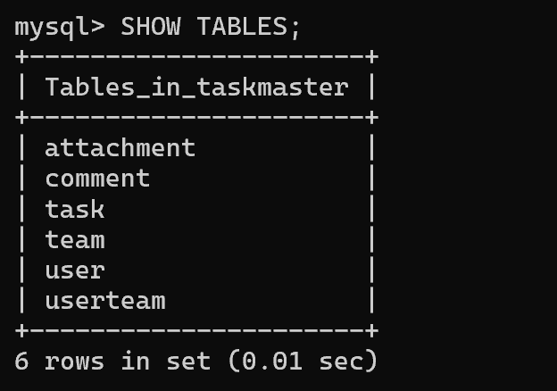  
  
User Table:  
Hashed Password hidden  
  
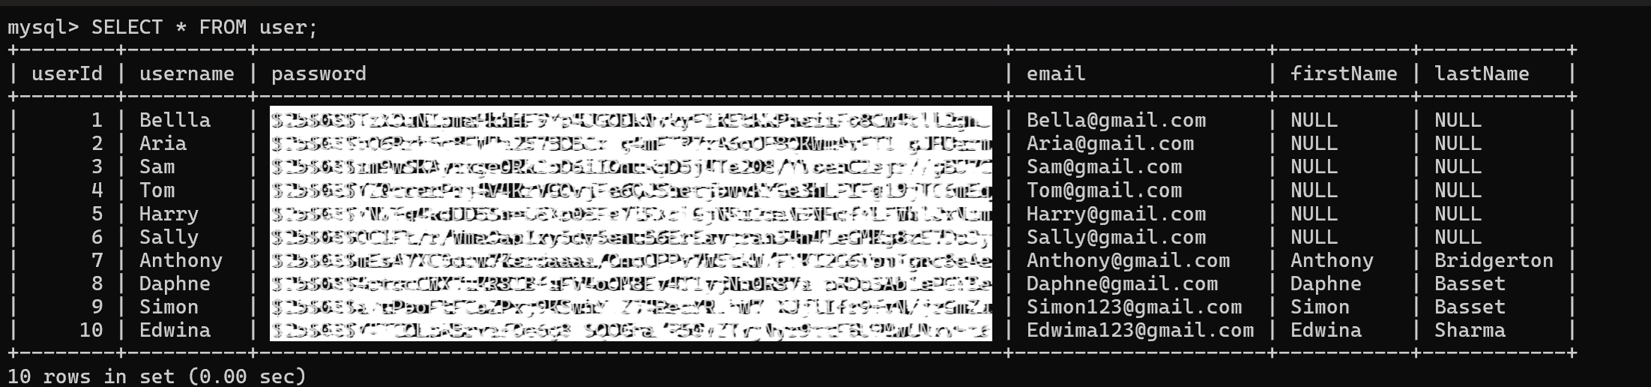  
  
  
Task Table:  
  
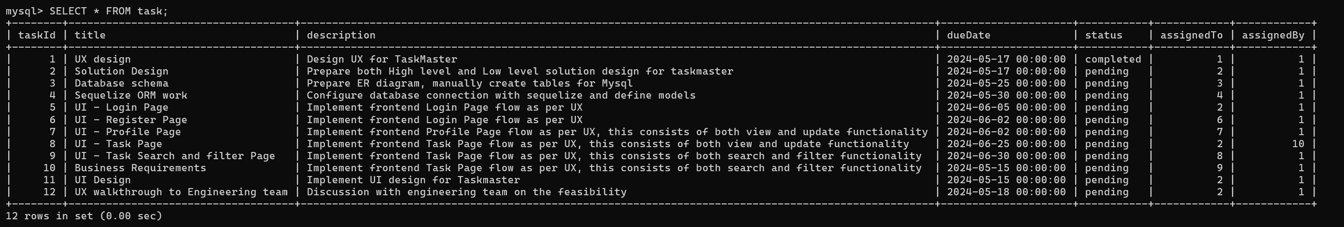  
  
Team Table:  
  
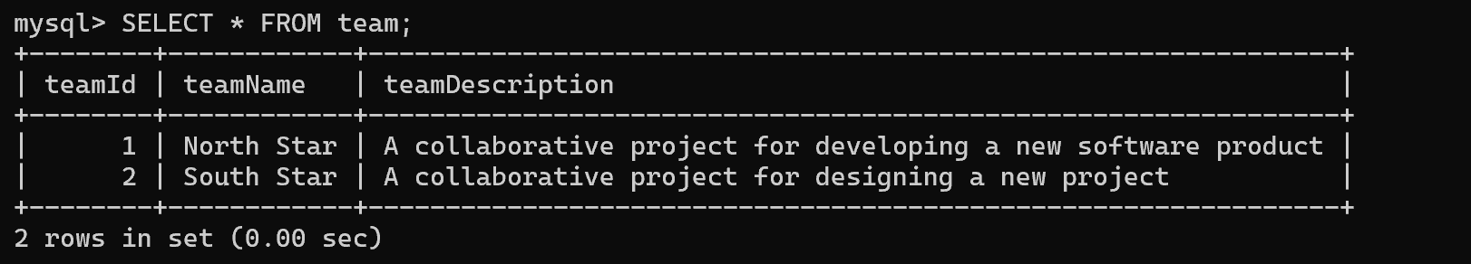

UserTeam Table:  
  
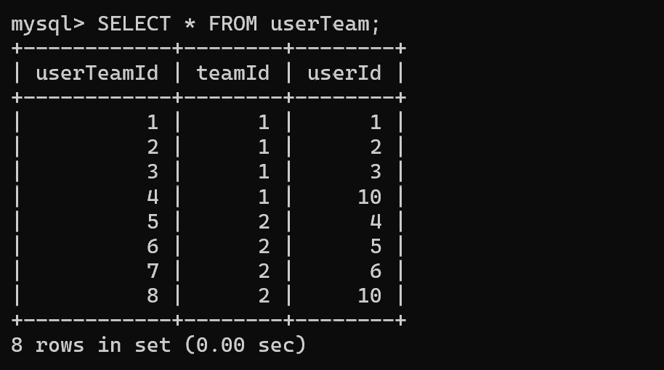  
  
Comment Table:  
  
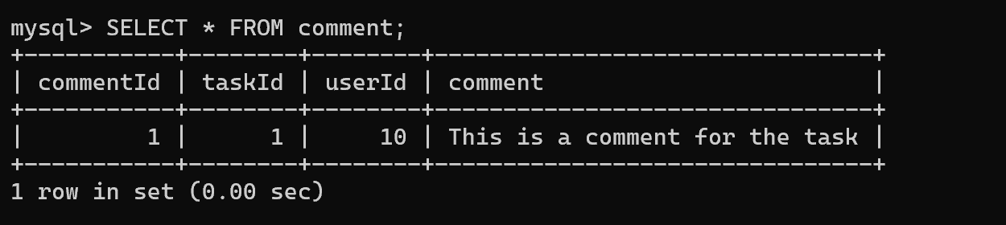  
  
Attachment Table:  
  
