Software Requirement Specification (SRS)

Project Name: Fraud Detection System with Concept Drift Handling

Revision History

Version | Date of Release | Pages Affected | Reasons for Change | Signature
1.0 |  | All | First Release
1.1 |  | Appendix N  Page 21 and 22 | Test Cases added in the Requirements Traceability matrix
2.0 |  | All | Version Release
2.1 |  | Page 6 | Change in Management executive

Table of Contents

1.0 Project Code........................................................................................................... 5
2.0 Title of the project...................................................................................................5
3.0 Introduction.............................................................................................................5
3.1 Purpose.................................................................................................................5
3.2 Document Conventions........................................................................................6
3.3 Intended Audience and Reading Suggestions......................................................6
3.4 Project/Product Scope..........................................................................................7
3.5 References............................................................................................................8
4.0 Overall Description..................................................................................................9
4.1 Project/Product Perspective.....................................................................................9
4.2 Project/Product Functions.......................................................................................10
4.3 Operating Environment...........................................................................................11
4.3.1 Server..................................................................................................................11
4.3.2 Client:..................................................................................................................11
4.4 Design and Implementation Constraints.....................................................................................................................12
4.5 User Documentation................................................................................................12
5.0 External Interface Requirements.................................................................................................................12
5.1 User Interfaces.......................................................................................................13
5.2 Hardware Interfaces...............................................................................................13
5.3 Communications Interfaces....................................................................................13
6.0 System Features ........................................................................................................15

Other Nonfunctional Requirements............................................................................16
[] Performance Requirements...................................................................................16
[] Safety Requirements..............................................................................................17
[] Security Requirements...........................................................................................17
[] Software Quality Attributes...................................................................................18
6.1 Other Requirements.............................................................................................19
6.2 Applicable Standards...........................................................................................19
7.0 Acceptance criteria..................................................................................................20
8.0 Deliverables.............................................................................................................21

- Project Code

PGCP – CD – 00002

- Title of the project
Fraud Detection System with Concept Drift Handling

- Introduction
3.1 Purpose
This document specifies the software requirements for the Fraud Detection System with Concept Drift Handling — a machine learning pipeline designed to identify fraudulent transactions in real-time while automatically adapting to evolving fraud patterns.
The system addresses a critical limitation of traditional fraud detection models: performance degradation over time due to concept drift, where the statistical properties of input data and fraud patterns shift. By integrating Population Stability Index (PSI) monitoring and automated retraining triggers, the system maintains detection accuracy without manual intervention.
Core objectives:
- Detect fraudulent transactions using gradient boosting (XGBoost) with engineered features capturing velocity, geography, device, and temporal patterns
- Monitor input distribution drift using PSI to identify when the production data diverges from training data
- Track model performance via AUROC and KS-statistics to detect classification degradation
- Automatically trigger retraining when drift or performance thresholds are breached
- Enable safe model updates through an A/B champion-challenger comparison framework

Convention | Meaning
Bold | Key terms, component names, or emphasis
Monospace | Code elements, file names, configuration parameters
Italics | Document titles, variable names, or first use of defined terms
PSI | Population Stability Index
AUROC | Area Under the Receiver Operating Characteristic Curve
KS | Kolmogorov-Smirnov statistic
  - Document Conventions
Priority definitions:
- Must — Non-negotiable requirement; system cannot function without it
- Should — Important requirement; absence degrades system value significantly
- May — Optional enhancement; included if resources permit

  - Intended Audience and Reading Suggestions(BD team,BD head,ED, HoDs)

Audience | Relevant Sections | Reading Priority
Data Scientists / ML Engineers | Sections 3 (System Features), 4 (Data Requirements), 5 (External Interfaces) | Full document — primary implementers
Software Engineers | Sections 3, 5 (External Interfaces), 6 (Non-functional Requirements) | Focus on integration points and system architecture
Project Managers | Sections 1 (Introduction), 2 (Overall Description), 7 (Deliverables) | Scope, timeline, and deliverables overview
QA / Test Engineers | Sections 3, 6 (Non-functional Requirements) | Feature specifications and acceptance criteria
Stakeholders / Product Owners | Sections 1.1, 1.4, 2.1, 7 | High-level scope, business value, deliverables
Suggested reading path:
- All readers should begin with Section 1 (Introduction) and Section 2 (Overall Description) for context
- Technical readers should proceed to Section 3 (System Features) for detailed functional requirements
- Reviewers focused on compliance or deployment should prioritize Section 6 (Non-functional Requirements)

  - Project/Product Scope (about the internal use, deployment)
In Scope:
- Internal deployment —
The system is designed for internal use within the organization's fraud operations infrastructure. It is not a customer-facing product.

- Batch and near-real-time scoring —

The pipeline supports both scheduled batch inference on historical transactions and near-real-time scoring for incoming transactions.

- Single-model gradient boosting —
The core detection model is XGBoost with cost-sensitive learning for class imbalance. Ensemble methods beyond XGBoost or deep learning approaches are out of scope for this version.

- Tabular transaction data —
The system processes structured transaction records with predefined feature schemas. Unstructured data (text, images) is not supported.

- Offline retraining —
When drift is detected, retraining is triggered on accumulated labeled data. Online learning (continuous incremental updates) is not implemented.

- Champion-challenger evaluation —
New models are validated against the production champion using A/B comparison before promotion. Multi-armed bandit or automated model selection is out of scope.
Out of Scope:
- Real-time streaming infrastructure (Kafka, Flink) — the system assumes batch or micro-batch data ingestion
- Labeling workflows for fraud confirmation — labeled data is assumed to be provided by upstream systems
- Integration with external case management or alerting systems
- Multi-region or multi-tenant deployment considerations
- Explainability/interpretability tooling (SHAP, LIME) beyond basic feature importance
Deployment context:
The system will be deployed in a controlled internal environment with access to historical transaction data and periodic label updates. Initial deployment targets a single business unit, with potential expansion after validation.

  - References
    - Ref Docs

Reference | Description | URL / Location
XGBoost Documentation | Official documentation for XGBoost gradient boosting library | https://xgboost.readthedocs.io/
scikit-learn User Guide | Machine learning utilities, preprocessing, and evaluation metrics | https://scikit-learn.org/stable/user_guide.html
pandas Documentation | Data manipulation and analysis | https://pandas.pydata.org/docs/
scipy.stats | Statistical functions for KS-test and distribution analysis | https://docs.scipy.org/doc/scipy/reference/stats.html
Population Stability Index | PSI methodology for distribution drift detection | Siddiqi, N. (2006). Credit Risk Scorecards
Imbalanced Learning | Techniques for handling class imbalance in fraud detection | He, H., & Garcia, E. A. (2009). Learning from Imbalanced Data
AUROC and KS-Statistic | Model evaluation metrics for binary classification | Fawcett, T. (2006). An Introduction to ROC Analysis
Concept Drift Literature | Survey of drift detection methods | Gama, J. et al. (2014). A Survey on Concept Drift Adaptation

- Overall Description
  - Project/Product Perspective
The Fraud Detection System with Concept Drift Handling is a dynamic, machine-learning-driven middleware solution designed to integrate directly into a financial institution’s payment processing pipeline.
Unlike traditional static rule-based engines or frozen ML models that rapidly lose accuracy as fraudsters change their behaviour, this system operates as a continuous, self-monitoring loop. It acts as an intelligent inference layer between the transaction gateway and the core banking ledger. By continuously monitoring input distributions and model performance in production, the system automatically triggers retraining pipelines when degradation is detected, ensuring the fraud detection mechanism evolves synchronously with emerging threats while requiring minimal manual intervention.

  - Project/Product Functions
The system comprises the following primary functional modules:
- Real-Time Feature Engineering: Ingests raw transaction data and computes streaming features with low latency, including transaction velocity (counts/amounts over time windows), geographical anomalies (IP/shipping mismatches), device fingerprinting, and time-of-day risk scoring.
- Cost-Sensitive Fraud Classification: Evaluates transactions using an XGBoost gradient boosting model specifically tuned for extreme class imbalance. The model penalises false negatives (missed fraud) significantly more than false positives to protect financial assets.
- Concept Drift Detection (Input Monitoring): Continuously calculates the Population Stability Index (PSI) on incoming feature distributions compared to the training baseline to detect shifts in user or fraudster behaviour.
- Live Performance Tracking: Monitors real-time predictive degradation by asynchronously calculating the Area Under the Receiver Operating Characteristic (AUROC) curve and Kolmogorov-Smirnov (KS) statistic based on delayed transaction feedback (e.g., chargebacks).
- Automated Retraining Orchestrator: Automatically initiates a data-fetching and model-retraining pipeline when PSI or performance metrics breach predefined safety thresholds.
- Champion-Challenger Evaluation: Deploys the newly trained model (Challenger) in a shadow mode alongside the production model (Champion) to conduct A/B testing, automatically promoting the Challenger if it proves statistically superior without regressions.
User Classes and Characteristics

Data Scientists / Machine Learning Engineers: This technical user group is responsible for developing, tuning, and maintaining the offline fraud detection pipeline. They interact directly with the Python codebase, configure the XGBoost cost-sensitive learning parameters, and adjust the Population Stability Index (PSI) thresholds for drift detection. They possess strong programming skills in Python and are highly familiar with navigating Jupyter Notebooks.

Risk Analysts: These users focus primarily on the output of the monitoring and visualization layers rather than the raw code. They analyze the generated Matplotlib and Seaborn plots to track AUROC and KS-statistic trends, review PSI drift visualizations, and interpret the final summary reports to understand shifts in fraudster behavior.

Project Evaluators: Because this is an academic or evaluated project, evaluators will assess the system for modularity, explainability, and reproducibility. They will likely pull the code from GitHub, run the pipeline on their local machines to verify that the same results occur on rerun, and review the final presentation in PowerPoint.

  - Operating Environment
    - Server

Server OS: | Linux (Ubuntu 22.04 LTS or Red Hat Enterprise Linux 8/9 for production stability).
Language: | Python 3.10+ (Core ML logic, API, and Orchestration); SQL (Data querying).
Database: | * Analytical/Metadata: PostgreSQL (for model registry, logs, and drift metrics).  Feature Store/Caching: Redis or Apache Cassandra (for low-latency retrieval of streaming velocity features).
Application Server: | FastAPI (hosted via Uvicorn/Gunicorn) to serve the ML model as a high-performance RESTful API.
Tool: | Model Monitoring/Registry: MLflow.  Pipeline Orchestration: Apache Airflow.  Deployment: Docker and Kubernetes.

    - Client:
Transaction Gateway Client: Any backend financial service capable of consuming REST API webhooks over secure HTTPS.
Monitoring Dashboard Client: Web browsers (Chrome, Edge, Firefox) used by Data Scientists and Risk Analysts to view drift metrics, model performance, and pipeline statuses.

  - Design and Implementation Constraints
Latency Requirements: The real-time inference API (feature calculation + model prediction) must execute in under 100 milliseconds to avoid blocking the user's checkout experience.
Regulatory & Security Compliance: The system must strictly adhere to GDPR and DPDPA. All Personally Identifiable Information (PII) and sensitive payment data must be tokenised or hashed prior to being stored in the model monitoring databases.
Graceful Degradation: If the automated retraining pipeline fails or the underlying feature store experiences downtime, the system must fail open to a simplified heuristic rule-set or the last known stable "Champion" model rather than halting all transaction processing.
Resource Constraints: Automated retraining is computationally intensive. The system must schedule retraining jobs dynamically or scale Kubernetes nodes to ensure it does not steal CPU/GPU resources from the real-time inference server.

  - User Documentation
API Integration Guide: Technical specifications, payload schemas, and authentication protocols for backend developers connecting the payment gateway to the scoring engine.
MLOps Dashboard Manual: A comprehensive guide for risk teams detailing how to interpret PSI charts, AUROC graphs, and manually override Champion-Challenger deployments.
Deployment and Runbook: Step-by-step installation instructions for DevOps engineers covering Docker composition, Kubernetes helm charts, environment variable configurations, and disaster recovery procedures. Online help and tooltips will be embedded directly within the monitoring dashboard.

- External Interface Requirements

This section defines how the Adaptive Fraud Detection Pipeline interacts with users, underlying hardware, software components, and communication protocols.

  - User Interfaces
The system requires interfaces for two distinct user groups:
Data Scientists/Engineers managing the pipeline, and
analysts reviewing the outputs.

Execution Environment Interface:
The core machine learning pipeline shall be executable via standard Command-Line Interfaces (CLI) or interactive notebook environments (e.g., Jupyter) without requiring a graphical interface.

Dashboard View:
The system shall provide a web-based visualization dashboard accessible via standard web browsers (Chrome, Firefox, Edge).

Visual Reporting Metrics:
The dashboard UI shall render interactive charts displaying Champion vs. Challenger metrics, Population Stability Index (PSI) drift trends and feature importance scores derived from the backend JSON API.
The targeted browser Mozilla FireFox 12.0,Goolge Chrome,MS Edge

  - Hardware Interfaces
The Proposed system configuration is as follows:

Sl. No. | ITEM | Server 1 | Server 2
01 | Processor | Quad core Processor (64 bit) | Quad core Processor (64 bit)
03 | No. of processor | One | One
04 | Memory | 8 GB expandable to 24 GB | 8 GB expandable to 24 GB
10 | HDD capacity |  | 1TB
12 | Network |  | 2 Gigabit RJ45 connectors
13 | USB ports |  | Four
17 | OS |  | Linux

  - Communications Interfaces:

Communication requirements are restricted to internal system-decoupled data-sharing, as external banking integrations are excluded.

RESTful API Communication:
The Spring Boot backend shall expose a set of RESTful API endpoints communicating via HTTP/HTTPS protocols.
Data Payload Formatting:
All communication between the Spring Boot API and the frontend dashboard shall utilize strictly formatted JSON (JavaScript Object Notation) payloads.

Cross-Origin Resource Sharing (CORS):
The API shall be configured to accept CORS requests to allow standard communication between the backend (e.g., localhost:8080) and the frontend UI application.
Network Exclusions:
The system shall explicitly NOT interface with real-time banking gateways, external payment processing networks, or live production transaction streams during Phase 1 operations.

- System Features

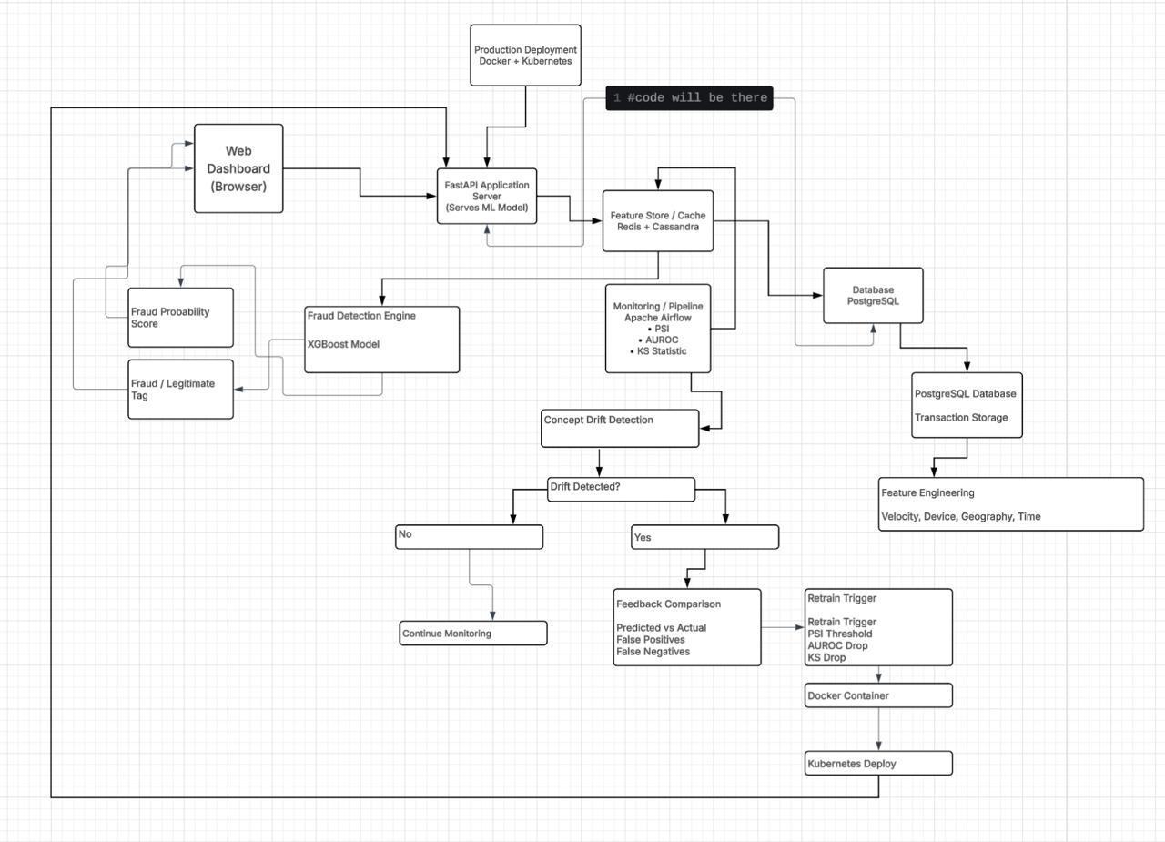

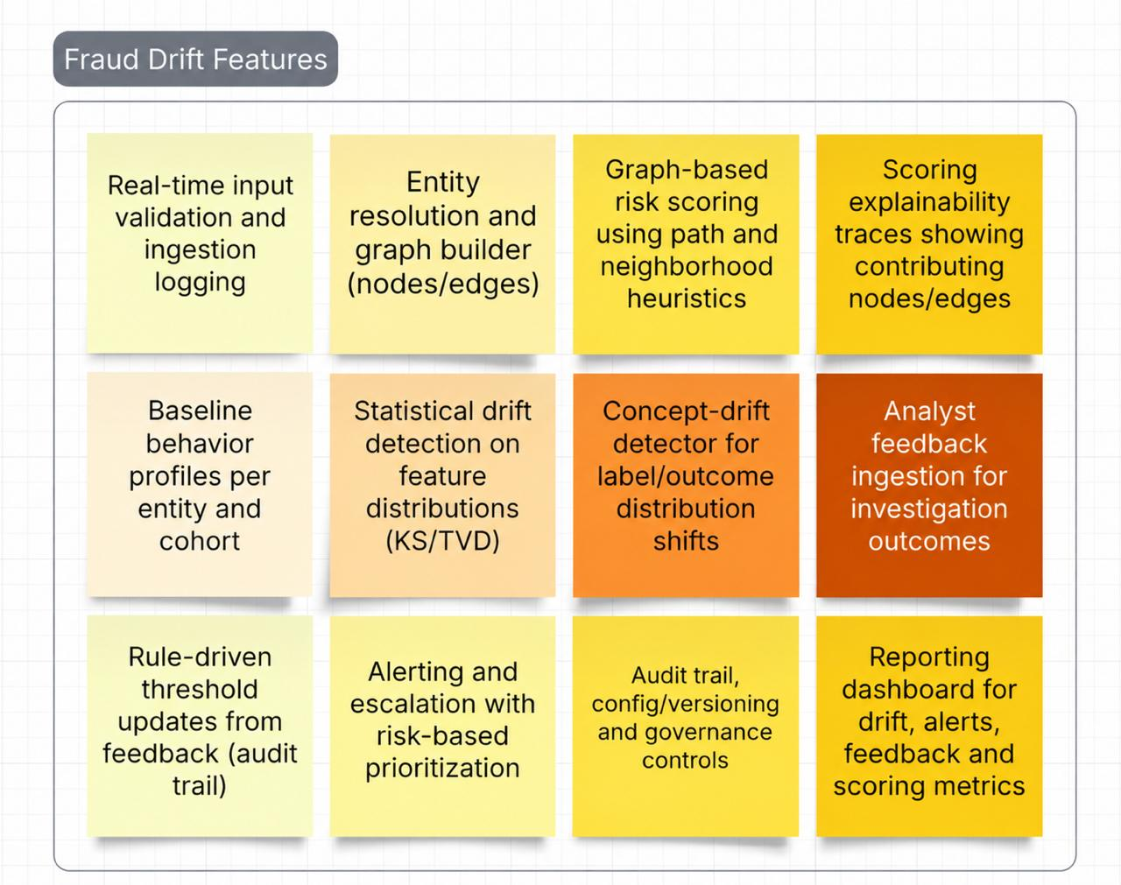

6.0 Other Nonfunctional Requirements
System features establishes the nonfunctional requirements that constrain the operation, performance, safety, and security of the real-time machine learning-based payment fraud detection system. While functional requirements describe the specific actions the software must execute—such as extracting features or generating alerts—these nonfunctional requirements define the quality boundaries, performance margins, and regulatory rules the system must maintain. For an intelligent financial ecosystem, these constraints are mission-critical; a failure to meet performance latencies or compliance guidelines can result in catastrophic financial losses, regulatory penalties, and a complete breakdown of user trust.
Performance Requirements
Real-time transaction authorisation pathways require the fraud detection system to execute feature extraction, statistical aggregation, model inference, and decision routing within an extremely tight temporal window. To minimise payment friction and prevent card-abandonment issues, the system must score incoming transactions with minimal latency under peak operational loads.
The system must guarantee a sub-50 millisecond model inference latency at the 99th percentile (p99) of transaction load. The median inference latency (p50) must remain below 34 milliseconds. In a containerised Docker deployment, the optimised XGBoost classifier must execute the entire scoring sequence in less than 42 milliseconds to accommodate payment gateway limitations. The system must maintain these latency profiles while supporting a throughput of 15,000 transactions per second (TPS) during baseline operations, with the architectural headroom to auto-scale to 10x this volume to absorb sudden market spikes.
To support this level of performance, the real-time streaming feature store must evaluate over 200 behavioural and contextual features simultaneously. Features include historical velocity, time-series aggregations, and spatial-temporal anomalies
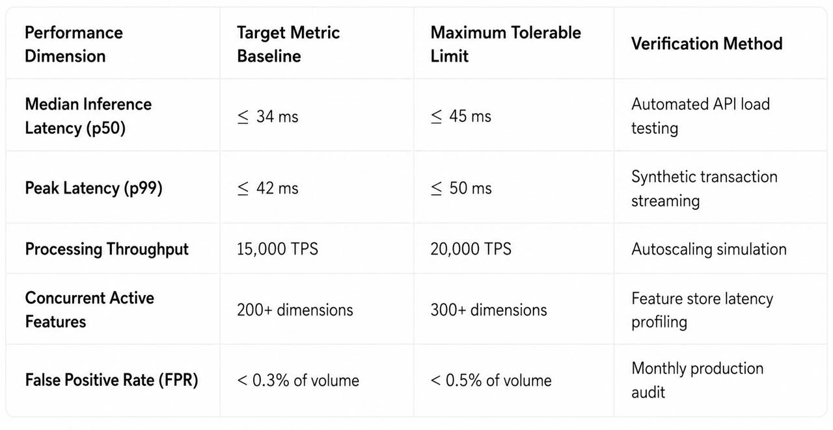
Safety Requirements
In the context of payment processing, software safety focus is centered on protecting the integrity of the financial transaction loop and preventing cascading system failures that could lead to massive capital losses or operational paralysis.
The system must employ a deterministic "fail-safe" fallback architecture. If the machine learning inference API experiences a connection timeout, network partition, or internal failure, the payment stream must not be blocked. Instead, the system must automatically route transactions to a localised, hard-rule safety layer within 200 milliseconds. This backup layer will run static security rules directly on the payment gateway, bypassing the remote machine learning cluster to ensure uninterrupted merchant operations.
To prevent severe automated fraud waves and API abuse, the safety subsystem must enforce rigid behavioural boundaries. Transactions must be blocked automatically if they violate physical spatial-temporal laws.

If the calculated velocity exceeds 500 kilometers per hour, the system must immediately trigger a high-priority geographic anomaly block, as such speed is impossible without aviation. Additionally, a safety rule must block transactions if the velocity exceeds 5 or more transactions under 2,000 currency units within a rolling 15-minute window, mitigating rapid card-testing attacks.

Security Requirements
Operating within financial services requires strict compliance with international security standards and data privacy mandates. The fraud detection system must protect sensitive payment data while ensuring that model decisions are secure from adversarial exploitation.
All personal identifiable information (PII) and cardholder data must be protected using AES-256 encryption at rest and TLS 1.3 protocol in transit. Clear-text storage of primary account numbers (PAN), CVVs, or biometric data is strictly prohibited. The system must implement robust data masking and tokenization techniques within the real-time feature store, ensuring that the machine learning models operate on anonymised behavioural representations rather than raw sensitive data.
Access to the administrative dashboard and model configurations must follow the principle of least privilege. Authentication must require multi-factor verification (MFA), and all modifications to thresholds, model weights, or system rules must be logged.
To meet regulatory requirements set by financial authorities (e.g., FinCEN, FCA, and APRA), the system must maintain an immutable audit trail. Every transaction evaluation must generate a complete decision record, including the raw input payload, the extracted feature vector, the exact model version utilised, the calibrated fraud probability score, the triggered decision thresholds, and the final action taken. This data must be written to an append-only, cryptographically signed ledger to prevent administrative tampering, facilitating seamless retroactive forensic audits.
Software Quality Attributes
Software quality attributes define the long-term operational sustainability, maintainability, reliability, and user-centred design of the system.
The system must guarantee an overall availability of 99.99%. Planned maintenance or model deployment windows must not exceed 2 hours per calendar month, and must be scheduled during low-volume hours. The system must feature high fault tolerance, employing isolated node cluster designs. A failure in the model retraining engine or the feature ingestion store must not impact the real-time scoring cluster's ability to execute inference using existing cached models.
The entire system architecture must be modular and containerised (e.g., utilising Docker containers) to ensure easy scaling and patching. The system must incorporate an active Model Registry to version control, monitor, and deploy updated classifiers without system downtime. The infrastructure must support hot-swapping of in-memory models, ensuring that updated parameters can be loaded in less than 1 second without dropping active connections.
The user interface must provide clear, real-time visualisation of system metrics for both risk analysts and system administrators. The dashboard must render key performance indicators, such as monthly sales fraud rates, total defrauded amounts, active false positive ratios, and feature importance drift. For borderline transactions flagged for manual review, the UI must present plain-language explanations. It must display interactive SHAP (SHapley Additive exPlanations) waterfall plots alongside the transaction, showing exactly which features contributed to the fraud probability score.
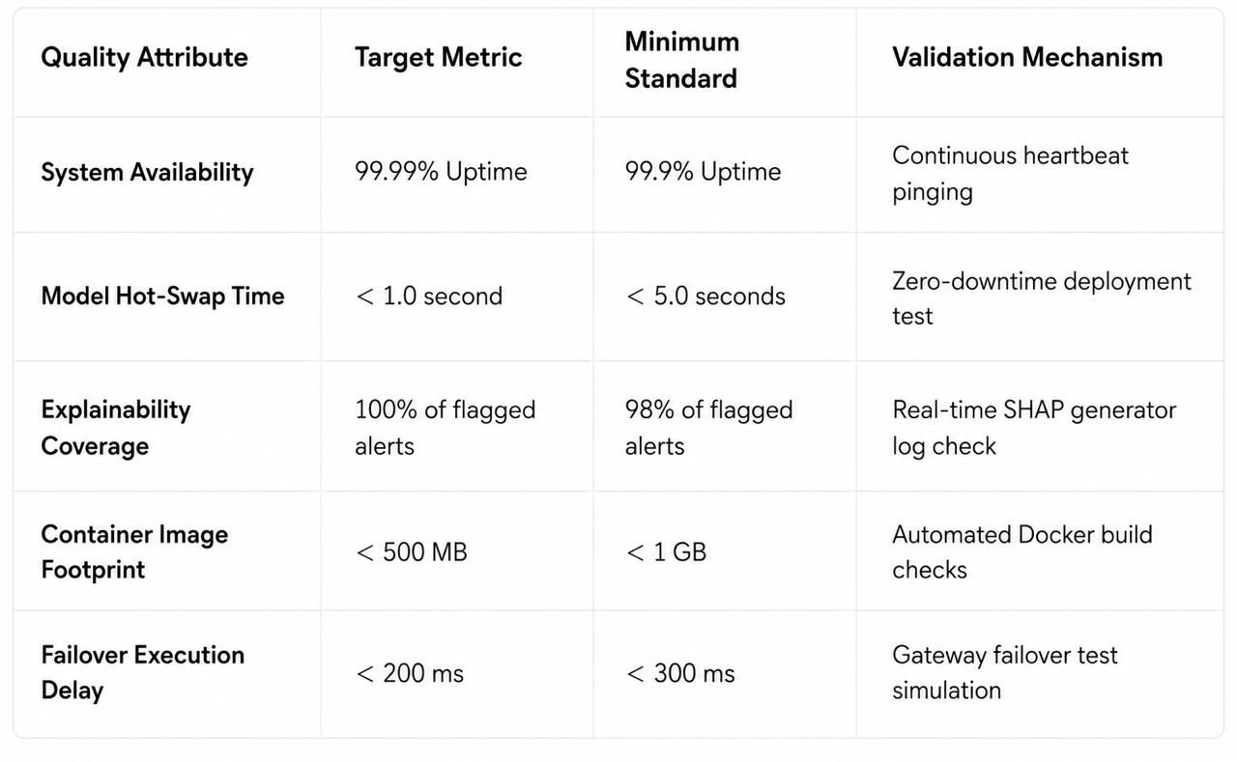
6.1 Other Requirements
The system must address specific operational constraints that lie outside standard performance and security parameters, but remain vital for financial systems. These requirements focus on data retention rules, demographic fairness policies, and managing label delay issues in machine learning pipelines.
Due to the temporal disconnect in credit card networks, verified fraud labels (chargeback reports or cardholder disputes) often arrive days or weeks after a transaction is authorised. This label delay can heavily skew models if they are retrained prematurely. The data storage layer must support a minimum 7-year data retention window to accommodate regulatory audits and chargeback resolution cycles. It must maintain transaction logs in an unalterable state while allowing retrospective updates to target labels as fraud feedback loop data becomes available.
Additionally, the system must enforce strict algorithmic fairness. The model governance framework must automatically monitor decision parity across demographic proxies (e.g., geographic location, account age, and card type) to ensure the system does not introduce systemic bias or disproportionately reject transactions from specific user groups.
6.2 Applicable Standards
The software requirements, architectural design, data handling protocols, and verification methods must adhere to international technical and financial regulatory standards.
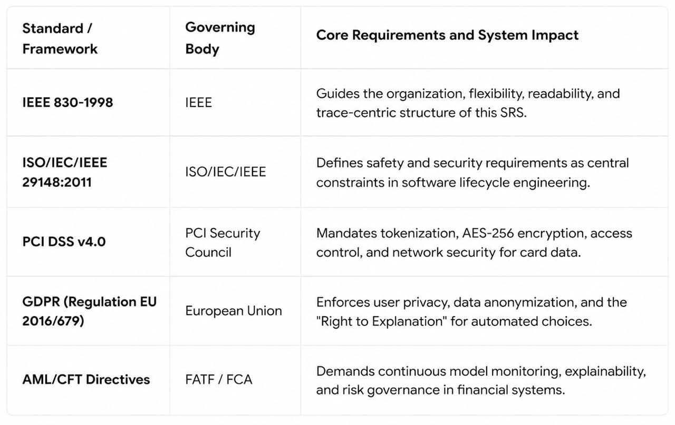
Compliance with the IEEE 830-1998 standard ensures that all requirements are written in an unambiguous, structured, and modifiable format. This framework allows developers to trace each functional and nonfunctional requirement from its source down to its implementation in code. Meanwhile, the modern ISO/IEC/IEEE 29148 standard ensures that hazard analysis, risk management, and software security policies are treated as fundamental attributes throughout system development.
7.0 Acceptance Criteria
Acceptance criteria define the precise quality thresholds and performance benchmarks the system must achieve during user acceptance testing (UAT) before deployment to production. These validation rules prevent the "Accuracy Paradox," where a model achieves misleadingly high overall accuracy (e.g., 99.9%) simply by classifying all transactions as legitimate, while failing to detect the small fraction of true fraud cases.
Model Performance and Class Imbalance Validation Under evaluation: The machine learning models must be tested using temporally held-out datasets to ensure validation integrity. To prove viability, the production model must achieve an area under the precision-recall curve (AUCPR) of at least 0.9994, an F1-score of at least 0.88, and a minimum true positive recall of 81%.
Class imbalance challenges must be resolved using advanced balancing techniques, such as SMOTE or SMOTEENN, which clean noisy samples near the decision boundaries to prevent elevated false positive counts.
Algorithmic Drift and Degradation Tolerances: The system must be validated against its ability to handle concept drift and data shift in production. To measure this, incoming data distributions must be continuously benchmarked against training baselines.
The Population Stability Index (PSI) evaluates the shift in score and feature distributions over time. The joint probability of features and target values must be monitored to detect changes in distribution:
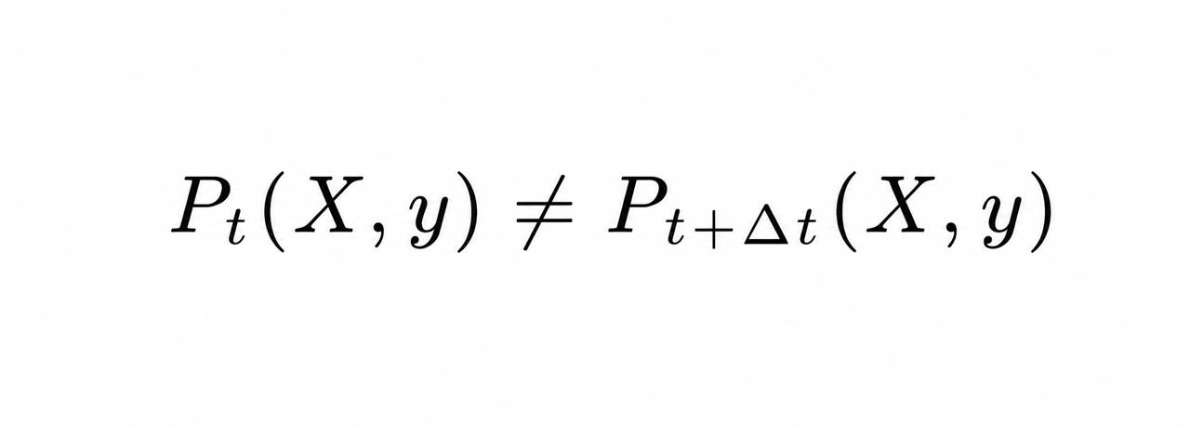
Any shift in feature mapping, P(y|X), indicates concept drift. The Kolmogorov-Smirnov (KS) statistic will be calculated daily to evaluate how well the model separates the fraudulent and legitimate transaction populations. The maximum separation point identifies the best decision boundary for operational classification rules.

- Deliverables

8.1 Core Pipeline Components

Deliverable | Description | Format
Feature Engineering Module | Transformation pipeline for velocity, geography, device, and time-of-day features | Python module (feature_engineering/)
XGBoost Training Pipeline | Cost-sensitive model training with hyperparameter configuration | Python module + Jupyter notebooks
Inference Pipeline | Batch and single-record scoring with feature preprocessing | Python module (inference/)
PSI Drift Monitor | Custom PSI implementation for input distribution monitoring | Python module (drift_detection/)
Performance Monitor | AUROC and KS-statistic tracking against labeled ground truth | Python module (monitoring/)
Retraining Trigger | Automated logic to initiate retraining when thresholds are breached | Python module (retraining/)
Champion-Challenger Framework | A/B comparison utilities for model evaluation and promotion | Python module (model_comparison/)

8.2 Configuration and Artifacts

Deliverable | Description | Format
Feature Configuration | Schema definitions and transformation parameters | YAML/JSON config files
Model Artifacts | Serialized XGBoost models with versioning metadata | .json or .ubj (XGBoost format)
Threshold Configuration | PSI, AUROC, and KS thresholds for drift/performance alerts | YAML config
Baseline Distributions | Reference feature distributions for PSI calculation | Pickle or Parquet files

8.3 Documentation

Deliverable | Description | Format
Software Requirements Specification | This document | Markdown / PDF
Technical Design Document | Architecture, data flow, and module interactions | Markdown / PDF
User Guide | Instructions for running pipelines, interpreting outputs, and configuring thresholds | Markdown
API Documentation | Module-level docstrings and function signatures | Auto-generated (Sphinx or similar)
Runbook | Operational procedures for monitoring, retraining, and incident response | Markdown

8.4 Development Artifacts

Deliverable | Description | Format
Exploratory Notebooks | EDA, feature analysis, and model experimentation | Jupyter notebooks
Unit Tests | Test coverage for feature engineering, PSI calculation, and evaluation metrics | pytest suite
Integration Tests | End-to-end pipeline validation | pytest suite
Git Repository | Version-controlled codebase with branching strategy | Git (GitHub/GitLab)

8.5 Visualization and Reporting

Deliverable | Description | Format
Drift Dashboard | PSI trends, feature distribution comparisons over time | matplotlib/seaborn visualizations
Performance Dashboard | AUROC, KS-statistic, precision-recall curves over time | matplotlib/seaborn visualizations
Champion-Challenger Report | Comparative metrics between candidate and production models | Generated report (HTML/PDF)

8.6. Overall Description

8.6.1 Product Perspective
This system operates as a standalone fraud detection and model lifecycle management pipeline within the organization's data infrastructure. It integrates with:
- Upstream data sources — Transaction databases or data warehouses providing raw transaction records
- Label sources — Confirmed fraud/non-fraud labels from investigation workflows (assumed to arrive with some delay)
- Downstream consumers — Fraud scores can be consumed by alerting systems, case management tools, or reporting dashboards (integration specifics are out of scope)
The system does not replace existing infrastructure but augments it with automated drift handling and model maintenance capabilities.

