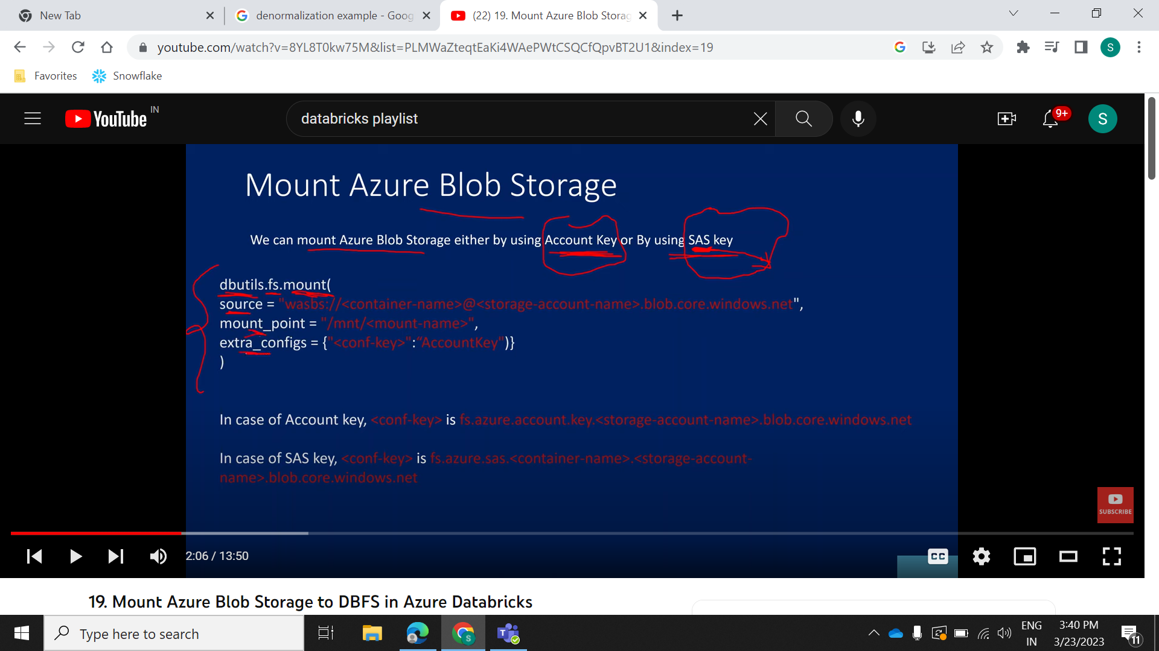

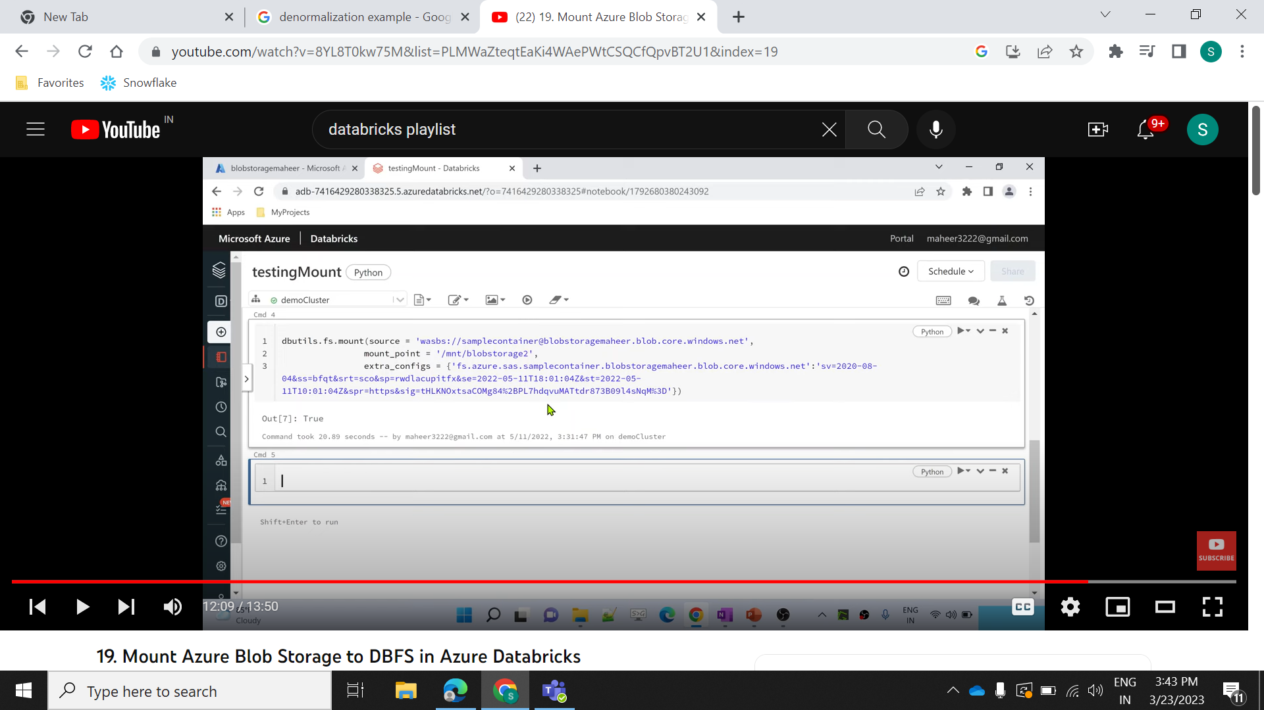

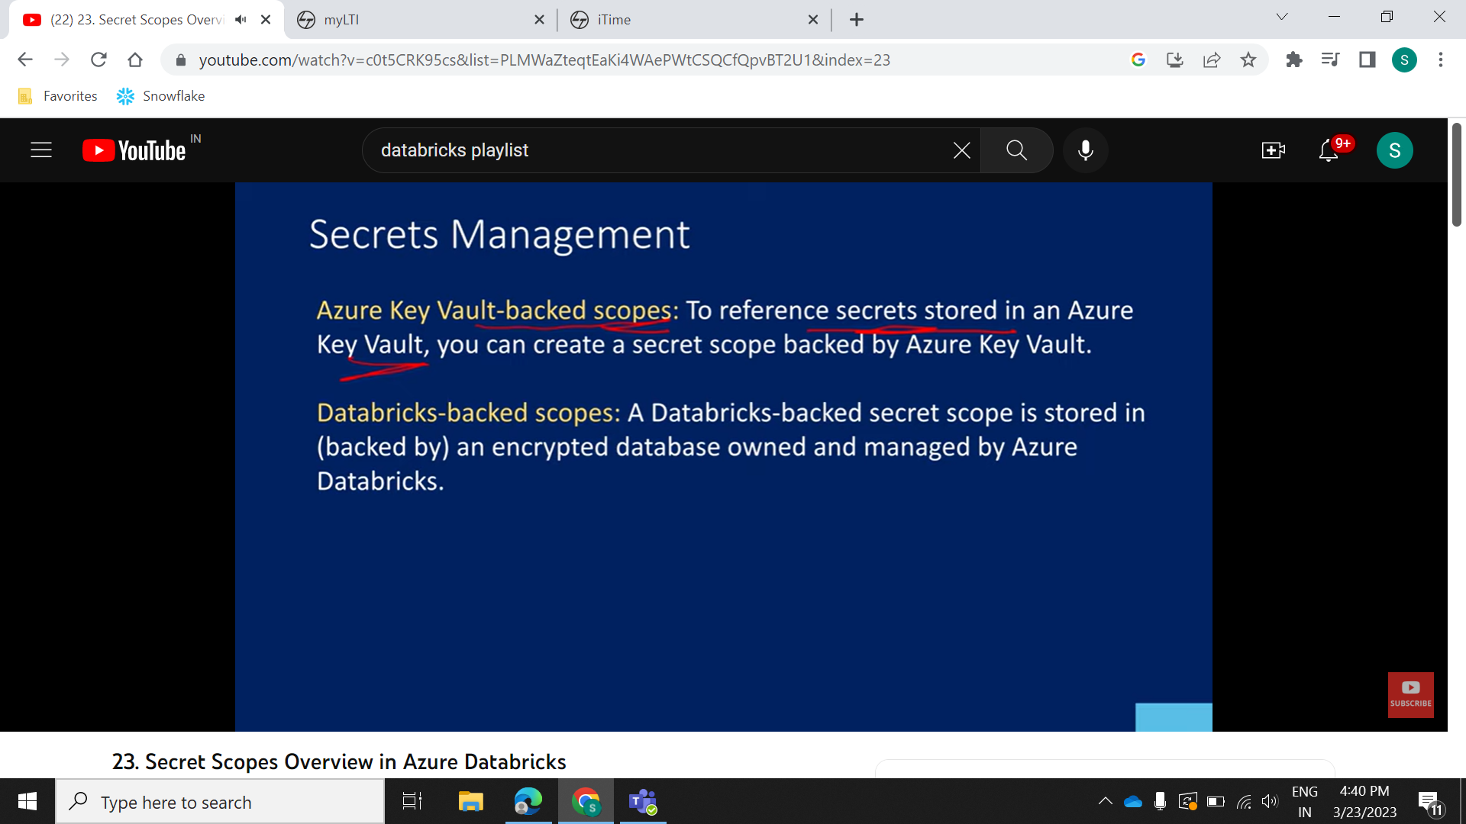



Optimize tableName

Vaccum tableName

Vaccum tableName DRY RUN

Vaccum tableName retain 720 hours DRY RUN (Default is 7 hours)