ASSIGNMENT 3 SHIKHA

* **SQS (Simple Queue Service):**
  + Acts as a buffer to store incoming messages.
  + Decouples the producer and consumer systems.
  + Messages are consumed by the Step Functions state machine.
* **Step Functions:**
  + Triggers Lambda functions for specific tasks like processing the order or notifying users.
* **Lambda:**
  + Executes specific tasks:
    - ProcessOrderFunction: Processes SQS messages.
    - HeartbeatFunction: Logs a periodic heartbeat message (triggered by EventBridge)..
* **SES (Simple Email Service):**
  + Sends email notifications to customers or administrators about order status.
* **SNS (Simple Notification Service):**
  + Publishes notifications to a topic, which can send alerts to multiple subscribers.
* **EventBridge:**
  + Schedules periodic execution of the HeartbeatFunction to log activity.

**Diagram of the Flow**

1. SQS → Step Functions → Lambda → (SES & SNS)

2. EventBridge → Heartbeat Lambda

| **Component** | **Role** | **Interaction** |
| --- | --- | --- |
| SQS | Buffer for messages | Messages sent to Step Functions |
| Step Functions | Orchestration | Manages Lambda function calls |
| Lambda | Business logic | Processes messages and triggers SES/SNS |
| SES | Email service | Sends order confirmation/status |
| SNS | Notification service | Sends alerts to multiple subscribers |
| EventBridge | Scheduler | Periodically triggers Heartbeat Lambda |

**2. Screenshots**

Provide the following screenshots:

1. **SQS Queue Configuration:**

1. **Step Functions State Machine:**

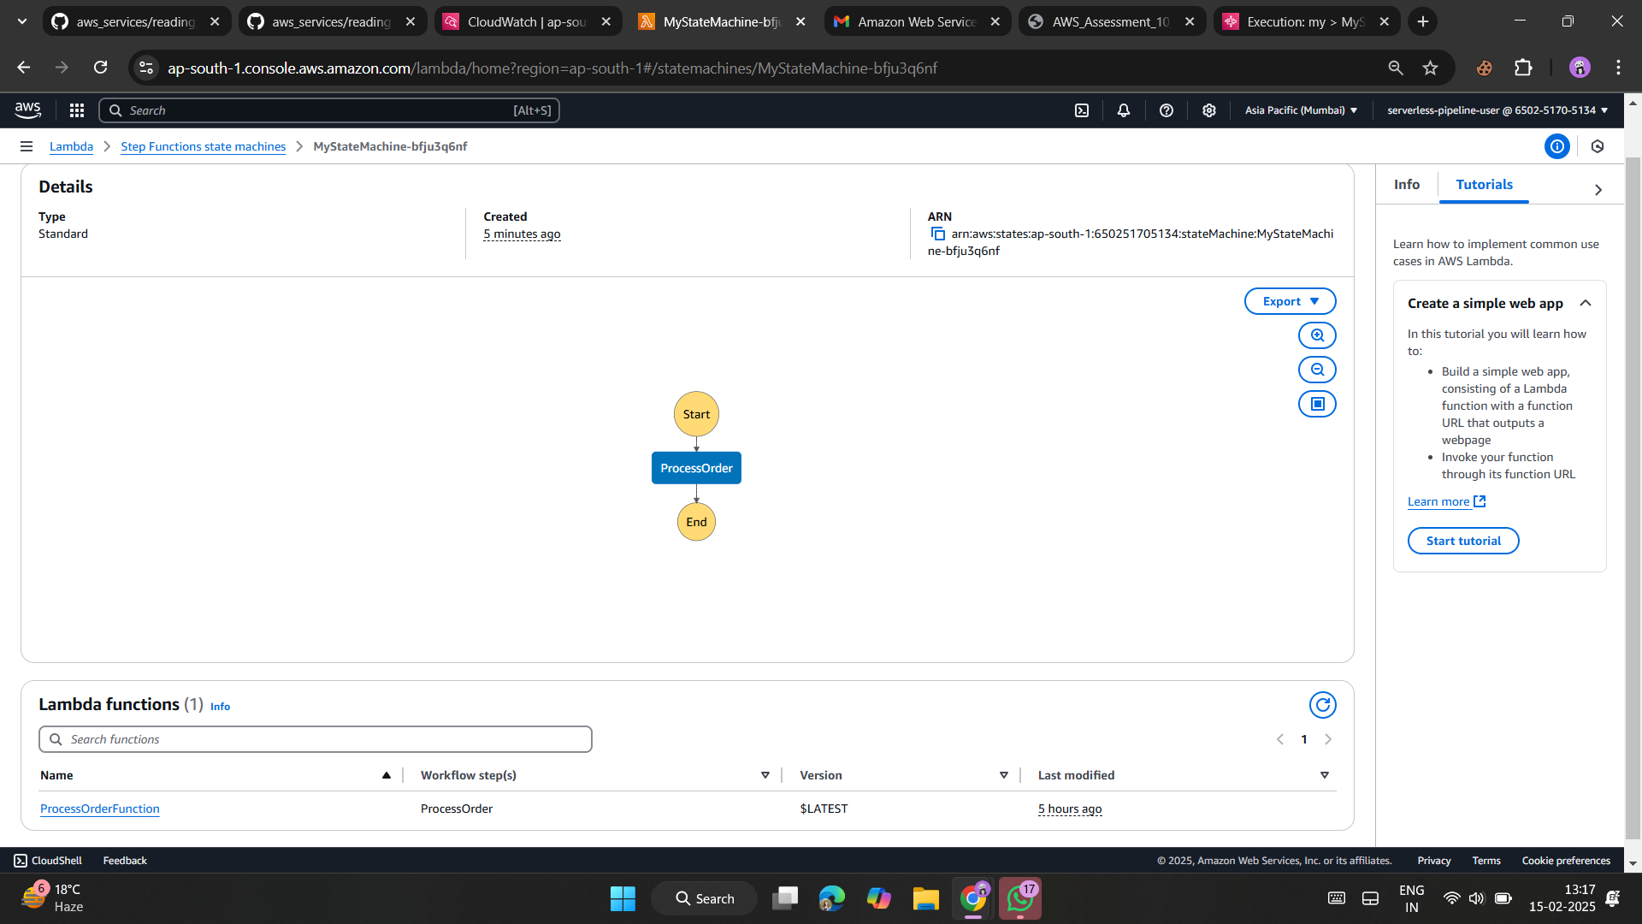

1. **Lambda Function Code and Logs:**
   * Include a snippet of the code for each Lambda function.

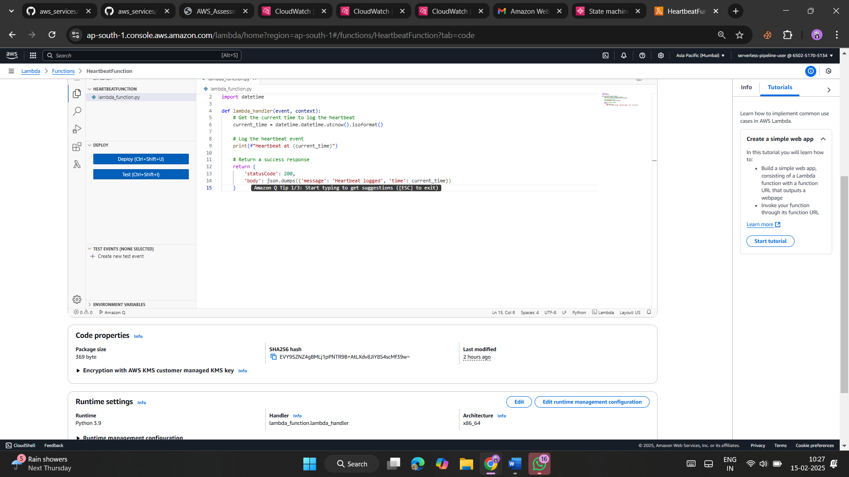

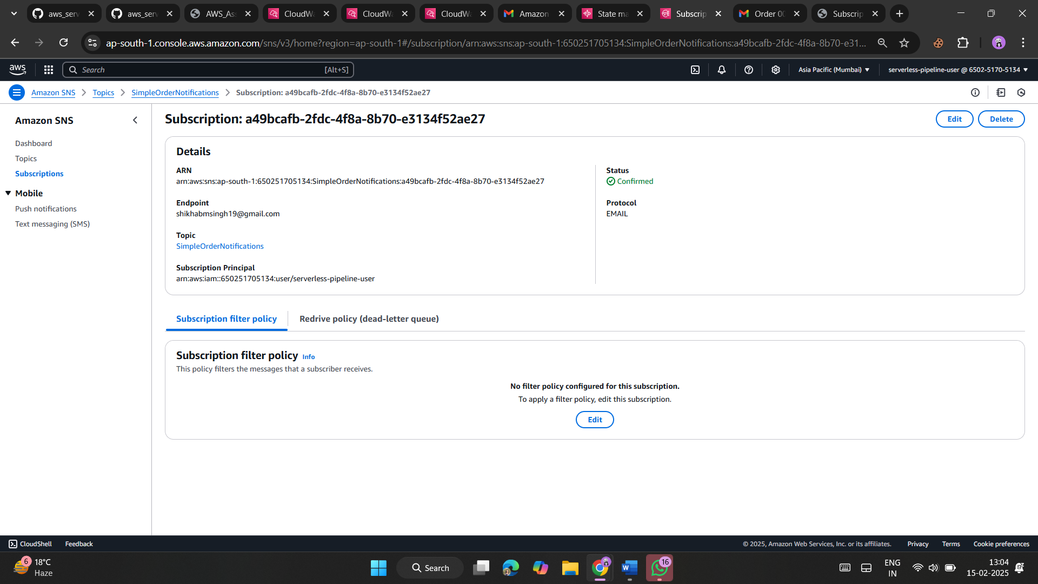

SUBSCRIPTION

EMAIL NOTIFICATION

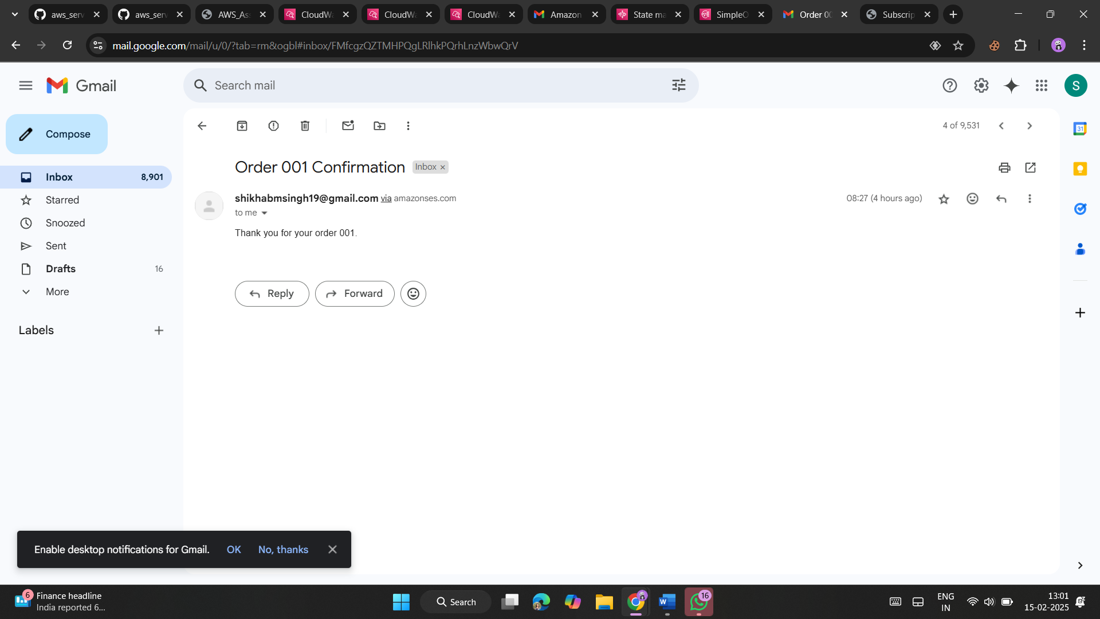

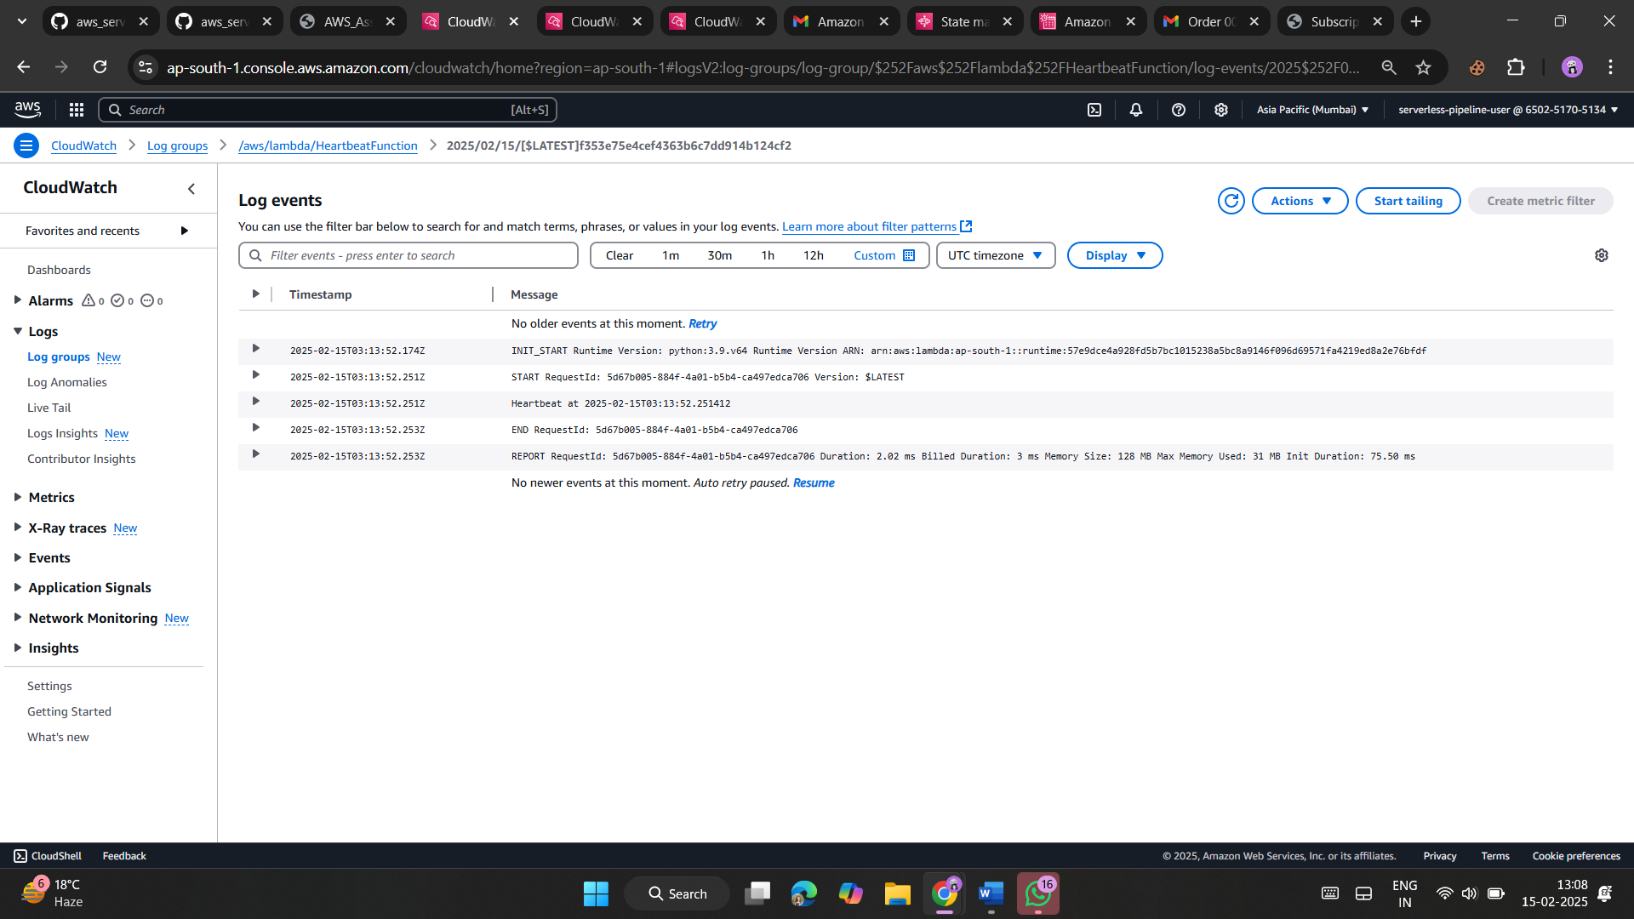

**3. Source Code**

Provide the source code for all Lambda functions. Include comments to explain the purpose of each part. Below is an example structure:

**ProcessOrderFunction**

Python

import json

import boto3

# Initialize clients

ses_client = boto3.client('ses')

sns_client = boto3.client('sns')

cloudwatch = boto3.client('logs')

def lambda_handler(event, context):

    # Log the incoming message

    print("Event Received:", event)

    # Parse SQS message

    for record in event['Records']:

        body = json.loads(record['body'])

        order_id = body['orderId']

        customer_email = body['customerEmail']

        # Send confirmation email

        ses_client.send_email(

            Source='shikhabmsingh19@gmail.com',

            Destination={'ToAddresses': [customer_email]},

            Message={

                'Subject': {'Data': f'Order {order_id} Confirmation'},

                'Body': {'Text': {'Data': f'Thank you for your order {order_id}.'}}

            }

        )

        # Publish SNS Notification

        sns_client.publish(

            TopicArn='arn:aws:sns:ap-south-1:650251705134:SimpleOrderNotifications',

            Message=f'Order {order_id} has been processed.',

        )

    return {"statusCode": 200, "body": "Order processed successfully!"}