**Vaccine Monitor**

**Abstract:**

Currently the available storage systems are not preventive in nature. they raise alarm only after the vaccines have reached their expiry date. Due to which a huge number of vaccines get wasted every year resulting in significant financial loss to the medical industry. Our project, the vaccine monitor aims at designing a preventive system that would notify the medical supervisors when the environmental conditions fluctuates from the optimal environmental conditions necessary for vaccine storage.

**A brief description of project:**

Vaccine monitor Provides the vaccine storage environment used to maintain and distribute vaccines in optimal condition. This Project is applicable to under developed and developing nations (like India) where the vaccines storage environment tracking is a big problem. When the environment is not optimal, the efficacy of these vaccines is lost. All the health worker carries is a portable box with some cold pads (door to door polio vaccine campaign). Our connected maraca has to help ensure the safety and efficacy of the vaccines. While the traveling health workers go around, based on the vaccine type and recommended environment setting, sensor data will be sent to the phone via bluetooth.

Multiple sensors are used to monitor the environment of the portable box carrying the vaccines.

* Temperature: Strict temperature range should be maintained, otherwise raise alert.
* Light Sensor: Over exposure to light can spoil the vials, raise alert.
* Air Quality: Degradation in air quality means, insulation is not working properly, raise alert.
* Buzzer: To raise alert.

**Program Code:**

#include <Wire.h>

#include <SFE_TSL2561.h>

SFE_TSL2561 light;

unsigned int ms;

boolean gain;

float temp;

static int aprint=0;

static int tprint=0;

static int lprint=0;

int templed=10;

int lightled=11;

int airled=12;

void setup()

{

Serial.begin(9600);

Serial1.begin(9600);

light.begin();

gain = 0;

unsigned char time = 2;

light.setTiming(gain,time,ms);

light.setPowerUp();

pinMode(templed, OUTPUT);

pinMode(lightled, OUTPUT);

pinMode(airled, OUTPUT);

}

void loop()

{

temp = (5.0 * analogRead(A0) * 100.0) / 1024;

Serial.println(temp);

delay(500);

int air;

air = analogRead(A1);

Serial.println("now the Air quality sensor is :");

Serial.println(air);

delay(700);

unsigned int data0, data1;

light.getData(data0,data1);

double lux;

boolean good;

good = light.getLux(gain,ms,data0,data1,lux);

Serial.print(" lux: ");

Serial.print(lux);

Serial.println(" ");

if(temp>40)

{

if(tprint==0)

{

Serial1.write(" Temperature");

tprint=tprint+1;

}

tone(7, 25, 50);

digitalWrite(templed, HIGH);

}

if(air>200)

{

if(aprint==0)

{

Serial1.write(" Air");

aprint=aprint+1;

}

tone(7, 494, 50);

digitalWrite(airled, HIGH);

}

if (lux>315)

{

if(lprint==0)

{

Serial1.write(" Light");

lprint=lprint+1;

}

tone(7, 494, 50);

digitalWrite(lightled, HIGH);

}

delay(700);

}

**Interface:**

**Block Diagram:**

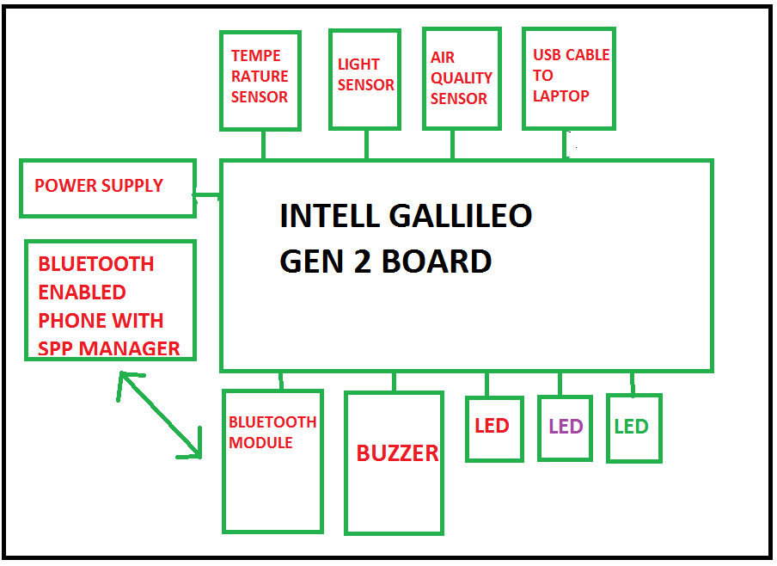

**Snapshot:**

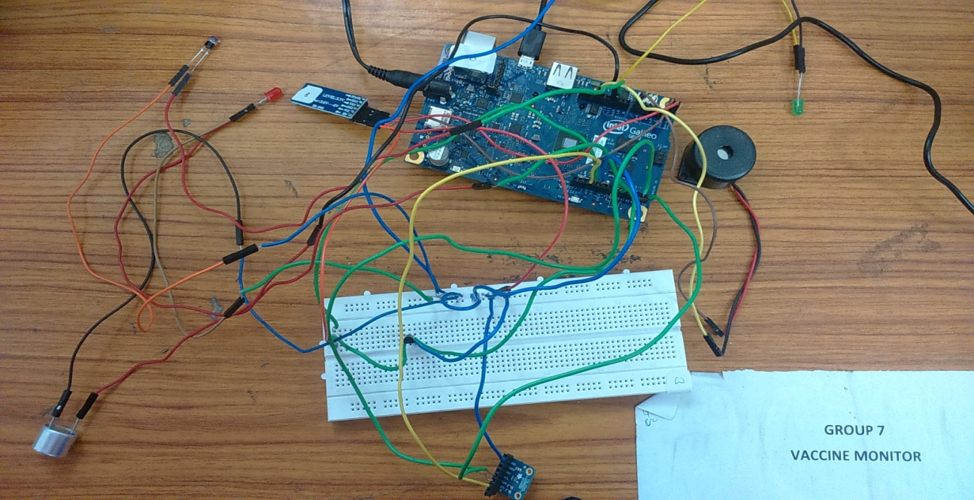

**Conclusion:**

Vaccine monitor is used to ensure that appropriate conditions are maintained. If fail to store and handle the vaccines properly can reduce vaccine potency, resulting in inadequate immune responses in patients and poor protection against disease. Patients loose confidence in vaccines and their providers when revaccination is necessary because the vaccines they received may have been compromised. It also leads to significant financial loss. Therefore, it encourages providers to implement best practices and recommendations to ensure the safety and efficacy of the vaccines.