

Department of Science and Mathematics BIOG-140.600 Cell C Molecular Biol Eng I Meiosis and Mitosis Lab Report Experiment 5

Student Name: Sandra Raj

Student ID: 377004126

Part 1: Observation of Mitosis Under the Microscope

You will be given a prepared slide of an onion root tip showing cells in various stages of mitosis. Using the microscope, observe the slide carefully and identify the different stages of mitosis. For each stage, name the stage of mitosis that you observe on the slide.

|  |  |  |
| --- | --- | --- |
| **Slide Number** | **Observation (Describe what you see)** | **Stage of Mitosis (Guess the stage)** |
| 1 | The cell is starting to lose its defined shape and it has a nucleus | Cytokinesis |
| 2 | The cell is starting to get separated with two structures on either side of the cell | Metaphase |
| 3 | The two structures of the cell are being pulled apart | Anaphase |
| 4 | A round cell with a defined nucleus | Interphase |
| 5 | Another round cell with a defined nucleus | Prophase |
| 6 | A cell with two groups of structures separting | Telophase |

Part 2: Outdoor Activity: Chromosome Count on Campus

As part of this activity, students will go on campus to find 6 different samples that undergo either mitosis or meiosis.

* **For each sample, identify the organism or tissue type and the type of cell division (mitosis or meiosis).**

|  |  |  |  |  |
| --- | --- | --- | --- | --- |
| **Sample No.** | **Location on Campus** | **Organism or Tissue Type** | **Cell Division Type (Mitosis/Meiosis)** | **Number of Chromosomes** |
| 1 | Outside E block | Snake | Both mitosis and meiosis | 36 |
| 2 | Outside E block | Hedgehog | Both mitosis and meiosis | 48 |
| 3 | Outside E block | Rat | Both mitosis and meiosis | 42 |
| 4 | Parking Lot | Cat | Both mitosis and meiosis | 38 |

|  |  |  |  |  |
| --- | --- | --- | --- | --- |
| 5 | Outside C block | Tree | Mitosis | 16 |

* **Record the chromosome number of the organism or tissue in the table provided below.**
* ***Note*: You will need to research or find information about the chromosome numbers of your selected organisms after identifying them on campus. If you cannot directly observe the chromosomes, you can reference textbooks or databases for chromosome count.**

Part 3: After studying mitosis and meiosis lab, write out the answers to the following questions. Answers should be written using complete sentences.

* Distinguish between synapsis and crossing-over, identify the stage of meiosis when synapsis and crossing-over take place, and explain why crossing over is significant.

|  |  |
| --- | --- |
| Synapsis | Crossing Over |
| * Process of homologous chromosomes aligning lengthwise during meiosis. * It occurs during prophase stage of meiosis. | * Process of homologous chromosomes exchanging different gene segments during synapsis. * It occurs during prophase stage of meiosis. * It improves genetic diversity and helps in the correct alignment and separation of homologous chromosomes. |

* List six main differences between mitosis and meiosis.

|  |  |
| --- | --- |
| Mitosis | Meiosis |
| 1. One cell division | Two cell divisions |
| 1. Produces 2 identical daughter cells | Produces four unique daughter cells |
| 1. Has same number of chromosomes as parent cell | Reduces number of chromosomes by half |
| 1. No genetic recombination | Genetic recombination occurs |
| 1. Growth and asexual reproduction. | Sexual reproduction and genetic diversity |

|  |  |
| --- | --- |
| 1. Homologous chromosomes do not pair up or undergo synapsis | Homologous chromosomes pair up and sometimes exchange genetic material |

* Compare between Spermatogenesis and Oogenesis:

|  |  |  |
| --- | --- | --- |
| According to | Spermatogenesis | Oogenesis |
| Cell division | Meiosis | Meiosis |
| Human sex | In Males | In females |
| Primary cell | Spermatogonium | Oogonium |
| No. of chromosomes in primary cells | 46 | 46 |
| End products | 4 sperm cells | 1 egg and 3 polar bodies |
| No. of chromosomes in each cell produced | 23 | 23 |
| Genetic variation | High genetic variation | Low genetic variation |

Part 4: Uploading Your Work

* + **Upload the photos of the samples you observed on campus.**

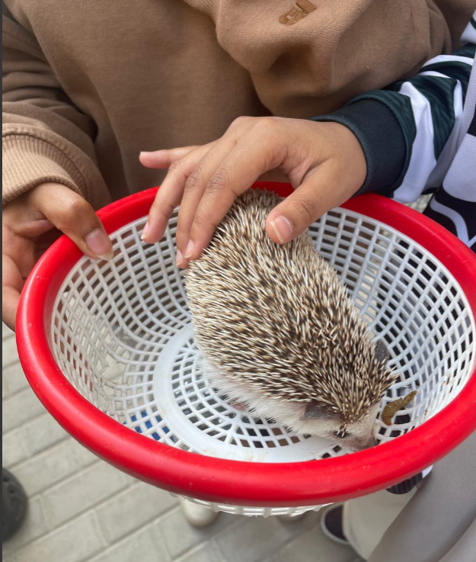 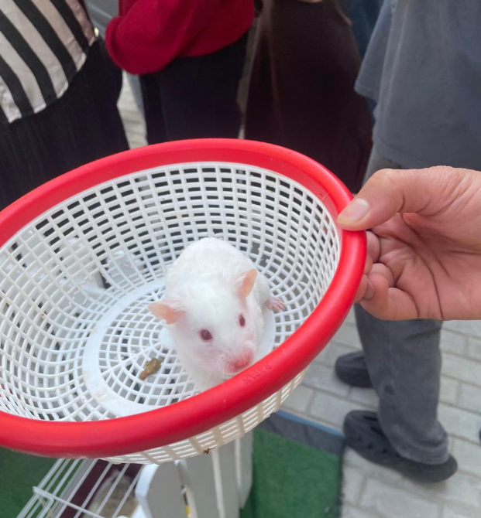

Snake Hedgehog Rat

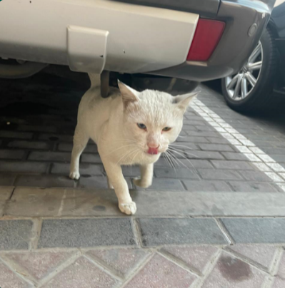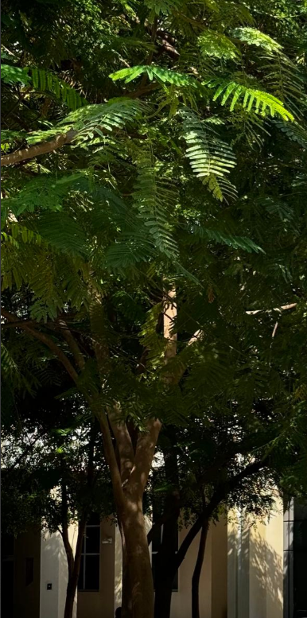

**Cat Tree**