INTRODUCTION

Body Mass Index (BMI) Calculator is a simple yet powerful tool that helps individuals determine their BMI, a numerical value derived from their weight and height. BMI serves as an indicator of whether a person is underweight, normal weight, overweight, or obese, based on standard health metrics. This project focuses on creating a user-friendly BMI Calculator application using Java programming.
The application aims to educate users about their BMI and promote a healthy lifestyle. The program calculates BMI using a standard formula and categorizes the result based on predefined health categories. The tool is designed to provide quick and accurate results, making it suitable for health-conscious individuals and fitness enthusiasts.
The simplicity of this calculator ensures accessibility for a broad audience, while its potential for expansion opens up opportunities for integration into larger health and fitness monitoring systems. This project not only demonstrates the practical implementation of Java programming but also highlights the importance of health awareness in today’s world.
This project focuses on the development of a user-friendly BMI Calculator application using Java programming. Java is a powerful, versatile, and platform-independent programming language that allows developers to create efficient and reliable applications. The primary objective of this project is to create a simple yet functional tool that can calculate BMI based on user input and classify the results according to predefined health categories. The calculator takes weight in kilograms and height in centimeters as input, applies a standard formula, and instantly provides the user with their BMI value along with the corresponding weight category.

OBJECTIVE

The primary objective of the Body Mass Index (BMI) Calculator is to develop a user-friendly and efficient tool that enables individuals to determine their BMI based on their weight and height. The calculator provides an instant assessment of a person’s weight category—underweight, normal weight, overweight, or obese, helping users gain insights into their health status.
Key Objectives:
- Accurate BMI Calculation: Implement the standard BMI formula to calculate BMI efficiently based on user inputs of weight (in kilograms) and height (in centimeters).
- User-Friendly Interface: Ensure ease of use by designing a simple, intuitive interface that allows users to input their details effortlessly and receive instant results.
- Health Awareness & Education: Educate users about the significance of BMI and its role in identifying potential health risks associated with being underweight or overweight.
- Categorization Based on BMI: Classify BMI results into predefined categories such as underweight, normal weight, overweight, and obese, providing users with meaningful interpretations of their BMI values.
- Java Implementation & Practical Learning: Demonstrate the practical application of Java programming by developing a real-world health-related application, showcasing skills in GUI development, input handling, and mathematical computation.
- Scalability & Future Enhancements: Lay the foundation for future expansions, such as adding features like BMI tracking over time, health recommendations, and integration with wearable health devices.

Background

Body Mass Index (BMI):
The concept of Body Mass Index (BMI) was introduced by the Belgian mathematician Adolphe Quetelet in the early 19th century. Originally known as the Quetelet Index, BMI was developed as a simple mathematical formula to estimate an individual’s body fat based on their weight and height. Over time, it became widely accepted by health professionals as a standard measure for assessing weight-related health risks. Today, BMI is used globally by medical organizations, fitness experts, and researchers to categorize individuals into different weight ranges—underweight, normal weight, overweight, and obese—helping in early detection of potential health issues.

Relevance of BMI in Modern Health and Fitness:
In today’s world, where obesity and lifestyle-related diseases are on the rise, BMI plays a crucial role in promoting health awareness and weight management. Governments, healthcare institutions, and fitness organizations often use BMI as a screening tool to assess population health trends and design preventive healthcare programs. While BMI is not a perfect measure of body fat (as it does not account for muscle mass, bone density, or fat distribution), it serves as a quick and convenient method for individuals to understand their weight status.

The Role of Technology in BMI Calculation:
With advancements in technology, BMI calculators have evolved from manual calculations to digital applications that provide instant and accurate results. Java programming offers an excellent platform for developing such applications due to its reliability, cross-platform compatibility, and extensive libraries for creating graphical user interfaces (GUIs). This project leverages Java-based development to create a BMI Calculator that is simple, efficient, and accessible to a wide audience.

Hardware and Software Requirements

Hardware Requirements:
- Processor: Intel Core i3 or equivalent.
- RAM: Minimum 4GB.
- Storage: At least 500MB of free disk space.
- Display: Screen resolution of 1280x720 or higher.
- Input Devices: Keyboard and mouse or touchscreen for user interaction.
Software Requirements:
- Operating System: Windows 10 or later, macOS, or Linux.
- Programming Language: Java.
- Development Environment: IntelliJ IDEA, Eclipse IDE, or any Java-supported IDE.
- JDK Version: Java Development Kit (JDK) 8 or higher.
- Tools/Libraries:
  - Scanner (for user input in Java).
  - Java Console Output for displaying results.
- Additional Utilities:
  - JVM (Java Virtual Machine) to run the application.
  - System terminal or command prompt to compile and execute the program.

SOURCE CODE

import java.util.Scanner;
public class projectBMI {

// Constructor
public projectBMI() {
displayWelcomeMessage();
}

public void displayChart() {
System.out.println("\n--------------------BMI CATEGORY CHART------------------");
System.out.println(" BMI Categories and their meaning");
System.out.println("--------------------------------------------------------");
System.out.println(" BMI < 18.5 : Underweight");
System.out.println(" 18.5 < = BMI < 24.9 : Normal weight");
System.out.println(" 25 < = BMI < 29.9 : Overweight");
System.out.println(" BMI > = 30 : Obese");
System.out.println("--------------------------------------------------------");
}
// Function to get user input for weight and height
public double[] getUserInput() {
Scanner sc = new Scanner(System.in);
System.out.println("\n--------------------------------------------------------");

System.out.print("\n Enter your weight(+ve kgs) : ");
double weight = sc.nextDouble();

System.out.print(" Enter your height (cm) : ");
double height = sc.nextDouble();

return new double[]{weight, height};
}
// Function to calculate BMI
public double calculateBMI(double weight, double height) {
height = height / 100; // Convert height from cm to meters
return weight / (height * height);
}
// Function to print BMI result
public void printResult(double bmi) {
String category;
if (bmi < 18.5) {
category = "Underweight!!\n\n You should aim for a balanced diet\n";
} else if (bmi < 24.9) {
category = "Normal weight \n\n Great job! Keep maintaining a healthy lifestyle.\n";
} else if (bmi < 29.9) {
category = "Overweight \n\n Consider a balanced diet & physical activities.\n";
} else {
category = "Obese \n\n It's recommended to a consult Doctor.\n";
}

String formattedBMI = String.format("%.7f", bmi);
System.out.println("\n--------------------------------------------------------");
System.out.println("\n Your BMI : " + formattedBMI);
System.out.println("\n Your Category : " + category);
}

public void displayWelcomeMessage() {
System.out.println("\n---------------------BMI CALCULATOR---------------------");
System.out.println("\n Welcome to the BMI Calculator!");
System.out.println(" This calculator will help you determine your Body");
System.out.println(" Mass Index (BMI) based on your weight and height.");
}
public static void main(String[] args) {
Scanner sc = new Scanner(System.in);

projectBMI bmiCal = new projectBMI();
bmiCal.displayChart();

System.out.println("\n 1. Calculate your BMI");
System.out.println(" 2. Exit");
System.out.print("\n Enter your choice (1 or 2) : ");
int choice = sc.nextInt();
if (choice == 1) {
double[] userInput = bmiCal.getUserInput();
double weight = userInput[0];
double height = userInput[1];
double bmi = bmiCal.calculateBMI(weight, height);
bmiCal.printResult(bmi);

} else if (choice == 2) {
System.out.println("\n--------------------------------------------------------");
System.out.println("\nTHANK YOU for using BMI calculator!!");
return;
}
}
}
OUTPUT SCREENSHOT

Project Interface :

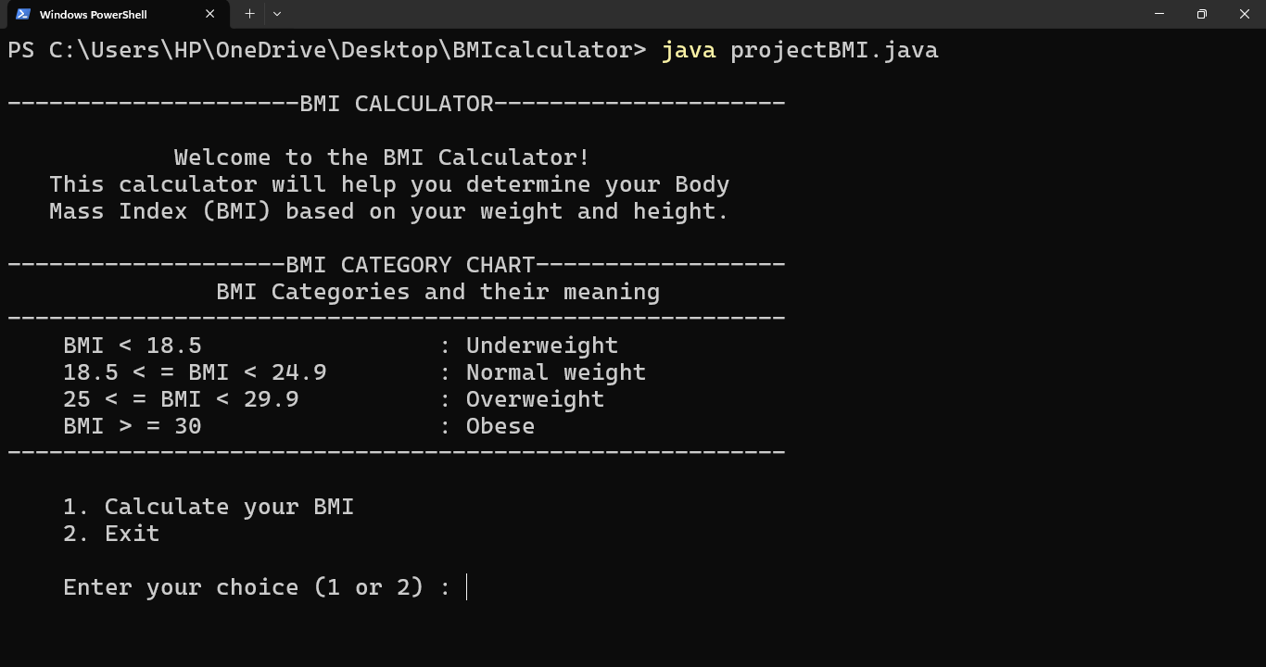

CALCULATING BMI :

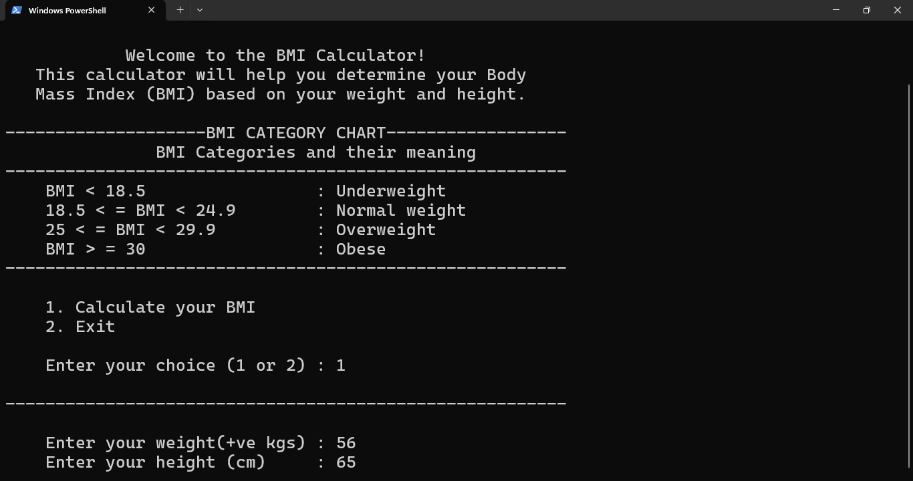
OBESE OUTPUT WITH MESSAGE :

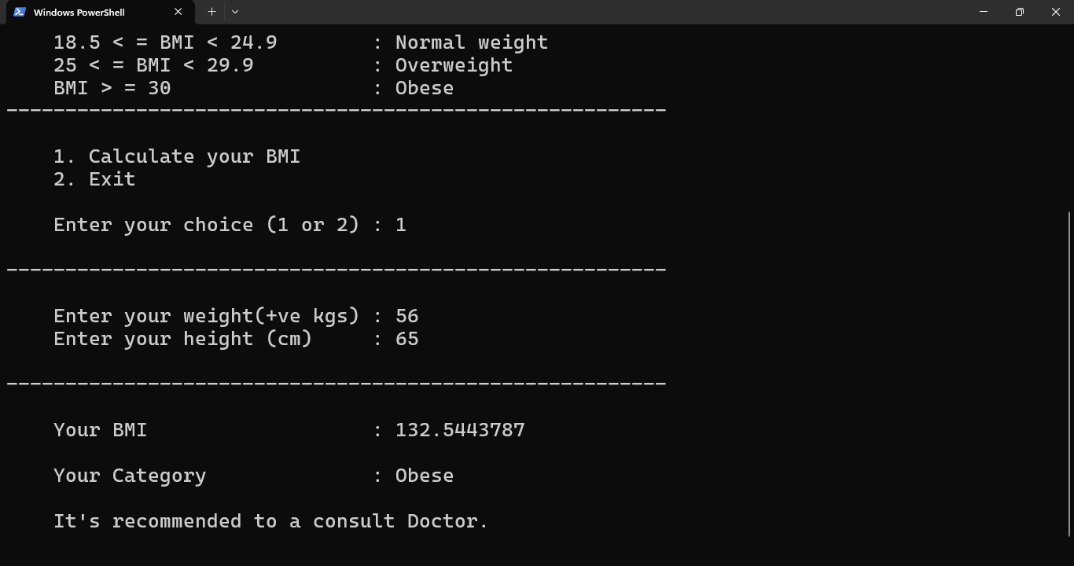

OVERWEIGHT OUTPUT WITH MESSAGE :

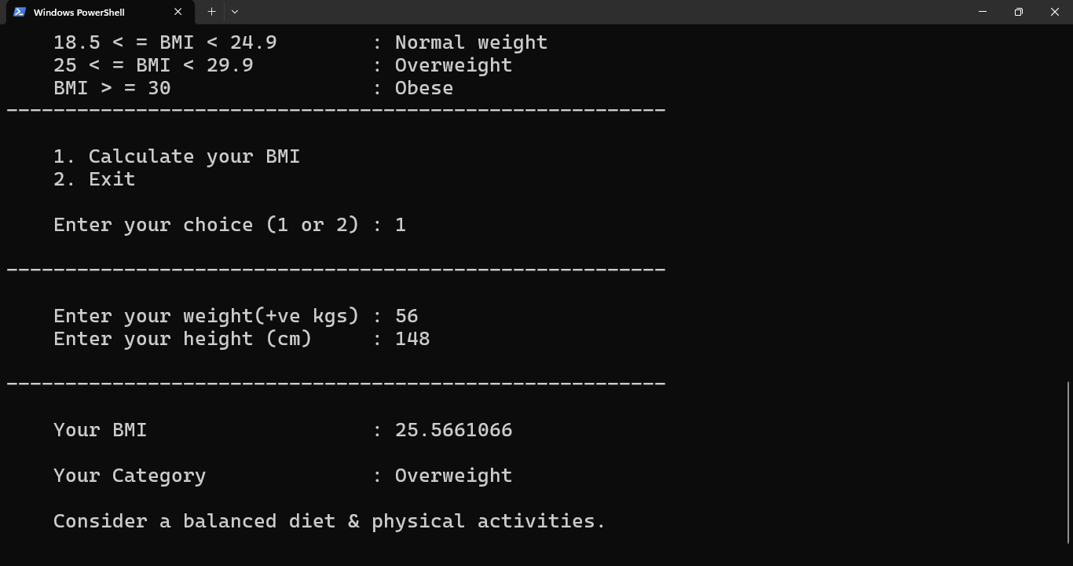
NORMAL WEIGHT OUTPUT WITH MESSAGE :

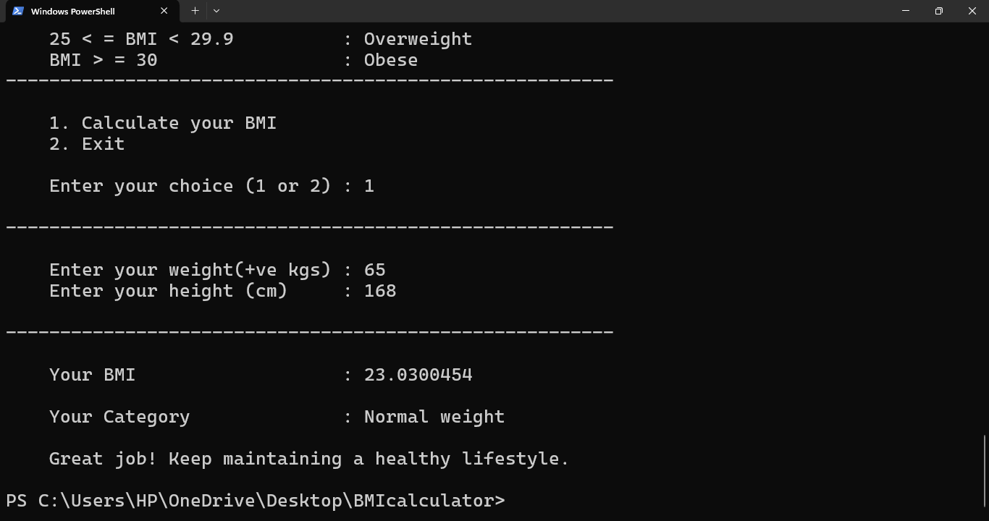

UNDER WEIGHT OUTPUT WITH MESSAGE :

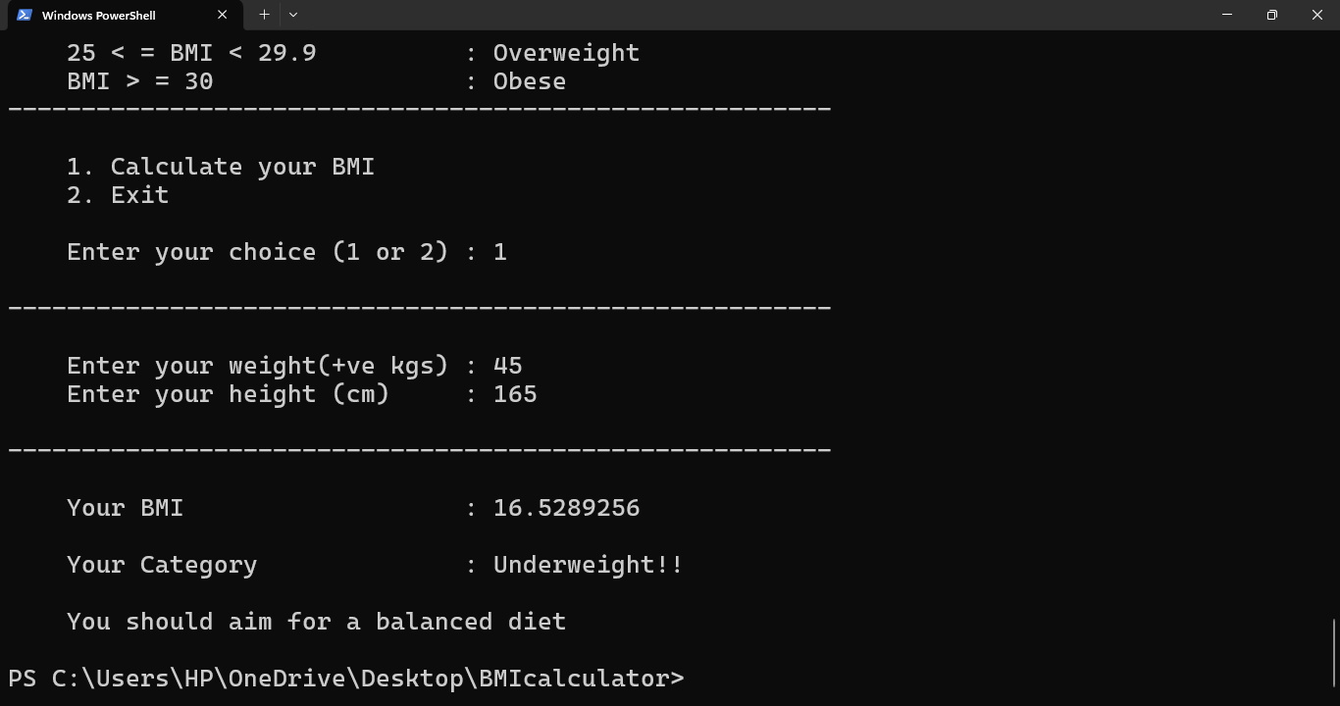

EXIT FROM THE PROGRAM :

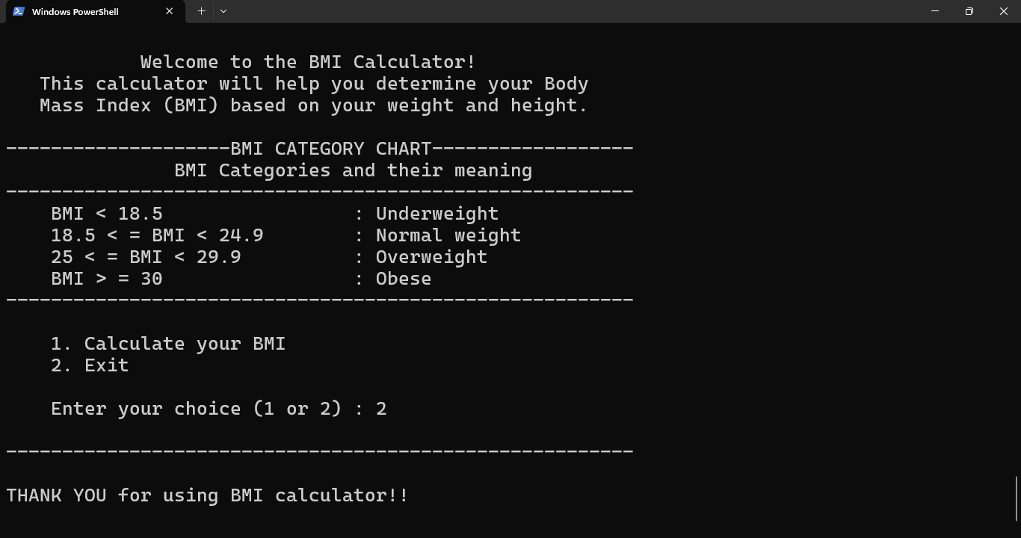

FUTURE SCOPE

The future scope for a BMI (Body Mass Index) calculator can be quite broad, especially with the integration of new technologies and trends in health and wellness. Here are some potential areas for growth and development:
- Integration with Wearable Devices:
  - BMI calculators can be integrated with wearable health devices (like fitness trackers or smartwatches) that track heart rate, activity levels, calories burned, and other health metrics. This data could provide a more holistic view of a person's health, helping users understand how their physical activity and nutrition impact their BMI.
- Personalized Health Recommendations:
  - The BMI calculator can evolve to not just calculate BMI but also provide tailored recommendations for diet, exercise, and lifestyle changes based on the individual's BMI and health data. This could be powered by machine learning algorithms to offer personalized health plans.
- AI-Driven Predictive Analysis:
  - With AI, the BMI calculator can predict potential health risks (such as heart disease, diabetes, or other obesity-related conditions) based on historical health data. This could allow users to take proactive steps toward better health before issues arise.
- Expanded Metrics for Comprehensive Health Assessment:
  - Instead of relying solely on BMI, future versions could include additional health metrics such as body fat percentage, muscle mass, waist-to-hip ratio, and metabolic rate to provide a more accurate and comprehensive assessment of a person's health.
- Integration with Medical Records:
  - The BMI calculator could be connected to electronic health records (EHR) systems, allowing doctors and healthcare providers to track changes in BMI over time and make data-driven decisions about a patient's care.
- Mobile App and Web Integration:
  - The BMI calculator could become a feature in larger health and wellness apps, where users can monitor their progress over time, set goals, and access resources such as fitness classes, healthy recipes, and stress management tips.

- Gamification and Engagement:
  - To keep users engaged, the BMI calculator can include gamification features such as challenges, rewards, and progress tracking. This could motivate users to stay active and make healthy choices in a fun and interactive way.
- Global Health Initiatives:
  - BMI calculators can be part of global public health campaigns to raise awareness about obesity and its risks. The tool could be used in schools, workplaces, and health institutions to help people become more conscious of their health and take preventive actions.
- Data Privacy and Security Enhancements:
  - As personal health data is sensitive, future BMI calculators could implement advanced encryption and data protection measures to ensure user privacy. Compliance with regulations like GDPR and HIPAA will be essential for widespread adoption.
- Community and Social Sharing:
- Future BMI calculators could allow users to share their progress with family, friends, or social media platforms, promoting community support and accountability for fitness goals.

CONCLUSION

The BMI (Body Mass Index) calculator is a simple yet powerful tool for assessing an individual’s body weight in relation to their height, helping to determine if they are underweight, normal weight, overweight, or obese. While it has been a standard method for evaluating general health and is widely used in both clinical and fitness settings, its future scope is expanding with technological advancements. By integrating data from wearable devices, machine learning for personalized recommendations, and offering more comprehensive health metrics, the BMI calculator can evolve into a more holistic health tool. Additionally, incorporating AI-driven predictions and personalized advice will enable users to make proactive and informed decisions about their health, improving long-term well-being.
The future of BMI calculators is not just limited to individual usage. It can play an important role in community health initiatives, data-driven public health policies, and preventative care strategies. Furthermore, integrating these calculators with health management apps and medical records could create a more connected healthcare ecosystem. Despite its limitations, such as the failure to account for muscle mass or distribution of fat, future enhancements will make BMI calculators a more effective and accurate tool for personalized health management.

References and Bibliography:

- BMI Calculator:
Calculator.net
BMI Calculator
This site provides a user-friendly BMI calculator with detailed explanations of how to interpret the results.
- OpenAI:
ChatGPT by OpenAI
ChatGPT
For AI-powered conversational assistance, including help with learning coding and much more.
- Java Resources:
W3Schools - Java Tutorial
Java Tutorial
W3Schools offers an excellent beginner-friendly guide to learning Java.

