Artha Banking Management System Unified Modelling language diagrams

Version: 1.0

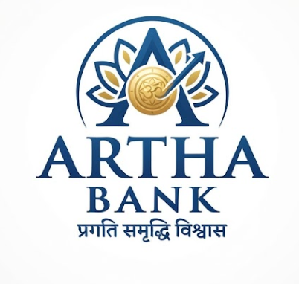

Project Type: Desktop Banking Application

Prepared By: Shikhar Chaturvedi
Unified modelling language diagrams
Purpose: UMLs form the core of design documents, they are used here to define various user flows, workflows and model the implementation logic first hand before committing to writing serious codebase in order to structure the project according to requirements and streamline the flow of execution.
Activity Diagrams
The Activity diagrams are used to model the workflow to create an understanding of how user interact and stages through various phases of interaction.

AD01: User Login
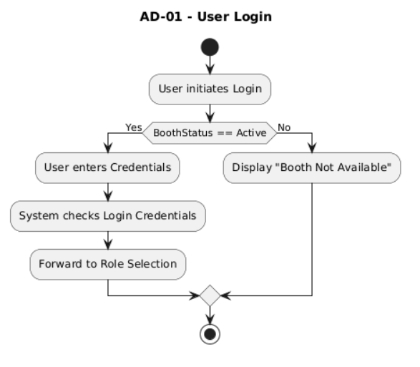

AD02: Authentication
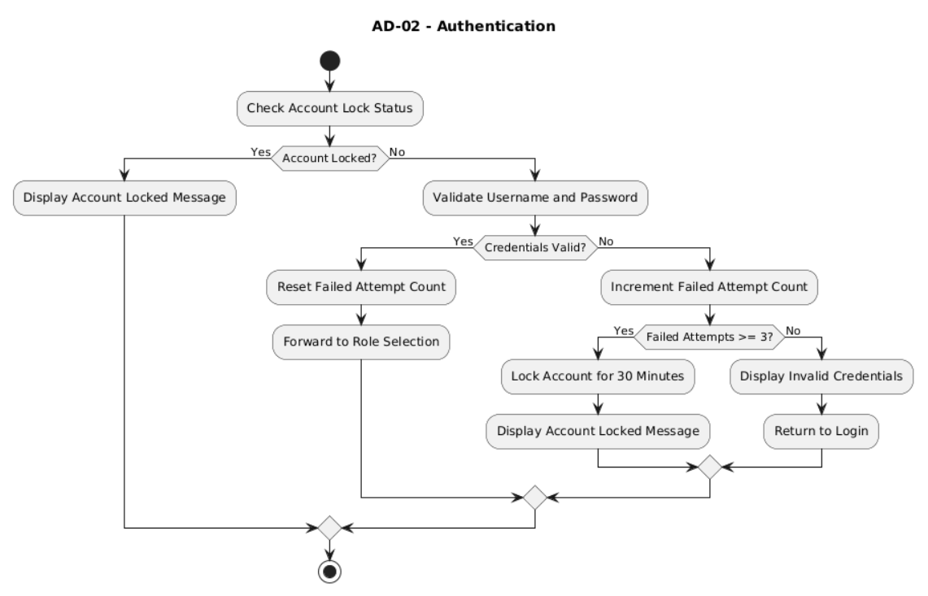
AD03: Account Lock Evaluation
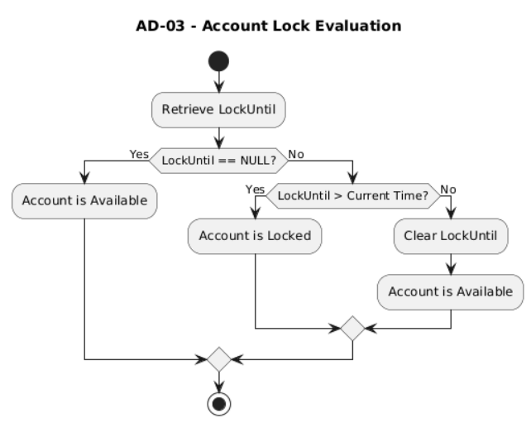
AD04: Role Selection
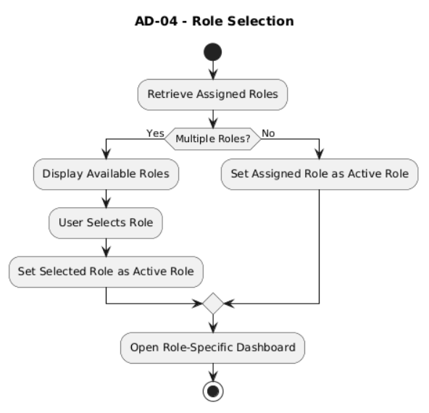

AD05: Locked-User-Recovery
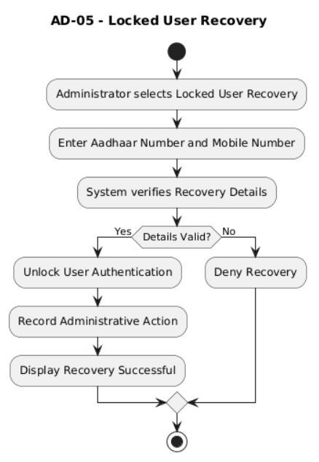
AD05.1: Recovery Details Verification
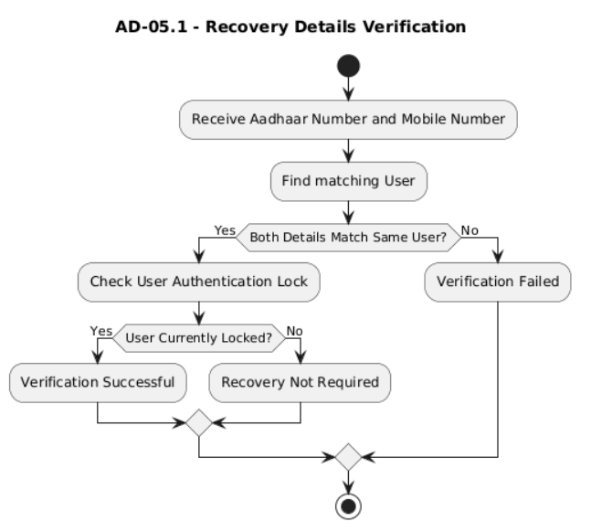
AD05.2: User Unlock
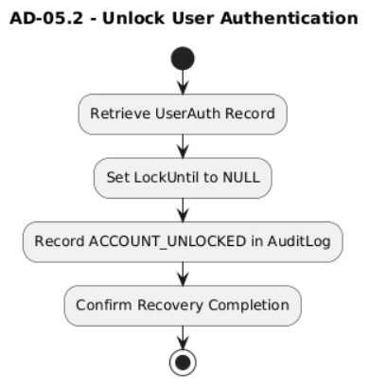

AD06: User Registration and Verification
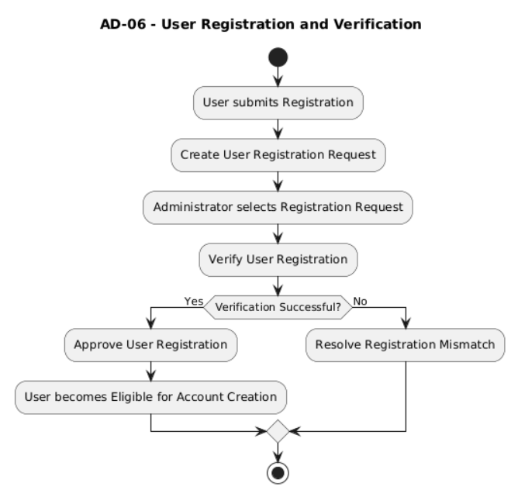

AD06.1: Registration Submission
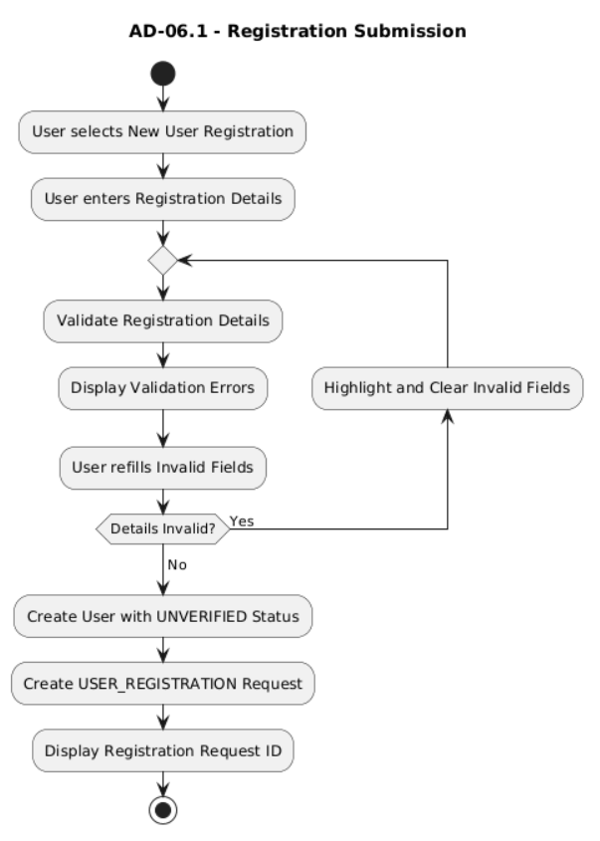
AD06.2: Request-Based Verification Navigation
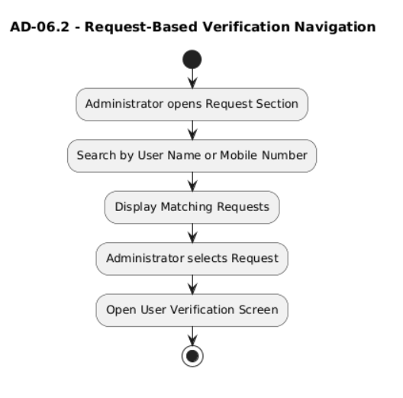
AD06.3: Request-Based Verification Navigation
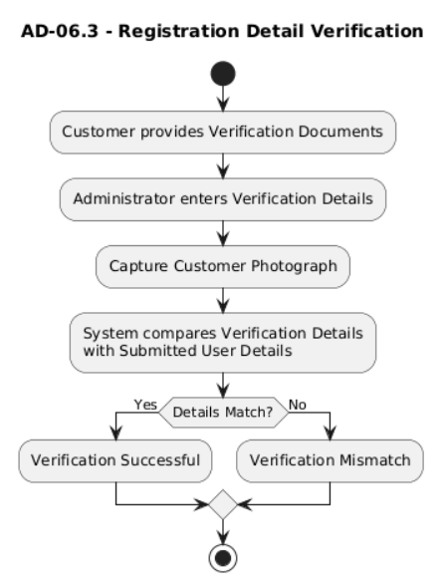

AD06.4: Request Mismatch resolution

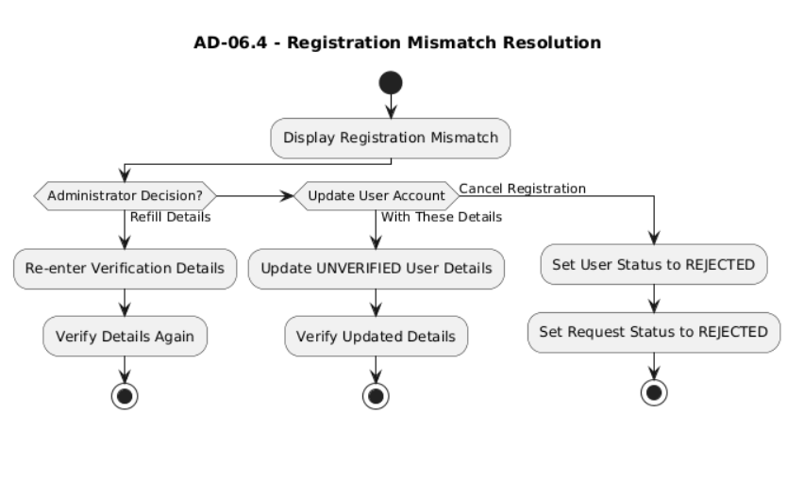
AD06.5: Request-Based Verification Navigation
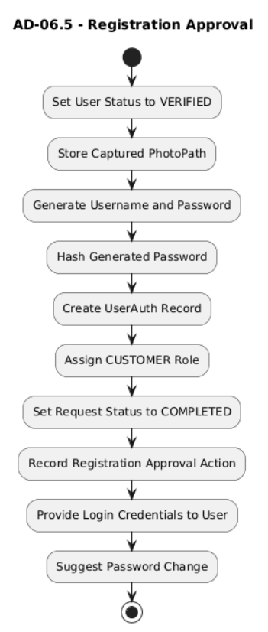

AD07: Account creation
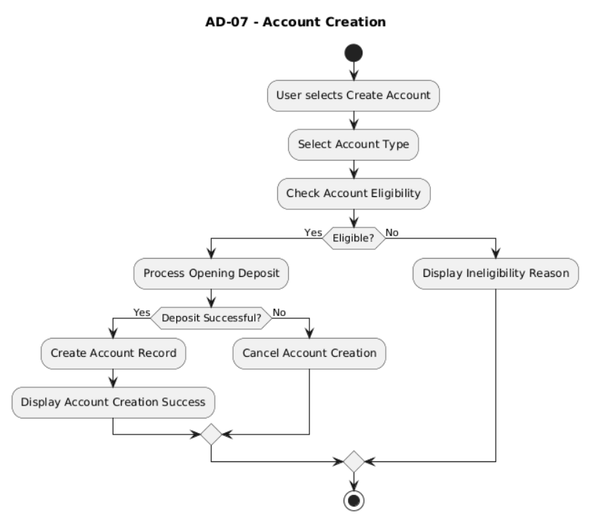

AD07.1: Account Eligibility Test
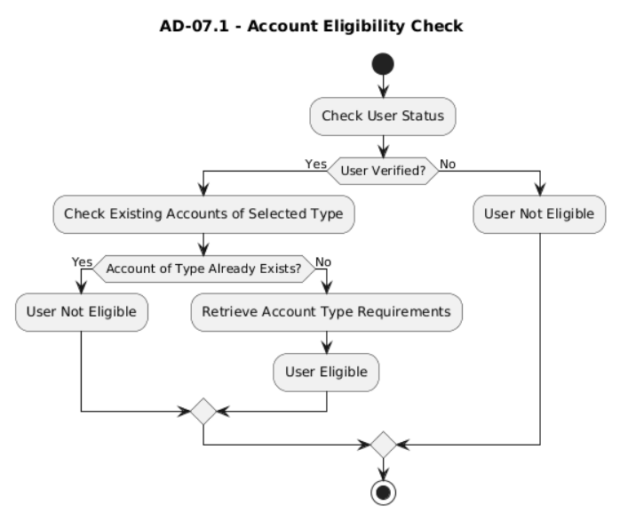

AD07.2: Opening Deposit

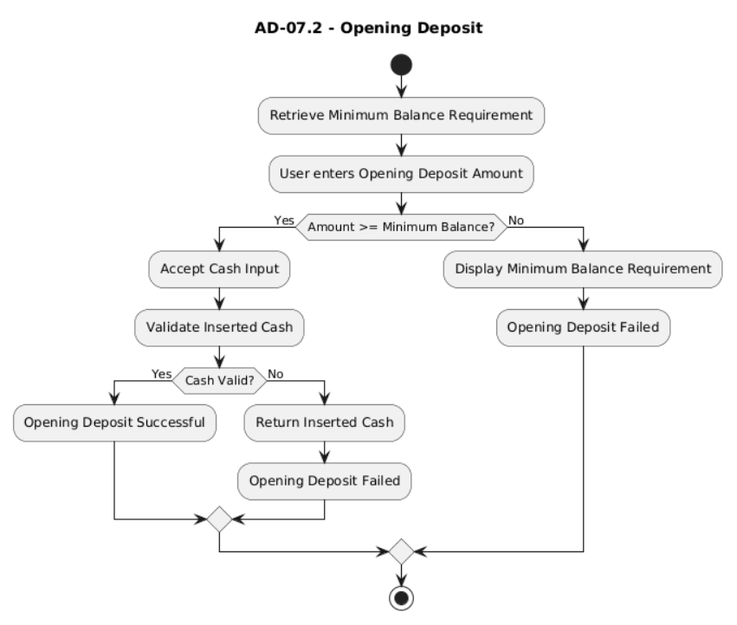

AD07.2: Account Record Creation
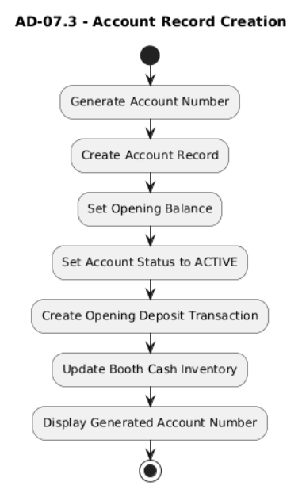

AD08: Cash Deposit

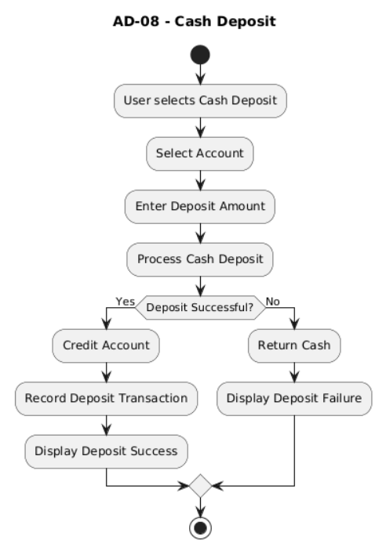

AD09: Cash Withdrawal
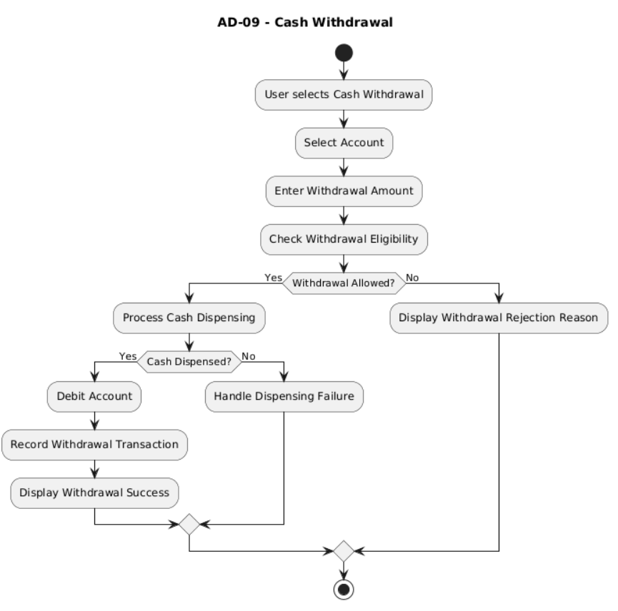

AD10: Fund Transfer
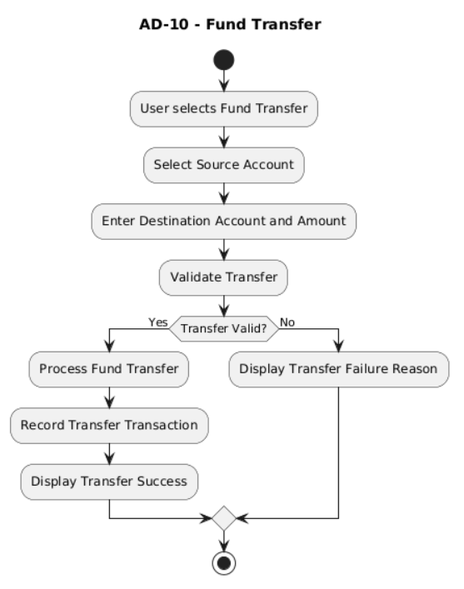

AD11: Payment

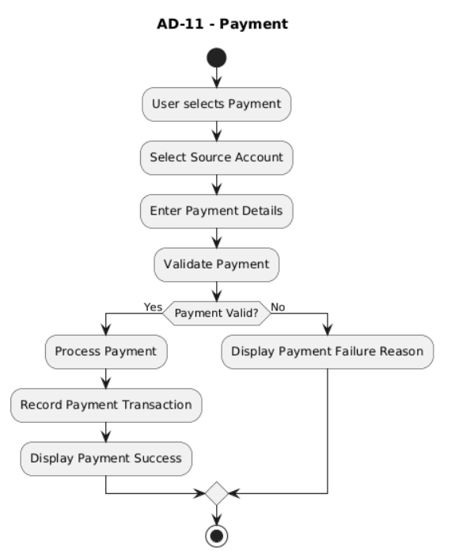

AD12: Investment Creation
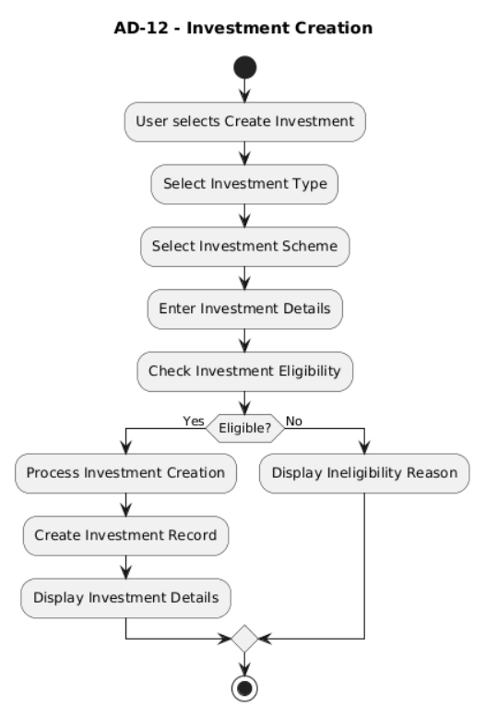

AD13: Investment Creation
@startuml
title AD-13 - Investment Management

start

:User opens Investment Section;
:Display User Investments;
:User selects Investment;
:Display Investment Details;
:User selects Investment Action;
:Process Selected Action;

stop

@enduml
AD14: Investment Creation
@startuml
title AD-14 - Investment Closure

start

:User selects Investment;
:Request Investment Closure;
:Evaluate Closure Conditions;

if (Closure Allowed?) then (Yes)
:Calculate Settlement Amount;
:Close Investment;
:Credit Settlement Amount;
:Display Closure Success;
else (No)
:Display Closure Rejection Reason;
endif

stop

@enduml
AD15: Investment Creation
@startuml
title AD-15 - RD Installment Processing

start

:RD Installment becomes Due;
:Attempt Installment Payment;

if (Payment Successful?) then (Yes)
:Record RD Installment;
:Update Investment Progress;
else (No)
:Handle Missed RD Installment;
endif

stop

@enduml
AD16: Investment Creation
@startuml
title AD-16 - Loan Application

start

:User selects Apply for Loan;
:Select Loan Scheme;
:Enter Loan Application Details;
:Check Loan Application Eligibility;

if (Eligible to Apply?) then (Yes)
:Create Loan Application Request;
:Display Application Submitted;
else (No)
:Display Ineligibility Reason;
endif

stop

@enduml
AD17: Investment Creation
@startuml
title AD-17 - Loan Approval

start

:Manager opens Loan Requests;
:Select Loan Application;
:Evaluate Loan Application;

if (Loan Approved?) then (Yes)
:Create Loan Record;
:Generate Repayment Schedule;
:Disburse Loan Amount;
:Update Request Status;
else (No)
:Reject Loan Application;
:Update Request Status;
endif

:Notify User;

stop

@enduml
AD18: Investment Creation
@startuml
title AD-18 - Loan Repayment

start

:User selects Loan Repayment;
:Select Loan;
:Select Due Repayment;
:Process Repayment;

if (Payment Successful?) then (Yes)
:Update Repayment Record;
:Update Outstanding Amount;
:Record Transaction;
:Display Repayment Success;
else (No)
:Display Repayment Failure;
endif

stop

@enduml
AD19: Investment Creation
@startuml
title AD-19 - Loan Overdue Handling

start

:Repayment Due Date Passes;
:Check Repayment Status;

if (Repayment Pending?) then (Yes)
:Apply Grace Period;
:Evaluate Overdue Repayment;
:Update Loan Liability;
:Notify User;
else (No)
:Continue Repayment Schedule;
endif

stop

@enduml
AD20: Investment Creation
@startuml
title AD-20 - Hardware Failure Handling

start

:Hardware Operation Requested;
:Execute Hardware Request;

if (Hardware Responds?) then (Yes)
:Continue Business Operation;
else (No)
:Confirm Hardware Failure;
:Update Hardware Status;
:Evaluate Booth Impact;
:Generate Failure Notification;
endif

stop

@enduml
AD21: Investment Creation
@startuml
title AD-21 - Hardware Recovery

start

:Administrator initiates Hardware Recovery;
:Test Hardware;

if (Test Successful?) then (Yes)
:Set Hardware Status to ACTIVE;
:Evaluate Booth Availability;
else (No)
:Keep Hardware Status DOWN;
:Display Recovery Failure;
endif

stop

@enduml
AD22: Investment Creation
@startuml
title AD-22 - Notification Processing

start

:Business Event Occurs;
:Create Notification;
:Associate Relevant Business Reference;
:Make Notification Available to User;
:User views Notification;
:Mark Notification as Read;

stop

@enduml

