Tiger Population Recovery and Forest Cover Dynamics in Nepal: A Comparative Analysis with Global Trends
Shikhar Pandey
West Virginia State University, Institute, WV, USA
ESIIL Summer Research Internship Program, University of Colorado Boulder, Boulder, CO, USA
spandey@wvstateu.edu
Abstract. Nepal's wild tiger population grew from 121 individuals in 2009 to 429 in 2026, a 3.5-fold increase that comfortably exceeded the international Tx2 commitment to double tiger numbers by 2022. Over the same period, independent national forest assessments place Nepal's forest cover in a stable 39–45% range, in contrast to the net forest loss reported across much of the tropics. This paper compiles and analyzes publicly available tiger census and forest-cover data for Nepal from 2000–2026, situates Nepal's recovery within the global tiger-conservation landscape, and examines the government-led interventions most frequently credited with this outcome: the Terai Arc Landscape Program, protected-area and buffer-zone management, community-based anti-poaching units, and Nepal's community forestry system of over 22,000 Community Forest User Groups. Nepal's tiger population growth rate outpaces every other tiger-range country in relative terms, while its forest-cover trajectory diverges from the global pattern of continued tropical deforestation. The analysis is descriptive rather than causal: it documents a strong temporal association between sustained government investment and ecological recovery, while noting that forest-cover stability alone does not explain tiger population growth, which is more directly attributed to enforcement and habitat-connectivity interventions.
Keywords: Tiger conservation · Forest cover change · Nepal · Terai Arc Landscape · Community forestry · Remote sensing · Tx2
1 Introduction
At the turn of the twentieth century an estimated 100,000 tigers (Panthera tigris) roamed across Asia. By 2010, poaching, habitat loss, and human encroachment had reduced the global wild tiger population to an all-time low of approximately 3,200 individuals [1]. In response, the thirteen tiger-range countries, meeting in St. Petersburg in 2010, adopted the Tx2 goal: doubling the global wild tiger population by 2022, the next Chinese Year of the Tiger [1].
Nepal has emerged as one of the most frequently cited success stories within this global effort. Its national tiger census rose from 121 tigers in 2009 to 429 in 2026, nearly quadrupling in seventeen years [2, 3]. This recovery has occurred alongside a national forest-cover trajectory that independent assessments describe as broadly stable, a pattern that stands in contrast to net deforestation trends observed across many tropical and subtropical range states over the same period [4, 5]. This paper asks three questions: (1) how have Nepal's tiger population and forest cover changed from 2000 to 2026; (2) how does Nepal's recovery compare with global and range-country trends; and (3) what role have government-led conservation programs played in this outcome.
2 Background
2.1 Nepal's Tiger Conservation Program
The Government of Nepal has run a national tiger census roughly every four years since 2009, using systematic camera-trap surveys across the Terai Arc Landscape (TAL) — a lowland forest corridor of approximately 2.47 million hectares spanning Chitwan, Bardiya, Parsa, Banke, and Shuklaphanta National Parks and their connecting buffer zones [3, 6]. The TAL Program itself was launched by the Government of Nepal in 2001, based on a tiger-dispersal model recognizing that protected areas alone were insufficient to sustain tiger populations over the long term [6, 7]. Two successive ten-year strategic plans (2004–2014 and 2015–2025) expanded community forestry and buffer-zone management alongside habitat restoration in biological corridors [7].
Enforcement has been a central pillar of this strategy. Community-based anti-poaching units, supported by the Nepali Army's deployment in protected areas, are widely credited with controlling the poaching of tiger parts [8]. A transboundary partnership with India — supported by the Zoological Society of London and international partners — has trained roughly 1,700 protected-area and law-enforcement staff and established Rapid Response Teams that made 70 arrests in a single reporting year, contributing to a reported 40% increase in tiger numbers since 2013 across focal protected areas in Nepal [9]. Community forestry, initiated in Nepal in the late 1970s, now involves more than 22,000 Community Forest User Groups managing nearly 2.9 million hectares and benefiting more than three million households [10]. Since 2023, Nepal's conservation strategy has shifted from a narrow focus on population numbers toward human–tiger coexistence, reflecting rising concern over negative human–wildlife interactions as tiger range expands [8].
2.2 Global Tiger Conservation Context
Thirteen countries currently retain confirmed wild tiger populations: Bangladesh, Bhutan, China, India, Indonesia, Malaysia, Myanmar, Nepal, Russia, and Thailand, with Cambodia, Laos, and Vietnam considered functionally extinct for the species [11]. The Global Tiger Forum's most recent global estimate places the wild tiger population at approximately 5,574 individuals as of 2023, a roughly 74% increase from the 2010 baseline of 3,200 [1]. Growth over this period has been concentrated in India, Nepal, Bhutan, Russia, and China, while range and habitat have continued to contract in most other tiger-range states [1]. India retains by far the largest population — 3,682 tigers in its 2022 national survey, roughly three-quarters of the global total — built on a conservation program (Project Tiger) dating to 1973 [12, 13]. Populations in Malaysia, Bangladesh, and China remain critically low, at under 150, roughly 114, and approximately 50 individuals respectively [13].
3 Data and Methods
3.1 Data Sources
Nepal tiger population figures (2009–2026) were compiled from Nepal's Department of National Parks and Wildlife Conservation (DNPWC) national census releases, cross-referenced against reporting from the Kathmandu Post, IUCN, and the Global Tiger Forum. Nepal forest-cover figures (1994–2021) were compiled from four independent sources: the National Forest Inventory (aerial photography and field plots), a Landsat-based national land-cover map [4], the Department of Forest Research and Survey's Forest Resource Assessment using RapidEye 5 m imagery [5], and the Hansen/University of Maryland Global Forest Change dataset distributed via Global Forest Watch. Global and range-country tiger population figures were drawn from the most recent national surveys reported to or by the Global Tiger Forum, WWF, and range-state wildlife agencies [1, 11, 12, 13].
3.2 Analytical Approach
Because Nepal's forest-cover estimates use different sensors, resolutions, and forest definitions across assessments, they are treated as independent point estimates rather than a harmonized time series. Where tiger-census years and forest-assessment years do not align, linear interpolation was applied strictly to enable a shared-timeline visualization; interpolated values are distinguished from measured data points throughout and are not used to support causal inference. A simple correlation coefficient between interpolated tiger counts and forest-cover percentages is reported as a descriptive statistic only.
4 Results
4.1 Nepal's Tiger Population Trend
Nepal's national tiger census rose from 121 individuals in 2009 to 198 (2013), 235 (2018), 355 (2022), and 429 (2026) — a 3.5-fold increase (Fig. 1). Nepal surpassed the Tx2 goal of 250 tigers four years ahead of the original 2022 deadline for many range states. Between the 2022 and 2026 censuses, four of five national parks recorded gains: Chitwan (128→145), Parsa (41→71), Banke (25→51), and Shuklaphanta (36→50); Bardiya was the sole park to record a decline (125→112) [2].
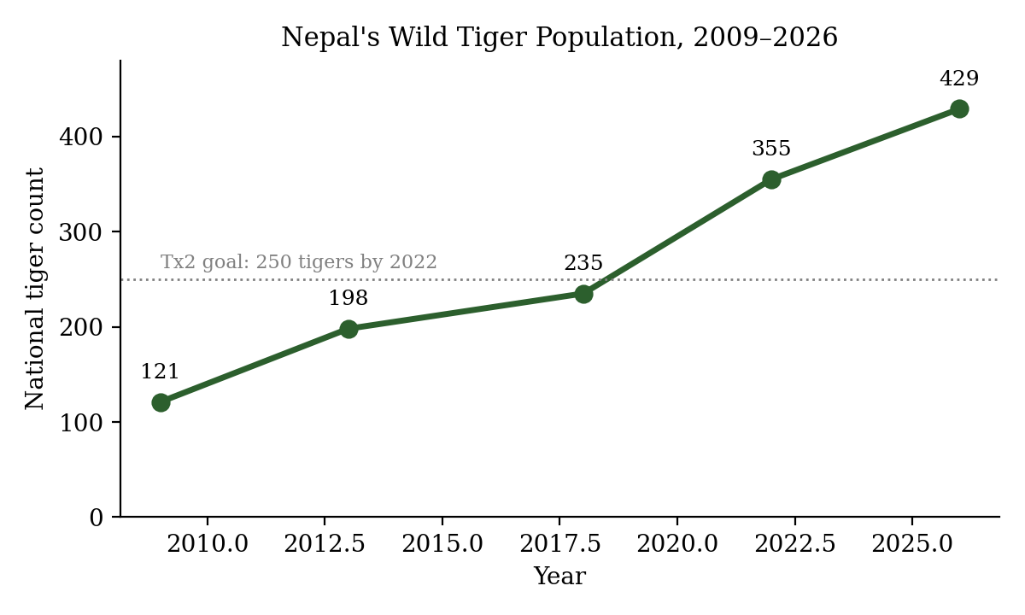
Fig. 1. Nepal's national tiger census counts, 2009–2026, relative to the Tx2 goal.
4.2 Nepal's Forest-Cover Trend
Independent forest assessments place Nepal's national forest cover in a narrow 39–45% band between 1994 and 2021 (Fig. 2), with no single assessment indicating a steep decline over this period. Global Forest Watch recorded approximately 4,900 hectares of natural forest loss in Nepal in 2025 — a small fraction of the roughly 6.5 million hectares of natural forest present in 2020.
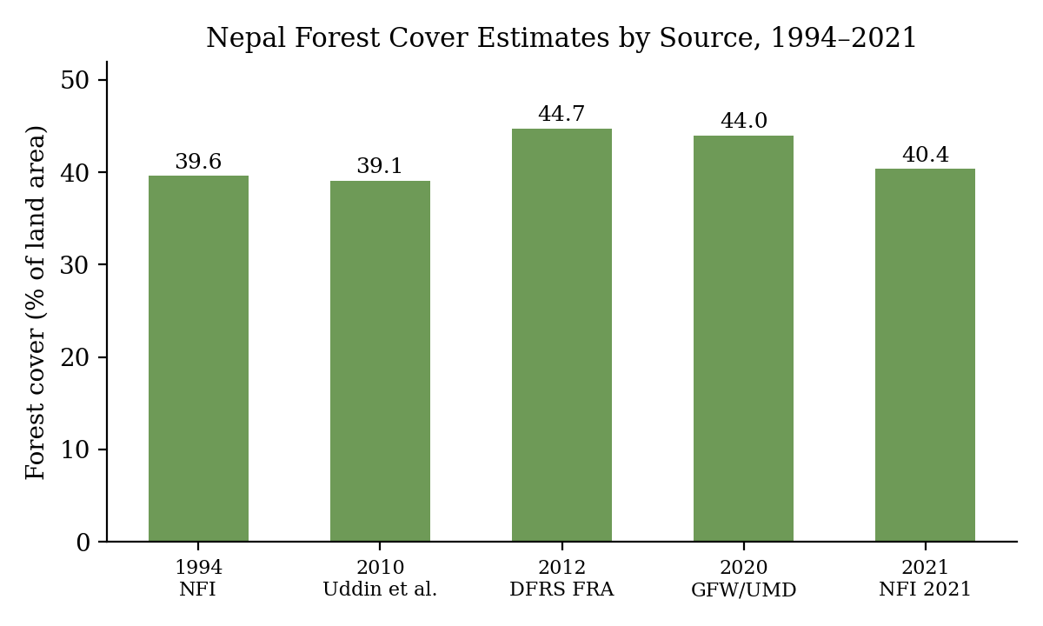
Fig. 2. Nepal forest-cover estimates from independent national and global assessments, 1994–2021.
4.3 Nepal in Global Comparative Context
Among the nine range countries with confirmed populations exceeding trace numbers, India dominates with 3,682 tigers (2022), followed by Russia (~510), Indonesia (~450), and Nepal (355 in 2022; 429 in 2026) (Fig. 3). In relative terms, however, Nepal's population growth rate since 2009 (3.5×) exceeds that of every other major range country over a comparable interval, including India's roughly two-fold increase since 2006 and Bhutan's 27% increase between 2015 and 2022 [11, 12].
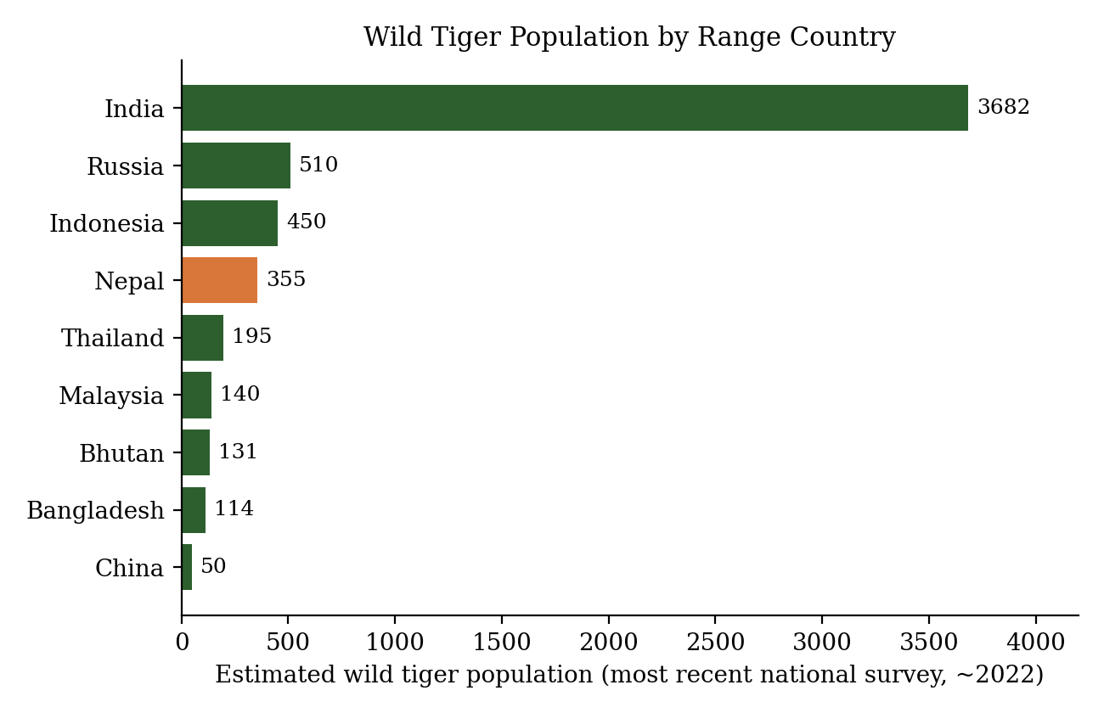
Fig. 3. Estimated wild tiger population by range country, most recent national surveys (~2022).
At the global level, the estimated wild tiger population rose from approximately 3,200 in 2010 to 5,574 in 2023, a 74% increase (Fig. 4). Nepal's national trajectory is broadly consistent with — and proportionally stronger than — this global recovery.
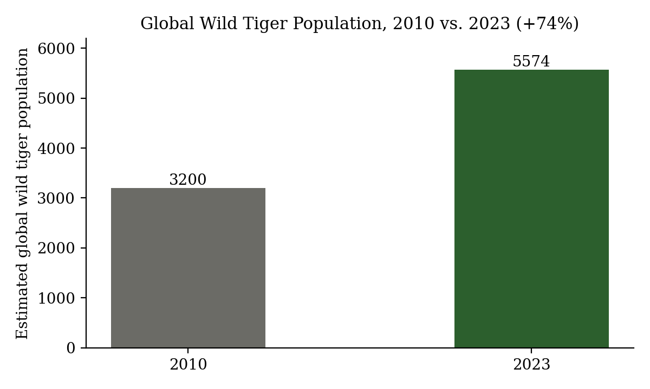
Fig. 4. Estimated global wild tiger population, 2010 vs. 2023.
4.4 Combined Trends
Overlaying Nepal's tiger-population and forest-cover series on a shared, interpolated timeline (Fig. 5) shows both quantities rising or remaining stable over 2000–2026, with a weak positive descriptive correlation (r ≈ 0.22). Given the small number of measured points and the use of interpolation to align mismatched years, this correlation should be read as illustrative rather than as evidence of a direct causal link between forest-cover levels and tiger population size.
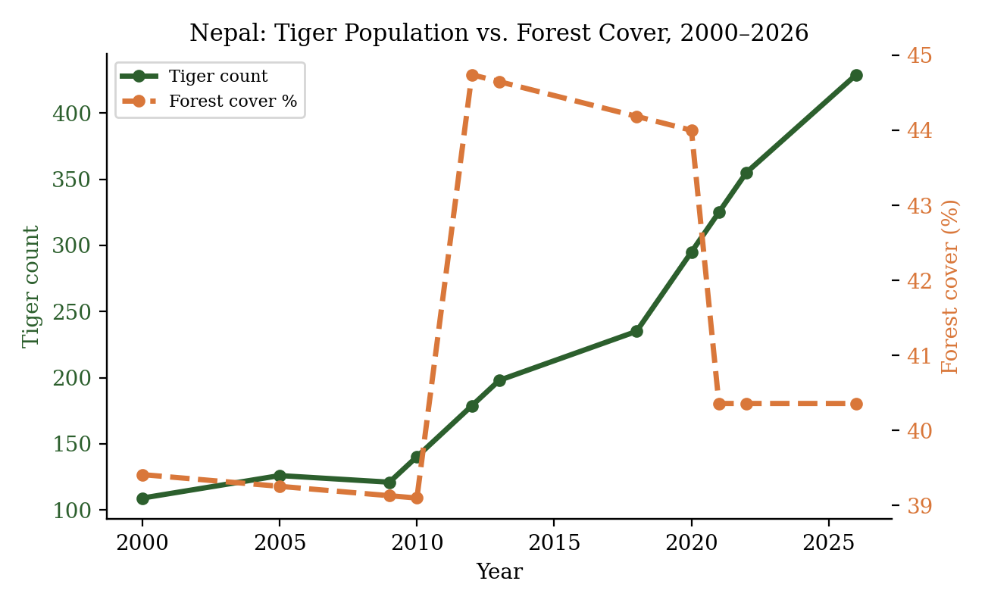
Fig. 5. Nepal's tiger population and forest cover percentage on a shared interpolated timeline, 2000–2026.
5 Discussion
5.1 The Role of Government Programs and Community Forestry
The temporal coincidence of Nepal's tiger recovery with sustained government investment is striking. The Terai Arc Landscape Program, in place since 2001, reoriented conservation policy from isolated protected areas toward a connected landscape approach, restoring corridors and reducing inbreeding risk among source populations [6, 7]. Enforcement measures — community-based anti-poaching units, Nepali Army deployment, and transboundary Rapid Response Teams — directly target the poaching pressure historically responsible for tiger decline [8, 9]. Community forestry, meanwhile, has been the most frequently cited driver of Nepal's forest-cover resilience, aligning local livelihoods with forest protection across nearly three million hectares [10]. Together, these programs illustrate a model in which habitat stability and targeted enforcement operate as complementary, rather than substitute, mechanisms for species recovery.
5.2 Nepal in Global Context
Nepal's experience sits within a broader, uneven global pattern. Growth has been concentrated in a handful of countries — India, Nepal, Bhutan, Russia, and China — each pursuing comparatively well-resourced, government-backed conservation programs, while tiger populations in Malaysia, Bangladesh, and China remain critically low and functionally extinct populations persist in Cambodia, Laos, and Vietnam [1, 11]. Nepal's case is notable for achieving one of the highest proportional growth rates worldwide despite a comparatively small land area and high rural population density in the Terai, suggesting that landscape-level planning and community engagement can offset — rather than being precluded by — human population pressure.
5.3 Limitations
This analysis has four limitations. First, Nepal's forest-cover figures come from methodologically distinct assessments and do not constitute a single continuous measurement series. Second, pre-2009 tiger figures are pre-camera-trap estimates and are not directly comparable to later systematic censuses. Third, the interpolated shared timeline used in Fig. 5 is a visualization aid, not measured data, and the resulting correlation coefficient should not be interpreted causally. Fourth, global and range-country comparisons in Fig. 3 mix survey years (approximately 2018–2022) because range countries do not conduct censuses on a synchronized schedule.
6 Conclusion
Nepal's wild tiger population grew 3.5-fold between 2009 and 2026, exceeding the international Tx2 target well ahead of schedule, while national forest cover remained within a stable 39–45% range across independent assessments spanning nearly three decades. This combination — population recovery alongside forest-cover stability — distinguishes Nepal from the global norm of continued tropical forest loss and positions it among the strongest performers of the thirteen tiger-range countries in relative terms. The evidence reviewed here associates this outcome with a sustained, government-led policy mix: the Terai Arc Landscape Program's corridor-based approach, community-based anti-poaching enforcement, transboundary cooperation with India, and a long-running community forestry system. Future work could extend this analysis with harmonized, pixel-level forest-change data (e.g., via Google Earth Engine, as outlined in the companion notebook to this study) to test spatial associations between corridor-level forest change and tiger occupancy more rigorously than the national-scale, descriptive comparison presented here.
Acknowledgments. This study was conducted as part of the ESIIL (Environmental Data Science Innovation and Inclusion Lab) Summer Research Internship Program, University of Colorado Boulder, supported by the U.S. National Science Foundation (NSF). The author thanks Nate Quarderer, ESIIL Education Director, for his mentorship and guidance throughout this project.
Disclosure of Interests. The author has no competing interests to declare.
References
1. World Wildlife Fund: New tiger population estimate of 5,574 wild tigers announced by Global Tiger Forum. https://www.worldwildlife.org/news/stories/new-tiger-population-estimate-of-5574-wild-tigers-announced-by-global-tiger-forum/
2. IUCN: Tiger census: Nepal's tiger number increases to 429. https://iucn.org/story/202607/tiger-census-nepals-tiger-number-increases-429
3. Kathmandu Post: Nepal's tiger population rises to 429, latest census shows. https://kathmandupost.com/national/2026/07/29/nepal-s-tiger-population-rises-to-429-latest-census-shows
4. Uddin, K., Shrestha, H.L., Murthy, M.S.R., et al.: Development of 2010 national land cover database for Nepal. J. Environ. Manage. (2015).
5. Department of Forest Research and Survey (DFRS): Forest Resource Assessment 2010–2014, State of Nepal's Forests. Kathmandu (2015).
6. Food and Agriculture Organization of the United Nations: Terai Arc Landscape, Forest and Landscape Restoration Mechanism. https://www.fao.org/in-action/forest-landscape-restoration-mechanism/un-decade/world-restoration-flagships/terai-arc-landscape/
7. WWF: Connecting Corridors — Terai Arc Landscape Nepal. https://files.worldwildlife.org/wwfcmsprod/files/Publication/file/5nxtq5ipb1_cfp_web.pdf
8. Mongabay: For Nepal, 2023 changed course of tiger conservation efforts. https://news.mongabay.com/2023/12/for-nepal-2023-changed-course-of-tiger-conservation-efforts/
9. IUCN Save Our Species: Tigers Beyond Borders — Partnering for Success in the Terai Arc Landscape. https://iucnsos.org/tigers-beyond-borders-partnering-for-success-in-the-terai-arc-landscape/
10. Sustainability: Monitoring Forest Cover Trends in Nepal: Insights from 2000–2020. https://www.mdpi.com/2071-1050/17/14/6511
11. WWF Canada: Tigers still roam wild in these 13 tiger-range countries. https://wwf.ca/stories/13-countries-wild-tigers/
12. Tiger-Universe: Map of Tiger Population. https://tiger-universe.com/pages/map-of-tiger-population
13. HowStuffWorks: What's the Country With the Most Wild Tigers?. https://animals.howstuffworks.com/mammals/country-with-most-wild-tigers.htm
14. Global Forest Watch: Nepal Country Dashboard. https://www.globalforestwatch.org/dashboards/country/NPL/

