**SMART**

**Social Media Analyser and Recognition Tool**

Capstone Project Report

**MID SEMESTER EVALUATION**

**Submitted by:**

**101903188 JAPPREET KAUR**

**101903207 EKARTH JAIN**

**101903714 TANISH SHARMA**

**102083022 RAKSHIT**

**BE Fourth Year- COE 23**

**CPG No. 170**

Under the Mentorship of

Dr. Jasmeet Singh

Assistant Professor



**Computer Science and Engineering Department**

**Thapar Institute of Engineering and Technology, Patiala**

**July, 2022**

# ABSTRACT

Over the past few decades, we have seen how the world works in the clothing industry; one goes and tries on clothes and then buys the clothes. Since the pandemic, there has been an increase in demand to try clothes at customers' leisure. However, there has not been much advancement in this field. Now, most industries are shifting to visual mode, and competitors try to advance to one; other textile industries have become popular during these difficult times with their quick shift to online mode.

Image visual try-on aims at transferring a target clothing image onto a reference person, and has become a hot topic in recent years. Prior arts usually focus on preserving the character of a clothing image when warping it to arbitrary human pose. However, it remains a big challenge to generate photo-realistic try-on images when large occlusions and human poses are presented in the reference person

With the advanced technology growth, online shopping as known as e-shopping has grown exponentially throughout the world nowadays. Advances in e-shopping has driven a shopping revolution where customers are able to purchase items anywhere and anytime. Despite the benefits of e-shopping, the main drawback is the difficulty for online shoppers to try items on especially for clothing. Hence, our project *FACTORS- Fine-grained Apparel category Classification and Try-On Recommender System* is proposed to be developed to allow shoppers to visualize how clothing looks and fits on their bodies without wearing it actually. This is to improve shoppers shopping experience by giving them an ability to virtually try clothing on in order to check for size, fit or style. In this development, it first predicts semantic layout of the reference image that will be change after try-on and then determines whether its image content needs to be generated or preserved according to the semantic layout, leading to photo realistic try-on and rich clothing details. In addition, the body and garment measurements are also analysed and interpreted to help in seamlessly fitting the virtual garments to the body.

# DECLARATION

We hereby declare that the design principles and working prototype model of the project entitled, *SMART - Social Media Analyser and Recognition Tool,* is an authentic record of our own work carried out in the Computer Science and Engineering Department, TIET, Patiala, under the guidance of **Dr. Jasmeet Singh** during 7th semester (2022).

Date: 20/07/2022

|  |  |  |
| --- | --- | --- |
| **Registration No.** | **Name** | **Signature** |
| 101903188 | Jappreet Kaur |  |
| 101903207 | Ekarth Jain |  |
| 101903714 | Tanish Sharma |  |
| 102083022 | Rakshit |  |

*Counter Signed By:*

Faculty Mentor:

Dr. Jasmeet Singh

Assistant Professor, CSED, TIET, Patiala

# ACKNOWLEDGEMENT

We would like to express our thanks to our mentor Dr. Jasmeet Singh. He has been of great help in our venture, and an indispensable resource of technical knowledge. He has been a truly remarkable as our mentor.

We are also thankful to Dr. Shalini Batra, Head, Computer Science and Engineering Department, entire faculty and staff of Computer Science and Engineering Department, and also our friends who devoted their valuable time and helped us in all possible ways towards documentation of this project. We thank all those who have contributed either directly or indirectly towards this project.

Date: 20/07/2022

|  |  |  |
| --- | --- | --- |
| **Registration No.** | **Name** | **Signature** |
| 101903188 | Jappreet Kaur |  |
| 101903207 | Ekarth Jain |  |
| 101903714 | Tanish Sharma |  |
| 102083022 | Rakshit |  |

**LIST OF FIGURES**

|  |  |  |
| --- | --- | --- |
| **Figure No.** | **Caption Page** | **Page No.** |
| Figure No --1 | WSS asks permission from user to access camera and microphone | 21 |
| Figure No –2 | A photo of a user wearing virtual garment on WSS. | 21 |
| Figure No –3 | Zeekit Prototype Design | 22 |
| Figure No –4 | This figure shows symbols of the technologies used in the development of the project i.e., OpenCV, Python, PyTorch,  TensorFlow from left to right | 29 |
| Figure No --5 | Gantt Chart for work distribution | 44 |
| Figure No --6 | This figure shows the overall processes of the product/solution | 49 |
| Figure No –7 | This figure shows the state chart diagram of the product/solution | 50 |
| Figure No –8 | This figure shows the sequence diagram for the product/solution | 52 |
| Figure No --9 | This figure shows the ER Diagram for the product/product | 53 |
| Figure No –10 | This figure shows the activity diagram for the product/solution | 54 |
| Figure No –11 | This figure shows the component diagram for the  product/solution | 54 |
| Figure No --12 | This figure shows the MVC diagram for the product | 55 |
| Figure No --13 | This figure shows the data flow diagram (context diagram) for the solution/product | 56 |
| Figure No –14 | This figure shows the data flow diagram (DFD-1) for  the solution/product | 57 |
| Figure No –15 | This figure shows the data flow diagram (DFD-2) for  the solution/product | 57 |
| Figure No –16 | This figure shows the use case diagram for the  product/solution | 58 |
| Figure No –17 | Identifying key points on the person | 59 |
| Figure No –18 | Source Image | 63 |
| Figure No –19 | LIP Parsing Result | 63 |
| Figure No –20 | ATR Parsing Resulting | 64 |
| Figure No –21 | Pascal Person Art Parsing Result | 64 |
| Figure No –22 | Demo Image | 65 |
| Figure No –23 | Global Human Parsing | 65 |
| Figure No –24 | Demo Instance Human Mask Parsing | 66 |
| Figure No –25 | Multiple Human Parsing | 66 |
| Figure No –26 | UI Design-1 for the prototype | 67 |
| Figure No –27 | UI Design-2 for the prototype | 68 |
| Figure No –28 | UI Design-3 for the prototype | 69 |
| Figure No –29 | UI Design-4 for the prototype | 70 |
| Figure No –30 | UI Design-5 for the prototype | 71 |
| Figure No –31 | Inaccurate Segmentation | 72 |
| Figure No –32 | Accurate Segmentation | 72 |

**LIST OF TABLES**

|  |  |  |  |
| --- | --- | --- | --- |
| **Table No.** | **Caption Page** |  | **Page No.** |
| Table No -–1 | Strengths and weaknesses of WSS software | 23 |  |
| Table No –-2 | Strengths and weaknesses of  Zeekit’s virtual fitting room application | 24 |  |
| Table No –3 | Research Findings | 25 |  |
| Table No -–4 | Minimum Web Browser  Requirements | 30 |  |
| Table No -–5 | Risk Register | 38 |  |
| Table No -–6 | Qualitative Analysis | 39 |  |
| Table No --7 | Brief description of need and basic content of UML diagrams | 46 |  |
| Table No --8 | Use Case template considering three major use cases, Login, create new account and log out | 60 |  |

# LIST OF ABBREVIATIONS

|  |  |  |
| --- | --- | --- |
| **Sr. No** | **Abbreviation** | **Full Forms** |
| 1 | FPM | Fake Profile Model |
| 2 | FNM | Fake News Model |
| 3 | SAM | Sentiment Analysis Model |
| 4 | GUI | Graphical User Interface |
| 5 | UML | Unified Modelling Language |
| 6 | NFR | Non-Functional Requirements |
| 7 | ER | Entity Relationship |
| 8 | MVC | Model View Component |
| 9 | IP | Internet Protocol |
| 10 | UI | User Interface |

# TABLE OF CONTENTS

## ABSTRACT

## DECLARATION

## ACKNOWLEDGEMENT

## LIST OF FIGURES

## LIST OF TABLES

## LIST OF ABBREVIATIONS

## CHAPTER 1- INTRODUCTION

1.1 Project Overview

1.2 Need Analysis

1.3 Research Gaps

1.4 Problem Definition And Scope

1.5 Assumptions And Constraints

1.6 Standards

1.7 Approved Objectives

1.8 Methodology Used

1.9 Project Outcomes And Deliverables

1.10 Novelty Of Work

## CHAPTER 2 - REQUIREMENT ANALYSIS

2.1 Literature Survey

2.1.1 Theory Associated with Problem Area

2.1.2 Existing Systems and Solutions

2.1.3 Research Findings for Existing Literature

2.1.4 The Problem That Has Been Identified

2.1.5 Survey of Tools and Technologies Used

2.2 SOFTWARE REQUIREMENTS *SPECS*

2.2.1 Introduction

2.2.1.1 Purpose

2.2.1.2 Intended Audience and Reading Suggestions

2.2.1.3 Project Scope

2.2.2 Overall Description

2.2.2.1 Product Perspective

2.2.2.2 Product Features

2.2.3 External Interface Requirements

### 2.2.3.1 User Interfaces

### 2.2.3.2 Hardware Interfaces

### 2.2.3.3 Software Interfaces

2.2.4 Other Non-functional Requirements

2.2.4.1 Performance Requirements

2.2.4.2 Safety Requirements

2.2.4.3 Security Requirements

2.3 COST ANALYSIS

2.4 RISK ANALYSIS

## CHAPTER 3 – METHODOLOGY ADOPTED

3.1 INVESTIGATIVE TECHNIQUES

3.2 PROPOSED SOLUTION

3.3 WORK BREAKDOWN STRUCTURE

## 3.4 TOOLS AND TECHNOLOGIES USED

## CHAPTER 4 - DESIGN SPECIFICATIONS

4.1 SYSTEM ARCHITECTURE

4.2 DESIGN LEVEL DIAGRAMS

4.3 USER INTERFACE DIAGRAMS

4.4 SNAPSHOTS OF WORKING PROTOTYPE

## CHAPTER 5: CONCLUSIONS AND FUTURE

5.1 WORK ACCOMPLISHED

5.2 CONCLUSIONS

5.3 ENVIRONMENTAL/ECONOMIC/SOCIAL

5.4 FUTURE WORK PLAN

**APPENDIX A: REFERENCES**

**APPENDIX B: PLAGIARISM REPORT**

# CHAPTER 1: INTRODUCTION

## PROJECT OVERVIEW

## Over the passage of the last decade, social media has evolved at a rapid pace. At present, social media sites are an irreplaceable part of most of the peoples' lives. Apart from being an integral part of our lives, these platforms also pose a serious threat to the security of their users and their personal information. One of the main problems being the large number of fake profiles that are being created on a daily basis on all platforms, posing threat to users' privacy. These fake profiles are used by scammers to hide their true identity online by impersonating someone else, for instance, a celebrity.

## These fake accounts are further used to spread fake news, rumors and hate speech as well. It is a fact that fake news spreads more rapidly than the truth and the scammers are ever ready to take advantage of this in their favour. They tend to create unrest and panic among the audience by spreading rumors/fake news over social media. Hence, fake news is a very serious issue that needs to be addressed. Fake news articles, fake forwarded messages, images, videos and all kinds of media are witnessed being shared of all kinds of social media platforms like WhatsApp, Facebook, Twitter, Instagram and any other platform that exists.

## The growing popularity of social media also contributes to generating a large amount of data. This large volume of data attracts researchers and practitioners as it can be used to find solutions to problems which were impossible to solve earlier because of the scarcity of resources (data). With the current advancements in modern technology and the readily available resources, all these tasks have become much easier both for people with good intentions and also with harmful ones. Online frauds are increasing at a record pace and it’s our responsibility to everything in our power to try and prevent them.

## The current multitude of available data sources has made it way easier to solve problems like Sentiment Analysis, Opinion Mining, Product Mining etc. These tools can immensely contribute towards filtering out the fake news, hate speech, fake profiles and even scam posts by identifying a general pattern that these kinds of posts follow. Sentiment analysis can help reduce the misinterpretation of text/posts that happens very often on social media due to the inability of text to express one’s emotions precisely. Opinion mining can be really helpful in understanding the general public opinion on a topic of mass interest.

## This project primarily aims at detecting and classifying whether an id is real or fake, identify fake news and spam messages spreading over social media platforms, perform sentiment analysis on the data gathered from the social media sites (Twitter primarily), that can further assist us in extracting public opinion about a general issue/topic and any products that want to find their place in the current competitive market.

## 1.2 NEED ANALYSIS

Daily, massive number of pieces of textual information is gathered into Social Media. They comprise a challenging style as they are formed with both slang and formal words. Google says spelling remains “an ongoing challenge of language understanding” with one in 10 search queries misspelled daily and new words (and new misspellings of them) constantly being introduced. This problem gets even more challenging when we look into the world of social media due to the frequent use of slangs and difference in the spellings depending on the region of the world. In 2020, 1.7 MB of data was generated every second for every person on Earth, which is over 2.5 quintillion bytes of data every single day! [1]

Sentiment analysis is perceived to be a multi-disciplinary research domain composed of machine learning, artificial intelligence, deep learning, image processing, and social networks. It can be used to determine opinions of the public about products and to find the customers' interest and their feedback through social networks. To perform any natural language processing task, the input text/comments should be represented in a numerical form. Word embeddings represent the given text/sentences/words as a vector that can be employed in performing subsequent natural language processing tasks.

Social Media is like a double-edged sword. On the one hand, its low cost, easy access, and rapid dissemination of information lead people to seek out and consume news from social media. On the other hand, it enables the wide spread of fake news. The extensive spread of fake news has the potential for extremely negative impacts on individuals and society. Therefore, fake news detection on social media has recently become an emerging research that is attracting tremendous attention. The fake profile issue is present on all popular social media websites mainly Facebook having 1.3 billion fake profiles. Fake profiles are generally used to post spam messages, rumors, promotional posts, and others to make money illegally. Twitter is the most favorite website for scammers to spread unethical, untruthful, and spam messages. These messages are generally posted using a fake account/profile. There are many pieces of research that have been done to detect the spam messages, but the detection of fake profiles is still a big issue.

## 1.3 RESEARCH GAPS

The most crucial aspect of every project is to cover all research gaps in order to address any difficulty that may arise, or to reduce as much as possible the disparities between items in order to bring them closer together and eliminate any additional discrepancies. According to our research, there have been various products attempting to improve social media analysis, but none like what we are creating; there has never been any project in this field before attempting to evaluate on the personal preferences of its users and providing him with a detailed analysis based on his preferences. We are developing a one-stop solution for textual analysis and determining the sentiment underlying it.

## 1.4 PROBLEM DEFINITION AND SCOPE

With increase in the popularity of social networking sites, the data generated by them has also grown exponentially. For instance, every second, on average, around 6,000 tweets are tweeted on Twitter, which corresponds to over 350,000 tweets sent per minute, 500 million tweets per day and around 200 billion tweets per year. Since, all this data is unstructured and is obtained from different regions of the world, apart from being multilingual, it also contains a lot of noise in the form of grammatical errors, internet slangs, spelling mistakes etc. This noise can create significant problems while performing training and testing on the data. During training, noise above an acceptable level can inhibit the learning ability of the machine learning algorithms while excess noise at the time of testing can lead to wrong predictions.

However, this boom comes with quite a lot of problems. In the past few years, there have been an ever-increasing number of fake profiles on all kinds of social media platforms. For example, 6.5 Billion fake accounts were deleted by Facebook in 2021, that‟s a little less than the total world population! These fake accounts are further used to create fake following on social media and to win people‟s trust, pulling bigger scams in the future.

Social media posts need not always be truthful information. These posts are widely disseminated with little regard for the truth. It is necessary to realize the evolution and origins of false news patterns in order to improve the progression of quality news and combat fake news on social media. Another major problem is the spreading of fake news and rumors on the Internet. Thousands of rumors spread like forest fire every day on all kinds of social media platforms. There are millions of tweets, posts, messages etc. being sent over social media every day, which fail to communicate the exact meaning attached to them contrary to verbal means of communication. This often leads to misinterpretation of one‟s tweet/post/message which can further create conflicts at a higher level.

## 1.5 ASSUMPTIONS AND CONSTRAINTS

Table 1.1 Assumptions and Constraints of SMART

|  |  |
| --- | --- |
| **S. No.** | **Assumptions** |
| 1. | Since the data is collected from social media, it is assumed that the users will possess a device with decent internet connectivity and are active on social media. |
| 2. | It is assumed that information provided by the user on social media is in English language only. |
| 3. | It is assumed the users will share that information through Twitter only. The system developed works on twitter only, but can be extended to other microblogging sites like Facebook and Instagram. |
| 4. | It is assumed that if such a service is offered, individuals will provide more informative data such as their preferences, wants, availability, and ground-level information about their social media likings. |

**Constraints:**

Table 1.2 Constraints of SMART

|  |  |
| --- | --- |
| S. No. | Constraints |
| 1. | The dataset available to train our models is limited because of no access to paid Twitter APIs. |
| 2. | The computational power available to fetch the data and train the model is another constraint in this project. |
| 3. | The system currently works on tweets written in the English language. |

## 1.6 STANDARDS

Table 1.3 Standards of SMART

|  |  |  |
| --- | --- | --- |
| S.No | Standards | Details |
| 1 | Web 2.0 | Web 2.0 refers to websites that emphasize user-generated content, ease of use, participatory culture and interoperability for end users. |
| 2 | ISO/IEC  90003 | Software engineering -- Guidelines for the application of ISO 9001:2008 to computer software is a guideline developed for organizations in the application of ISO 9001 to the acquisition, supply, development, operation and the maintenance of computer software and related support services. |
| 3 | ISO/IEC/IE  EE 29148 | This standard provides details for the processes and products related to the engineering of requirements for software products (including services) and systems throughout their life cycle. It defines the construct of a good requirement, provides attributes and characteristics of requirements, and discusses the iterative and recursive application of requirements processes throughout the life cycle. It also provides guidance in the 7 application of requirements engineering and management processes for requirements-related activities in ISO/IEC/IEEE 12207 and ISO/IEC/IEEE 15288. |

## 1.7 APPROVED OBJECTIVES

1. To devise an automated Natural Language processing based system to retrieve textual information from users through microblogging online social media site Twitter.
2. Our main contribution will be to create a web portal that will provide users means to:

* Identify fake ids so as to be aware of fraudulent profiles.
* Identify fake news in order to identify a propaganda.
* Perform sentiment analysis on a given text to know about its sentiment and opinion.

## 1.8 METHODOLOGY USED

***With reference to the all the diagrams and the table describing importance of each UML diagram depicted in the diagrams section we propose the methodology as follows*:**

## 1.9 PROJECT OUTCOMES AND DELIVERABLES

Through this project, we aim to increase the accuracy of the current text analysis techniques by incorporating the checking of spelling mistakes as a preprocessing step. Spelling errors lead to inefficacious vectors during training, resulting in a low accuracy of the model.

The project will:

1. **In the case of Fake ID Detection**, the data is firstly pre-processed, then it is passed through a Fake profile model which in return gives the user the analysis of the Total Fake Ids Detected.
2. **In the case of Fake News Detection**, the data is firstly pre-processed, then it is passed

through a Fake News model which in return gives the user the analysis of Total Fake News Detected.

1. **Similarly, in the case of Opinion Mining and Product Mining**, the data is firstly preprocessed, then it is passed through a Sentiment Analysis model which in return gives the user the analysed sentiments.
2. **Personalized News Feed** is one of the features that the User has access to, this feature allows the user to get a news feed that is personalized according to the Users choices.

## 1.10 NOVELTY OF WORK

1. The product will be designed in a way that it will provide better word embeddings by correcting many of the misspelled words which occur usually during interactions on social media.
2. As the project will be available in the form of a website it will be easily accessible for the user to visualize the analysis in the form of graphs and charts.
3. SMART will also be capable of scrutinizing profiles of different users in details and discovering whether the profile is novel or fraudulent.
4. SMART also detects the sentiment behind the tweets and checks whether the news is authentic or fake.

# CHAPTER 2: REQUIREMENT ANALYSIS

## 2.1 LITERATURE SURVEY

In order to start off with a project, the most important thing that one should do is to survey the market and gather information about ongoing works.

**The aim of our project is to develop a social media analyser for providing the user with textual tweet analysis in the form of graphs and charts** .

We referred the works of people who have done remarkable work in this field and structured our project according to the **feasibility** and **quality** that needs to be met. With the objectives already defined, we select the research works that *have direct or indirect correspondence* with our project and **fetch those ideas and methodology** that will help us make effective authentication system that is **easy to use**.

It shows the various analyses and research made in the field of our interest and the results already published, taking into account the various parameters of the project and the extent of the project.

### 2.1.1 Concept behind the Problem Statement

Social Media has tremendously changed the world. The roots of social media stretch far deeper than we might imagine. Although it may seem like a new trend, social media sites like Facebook, Twitter, etc. are the outcome of decades of social media development dating back to 1792 when the Telegraph was invented. Technology began to change rapidly in the early 2000s. After the invention of blogging, social media began to explode in popularity. Sites like MySpace and LinkedIn gained prominence in the early 2000s. YouTube came out in 2005, creating an entirely new way for people to communicate and share with each other across great distances. By 2006, Facebook and Twitter both became available to users throughout the world. These sites remain some of the most popular social networks on the Internet [2].

However, that is just one side of the coin. This technology revolution came with a cost. The misuse of social media has become a common thing. We witness a large number of fake news/rumors, fake profiles, scammers etc. on the internet on a daily basis. Apart from all this, the text on social media is a mixture of slangs, formal words, abbreviations, spelling and grammatical errors. This often leads to the misinterpretation of one‟s actual emotions associated with a post/tweet. Analyzing users‟ sentiments on the internet has become important both for understanding the correct meaning of a piece of text as well as for product mining purposes.

### 2.1.2 Existing Systems and Solutions

• **Plasticity.AI:** Plasticity's targeting application helped national security journalists at the Wall Street Journal uncover similar accounts on Twitter spreading an abusive hashtag campaign. Analysts can automatically uncover rings of accounts from just one sample account. Uses NLP to fingerprint text content:

1. Finds similarities between account metadata
2. Saves all data for further analysis and reporting
3. Point-in-time or ongoing monitoring
4. Scour YouTube, Twitter, and more

Prior to the 2020 presidential election, Plasticity's targeting application helped uncover 800 YouTube accounts linked to Russia and Ukraine that were posting doctored news videos as disinformation. Our publicly available information (PAI) toolkit was custom-designed for intelligence analysts with support from the U.S. Air Force.

Monitor news and social media for your brand or your competitor's. Plasticity helped the Wall Street Journal automatically scan social media to turn tweets into structured data. They used this data to quickly report on negative activity and sentiment towards political campaigns. Our product helps businesses find brand mentions and derive insights [3].

* **Check4Spam:** A Bangalore based startup, founded by a group of IT professionals, Bal Krishna Birla and Shammas Oliyath, Check4Spam provides non-commercial online service to identify [fake news c](https://analyticsindiamag.com/hands-on-guide-to-predict-fake-news-using-logistic-regression-svm-and-naive-bayes-methods/)irculating social media platforms. Last year, Karnataka State Police collaborated with Check4Spam to counter fake news and rumours amid the Coronavirus outbreak [6].

**2.1.3 Research Findings for Existing Literature**

The research done by the group has been tabulated below in table 3.

***Table 3:*** *Research Findings*

|  |  |  |  |  |  |  |
| --- | --- | --- | --- | --- | --- | --- |
| S  No | Roll  Number | Name | Paper Title | Tools/  Technology | Findings | Citations |
| 1 | 101903188 | Jappreet Kaur | Network-based fake news detection: A pattern-driven approach | Network-based Approach | The microblog emotion classification model,  CNN_Text_Word2vec, trains distributed word embeddings on each word and uses them as inputs for the model. These allow the model to learn microblog text features through parallel convolution layers with varying convolution kernels. This method reported a significantly higher accuracy than the competing methods in the evaluated task. Thus, it could also prove valuable for fake news detection in social media, especially for twitter- like content. | [86] |
|  |  |  | L-Boost: Identifying Offensive Texts From  Social Media Post in Bengali. | BERT | It uses five types of N-gram properties and applies all classification algorithms to different properties, including different feature extraction methods. Finally, selecting LSTM with BERT text classifiers to reduce the underfitting and overfitting problems. For the ensemble testing, it uses the AdaBoost algorithm with different types of BERT fine-tuning classification models. | [2] |

|  |  |  |  |  |  |  |
| --- | --- | --- | --- | --- | --- | --- |
| 2 | 101903207 | Ekarth Jain | Fake profile detection on social networking websites: A comprehensive review | Deep Learning | Wanda and Jie proposed a DL model called DeepProfile to detect fake accounts on OSN websites. They proposed a dynamic CNN by introducing WalkPool, a novel pooling layer in the hidden layer to train NN in the classification task. It is a stochastic pooling paradigm in a neural network that harnesses the network parameter to obtain a pooling value | [13] |
|  |  |  | DeepProfile: Finding fake profile in online social network using dynamic CNN | Dynamic CNN | Principally, a pooling simplifies the output features by performing nonlinear computation and reducing the number of parameters. It is to get a proper feature map width of the middle layer. They established WalkPool pooling by calculating a k- max pooling function to take the pooling parameter k that corresponds to the network aspects | [22] |
| 3 | 101903714 | Tanish Sharma | Technical solution to counter potential crime: Text analysis to detect fake  news and disinformation | BERT | A hybrid approach to dealing with the  fake news detection problem. Instead of proposing one big model which  is trained on different types of data, we present an ensemble of smaller  models using meta-learning techniques. This is justified by the fact  that different NLP-based solutions show great performance in a single  domain, but transferring them to another one is a tedious task | [1] |
|  |  |  | Twitter Sentiment Analysis with Deep Convolutional Neural Networks | Dynamic CNN | It describes a deep learning approach to sentiment analysis of tweets for predicting polarities at both message and phrase levels. It gives a detailed description of a 3-step process to train  the parameters of the network. The resulting model sets a new state-of-the-art on the phrase-level and is 2nd on the message-level subtask. | [2] |
| 4 | 102083022 | Rakshit | Fake News Detection on Social Media using  Geometric Deep Learning | Geometric Deep Learning | It gives a geometric deep learning approach for fake news detection on Twitter  social network. It integrates heterogeneous data pertaining to the user profile and activity, social network structure, news spreading patterns and content. The key  advantage of using a deep learning approach as opposed to ‘handcrafted’ features is its ability to automatically learn task-specific features from the data; the choice of geometric deep learning. | [277] |
|  |  |  | Detecting malicious activity in Twitter using deep learning techniques | Bi-LSTM | It proposed a novel method that aims to detect bots in Twitter, both at account and tweet level. Firstly, feature extraction and selection techniques have been exploited to identify Twitter bots. In this respect, a thorough analysis over the features used has been presented. Later, the usage of an attention mechanism led to a substantial improvement with regards to the evaluation metrics. | [12] |

### 2.1.4 The Problem That Has Been Identified

With increase in the popularity of social networking sites, the data generated by them has also grown exponentially. For instance, every second, on average, around 6,000 tweets are tweeted on Twitter, which corresponds to over 350,000 tweets sent per minute, 500 million tweets per day and around 200 billion tweets per year. Since, all this data is unstructured and is obtained from different regions of the world, apart from being multilingual, it also contains a lot of noise in the form of grammatical errors, internet slangs, spelling mistakes etc. This noise can create significant problems while performing training and testing on the data. During training, noise above an acceptable level can inhibit the learning ability of the machine learning algorithms while excess noise at the time of testing can lead to wrong predictions.

However, this boom comes with quite a lot of problems. In the past few years, there have been an ever-increasing number of fake profiles on all kinds of social media platforms. For example, 6.5 Billion fake accounts were deleted by Facebook in 2021, that‟s a little less than the total world population! These fake accounts are further used to create fake following on social media and to win people‟s trust, pulling bigger scams in the future.

Social media posts need not always be truthful information. These posts are widely disseminated with little regard for the truth. It is necessary to realize the evolution and origins of false news patterns in order to improve the progression of quality news and combat fake news on social media. Another major problem is the spreading of fake news and rumors on the Internet. Thousands of rumors spread like forest fire every day on all kinds of social media platforms. There are millions of tweets, posts, messages etc. being sent over social media every day, which fail to communicate the exact meaning attached to them contrary to verbal means of communication. This often leads to misinterpretation of one‟s tweet/post/message which can further create conflicts at a higher level.

### 2.1.5 Survey of Tools and Technologies Used

**Technologies Used:**

1. Natural Language Processing : Used for data pre-processing
2. Word Embeddings
3. Keras
4. Tensor Flow
5. Scikit
6. NodeJS: For Backend development
7. React: For frontend development
8. MongoDB: For handling database
9. Deep Learning
10. Tweepy: It is an open source Python package that gives you a very convenient way to access the Twitter API with Python.

## 2.2 STANDARDS

The web application recognizes the diverse Operating Systems, Devices, and Internet browsers our customers are using. While we want every customer to have the best possible experience, we recognize that it is impossible to develop applications that work identically, efficiently, and effectively with all browsers and versions.

***Table 4:*** *Minimum Web Browser Requirements*

|  |  |  |
| --- | --- | --- |
| **Browser** | **Minimum Version** | **Restrictions** |
| Chrome | 71 | Size of picture uploaded must not exceed the upper threshold |
| Firefox | 64 | Size of picture uploaded must not exceed the upper threshold |
| Microsoft Edge | 42 | Size of picture uploaded must not exceed the upper threshold |
| Opera | 53 | Size of picture uploaded must not exceed the upper threshold |

## 2.3 SOFTWARE REQUIREMENTS SPECIFICATION

### 2.3.1 Introduction

#### Purpose

The prime purpose of our project is to help the general public, especially those who are not very tech savvy, to identify fake news and rumours spreading over social media, identify fake profiles to avoid scams, perform sentiment analysis on a post to better understand the emotions behind it and, perform opinion and product mining on posts and products of interest. The current multitude of available data sources has made it way easier to solve problems like Sentiment Analysis, Opinion Mining, Product Mining etc. These tools can immensely contribute towards filtering out the fake news, hate speech, fake profiles and even scam posts by identifying a general pattern that these kinds of posts follow.

#### 2.3.1.2 Intended Audience and Reading Suggestions

Any person who uses social media services like Twitter, Facebook, Instagram etc. is part of our target audience and can use our services. Our feature-set is focused on enhancing the experience of an average social media user across all age groups.

#### 2.3.1.3 Project Scope

Over the passage of the last decade, social media has evolved at a rapid pace. At present, social media sites are an irreplaceable part of most of the peoples' lives. Apart from being an integral part of our lives, these platforms also pose a serious threat to the security of their users and their personal information. One of the main problems being the large number of fake profiles that are being created on a daily basis on all platforms, posing threat to users' privacy. These fake profiles are used by scammers to hide their true identity online by impersonating someone else, for instance, a celebrity. Mainly, these accounts are used to spread fake news, rumors etc. It’s a fact that fake news spreads more rapidly than the truth. Scammers take advantage of this to create unrest and panic among the audience by spreading rumors over social media.

With the current advancements in modern technology and the readily available resources, all these tasks have become much easier both for people with good intentions and also with harmful ones. Online frauds are increasing at a record pace and it’s our responsibility to everything in our power to try and prevent them. This project primarily aims at detecting and classifying whether an id is real or fake, identify fake news and spam messages spreading over social media platforms, perform sentiment analysis on the data gathered from the social media sites (Twitter primarily), that can further assist us in extracting public opinion about a general issue/topic and any products that want to find their place in the current competitive market.

In the future, these tools can be expanded over to other social media networks like Instagram, Facebook etc. apart from Twitter. It can also be deployed to check the news websites, blogs and articles for any kind of fake news that could lead to misinformation and rumours.

#### 2.3.2 Overall Description

Over the passage of the last decade, social media has evolved at a rapid pace. At present, social media sites are an irreplaceable part of most of the peoples' lives. Apart from being an integral part of our lives, these platforms also pose a serious threat to the security of their users and their personal information. One of the main problems being the large number of fake profiles that are being created on a daily basis on all platforms, posing threat to users' privacy. These fake profiles are used by scammers to hide their true identity online by impersonating someone else, for instance, a celebrity.

These fake accounts are further used to spread fake news, rumors and hate speech as well. It is a fact that fake news spreads more rapidly than the truth and the scammers are ever ready to take advantage of this in their favour. They tend to create unrest and panic among the audience by spreading rumors/fake news over social media. Hence, fake news is a very serious issue that needs to be addressed. Fake news articles, fake forwarded messages, images, videos and all kinds of media are witnessed being shared of all kinds of social media platforms like WhatsApp, Facebook, Twitter, Instagram and any other platform that exists.

This project primarily aims at detecting and classifying whether an id is real or fake, identify fake news and spam messages spreading over social media platforms, perform sentiment analysis on the data gathered from the social media sites (Twitter primarily), that can further assist us in extracting public opinion about a general issue/topic and any products that want to find their place in the current competitive market.

##### 2.3.2.1 Product Perspective

##### 2.3.2.2 Product Features

1) Performance: Our { _fill_ } model is reliable and secure, which takes into consideration the user’s privacy and security. The model in its own might take a while to analyse the tweets and display the result on the user dashboard. It is recommended to let the model load for a couple minutes to see the result.

2) Maintainability: The software is extremely easy to maintain. The source code of the whole project has been written following the best programming practices and conventions, making it easy for anyone to read, understand and maintain the code. The model will remain static with the same code once completed so it will experience no issues in the future.

3) Security: Only the users that are authenticated via email & password or Google/Twitter OAuth will be able to access the core features of the website. User interests and the posts they analyse will not be made public and will only be visible to the user itself. Apart from this, the user will have the option to completely delete their profile from the portal for increased customer satisfaction.

4) Availability: Our system is available for users at any point of time. Therefore, has a 100% uptime and 24*7 operation.

**2.3.3 External Interface Requirements**

**2.3.3.1 User Interfaces**

The computer or the device they are working on must be fast enough so as to allow smooth functioning of the application. They must be compatible to run python for the { _modelName_ } model to work properly.

**2.3.3.2 External Interface Requirements**

The web app will work in the browser itself, hence there are no external interface requirements apart from a device (mobile, tablet, laptop or PC) to access the web application.

**2.3.3.3 Hardware Interfaces**

Since our project is entirely based on software, it doesn’t require any hardware interfaces. The computer or the device they are working on must be fast enough so as to allow smooth functioning of the application.

**2.3.3.4 Software Interfaces**

* MongoDB Database
* Platform to run python
* NodeJS (npm)
* ES6 compatible browser (All modern browsers)
* TensorFlow

**2.3.4 Other Non-functional Requirements**

In systems engineering and requirements engineering, a non-functional requirement (NFR) is a requirement that specifies criteria that can be used to judge the operation of a system, rather than specific behaviours.

**2.3.4.1 Performance Requirements**

1. Performance: Our { _fill_ } model is reliable and secure, which takes into consideration the user’s privacy and security. The model in its own might take a while to analyse the tweets and display the result on the user dashboard. It is recommended to let the model load for a couple minutes to see the result.
2. Scalability: Our system is working on the website’s server it is embedded in. Therefore, the range is not confined, and users can access the project anywhere. Our system supports users according to the website’s range and server details. The project is therefore highly scalable.
3. Portability and Compatibility Web: Our design is extremely portable and compatible with all Operating Systems and devices of all sizes. The device it works on would need to supports python and the libraries involved in the project.
4. Reliability: Our system is running on the website’s servers. The reliability of the system depends entirely on the servers on which the application will be hosted. The hosting service must ensure maximum uptime and smooth functioning of the entire web application.
5. Maintainability: The software is extremely easy to maintain. The source code of the whole project has been written following the best programming practices and conventions, making it easy for anyone to read, understand and maintain the code. The model will remain static with the same code once completed so it will experience no issues in the future.
6. Security: Only the users that are authenticated via email & password or Google/Twitter OAuth will be able to access the core features of the website. User interests and the posts they analyse will not be made public and will only be visible to the user itself. Apart from this, the user will have the option to completely delete their profile from the portal for increased customer satisfaction.
7. Availability: Our system is available for users at any point of time. Therefore, has a 100% uptime and 24*7 operation.
8. Localization: The model can be used for any website, written in any language since the code is written in Python. Our software project would be focusing on the universal language that is English.
9. Usability: The system is not at all hard to use. The user needs to choose the service they want to use and provide the required input like the post URL or Twitter username. The model automatically displays news on the dashboard according the user’s interests.

**2.3.4.2 Safety Requirements**

* Data Sharing
* Do not share login credentials with anyone

**2.2.4.3 Security Requirements**

Security systems need database storage just like many other applications. However, the special requirements of the security market mean that vendors must choose their database partner carefully. We propose to use everything on-board with minimal dependency of third-party systems. Security requirements are Functional requirements for this project and mentioned in detail in the Product Overview.

**2.4 COST ANALYSIS**

The project is entirely software based and doesn’t involve any hardware components. The libraries and datasets used are all free of cost and therefore the entire project is free without any need of additional costing.

## 2.5 RISK ANALYSIS

In order to do the risk analysis, we first need to identify risk and then do a qualitative analysis of each identified risk. Once this is done, we define a risk management plan to track breach and develop a service routine to maintain the normal functioning of development process.

**2.5.1 RISK IDENTIFICATION**

|  |  |  |  |
| --- | --- | --- | --- |
| **S.No.** | **Hazards** | **Effects** | **Control Measures** |
| 1 | User does not use English Language | Inaccurate results, Wrong analysis, performance | Strictly restrict the use of any other language except English |
| 2 | Whole tweet consists of random emoticons | Inaccurate results, poor evaluation | Avoid the analysis and display invalid input |
| 3 |  |  |  |

# CHAPTER 3: METHODOLOGY ADOPTED

## 3.1 INVESTIGATIVE TECHNIQUES

**TYPE**: Experimental and Comparative

1. VDRS realistically reflect the look and feel is implemented. The application with the help of the customer (or the person) will carry out the process of trying the clothing fast and easily, and then selecting the best for him or her, which will, consequently, help us to take advantage of the enormous capacity provided by the science of interaction between man and computer.

1. Existing image-based works try to synthesize a try-on image from a single image of a target garment, but it inherently limits the ability to react to possible interactions. It is difficult to reproduce the changes caused by pose and body size change, as well as pulling and stretching of the garment by hand.

1. In the area of virtual try-on, only limited methods have been proposed which are applicable to some defined garment styles or under restrictive sewing assumptions.

1. A series of new techniques from virtually sewing up complex garment patterns on human models to visualizing design effects through physical-based real-time simulation were also tried. Four types of user interactive operation were introduced to manipulate cloth patterns for pre-positioning, virtual sewing and later obtaining cloth simulation.

1. It is shown how to learn the embedding from an online catalog displaying fashion models of various shapes and sizes wearing the products, and we devise a method to explain the algorithm's suggestions for well-fitting garments.

1. The approach was applied to a dataset of diverse subjects, and demonstrated its strong advantages over status quo body-agnostic recommendation, both according to automated metrics and human opinion.

1. Despite the progress in body shape estimation from images, it turns out to be challenging to infer body shape from such diverse, real-world photos. Hence, a novel and robust multi-photo approach was proposed to estimate body shapes of each user and build a conditional model of clothing categories given body-shape.

1. A framework was proposed for learning the compatibility of clothing styles and body shapes from social big data, with the goal to recommend a user about what to wear better in relation to his/her essential body attributes. The experimental results demonstrate the superiority of our proposed approach, leading to a new aspect for research into fashion recommendation.

## 3.2 PROPOSED SOLUTION

Through this project, we aim to increase the accuracy of the current text analysis techniques by incorporating the checking of spelling mistakes as a pre-processing step. Spelling errors lead to inefficacious vectors during training, resulting in a low accuracy of the model.

The proposed work is divided into two components:

1. Natural Language processing

2. Deep Learning

3. Software Development

**3.2.1 Natural Language processing:**

The Deep learning solution involves 4 major steps to build a model Data Collection,

Data Cleaning, and Pre-processing, Feature Extraction and Classification. This model will then be used to classify tweets as needs, availability, and others.

● Data Collection: Using two public annotated datasets

● Data Cleaning and Pre-processing: Applying Data cleaning and pre-processing

techniques to clean and structure the data. The techniques used are Removal of

special symbols, Removal of stop words and Lemmatization.

● Feature Extraction: Features can be extracted from the corpus by using TF-IDF or

word embeddings. Our system used pre-trained word embeddings and represented

it for further processing.

● Classification Algorithms: The plan is to select a Classification Algorithm by

comparative analysis of state of art algorithms for example Logistic Regression,

SVM and Advanced Deep Learning algorithms.

● Prediction: Using the Trained model to predict the class of a tweet in the real time

during a disaster.

**3.2.2 Software Development**

Software development includes the building of a modular web application for delivering the product to various stakeholders i.e. Control centre, NGOs, and offsite helpers. Each disaster will have a control centre that will coordinate the whole disaster management process. NGOs can enlist themselves to each Control Centre to take part in the process. Offsite helpers will be the people not connected to NGOs, who can look at data presented on our platform and see for things s(he) may want to contribute. Each of the stakeholders will have a very different mental model while using the system. The design part will heavily focus on making the system easy to use and understand at times of distress. All the three users will be able to view need, availability and matched tweets. Also, they can view the visualizations of data of the disaster and comment on the tweets. A control centre will have all the tools required to set up parameters to extract necessary information from twitter. It will be able to manage the various users associated with itself, update the details about a disaster, accept the request from the NGO for the fulfilment of Task, Verify the completion of the task, mark the task as completed, and once complete, will be able to delete the disaster page.

An NGO will have to register itself on the system for a disaster. It could bid on a task to fulfil a need or accept availability, mark the task as done and could comment on the tweets. An offsite helper will be able to register itself on the system irrespective of the Disaster.

## 3.3 WORK BREAKDOWN STRUCTURE

The project has been broken into different modules and at the end all of them will be interfaced as per the dataflow of the project. The Gantt chart given below defines the duration of each module or activity that sums up to the overall completion of the project.

**Module 1**: Identification, formation, and planning of project

**Module 2**: Study and analysis of FPM, FNM, SAM and Fastext

**Module 3**: Corpus Generation and Finalization

**Module 4**: Development of Models

**Module 5**: Model Optimization

**Module 6**: Accuracy Analysis

**Module 7**: Model Improvement

**Module 8**: Development of Dashboard and final integration

**Module 9**: Result Evaluation

**Module 10**: Final Report

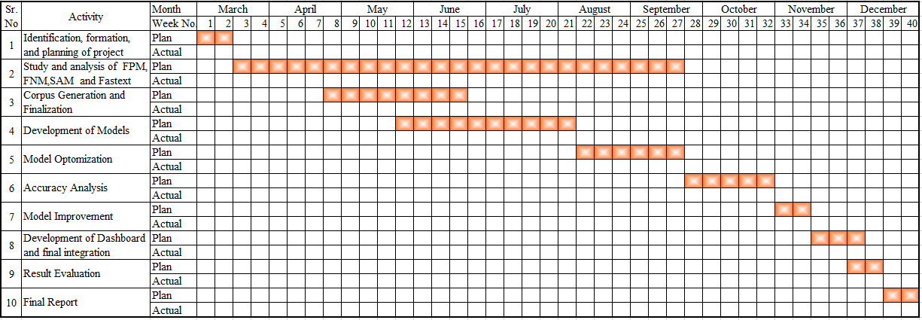

## 3.4 TOOLS AND TECHNOLOGIES USED

The Software Tools used by this system are:

1. Python
2. OpenCV [Open-Source Python library for CV]
3. PyTorch
4. U2 Net
5. Tensor Flow
6. Scikit image

### • Machine Learning (Using body Recognition-Python module)

Machine learning is ability of a computer to learn on its itself. It’s an extension of Artificial Intelligence. It’s a field where we try to replicate a human mind itself. We provide computers “the ability to learn”.

### • Computer Vision (Using OpenCV-Python module)

This provides computers the “ability to see”. It uses mathematical operations on visualimages to break down, store and learn from them and finally operate on them. This enables us to process high level images and videos.

### • PyTorch and TensorFlow

PyTorch is an open-source deep learning framework built to be flexible and modular for research, with the stability and support needed for production deployment.

TensorFlow provide useful abstractions to reduce amounts of boilerplate code and speed up model development. It can train and run deep neural networks for handwritten digit classification, image recognition, word embeddings, recurrent neural networks, sequence-to-sequence models for machine translation, natural language processing,

### • U2 Net

U2-Net is a two-level nested U-structure architecture that is designed for salient object detection (SOD). Th architecture allows the network to go deeper, attain high resolution, without significantly increasing the memory and computation cost.

### • Scikit Image

Scikit image is an open-source image processing library for the Python programming language. It includes algorithms for segmentation, geometric transformations, colour space manipulation, analysis, filtering, morphology, feature detection.

# CHAPTER 4: DESIGN SPECIFICATIONS

## *Table 7: Brief description of need and basic content of UML diagrams*

|  |  |  |
| --- | --- | --- |
| **S.**  **No** | **Diagram Name** | **Description** |
| 1 | **BLOCK DIAGRAM** | Block diagrams show a high-level view of the product under development and their interaction with different components including the sensors, actuators and servers. |
| 2 | **SEQUENCE** **DIAGRAM** | A sequence diagram simply depicts interaction between objects in a sequential order i.e., the order in which these interactions take place. We can also use the terms event diagrams or event scenarios to refer to a sequence diagram. |
| 3 | **USE CASE** **DIAGRAM** | A use case diagram at its simplest is a representation of a user’s interaction with the system that shows the relationship between the user and the different use cases in which the user is involved. Note: - The logout/login use case use same as normal/master mode. |
| 4 | **ACTIVITY** **DIAGRAM** | Activity diagrams are graphical representations of workflows of stepwise activities and actions with support for choice, iteration and concurrency. |
| 5 | **DATA FLOW** **DIAGRAM** | A data-flow diagram (DFD) is a way of representing a flow of a data of a process or a system (usually an information system). |
| 6 | **ENTITY**  **RELATIONSHIP**  **DIAGRAM** | Entity Relationship (ER) model is a high-level conceptual data model diagram. ER modelling helps you to analyse data requirements systematically to produce a well-designed database. The Entity-Relation model represents real-world entities and the relationship |

|  |  |  |
| --- | --- | --- |
|  |  | between them. It is considered a best practice to complete ER modelling before implementing your database. |
| 7 | **COLLABORATION DIAGRAM** | Collaboration diagrams (known as Communication Diagram in UML 2.x) are used to show how objects interact to perform the behaviour of a particular use case, or a part of a use case. Along with sequence diagrams, collaboration is used by designers to define and clarify the roles of the objects that perform a particular flow of events of a use case. They are the primary source of information used to determining class responsibilities and interfaces. |
| 8 | **GANTT CHART DIAGRAM** | A Gantt chart is a type of bar chart that illustrates a project schedule, named after its inventor, Henry Gantt, who designed such a chart around the years 1910–1915. Modern Gantt charts also show the dependency relationships between activities and current schedule status |
| 9 | **CLASS DIAGRAM** | Class diagram describes the attributes and operations of a class and also the constraints imposed on the system. The class diagrams are widely used in the modelling of object-oriented systems because they are the only UML diagrams, which can be mapped directly with object oriented languages. |
| 10 | **STATE DIAGRAM** | State Diagram is a diagram that depicts the different states the project has and their transitions on receiving particular inputs. It is a model that depicts the functionality of the system. |
| 11 | **COMPONENT DIAGRAM** | Component Diagram is a pictorial representation of various components that the product has and it also highlights the various dependencies between the components. |
| 12 | **INTERFACE DIAGRAM** | Interface Diagram is an important design document diagram that highlights how the various components function through the interfaces that are designed at a higher level and also how various actors can use the interfaces to perform certain functionality through the system. |

## 4.1 SYSTEM ARCHITECTURE

The following diagrams depicts the system architecture in a visual manner.

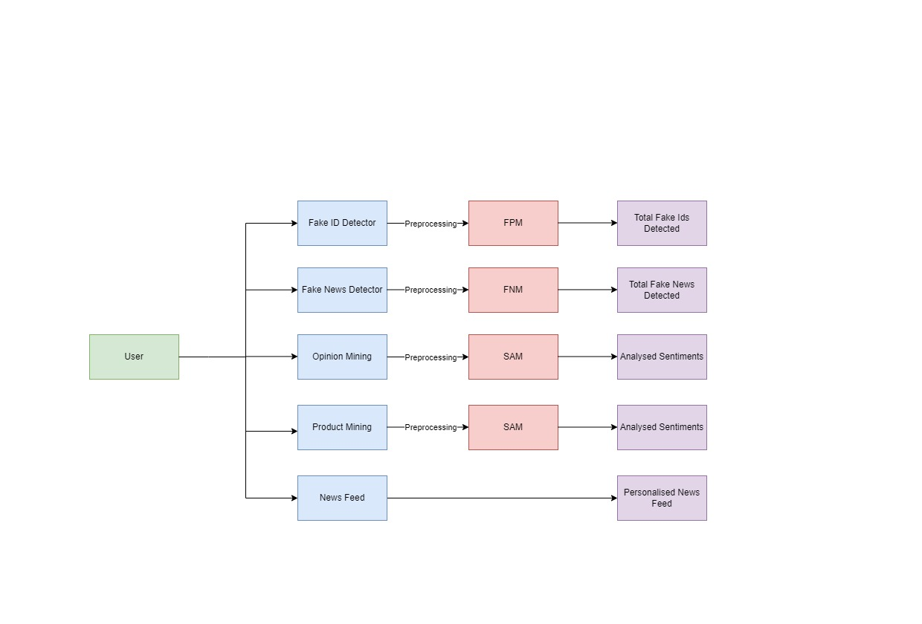

***Figure 6****: This figure shows the overall processes of the product/solution*

The system asks the **USER** to log in, User here has several features to access. The User can change the password in case he forgets it. After logging into the website, the user has the option of selecting a feature from the following: Fake ID Detection, Fake News Identification, Opinion Mining, Product Mining, and Personalised News Feed.

According to the option selected by the user, the system then follows a flow of events required for running the selected option.

**In the case of Fake ID Detection,** the data is firstly pre-processed, then it is passed through a Fake profile model which in return gives the user the analysis of the Total Fake Ids Detected.

**In the case of Fake News Detection,** the data is firstly pre-processed, then it is passed through a Fake News model which in return gives the user the analysis of Total Fake News Detected.

**Similarly, in the case of Opinion Mining and Product Mining**, the data is firstly preprocessed, then it is passed through a Sentiment Analysis model which in return gives the user the analysed sentiments.

**Personalized News Feed** is one of the features that the User has access to, this feature allows

the user to get a news feed that is personalized according to the Users choices.

**PENDING(ekarth)**

***Figure 7****: This figure shows the state chart diagram of the product/solution*

## 4.2 DESIGN LEVEL DIAGRAMS

A *sequence diagram* shows object interactions arranged in time sequence. It depicts the objects and classes involved in the scenario and the sequence of messages exchanged between the objects needed to carry out the functionality of the scenario. Sequence diagrams are typically associated with use case realizations in the Logical View of the system under development. Sequence diagrams are sometimes called event diagrams or event scenarios.

**Purpose of Interaction Diagrams:**

The purpose of interaction diagrams is to visualize the interactive behaviour of the system. Visualizing the interaction is a difficult task. Hence, the solution is to use different types of models to capture the different aspects of the interaction.

Sequence and collaboration diagrams are used to capture the dynamic nature but from a different angle.

The purpose of interaction diagram is:

* To capture the dynamic behaviour of a system.
* To describe the message flow in the system.
* To describe the structural organization of the objects.
* To describe the interaction among objects.

Interaction diagrams can be used −

* To model the flow of control by time sequence.
* To model the flow of control by structural organizations.
* For forward engineering.
* For reverse engineering.

The description (Table 6) of other diagrams mentioned in this section and next section that include ER diagram, Activity Diagram, etc. have been given at the starting of this chapter.

**PENDING(ekarth)**

***Figure 8****: This figure shows the sequence diagram for the product/solution*

**PENDING(tanish)**

***Figure 9****: This figure shows the ER Diagram for the product/product*

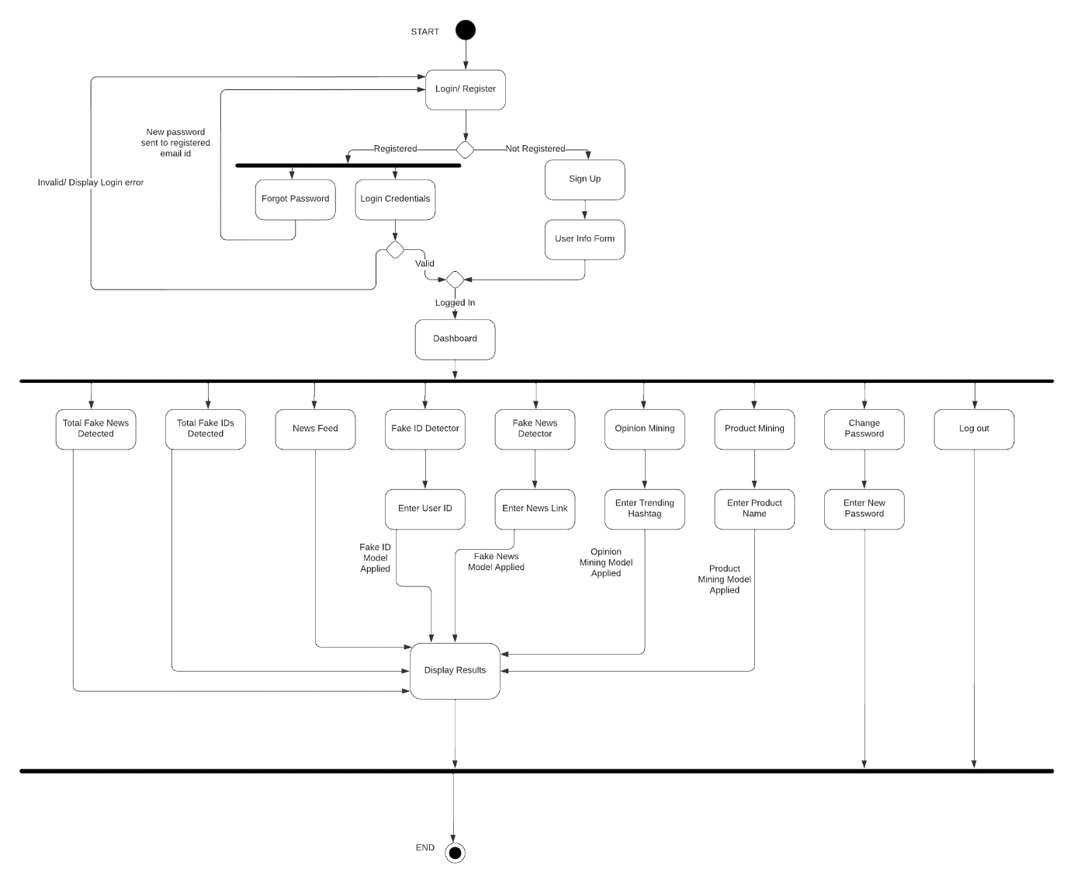

### *Figure 10: This figure shows the activity diagram for the product/solution*

## 4.3 USER INTERFACE DIAGRAMS

The following fig. describe how the user would interact with the system i.e., via LCD module, Sensor Unit and the Android Application. The DFD describes the flow of data when the user triggers a request to get access and what all processes come in its flow. Use Case Diagram and Use case template (Table 7) describes what all options the user has to interact with the system along with the action and pre and post conditions.

**PENDING(ekarth)**

***Figure 11****: This figure shows the data flow diagram (context diagram) for the solution/product*

**PENDING(ekarth)**

*Figure 12****: This figure shows the data flow diagram (DFD-1) for the solution/product***

**PENDING(ekarth)**

### *Figure 13: This figure shows the data flow diagram (DFD-2) for the solution/product*