Minmax and Tic-Tac-Toe:

The Minimax algorithm is basically a recursive algorithm which determines the optimal move to make. In a two-player game like tic-tac-toe where the players play alternatingly in turns the minimax algorithm determines the optimal move by minimising the maximum loss for the given player. Tic-Tac-Toe can be visualised using a game tree where the nodes of the tree are the state of the board and the children of a given node are the new board states obtained by picking various moves as illustrated in the figure. As the depth of the tree increases the one who plays keeps alternating. Minmax can be decomposed into two functions, a MAX function and a MIN function. The MAX function picks the best move for one symbol amongst its various children while the MIN function picks the best move for the other symbol amongst its various children. Thus at a given board state the best branches to take can be determined and thus the optimal move is picked.

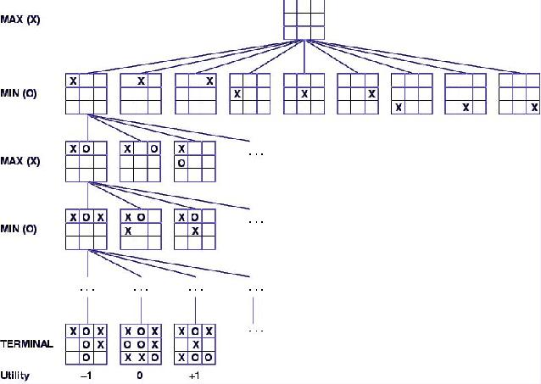

SOURCE: http://www.owlnet.rice.edu/~comp210/02fall/Labs/Lab15/