Shikhar Bahal

St10461875

Part 1

Group 1

Essay of 300 words 3

Wire Frame 4

Reference 7

# Essay of 300 words

A global non-profit organization called Worldwide Animal Protection (WAP) is committed to enhancing animal welfare all around the world. The organization strives to improve the living conditions of farm animals by supporting humane and sustainable agricultural methods. It also campaigns against inhumane entertainment activities, such as the use of wild animals in circuses, marine parks, and roadside zoos. By offering veterinarian treatment, immunizations, and information on appropriate pet management, WAP also assists communities in providing better care for their animals, particularly pets and street animals. They also support the preservation of wild animals in their native habitats, fight to put an end to the illegal wildlife trade, and aid in the rescue and relief of animals afflicted by natural calamities. WAP works with countries and international organizations to change worldwide policy and enact and uphold laws that safeguard animal welfare. The overarching objective of Worldwide Animal Protection is to establish a world free from animal exploitation and suffering by fostering animal welfare and guaranteeing animal protection via direct action, education, and advocacy.

Those who join Worldwide Animal Protection have the opportunity to significantly improve animal welfare on a worldwide level. By joining this organization, individuals can help put an end to inhumane entertainment practices, enhance farm animal welfare, and save wildlife from exploitation and illegal trade. WAP offers you to take part in practical rescue and relief operations during natural disasters, engage in meaningful advocacy, and support communities in providing veterinarian care and education for their pets and street animals. Members can also have an impact on and contribute to the creation of policies that guarantee the long-term preservation of animals by working with governments and international organizations. By joining WAP, you can truly impact the lives of countless animals by being a part of a committed team that works towards a world free from animal exploitation and suffering.

# Wire Frame

Home Page

About

Service

Gallery

Contact us

# Assets

Home Page



• Wortman, R. and Wortman, R., 2023. World Wildlife Day 2023! | Global Conservation Corps. [online] Global Conservation Corps. Available at: <https://globalconservationcorps.org/world-wildlife-day-2023/> [Accessed 5 Aug. 2024].

About

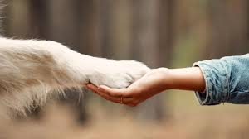

• Shutterstock, 2024. Hand Holding Paw Photos and Images | Shutterstock. [online] Available at: <https://www.shutterstock.com/search/hand-holding-paw> [Accessed 5 Aug. 2024].

**Gallery**

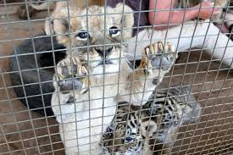

• Bloodlions.org, 2021. Youth For Lions Blog: A visit to the zoo or a captive wildlife facility – education or edutainment? – Blood Lions. [online] Available at: <https://bloodlions.org/youth-for-lions-blog-a-visit-to-the-zoo-or-a-captive-wildlife-facility-education-or-edutainment/> [Accessed 5 Aug. 2024].

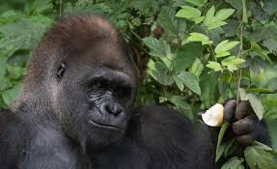

• World Animal Protection, 2024. World Animal Protection. [online] Available at: <https://www.worldanimalprotection.or.ke/our-campaigns/wildlife/commercial-exploitation/sign-the-petition-urging-your-government-to-stop-commercial-exploitation-of-wildlife/> [Accessed 5 Aug. 2024].

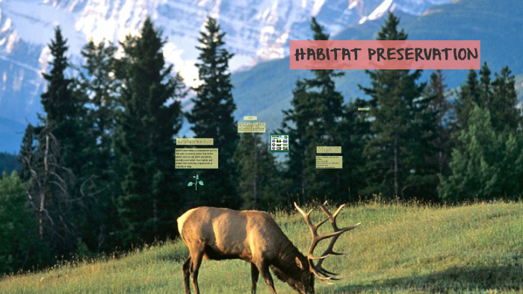

• World Animal Protection, 2015. How World Animal Protection supports animal sanctuaries. [online] Available at: <https://www.worldanimalprotection.org/our-campaigns/wildlife/innovative-solutions/sanctuaries/> [Accessed 5 Aug. 2024].

• Facebook.com, 2023. Facebook. [online] Available at: <https://www.facebook.com/photo/?fbid=112509917544845&set=a.112510017544835> [Accessed 5 Aug. 2024].

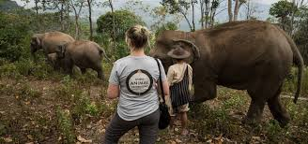

• Animal Legal Defense Fund, 2019. Cities Are Fighting Back Against Puppy Mills – But Some States Won’t Let Them. [online] Available at: <https://aldf.org/article/cities-fighting-back-puppy-mills-states-wont-let/> [Accessed 5 Aug. 2024].

# Website Content and Pages

Home

Logo

Navigation

Slogan

Picture of world wildlife day

Text about the worldwide animal protection NGO

Navigation

About

Logo

Navigation

Heartwarming picture

Our work information

Picture of the founder of worldwide animal protection

Information about the founder and some history

Navigation

Service

Logo

Navigation

Our mission information

List of Services offered

Gallery

Logo

Navigation

Nine pictures in a 3x6 table

Contact us

Logo

Navigation

We’re here to help information

Contact us information

Gps location

Navigation

# Reference

• Animal Legal Defense Fund, 2019. Cities Are Fighting Back Against Puppy Mills – But Some States Won’t Let Them. [online] Available at: <https://aldf.org/article/cities-fighting-back-puppy-mills-states-wont-let/> [Accessed 5 Aug. 2024].

• Bloodlions.org, 2021. Youth For Lions Blog: A visit to the zoo or a captive wildlife facility – education or edutainment? – Blood Lions. [online] Available at: <https://bloodlions.org/youth-for-lions-blog-a-visit-to-the-zoo-or-a-captive-wildlife-facility-education-or-edutainment/> [Accessed 5 Aug. 2024].

• Facebook.com, 2023. Facebook. [online] Available at: <https://www.facebook.com/photo/?fbid=112509917544845&set=a.112510017544835> [Accessed 5 Aug. 2024].

• FreeMe Wildlife, 2024. About Wildlife Rehabilitation. [online] Available at: <https://freemewildlife.org/about/> [Accessed 5 Aug. 2024].

• prezi.com, 2018. HABITAT PRESERVATION. [online] Available at: <https://prezi.com/df6zqeuknhnw/habitat-preservation/> [Accessed 5 Aug. 2024].

• Shutterstock, 2024. Hand Holding Paw Photos and Images | Shutterstock. [online] Available at: <https://www.shutterstock.com/search/hand-holding-paw> [Accessed 5 Aug. 2024].

• Valley, U. (2019). Umgeni Valley Nature Reserve · PO Box 394, Howick, 3290. [online] Umgeni Valley Nature Reserve · PO Box 394, Howick, 3290. Available at: <https://www.google.com/maps/place/Umgeni+Valley+Nature+Reserve/@-29.371992,30.331897,13z/data=!4m6!3m5!1s0x1ef6a93c9cc84957:0x39f91be4fd7cdbe5!8m2!3d-29.4756086!4d30.2393713!16s%2Fg%2F1thh4v5t?hl=en&entry=ttu> [Accessed 11 Aug. 2024].

• Wild Unlimited, 2024. Safeguarding Biodiversity: Strategies for Protecting Endangered Species. [online] Wild Unlimited. Available at: <https://wildunlimited.com/blogs/news/protecting-species> [Accessed 5 Aug. 2024].

• World Animal Protection, 2015. How World Animal Protection supports animal sanctuaries. [online] Available at: <https://www.worldanimalprotection.org/our-campaigns/wildlife/innovative-solutions/sanctuaries/> [Accessed 5 Aug. 2024].

• World Animal Protection, 2024. World Animal Protection. [online] Available at: <https://www.worldanimalprotection.or.ke/our-campaigns/wildlife/commercial-exploitation/sign-the-petition-urging-your-government-to-stop-commercial-exploitation-of-wildlife/> [Accessed 5 Aug. 2024].

• Wortman, R. and Wortman, R., 2023. World Wildlife Day 2023! | Global Conservation Corps. [online] Global Conservation Corps. Available at: <https://globalconservationcorps.org/world-wildlife-day-2023/> [Accessed 5 Aug. 2024].

‌

‌

‌

‌

‌

‌

‌