<https://www.dbdesigner.net/designer/schema/new>

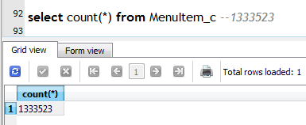

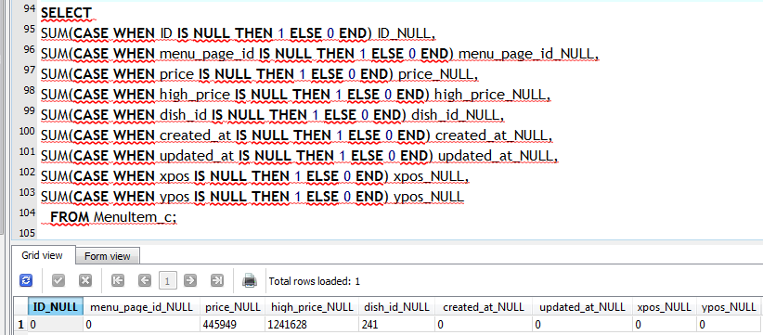

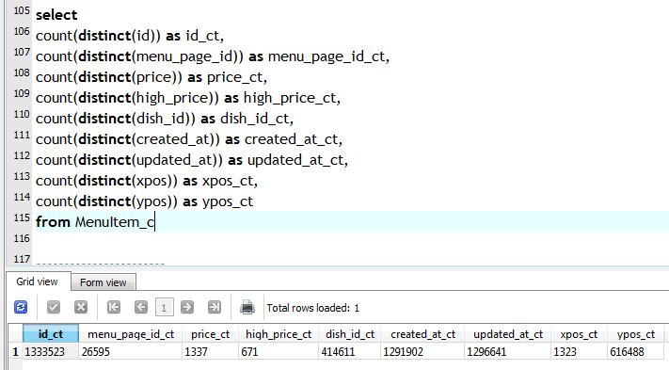

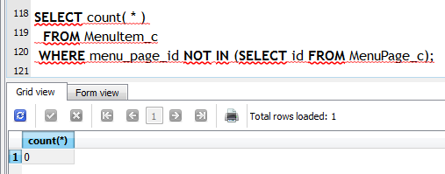

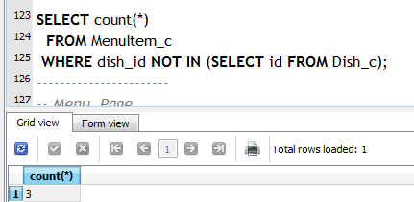

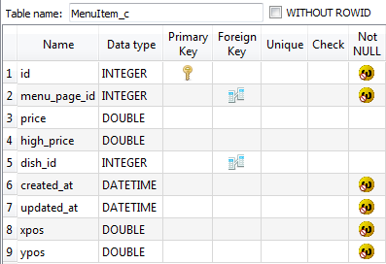

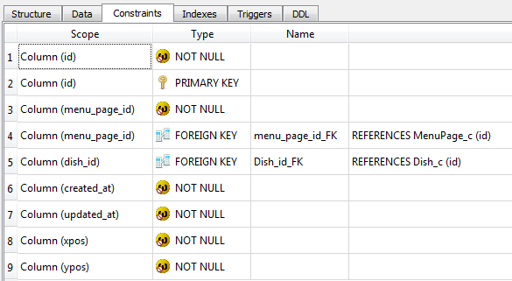

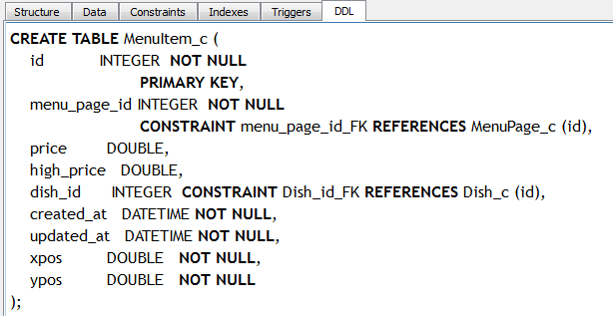

CREATE TABLE MenuItem_c (

id INTEGER NOT NULL

PRIMARY KEY,

menu_page_id INTEGER NOT NULL

CONSTRAINT menu_page_id_FK REFERENCES MenuPage_c (id),

price DOUBLE,

high_price DOUBLE,

dish_id INTEGER CONSTRAINT Dish_id_FK REFERENCES Dish_c (id),

created_at DATETIME NOT NULL,

updated_at DATETIME NOT NULL,

xpos DOUBLE NOT NULL,

ypos DOUBLE NOT NULL

);

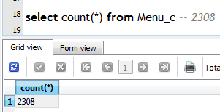

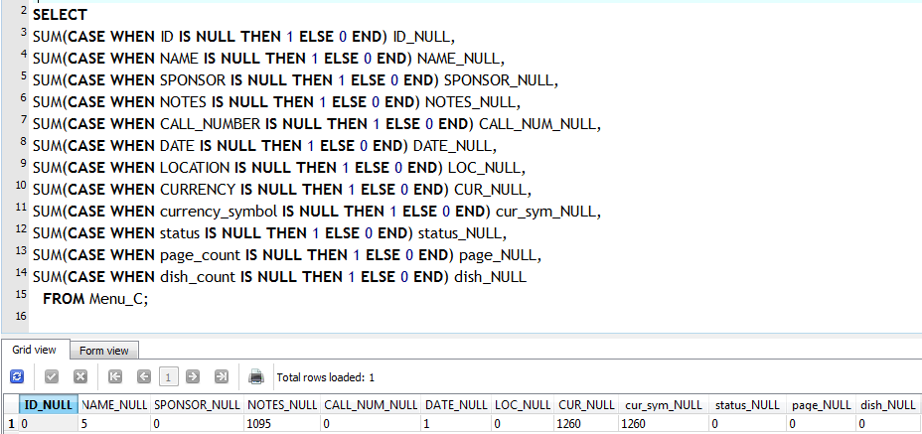

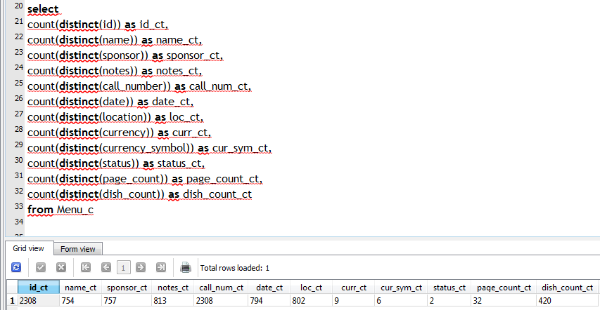

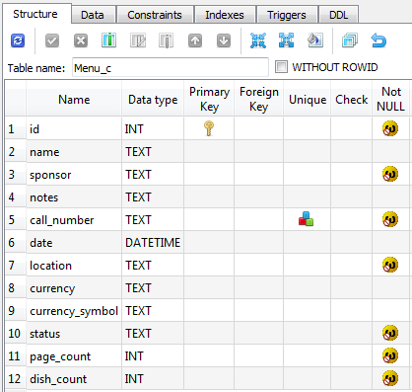

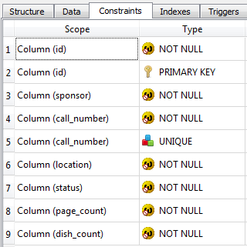

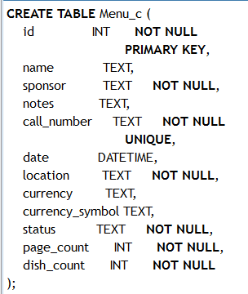

CREATE TABLE Menu_c (

id INT NOT NULL

PRIMARY KEY,

name TEXT,

sponsor TEXT NOT NULL,

notes TEXT,

call_number TEXT NOT NULL

UNIQUE,

date DATETIME,

location TEXT NOT NULL,

currency TEXT,

currency_symbol TEXT,

status TEXT NOT NULL,

page_count INT NOT NULL,

dish_count INT NOT NULL

);

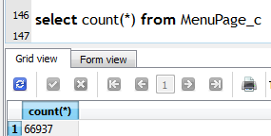

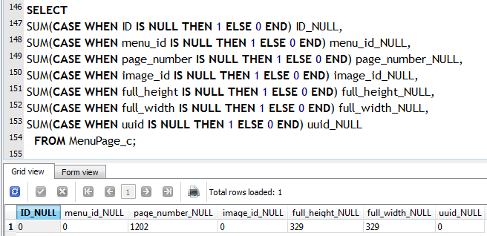

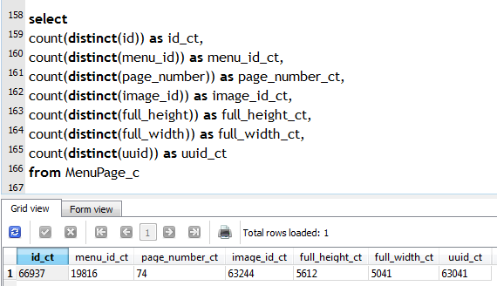

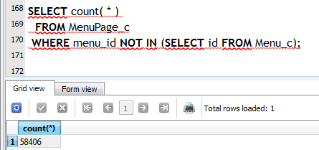

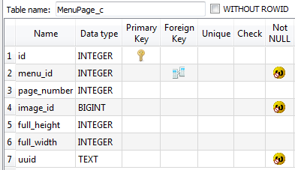

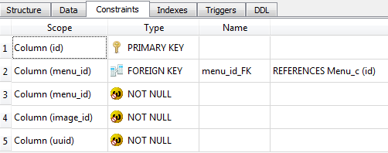

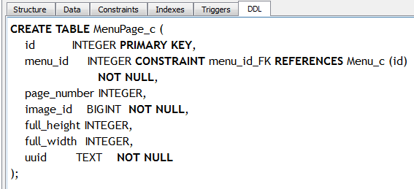

CREATE TABLE MenuPage_c (

id INTEGER PRIMARY KEY,

menu_id INTEGER CONSTRAINT menu_id_FK REFERENCES Menu_c (id)

NOT NULL,

page_number INTEGER,

image_id BIGINT NOT NULL,

full_height INTEGER,

full_width INTEGER,

uuid TEXT NOT NULL

);

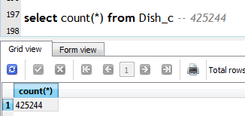

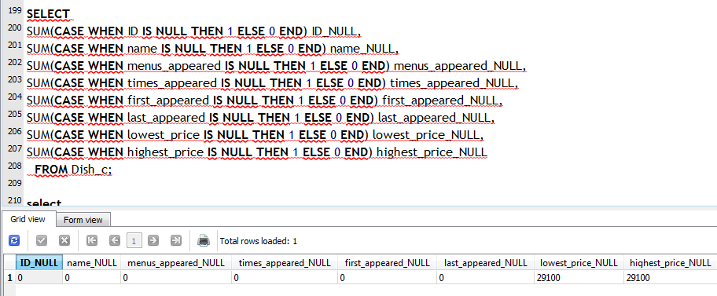

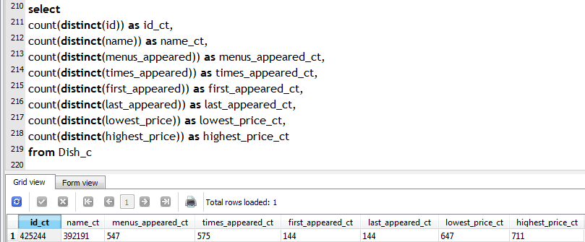

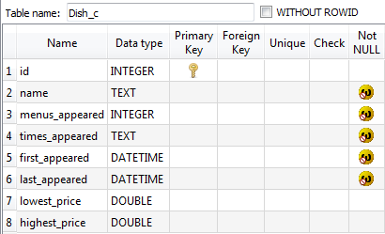

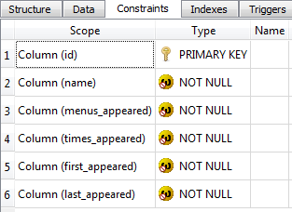

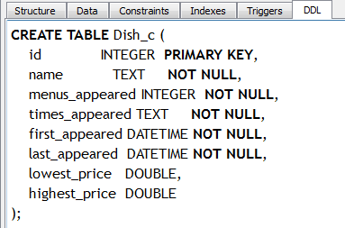

CREATE TABLE Dish_c (

id INTEGER PRIMARY KEY,

name TEXT NOT NULL,

menus_appeared INTEGER NOT NULL,

times_appeared TEXT NOT NULL,

first_appeared DATETIME NOT NULL,

last_appeared DATETIME NOT NULL,

lowest_price DOUBLE,

highest_price DOUBLE

);