Table 1-

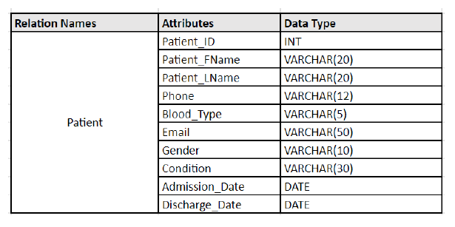

CREATE TABLE Patient (   
 Patient_ID INT NOT NULL,   
 Patient_FName VARCHAR(20) NOT NULL,  
 Patient_LName VARCHAR(20) NOT NULL,   
 Phone VARCHAR(12) NOT NULL,  
 Blood_Type VARCHAR(5) NOT NULL,   
 Email VARCHAR(50),   
 Gender VARCHAR(10),  
 Condition_ VARCHAR(30),  
 Admission_Date DATE,  
 Discharge_Date DATE,   
 PRIMARY KEY (Patient_ID)  
);

Table 2-

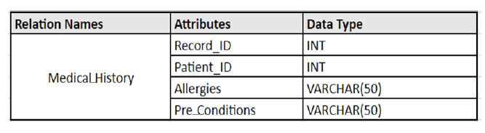

CREATE TABLE Medical History (   
 Record_ID INT NOT NULL,   
 Patient_ID INT NOT NULL,  
 Allergies VARCHAR(50),   
 Pre_Conditions VARCHAR(50),   
 PRIMARY KEY (Record_ID),   
 FOREIGN KEY (Patient_ID) REFERENCES Patient (Patient_ID)  
);

Table 3-

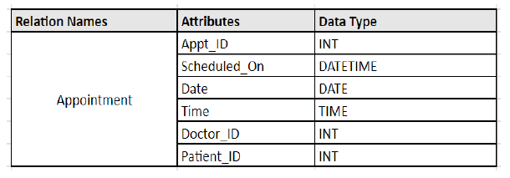

CREATE TABLE Appointment (   
 Appt_ID INT NOT NULL,   
 Scheduled_On DATETIME NOT NULL,  
 Date_ DATE,  
 Time_ TIME,  
 Doctor_ID INT NOT NULL,   
 Patient_ID INT NOT NULL,   
 PRIMARY KEY (Appt_ID),   
 FOREIGN KEY (Doctor_ID) REFERENCES Doctor (Doctor_ID),   
 FOREIGN KEY (Patient_ID) REFERENCES Patient (Patient_ID)   
);

Table 4-

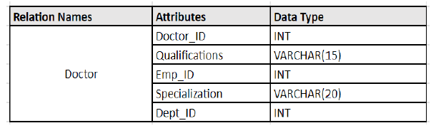

CREATE TABLE Doctor (   
 Doctor_ID INT NOT NULL,   
 Qualifications VARCHAR(15) NOT NULL,  
 Emp_ID INT NOT NULL,   
 Specialization VARCHAR(20) NOT NULL,   
 Dept_ID INT NOT NULL,   
 PRIMARY KEY (Doctor_ID),   
 FOREIGN KEY (Emp_ID) REFERENCES Staff (Emp_ID),   
 FOREIGN KEY (Dept_ID) REFERENCES Department (Dept_ID)   
);

Table 5-

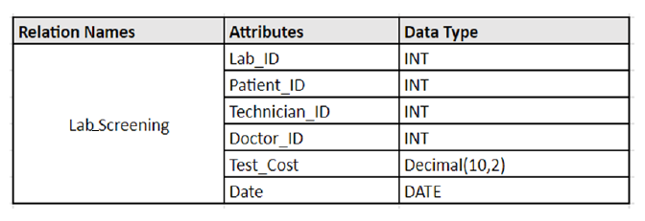

CREATE TABLE Lab_Screening (   
 Lab_ID INT NOT NULL,   
 Patient_ID INT NOT NULL,  
 Technician_ID INT NOT NULL,   
 Doctor_ID INT NOT NULL,   
 Test_Cost DECIMAL(10,2),  
 Date_ DATE NOT NULL,   
 PRIMARY KEY (Lab_ID),   
 FOREIGN KEY (Patient_ID) REFERENCES Patient (Patient_ID),   
 FOREIGN KEY (Technician_ID) REFERENCES Patient (Patient_ID),   
 FOREIGN KEY (Doctor_ID) REFERENCES Doctor (Doctor_ID)  
);

Table 6-

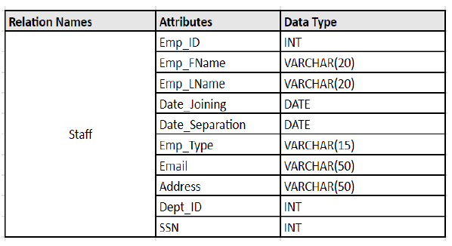

CREATE TABLE Staff (   
 Emp_ID INT NOT NULL,   
 Emp_FName VARCHAR(20) NOT NULL,   
 Emp_LName VARCHAR(20) NOT NULL,  
 Date_Joining DATE,   
 Date_Seperation DATE,   
 Emp_Type VARCHAR(15) NOT NULL,   
 Email VARCHAR(50),   
 Address VARCHAR(50) NOT NULL,  
 Dept_ID INT NOT NULL,  
 SSN INT NOT NULL,   
 PRIMARY KEY (Emp_ID),   
 FOREIGN KEY (Dept_ID) REFERENCES Department (Dept_ID)   
);

Table 7-

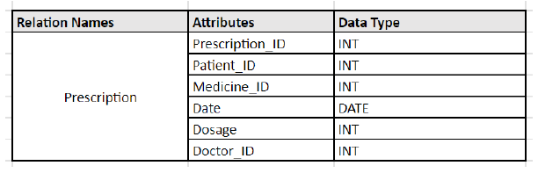

CREATE TABLE Prescription (   
 Prescription_ID INT NOT NULL,   
 Patient_ID INT NOT NULL,  
 Medicine_ID INT NOT NULL,   
 Date_ DATE,   
 Dosage INT,   
 Doctor_ID INT NOT NULL,   
 PRIMARY KEY (Prescription_ID),   
 FOREIGN KEY (Patient_ID) REFERENCES Patient (Patient_ID),  
 FOREIGN KEY (Doctor_ID) REFERENCES Doctor (Doctor_ID),   
 FOREIGN KEY (Medicine_ID) REFERENCES Medicine (Medicine_ID)  
);

Table 8-

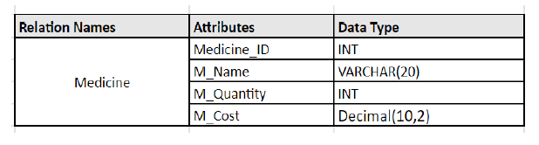

CREATE TABLE Medical History (   
 Record_ID INT NOT NULL,   
 Patient_ID INT NOT NULL,  
 Allergies VARCHAR(50),   
 Pre_Conditions VARCHAR(50),   
 PRIMARY KEY (Record_ID),   
 FOREIGN KEY (Patient_ID) REFERENCES Patient (Patient_ID)  
);

Table 9-

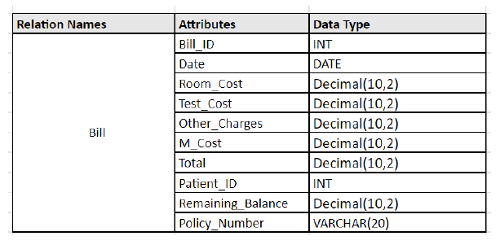

CREATE TABLE Bill (   
 Bill_ID INT NOT NULL,   
 Date_ DATE NOT NULL,   
 Room_Cost Decimal(10,2),   
 Test_Cost DECIMAL(10,2),   
 Other_Charges DECIMAL(10,2),   
 M_Cost DECIMAL(10,2),   
 Total DECIMAL(10,2),   
 Patient_ID INT NOT NULL,   
 Remaining_Balance DECIMAL(10,2),   
 Policy_Number VARCHAR(20) NOT NULL,  
 PRIMARY KEY (Payment_ID),   
 FOREIGN KEY (Room_Cost) REFERENCES Room (Room_Cost),  
 FOREIGN KEY (Test_Cost) REFERENCES Lab_Screening (Test_Cost),   
 FOREIGN KEY (M_Cost) REFERENCES Medicine (M_Cost),   
 FOREIGN KEY (Patient_ID) REFERENCES Patient (Patient_ID),   
 FOREIGN KEY (Policy_Number) REFERENCES Insurance (Policy_Number)   
);