INDEPENDENT UX REVIEW · FIRST-TIME USER ONBOARDING
Wise India Onboarding Review
Can an India-based first-time visitor tell whether they can use Wise, and what it will cost?
BOTTOM LINE
The transfer calculator is easy to find and easy to read: in this walkthrough the cost and an arrival estimate were both reached within a few clicks.
The journey does not resolve whether an India-based visitor is eligible. Selecting “Personal” and “India” during signup returned the form to its previous screen with no message, and the likely explanation was only found through an external search - not through Wise.

TOP THREE OPPORTUNITIES
1 | Replace the silent signup reset with an explicit explanation | F1 · High
2 | Surface country eligibility before signup begins | F2 · High
3 | Add a reference rate and an explicit time zone to the calculator | F3, F4 · Medium

Method | One expert cognitive walkthrough (single evaluator, no participants), desktop Chrome, six decision points, 16 screenshots.
Scenario | First-time visitor resident in India, no existing account, using only public pages.
Evaluator / date | Shikhar Shukla · 16 September 2026
Status | Independent review, not commissioned by or affiliated with Wise. No account was created and no financial data was entered.

HOW TO READ THIS DOCUMENT
Sections 1–4 are the report: summary, findings, recommendations, and the proposed validation step - roughly four pages.
Appendices A and B hold the full method and the step-by-step walkthrough log with all screenshot evidence, for anyone who wants to audit the reasoning.

Contents
If this list appears blank, right-click it and choose “Update Field” to generate page numbers.
Contents 2
1. Executive summary 3
Priority findings 3
What worked well 3
Walkthrough at a glance 4
Limitations of this review 4
2. Findings 5
2A. Journey A - Can I use Wise, and what will it cost? 5
2B. Journey B - Can I actually open an account? 6
3. Recommendations 8
4. What I would validate with real users 9
Hypotheses 9
A. Appendix A - Method, scope, and evaluation assumptions 11
A1. User goal 11
A2. Task scenario 11
A3. Scope and safety 11
A4. Expected path 11
A5. Success criteria 11
A6. The four cognitive-walkthrough questions 12
B. Appendix B - Step-by-step walkthrough log 13

1. Executive summary
Acting as a first-time visitor resident in India, the evaluator set out to answer four questions from Wise's public website: what a transfer costs, how long it takes, whether they are eligible, and how to open an account. Two of the four resolved cleanly. The homepage states the service purpose in plain language, and the pricing calculator gives a transfer cost and an arrival estimate in a form that needed no interpretation.
The other two did not. India-specific eligibility information was not located through the send-money page, the FAQ, or a Help Centre search using the terms tested. The signup flow then failed silently: selecting “Personal” as account type and “India” as residence country returned the form to the “Welcome to Wise” screen without an error, a warning, or an explanation. An external search suggested that Wise does not currently issue personal accounts to residents of India; if that is correct, the restriction is being enforced by the system but never communicated by the interface.
The priority opportunity is therefore not a visual or copy refinement. It is that a decision the product has already made - who is eligible - is invisible to the person it affects, at the exact moment they are trying to act on it.
WHAT'S CONFIRMED vs. WHAT NEEDS VERIFICATION
Confirmed, directly observed: the signup form silently returns to the start screen for the Personal + India combination, with zero error message - this is a screenshotted fact (Figures 14–16), not an inference.
Not yet confirmed: the specific reason - that Wise does not currently issue personal accounts to Indian residents - came from an external search, not from Wise. Recommendation 1 depends on this being correct; confirm it with Wise's product or compliance team before shipping copy that names this reason. If unconfirmed, use generic decline wording instead.

Priority findings
ID | Finding | User impact | Product risk | Sev. | Recommended action
F1 | Personal + India signup loops silently | Visitor cannot tell whether signup failed, was rejected, or is possible at all | Abandonment at the highest-intent moment; behaviour reads as a bug | High | Show an explicit restriction message at the point of selection
F2 | India eligibility not discoverable pre-signup | Visitor must leave the site to find an answer | Support load and lost conversion from ineligible and eligible users alike | High | Display country-aware eligibility on pricing and send-money pages
F3 | Arrival estimate carries no time zone | “By Thursday 3:00 AM” may be read as IST or recipient-local time | Expectation mismatch and avoidable “where is my money” contacts | Medium | Label the arrival estimate with an explicit time zone
F4 | No reference rate shown beside Wise's rate | Visitor opened other sites to judge whether the rate was competitive | Comparison happens on a competitor's page, not on Wise's | Medium | Show the mid-market rate alongside the quoted rate
F5 | “Estimated amount per month” is ambiguous | Unclear whether recurring monthly sending is implied | Minor confusion in the fee-comparison module | Low | Add one line of clarifying microcopy
F6 | Pricing reachable only via hover sub-menu | Three nav items had to be hovered before fees were found | Minor added discovery effort; goal was still reached | Low | Add a visible top-level pricing entry

What worked well
- The homepage hero was the most prominent element above the fold and communicated the service purpose without requiring interpretation.
- The calculator's “you send exactly” and “recipient gets” pattern mapped directly onto the question the evaluator was holding.
- Total fees and an arrival estimate were both shown on the same card as the converted amount, rather than being deferred to a later step.

Walkthrough at a glance
Step | Outcome | Main issue | Severity
1. Homepage | Succeeded | None significant | -
2. Navigation to fees | Succeeded with effort | Fees sit behind a hover sub-menu | Low
3. Transfer calculator | Partially succeeded | No reference rate; arrival estimate has no time zone | Medium
4. Fee breakdown | Partially succeeded | “Per month” framing not understood | Low
5. Eligibility search | Failed | India eligibility not found across three surfaces | High
6. Account creation | Failed | Personal + India returns the form with no message | High

Limitations of this review
Stated up front so the findings are read at the weight the method supports.
- This is an expert evaluation of one scenario by a single evaluator - not a usability study with participants, and not evidence of how often these issues occur.
- One context only: desktop Chrome, one country, one currency corridor, one session.
- No analytics, conversion data, support-ticket volume, or internal business context was available.
- The eligibility explanation came from an external search and has not been confirmed against Wise's official policy or regulatory position. It should be verified before being treated as established fact.
- The rate comparison figures were captured at different moments on different sites and are not a controlled, time-matched comparison.
- Findings should be treated as hypotheses to validate, not as measured usability rates.

2. Findings
The journey splits into two questions with different answers. Section 2A covers discovery and cost, which largely succeeded. Section 2B covers account creation, which did not.

2A. Journey A - Can I use Wise, and what will it cost?
Cost discovery worked. Fees sat behind a hover sub-menu rather than a top-level link, which added effort but did not block the task (F6). The calculator itself was the strongest part of the journey: entering ₹800,000 for an INR→USD transfer returned a recipient amount of 8,210.01 USD, total fees of ₹12,098.81, and an arrival estimate, all on one card.
Two gaps remained, and both are about interpretation rather than availability. The information needed to judge the quote is not on the page - so the evaluator opened other sites to supply it.
F3 | The arrival estimate does not say which time zone it refers to |  | Medium
What happened |  | The calculator displayed “Arrives by Thursday 3:00 AM.” No time zone was stated on the card.
Evidence |  | Figure 5 (Appendix B, Step 3).
Why it matters |  | For a cross-border transfer the ambiguity is inherent: 3:00 AM could reasonably be read as the sender's local time, the recipient's local time, or the reference time of the transfer network. A visitor cannot convert an estimate they cannot anchor.
Recommended action |  | Label the estimate with an explicit zone, e.g. “by Thursday, 3:00 AM IST.”

F4 | No reference rate is shown next to the quoted rate |  | Medium
What happened |  | The calculator shows what the recipient gets, but no benchmark against which to judge it. The evaluator left the site and checked Google (8,338.04 USD) and Western Union (8,304.40 USD) for the same nominal amount.
Evidence |  | Figures 5–7 (Appendix B, Step 3). These quotes were captured at different moments on different sites, with different fee structures, funding methods, and delivery speeds. They are an indicative comparison only, not a controlled pricing conclusion.
Why it matters |  | The finding is a transparency question, not a pricing one: whether or not Wise's rate is competitive, the page does not give a first-time visitor any way to tell. The comparison then happens on a competitor's site instead of on Wise's - which is a weaker position for a product whose pricing page is headlined “Wise is built to save you money.”
Recommended action |  | Show the mid-market reference rate beside the quoted rate on the calculator card, so the spread is legible without a second tab.

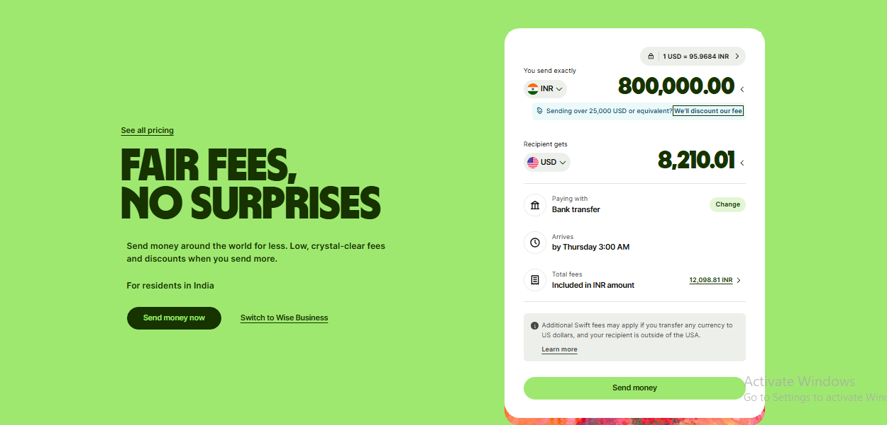
Figure A Evidence: cost and arrival appear together, but with no reference rate and no time zone (F3, F4).
F5 | “Estimated amount per month” is ambiguous for a one-off transfer |  | Low
What happened |  | Below the main calculator, a module labelled “Estimated amount per month” drives an average-fee percentage. The evaluator could not determine whether it described recurring monthly sending, a subscription-style estimate, or the same one-off transfer restated.
Evidence |  | Figure 8 (Appendix B, Step 4).
Why it matters |  | The module's purpose - showing that larger volumes attract lower fees - is lost if the visitor cannot tell what the input represents.
Recommended action |  | Add one clarifying line, e.g. “If you send this much each month, here's your average fee,” or relabel for a single transfer.

2B. Journey B - Can I actually open an account?
This is where the journey ended, and it accounts for both High-severity findings. The two issues compound: the eligibility question could not be answered in advance (F2), so the only remaining way to find out was to attempt signup - which then failed without explaining itself (F1).
F2 | India-specific eligibility could not be located anywhere in the public journey |  | High
What happened |  | The evaluator searched three surfaces in sequence: the send-money product page, its FAQ section, and the Help Centre. The FAQ carries a general INR-restrictions question but no India eligibility answer. A Help Centre search for “restriction india” returned restriction articles for Türkiye, Belarus, Russia, and Myanmar - not India. The search was abandoned unresolved.
Evidence |  | Figures 9–13 (Appendix B, Step 5). Stated precisely: eligibility information could not be located through these three surfaces using the terms tested. This does not establish that no such content exists anywhere on the site.
Why it matters |  | A visitor who cannot confirm eligibility either abandons, or proceeds to signup on the assumption that they qualify - which is what happened here, and what led directly to F1.
Recommended action |  | Display country-aware eligibility status on the pricing and send-money pages once the visitor's country is known or selected.

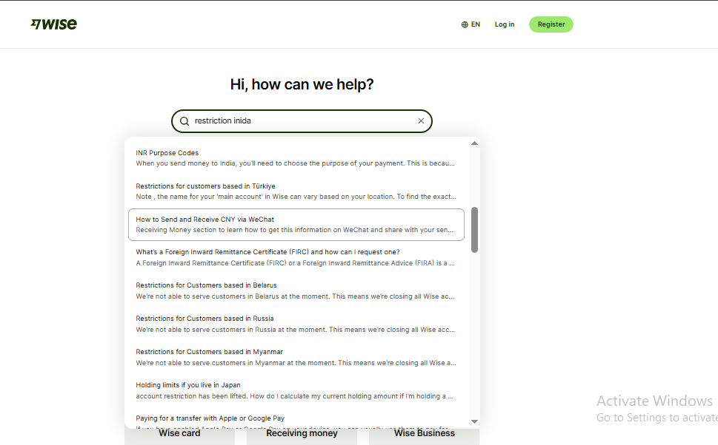
Figure B Evidence: a Help Centre search for “restriction india” returns articles for other countries (F2).
F1 | Selecting Personal + India returns the signup form to its previous screen with no message |  | High
What happened |  | On “Welcome to Wise,” the evaluator selected “Personal” as account type, then “Personal” again on the account-kind screen - and was returned to “Welcome to Wise.” Selecting “India” as residence country produced the same return. No error, warning, validation message, or explanation appeared at any point. An external search afterwards suggested the cause is that Wise does not currently issue personal accounts to residents of India; this was not stated anywhere in the flow and remains unverified against official Wise policy.
Evidence |  | Figures 14–16 (Appendix B, Step 6), plus the external search result, which is reported here as an external source rather than as a confirmed product fact.
Why it matters |  | This is the highest-intent moment in the funnel - the visitor has already decided to sign up. A silent reset is indistinguishable from a technical fault, so the most likely reading is “this site is broken,” not “I am not eligible.” The visitor then learns the restriction from a search engine rather than from Wise, which is the least favourable way for a trust-dependent financial product to communicate a constraint it is already enforcing.
Recommended action |  | Interrupt the loop with an explicit message when the blocked combination is detected - e.g. “Wise doesn't currently offer personal accounts to residents of India” - with a route to any available alternative.

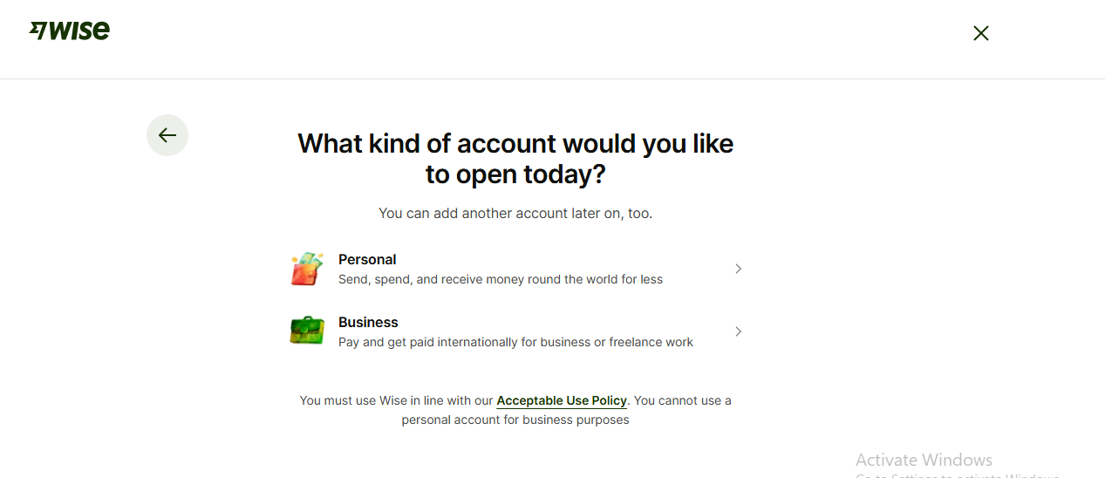
Figure C Evidence: choosing “Personal” here returns to the Welcome screen with no message shown (F1).

3. Recommendations
Three changes, ordered by priority, each tied to specific findings above.
RECOMMENDATION 1 Replace the silent signup reset with an explicit restriction message
Findings addressed: F1
When a blocked account-type and residence combination is detected, stop the loop and state the reason in place, with a route to any available alternative.
Rationale: The system already detects the condition - it is acting on it. The only thing missing is telling the person it affects. An unexplained reset converts a policy constraint into what looks like a defect.
Placement: At the moment the blocking combination is detected, immediately after country or account-type selection.
Success signal: No visitor attempts the blocked combination more than once; drop-off at this step becomes an explicit, auditable event rather than inferred abandonment.
Before shipping: confirm the specific reason with Wise's product or compliance team. It is sourced from an external search, not from Wise (see “What's confirmed”, Section 1). If unconfirmed, use generic decline wording rather than naming India specifically.

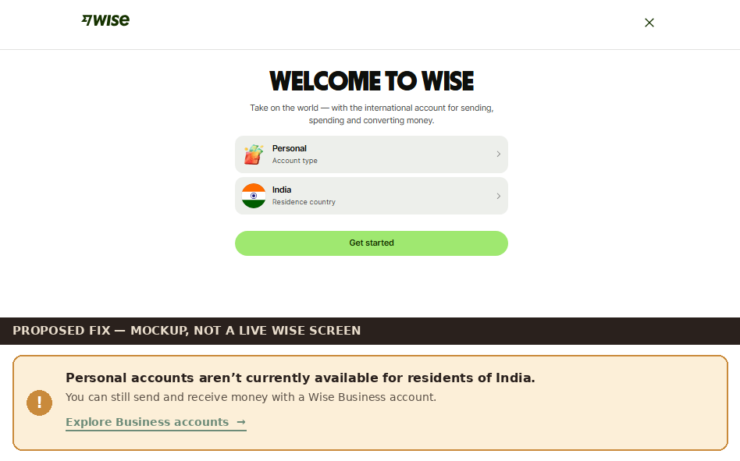
Figure D Proposed fix (mockup, not a live Wise screen): the Welcome-to-Wise screen with an inline restriction message and an alternative path. Wording is illustrative - confirm the stated reason before shipping.

RECOMMENDATION 2 Surface country eligibility before signup begins
Findings addressed: F2
Show a short, country-aware eligibility line on the pricing and send-money pages once the visitor's country is known or selected.
Rationale: The evaluator checked three separate surfaces and still could not find this. It is decided-but-hidden information, not unknown information - and showing it earlier prevents the wasted signup attempt entirely.
Placement: Directly beneath the transfer calculator, and on the send-money landing page.
Success signal: Visitors can state their eligibility status without leaving the pricing or send-money page; Help Centre searches for country restrictions fall.

RECOMMENDATION 3 Give the calculator enough context to be interpreted
Findings addressed: F3, F4
Add a mid-market reference rate beside the quoted rate, and an explicit time zone on the arrival estimate.
Rationale: Both are things the evaluator wanted and had to source elsewhere or guess at. The underlying data is already on the page - it is presented in a form that cannot be anchored.
Placement: Inside the existing calculator card, beside “Total fees” and “Arrives.”
Success signal: Visitors can judge rate competitiveness and expected local arrival time without opening another tab.

4. What I would validate with real users
A cognitive walkthrough evaluates one path through the eyes of one evaluator. The plan below is what would turn these hypotheses into evidence.
Participants | Five to eight first-time, India-based visitors who have not used Wise or a comparable transfer service, including at least one intending a large (>₹5,00,000) transfer.
Method | Moderated remote usability sessions with think-aloud, plus a short follow-up interview.
Tasks | The same scenario: find the cost and rate, find the delivery time, determine eligibility, and reach the first signup step.
Success measures | Task completion per question, time on task, number of tab-switches to external sites, self-reported confidence, and whether signup was completed or abandoned.
Evidence to collect | Screen recordings, think-aloud quotes, hesitation points and misclicks at the Personal + India step, and every moment a participant leaves the site to verify something Wise could have told them.

Hypotheses
- H1 - First-time, India-based visitors attempting a Personal account will encounter the same unexplained loop, and will attribute it to a site fault rather than to an eligibility restriction.
- H2 - Visitors will judge Wise's exchange rate by comparing it against a figure sourced outside the page, rather than from information Wise provides.
- H3 - An explicit inline eligibility message will reduce both abandonment at the signup step and Help Centre searches for country restrictions.

A. Appendix A - Method, scope, and evaluation assumptions
The scenario below was defined before the product was inspected, to reduce the risk of fitting a task to an interesting discovery after the fact.

A1. User goal
USER GOAL | First confirm that Wise can send money internationally. If so, learn what it costs (fees and exchange rate), how long it takes, and what eligibility criteria apply to a resident of India - then find the first step to create an account.

A2. Task scenario
“You are a first-time user who wants to understand whether this service can help you send money internationally. Find the fees, exchange-rate information, delivery time, eligibility requirements, and the first step to create an account.”

A3. Scope and safety
Product | Wise - https://wise.com/
Starting point | Landing page (wise.com), arrived at as an unauthenticated first-time visitor
Device / browser | Chrome, desktop
Account status | First-time visitor, no existing account
Stopping point | After collecting the required information, or immediately before entering personal or financial data during signup
Evaluator role | Throughout this report, “the evaluator” refers to the author acting out the first-time-visitor scenario. No real participants took part.

A4. Expected path
These expectations describe what a first-time visitor needs in order to complete this task. They are evaluation assumptions, not claims about Wise's information architecture, business model, or regulatory obligations.
Step | Expected observation
1. Understand the service | The homepage states in plain language that the product sends money abroad.
2. Find transfer information | A short navigation path surfaces “send money” or “transfer” content.
3. Find fees | A pricing or fees page is reachable within a click or two of the homepage.
4. Understand exchange rate | A calculator shows “you send” against “recipient gets” at the current rate.
5. Find delivery time | The same calculator gives an arrival estimate.
6. Check eligibility | Country-specific eligibility is visible before the visitor is asked to sign up.
7. Start account creation | An unambiguous signup CTA leads into a linear flow.

A5. Success criteria
Criterion | Target
10-second comprehension | The visitor can explain what the service does within 10 seconds of landing.
Fee discovery | Fees can be found on-site, without leaving Wise.
Rate clarity | The visitor can explain how the quoted rate relates to a reference rate.
Restrictions | Country eligibility is visible before signup begins.
Verification | Identity-verification requirements are explained when they appear.
Progress | The visitor can tell what happened after each action.

A6. The four cognitive-walkthrough questions
Right outcome, notice the action, associate action with outcome, see progress - applied at every decision point in Appendix B. These follow Nielsen Norman Group's standard cognitive-walkthrough framework; full definitions are omitted here since they're applied, not just listed, throughout Appendix B.

B. Appendix B - Step-by-step walkthrough log
Six decision points, from arrival to the point signup could not be completed. Each records the four-question verdicts and the screenshot evidence behind the findings in Section 2.
1 | Landing on the homepage  URL / page: wise.com

Cognitive-walkthrough question | Verdict - evidence observed
Q1 - Right outcome? | Yes - The evaluator's opening question - can this service send money abroad - is what the page addresses first.
Q2 - Notice action? | Yes - The hero headline was the most prominent element above the fold in this walkthrough.
Q3 - Action → outcome? | Yes - “Send and spend money worldwide” uses the same words the evaluator was holding, so no interpretation was needed.
Q4 - See progress? | Yes - A supporting line about fees and a “Sign up in minutes” CTA indicate what to do next.

OBSERVATION / UNCERTAINTY
None of consequence - the only step in the journey that resolved on the first screen, with no observed hesitation.
DESIGN IMPLICATION
No change required. This direct, plain-language hero pattern is worth preserving as other pages are designed.
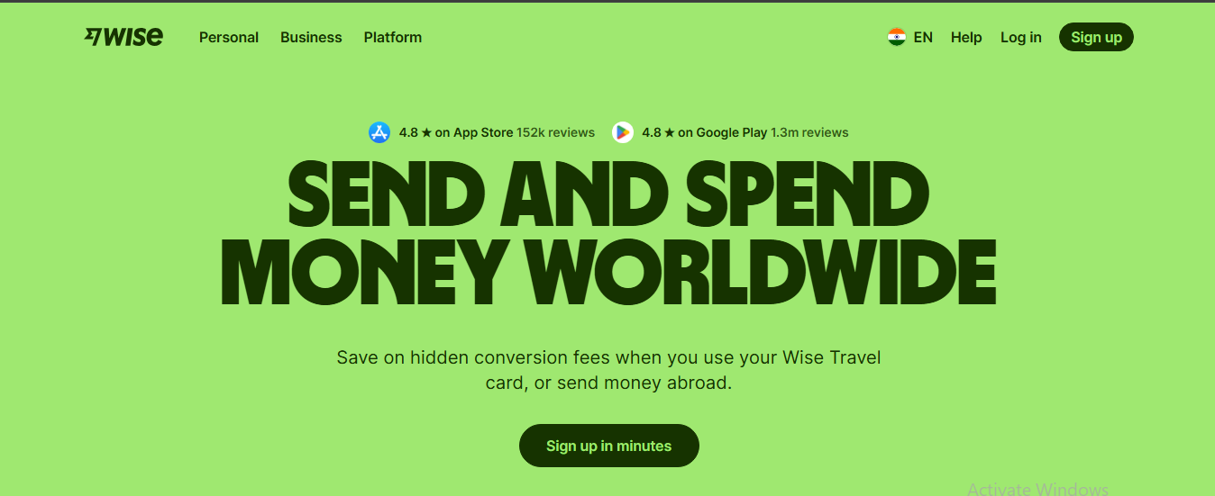
Figure 1 Homepage hero answers the service-purpose question directly.

2 | Navigating to find fees  URL / page: wise.com → hover “Personal” → wise.com/in/pricing/

Cognitive-walkthrough question | Verdict - evidence observed
Q1 - Right outcome? | Yes - The evaluator reasoned that fee information would sit under one of the three top-level nav items.
Q2 - Notice action? | Partially - Personal / Business / Platform carry no pricing or fees label; each had to be hovered and read before “Personal pricing” was found.
Q3 - Action → outcome? | Yes - Once visible, “Personal pricing” and “Send money” map directly onto the goal.
Q4 - See progress? | Yes - The destination page is headlined “Wise is built to save you money,” confirming the right page was reached.

OBSERVATION / UNCERTAINTY
Three unlabelled nav items had to be hovered and their mega-menus read before pricing was found - findable, but effortful on a first visit. (Finding F6.)
DESIGN IMPLICATION
Add a visible “Pricing” or “Fees” entry at the top level of the navigation.
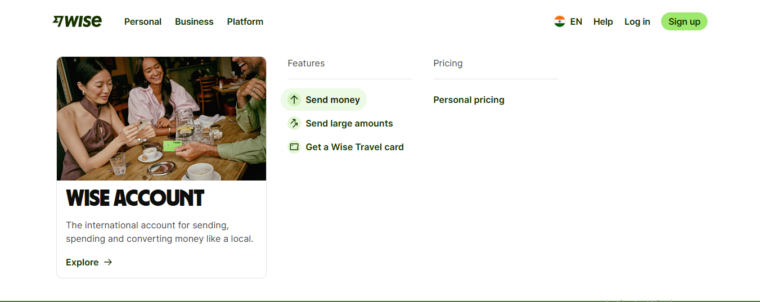
Figure 2 Evidence: pricing is nested inside the Personal hover menu, not the top-level nav.
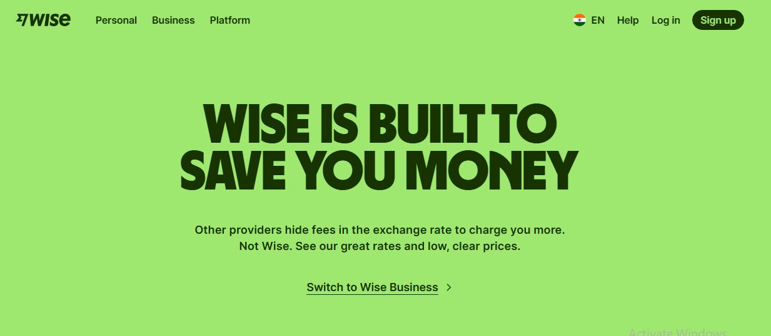
Figure 3 The pricing page confirms the right destination was reached.
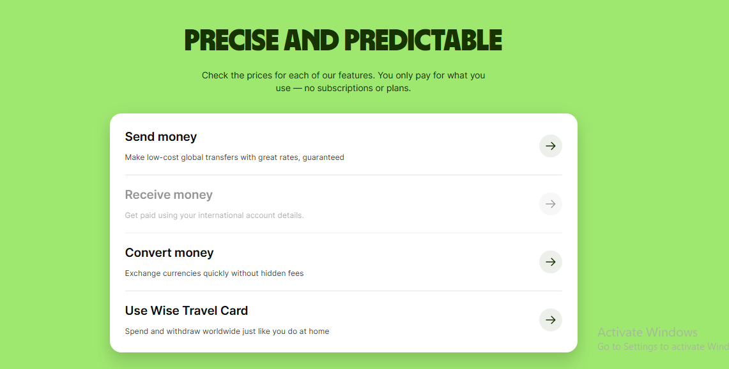
Figure 4 The four pricing options; “Send money” was the relevant path.

3 | Running the transfer calculator  URL / page: wise.com/in/pricing/send-money

Cognitive-walkthrough question | Verdict - evidence observed
Q1 - Right outcome? | Yes - The calculator is the control needed to answer the cost question.
Q2 - Notice action? | Yes - “You send exactly” and “Recipient gets” are immediately visible and editable.
Q3 - Action → outcome? | Yes - Entering ₹800,000 INR→USD returns 8,210.01 USD with total fees of ₹12,098.81.
Q4 - See progress? | Partially - Cost and arrival are both shown, but neither is interpretable without external context: no reference rate (F4), and no time zone on the arrival estimate (F3).

OBSERVATION / UNCERTAINTY
The evaluator opened Google and Western Union to judge the quote. Those figures were captured at different moments under different fee and delivery conditions, so they are indicative only - the finding is that the page gives no way to judge the rate in place, not that the rate is uncompetitive.
DESIGN IMPLICATION
Show the mid-market reference rate on the calculator card and label the arrival estimate with an explicit time zone.
Figure 5 Evidence: cost and arrival shown together; arrival carries no time zone.
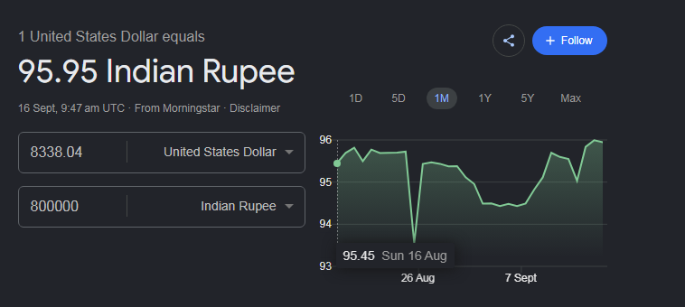
Figure 6 Indicative external reference point captured separately (Google).
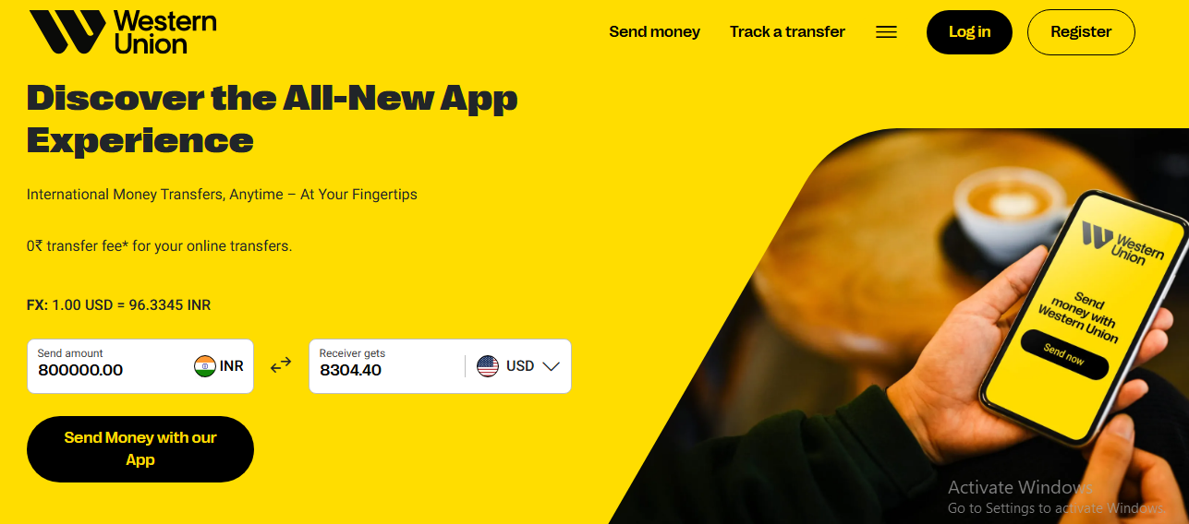
Figure 7 Second indicative external quote (Western Union); conditions not time-matched.

4 | Reading the fee breakdown  URL / page: wise.com/in/pricing/send-money (scrolled)

Cognitive-walkthrough question | Verdict - evidence observed
Q1 - Right outcome? | Yes - The module is still about fees, so it is the right area of the page.
Q2 - Notice action? | Yes - “Estimated amount per month” and “Average fee” sit directly below the calculator.
Q3 - Action → outcome? | No - The “per month” framing was not understood - it could describe recurring sending, a subscription-style estimate, or the same transfer restated.
Q4 - See progress? | Unclear - An average-fee percentage is shown, but without knowing what the input represents it could not be tied back to the transfer.

OBSERVATION / UNCERTAINTY
Ambiguous microcopy left the module's purpose unresolved. (Finding F5.)
DESIGN IMPLICATION
Add one line of explanatory microcopy, or relabel the module for a single transfer.
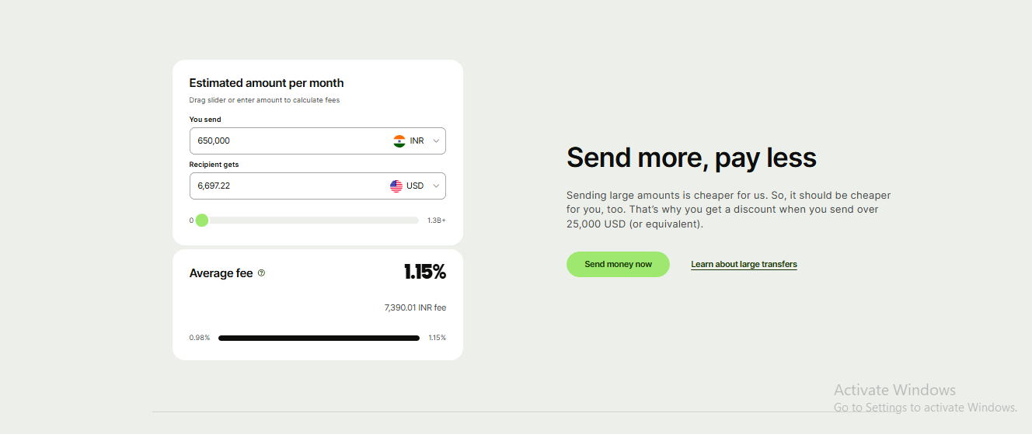
Figure 8 Evidence: “per month” framing is not explained on the card.

5 | Searching for eligibility and restrictions  URL / page: wise.com/in/send-money → wise.com/help/ (search)

Cognitive-walkthrough question | Verdict - evidence observed
Q1 - Right outcome? | Yes - The evaluator reasoned that eligibility rules would sit on the send-money page, the FAQ, or the Help Centre.
Q2 - Notice action? | No - None of the three surfaces surfaced an India eligibility answer using the terms tested. The FAQ carries a general INR-restrictions question; a Help Centre search for “restriction india” returned articles for Türkiye, Belarus, Russia, and Myanmar.
Q3 - Action → outcome? | No - No action-to-outcome connection could form, because the relevant content was never reached.
Q4 - See progress? | No - The search was abandoned without resolving whether personal accounts are available to Indian residents.

OBSERVATION / UNCERTAINTY
Eligibility could not be located through these three surfaces using the terms tested - which is a discoverability finding, not proof that no such content exists anywhere on the site. (Finding F2.)
DESIGN IMPLICATION
Surface country-specific eligibility on the pricing and send-money pages, rather than relying on Help Centre search.
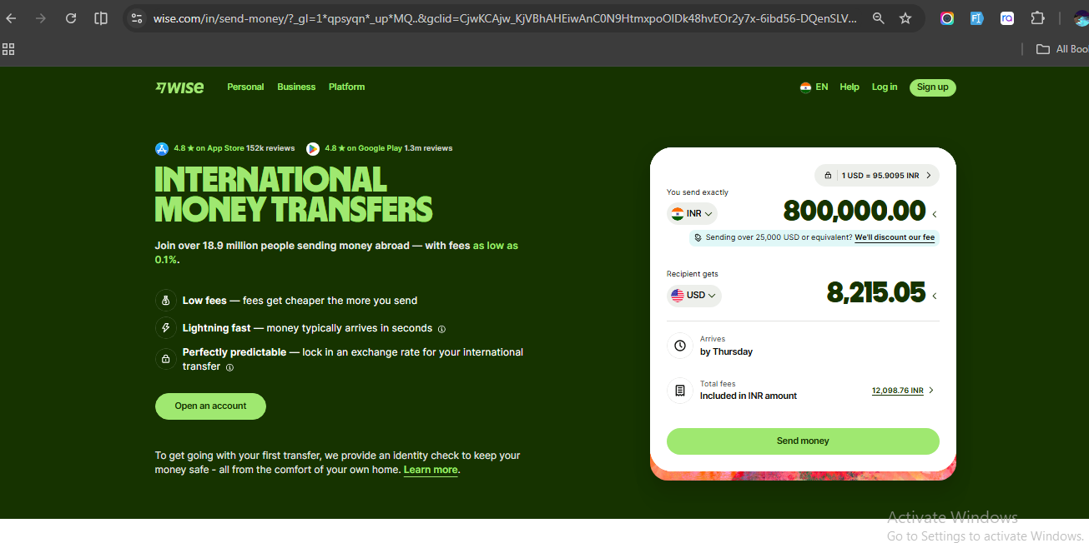
Figure 9 Send-money page reviewed for eligibility criteria; none stated.
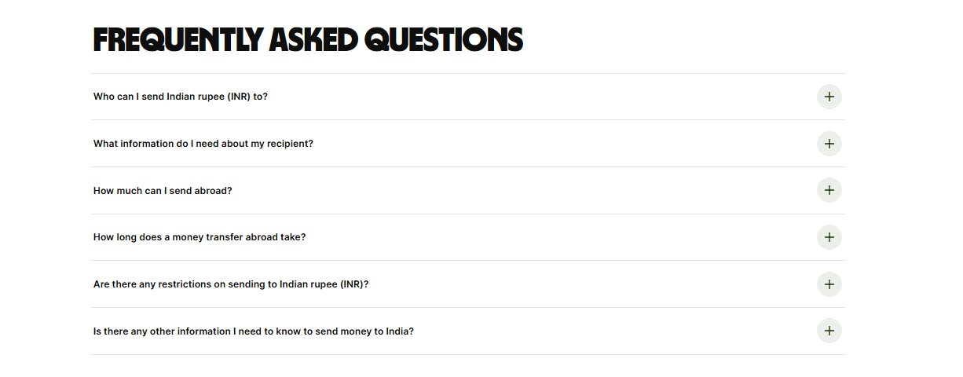
Figure 10 Evidence: FAQ carries a general INR-restrictions item, no India eligibility answer.
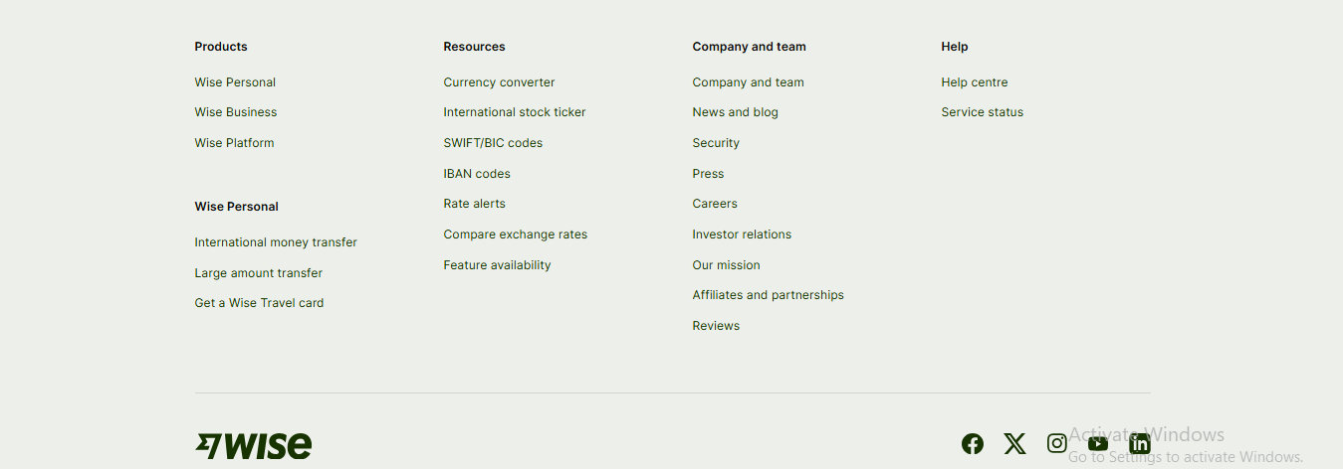
Figure 11 Footer reviewed; Help Centre followed as the next likely source.
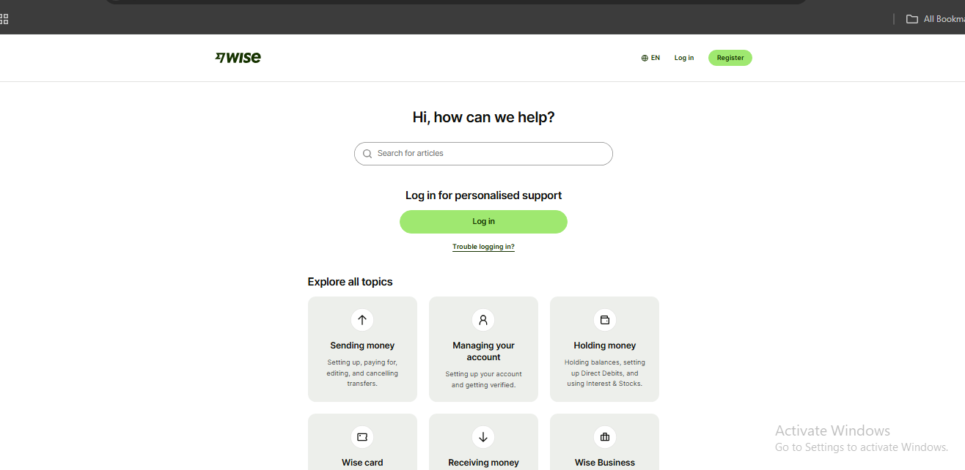
Figure 12 Help Centre search home.
Figure 13 Evidence: Help search returns restriction articles for other countries, not India.

6 | Attempting to create an account  URL / page: wise.com/register

Cognitive-walkthrough question | Verdict - evidence observed
Q1 - Right outcome? | Yes - “Register” in the navigation clearly maps to the account-creation goal.
Q2 - Notice action? | Partially - “Welcome to Wise” shows two rows - Personal (account type) and India (residence country) - without indicating that both must be opened, or in what order.
Q3 - Action → outcome? | No - Selecting “Personal” opens an account-kind screen; choosing “Personal” again returns to “Welcome to Wise” rather than advancing. Selecting “India” as residence produces the same return.
Q4 - See progress? | No - No error, warning, or explanation appears - the form resets, so it is impossible to tell whether the input was accepted, rejected, or lost.

OBSERVATION / UNCERTAINTY
Signup could not be completed. An external search afterwards suggested Wise does not currently issue personal accounts to residents of India; that explanation came from outside the product and has not been verified against official Wise policy. (Finding F1.)
DESIGN IMPLICATION
When a blocked combination is detected, show an explicit inline message explaining the restriction instead of silently resetting the form.
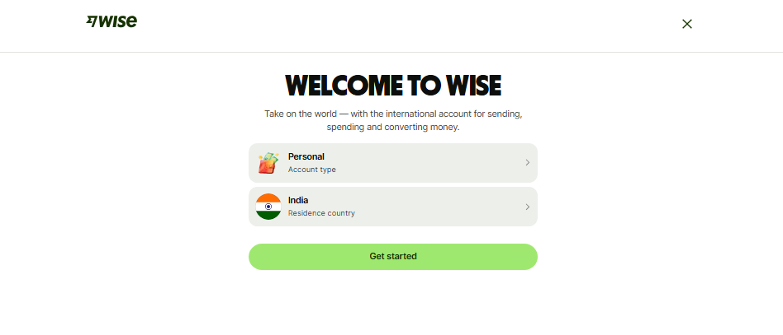
Figure 14 “Welcome to Wise”: account type and residence country, selectable in either order.
Figure 15 Evidence: choosing “Personal” here returns to the Welcome screen rather than advancing.
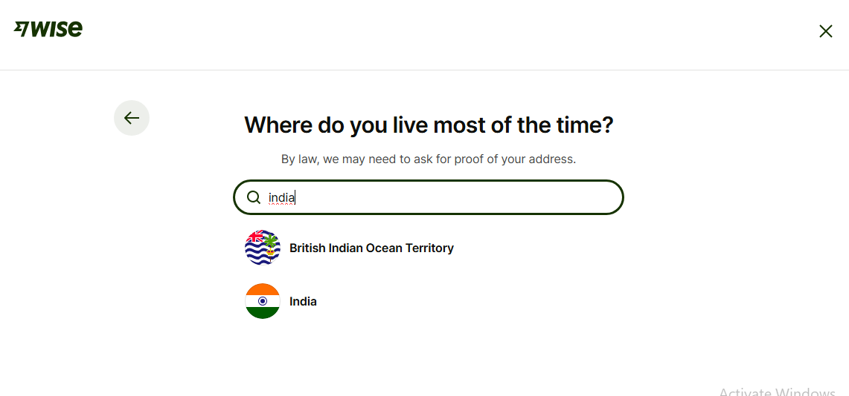
Figure 16 Evidence: selecting “India” also returns, with no explanation shown.

Method reference: adapted from Nielsen Norman Group's Heuristic Evaluation Workbook, restructured from heuristic evaluation to a task-based cognitive walkthrough for fintech onboarding. This is an independent review; the author has no affiliation with Wise.

