1. Initial ‘Home’ Page
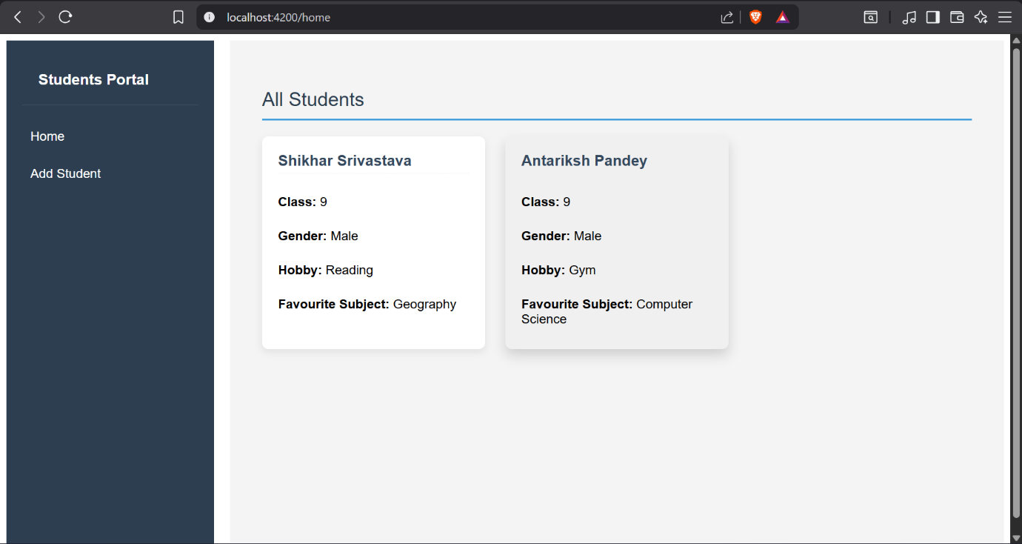

2. Initial ‘Add Student’ Page
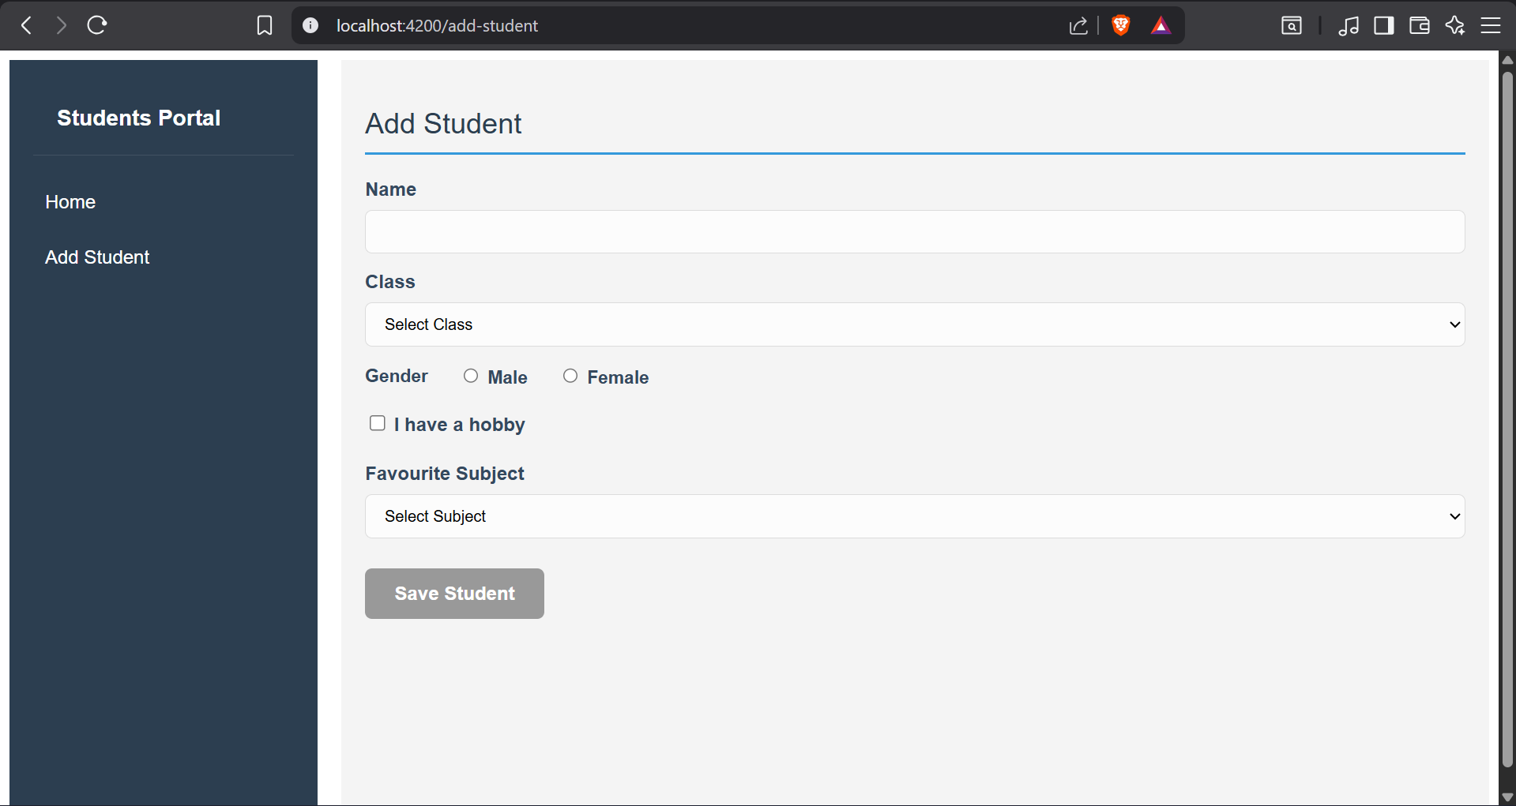

3. ‘Add Student’ page with *ngIf fields enabled
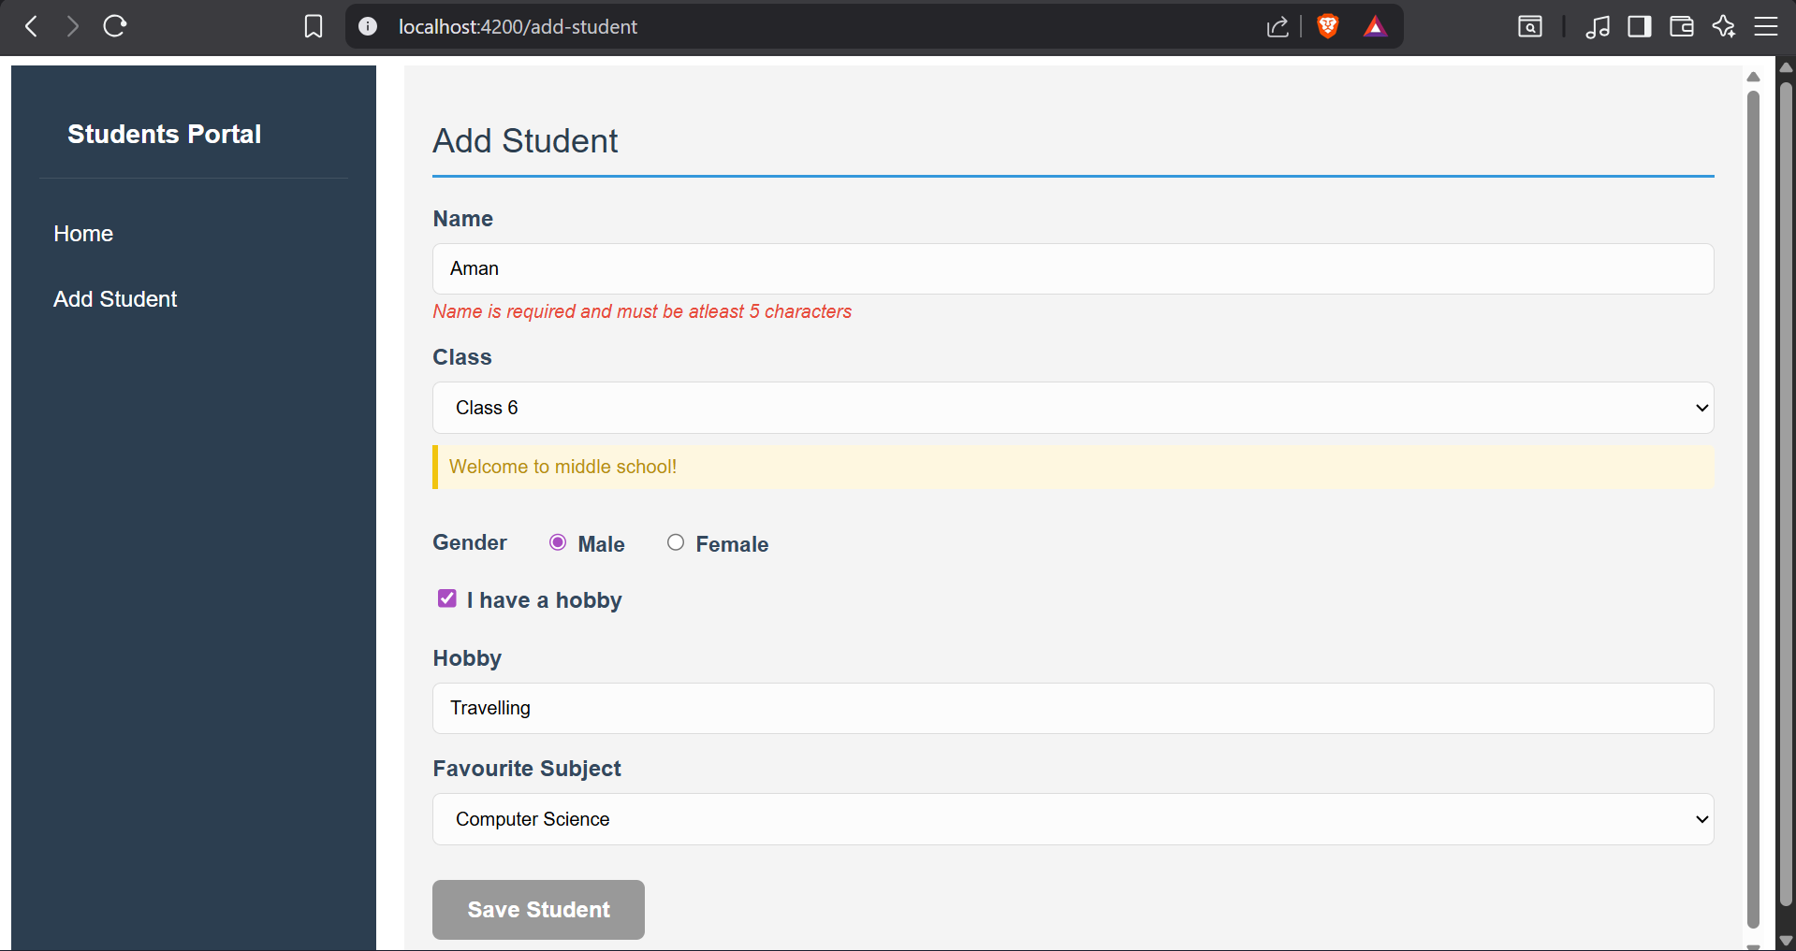

4. ‘Add students’ page with Hobby unchecked and Class 9 selected
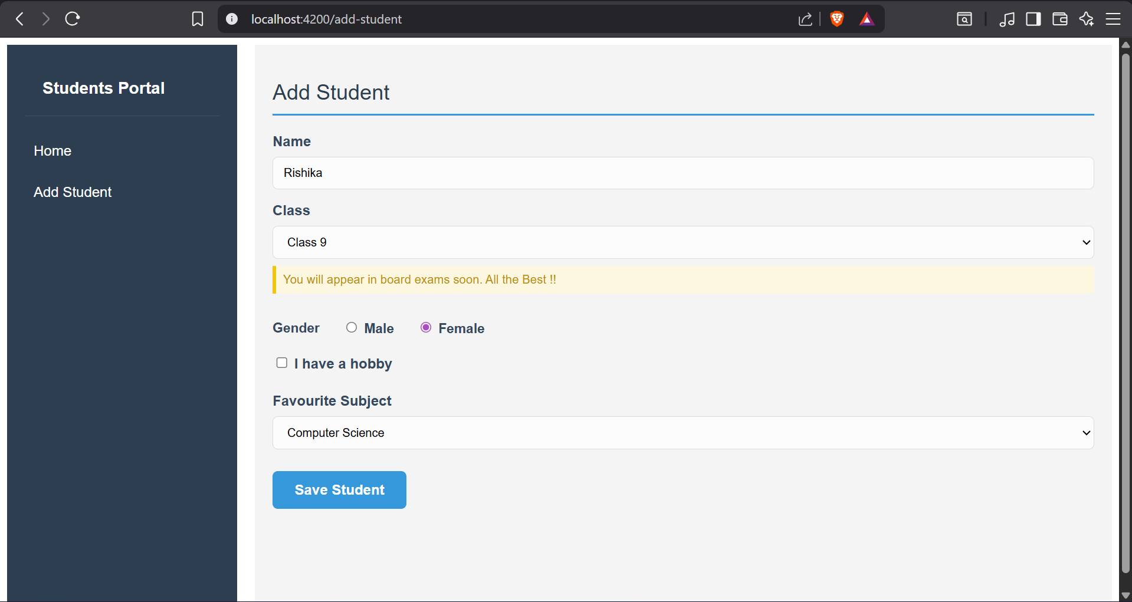

5. ‘Add Student’ page (without hobby and favourite subject) and class 7 selected
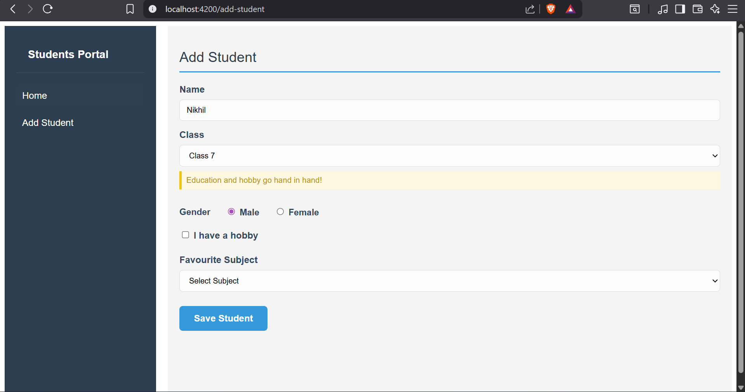

6. Updated ‘Home’ page
