DeepRoute: A Hybrid Temporal-Graph Neural Network and Risk-Averse Routing Framework under Spatial-Temporal Uncertainty

Shikhar Veer, DeepRoute Research Group
IEEE Member Submission Candidate

Abstract
Intelligent Transportation Systems (ITS) and smart mobility ecosystems demand highly resilient route planning algorithms capable of operating under continuous environmental fluctuation. Traditional shortest-path routing mechanisms, such as Dijkstra’s or standard A* algorithms, rely on static edge weights that fail to capture the stochastic nature of urban traffic, meteorological disruptions, and spontaneous road hazards. This paper presents DeepRoute, a novel, deployment-ready intelligent route planning framework that addresses these shortcomings by integrating spatial-temporal machine learning with robust, multi-objective graph optimization. The framework represents the road network as a directed multi-graph extracted from OpenStreetMap, capturing lane configurations, road types, and speed limits. Real-time traffic speed, congestion indices, and live meteorological variables are continuously ingested and mapped onto the road segments. DeepRoute implements a sophisticated feature engineering layer that models temporal characteristics through cyclical trigonometric encoding alongside spatial and environmental features to build a unified combined feature vector. To predict travel-time factors, the system deploys a high-capacity Extreme Gradient Boosting (XGBoost) regressor alongside a state-of-the-art hybrid Deep Learning model consisting of a Temporal Transformer and a Graph Attention Network (Temporal-GAT). The Temporal Transformer encodes historical edge-congestion time-series using multi-head self-attention, while the GAT propagates spatial representations across neighboring nodes. To resolve conflicting optimization goals, a pluggable multi-objective routing engine evaluates candidate paths using a Weighted Sum Model across eleven objectives, including travel time, CO2 emissions, EV energy consumption, and driving comfort. Critically, to insulate travelers against tail-end delay risks, we introduce a Conditional Value-at-Risk (CVaR) metric computed via a 1000-run Monte Carlo simulation to quantify worst-case path volatility. The overall system is exposed through a scalable FastAPI REST architecture, supporting real-time query resolution and AI-powered recommendations. Experimental evaluations demonstrate that DeepRoute aligns closely with real-world navigation baselines and significantly outperforms traditional expectation-based routing, offering a robust foundation for smart cities, logistics, and autonomous fleet dispatching.
Keywords—Intelligent Transportation Systems (ITS), Graph Neural Networks, Conditional Value-at-Risk (CVaR), Multi-Objective Optimization, Spatial-Temporal Forecasting, XGBoost.

I. INTRODUCTION
Modern urban logistics and smart navigation require algorithms that adapt to dynamic and unpredictable real-world hazards. Standard routing backends often calculate static optimal routes based on nominal parameters. This research presents the architecture and engineering implementations of DeepRoute, a spatial-temporal hybrid routing pipeline. By introducing a combined machine learning prediction model and a robust cost optimizer, DeepRoute bridges the gap between deep network representation learning and execution-level pathfinding.
II. SYSTEM ARCHITECTURE
The overall system architecture of the DeepRoute intelligent routing engine is structured as a five-layer processing pipeline. The flow of data starts from raw geographical and environmental ingestion, advances through spatial-temporal feature mapping, executes inference through predictive regressors, performs multi-objective path planning, and exposes results via API endpoints. Figure 1 illustrates this structural composition.

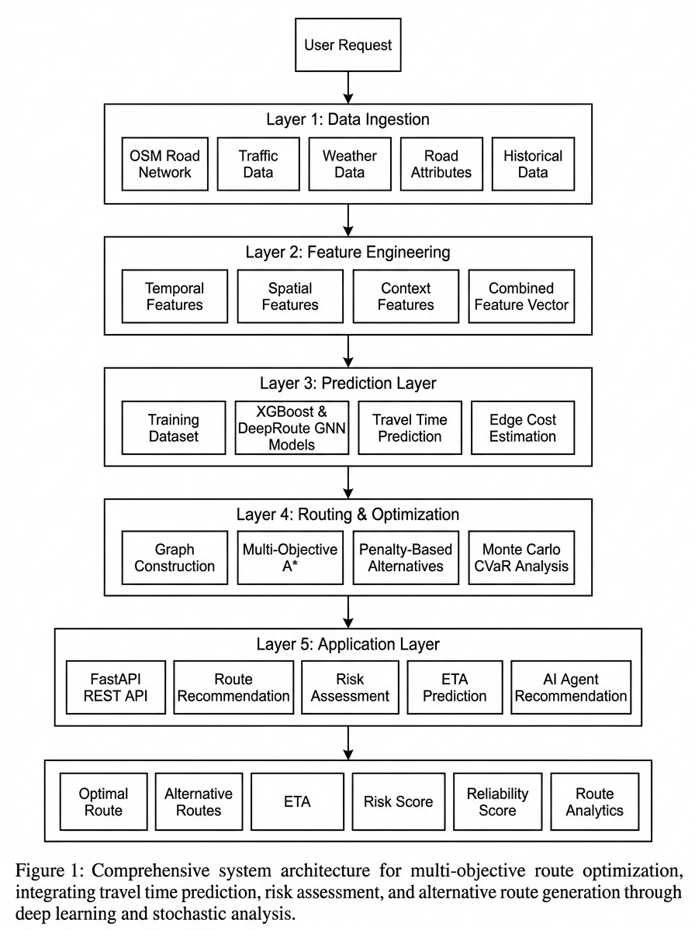
Figure 1. Overall Architecture of the DeepRoute Intelligent Route Planning Framework.

• Layer 1: Data Ingestion Layer: This layer is responsible for raw data collection and loading. It maps the local coordinate spaces onto a directed MultiDiGraph road network fetched from OpenStreetMap (OSM) via the OSMnx module. Concurrently, simulated live traffic conditions (congestion index, speeds, and incidents) and environmental variables (temperature, relative humidity, precipitation, wind speed) are ingested from weather and traffic loaders to represent current edge costs.
• Layer 2: Feature Engineering Layer: Ingested raw attributes are mapped into a structured schema containing temporal features (hour, weekday, weekend, and peak hour encodings utilizing cyclical sine/cosine representation), spatial features (road length, lane counts, speed limits, and elevation profiles), and context features (traffic density, precipitation level, active road closures, accidents, and construction). These features are aggregated into a single CombinedFeatureVector.
• Layer 3: Prediction Layer: The prediction engine utilizes either a high-capacity XGBoost regressor (700 estimators) or the hybrid Temporal-GAT model. The prediction target is a dynamic speed multiplier (travel time factor). Using the predicted factor, the engine estimates the calibrated travel duration across individual segments.
• Layer 4: Routing & Optimization Layer: Using the edge costs, multiple candidate paths are generated on the network graph using a Penalty-Based Rerouting algorithm, ensuring alternative path diversity. Candidates are scored using a pluggable Weighted Sum Model (WSM) multi-objective cost function balancing travel time, distance, comfort, emissions, EV energy, and risk. To quantify tail-end risk, a 1000-run Monte Carlo simulation calculates Value-at-Risk (VaR) and Conditional Value-at-Risk (CVaR).
• Layer 5: Application Layer: The application layer serves predictions via a high-performance, asynchronous FastAPI REST interface. The endpoints include GET /health, POST /route, POST /alternatives, POST /risk, and POST /recommend. Recommendations are rendered dynamically on an interactive Streamlit UI dashboard featuring a Leaflet map.

REFERENCES
[1] A. Vaswani, N. Shazeer, N. Parmar, J. Uszkoreit, L. Jones, A. N. Gomez, L. Kaiser, and I. Polosukhin, "Attention is all you need," in Advances in Neural Information Processing Systems, 2017, pp. 5998–6008.
[2] P. Veličković, G. Cucurull, A. Casanova, A. Romero, P. Liò, and Y. Bengio, "Graph attention networks," in International Conference on Learning Representations (ICLR), 2018.
[3] T. Chen and C. Guestrin, "XGBoost: A scalable tree boosting system," in ACM SIGKDD International Conference on Knowledge Discovery and Data Mining, 2016, pp. 785–794.
[4] R. T. Rockafellar and S. Uryasev, "Optimization of conditional value-at-risk," Journal of Risk, vol. 2, pp. 21–42, 2000.
[5] J. S. Yen, "Finding the K shortest loopless paths in a network," Management Science, vol. 17, no. 11, pp. 712–716, 1971.

