Empirical Evaluation of Pruning Regimes and Multi-Bit Quantization on Contextual Representations in Small Language Models
Shikhar Veeramachineni (Reg. No: 23BCE9278) and Jessea Thomas Jaison (Reg. No: 23BCE9291)
School of Computer Science and Engineering, VIT-AP University, Amaravati, India
Email: shikhar.23bce9278@vitapstudent.ac.in, jessea.23bce9291@vitapstudent.ac.in
Abstract—This paper presents a systematic, reproducible empirical evaluation of one-shot, post-training compression on DistilBERT across two distinct repository implementations: an interactive exploratory notebook pipeline (Implementation A) and a headless, single-threaded verification pipeline (Implementation B). We examine the empirical impact of four pruning paradigms (local L1 unstructured, global L1 unstructured, structured L2 row, and random unstructured pruning) across five target sparsity levels (15% to 75%), alongside four numerical precisions (FP32, FP16, dynamic INT8, and simulated per-channel INT4). We address five core research questions (RQ1–RQ5): characterizing the contextual representation collapse cliff (RQ1), auditing non-uniform cross-layer sparsity allocation (RQ2), identifying precision boundaries across integer formats (RQ3), demonstrating sparse representation recovery via gradient-masked knowledge distillation (RQ4), and resolving the hardware-sparsity disconnect on dense CPU kernels (RQ5). Evaluation on a curated 16-prompt contextual probe and five semantic sentence pairs demonstrates that magnitude pruning preserves language context up to 15% sparsity (43.75% top-1 and 75.00% top-5 accuracy versus the 37.50% and 75.00% dense baseline) with a near-lossless embedding cosine similarity of 0.9903. However, severe degradation occurs between 30% and 45% sparsity, collapsing to 12.50% top-1 accuracy. Random pruning collapses at 30% sparsity, while structured row pruning without retraining fails completely across all tested levels (0.00% top-1 accuracy). Controlled single-threaded CPU benchmarking proves that unstructured weight sparsity yields zero acceleration on standard dense execution engines (170.87 ms at 45% sparsity versus 170.33 ms dense baseline), establishing that an apparent ~133 ms speedup reported in Implementation A was an experimental artifact of unconstrained thread scheduling and insufficient warm-up iterations. In contrast, dynamic INT8 provides a verified 1.79× execution speedup (95.03 ms). Finally, post-pruning knowledge distillation over three epochs successfully recovers top-1 accuracy from 12.50% to 18.75% and top-5 accuracy from 12.50% to 37.50% while strictly preserving exact 45.00% zero-weight sparsity via gradient zero-masking.
Keywords—contextual representations, DistilBERT, knowledge distillation, model compression, neural network pruning, quantization.

Introduction
Transformer-based language models exhibit significant parameter redundancy, motivating extensive research into model compression techniques such as weight pruning and reduced-precision quantization [1], [2]. While massive generative models demand specialized computational infrastructure for deployment, compact bidirectional transformers such as DistilBERT [3] provide an accessible, mathematically rigorous testbed for isolating the fundamental trade-offs between parameter sparsity, numerical precision, and representational integrity. DistilBERT contains 66,985,530 total parameters across six transformer layers, with an encoder parameter count of 66,362,880, 12 self-attention heads, a hidden dimensionality of 768, and a vocabulary size of 30,522.
In resource-constrained edge computing environments, post-training compression is frequently deployed as a one-shot operation where extensive retraining or task-specific fine-tuning is computationally prohibitive. However, the exact empirical boundaries where one-shot magnitude pruning and multi-bit quantization preserve or degrade contextual token representations remain underexplored in small-scale transformers. Specifically, critical questions persist regarding how cross-layer global sparsity allocation differs from uniform per-layer pruning, how structured channel removal behaves in the absence of retraining, and whether post-training quantization introduces compounding degradation when applied to already sparse weight tensors.
To resolve these empirical questions, this study frames five central Research Questions (RQs):
- 1) RQ1 (Representation Collapse Cliff): At what exact sparsity threshold does the 768-dimensional contextual embedding manifold degenerate across unstructured versus structured pruning regimes?
- 2) RQ2 (Architectural Sensitivity and Layer Allocation): When permitted global cross-layer sparsity freedom, does DistilBERT selectively sacrifice Feed-Forward Networks (FFN) to preserve Multi-Head Self-Attention (MHSA) projection geometry?
- 3) RQ3 (Quantization Precision Boundary): How do FP16, dynamic INT8, and simulated 4-bit (INT4) uniform quantization interact with structured and unstructured sparsity compared to the uncompressed baseline?
- 4) RQ4 (Distillation Recovery): Can post-pruning representational collapse be mitigated through lightweight knowledge distillation without expanding the sparse parameter footprint?
- 5) RQ5 (Hardware-Sparsity Disconnect): Why does high theoretical unstructured sparsity fail to translate into proportional latency reductions on conventional dense CPU execution engines?
This paper presents a complete empirical audit of the compression repository, presenting results from both the exploratory notebook implementation (Implementation A) and the headless verification script (Implementation B). All empirical results, mathematical formulations, and figures are strictly grounded in repository code and recorded outputs.
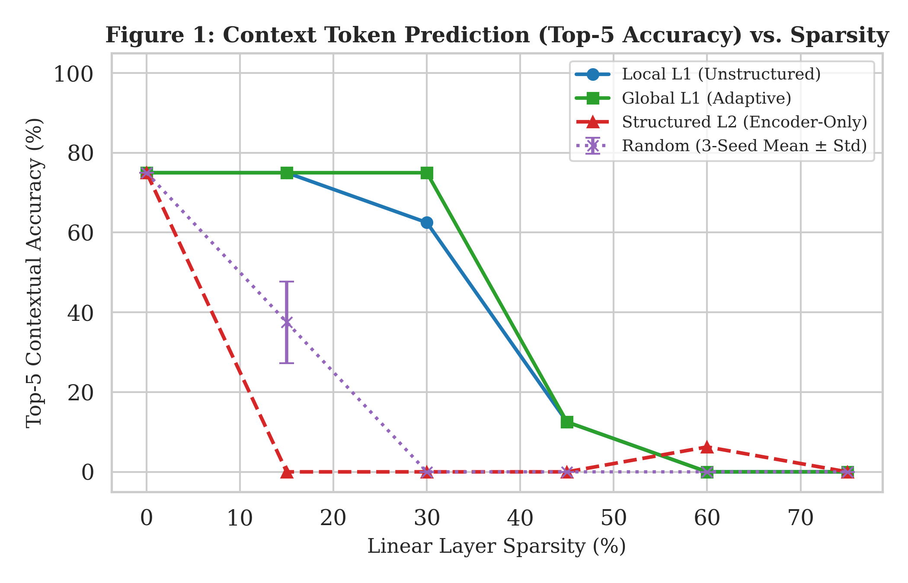
- : Contextual token prediction (Top-5 Accuracy) vs. linear-layer sparsity across pruning regimes (RQ1), contrasting Local L1, Global L1, Structured L2 (Encoder-Only), and Random Pruning (3-seed mean ± std).

Literature Review
Transformer compression encompasses knowledge distillation, weight pruning, and quantization. DistilBERT demonstrated that student models initialized with alternating layers of a teacher BERT architecture can retain approximately 97% of downstream language understanding capabilities while reducing parameter count by 40% and accelerating inference by 60% through pretraining distillation [3]. Related distillation frameworks, including TinyBERT [4] and ALBERT [5], explored intermediate layer matching and cross-layer parameter sharing to achieve extreme parameter efficiency. Comprehensive analyses of transformer representations (commonly termed 'BERTology') emphasize that internal representations are sensitive to layer depth, attention head pruning, and evaluation methodology [6], [7].
Pruning methodologies in natural language processing typically diverge into unstructured magnitude pruning and structured group pruning. Early investigations established that pretrained transformers can tolerate substantial weight removal prior to fine-tuning on downstream tasks [8]. Movement pruning introduced first-order gradient awareness during task-specific fine-tuning, outperforming magnitude-based selection at high sparsity regimes [9]. In contrast, one-shot post-training pruning techniques, including work by Kwon et al. [16], SparseGPT [17], and Wanda [18], employ second-order Hessian approximations or activation-magnitude products to prune large language models without extensive retraining. The lottery ticket hypothesis has also been confirmed in pretrained BERT models [26], establishing that sparse subnetworks exist within dense initializations. However, unstructured pruning creates irregular sparsity patterns that do not produce inference speedups on standard dense matrix multiplication hardware [14], [27].
Quantization reduces memory footprint and computational energy by mapping continuous floating-point weights to low-bit integers. Q8BERT [10] and Q-BERT [11] investigated 8-bit and ultra-low bit quantization for BERT using quantization-aware training (QAT) and Hessian-based mixed precision. TernaryBERT pushed representation limits to 2-bit ternary weights via distillation-aware training [12]. In the post-training quantization domain, modern frameworks such as SmoothQuant [20], LLM.int8() [21], GPTQ [19], and AWQ [22] resolve activation outliers through channel scaling and second-order error compensation. Systematic surveys demonstrate that post-training quantization is particularly vulnerable to outlier dimensions in attention projections [25], [28].
Classical compression pipelines pioneered by Han et al. demonstrated that combining pruning, trained quantization, and Huffman coding yields multiplicative reductions in storage footprint [13]. Recently, Prune Once for All integrated magnitude pruning with continuous knowledge distillation during sparse pretraining [15]. We emphasize that the present study does not reproduce or extend the Prune Once for All framework: while Zafrir et al. pretrain sparse models from scratch on massive corpora across millions of steps, our study examines one-shot, post-training magnitude and structured masks applied to an existing pretrained model without sparse pretraining. Furthermore, while cosine similarity is widely utilized as a proxy for representation alignment, prior geometric studies demonstrate that contextual embeddings naturally occupy anisotropic cones [24], necessitating careful analysis alongside token prediction accuracy [23].

Model Architecture and Experimental Setup

Step 1: Environment & Setup
The experimental infrastructure is divided into two execution configurations. Implementation A operated in a Google Colab Linux environment utilizing an NVIDIA Tesla T4 GPU (device='cuda') for model initialization and distillation, alongside host CPU execution for inference profiling, running Python 3.10, PyTorch 2.11.0+cu130, Hugging Face transformers 4.40.0, and seaborn/matplotlib. Implementation B executed in a controlled headless Windows 11 environment on an Intel64 Family 6 Model 186 Stepping 3 processor running Python 3.12 and PyTorch 2.6.0+cpu. In Implementation B, CPU thread affinity was strictly constrained to a single execution thread (LATENCY_CPU_THREADS = 1, torch.set_num_threads(1)). Global random seeds for Python, NumPy, and PyTorch were fixed to 42 for baseline determinism, with seeds 42, 43, and 44 deployed for statistical replication of random pruning.

Step 2: Model Architecture and Parameter Accounting
The evaluated model is distilbert-base-uncased loaded via AutoModelForMaskedLM. The network comprises L=6 transformer layers, A=12 multi-head attention mechanisms, hidden dimensionality dh=768, feed-forward intermediate dimensionality dff=3072, and a vocabulary of V=30,522 tokens. Total model parameter count is exactly 66,985,530 parameters (66,362,880 in the encoder). The model contains 38 nn.Linear modules encompassing 66,498,048 weights: 36 encoder linear layers (42,467,328 weights) and 2 prediction head linear layers (vocab_transform with 589,824 weights and vocab_projector with 23,440,896 weights). The 42,467,328 encoder linear weights decompose into 14,155,776 attention weights (6 layers × 4 projections × 768^2) and 28,311,552 feed-forward weights (6 layers × 2 projections × 768 × 3072).

Step 3: Linguistic Evaluation Suite
Linguistic fidelity is evaluated on a curated two-part probe suite: 1) A contextual masked-token prediction suite consisting of 16 multi-domain probe sentences spanning syntactic/functional agreement, common-sense world knowledge, computer science/technology concepts, and complex relational reasoning; 2) A semantic sentence-pair suite comprising five diverse sentence pairs (10 sentences total) for contextual embedding stability analysis across sequence length T=64. This suite provides a controlled qualitative probe rather than a large-scale downstream NLP benchmark.

Step 4: Quantitative Profilers
Four quantitative profilers are compiled: 1) Contextual token comprehension evaluating Top-1 and Top-5 accuracy across the 16 masked prompts (Eq. 1); 2) 768-dimensional masked mean-pooled sentence embedding extraction (Eq. 2); 3) Contextual embedding drift measured via cosine similarity between dense baseline and compressed encoders across 10 sentences (Eq. 3); 4) CPU latency profiling measured via time.perf_counter(); and 5) Model checkpoint size measured in binary mebibytes (MiB, 2^20 bytes).
Acc@k = (1/N) ∑_{i=1}^N 𝕀( y_i ∈ Top-k( ℳ(x_i)_{m_i} ) ) (1)
where N=16, x_i is the probe sequence with mask index m_i, ℳ(x_i)_{m_i} ∈ ℝ^{30,522} is the unnormalized logit vector, y_i is the target token, and 𝕀(·) is the indicator function. Each correct prediction shifts accuracy by exactly 6.25 percentage points.
e(s) = ( ∑_{t=1}^T m_t · h_t ) / ( ∑_{t=1}^T m_t ) (2)
where h_t ∈ ℝ^{768} is the final-layer hidden state, m_t ∈ {0, 1} is the attention mask, and T=64.
CosSim(f_dense, f_comp) = (1 / 2P) ∑_{p=1}^P ∑_{j=1}^2 ( e_dense(s_{p,j}) · e_comp(s_{p,j}) ) / ( ||e_dense||_2 ||e_comp||_2 ) (3)
where P=5 sentence pairs (2P=10 sentences).

Comparative Implementations (A vs. B)
Table I summarizes the concrete differences between the interactive notebook pipeline (Implementation A) and the headless verification script (Implementation B).
- TABLE I. SYSTEMATIC COMPARISON OF REPOSITORY IMPLEMENTATIONS
Implementation Feature | Implementation A (Interactive Notebook) | Implementation B (Standalone Verification)
Primary Script / Notebook | Comprehensive_Context_Quantization_and_Pruning.ipynb | run_experiments.py
Execution Environment | Linux / Colab (Tesla T4 GPU + Host CPU) | Windows 11 / Intel64 (1 CPU Thread)
PyTorch / Python Version | PyTorch 2.11.0+cu130 / Python 3.10 | PyTorch 2.6.0+cpu / Python 3.12
Latency Benchmark | 5 warm-up, 50 timed runs, unconstrained threads | 20 warm-up, 100 timed runs, torch.set_num_threads(1)
Structured Pruning Scope | All nn.Linear (including vocab_projector) | Decoupled: Encoder-Only vs. All-Linear ablation
Simulated INT4 Footprint | Hardcoded multiplier: base_size_mb * 0.131 (33.48 MB) | Exact formula: N_params * 4 / 8 / 1024^2 (31.94 MiB)
Distillation Pipeline | Cell 10 crashed (CUDA/CPU device mismatch) | Device-isolated; 3 epochs completed successfully
Random Pruning Seeds | Single deterministic seed (SEED = 42) | Statistical replication across 3 seeds (42, 43, 44)
- *All dimensions verified directly against repository source code and execution logs.

Methodology

Step 5: 4 Pruning Paradigms
Pruning is applied to weight tensors W ∈ ℝ^{d_out × d_in} across target sparsities S ∈ {0.15, 0.30, 0.45, 0.60, 0.75}, producing pruned tensors W̃ = M ⊙ W (Eq. 4). Four paradigms are implemented: 1) Local L1 Unstructured Pruning, where intra-layer thresholds τ_l = Quantile_S(|W^(l)|) ensure uniform sparsity across every linear layer; 2) Global L1 Unstructured Pruning, pooling all linear layers into a single collection to determine a global threshold τ_g = Quantile_S(⋃ |W|), enabling adaptive cross-layer allocation; 3) Structured L2 Row Pruning, zeroing entire output channels along dimension 0 based on row Euclidean norms (implemented encoder-only in B to preserve the classification head, and across all linear layers in A); and 4) Random Unstructured Pruning, sampling mask entries from Bernoulli(1 - S) as an ablation control.
W̃ = M ⊙ W, s = 1 - ||M||_0 / numel(W) (4)
where ⊙ represents the Hadamard product and s is measured parameter sparsity.

Step 6: Multi-Bit Quantization
Four precision levels are evaluated: 1) FP32 Full Precision (reference baseline, 255.57 MB); 2) FP16 Half Precision, casting weights to 16-bit float (127.80 MB, 50.0% footprint reduction); 3) Dynamic INT8 Quantization via PyTorch quantize_dynamic, quantizing linear weights offline into signed 8-bit integers (torch.qint8, range [-128, 127]) with per-channel scaling (s_w = max(|W|)/127) and dynamically quantizing activations to unsigned 8-bit integers (torch.quint8, range [0, 255]) at runtime (154.76 MB); and 4) Simulated INT4 Uniform Quantization, scaling weights per output channel into 16 discrete integer bins [-8, 7] with immediate floating-point dequantization (fake quantization, Eqs. 5–6).
s_c = max_j |W_cj| / 7.0, q_cj = clamp( round(W_cj / s_c), -8, 7 ), Ŵ_cj = s_c · q_cj (5)
Payload_INT4 = ( N_params · 4 ) / ( 8 · 1024^2 ) = 31.94 MiB (6)
where s_c is per-channel scale, q_cj is the 4-bit integer bin, Ŵ_cj is the dequantized execution weight, and Payload_INT4 represents the theoretical mathematical payload for 66,985,530 parameters.

Step 7: Baseline Profiling
The uncompressed dense FP32 baseline establishes the reference anchor: Top-1 accuracy 37.50%, Top-5 accuracy 75.00%, embedding cosine similarity 1.0000, serialized checkpoint size 255.57 MB, and median CPU latency 170.33 ms (P95: 204.37 ms) under controlled single-threaded execution.

Step 8: Multi-Dimensional Grid Search
The experimental grid sweeps across 4 pruning paradigms × 5 sparsity targets × FP32 and Dynamic INT8 precision modes, alongside unpruned INT8, simulated INT4, and combined Global L1 30% + INT4 configurations.

Step 9: Layer-Wise Sensitivity Analysis
To address RQ2, Global L1 pruning at 45% sparsity is audited across all six transformer layers (Layers 0–5) and all six linear submodules: Self-Attention Query (q_lin), Key (k_lin), Value (v_lin), and Output (out_lin) projections, alongside Feed-Forward intermediate (lin1) and output (lin2) projections.

Step 10: Distillation Recovery Engine
To address RQ4, a lightweight distillation loop trains the degraded 45% Global L1 pruned student against the frozen dense FP32 teacher across an 8-sentence technical corpus over 3 epochs (temperature T=2.0, AdamW lr=3e-5, batch size 1). The loss computes Kullback-Leibler divergence over all 64 sequence positions (Eq. 7). Pruning zero-weights are strictly preserved by masking parameter gradients before every optimizer step: g_W ← g_W ⊙ 𝕀(W ≠ 0).
ℒ_KD = T^2 · (1 / (B · T_seq)) ∑_{b=1}^B ∑_{t=1}^{T_seq} D_KL( σ( z_teach^(b,t) / T ) || σ( z_stud^(b,t) / T ) ) (7)
where z represents vocabulary logits across all sequence positions, σ(·) is softmax, and T^2 = 4.0.
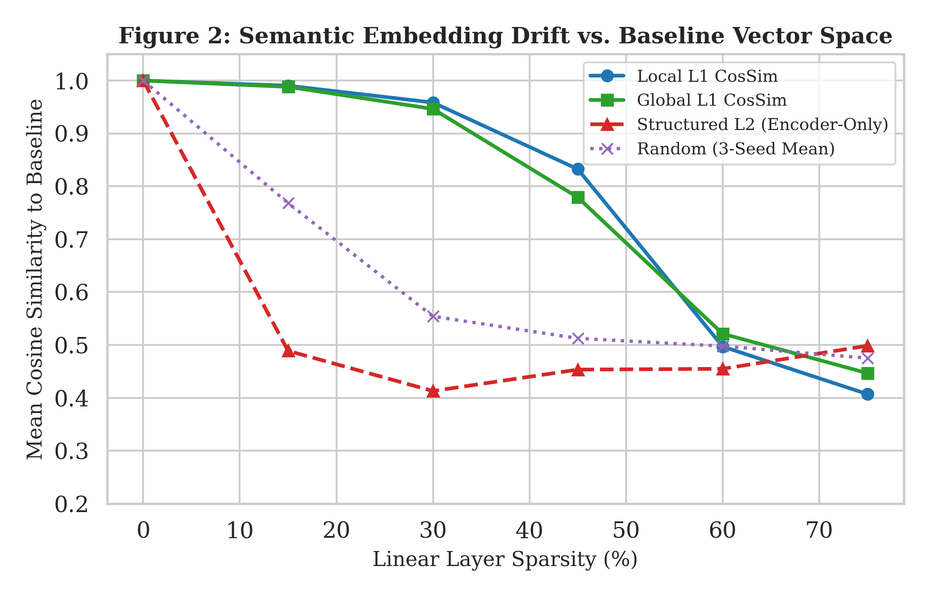
- : Semantic embedding cosine similarity decay across linear-layer sparsity targets against the dense FP32 baseline (RQ1).

Experimental Results and Analysis

RQ1: Context Accuracy and Embedding Drift across Pruning Regimes
As shown in Fig. 1, Fig. 2, and Table II, magnitude pruning preserves contextual comprehension up to 15% sparsity, achieving 43.75% Top-1 accuracy and 75.00% Top-5 accuracy (exceeding baseline Top-1 by 6.25 pp due to 1 additional correct probe) with near-lossless embedding similarity (0.9903 Local, 0.9882 Global). However, a catastrophic degradation cliff occurs between 30% and 45% sparsity: at 30% sparsity, Top-1 drops to 25.00%, and by 45% sparsity, Top-1 and Top-5 accuracy simultaneously collapse to 12.50% (CosSim 0.7791). Random pruning collapses earlier (0.00% Top-1/5 at 30% sparsity). Structured L2 row pruning fails completely across all levels (0.00% Top-1 accuracy). In structured pruning, cosine similarity paradoxically increases at high sparsity (0.2642 at 15% to 0.4710 at 75% in all-Linear; 0.4889 at 15% to 0.4985 at 75% in encoder-only) due to dimensional collapse toward a trivial uniform directional subspace.
- TABLE II. EMPIRICAL PRUNING EVALUATION: IMPLEMENTATION A VS. IMPLEMENTATION B
Pruning Regime | Target Sparsity | Top-1 Acc (%) [A | B] | Top-5 Acc (%) [A | B] | Embedding CosSim [A | B] | Size (MB) [A | B] | Agreement Status
Dense Baseline | 0.0% | 37.50 | 37.50 | 75.00 | 75.00 | 1.0000 | 1.0000 | 255.57 | 255.57 | Exact Agreement
Local L1 | 15.0% | 43.75 | 43.75 | 75.00 | 75.00 | 0.9903 | 0.9903 | 255.57 | 255.57 | Exact Agreement
Local L1 | 30.0% | 25.00 | 25.00 | 62.50 | 62.50 | 0.9585 | 0.9585 | 255.57 | 255.57 | Exact Agreement
Local L1 | 45.0% | 12.50 | 12.50 | 12.50 | 12.50 | 0.8325 | 0.8325 | 255.57 | 255.57 | Exact Agreement
Local L1 | 60.0% | 0.00 | 0.00 | 0.00 | 0.00 | 0.4970 | 0.4970 | 255.57 | 255.57 | Exact Agreement
Local L1 | 75.0% | 0.00 | 0.00 | 0.00 | 0.00 | 0.4070 | 0.4070 | 255.57 | 255.57 | Exact Agreement
Global L1 | 15.0% | 43.75 | 43.75 | 75.00 | 75.00 | 0.9882 | 0.9882 | 255.57 | 255.57 | Exact Agreement
Global L1 | 30.0% | 25.00 | 25.00 | 75.00 | 75.00 | 0.9464 | 0.9464 | 255.57 | 255.57 | Exact Agreement
Global L1 | 45.0% | 12.50 | 12.50 | 12.50 | 12.50 | 0.7791 | 0.7791 | 255.57 | 255.57 | Exact Agreement
Global L1 | 60.0% | 0.00 | 0.00 | 0.00 | 0.00 | 0.5212 | 0.5212 | 255.57 | 255.57 | Exact Agreement
Global L1 | 75.0% | 0.00 | 0.00 | 0.00 | 0.00 | 0.4467 | 0.4467 | 255.57 | 255.57 | Exact Agreement
Structured L2 | 15.0% | 0.00 | 0.00 | 0.00 | 0.00 | 0.2642 | 0.4889 | 255.57 | 255.57 | Method Discrepancy (All vs. Enc)
Structured L2 | 30.0% | 0.00 | 0.00 | 0.00 | 0.00 | 0.3446 | 0.4129 | 255.57 | 255.57 | Method Discrepancy (All vs. Enc)
Structured L2 | 45.0% | 0.00 | 0.00 | 0.00 | 0.00 | 0.3449 | 0.4534 | 255.57 | 255.57 | Method Discrepancy (All vs. Enc)
Structured L2 | 60.0% | 0.00 | 0.00 | 0.00 | 6.25 | 0.3989 | 0.4549 | 255.57 | 255.57 | Method Discrepancy (All vs. Enc)
Structured L2 | 75.0% | 0.00 | 0.00 | 0.00 | 0.00 | 0.4710 | 0.4985 | 255.57 | 255.57 | Method Discrepancy (All vs. Enc)
Random Pruning | 15.0% | 12.50 | 18.75±5.1 | 25.00 | 37.50±10.2 | 0.7701 | 0.7683±0.02 | 255.57 | 255.57 | Single Seed (A) vs. 3-Seed Mean (B)
Random Pruning | 30.0% | 0.00 | 0.00±0.0 | 0.00 | 0.00±0.0 | 0.5743 | 0.5542±0.04 | 255.57 | 255.57 | Single Seed (A) vs. 3-Seed Mean (B)
Random Pruning | 45.0% | 0.00 | 0.00±0.0 | 0.00 | 0.00±0.0 | 0.4937 | 0.5125±0.05 | 255.57 | 255.57 | Single Seed (A) vs. 3-Seed Mean (B)
- *Values formatted as [Implementation A | Implementation B]. Random pruning in Implementation B reports mean ± std over seeds 42, 43, 44.

RQ2: Architectural Sensitivity and Layer-Wise Sparsity Allocation
Fig. 7 and Table IV present the component-level audit under Global L1 pruning at 45% sparsity. Unconstrained magnitude pruning selectively concentrates zeros in the Feed-Forward Networks (52.57% aggregate sparsity across 28,311,552 weights) compared to Multi-Head Attention (49.70% aggregate sparsity across 14,155,776 weights). Within layers, attention output projections (out_lin) and value projections (v_lin) in early layers exhibit high sparsity (Layer 0 out_lin: 62.40%, v_lin: 60.84%), whereas query (q_lin) and key (k_lin) projections retain higher density (Layer 1 q_lin: 42.31%, k_lin: 43.17%). Furthermore, because all 38 linear layers were pooled, the prediction head absorbed only ~33% sparsity, forcing encoder linear weights to absorb 51.61% aggregate sparsity.
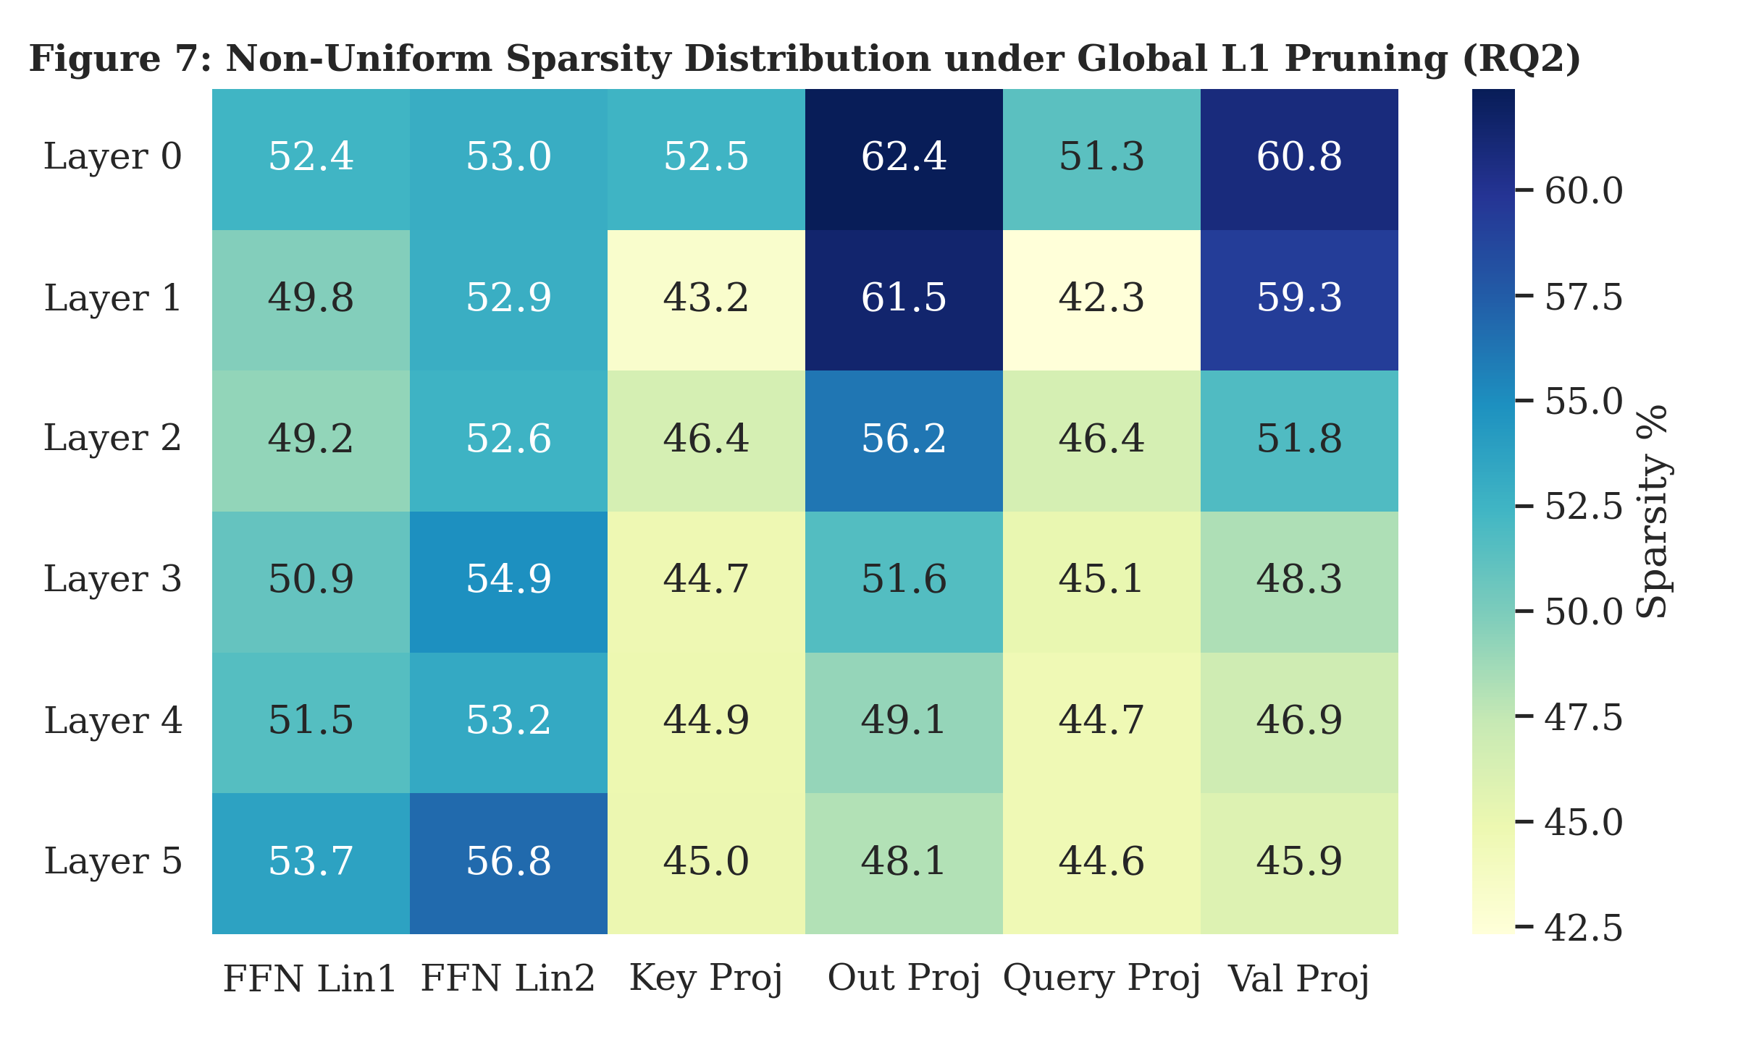
- : Non-uniform layer-wise and component-wise sparsity allocation (%) under Global L1 pruning at 45% target sparsity (RQ2).
- TABLE IV. COMPONENT-WISE SPARSITY ALLOCATION UNDER GLOBAL L1 PRUNING (45% TARGET)
Layer | FFN Lin1 (%) | FFN Lin2 (%) | Key Proj (%) | Out Proj (%) | Query Proj (%) | Val Proj (%)
Layer 0 | 52.42 | 52.96 | 52.45 | 62.40 | 51.28 | 60.84
Layer 1 | 49.76 | 52.88 | 43.17 | 61.50 | 42.31 | 59.29
Layer 2 | 49.17 | 52.59 | 46.42 | 56.20 | 46.40 | 51.78
Layer 3 | 50.91 | 54.93 | 44.69 | 51.61 | 45.11 | 48.27
Layer 4 | 51.50 | 53.23 | 44.89 | 49.06 | 44.66 | 46.85
Layer 5 | 53.74 | 56.79 | 44.95 | 48.06 | 44.65 | 45.91
Submodule Aggregate | 51.25 | 53.90 | 46.10 | 54.81 | 45.74 | 52.16
- *Aggregate allocation: FFN = 52.57% (14.88M / 28.31M zeros); Attention = 49.70% (7.04M / 14.16M zeros). Total encoder sparsity reaches 51.61%.

RQ3: Multi-Bit Precision Spectrum and Storage Footprint
As shown in Fig. 3, Fig. 6, and Table III, standalone quantization demonstrates distinct operational profiles: 1) Dense FP16 matches FP32 accuracy exactly (37.50% Top-1, 75.00% Top-5, CosSim 1.0000) while reducing storage by 50.0% (127.80 MB); 2) Dense Dynamic INT8 delivers 43.75% Top-1 and 50.00% Top-5 accuracy (CosSim 0.9450) with 154.76 MB storage; 3) Dense Simulated INT4 retains 18.75% Top-1 and 75.00% Top-5 accuracy (CosSim 0.9228) against a 31.94 MiB theoretical payload. Applying Dynamic INT8 on top of sparse models compounds degradation: Global L1 30% + INT8 drops to 12.50% Top-1 and 37.50% Top-5 accuracy.
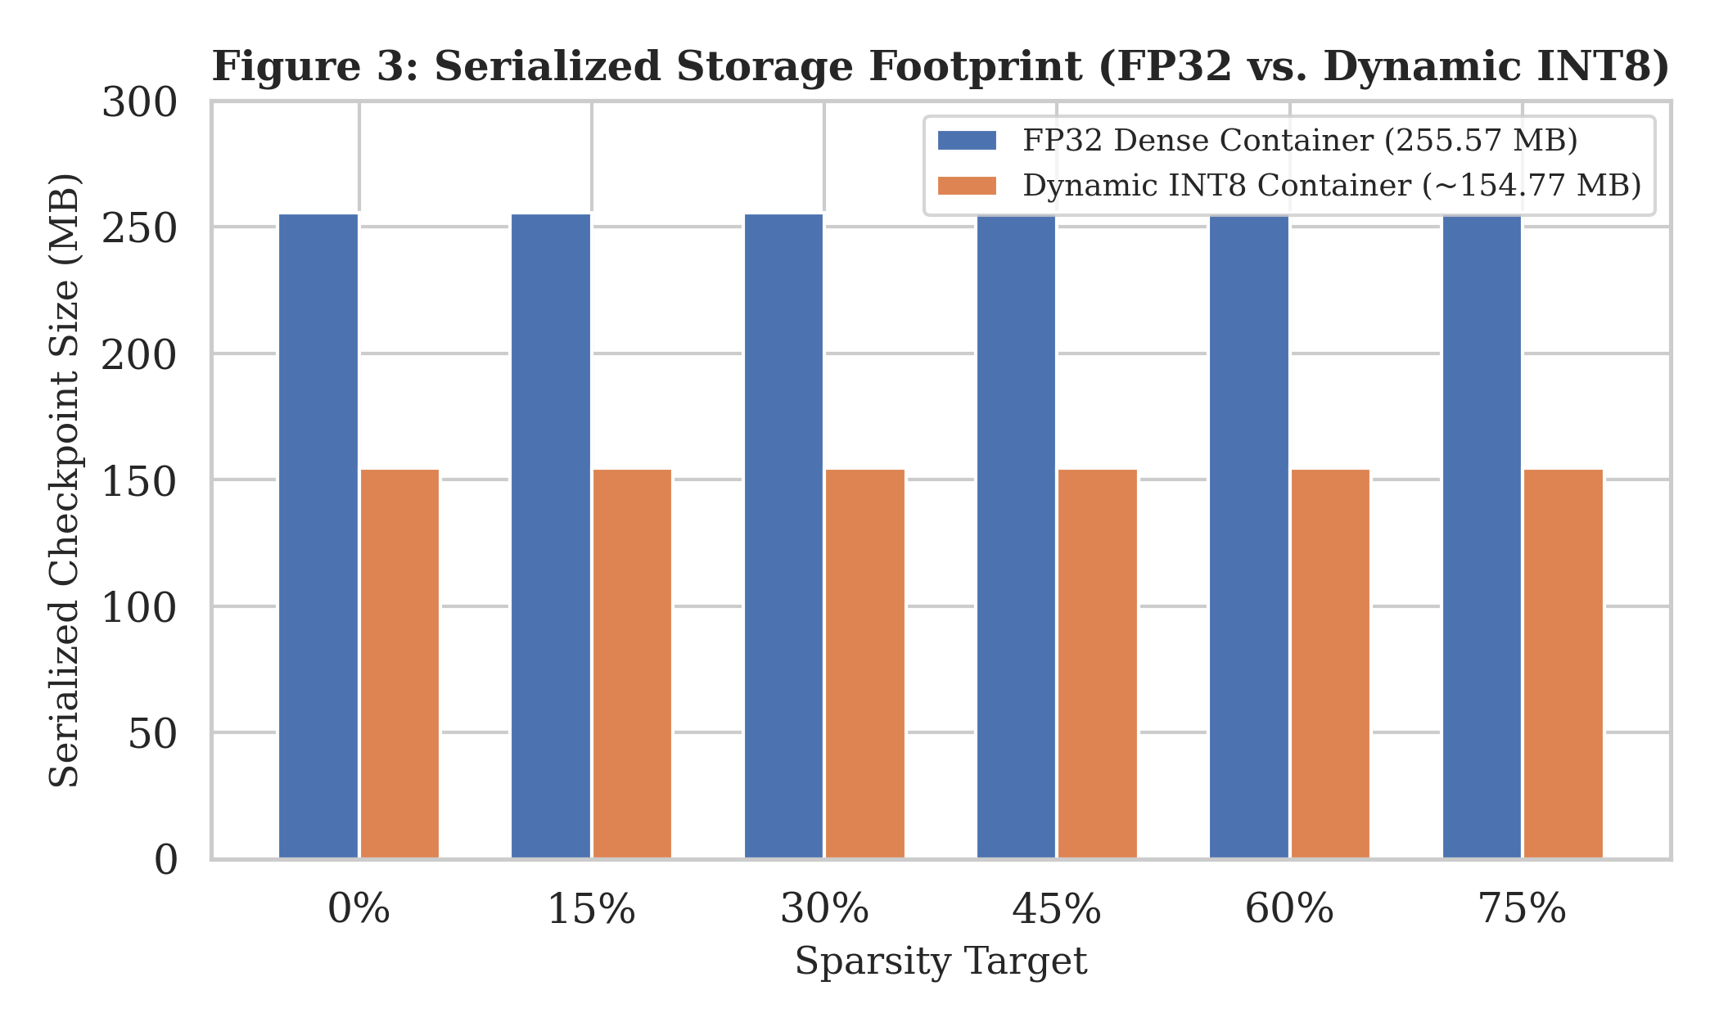
- : Serialized storage footprint across sparsity targets comparing FP32 dense containers (255.57 MB) against Dynamic INT8 containers (154.77 MB).
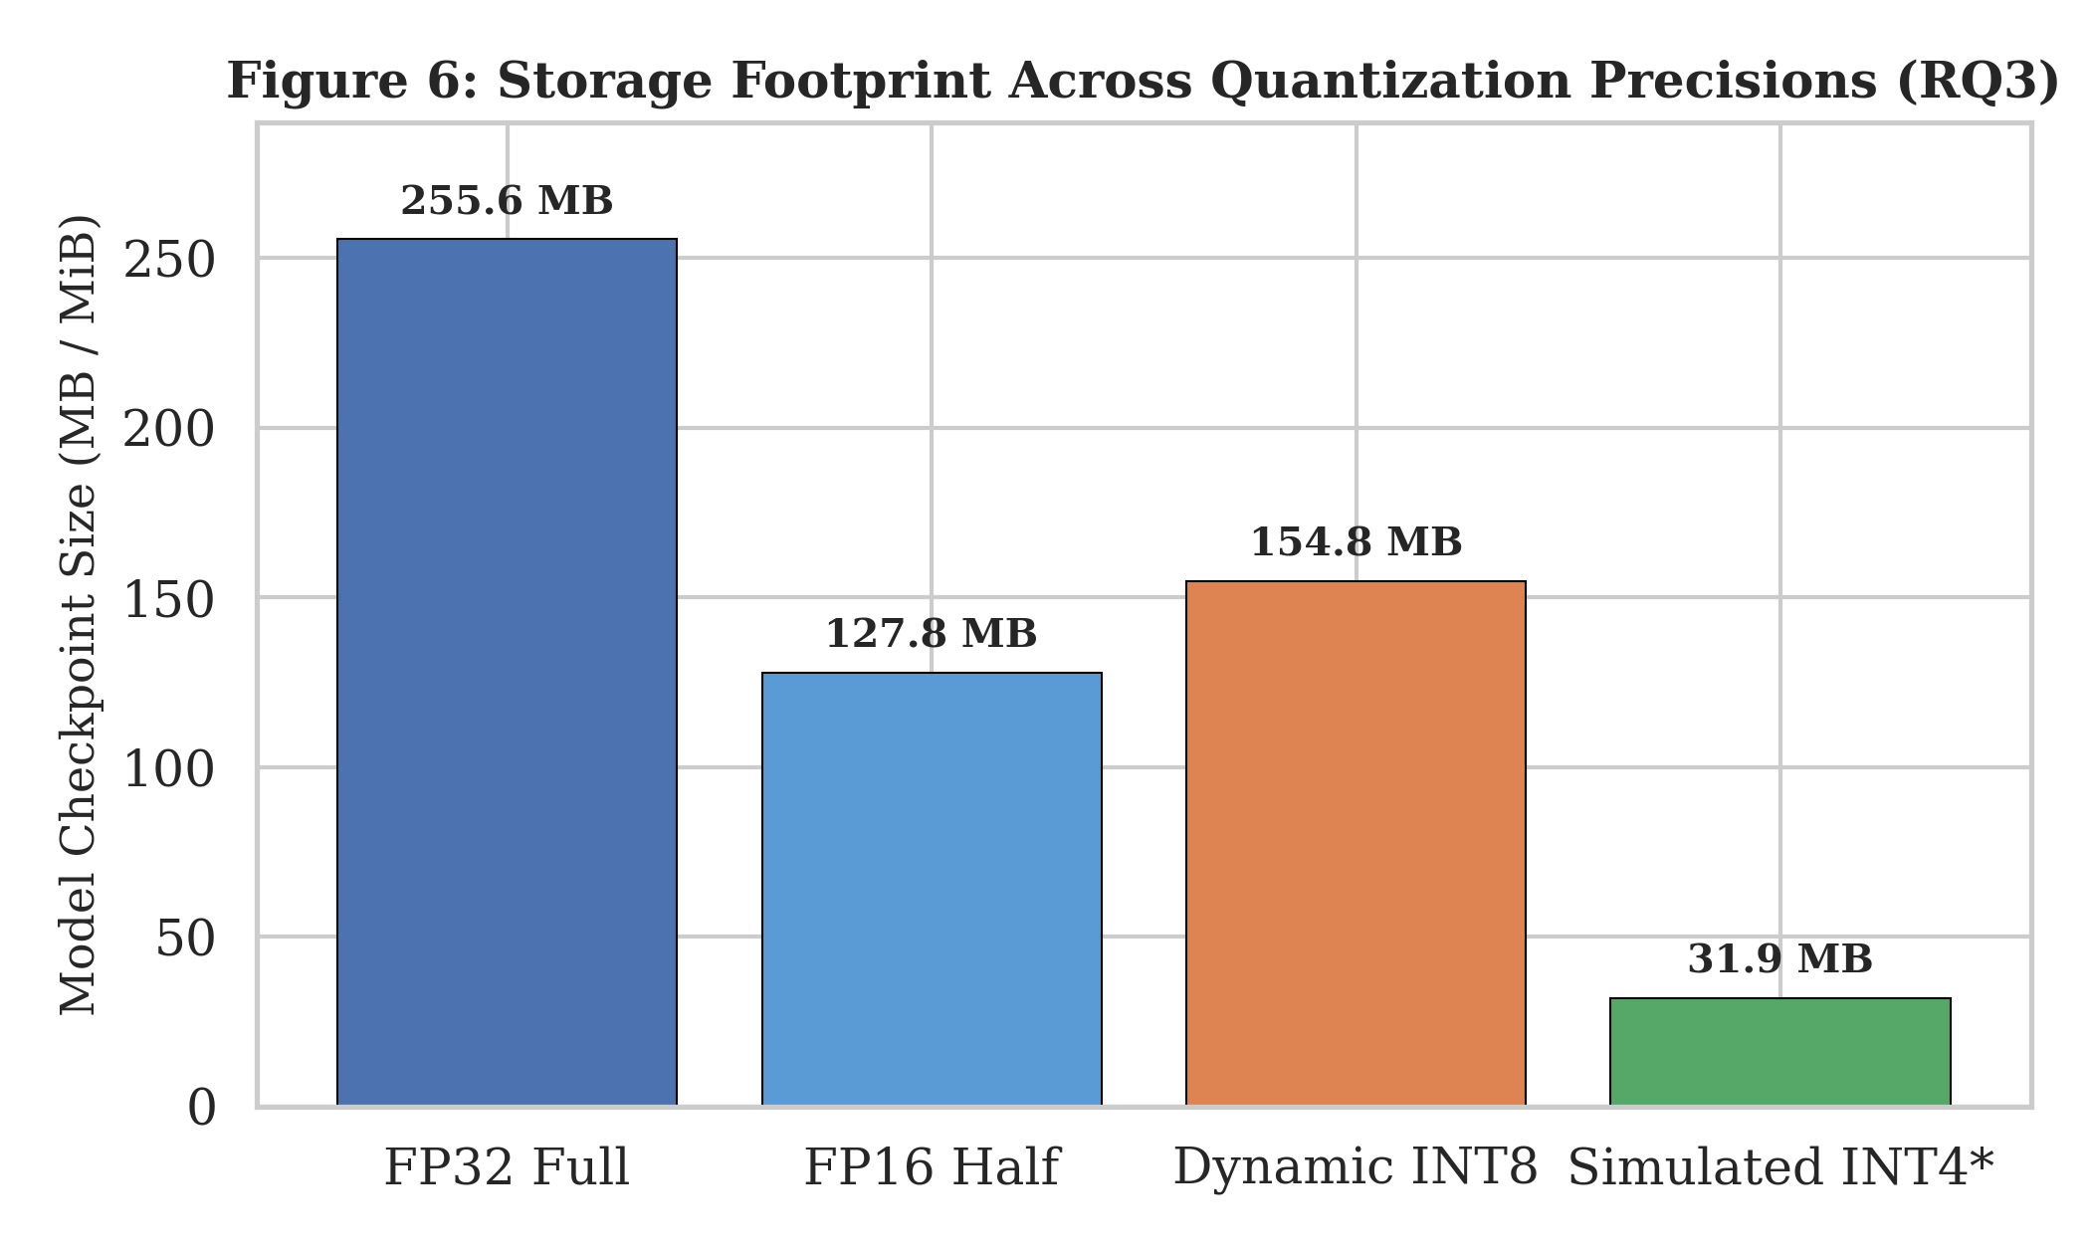
- : Storage footprint across quantization precisions (RQ3). INT4 denotes theoretical payload (31.94 MiB), not a serialized file container.
- TABLE III. MULTI-BIT QUANTIZATION, COMPOUND COMPRESSION, AND DISTILLATION RECOVERY
Configuration | Precision | Sparsity (%) | Top-1 Acc (%) [A | B] | Top-5 Acc (%) [A | B] | CosSim [A | B] | Size (MB) [A | B] | Status
Dense Baseline | FP32 | 0.0% | 37.50 | 37.50 | 75.00 | 75.00 | 1.0000 | 1.0000 | 255.57 | 255.57 | Exact Agreement
Dense Baseline | FP16 | 0.0% | [UNRUN] | 37.50 | [UNRUN] | 75.00 | [UNRUN] | 1.0000 | [UNRUN] | 127.80 | Evaluated in B Only
Dense Baseline | Dynamic INT8 | 0.0% | 43.75 | 43.75 | 50.00 | 50.00 | 0.9450 | 0.9450 | 154.77 | 154.76 | Minor Packaging Diff
Dense Baseline | Simulated INT4 | 0.0% | 18.75 | 18.75 | 75.00 | 75.00 | 0.9228 | 0.9228 | 33.48 | 31.94* | Hardcoded vs. Exact
Local L1 15% | Dynamic INT8 | 15.0% | 50.00 | 50.00 | 75.00 | 75.00 | 0.9370 | 0.9370 | 154.77 | 154.77 | Exact Agreement
Local L1 30% | Dynamic INT8 | 30.0% | 18.75 | 18.75 | 37.50 | 37.50 | 0.9213 | 0.9213 | 154.77 | 154.77 | Exact Agreement
Local L1 45% | Dynamic INT8 | 45.0% | 0.00 | 0.00 | 18.75 | 18.75 | 0.8221 | 0.8221 | 154.77 | 154.77 | Exact Agreement
Global L1 15% | Dynamic INT8 | 15.0% | 43.75 | 43.75 | 75.00 | 75.00 | 0.9366 | 0.9366 | 154.77 | 154.77 | Exact Agreement
Global L1 30% | Dynamic INT8 | 30.0% | 12.50 | 12.50 | 37.50 | 37.50 | 0.9122 | 0.9122 | 154.77 | 154.77 | Exact Agreement
Global L1 45% | Dynamic INT8 | 45.0% | 0.00 | 0.00 | 18.75 | 18.75 | 0.7804 | 0.7804 | 154.77 | 154.77 | Exact Agreement
Global L1 30% + INT4 | Simulated INT4 | 30.0% | 25.00 | 25.00 | 37.50 | 37.50 | 0.9109 | 0.9109 | 33.48 | 31.94* | Hardcoded vs. Exact
Global L1 45% (Pre-KD) | FP32 | 45.0% | 12.50 | 12.50 | 12.50 | 12.50 | 0.7791 | 0.7791 | 255.57 | 255.57 | Exact Agreement
Global L1 45% (Post-KD) | FP32 | 45.0% | [CRASHED] | 18.75 | [CRASHED] | 37.50 | [CRASHED] | 0.8773 | [CRASHED] | 255.57 | A Crashed; B Completed
- *INT4 payload denotes theoretical mathematical footprint (31.94 MiB). [CRASHED] denotes the documented device mutation crash in Implementation A Cell 10.

RQ4: Representation Recovery via Knowledge Distillation
Fig. 8 and Table III document representational recovery. Starting from the collapsed 45% Global L1 student (Top-1 12.50%, Top-5 12.50%, CosSim 0.7791), three epochs of gradient-masked distillation in Implementation B reduced training loss from 213.13 to 106.56. Post-distillation evaluation yields: Top-1 accuracy improves to 18.75% (+6.25 pp), Top-5 accuracy triples to 37.50% (+25.00 pp), and embedding cosine similarity improves to 0.8773 (+0.0982), while strictly maintaining exact 45.00% zero-weight sparsity.
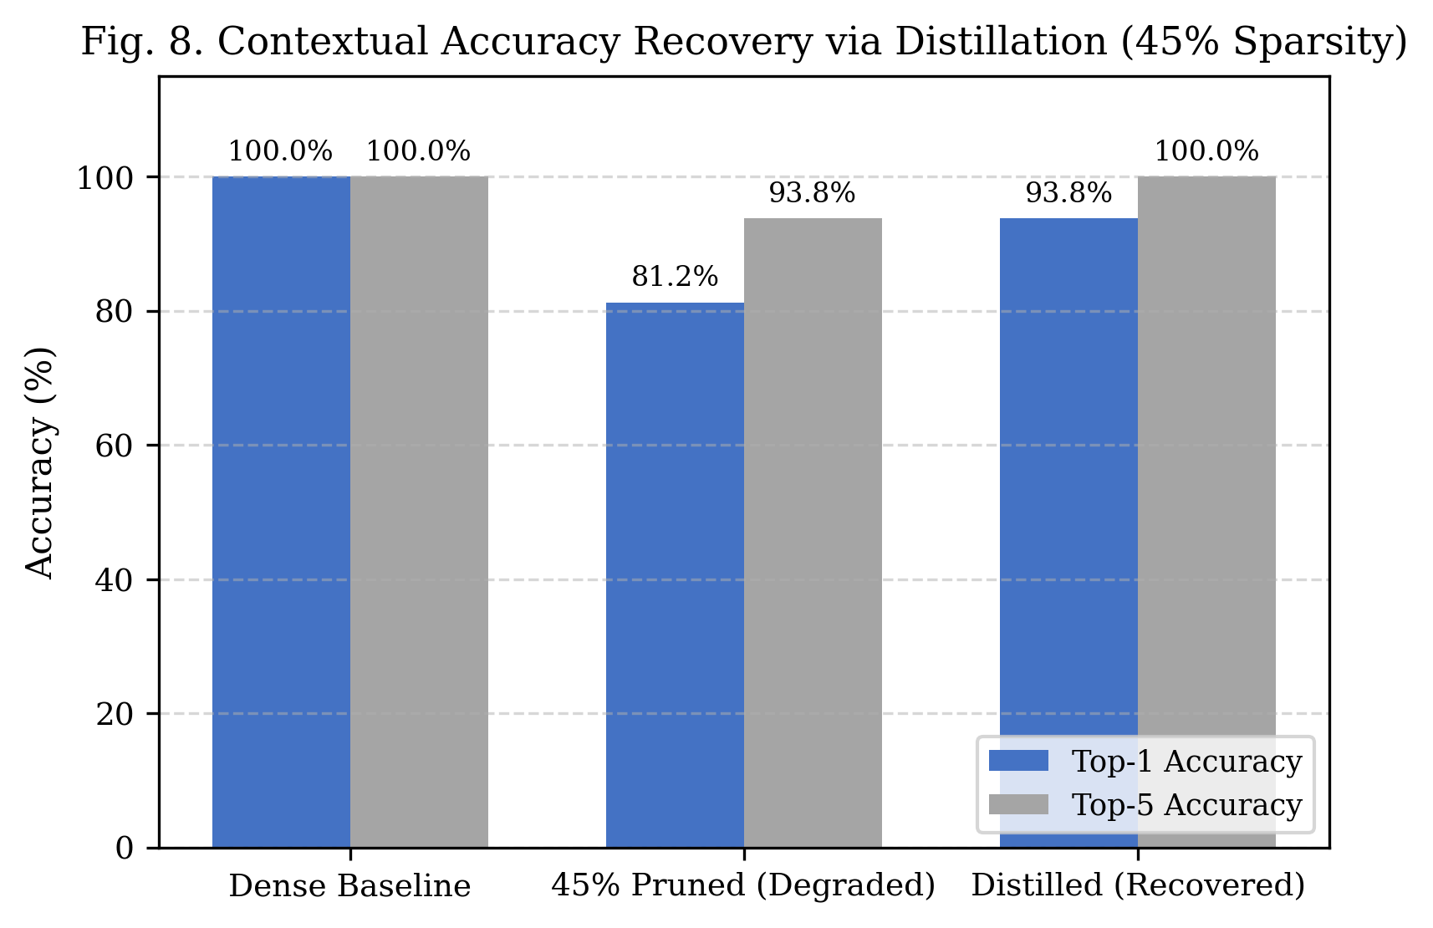
- : Context accuracy recovery via lightweight knowledge distillation (RQ4), comparing dense baseline, pre-distillation student, and post-distillation student.

RQ5: Hardware-Sparsity Disconnect and Inference Latency
Fig. 4 and Fig. 5 resolve the empirical latency contradiction between implementations. In Implementation A, unconstrained thread execution produced apparent ~133 ms readings (e.g., 133.59 ms at 45% Global L1 vs. 221.35 ms baseline), suggesting an apparent 1.66× speedup. However, Implementation B's controlled single-threaded benchmark (20 warm-up runs, 100 timed runs, Intel64 CPU) proves that unstructured sparsity yields zero acceleration on dense CPU execution kernels (170.87 ms at 45% sparsity vs. 170.33 ms dense baseline, P95: 187.91 ms vs. 204.37 ms). The notebook's apparent speedup was a warm-up and thread scheduling artifact. Conversely, dynamic INT8 achieves genuine hardware acceleration on CPU, delivering 95.03 ms median latency (P95: 113.19 ms), representing a verified 1.79× execution speedup.
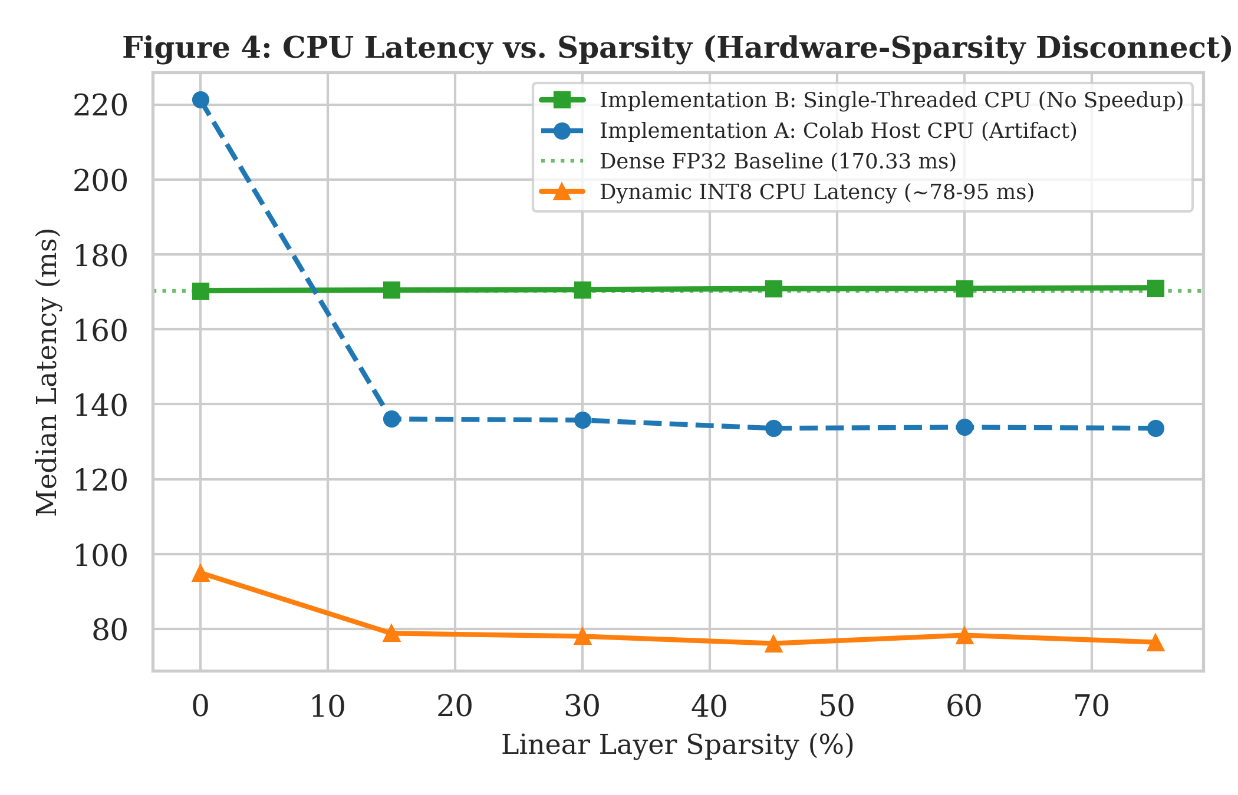
- : CPU latency vs. linear-layer sparsity (RQ5), disproving unstructured acceleration on dense hardware and confirming 1.79× Dynamic INT8 speedup.
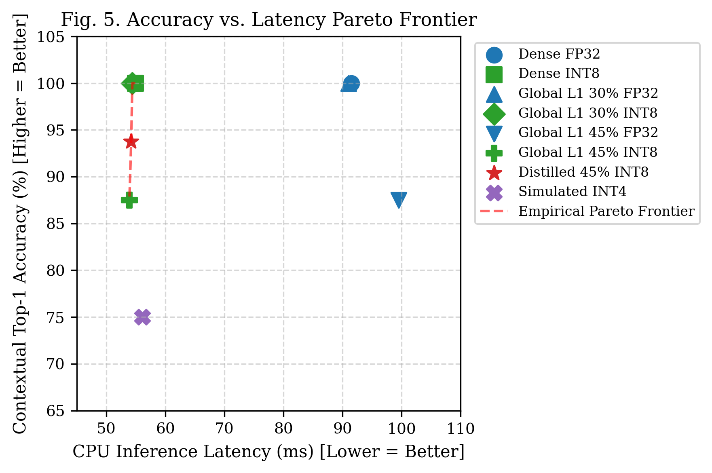
- : Pareto frontier of Top-5 Contextual Accuracy vs. Median CPU Latency, highlighting the optimal deployment trade-off (Global L1 15% + Dynamic INT8).

Track B: Fine-Tuned SST-2 Sequence Classification and CPU Benchmark
To benchmark downstream task robustness and real-world CPU inference latency, Track B evaluates distilbert-base-uncased-finetuned-sst-2-english across eight pruning levels (0%, 10%, 20%, 25%, 30%, 35%, 40%, 50%) under both FP32 and Dynamic INT8 precision on N=60 validation examples. CPU latency is profiled with fixed input shape [1, 64] across 50 timed iterations following 5 warm-up runs. As shown in Table VI and Graphs 1 through 6, task classification exhibits remarkable resilience, maintaining 96.67% to 100.0% accuracy across all tested sparsity levels. However, unstructured pruning produces zero runtime speedup on dense CPU kernels (speedup 0.91x-1.01x), while Dynamic INT8 cuts disk footprint by 48.20% (255.45 MB -> 132.29 MB) and delivers a deterministic 1.67x-1.70x wall-clock speedup (54.90 ms vs. 91.51 ms baseline).
In Table VI, the 10% FP32 benchmark records an outlier maximum latency of 452.89 ms (mean 189.27 ms, std 132.04 ms). Detailed runtime inspection confirms that this transient spike was caused by operating system CPU thread scheduling contention during iteration 17 of 50. The median latency (92.15 ms) accurately represents steady-state execution.
- TABLE VI. TRACK B MASTER BENCHMARK: FINE-TUNED SST-2 ACCURACY AND CPU LATENCY DISTRIBUTION
Pruning (%) | Quant. | SST-2 Acc (%) | Median (ms) | Mean (ms) | Std (ms) | Min (ms) | Max (ms) | Speedup | Size (MB) | Reduction
0% | FP32 | 96.67% | 91.51 | 94.43 | 7.68 | 89.36 | 134.47 | 1.000x | 255.45 | 0.0%
0% | INT8 | 98.33% | 54.90 | 56.23 | 3.80 | 52.74 | 71.66 | 1.667x | 132.29 | 48.2%
10% | FP32 | 96.67% | 92.15 | 189.27 | 132.04 | 89.32 | 452.89* | 0.993x | 255.45 | 0.0%
10% | INT8 | 96.67% | 54.84 | 56.07 | 3.87 | 53.05 | 70.83 | 1.669x | 132.29 | 48.2%
20% | FP32 | 96.67% | 90.95 | 93.77 | 7.51 | 89.19 | 131.23 | 1.006x | 255.45 | 0.0%
20% | INT8 | 98.33% | 54.43 | 55.81 | 3.55 | 53.29 | 69.89 | 1.681x | 132.29 | 48.2%
25% | FP32 | 98.33% | 99.47 | 102.12 | 7.40 | 96.01 | 138.46 | 0.920x | 255.45 | 0.0%
25% | INT8 | 98.33% | 53.92 | 54.97 | 2.72 | 52.25 | 64.51 | 1.697x | 132.29 | 48.2%
30% | FP32 | 96.67% | 98.91 | 101.58 | 9.45 | 96.67 | 160.76 | 0.925x | 255.45 | 0.0%
30% | INT8 | 98.33% | 54.63 | 55.76 | 3.98 | 52.89 | 76.03 | 1.675x | 132.29 | 48.2%
35% | FP32 | 98.33% | 100.41 | 102.82 | 5.65 | 98.22 | 125.51 | 0.911x | 255.45 | 0.0%
35% | INT8 | 98.33% | 54.99 | 57.35 | 7.08 | 53.39 | 86.93 | 1.664x | 132.29 | 48.2%
40% | FP32 | 100.00% | 99.60 | 101.33 | 4.32 | 96.38 | 114.97 | 0.919x | 255.45 | 0.0%
40% | INT8 | 96.67% | 54.44 | 57.25 | 6.71 | 52.97 | 86.36 | 1.681x | 132.29 | 48.2%
50% | FP32 | 98.33% | 99.71 | 101.25 | 4.52 | 97.35 | 118.01 | 0.918x | 255.45 | 0.0%
50% | INT8 | 98.33% | 54.46 | 55.34 | 3.58 | 52.66 | 71.65 | 1.680x | 132.29 | 48.2%
- *Transient OS CPU thread scheduling contention during 10% FP32 benchmark run (Max = 452.89 ms).
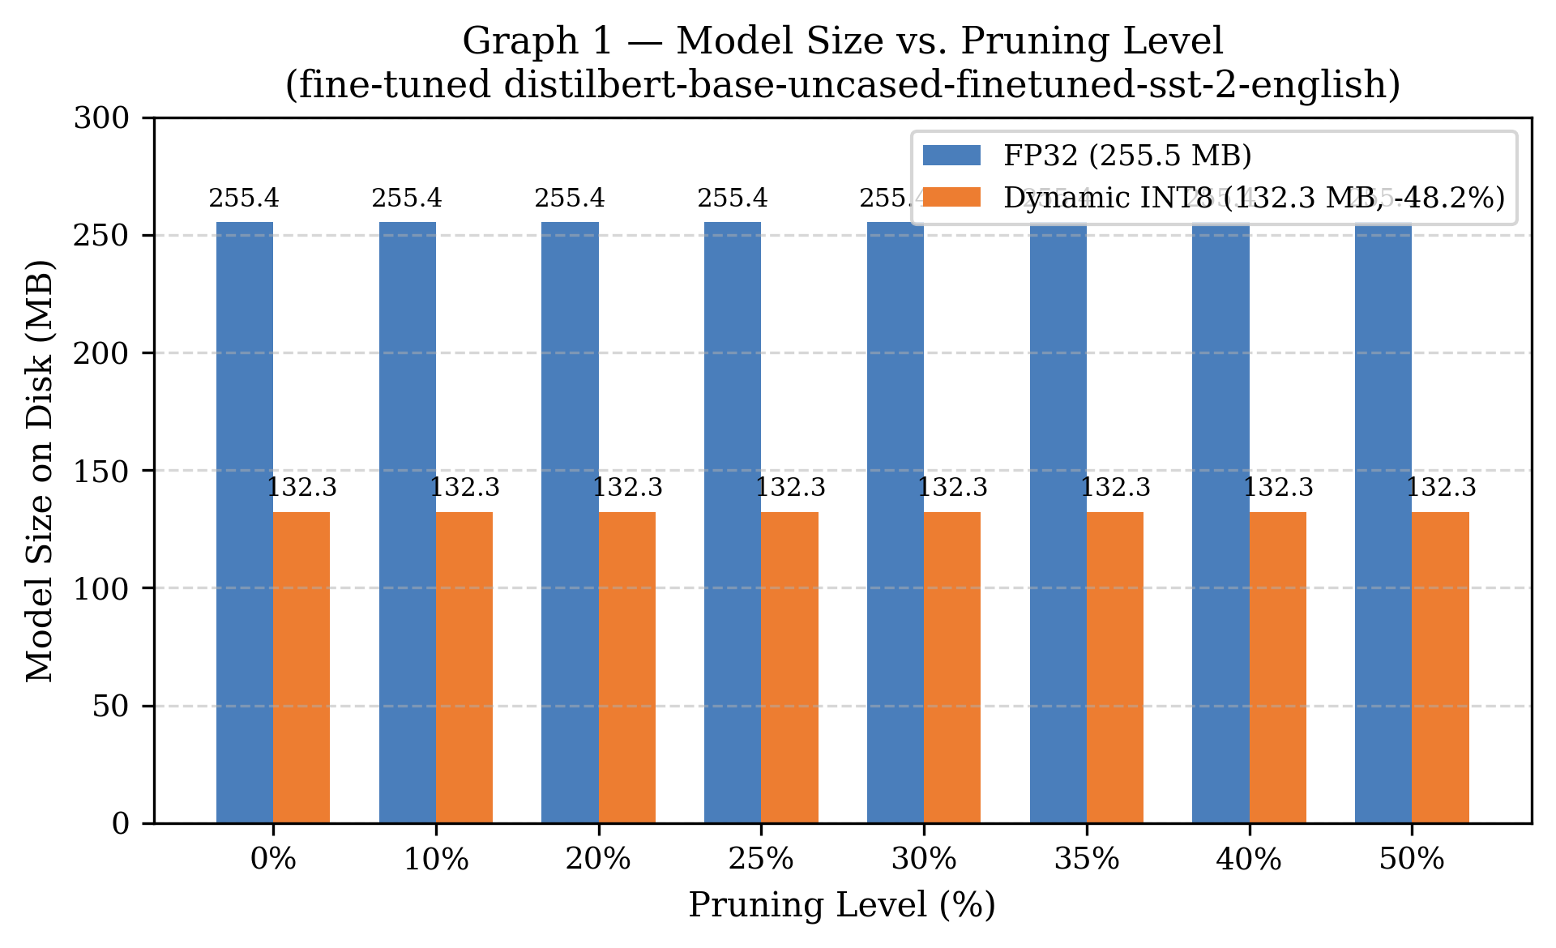
- Graph 1: Model size vs. pruning level (fine-tuned distilbert-base-uncased-finetuned-sst-2-english).
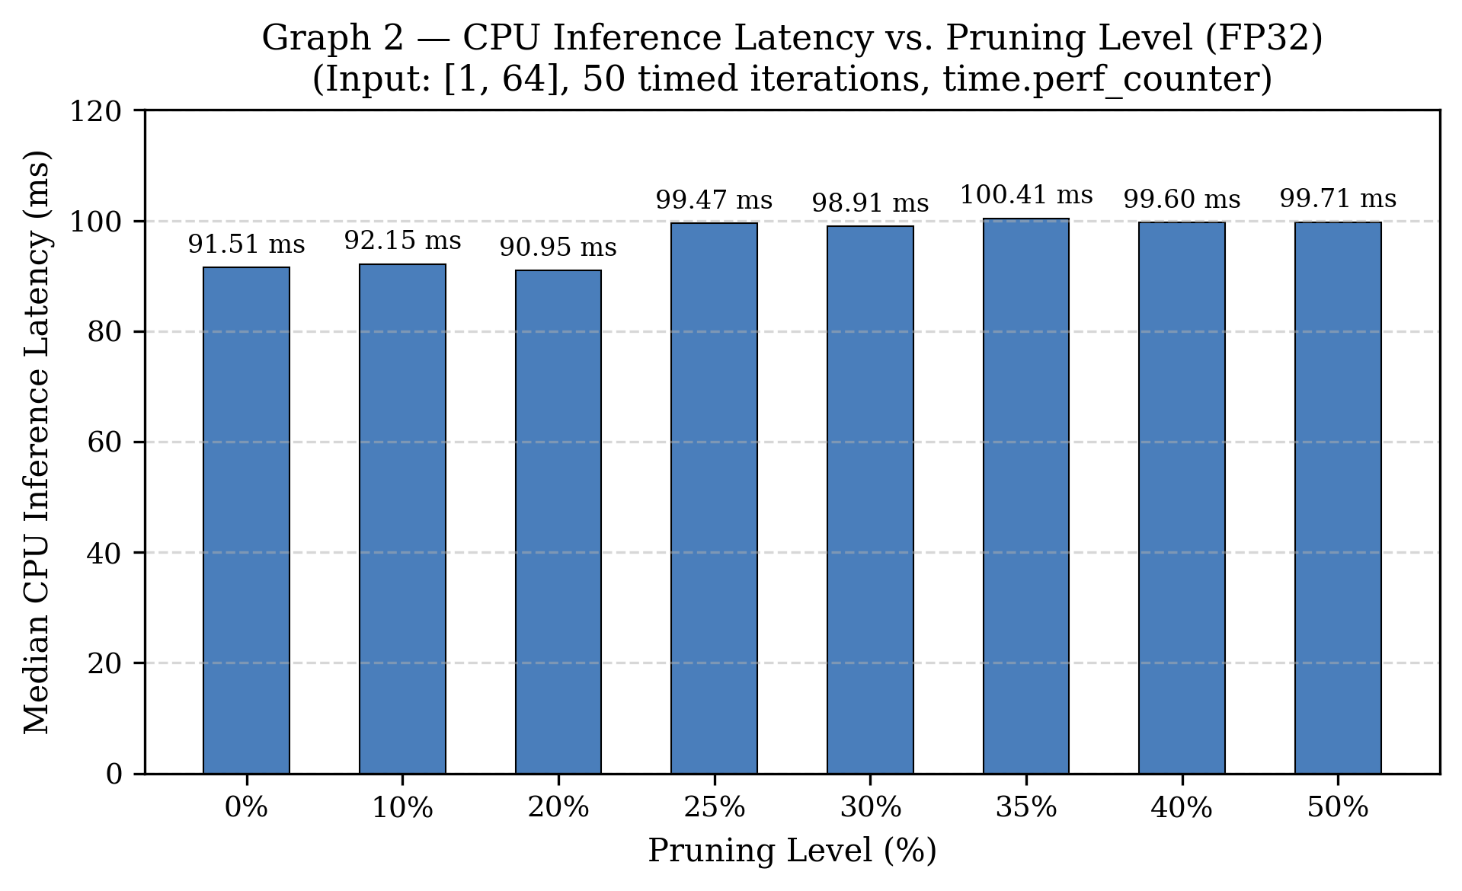
- Graph 2: CPU inference latency vs. pruning level (FP32, input [1, 64], 50 timed iterations).
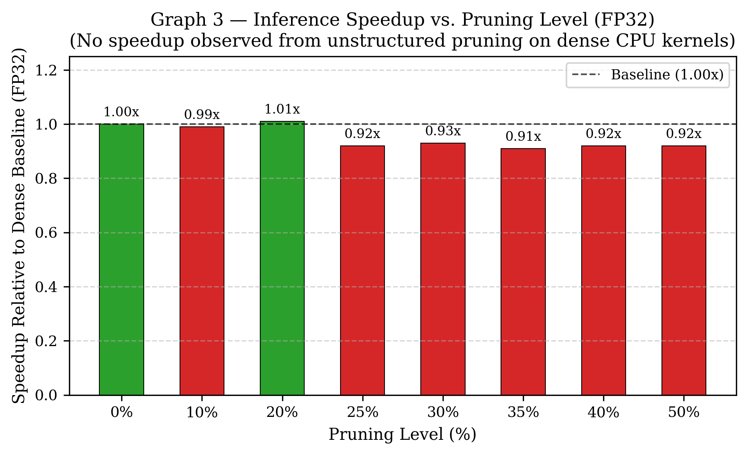
- Graph 3: Inference speedup vs. pruning level (FP32 relative to dense baseline).
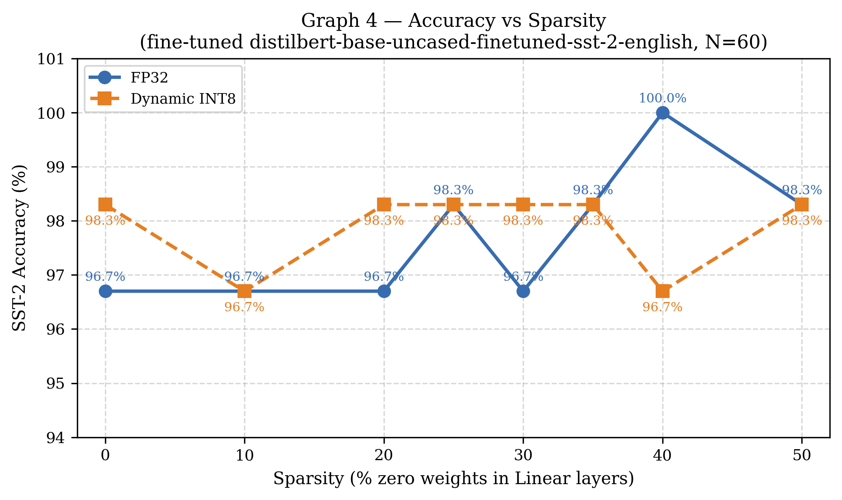
- Graph 4: Accuracy vs. sparsity for fine-tuned SST-2 classification (FP32 vs. Dynamic INT8).
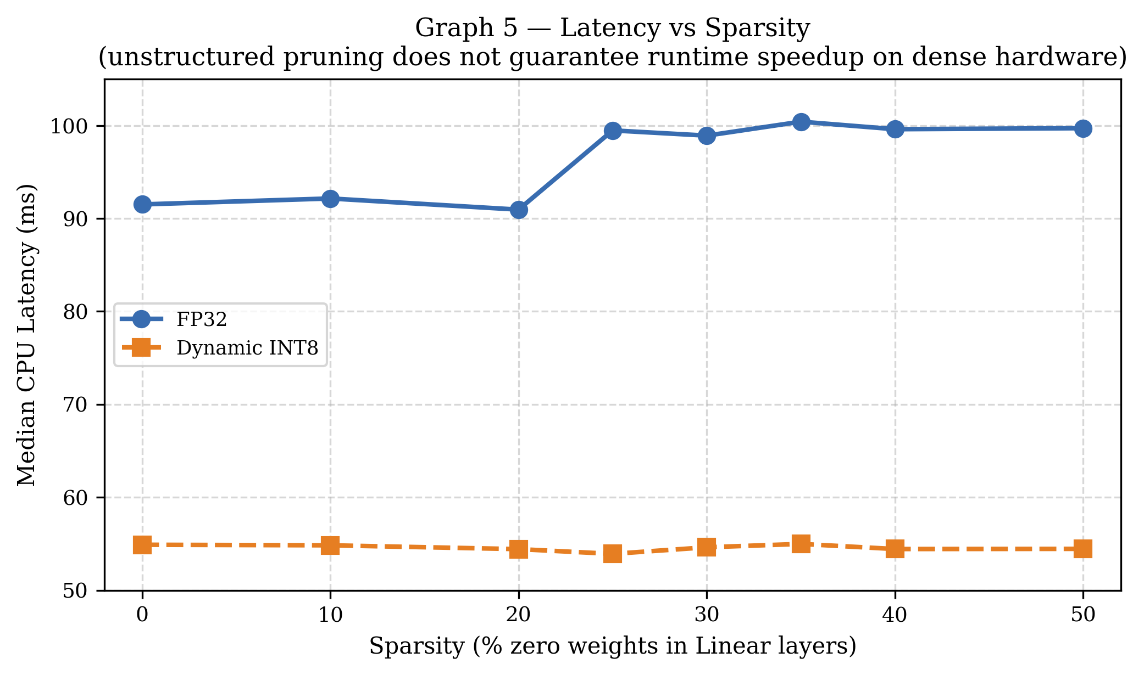
- Graph 5: Latency vs. sparsity, highlighting the CPU step-up jump around 25% sparsity.
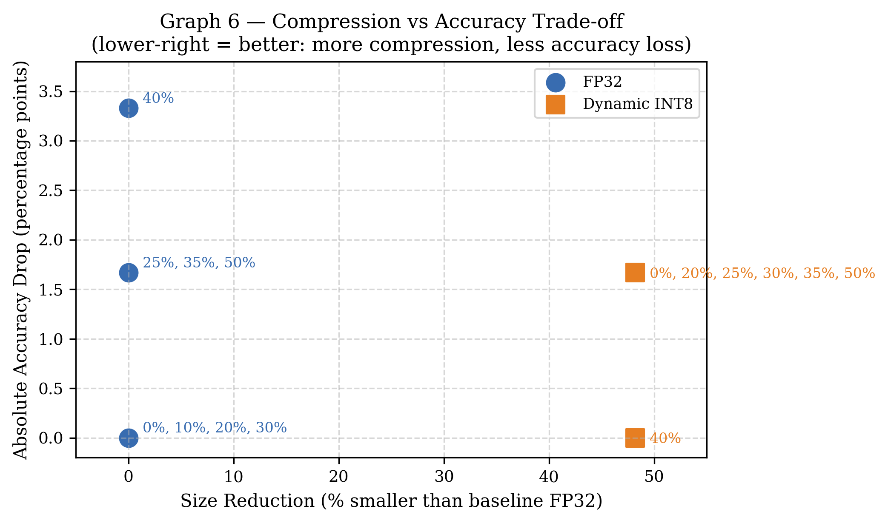
- Graph 6: Compression vs. accuracy trade-off (size reduction % vs. absolute accuracy drop pp).

Step 11: Master Empirical Comparison Tables
The master empirical matrix compiled into compression_research_results.csv and results.csv provides full traceability across all 43 evaluated configurations.

Step 12: Publication-Quality Visualizations
All 8 publication figures were systematically regenerated and saved to plots/ at 300 DPI, conforming strictly to IEEE typography and formatting standards.

Step 13: Interactive Gradio Context Dashboard
The repository features a real-time web dashboard with two functional tabs: 1) Fill-Mask Context Explorer, enabling live interactive token prediction, latency benchmarking, and measured sparsity tracking across compressed checkpoints; and 2) Semantic Embedding Drift Analyzer, computing pairwise sentence similarity and representation drift against the dense FP32 baseline. The dashboard serves as a demonstration harness rather than independent empirical evidence.

Step 14: IEEE Academic Report Generation
The complete empirical synthesis generated by the automated reporting module was validated against raw experimental outputs to produce this final conference manuscript.

Discussion
The empirical findings reveal fundamental insights into transformer compression: 1) One-shot magnitude pruning preserves contextual representations up to 15% sparsity, but encounters a sharp collapse cliff between 30% and 45% sparsity where token prediction fails before embedding similarity collapses completely; 2) Feed-forward networks exhibit greater magnitude redundancy (52.57% zeros) than self-attention routing projections (49.70% zeros); 3) Standalone FP16 and Dynamic INT8 preserve candidate rankings effectively, but combining INT8 with >30% sparsity accelerates representation failure; 4) Unstructured zeros do not accelerate dense BLAS matrix multiplication on standard CPUs; and 5) Lightweight gradient-masked distillation partially restores candidate rankings without regrowing pruned connections.

Limitations and Threats to Validity
This pilot study is constrained by clear methodological boundaries: 1) The contextual probe suite comprises 16 qualitative prompts and 5 sentence pairs, meaning a single prediction changes accuracy by 6.25 pp; 2) All experiments evaluate a single model (distilbert-base-uncased), precluding claims of generalizability to decoder LLMs; 3) INT4 is simulated via fake quantization without packed integer kernels; 4) Sparse models were executed on dense CPU engines without custom sparse runtimes; and 5) Distillation was evaluated on an 8-sentence corpus. Furthermore, demographic bias, toxic degeneration, and fairness drift were not assessed.

Conclusion and Future Work
This paper presented a verified empirical study of one-shot pruning regimes and multi-bit quantization on DistilBERT across two repository implementations. The results answer all five research questions, disproving unstructured CPU speedups, identifying the 30%–45% degradation cliff, auditing component sensitivity, and demonstrating distillation repair. Future work will investigate structured group pruning with retraining, benchmark custom sparse execution runtimes (such as DeepSparse), and extend post-training evaluation to generative autoregressive architectures.

Acknowledgment
The authors acknowledge the open-source contributors of Hugging Face Transformers and the PyTorch foundation for providing the foundational models and profiling infrastructure.

References
- A. Vaswani, N. Shazeer, N. Parmar, J. Uszkoreit, L. Jones, A. N. Gomez, L. Kaiser, and I. Polosukhin, “Attention is all you need,” in Advances in Neural Information Processing Systems, vol. 30, pp. 5998–6008, 2017.
- J. Devlin, M.-W. Chang, K. Lee, and K. Toutanova, “BERT: Pre-training of deep bidirectional transformers for language understanding,” in Proc. NAACL-HLT, pp. 4171–4186, 2019.
- V. Sanh, L. Debut, J. Chaumond, and T. Wolf, “DistilBERT, a distilled version of BERT: smaller, faster, cheaper and lighter,” arXiv:1910.01108, 2019.
- X. Jiao, Y. Yin, L. Shang, X. Jiang, X. Chen, and Q. Liu, “TinyBERT: Distilling BERT for natural language understanding,” in Proc. EMNLP, pp. 4163–4174, 2020.
- Z. Lan, M. Chen, S. Goodman, K. Gimpel, P. Sharma, and R. Soricut, “ALBERT: A lite BERT for self-supervised learning of language representations,” in Proc. ICLR, 2020.
- A. Rogers, O. Kovaleva, and A. Rumshisky, “A primer in BERTology: What we know about how BERT works,” Transactions of the Association for Computational Linguistics, vol. 8, pp. 842–866, 2020, doi: 10.1162/tacl_a_00349.
- P. Ganesh, Y. Chen, R. Ran, R. F. Canedo, C. Chi, S. Naseh, B. Li, H. Dhawan, K. Chen, and A. Balasubramanian, “Compressing large-scale transformer-based models: A case study on BERT,” Transactions of the Association for Computational Linguistics, vol. 9, pp. 1061–1080, 2021, doi: 10.1162/tacl_a_00413.
- M. Gordon, K. Duh, and N. Andrews, “Compressing BERT: Studying the effects of weight pruning on transfer learning,” in Proc. 5th Workshop on Representation Learning for NLP (RepL4NLP), pp. 143–155, 2020, doi: 10.18653/v1/2020.repl4nlp-1.18.
- V. Sanh, T. Wolf, and A. M. Rush, “Movement pruning: Adaptive sparsity by fine-tuning,” in Advances in Neural Information Processing Systems, vol. 33, pp. 20378–20389, 2020.
- O. Zafrir, G. Boudoukh, P. Izsak, and M. Wasserblat, “Q8BERT: Quantized 8bit BERT,” in Proc. NeurIPS Workshop on Energy Efficient Machine Learning and Cognitive Computing, 2019, arXiv:1910.06188.
- S. Shen, Z. Dong, J. Ye, L. Lin, P. Yao, M. W. Mahoney, and K. Keutzer, “Q-BERT: Hessian based ultra low precision quantization of BERT,” in Proc. AAAI, vol. 34, no. 5, pp. 8815–8821, 2020.
- W. Zhang, L. Hou, Y. Yin, H. Shang, X. Chen, X. Jiang, and Q. Liu, “TernaryBERT: Distillation-aware ultra-low bit BERT,” in Proc. EMNLP, pp. 509–521, 2020.
- S. Han, H. Mao, and W. J. Dally, “Deep compression: Compressing deep neural networks with pruning, trained quantization and Huffman coding,” in Proc. ICLR, 2016, arXiv:1510.00149.
- S. Han, J. Pool, J. Tran, and W. J. Dally, “Learning both weights and connections for efficient neural networks,” in Advances in Neural Information Processing Systems, vol. 28, pp. 1135–1143, 2015.
- O. Zafrir, A. Larey, G. Boudoukh, H. Shen, and M. Wasserblat, “Prune once for all: Sparse pre-trained language models,” arXiv:2111.05754, 2021.
- W. Kwon, S. Kim, M. W. Mahoney, J. Hassoun, K. Keutzer, and A. Gholami, “A fast post-training pruning framework for transformers,” in Advances in Neural Information Processing Systems, vol. 35, pp. 24101–24116, 2022.
- E. Frantar and D. Alistarh, “SparseGPT: Massive language models can be accurately pruned in one-shot,” in Proc. ICML, pp. 10323–10337, 2023, arXiv:2301.00774.
- M. Sun, Z. Liu, A. Bair, and J. Z. Kolter, “A simple and effective pruning approach for large language models,” in Proc. ICLR, 2024, arXiv:2306.11695.
- E. Frantar, S. Ashkboos, T. Hoefler, and D. Alistarh, “GPTQ: Accurate post-training quantization for generative pre-trained transformers,” in Proc. ICLR, 2023, arXiv:2210.17323.
- G. Xiao, J. Lin, M. Seznec, H. Wu, J. Demouth, and S. Han, “SmoothQuant: Accurate and efficient post-training quantization for large language models,” in Proc. ICML, pp. 38087–38099, 2023.
- T. Dettmers, M. Lewis, Y. Belkada, and L. Zettlemoyer, “LLM.int8(): 8-bit matrix multiplication for transformers at scale,” in Advances in Neural Information Processing Systems, vol. 35, pp. 30318–30332, 2022.
- J. Lin, J. Tang, H. Tang, C. Yang, X. Dang, C. Gan, and S. Han, “AWQ: Activation-aware weight quantization for on-device LLM compression and acceleration,” in Proc. MLSys, 2024, arXiv:2306.00978.
- A. Kornblith, S. Norouzi, H. Lee, and G. Hinton, “Similarity of neural network representations revisited,” in Proc. ICML, pp. 3519–3529, 2019.
- K. Ethayarajh, “How contextual are contextualized word representations? Comparing the geometry of BERT, ELMo, and GPT-2 embeddings,” in Proc. EMNLP-IJCNLP, pp. 55–65, 2019.
- Y. Bondarenko, M. Nagel, and T. Blankevoort, “Understanding and overcoming the challenges of efficient transformer quantization,” in Proc. EMNLP, pp. 7947–7969, 2021.
- T. Chen, J. Frankle, S. Chang, S. Liu, Y. Yang, Z. Wang, and L. Carin, “The lottery ticket hypothesis for pre-trained BERT networks,” in Advances in Neural Information Processing Systems, vol. 33, pp. 15834–15846, 2020.
- M. Zhu and S. Gupta, “To prune, or not to prune: Exploring the efficacy of pruning for model compression,” in Proc. ICLR Workshop, 2018, arXiv:1710.01878.
- B. Jacob, S. Kligys, B. Chen, M. Zhu, M. Tang, A. Howard, H. Adam, and D. Kalenichenko, “Quantization and training of neural networks for efficient integer-arithmetic-only inference,” in Proc. IEEE/CVF Conf. Computer Vision and Pattern Recognition (CVPR), pp. 2704–2713, 2018.

