RabbitMQ

RabbitMQ Server
- Messages
- Exchanges
- Binding
- Queues
This RabbitMQ system then will closely look at the Erlang Engine and of the processes that run. It is asynchronous messaging to decouple your systems for easy scalable system. RabbitMQ will connect and then send and consume messages.

Why we need RabbitMQ and what does it
First, it will decouple our application in a way that is asynchronous so we can publish to the broker and can enqueue them to work later. So, the actual publishing and working with the message is not in the same timeframe for instance and it’s not even coupled to one another.

The other thing is the application don’t even have to know that they exist. You can use patterns like Publish and subscribe where you publish an event and don’t even know if there is one or more subscribers to this message.
Decoupling
- Asynchronous work
- Applications
- Patterns: RPC, Pub/Sub
Suppose, App1 and App2 will publish it to the message broker that is RabbitMQ. Then there is another application App3 which will consume App1 and App2 and simultaneously publish it to the Message broker called RabbitMQ. The main advantage is that each application knows the existence of only broker not any other application and if some more Apps also want to publish and consume something they can do without changing the existing application code and structure. So, there is no coupling except the coupling through the broker in this entire course of action.

Another thing that comes for free with a message broker is something like load balancing by enqueuing.so, effectively push lots of messages and there is no consumer or two to few consumers to handle. But queues are effectively loading balancing. Our load and all publishing applications have free resources instead of waiting for an online response.

There are few important points you must know before using any message brokers.
- Use dumb brokers (Because they put your logic inside the message broker).
- No Logic
- Only Routing

If we have lots of messaging patterns, then why do we use RabbitMQ
- Open Source
- Well, designed as lots of protocols are there.
- AMQP
- Building in clustering
- Optimized for throughput.
Drawbacks of RabbitMQ
- Lots of configuration
- Queues have lots of properties.

RabbitMQ is a message broker. It means it sits between two applications and passes messages from one application to another.
Suppose we have OrderService and PaymentService.
OrderService ------------>RabbitMQ----------------PaymentService.
Instead of OrderService directly calling PaymentService, it can put message into RabbitMQ.

- Without RabbitMQ
Suppose a customer place an order.
Client---------Order Service------via HTTP----Payment Service.

Order Service needs to know: -
- PaymentService URL.
- Payment Service is running.
- How to call it Api
- What happens if payment service is down.
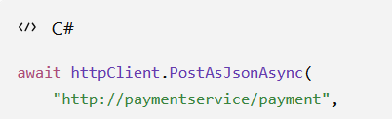
Then we need to use HTTP client like above. This is synchronous communication.

- With RabbitMQ

Client -----Order Service --------RabbitMQ-----------Payment Service

OrderService says:
! "Here is a message: Order #123 has been created."

RabbitMQ stores/delivers that message.
PaymentService receives it and processes payment.
The important difference is:

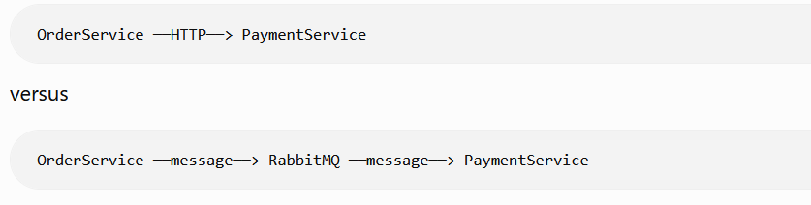

- What’s exactly is the message.

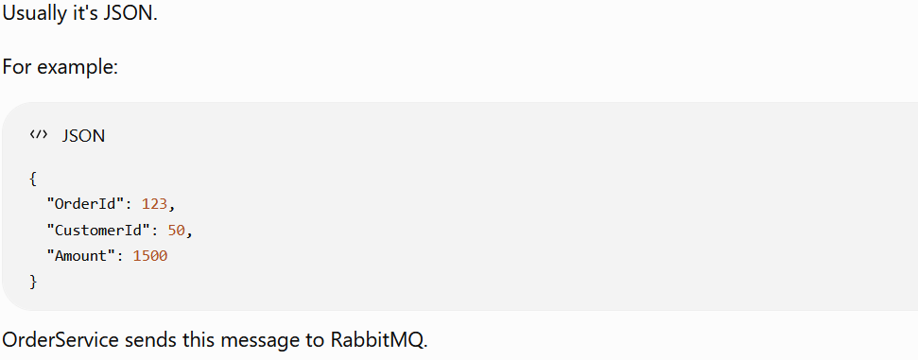

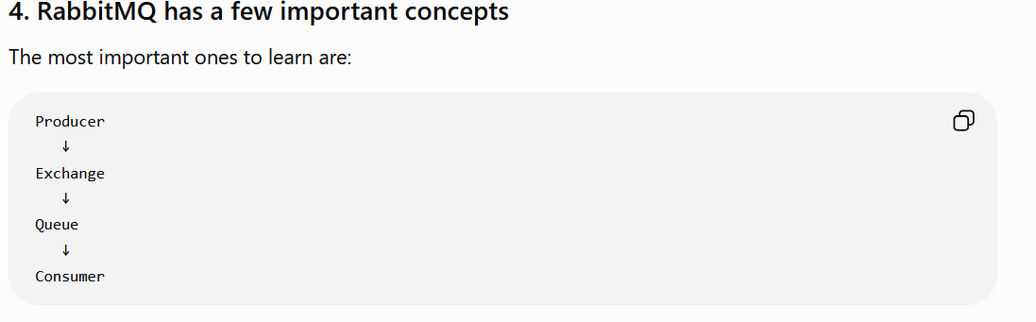

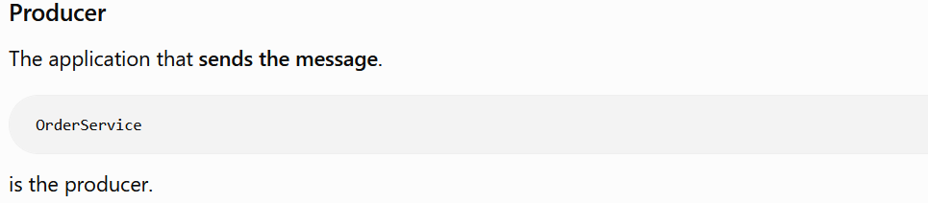

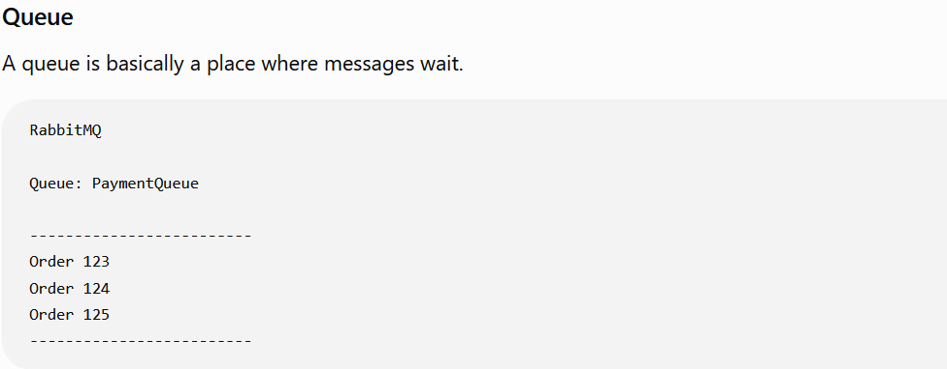

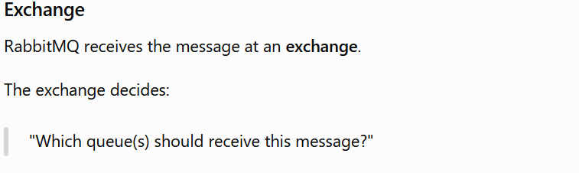

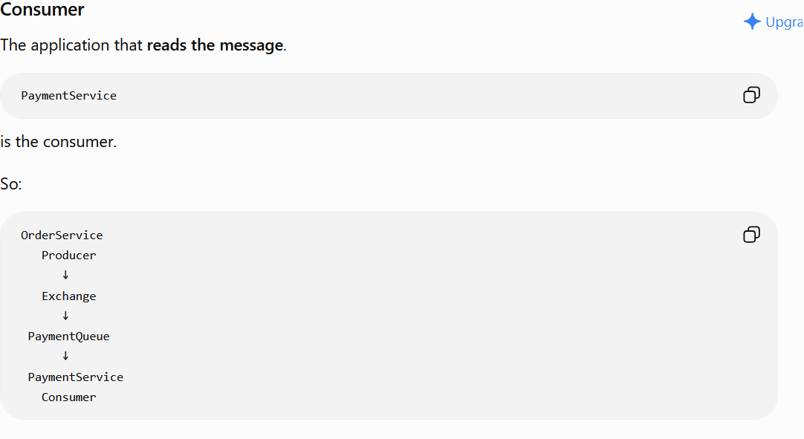

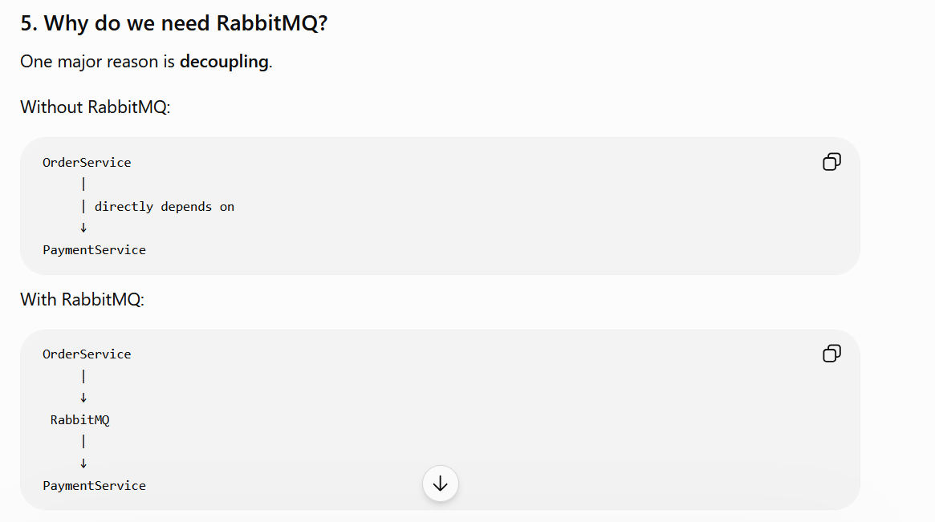

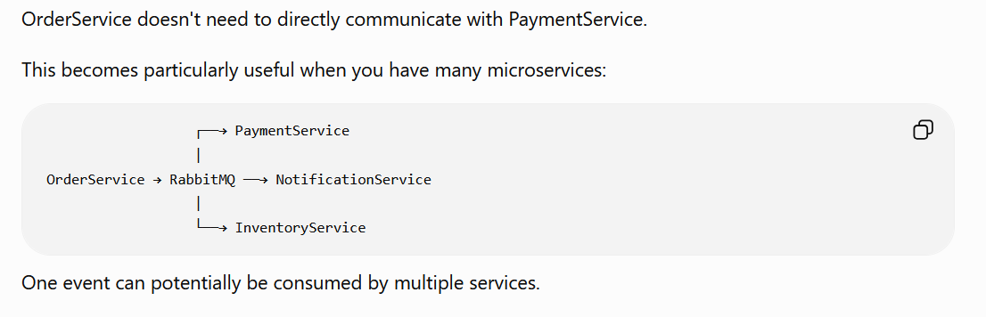

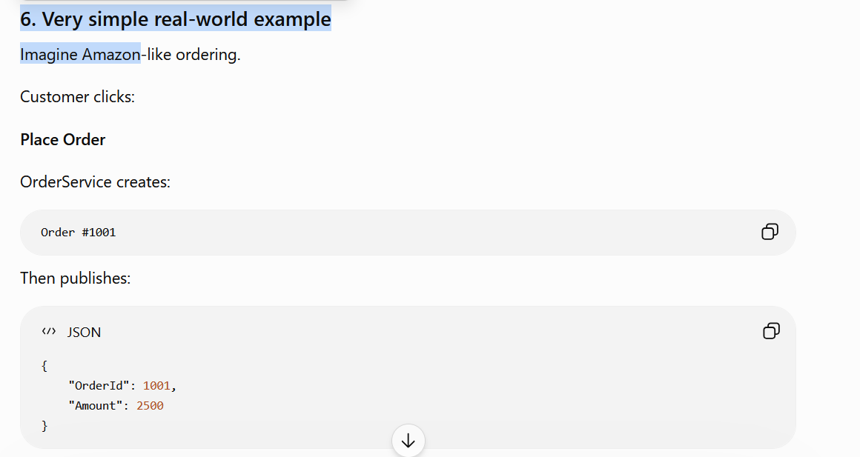

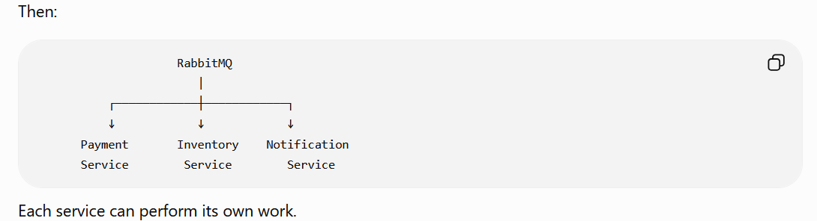

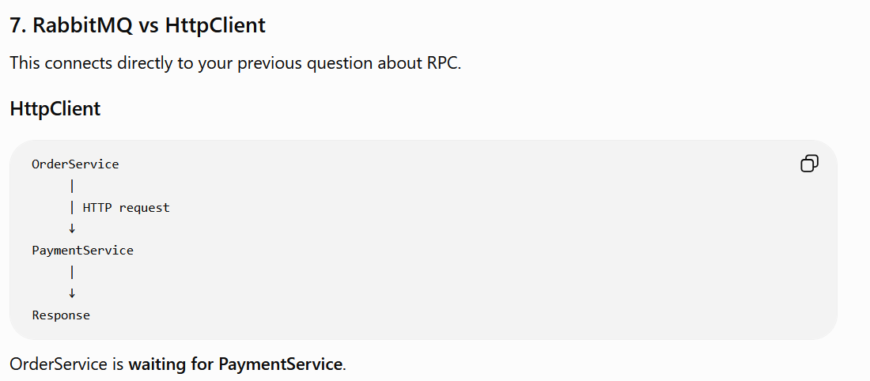

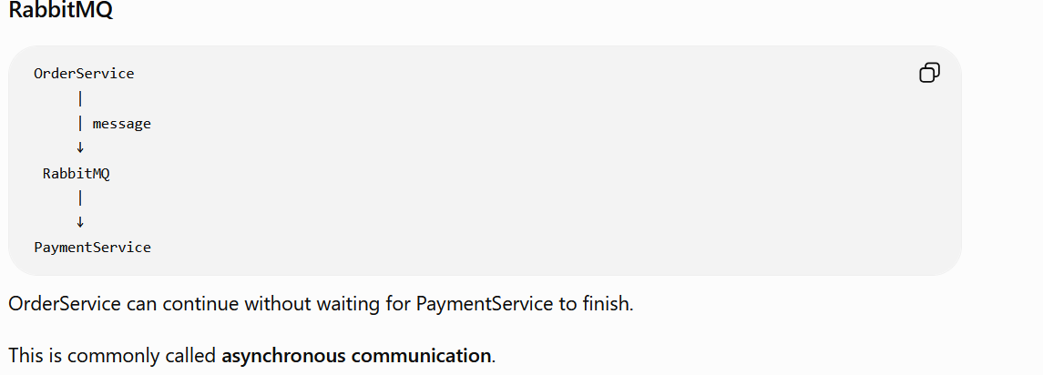

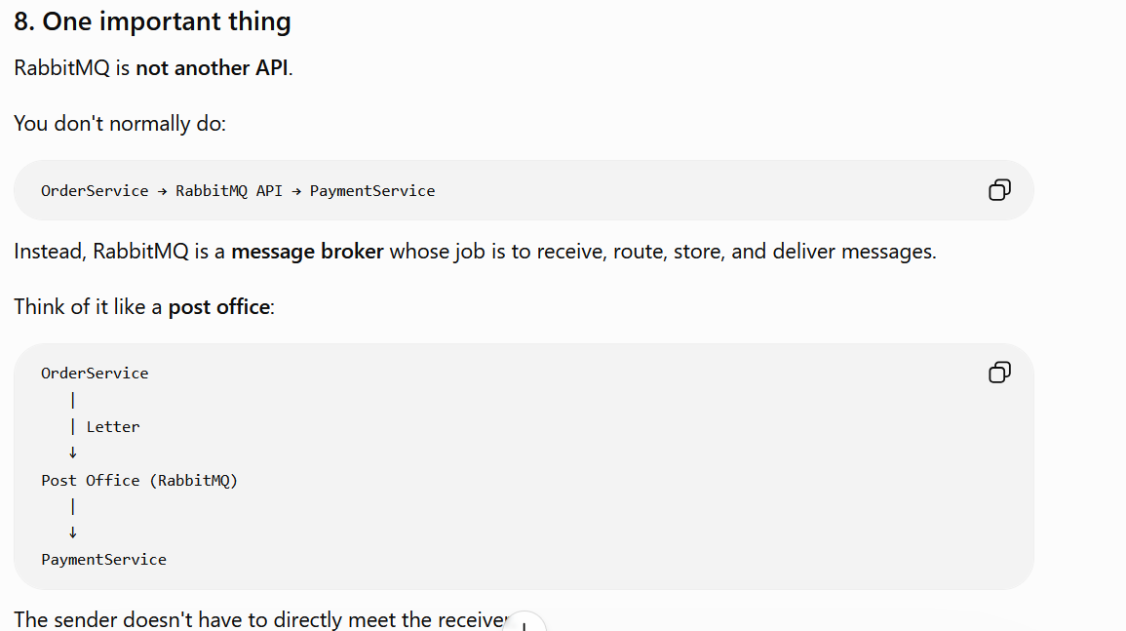

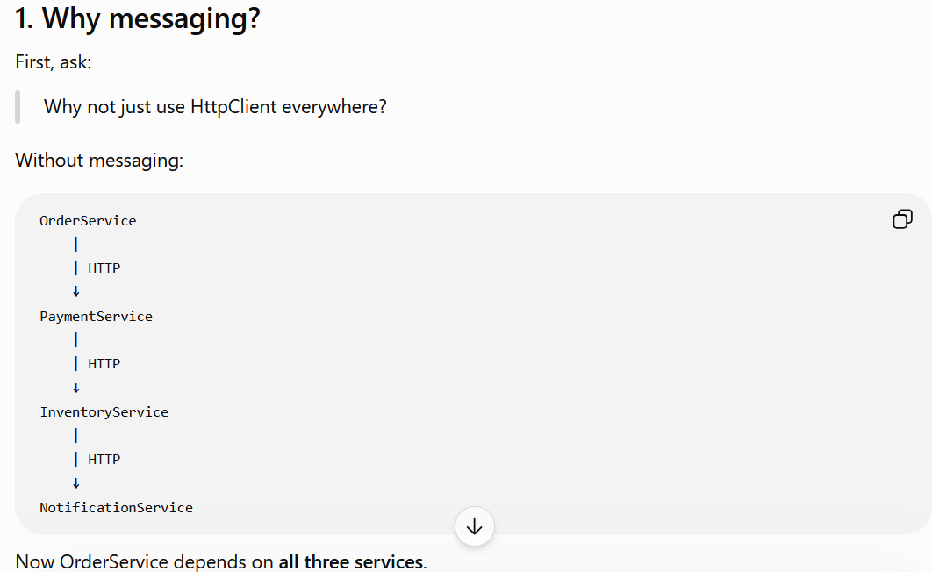

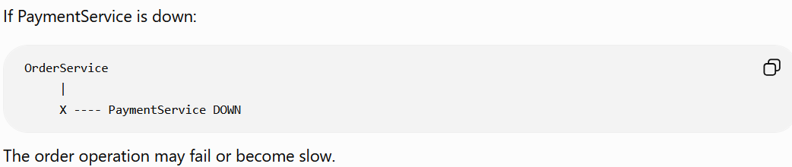

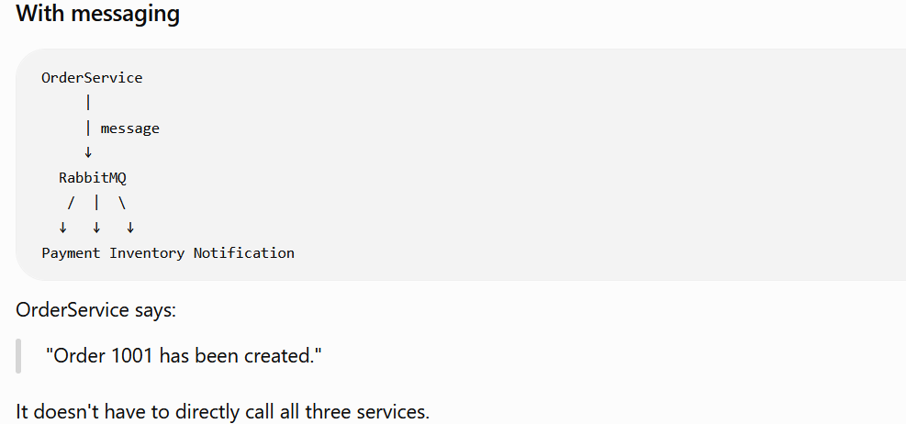

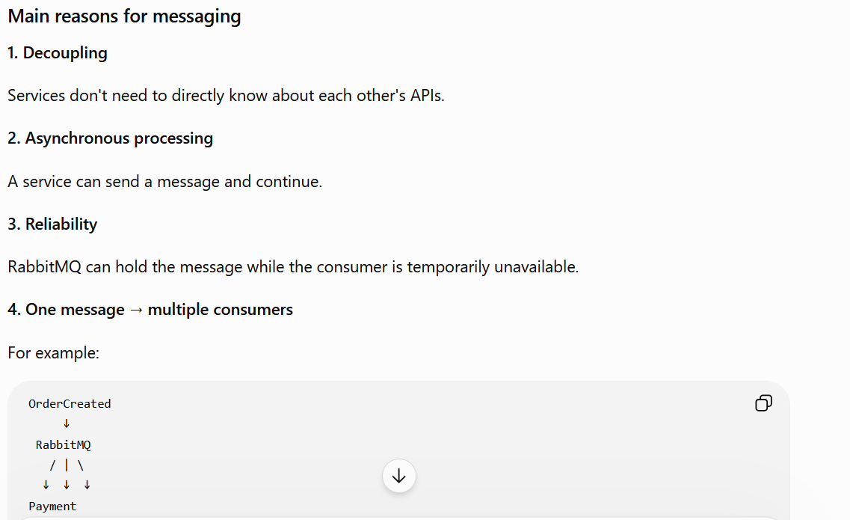

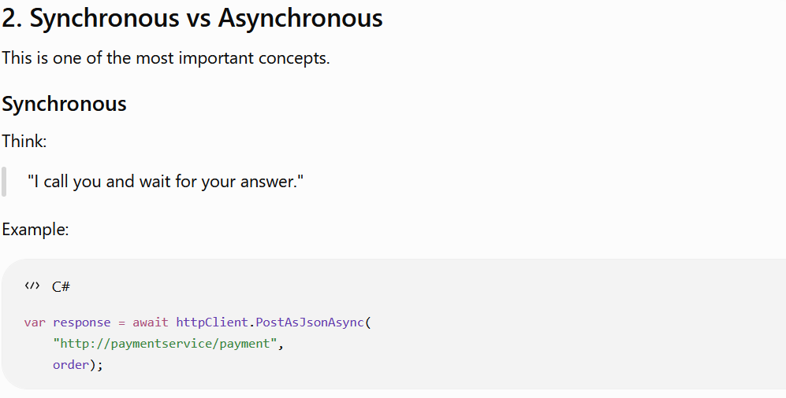

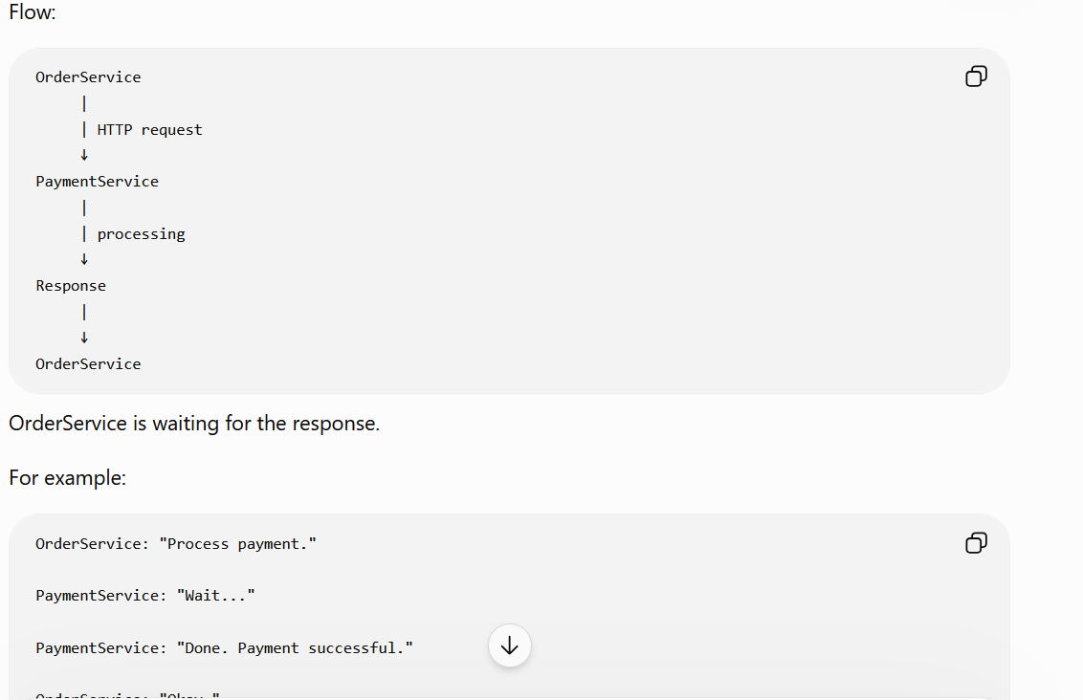

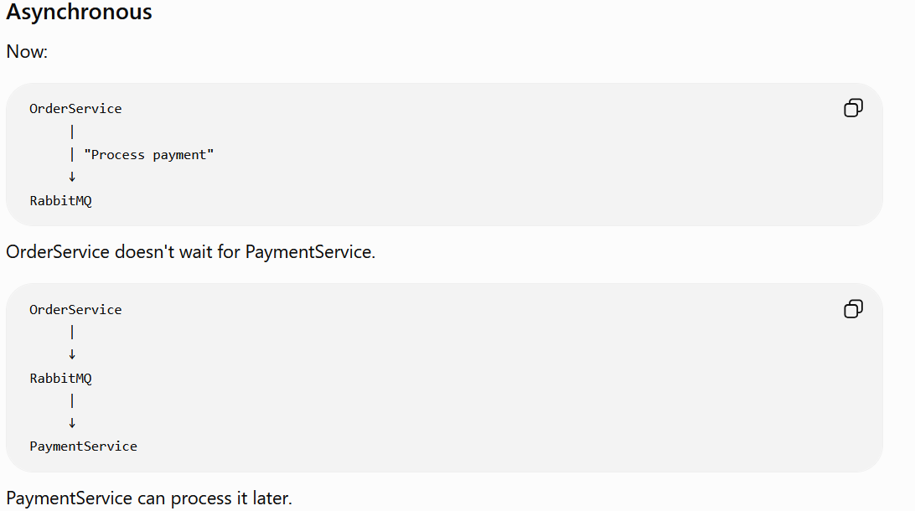

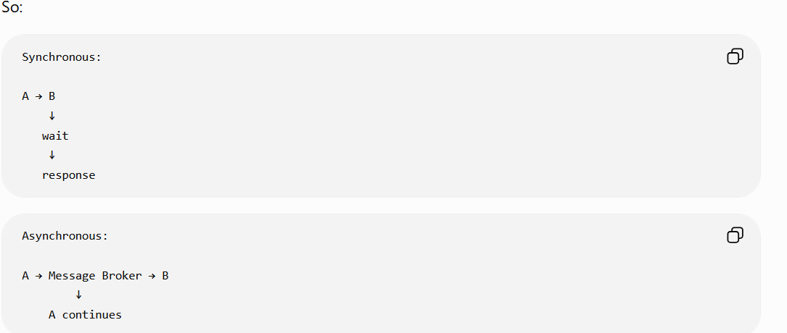

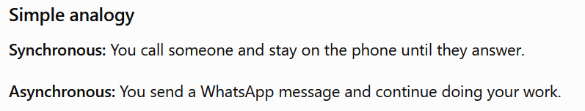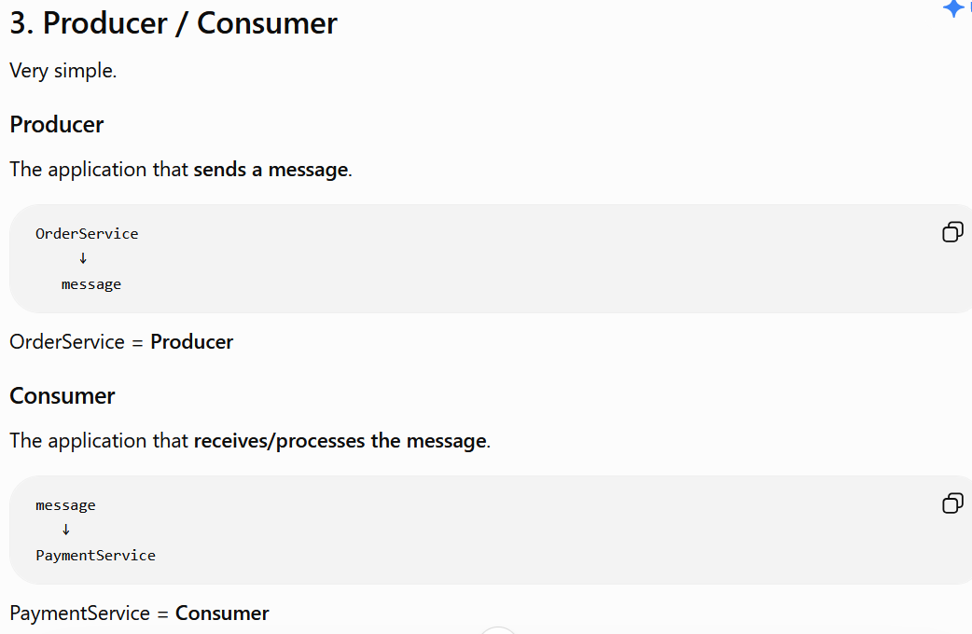

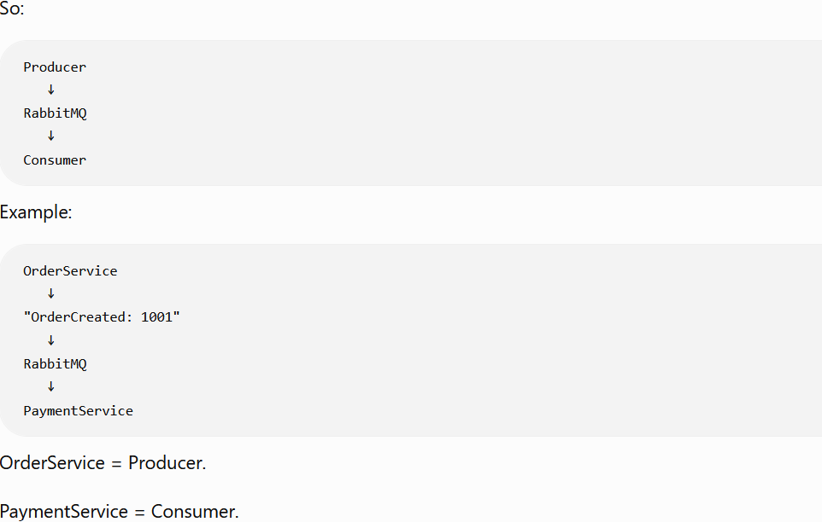

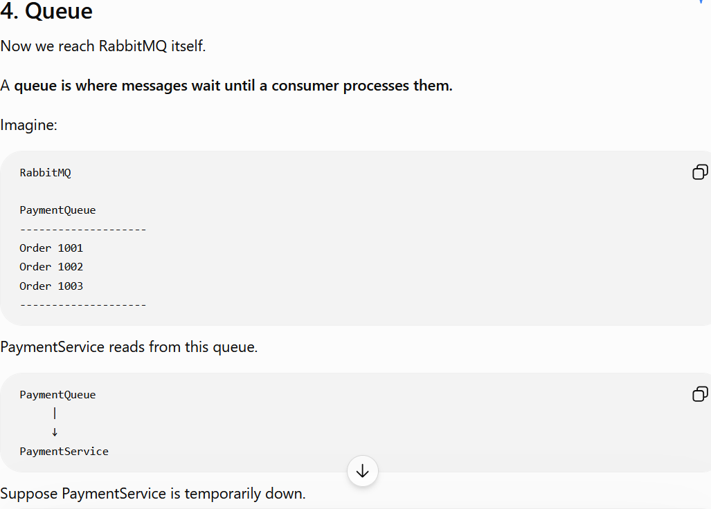

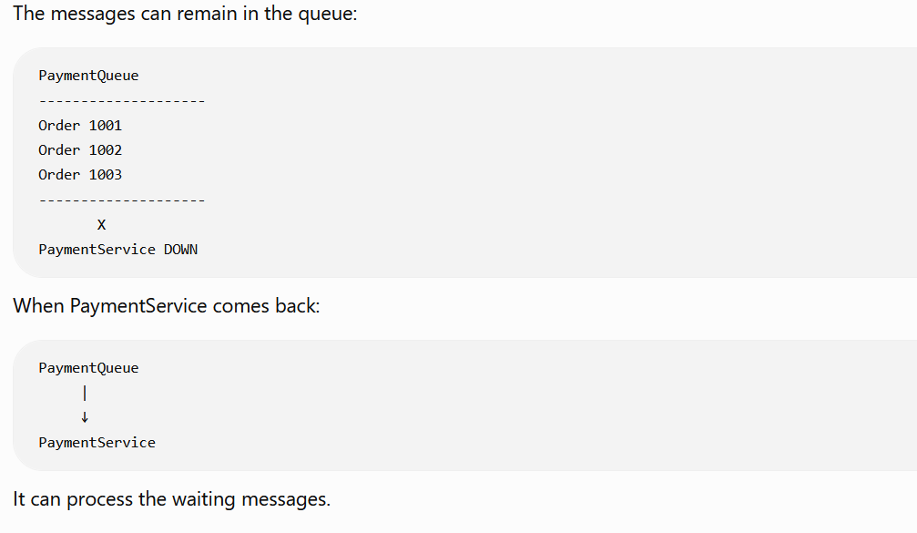

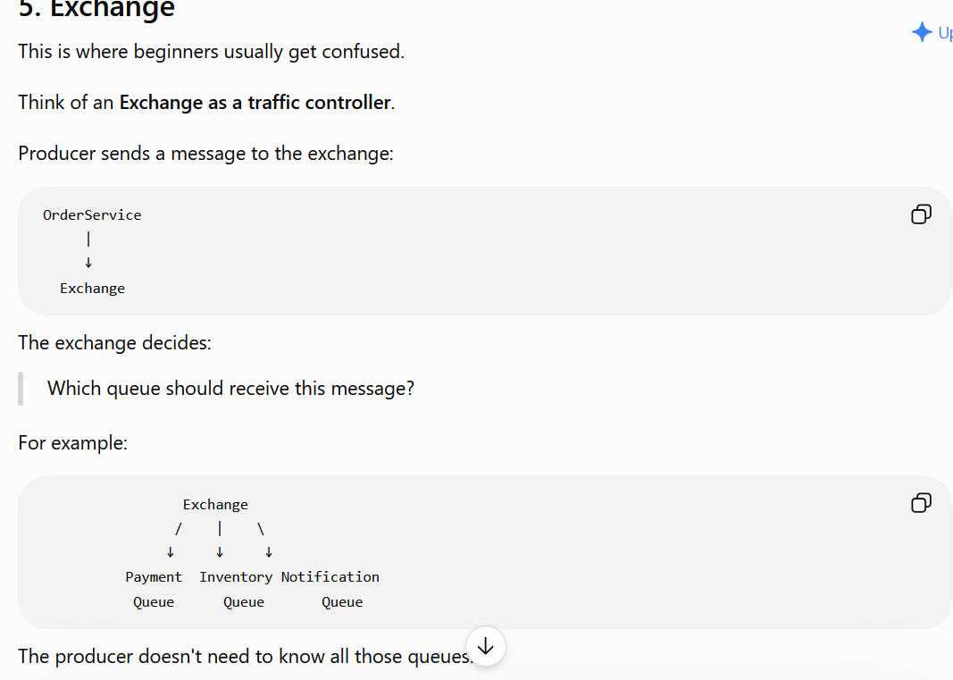

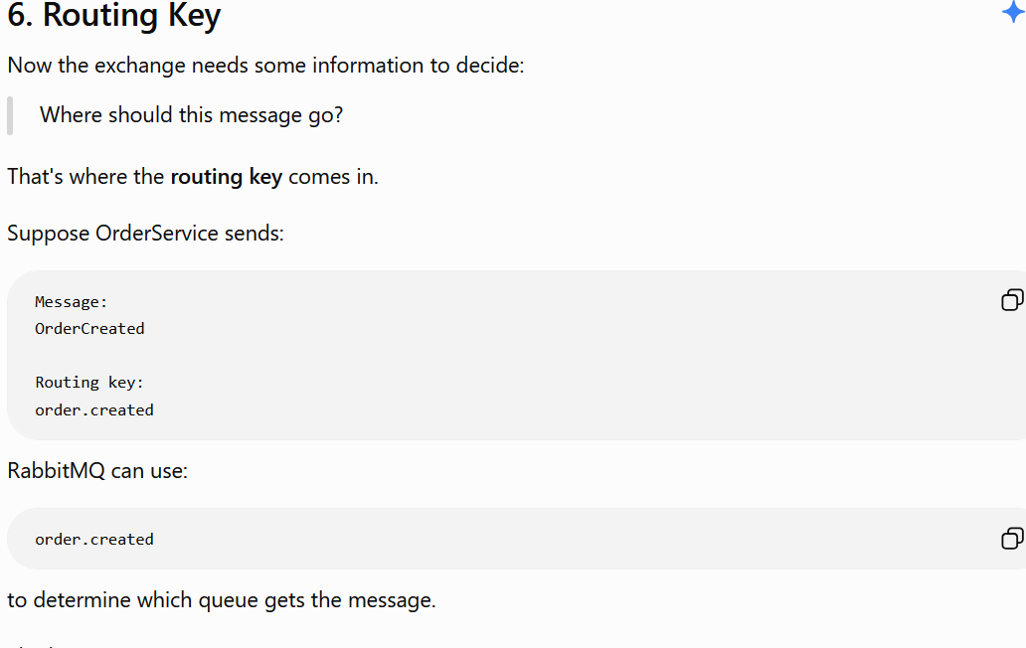

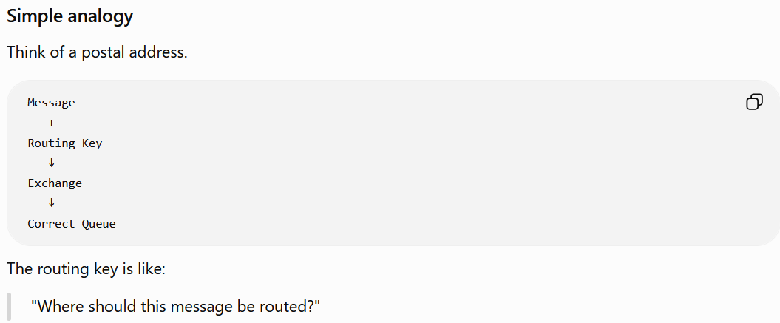
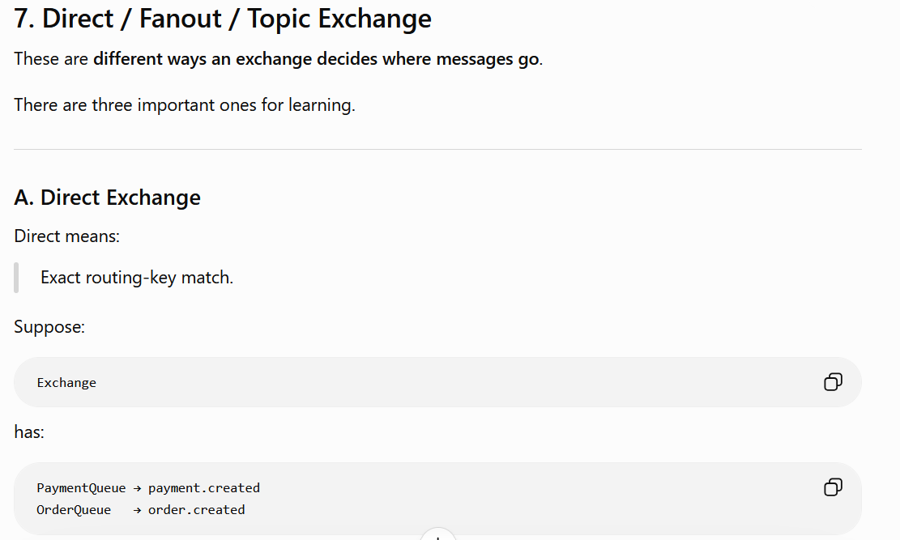

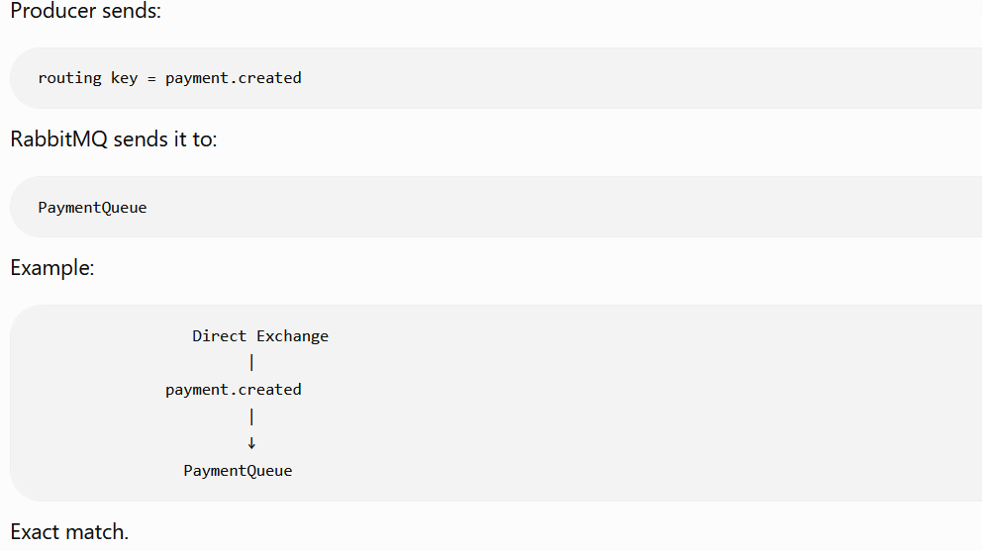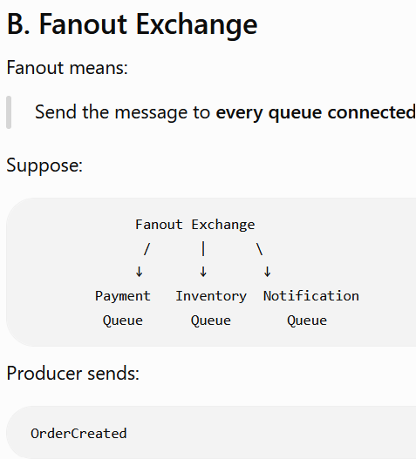
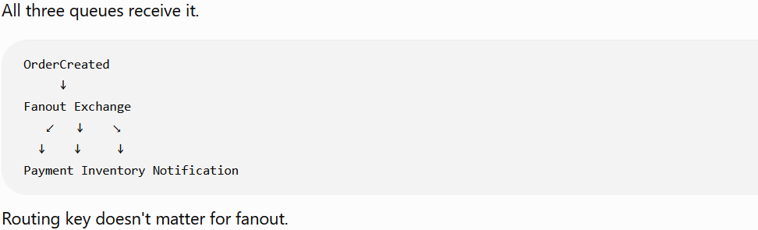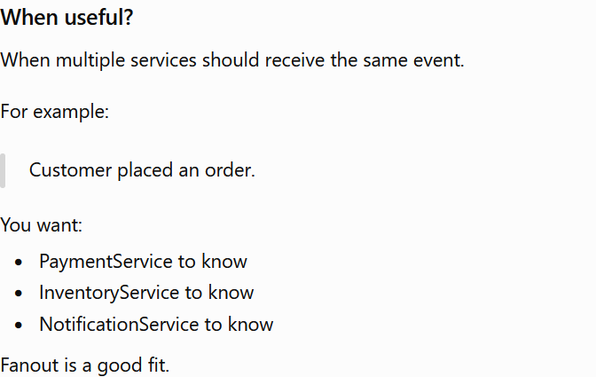

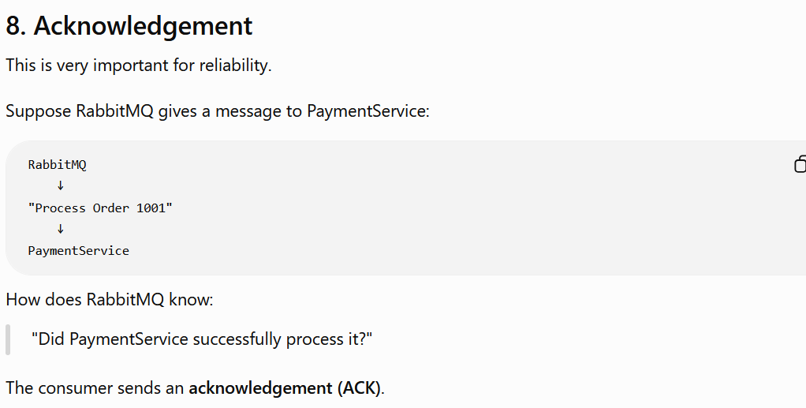

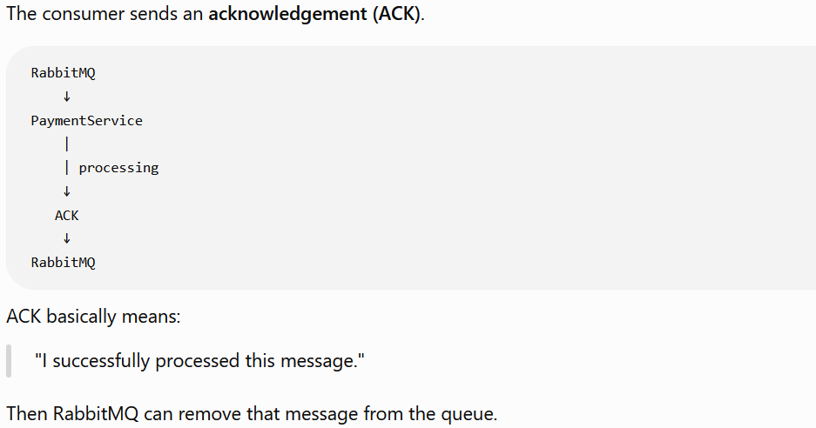

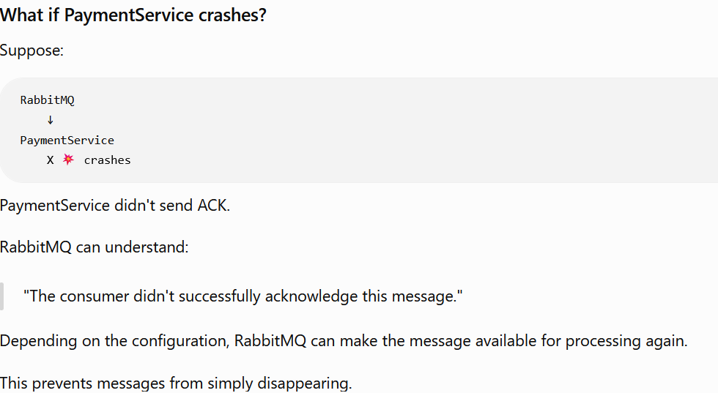

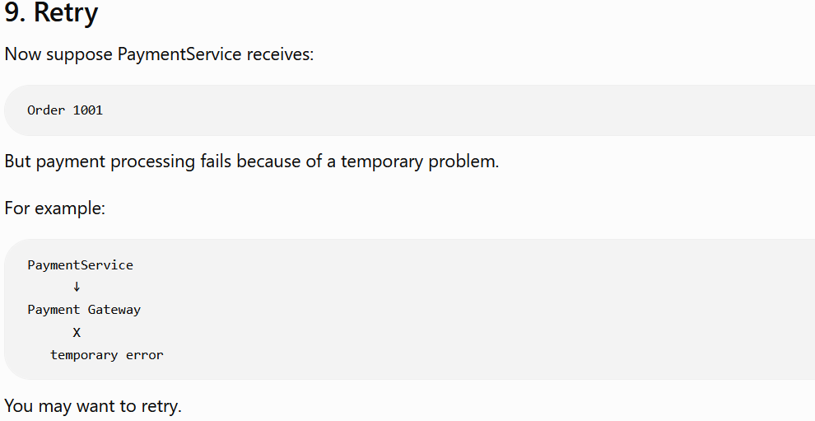

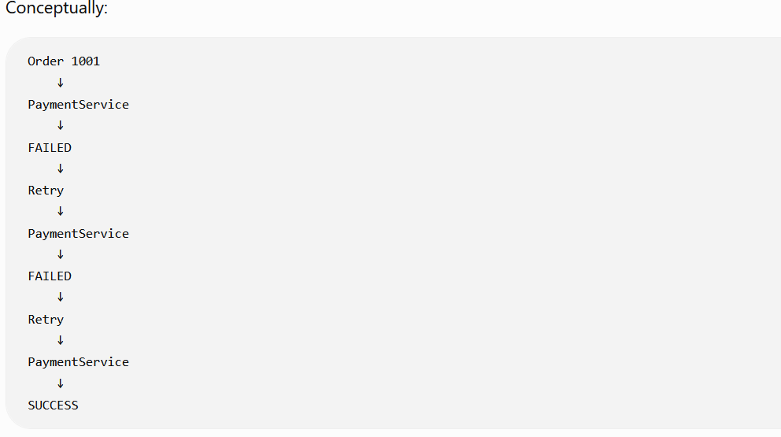

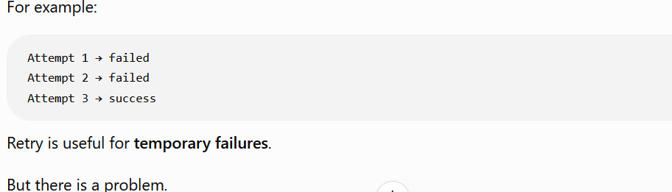

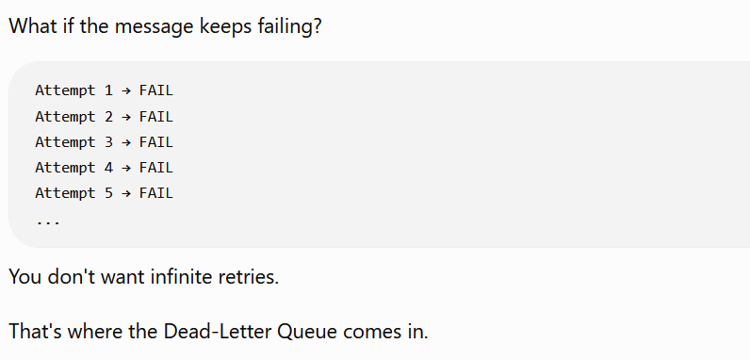

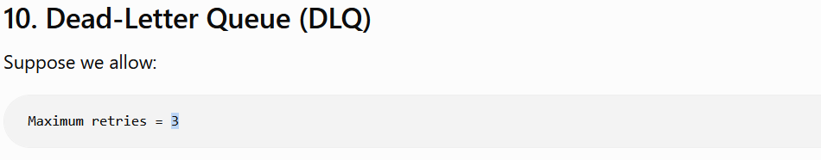

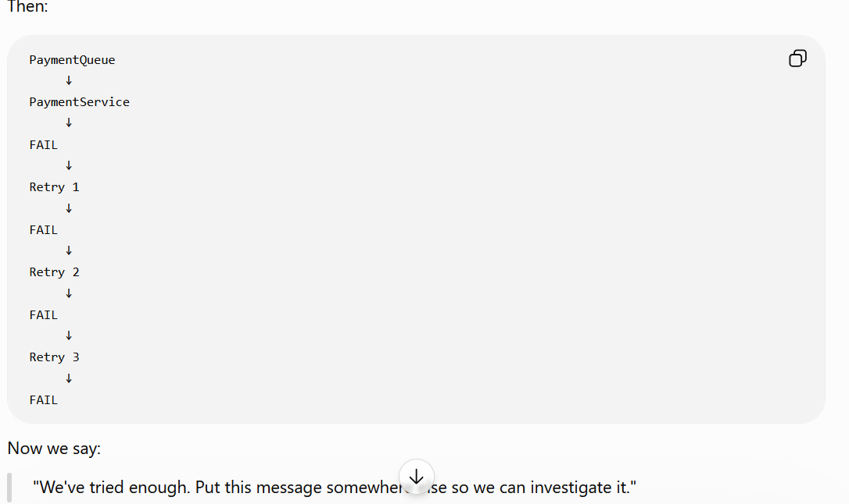

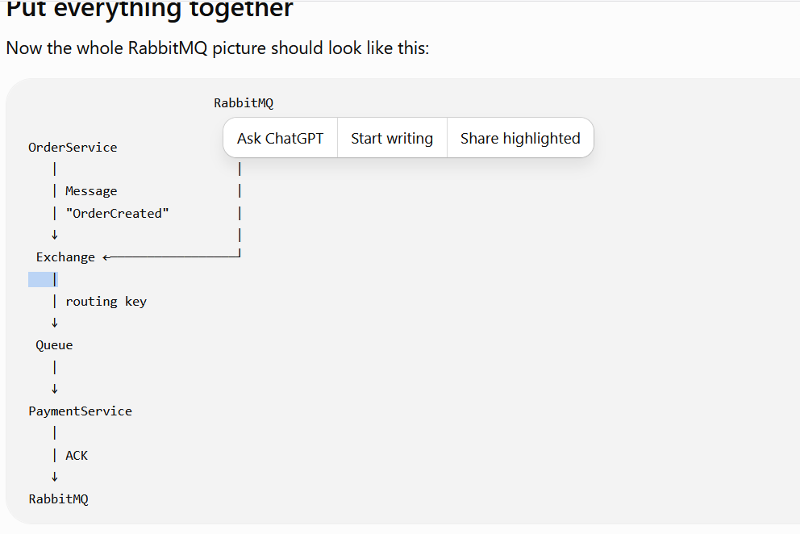
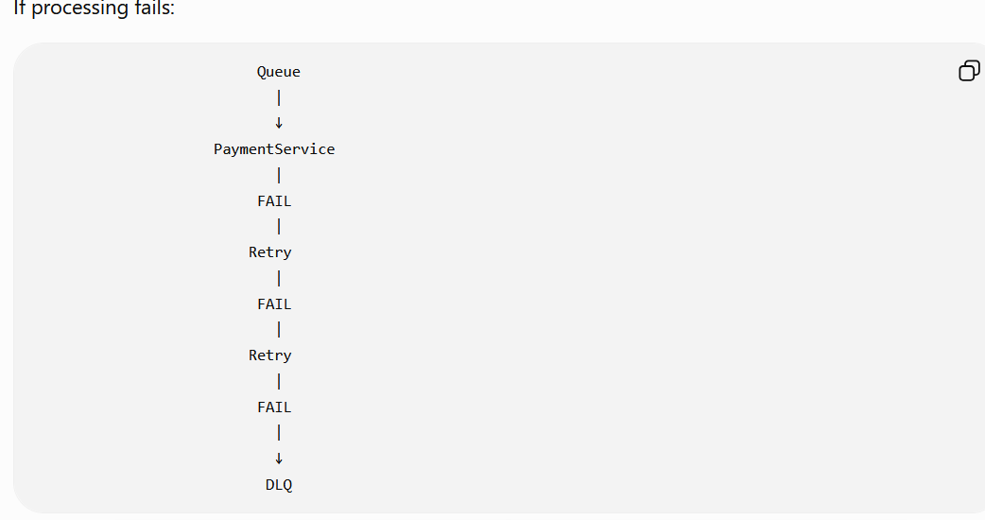

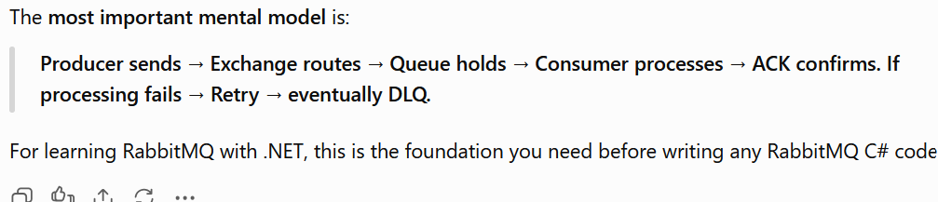

RabbitMQ - >
- It is a message broker
- Receives and forwards messages
- It stores, accepts and forwards binary blobs of data – messages.

Producing - > It means sending a message. A program that sends a message is called a producer. A queue is the name for the post box in RabbitMQ. Although messages flow through RabbitMQ and your applications, they can only be stored inside a queue. A queue is only bound by the host's memory & disk limits; it's essentially a large message buffer.
Note –
Many producers can send messages that go to one queue, and many consumers can try to receive data from one queue.

Consuming has a similar meaning to receiving. A consumer is a program that mostly waits to receive messages:
Note that the producer, consumer, and broker do not have to reside on the same host; indeed, in most applications they don't. An application can be both a producer and consumer, too.

Question – Is it possible that there are few message that are residing in exchange but not in queue?
Answer – Yes, it usually means those messages were published to the exchange but were not routed to your queue. your exchange → queue binding is missing or the routing key doesn't match

Note - The queue must exist before the message is published when you're using this default-exchange approach.
However, once the queue already exists, you don't need to declare it again before every publish.
The two method names are:
- QueueDeclareAsync () → creates/ensures the queue exists.
- BasicPublishAsync () → publishes/sends the message.

RabbitMQ Default Exchange vs Custom Exchange

The most important rule is:
When you publish to the default exchange (exchange: ""), the routing key is treated as the queue name. RabbitMQ automatically creates a binding from the default exchange to every queue using that queue's name as the binding key.
Therefore, you don't explicitly call QueueBindAsync() in the basic example.
Note - In case of default exchange the exchange name should be blank like “” and routing key must match Queue name.

In case of fanout-
exchange: "OrderServiceExchange" routingKey: ""
The routing key is ignored.
So, remember:
Default exchange → routing key = queue name.
Fanout exchange → routing key doesn't matter.

Prefetch Concept
The Maximum number of messages RabbitMQ can give to a consumer before the consumer sends an ACK for them.
In plain English:
"RabbitMQ, don't give this consumer more than X messages that it hasn't finished yet."
Example:
- Prefetch = 1 → give the consumer 1 message, wait for ACK, then give another.
- Prefetch = 10 → give the consumer up to 10 messages that are not yet ACKed.
- Prefetch = 100 → the consumer can have up to 100 unacknowledged messages.
So, Prefetch is basically a limit on how many unfinished messages a consumer can hold at one time.

DLQ/DLX Concept
DLX = the exchange that routes dead messages.
DLQ = the queue that stores those dead messages.

Idempotency
What you should remember for interviews
If someone asks:
"How do you achieve idempotency in RabbitMQ?"
A strong answer is:
"I assign a unique message ID to each message. The consumer maintains a processed-message record with a unique constraint. Before applying the business operation, it ensures the message hasn't already been processed. The business operation and recording of the message ID should be handled atomically where possible. If RabbitMQ redelivers the message, the consumer detects the existing ID, skips the duplicate business operation, and acknowledges the message."
That is the core Idempotent Consumer pattern.
Note-idempotency belongs primarily on the consumer side.

RabbitMQ: Classic vs Quorum Queues
A RabbitMQ queue is simply a place where messages wait until consumers process them.
Final interview cheat sheet
If an interviewer asks:
What is Classic Queue?
Traditional, non-replicated RabbitMQ queue.
What is Quorum Queue?
Replicated queue using Raft consensus, designed for high availability and data safety.
Why Quorum?
To maintain queue availability and replicated state when a broker node fails.
What is a leader?
The active member of a Quorum Queue that coordinates operations.
What is a replica?
Another member maintaining replicated queue state.
What is quorum?
A majority of members required for safe consensus.
3-node quorum: how many failures can it tolerate?
One failure while retaining a majority.
Does RabbitMQ Cluster automatically replicate Classic Queues?
No.
Does durable mean replicated?
No.
Does Quorum mean unlimited availability?
No. You still need a majority and disaster-recovery planning.
Does Quorum increase consumer processing capacity?
No. Consumers are scaled independently.
Does Prefetch replicate messages?
No. Prefetch controls outstanding unacknowledged deliveries to consumers.
Can Quorum Queues use DLQ, retry and ACK?
Yes.
Can I use Fanout/Direct/Topic with Quorum Queues?
Yes. Exchange routing and queue type are separate concerns.
Classic or Quorum?
Choose based on the workload's requirements for replication, availability, durability, performance and operational cost—not simply because one is newer.

Question 1
How does RabbitMQ decide which queue gets the message?
Answer:
Exchange + binding + routing key
Question 2
How is the message stored inside that queue?
Answer:
Classic Queue or Quorum Queue
Question 3
What happens if RabbitMQ server crashes?
Answer:
Cluster + replication/HA strategy
Question 4
How many messages can a consumer receive before ACK?
Answer:
Prefetch
Question 5
What happens if processing fails?
Answer:
NACK/reject + retry/DLX/DLQ
Question 6
What if the same message is delivered twice?
Answer:
Idempotency
These are separate concepts.

"What is a replicated queue?"
Say:
"A replicated queue is a queue whose state is maintained on multiple RabbitMQ nodes. The purpose is to provide queue-level high availability, so if one node hosting a queue member fails, another member can continue operating when quorum requirements are satisfied. A non-replicated queue has no such live copy on another node."
And if they ask:
"Which RabbitMQ queue type is replicated?"
Say:
"Quorum Queue is the modern RabbitMQ queue type designed for replicated, highly available queues. Classic Queues are non-replicated in modern RabbitMQ."
One sentence to remember
Non-replicated = another RabbitMQ node doesn't have a live copy of that queue. Replicated = multiple RabbitMQ nodes maintain members of the same logical queue.
Durable | Queue/exchange survives broker restart

Replicated | Queue data/state exists on multiple RabbitMQ nodes

Persistent message | Message is stored in a durable way so it can survive restart.  Very important  durable: true does NOT mean:  - ❌ queue is replicated  - ❌ queue is highly available  - ❌ message can never be lost  - ❌ there are multiple copies  - ❌ RabbitMQ cluster automatically protects it  Think of it like this:  Durable = "remember this after restart."  Replicated = "keep copies on multiple nodes."  Horizontal and Vertical Scaling  Generally, we scale to increase the availability, fault tolerance or to accept a bigger load related to processing.  Legacy system, old relational databases or system implemented many years ago, scale vertically only.  When they process data too slow. You add more memory and CPU and add hardware to the faster one. But it is not the ultimate solution. But data systems by design can be scaled horizontally and vertically. You can add more hardware to make it faster one but adding more servers to the cluster, allow to scale broker indefinitely.  Group of servers are called clusters. Scaling-Out means, adding more servers to the cluster. Scaling-In means removing servers from the cluster.  There are 3 ways to accomplish clustering in RabbitMQ.  - The first one is typical clustering which forms a single broker from many small ones.  Inter-node communication is transparent for connected processes, and messages are distributed. Consumers can consume a message from a queue, even if a queue is not located on the node it’s connected.  Clustering requires very fast and reliable network with very low latency rate. Otherwise, you will face issues related to data inconsistency.  Suppose we have two networks one is on India and another one is on UK. So, to replicate data between both needs a very fast networking. So, the solution is Federation.  Federation- Creates an upstream link to transmit messages. It is to receive message published to an exchange or queue upstream broker. Used to replicate messages between local clusters and datacentres (across WLAN).  Shovel is similar to Federation; it is basically well-designed RabbitMQ client. It consumes messages from one cluster and publishes to another cluster.  Note – Both federations and shovels are also used to perform safe migrations and cluster upgrades.  Why do we need clusters  Generally, we form a cluster to improve fault tolerance or availability for client’s operation. With single node, when node goes down it causes outrage and clients cannot use service. With more nodes linked together as a cluster, even if part is down, broker continues the service. It is used for high availability and fault tolerance.  High Availability – system might perform in a degraded state, where fault tolerance system is a higher bar. With more servers, you increase performance and overall throughput. You can publish messages faster and higher bigger load. Another importance and advantage is data safety, when node goes down, it takes all the messages together with it. With more servers you can replicate queue to be stored on more than one node. With configuring RabbitMQ cluster we need to remember that: node must be run in the same version, or at least a compatible one. Nodes in a cluster may lose connection between each other due to network issues and split clusters into parts. we can tell RabbitMQ how to handle the issue by choosing between consistency or availability.

RabbitMQ Permissions _ Hands On

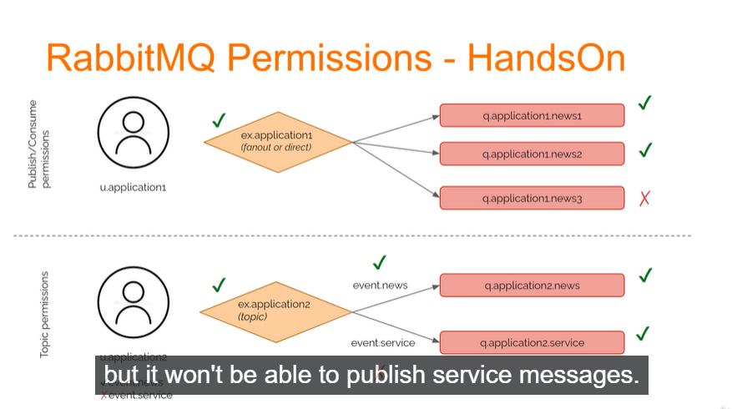

In the first one, we create a user and fanout exchange with three queues. Users will be allowed to publish into exchange and consume from first two queues only.
In second case, we will play with topic permissions. We will create user and topic exchange with two queues. Users will be allowed to consume from two queues but it won’t be able to publish service messages. Just news only.

Backup and Restore
Schema definition export and import

All the nodes in the cluster store definitions for users vhosts, queues, exchanges, bindings, permissions and run-time parameters etc.

The architect-level sentence
If an interviewer asks:
"How do you replicate a RabbitMQ queue across nodes?"
A strong answer is:
"I would use a quorum queue in a RabbitMQ cluster. A quorum queue is replicated across multiple cluster nodes using Raft, with one leader and follower replicas. If the leader fails, another replica can become leader, provided a quorum remains available. Simply creating a RabbitMQ cluster does not replicate queue messages."
Cluster gives you multiple RabbitMQ nodes.
Quorum Queue gives you replicated queue data.
And:
You don't manually replicate the messages — RabbitMQ does it for a quorum queue.

Exclusive queue = tied to one connection and deleted when that connection closes.
autoDelete: false RabbitMQ should not automatically delete the queue when consumers disappear.

durable = Does the queue survive RabbitMQ restart?
exclusive = Is the queue tied to one connection?
autoDelete = Should RabbitMQ automatically remove the queue when it becomes unused?
autoDelete is about consumer lifecycle, NOT message count.

autoDelete: true does NOT simply mean "delete the queue when there are 0 messages."
The key is consumers, not the number of messages.
Example
Suppose:
autoDelete: true
You have:
orders queue
10 messages
1 consumer
Consumer processes all 10:
orders queue
0 messages
1 consumer
The queue is NOT deleted just because it has 0 messages.
If the consumer disconnects, RabbitMQ evaluates the auto-delete condition.
Think of it this way
Message count = 0
↓
Does NOT automatically mean
"delete queue"
Instead:
autoDelete = true
↓
Queue has had consumers
↓
Consumers disappear
↓
Queue can be automatically deleted
So:
autoDelete: false
means:
Keep the queue even when there are no consumers and no messages.
And:
autoDelete: true
means:
This is a temporary-style queue; RabbitMQ can remove it after its consumer usage ends.
Question - how queue knows when conusmer is disconnected
RabbitMQ knows because the consumer is connected to RabbitMQ through a TCP connection/channel.

A RabbitMQ consumer exists on a channel, and that channel belongs to a connection. RabbitMQ detects consumer disconnection when the underlying connection/channel closes or when a failed connection is detected.
And remember:
Connection ≠ Channel ≠ Consumer

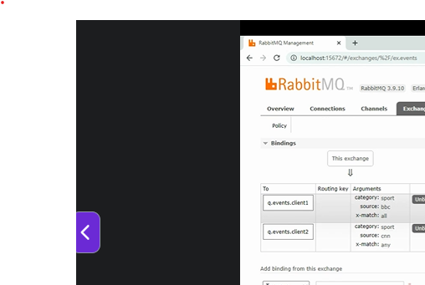

Interview answer
If an interviewer asks:
What is a Headers Exchange in RabbitMQ?
A good answer is:
A Headers Exchange routes messages based on message headers rather than routing keys. A queue binding specifies header conditions, and x-match determines whether all or any of those conditions must match. It is useful when routing depends on multiple message attributes or metadata rather than a simple routing-key pattern.

Question – Does RabbitMQ contains non persistent message as well in Hard Disk Drive?
Answer - Yes, but it's a bit nuanced.
Non-persistent messages are not guaranteed to stay only in RAM.
RabbitMQ can keep transient (non-persistent) messages in memory, but under memory pressure it may page messages to disk. However, unlike persistent messages, RabbitMQ does not guarantee that non-persistent messages will survive a broker restart. Persistent and non-persistent messages differ primarily in their durability guarantees, not strictly by whether they ever touch disk.

But if RabbitMQ restarts:
rabbitmq stop
rabbitmq start
those non-persistent messages are not guaranteed to be recovered.
Persistent Message = Durable Queue + Persistent Message
These are intended to survive broker restarts because they are written to RabbitMQ's message store.
Practical Rule
When documenting RabbitMQ:
Non-persistent messages may be temporarily written to disk by RabbitMQ for memory management purposes, but they are not durable and are not guaranteed to survive a broker restart. Persistent messages stored in durable queues are intended for recovery after restart.
This distinction between "stored on disk" and "durable across restart" is the key concept.
Question - If I take a backup of RabbitMQ's data folder/volume, will non-persistent messages also be present in that backup?
Answer - No, you should not rely on backups to recover non-persistent messages.
Even if RabbitMQ temporarily writes some transient (non-persistent) messages to disk during operation, RabbitMQ does not guarantee their recovery from backup or after restart. RabbitMQ distinguishes between definitions (topology) and message store data and warns that message backup from a running node can produce inconsistent results.
while RabbitMQ is running.
Later you restore the backup.
You cannot assume the 100 non-persistent messages will be available after restoring.
What Should Be Backed Up?
Durable Queue + Persistent Messages.
Not Guaranteed = Non-persistent Messages (These are designed for temporary delivery and should not be considered backup-worthy data).

Documentation Statement
You can use this wording:
RabbitMQ stores its data in the node data directory. While transient (non-persistent) messages may be written to disk internally during operation, RabbitMQ does not guarantee their recovery from backups or after broker restart. Only durable queues containing persistent messages should be considered recoverable through RabbitMQ disaster recovery procedures. Definitions can be exported separately as JSON files.
Rule of Thumb
If the business needs a message to survive:
✅ Server restart
✅ RabbitMQ crash
✅ Restore from backup
then publish it as a persistent message to a durable queue.
If the message is non-persistent, treat it as disposable and do not depend on backups for recovery.

Question - how can I restore durable messages from HDD when not using docker?
Answer - If you're not using Docker and RabbitMQ is installed directly on Windows/Linux, restoring durable messages is done by restoring the RabbitMQ data directory, not by individually restoring queue files.
RabbitMQ stores definitions and messages in its node data directory. RabbitMQ documentation states that every node has a data directory containing definitions and message store data.

Ensure Same Node Name while taking backup. RabbitMQ's backup/restore documentation states that modern versions restore disk data only when restored to a node with the same node name
Suppose we have a node named “node1” and later we stop the service and took the backup. Now, I want the name to be changed to something like “node123”. It is not possible. If you have taken the backup from “node1” then you will have to copy it to backup “node1” only.

