Social Cops Assignment

1-Microservices

They are *stateless* microservice in Nodejs, with three major functionalities -

* Authentication
* JSON patching
* Image Thumbnail Generation

I have dockerize these microservices . We could also use 3 different servers.

Architecture using Heroku:

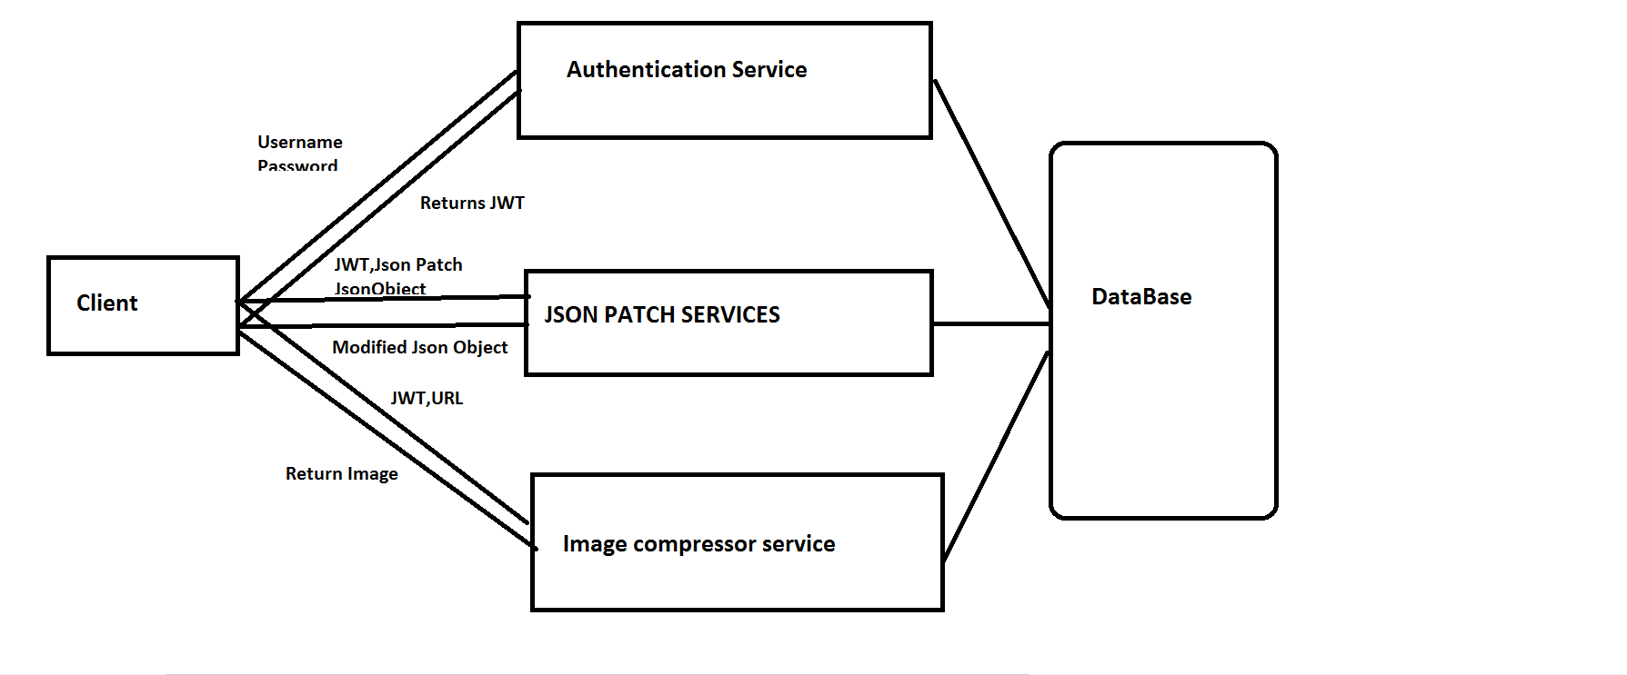

Architecture using Docker

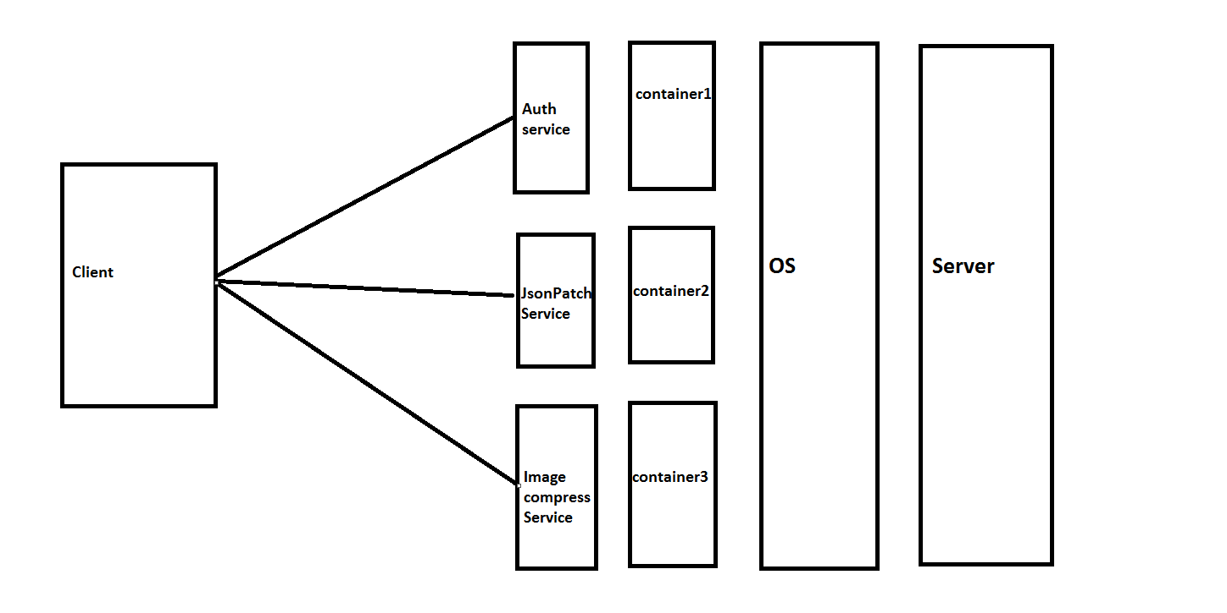

Authenticaiton Service:

* It is used to login user.It returns Json Web Token which can be used to validate future requests.
* It is used to Register a user. It also return JWT.
* It also returns the id and name of the user after verifying the JWT.

It has 4 Restful API

/api/auth/login(For login)

/api/auth/logout(For logout)

/api/auth/register(To register the user)

/api/auth/me(To identify the user)

/api (To check Authentication service)

Json Patch Service:

* Request body should contain a JSON object and a JSON patch object.
* Header should contain a token.
* Apply the json patch to the json object, and return the resulting json object.
* It is protected End point. The JWT obtained in the “Login” endpoint must be attached to each request.

It has 2 Restful API’s

/api/jsonpatch(To apply json patch)

/api (To check Json Patch Service)

Image compressor Service:

* It is used to compress an image.
* Request body should contain a image url
* Header should contain a token.
* It is protected End point. The JWT obtained in the “Login” endpoint must be attached to each request

It has 2 Restful API’s

/api/imagecompressor

/api (To check Json Patch Service)

Technologies Used

* Mocha for test cases.
* Istanbul for test coverage
* Docker for creating containers
* Node.js
* ES linter