**Progress 3: Delete a Function.**

The ‘Booked Rooms’ function was identified as the function to be deleted.

**The purpose of the function:** The function was used to display the details of the rooms that are booked. It also displayed the total.

**Importance:** The function provides an easy go to page that displays booked rooms, thus aiding with record keeping. The have an understanding of the rooms that I booked, the admin simply navigates to the page.

**Why delete**: After intensive review, we identified this page as a potential candidate to delete

**Dashboard View**

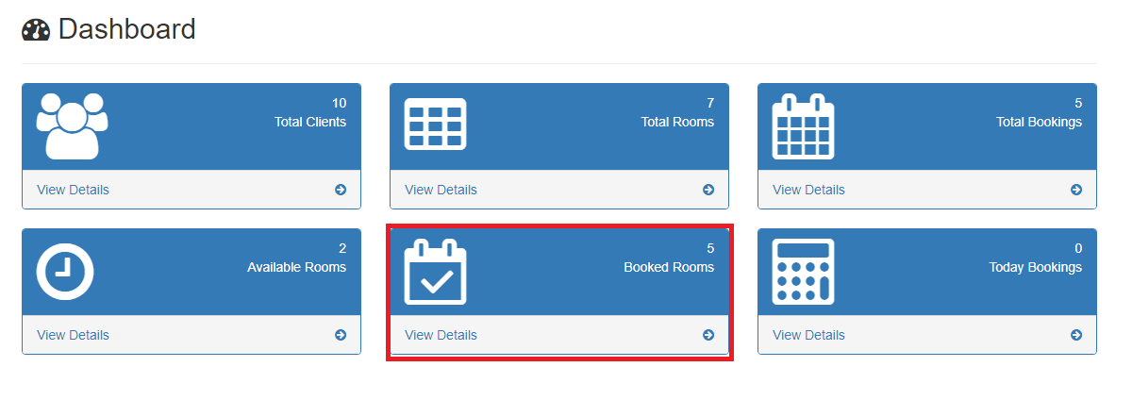

**Actual Page**

