# ABSTRACT

Book Nook is a comprehensive online platform designed for book enthusiasts, offering a seamless and enriching experience that caters to all your reading needs. Our mission is to make literature accessible to everyone by providing external links to legitimate PDF versions of books and trusted sources where you can purchase physical or digital copies. With an extensive library covering various genres and categories—from fiction and non-fiction to self-help and academic texts—Book Nook ensures that every reader finds something to enjoy. In addition to offering reading materials, our platform features a donation page where users can contribute books they no longer need, supporting our initiative to distribute these books to schools, libraries, and readers in need. By integrating these features, Book Nook not only helps you expand your personal library and enjoy literature on the go but also empowers you to give back to the community, fostering a culture of sharing and lifelong learning. Join us at Book Nook, where every book read, bought, or donated contributes to a broader community of readers and learners, making the world a more literate and connected place. Embark on your literary journey with ease and purpose, knowing that every click brings you closer to a world of knowledge and community support.

TABLE OF CONTENTS

|  |  |  |
| --- | --- | --- |
| Sr.no | Section | Page no |
| 1. | Introduction | 3-5 |
| 2. | Problem Statement | 5-7 |
| 3. | Technical Details | 7-8 |
| 4. | Key Features | 9 |
| 5. | Project Advantages | 10-11 |
| 6. | Bonus Features | 11-13 |
| 7. | Result | 13-17 |
| 8. | Conclusion | 17-19 |

# INTRODUCTION

In the digital age, the way we access and consume literature has undergone a revolutionary transformation. No longer confined to the shelves of brick-and-mortar bookstores or the silence of libraries, books have found a new home in the digital realm. Book Nook stands at the forefront of this literary evolution, offering a comprehensive and user-friendly platform that caters to the diverse needs of book enthusiasts around the world. With a mission to make literature accessible to everyone, Book Nook seamlessly integrates multiple features to provide an unparalleled reading experience. From external links to legitimate PDF versions of books and trusted sources for purchasing titles, to a dedicated page for book donations, Book Nook is more than just a repository of books—it is a community where the love for reading thrives. Our website, meticulously crafted using HTML and CSS, ensures a seamless and visually appealing experience for all users.

At its core, Book Nook is driven by the belief that literature is a powerful tool for personal and collective growth. Books open doors to new worlds, ideas, and perspectives, enriching our understanding of ourselves and the world around us. However, despite the proliferation of digital resources, access to quality literature remains unevenly distributed. Many readers, particularly in underserved communities, face barriers that prevent them from accessing the books they need or desire. This is where Book Nook steps in. By providing free and legitimate PDF links, Book Nook ensures that financial constraints do not hinder the pursuit of knowledge and pleasure derived from reading. Additionally, our platform offers reliable links to purchase books, giving readers the flexibility to choose between digital and physical copies, depending on their preferences.

The donation feature is a cornerstone of Book Nook’s community-centric approach. In a world where new books are constantly being published, many of us find our shelves filling up with titles we have already read. Instead of letting these books gather dust, Book Nook provides an avenue for readers to donate their books, giving them a new life in the hands of other eager readers. This initiative not only promotes sustainability by reducing waste but also fosters a spirit of generosity and sharing within the reading community. The books collected through donations are distributed to schools, libraries, and individuals who might otherwise have limited access to such resources. In this way, Book Nook not only addresses the issue of accessibility but also actively contributes to building a more literate and informed society.

Moreover, Book Nook recognizes the importance of user experience in the digital age. Our platform, designed with an intuitive and user-friendly interface using HTML and CSS, ensures that even those who are not tech-savvy can navigate and utilize our services with ease. The homepage greets visitors with a visually appealing layout, highlighting featured books, new arrivals, and popular categories. A robust search function allows users to quickly find specific titles or authors, while personalized recommendations guide readers to books that align with their interests. This personalization is made possible through sophisticated algorithms that analyze user behavior and preferences, making Book Nook not just a platform but a personal reading assistant.

In addition to its core features, Book Nook also serves as a hub for literary engagement. Users can leave reviews, rate books, and participate in discussions, creating a dynamic and interactive community of readers. Author interviews, book launch events, and reading challenges are regularly featured, providing opportunities for users to engage with the literary world beyond just reading. This interactive component transforms Book Nook from a static collection of books into a lively and engaging platform where readers can connect, share, and grow together.

In conclusion, Book Nook is more than just a book website; it is a holistic literary ecosystem that addresses the multifaceted needs of modern readers. By offering free access to PDF versions of books, reliable purchase links, and a robust donation program, Book Nook democratizes access to literature and fosters a sense of community among readers. Its user-friendly interface, crafted with HTML and CSS, and interactive features further enhance the reading experience, making it a go-to platform for anyone passionate about books. As we continue to innovate and expand our services, Book Nook remains committed to its mission of making literature accessible to all, nurturing a global community of informed and enthusiastic readers. Join us at Book Nook, where every book read, bought, or donated contributes to a broader community of readers and learners, making the world a more literate and connected place.

# PROBLEM STATEMENT

Books have long been a cornerstone of education, personal development, and cultural enrichment. However, various barriers still prevent many individuals from accessing these valuable resources. Financial constraints, geographical limitations, and the high cost of books are significant obstacles, particularly for students and readers in underserved communities. While digitalization has made strides in democratizing access to information, it has not completely bridged the gap. Many digital platforms require subscriptions or purchases, which can still be prohibitive for some users. Additionally, the lack of a centralized, user-friendly interface to access free and legitimate book resources further complicates the issue.

Book Nook was conceived to mitigate these challenges by leveraging technology to create a seamless and inclusive literary ecosystem. The platform is meticulously crafted using HTML and CSS to ensure an intuitive and aesthetically pleasing user experience. It offers a robust search function, personalized recommendations, and interactive features to engage users and foster a community of readers. The integration of a donation page further enhances its mission by allowing users to contribute books, which are then redistributed to those in need.

Core Issues

1. Financial Barriers: A significant number of potential readers are deterred by the cost of books. This issue is particularly acute among students and low-income individuals who may prioritize essential expenses over purchasing literature. The lack of access to affordable books limits their opportunities for learning and personal growth.

2. Geographical Limitations: In many parts of the world, physical bookstores and libraries are scarce, especially in rural or underserved urban areas. This geographical disparity means that even those who wish to purchase or borrow books may find it logistically challenging to do so.

3. Lack of Centralized Resources: While many online resources offer free or affordable books, they are often scattered across various platforms, making it difficult for users to find and access them efficiently. This fragmentation can be overwhelming and discouraging for readers.

4. Sustainability and Waste: The continuous production of new books leads to a surplus of used books that often end up discarded. This not only contributes to environmental waste but also represents a missed opportunity to redistribute these resources to new readers.

5. Digital Divide: Although digital platforms can potentially bridge the gap, not all users have equal access to digital devices and the internet. Ensuring that digital platforms are inclusive and accessible to all demographics remains a challenge.

# TECHNICAL DETAILS

In an era characterized by the digital revolution, access to information and literature has seen significant transformations. Despite these advancements, the challenge of making high-quality literature universally accessible persists. Book Nook aims to address this gap by providing a comprehensive online platform that not only offers external links to legitimate PDF versions of books and trusted purchase sources but also includes a donation feature to promote the redistribution of books. This problem statement outlines the multifaceted issues related to literature accessibility and the solutions proposed by Book Nook to foster a more literate and informed society.

3.1 Frontend Technologies:

* The website uses HTML5 for structuring content, ensuring semantic and accessible code.
* CSS3 is employed for styling and layout design, utilizing modern features such as Flexbox and Grid for responsive layouts. Custom styles are crafted to create visually appealing sections, navigation bars, buttons, and forms.
* JavaScript adds interactivity through search functionality, smooth scrolling, image-sliders, form validations and modal toggling, while handling user events like button clicks and key press actions for seamless navigation.

3.2 User Authentication:

* The project includes a login phase and a sign-in phase to manage user accounts securely. Input validation is handled using JavaScript to ensure data integrity during user registration and login.

3.3 Design and Typography:

* Google Fonts are integrated to enhance the website's aesthetics, ensuring consistency in typography and an appealing visual experience.
* Colors and font styles are chosen to complement the theme of the travel destination page, creating a welcoming atmosphere for users.

3.4 Navigation and Layout:

* The website is divided into multiple sections and pages for an organized and intuitive flow. Divs are used to segment content, making it easy to update and maintain.
* Navigation bars provide links to different sections, ensuring seamless transitions between pages. Hover effects and responsive designs improve usability.

3.5 Media Integration:

* The website integrates high-quality images for each destination to create a visually engaging experience, enhancing user interest and immersion. These images are displayed in responsive cards, ensuring they adapt seamlessly to different screen sizes.

3.6 Responsiveness:

* The website is designed to be responsive, ensuring compatibility across devices such as desktops, tablets, and mobile phones. Media queries are used in CSS to adjust layouts dynamically.

# KEY FEATURES

1. **Extensive Library**: Book Nook boasts a wide range of books across various genres, ensuring that every reader finds something to enjoy. From fiction and non-fiction to academic texts and self-help books, our platform caters to diverse literary tastes.
2. **Search and Discovery**: Our robust search function and personalized recommendation system make it easy for users to find specific titles or discover new books based on their interests. This feature ensures that users can efficiently navigate our extensive library.
3. **Seamless Access**: Book Nook provides external links to free and legitimate PDF versions of books, ensuring easy access to literature without financial constraints. This feature is particularly beneficial for students and low-income individuals.
4. **Purchase Options**: For readers who prefer owning physical or digital copies, Book Nook offers trusted links to purchase books from reliable retailers, providing a seamless shopping experience.
5. **Donation Platform**: Our donation page encourages users to contribute books they no longer need, promoting sustainability and fostering a spirit of generosity within the reading community. Donated books are redistributed to schools, libraries, and individuals in need.
6. **Interactive Community**: Book Nook is more than just a repository of books. It features an interactive platform where users can leave reviews, rate books, participate in discussions, and engage with author interviews, book launch events, and reading challenges.
7. **Intuitive Design**: Crafted using HTML and CSS, Book Nook’s user-friendly interface ensures that even non-tech-savvy users can easily navigate the platform. The visually appealing layout highlights featured books, new arrivals, and popular categories.

# PROJECT ADVANTAGES

1. Increased Accessibility to Literature:

One of the primary advantages of Book Nook is the enhanced accessibility it provides to a vast array of books. By offering free and legitimate PDF links, the platform ensures that financial constraints do not hinder access to literature. This is particularly beneficial for students, low-income individuals, and readers in underserved communities who may not have the means to purchase books regularly.

2. Cost-Effective Reading Solutions:

By providing access to free PDF versions of books, Book Nook offers a cost-effective solution for avid readers. Users can save money on purchasing books while still enjoying a wide range of literary works. This can be especially advantageous for students and those on a tight budget, allowing them to allocate their funds towards other essential expenses.

3. Sustainable Book Distribution:

The donation feature of Book Nook promotes sustainability by encouraging the recycling and redistribution of books. Users can donate books they no longer need, reducing waste and ensuring that these valuable resources find new homes. This initiative helps create a more environmentally conscious community and fosters a culture of sharing and generosity.

4. Community Building and Engagement:

Book Nook is more than just a book repository; it is a platform for community engagement. Users can interact through reviews, ratings, discussions, and participation in book-related events. This sense of community fosters a love for reading, encourages literary discussions, and provides a space for readers to connect and share their passion for books.

5. User-Friendly Interface and Personalized Experience:

The platform's intuitive design, crafted using HTML and CSS, ensures a seamless and visually appealing user experience. Personalized recommendations and a robust search function make it easy for users to find books that match their interests and preferences. This user-centric approach enhances the overall reading experience and encourages continuous engagement with the platform.

6. Reliable Purchase Options:

For readers who prefer owning physical or digital copies, Book Nook offers trusted links to purchase books from reliable retailers. This feature ensures that users can conveniently acquire books without the hassle of searching multiple platforms, providing a seamless shopping experience.

7. Educational Support:

By offering access to a wide range of academic texts and self-help books, Book Nook supports educational initiatives and lifelong learning. Students can find resources to aid their studies, and individuals seeking personal development can access valuable materials to enhance their knowledge and skills.

8. Promotes Literacy and Knowledge Sharing:

Book Nook's mission to make literature accessible to all contributes to the broader goal of promoting literacy and knowledge sharing. By breaking down barriers to access, the platform helps cultivate a more informed and literate society, empowering individuals with the knowledge and resources they need to succeed.

9. Convenience and Flexibility:

With features like free PDFs and digital access, Book Nook offers convenience and flexibility for readers who prefer reading on their devices. This is especially useful for those with busy schedules or those who travel frequently, as they can carry their entire library with them wherever they go.

In summary, Book Nook offers numerous advantages that cater to the diverse needs of readers. By enhancing accessibility, promoting sustainability, fostering community engagement, and providing a user-friendly experience, Book Nook stands as a valuable resource for book enthusiasts around the world. As we continue to innovate and expand our services, we remain committed to making literature accessible to all and nurturing a global community of informed and enthusiastic readers.

# BONUS FEATURES

Book Reviews and Purchase Links:

Book Nook is designed to offer a rich and interactive user experience by incorporating comprehensive book reviews and seamless purchase options. Users can browse through a wide selection of books and read detailed reviews to help them make informed decisions. These reviews are contributed by our vibrant community of readers, ensuring that prospective readers get diverse perspectives on each book. Whether users are looking for critical analyses, plot summaries, or personal reflections, our review section provides valuable insights into the content and quality of each book.

Non-Profit Organization Dedicated to Promoting Literacy:

Book Nook operates as a non-profit organization with a steadfast commitment to promoting literacy and providing books to those in need. Our mission is driven by the belief that every book deserves a loving home, and that access to literature should not be hindered by financial or geographical barriers. We strive to create a platform where readers from all walks of life can discover, read, and share books, fostering a global community of informed and passionate readers.

Book Donations and Redistribution:

One of the core features of Book Nook is our book donation initiative. Users can donate books they no longer need, which are then redistributed to schools, libraries, and individuals who might otherwise have limited access to reading materials. This initiative not only helps reduce waste but also plays a crucial role in promoting literacy and education in underserved communities. By giving books a second life, we ensure that valuable literary resources continue to benefit readers long after their initial use.

Adding Reviews on the Website and Books:

To further enrich the user experience, Book Nook allows users to add reviews directly on the website as well as on individual book pages. This interactive feature encourages users to engage with the content and share their thoughts, creating a dynamic and vibrant community. Reviews can cover various aspects such as the writing style, themes, characters, and personal reflections, providing a comprehensive view of each book. This collective knowledge helps other users find books that align with their interests and preferences, fostering a sense of community and shared learning.

# RESULTS

7.1 Navigation Bar

* The navigation bar of "Book Nook" website is thoughtfully designed, offering a clean and intuitive experience. It prominently features sections like Home, New Arrivals, Featured, Reviews, and Donate, ensuring visitors can effortlessly explore the platform. A sleek search bar on the right adds convenience, allowing users to quickly find their desired content. The overall layout is elegant and user-friendly, perfectly complementing the literary theme of the site..



7.2 Home Page

* The home page of "Book Nook" extends a gracious invitation to a realm of literary enchantment. Adorned with a captivating banner of vintage tomes and the tagline, "Your one-stop shop for books of all genres," it masterfully sets the stage for intellectual exploration. A compelling introduction entices readers to embark on their next great odyssey, whether through fiction, non-fiction, or niche genres. With meticulously organized categories and an elegantly crafted design, the browsing experience is both seamless and profoundly engaging.

7.3 Login/Sign-UP Page

* The login/signup page of "Book Nook" offers a sleek and minimalist design, providing users with a seamless and welcoming gateway to access or create their accounts effortlessly.

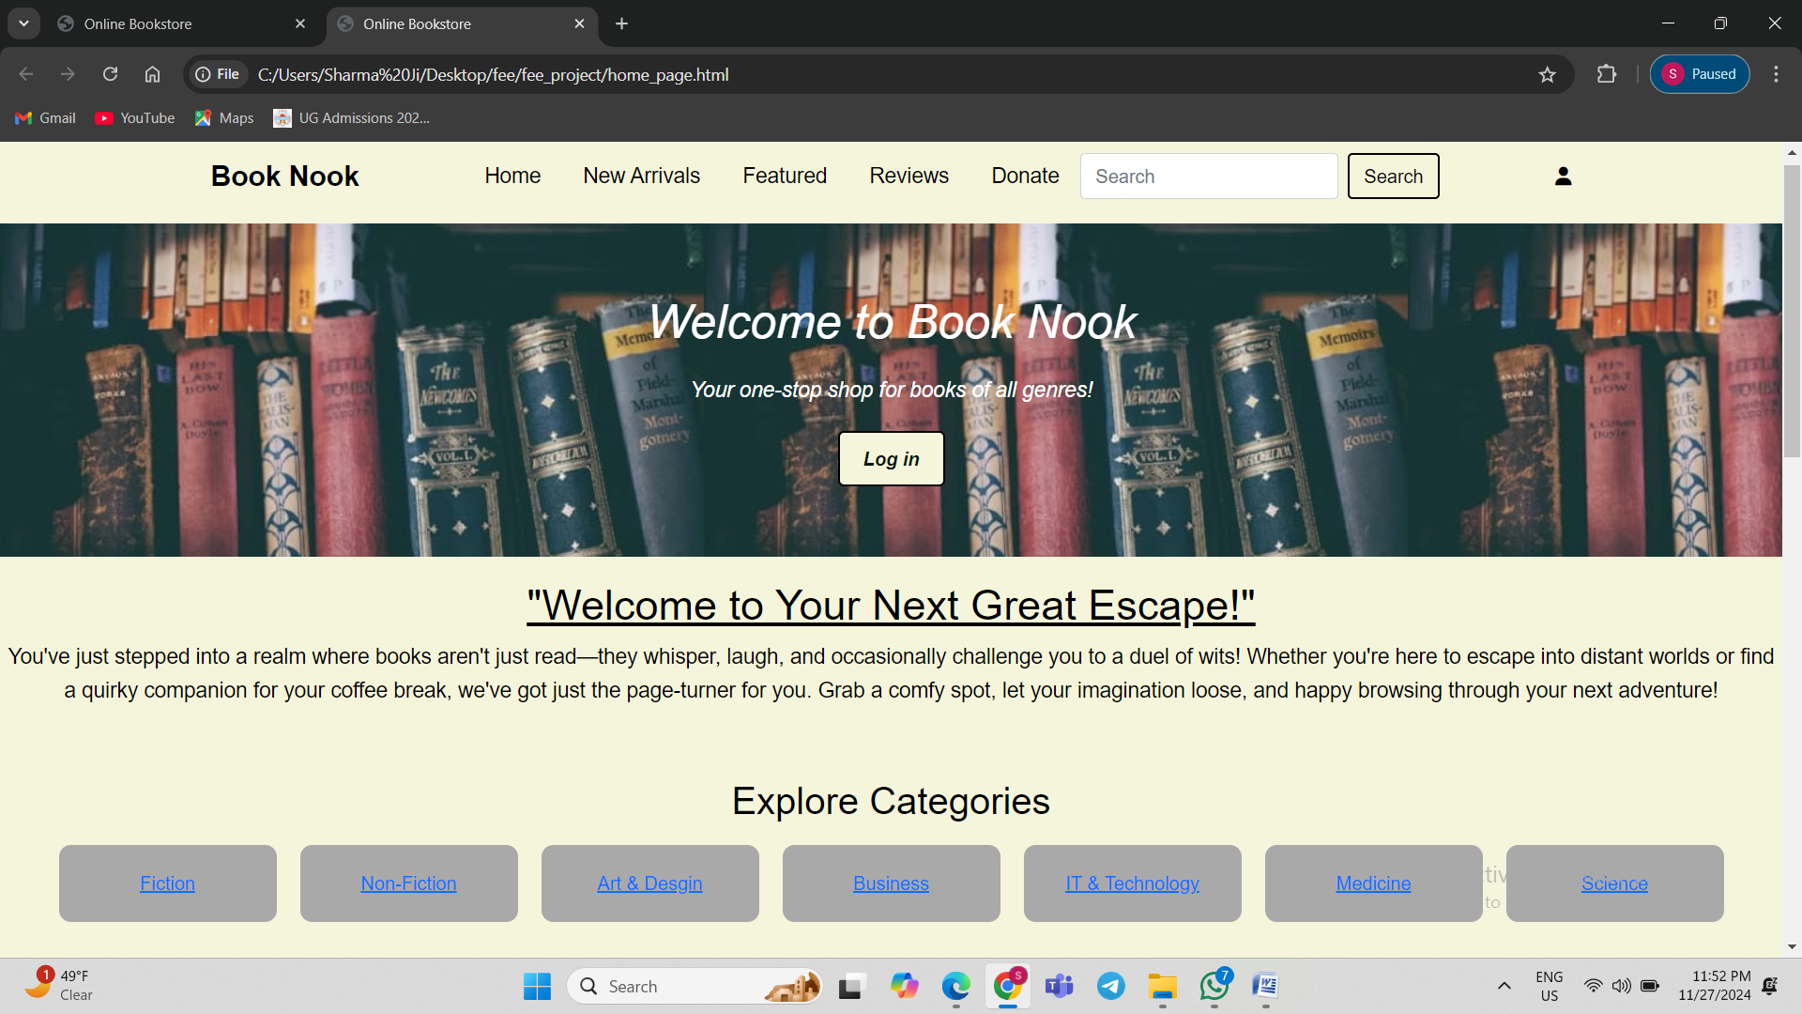

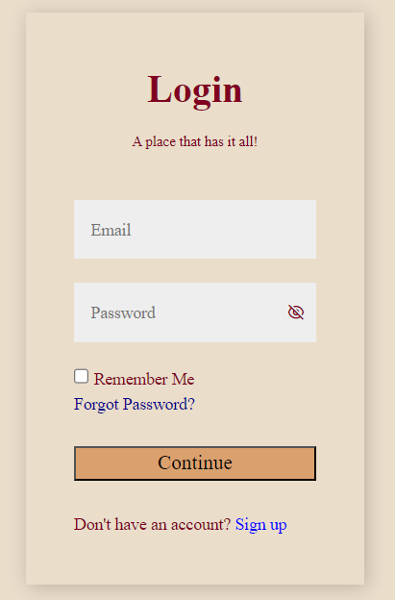 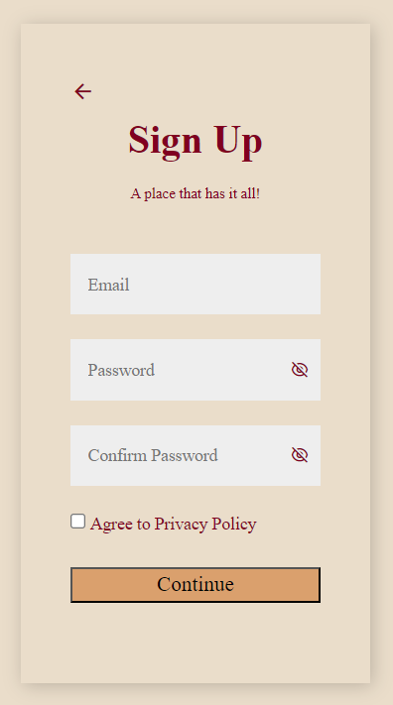

7.4 New arrivals and Featured Page

* The New Arrivals page of our online bookstore highlights the latest books added to the collection, featuring their covers, prices, and an option to view their ebooks through external links. The Featured page showcases specially curated books based on popularity, reviews, or recommendations to help users explore top picks.Also providing a reviews section for our users.

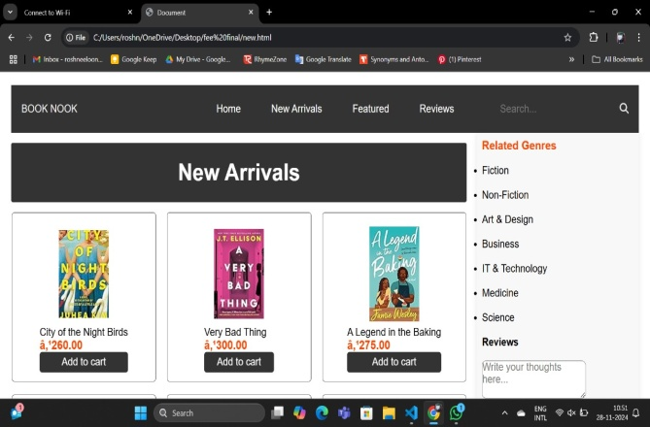 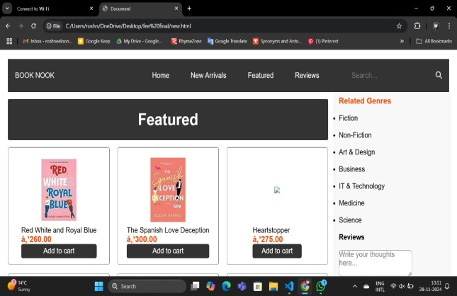

7.5 Review Page:

* The review page of "Book Nook" highlights insightful critiques and recommendations from readers, offering a diverse perspective on featured books. With neatly arranged cards, it creates an engaging space to discover and share literary experiences.

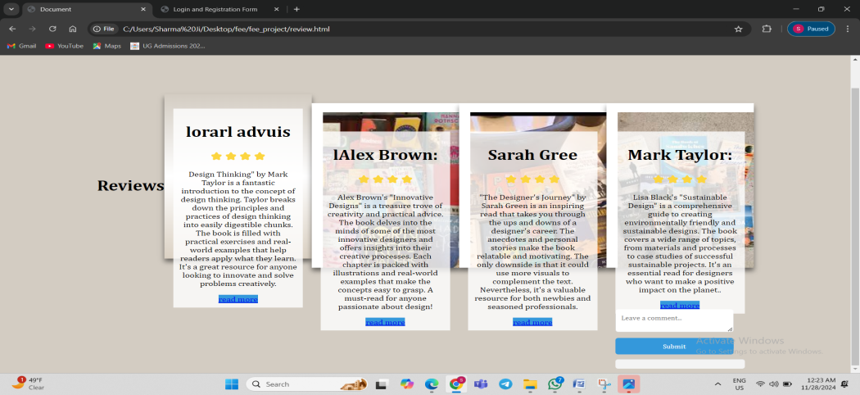

7.6 Explore Categories:

* The bookstore offers a variety of genres, including Fiction, Non-Fiction, Art & Design, Business, IT & Technology, Medicine, and Science, allowing users to easily navigate and find books based on their interests or professional needs.
* This section provides a curated collection of tech-related and all other genre books. The layout features trending books of the week, with cover images, star ratings, and a "Read More" option for detailed information. User can also write reviews about the page and books on website.

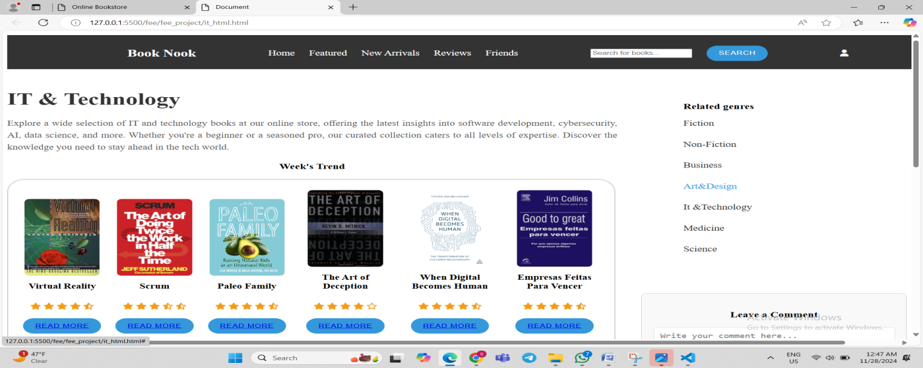

7.7 Donate Page:

* The Donate Books page of the Book Nook store encourages users to contribute to literacy by donating books to those in need. It features a simple form to enter donor details and book information, fostering a community-driven mission to share the joy of reading.One can also buy books from the same process.

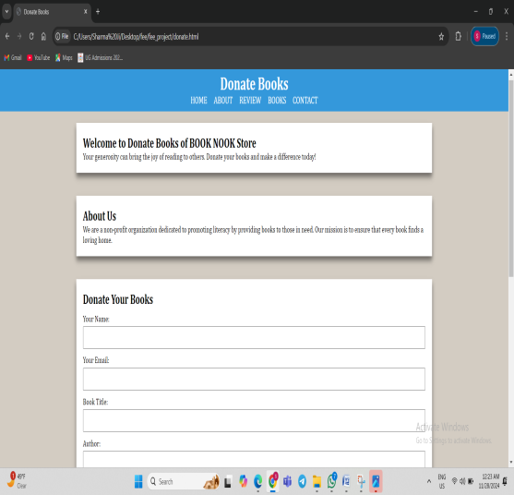 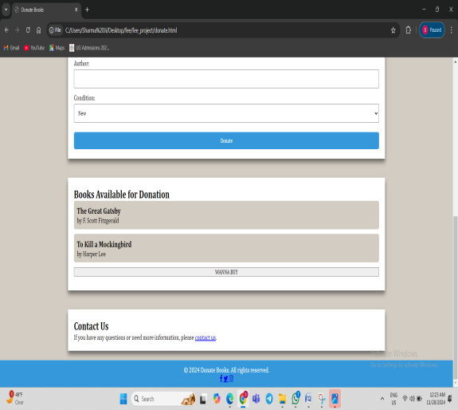

7.7 Footer

* The footer section of the Booknook website provides a "Contact Us" area with email addresses, a phone number, and an address, alongside a "Follow Us" section with social media links (Facebook, Twitter, Instagram). It also includes copyright details and links to the privacy policy and terms of service.



# CONCLUSION

Book Nook is more than just an online platform for books; it is a comprehensive and community-driven initiative dedicated to making literature accessible to all. By integrating features such as detailed book reviews, convenient purchase links, and a robust donation program, Book Nook provides a holistic solution to the challenges of accessing quality literature. Our mission as a non-profit organization is to promote literacy and ensure that every book finds a loving home, benefiting readers across diverse demographics. With an intuitive and user-friendly interface designed using HTML and CSS, Book Nook offers a seamless and engaging experience for all users. By fostering a sense of community and encouraging active participation, we aim to create a vibrant literary ecosystem where readers can connect, share, and grow together. As we continue to innovate and expand our services, we remain committed to our goal of nurturing a global community of informed and enthusiastic readers.

1. Enhanced Digital Library:

As Book Nook grows, we aim to expand our digital library to include an even wider range of genres and categories. This expansion will ensure that our platform continues to cater to the diverse literary tastes and needs of our users.

2. Mobile Application Development:

To increase accessibility and convenience, we plan to develop a mobile application for Book Nook. This app will provide users with on-the-go access to our extensive library, personalized recommendations, and interactive features, making it easier for readers to engage with literature anytime, anywhere.

3. Partnerships with Educational Institutions:

We aim to collaborate with schools, colleges, and universities to integrate Book Nook into their educational frameworks. By providing students with free access to a vast array of academic texts and self-help books, we can support their educational pursuits and promote lifelong learning.

4. Expanded Donation and Redistribution Network:

We will strengthen our donation and redistribution network by partnering with more schools, libraries, and non-profit organizations. This expansion will ensure that donated books reach a wider audience, promoting literacy and education in more communities.

5. Author and Reader Events:

Book Nook plans to host more virtual and in-person events, such as author talks, book signings, and literary festivals. These events will provide opportunities for readers to engage with authors and fellow readers, fostering a deeper connection to the literary world.

In conclusion, Book Nook is poised to continue its growth and impact, leveraging technology and community engagement to foster a more literate and connected world. By continually enhancing our features and expanding our reach, we aim to support and inspire readers everywhere, ensuring that literature remains a powerful tool for personal and collective growth.

8.2 References Used

* External References Used:

Goodreads.com

Amazon.com

* Social Media Platforms:

Facebook

Instagram

Twitter