PROJECT REQUIREMENTS

Objective

The goal of OldPal website is to create user-friendly platform that helps elderly individuals to reconnect with their childhood friends.The platform will facilitate friend matching based on shared history and provide a simple messaging system for communication.

Functional Requirements

1.User Registration and Login
- Users must be able to create an account with details such as name, age, childhood hometown, school, and interests.
- Secure authentication through password protection.
2.Friend Matching System
- The system will suggest potential friends based on shared childhood details.
- Users can search for others using specific filters.
3.Messaging Platform
- A secure chat feature enabling users to communicate privately.
- Simple, text-based interface for easy use.
4.Accessibility Features
Large fonts and high-contrast themes for improved readability.
Intuitive navigation with minimal steps to complete actions.

Non-Functional Requirements
- Security
  - Encrypted user data storage and secure authentication.
- Performance
  - Fast response time for search and messaging functions.
- Usability
  - Simple UI design tailored to elderly users.
- Scalability
  - Ability to handle an increasing number of users efficiently.
DESIGNS AND WIREFRAMES
1.HomePage
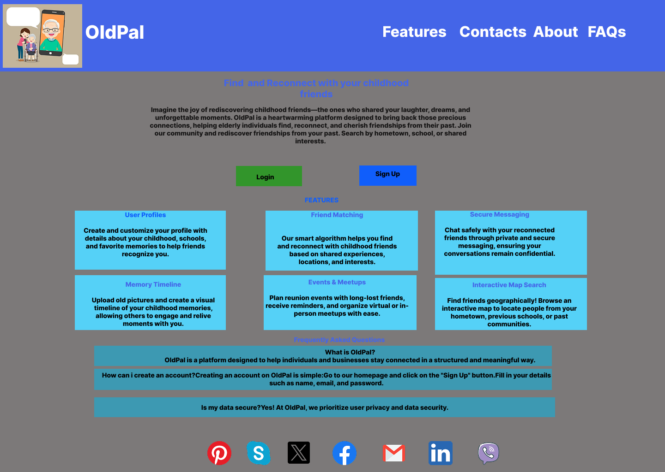
2.Login and Sign Up Page
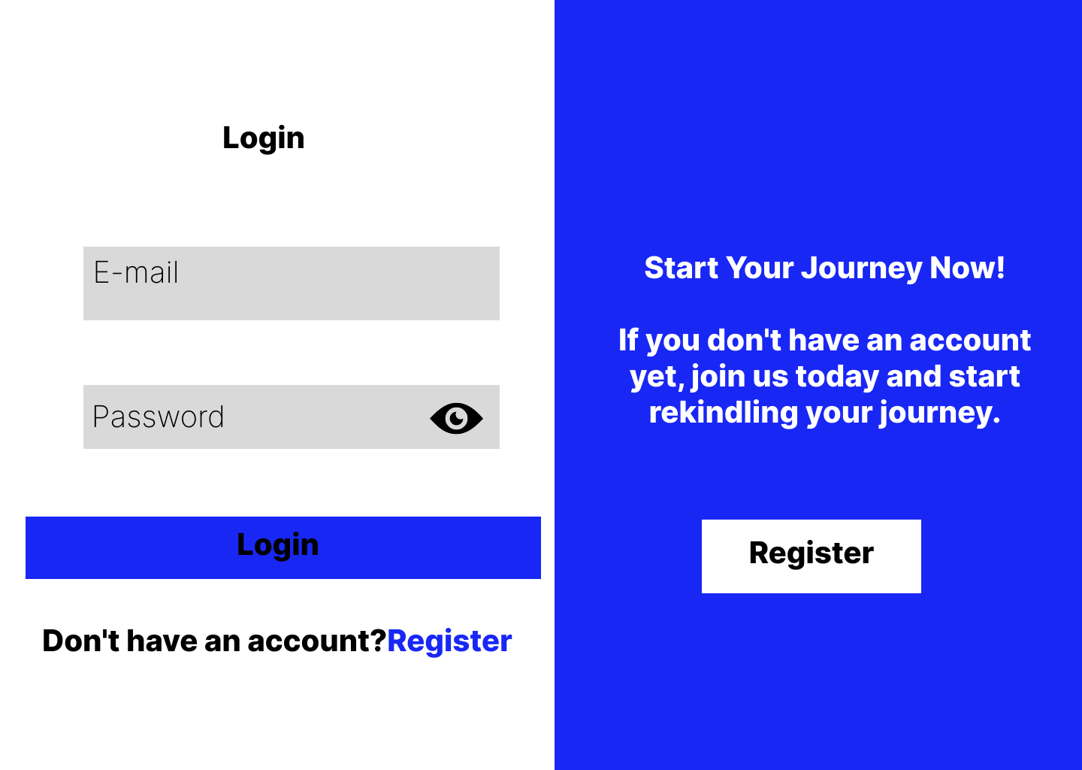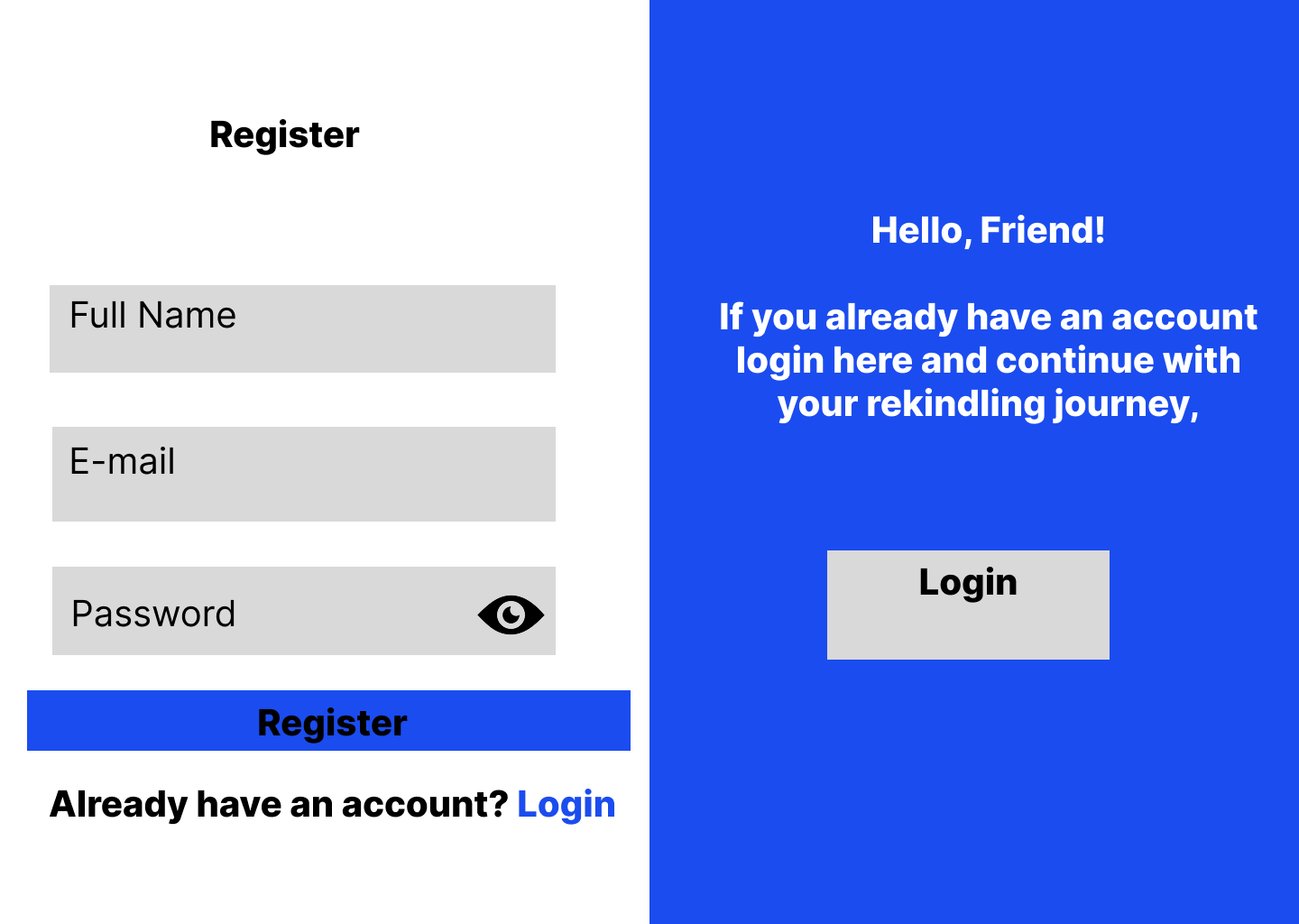
3.Details Page

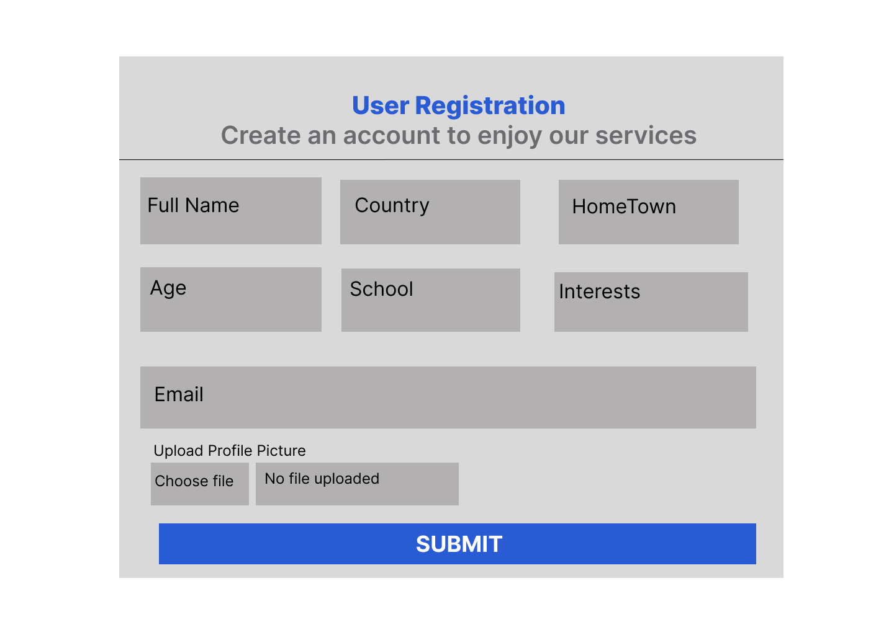
4.Search Page
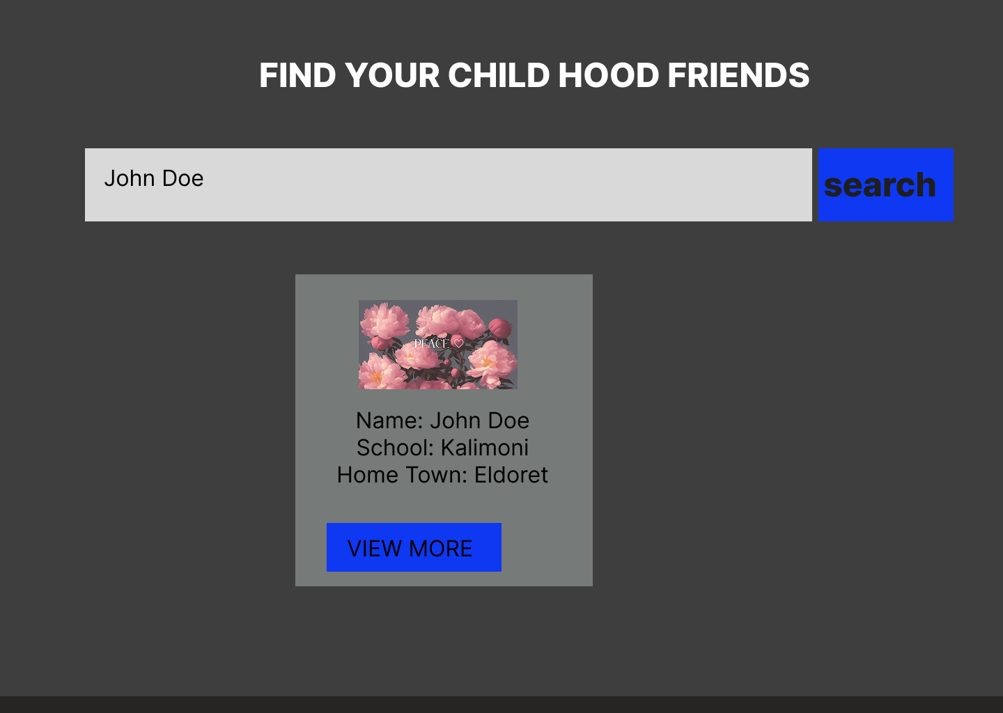

5.Chat Page
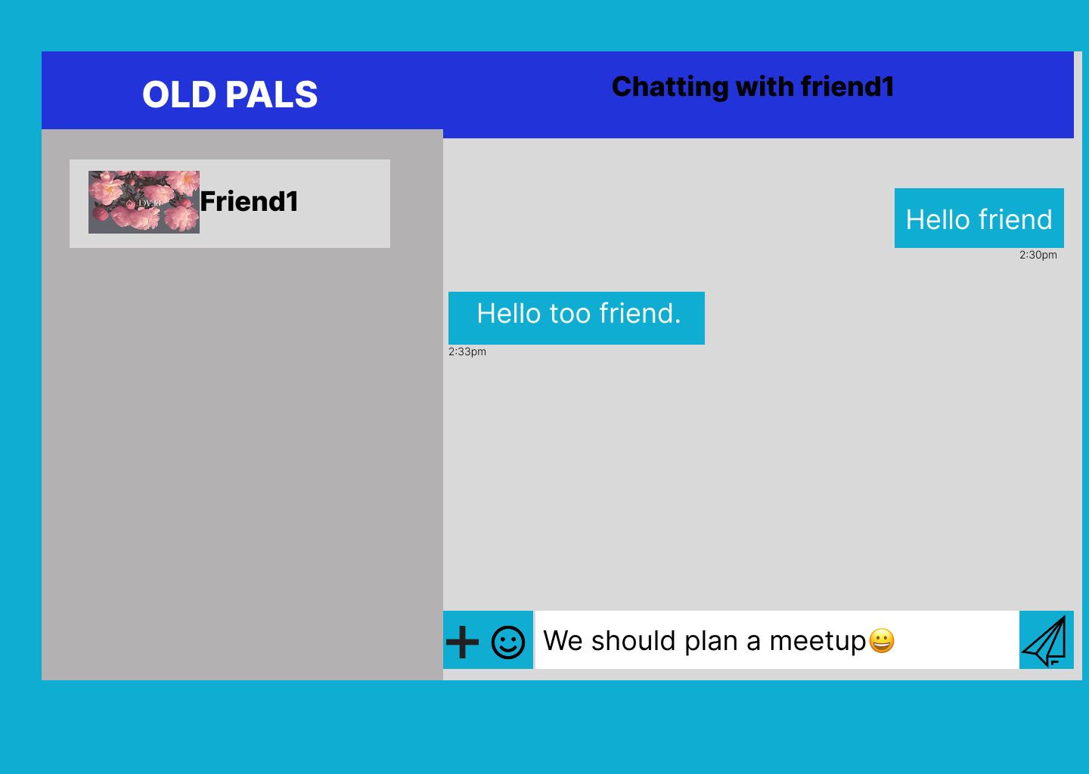

6.Profile Page
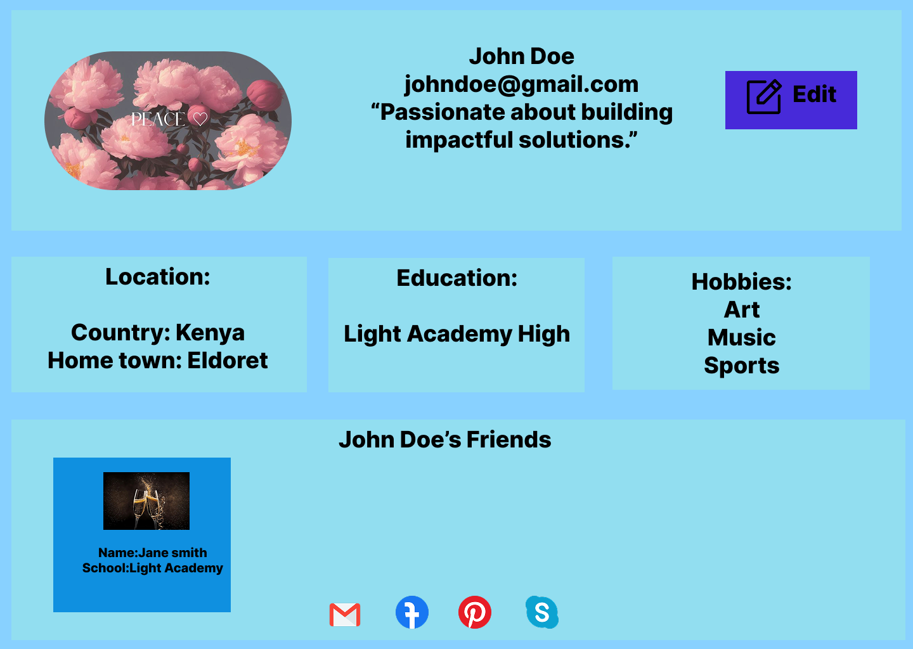

Implementation Steps
- Technology Stack
- Front-end: React.js with Redux Toolkit for state management
- Backend: Node.js with Express.js and MongoDB for data storage
- Authentication:JSON Web Tokens (JWT) for secure user authentication
- Messaging: WebSockets (Socket.io) for real-time communication
- Styling: Tailwind CSS and react-bootstrap for UI design
- Setting Up the Development Environment
- Installed required dependencies using yarn install .
- Set up the backend with Express.js and connected it to MongoDB using Mongoose.
- Initialized React for the frontend and configured Redux Toolkit
- Established WebSocket communication for real-time messaging.
- Started the backend using yarn start and the frontend using yarn dev.
- Backend Implementation
- User Registration & Authentication:
Implemented user sign-up and login with password hashing (bcrypt) and JWT authentication.
Stored user details including name, age, childhood hometown, school, and interest
- Friend Matching Algorithm:
Implemented a search system that finds potential matches based on shared childhood details.
- Messaging System:
Used WebSockets for real-time messaging.
Stored messages in MongoDB
- API Endpoints:
Developed endpoints for user management, friend matching, and messaging.
- Frontend Implementation
- User Registration & Login:
Created forms with validation for signing up and logging in.
- Friend Matching Interface:
Displayed suggested friends based on search criteria
Implemented an option to send friend requests.
- Messaging Interface:
Created a chat interface with real-time updates.
Integrated WebSockets for instant messaging updates.
- Accessibility Features:
Implemented large fonts and intuitive navigation

Testing Results
- FUNCTIONAL TESTING
Feature | Test Case | Expected Outcome | Status
User Registration | Sign up with valid details | User should be created successfully | Passed
Login | Log in with correct credentials | Redirect to Search | Passed
Friend Matching | Search for a childhood friend | Should return relevant results | Passed
Messaging | Send a message to a connected friend | Message should appear instantly | Passed
Security | Attempt unauthorized API access | Should return authentication error | Passed

- PERFORMANCE TESTING
- API Response Time: Tested with JMeter, average response time ~150ms.
- Real-time Messaging: Messages delivered with <1s latency using WebSockets.

Screenshots of the Application

User Registration Page

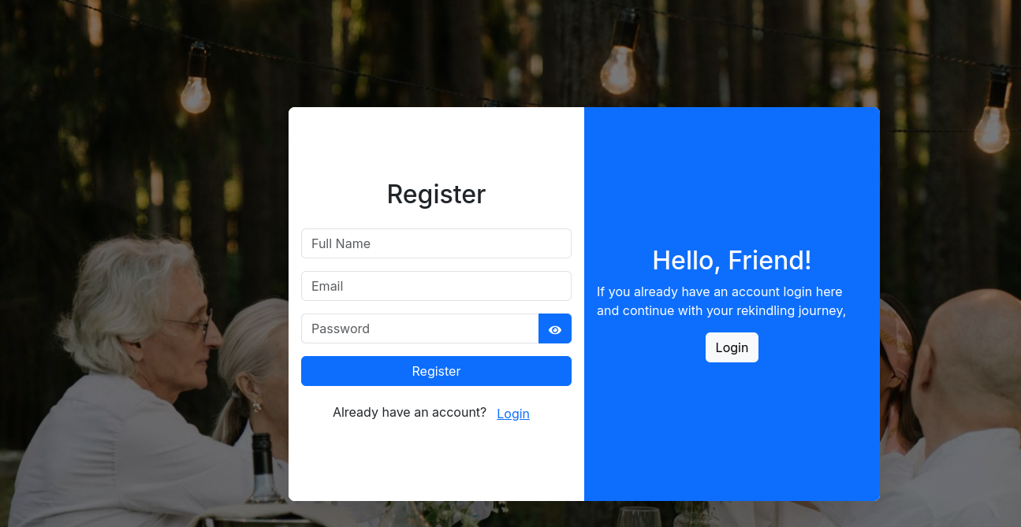
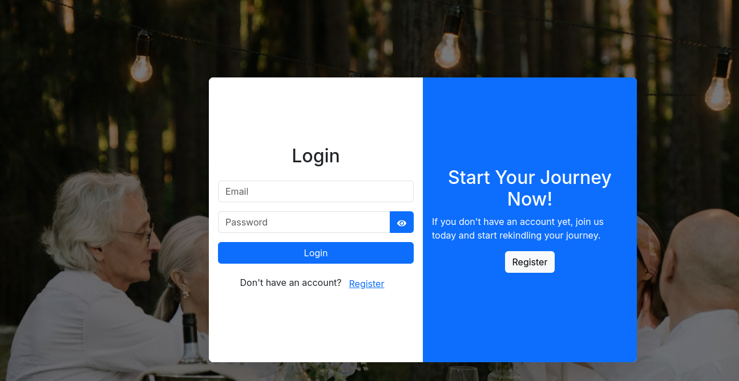
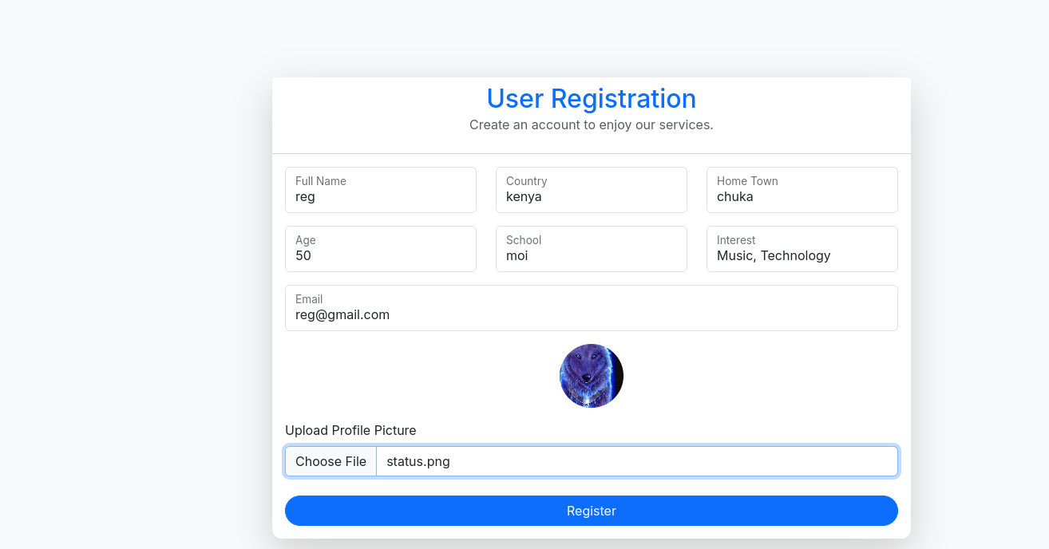

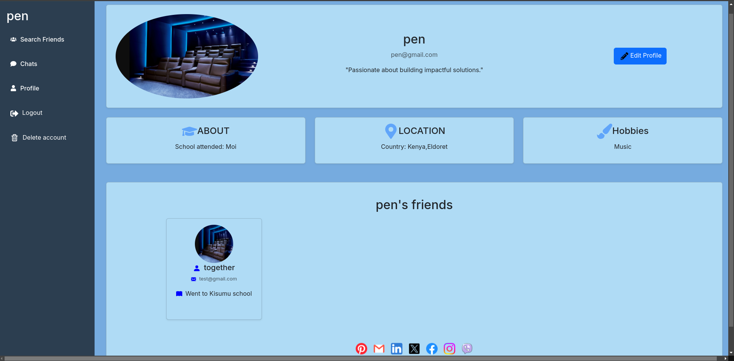

Friend Matching Page
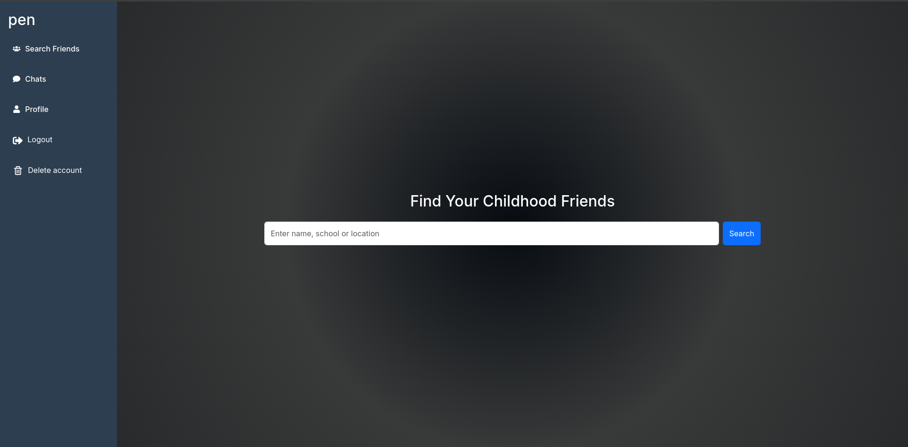

Messaging Interface

