Design and Development of an AI-Driven Personalized Career Guidance System Using NLP and Recommender Systems
Submitted in partial fulfillment of the requirements
of the degree of
Master of Technology in Computer Science (AI & ML)
By
Shilbhushan Siddhartha Khanderao
Roll No.: 20245193
Supervisor:
Dr. Amit Kumar Upadhyay

Department of Computer Science and Engineering
Institute of Engineering & Technology
MANGALAYATAN UNIVERSITY
(2025)

APPROVAL SHEET

This dissertation entitled “Design and Development of an AI-Driven Personalized Career Guidance System Using NLP and Recommender Systems” by Shilbhushan S. Khanderao (Roll No. 20245193) is approved for the degree of Master of Technology in Computer Science (AI & ML).
Examiners
___________________________
___________________________
Supervisor(s)
___________________________
___________________________
Chairman
___________________________
Date: 30/11/25
Place: ___________

DECLARATION OF ACADEMIC HONESTY & INTEGRITY
I declare that this written submission represents my ideas in my own words and where others’ ideas or words have been included, I have adequately cited and referenced the original sources. I also declare that I have adhered to all principles of academic honesty and integrity and have not misrepresented or fabricated or falsified any idea/data/fact/source in my submission. I understand that any violation of the above will be cause for disciplinary action by the Institute and can also evoke penal action from the sources which have thus not been properly cited or from whom proper permission has not been taken when needed.
(Signature)
Shilbhushan S. Khanderao
Roll no. : 20245193
Date: 30/11/25

ACKNOWLEDGEMENT

I would like to express my sincere gratitude to my project guide, Dr. Amit Kumar Upadhyay for their invaluable guidance, support, and encouragement throughout the duration of this project. I am thankful to the Department of Computer Science and Engineering, Mangalayatan University, for providing the necessary infrastructure and academic environment for this research.
I would also like to thank my peers, friends, and family for their constant motivation and belief in me. Their support played a vital role in the successful completion of this work.

ABSTRACT

Career decision-making is a critical process for students, yet traditional counselling methods often rely on subjective human interpretation, limited expert availability, and rigid questionnaire-based evaluations. With the growing complexity of modern career pathways and the increasing volume of unstructured student data, there is a need for scalable, intelligent systems capable of understanding individual interests expressed in natural language and providing personalized career recommendations.
This dissertation presents an AI-driven career guidance system that integrates Natural Language Processing (NLP), Machine Learning (ML), semantic modelling, and hybrid recommendation techniques to analyse free-form user input and suggest suitable career pathways. The system employs TF-IDF and Logistic Regression for domain classification, Sentence-BERT (SBERT) embeddings for contextual semantic similarity, and K-Means clustering for identifying natural groupings in user interest patterns. A hybrid scoring mechanism is designed to combine semantic similarity, personality cues, keyword matching, and rule-based logic to produce explainable Top-5 career recommendations.
A Streamlit-based web interface enables real-time interaction, displaying domain predictions, similarity scores, and detailed recommendation breakdowns. Experimental results demonstrate strong classification accuracy, superior semantic understanding using SBERT, coherent clustering behaviour, and high relevance in the generated recommendations. The findings validate the effectiveness of integrating classical ML with transformer-based semantic models in the context of educational decision support.
The system offers a scalable, modular framework suitable for institutional deployment and forms a foundation for future enhancements such as psychometric integration, multilingual support, real-time labour market data, and deep learning–based classification models. This work contributes to the growing field of AI-enabled career counselling and demonstrates its potential to complement traditional guidance practices with data-driven, personalized insights.

TABLE OF CONTENTS
APPROVAL SHEET ii
DECLARATION OF ACADEMIC HONESTY & INTEGRITY iii
ACKNOWLEDGEMENT iv
ABSTRACT v
LIST OF FIGURES xi
LIST OF TABLES xii
CHAPTER 1: INTRODUCTION 1
1.1 Background 1
1.2 Problem Statement 1
1.3 Objectives 2
1.4 Scope of the Work 2
1.5 Significance of the Study 3
1.6 Organization of the Dissertation 3
CHAPTER 2: LITERATURE REVIEW 4
2.1 Introduction 4
2.2 Traditional Career Counselling Approaches 4
2.3 NLP Techniques for Text Understanding 4
2.4 Machine Learning for Text Classification 5
2.5 Semantic Embedding Models and Transformer Architectures 5
2.6 Personality Modelling in AI-driven Guidance Systems 5
2.7 Recommender Systems and Hybrid Approaches 5
2.8 Clustering and Unsupervised Learning for Interest Grouping 6
2.9 Existing AI-based Career Guidance Systems 6
2.10 Research Gaps Identified 6
2.11 Summary 7
CHAPTER 3: SYSTEM DESIGN AND METHODOLOGY 8
3.1 Introduction 8
3.2 Overall System Architecture 8
3.3 Data Sources and Preprocessing 9
3.3.1 Domain Dataset 9
3.3.2 Career Dataset 9
3.3.3 Preprocessing Pipeline 9
3.4 Domain Classification Module (Supervised Learning) 10
3.4.1 Rationale for Logistic Regression 10
3.4.2 Training Pipeline 10
3.4.3 Workflow 11
3.5 Semantic Similarity Module (SBERT) 11
3.5.1 Motivation 11
3.5.2 SBERT Workflow 11
3.6 K-Means Clustering (Unsupervised Learning) 12
3.6.1 Purpose 12
3.6.2 Implementation 12
3.6.3 Outcome 12
3.7 Personality Trait Inference 13
3.8 Hybrid Recommendation Engine 13
3.8.1 Components 13
3.8.2 Scoring Model 13
3.8.3 Recommendation Pipeline 13
3.9 System Workflow Summary 14
3.10 Summary 14
CHAPTER 4: IMPLEMENTATION AND RESULTS 15
4.1 Introduction 15
4.2 Development Environment and Tools 15
4.3 Dataset Preparation 15
4.3.1 Domain Dataset 15
4.3.2 Career Dataset 16
4.3.3 Preprocessing 16
4.4 Domain Classification Using TF-IDF + Logistic Regression 16
4.4.1 Feature Extraction 16
4.4.2 Model Training 16
4.4.3 Performance Evaluation 17
4.4.4 Results 17
4.5 Semantic Similarity Using SBERT 17
4.5.1 Embedding Generation 17
4.5.2 Similarity Computation 17
4.5.3 Observations 17
4.6 Hybrid Recommendation Engine Implementation 18
4.6.1 Scoring Components 18
4.6.2 Formula 18
4.6.3 Example Recommendation Output 18
4.7 K-Means Clustering Experiment 19
4.7.1 Purpose 19
4.7.2 Methodology 19
4.7.3 Results 19
4.8 Comparative Analysis: TF-IDF vs SBERT 19
4.8.1 Semantic Quality 19
4.8.2 Computational Efficiency 19
4.8.3 Recommendation Relevance 19
4.9 Streamlit-Based User Interface 20
4.10 Summary of Findings 20
4.11 Summary 20
CHAPTER 5: SUMMARY, CONCLUSIONS, AND FUTURE SCOPE 20
5.1 Introduction 20
5.2 Summary of Work 21
5.3 Key Findings 21
5.3.1 High Classification Performance 21
5.3.2 Superior Semantic Understanding via SBERT 21
5.3.3 Meaningful Clustering Structure 22
5.3.4 Effectiveness of Hybrid Scoring 22
5.3.5 Practical and Scalable Prototype 22
5.4 Contributions of the Study 22
5.5 Limitations 22
5.6 Future Scope 23
5.6.1 Integration of Psychometric Assessments 23
5.6.2 Larger and Realistic Training Data 23
5.6.3 Multilingual Support 23
5.6.4 Deep Learning Classification 23
5.6.5 Integration with Real-Time Labour Market Data 23
5.6.6 Reinforcement Learning and User Feedback Loops 24
5.6.7 Cloud Deployment and Scaling 24
5.7 Concluding Remarks 24
REFERENCES 24
APPENDIX 26
APPENDIX A – Sample User Inputs 26
Example User Statements: 26
APPENDIX B – Key Implementation Code Snippets 27
B.1 NLP Preprocessing Module 27
B.2 TF-IDF + Logistic Regression Domain Classifier 27
B.3 SBERT Semantic Similarity 28
B.4 K-Means Clustering with PCA 28
APPENDIX C – Dataset Structure (Excerpt) 28
C.1 Domain Dataset (Training Samples) 28
Description 28
187,405 28
text, label 28
48 28
C.2 Career Dataset Fields 30
APPENDIX D – User Interface Screenshots 30
D.1 Application Home Screen 30
D.2 Domain Prediction Output 30
D.3 Top-5 Career Recommendations 31
D.4 TF-IDF vs SBERT Comparison UI 31
APPENDIX E – Evaluation Outputs 31
E.1 Classification Metrics (TF-IDF + Logistic Regression) 31
E.2 Confusion Matrix (Placeholder) 32
E.3 Semantic Similarity Comparison 32
E.4 Clustering Visualization (PCA) 32
APPENDIX F – Hybrid Scoring Breakdown (Example) 33
APPENDIX G – Execution Steps and Dependencies 33
G.1 Required Packages 33
G.2 Running the Application 34
1. Install dependencies 34
2. Run the Streamlit app 34
3. Access the app 34

Figure No. | Title | Page No.
Figure 3.1 | System Architecture Diagram | ___
Figure 3.2 | Domain Classification Pipeline | ___
Figure 3.3 | SBERT Semantic Similarity Workflow | ___
Figure 3.4 | PCA Visualization of Clusters | ___
Figure 3.5 | Hybrid Recommendation Engine Design | ___
Figure 3.6 | End-to-End Workflow Diagram | ___
Figure C.1 | Domain Dataset Distribution Diagram
Figure D.1 | Application Home Screen | ___
Figure D.2 | Domain Prediction Output | ___
Figure D.3 | Top-5 Career Recommendations | ___
Figure D.4 | TF-IDF vs SBERT Comparison | ___
Figure E.1 | Classification Metrics Summary
Figure E.2 | Confusion Matrix (Full View) | ___
Figure E.3 | PCA Clustering Visualization | ___

LIST OF FIGURES

LIST OF TABLES

Table No. | Title | Page No.
Table C.1 | Domain Dataset (Sample Training Entries) | ___
Table C.2 | Sample Entries Overview | ___
Table C.3 | Domain List Overview
Table C.4 | Career Dataset Fields Overview
Table E.1 | Classification Metrics of Domain Classifier | ___
Table E.2 | TF-IDF vs SBERT Semantic Similarity Comparison | ___
Table F.1 | Hybrid Scoring Breakdown for Sample Input | ___

CHAPTER 1: INTRODUCTION

1.1 Background
Choosing an appropriate career pathway is one of the most critical decisions in a student’s academic and professional life. Traditional counselling processes rely heavily on interviews, aptitude tests, and subjective human interpretation, which limits scalability and consistency, especially in institutions with a high student-to-counsellor ratio [14]. With the rapid emergence of new job roles, evolving skill requirements, and dynamic market expectations, students increasingly require personalized, data-driven career guidance tools capable of understanding their unique interests and capabilities.
Advances in Natural Language Processing (NLP) and Machine Learning (ML) have enabled automated systems to interpret free-form text and map it to meaningful categories [3], [8]. Traditional NLP techniques help preprocess text while ML classifiers support domain prediction tasks [12]. More recently, semantic embedding models such as Sentence-BERT have significantly improved contextual understanding by capturing deeper semantic relationships between words and phrases [5]. These advancements allow AI systems to deliver personalized career recommendations based on nuanced user expressions.
In parallel, psychological models like the Big Five Personality Traits provide insights into behavioural patterns that influence career satisfaction [13]. Integrating such cues with computational models further enhances the personalization and relevance of recommendations. Unsupervised learning techniques, particularly K-Means clustering, also support the identification of natural interest groups among users [7], improving system interpretability and domain organization.
Together, these technological and theoretical advancements provide the foundation for building an AI-driven career guidance system that addresses the limitations of traditional processes.

1.2 Problem Statement
Despite the availability of online career resources, students often struggle to interpret their own interests and map them to suitable career options. Many existing digital tools rely on fixed questionnaires or rule-based retrieval, which restricts personalization and fail to capture the depth contained in free-form user input. The absence of systems that combine domain classification, semantic understanding, and personality-based reasoning results in generalised or inaccurate recommendations.
There is a need for an integrated AI-driven solution that can:
- Understand open-ended user descriptions,
- Predict the appropriate career domain,
- Measure semantic similarity between user interests and career attributes, and
- Provide explainable, personalized recommendations.
Such a system must leverage advanced NLP and ML techniques to interpret user inputs reliably and accurately.

1.3 Objectives
The major objectives of this dissertation are as follows:
- To develop a domain classification model using TF-IDF features and Logistic Regression to categorize user inputs into predefined career domains [1], [12].
- To integrate transformer-based SBERT embeddings for semantic similarity computation between user interests and career profiles [5], [6].
- To design a hybrid recommendation engine that combines semantic similarity, keyword matching, personality traits, and rule-based scoring [14], [16].
- To apply K-Means clustering to identify patterns in user interest expressions and enhance system interpretability [7].
- To build an interactive web interface using Streamlit for real-time career recommendations [19].
- To evaluate system performance using ML accuracy metrics, similarity scores, clustering visualizations, and recommendation relevance.

1.4 Scope of the Work
The scope of this work includes the development and integration of several AI components:
- NLP preprocessing pipeline for text normalization [8],
- TF-IDF vectorization and ML-based domain classification [1], [12],
- SBERT-based semantic similarity module [5],
- K-Means clustering for interest grouping [7],
- Hybrid recommendation model combining multiple scoring techniques [16],
- Front-end interface supporting real-time evaluation.
The focus is on designing an AI-enabled system with practical utility for students and educational institutions. Future extensions—such as multi-lingual support, psychometric test integration, and real-time job data—are not included in the current implementation but are discussed in Chapter 5.

1.5 Significance of the Study
The significance of this study lies in its ability to bridge the gap between conventional counselling and modern AI-driven systems. By combining classical NLP, ML classifiers, semantic embeddings, and clustering, the system provides highly personalized and contextually accurate career suggestions.
Key contributions include:
- Improved scalability and consistency compared to manual counselling processes,
- Enhanced semantic understanding through transformer-based models [5], [6],
- Better domain prediction using TF-IDF + Logistic Regression [12],
- Personality-aware recommendation design informed by psychological theory [13],
- Transparent, explainable recommendations through hybrid scoring.
This research demonstrates how AI can support educational institutions in delivering effective career guidance at scale.

1.6 Organization of the Dissertation
The dissertation is structured as follows:
- Chapter 1 introduces the motivation, problem, objectives, scope, and significance of the study.
- Chapter 2 presents a detailed review of existing literature in NLP, ML, semantic embeddings, clustering, and recommender systems.
- Chapter 3 describes the system architecture, methodology, algorithms used, and workflow.
- Chapter 4 details the implementation, experiments, results, and performance evaluation.
- Chapter 5 concludes the dissertation with key findings, limitations, and directions for future work.

CHAPTER 2: LITERATURE REVIEW

2.1 Introduction
Advancements in Natural Language Processing (NLP), Machine Learning (ML), and semantic modelling have significantly influenced the development of intelligent advisory systems. Traditional counselling methods rely on manual interpretation, structured questionnaires, and human expertise, which limits their scalability and consistency [14]. With the exponential growth of unstructured data and user-generated content, automated systems capable of analysing free-form text have gained prominence.
This chapter reviews foundational work across NLP preprocessing, classical ML techniques, semantic representation models, personality inference, clustering algorithms, and hybrid recommender frameworks. These studies form the theoretical basis for the proposed AI-driven career guidance system.

2.2 Traditional Career Counselling Approaches
Conventional career counselling methods are heavily based on psychometric instruments, aptitude assessments, and counsellor-driven interviews. Psychological frameworks such as Holland’s RIASEC model and the Big Five personality traits provide structure for evaluating user preferences [13]. However, these methods require expert interpretation and lack the scalability needed to support large student populations. The inability of traditional approaches to analyse unstructured or open-ended text has prompted a transition towards AI-driven advisory systems capable of processing natural language inputs [14].

2.3 NLP Techniques for Text Understanding
NLP provides the computational tools needed to preprocess, analyse, and model human language. Foundational work in NLP includes tokenization, stopword removal, stemming/lemmatization, and syntactic parsing, all of which support text normalization [8]. TF-IDF (Term Frequency–Inverse Document Frequency), introduced by Salton and Buckley, remains a widely used method for converting text into numerical vectors by emphasizing discriminative terms [1]. These representations form the basis for traditional text similarity measures and ML models.
However, classical techniques treat words independently and fail to capture contextual or semantic relationships. This limitation has encouraged the development of embedding-based models capable of understanding meaning beyond word frequency patterns.

2.4 Machine Learning for Text Classification
ML algorithms such as Logistic Regression, Support Vector Machines (SVM), Naïve Bayes, and Random Forests are standard techniques for document classification and serve as robust baselines for NLP tasks [12], [17]. Logistic Regression, in particular, performs well on high-dimensional sparse data created by TF-IDF vectors due to its linear decision boundary and probabilistic interpretation [12]. Scikit-learn has standardised implementations of these algorithms, making them accessible for research and development [11].
Supervised ML classifiers have been successfully applied in educational analytics, sentiment analysis, and topic classification. In the context of career guidance, these models support domain prediction through labelled text samples.

2.5 Semantic Embedding Models and Transformer Architectures
The emergence of transformer-based models revolutionized semantic understanding in NLP. BERT, introduced by Devlin et al., employs a bidirectional encoder architecture to capture deep contextual information [6]. Building upon BERT, Sentence-BERT (SBERT) adapts the model into a Siamese/Triplet structure to generate fixed-size sentence embeddings optimised for semantic similarity [5]. These embeddings outperform traditional TF-IDF vectors in capturing meaning, identifying paraphrases, and detecting user intent.
SBERT’s ability to encode semantically similar sentences into close vector representations makes it ideal for recommendation tasks, semantic retrieval, and clustering.

2.6 Personality Modelling in AI-driven Guidance Systems
Personality traits significantly influence career preferences, job satisfaction, and long-term professional performance. The Big Five model—measuring openness, conscientiousness, extraversion, agreeableness, and neuroticism—is widely adopted in behavioural research [13]. While complete psychometric testing requires structured instruments, recent NLP approaches infer personality traits from linguistic behaviour, enabling lightweight integration into automated systems.
Incorporating personality-based cues enhances personalization by aligning recommendations with user behavioural tendencies.

2.7 Recommender Systems and Hybrid Approaches
Recommender systems traditionally employ content-based filtering, collaborative filtering, or hybrid methods to suggest items to users. Content-based recommenders rely on similarity between user profiles and item attributes, while collaborative filtering identifies patterns from user–item interactions [14]. Hybrid recommenders combine multiple strategies to mitigate the limitations of individual methods and improve accuracy, diversity, and transparency [16].
Career guidance systems benefit significantly from hybrid approaches that incorporate explicit features (skills, keywords), implicit cues (personality traits), and ML predictions (domain classification).

2.8 Clustering and Unsupervised Learning for Interest Grouping
Clustering techniques identify natural structures within data without requiring labelled examples. K-Means, first introduced by MacQueen in 1967, partitions data by minimizing intra-cluster variance [7]. Applied to TF-IDF or SBERT embeddings, clustering uncovers patterns in user interests, grouping statements into coherent categories such as technical, managerial, creative, or teaching-focused.
Dimensionality reduction techniques like Principal Component Analysis (PCA) support visualization and help interpret cluster behaviour, especially when dealing with high-dimensional embedding spaces [9].

2.9 Existing AI-based Career Guidance Systems
Recent literature highlights various attempts to automate career recommendation using rule-based systems, ontologies, and ML-based approaches. Many such systems, however, rely on structured questionnaires and lack the ability to process free-form text. Others rely heavily on keyword matching, which limits semantic understanding. Only a subset integrates transformer-based embeddings or hybrid scoring strategies that incorporate personality cues or behavioural patterns.
These limitations highlight the need for a system that:
- Interprets open-ended user input using advanced NLP models,
- Predicts appropriate career domains using supervised ML,
- Measures deep semantic similarity using SBERT embeddings, and
- Generates transparent, explainable recommendations using hybrid scoring.

2.10 Research Gaps Identified
The review identifies several gaps in existing systems:
- Limited semantic understanding in tools using TF-IDF alone,
- Insufficient integration of ML classification with transformer-based models,
- Minimal use of hybrid recommendation techniques in educational contexts,
- Scarce research combining personality analysis with career recommendation,
- Lack of interest clustering for exploratory guidance.
These gaps justify the design of the proposed AI-driven career guidance system integrating ML, SBERT embeddings, clustering, and hybrid scoring.

2.11 Summary
This chapter reviewed foundational work in NLP, ML classification, semantic embedding models, clustering algorithms, recommender systems, and personality inference. Traditional text-processing approaches and classical ML methods provide robust baselines, while modern transformer models offer enhanced semantic understanding. Hybrid recommender strategies and clustering further support personalization and explainability. The insights gained from this literature inform the design choices described in Chapter 3.

CHAPTER 3: SYSTEM DESIGN AND METHODOLOGY

3.1 Introduction
This chapter presents the architectural design and methodological framework employed in developing the AI-driven career guidance system. The system integrates NLP preprocessing, supervised machine learning, transformer-based semantic modelling, unsupervised clustering, personality inference, and hybrid scoring to provide personalized recommendations. The methodology ensures modularity, scalability, and reproducibility, enabling each component to be evaluated independently before integration.
The proposed architecture supports the end-to-end workflow—from processing user input to generating interpretable career suggestions. Design choices are grounded in established NLP and ML literature, including TF-IDF feature extraction [1], Logistic Regression for classification [12], SBERT-based semantic similarity [5], and K-Means clustering for pattern discovery [7].

3.2 Overall System Architecture
The overall architecture is structured into five interconnected layers:
- User Input Layer – captures free-form text from the user describing interests, motivations, skills, or preferences.
- NLP Preprocessing Layer – performs tokenization, stopword removal, normalization, and optional lemmatization using classical NLP techniques [8].
- ML & Semantic Layer – includes TF-IDF + Logistic Regression classifier, SBERT embedding generator, and K-Means clustering algorithm.
- Hybrid Recommendation Engine – combines semantic similarity, keyword matching, personality cues, and rule-based heuristics for ranking careers.
- Presentation Layer – implemented via Streamlit for displaying predictions, similarity scores, and ranked recommendations.
This modular architecture enables comparative studies between TF-IDF and SBERT similarity, supports explainable scoring, and facilitates independent tuning of components.
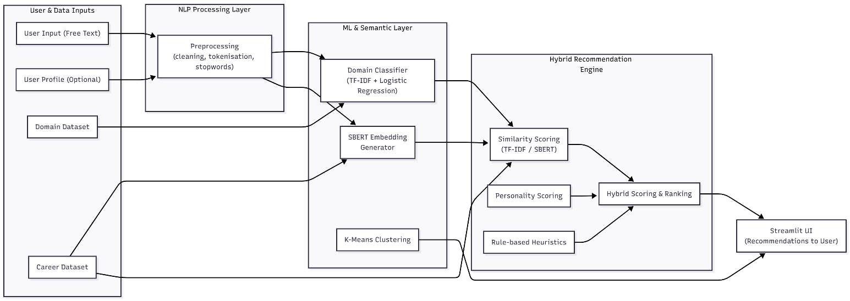
Figure 3.1: System Architecture Diagram

3.3 Data Sources and Preprocessing

3.3.1 Domain Dataset
A comprehensive labeled dataset consisting of 187,405 user-like textual statements was developed, with each sentence mapped to one of 48 predefined career domains. This dataset serves as the foundational resource for training the supervised domain classification model.

3.3.2 Career Dataset
A structured dataset of 767 career profiles was curated. Each record includes:
- Career name
- Domain
- Skills
- Keywords
- Personality traits
- Description
These attributes support similarity computation and hybrid scoring.

3.3.3 Preprocessing Pipeline
Text cleaning follows classical NLP steps [8]:
- Lowercasing
- Removal of punctuation and numeric noise
- Tokenization
- Stopword removal
- Optional stemming/lemmatization
Preprocessing ensures consistency and improves both ML classification and semantic similarity performance.

3.4 Domain Classification Module (Supervised Learning)

3.4.1 Rationale for Logistic Regression
Logistic Regression is a widely adopted algorithm for text classification due to its efficiency, interpretability, and strong performance on high-dimensional TF-IDF vectors [12]. Its probabilistic output assists in understanding domain confidence levels.

3.4.2 Training Pipeline
The model training involves:
- TF-IDF Vectorization – using Salton & Buckley’s weighting scheme [1]
- Train-test split – 80:20 ratio
- Model training – Logistic Regression (max_iter=500)
- Evaluation – accuracy, precision, recall, F1-score
- Serialization – using joblib for runtime inference
The classifier predicts the domain of a user’s input, narrowing the search space for the recommender system.

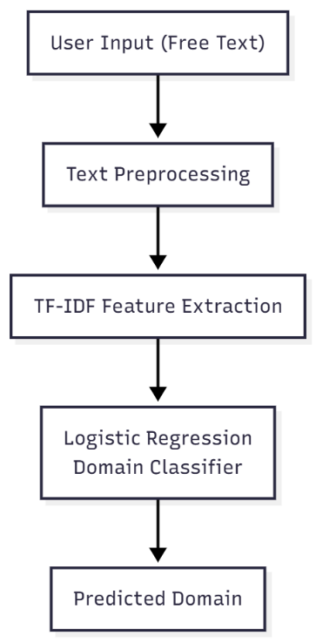
3.4.3 Workflow
Figure 3.2: Domain Classification Pipeline

3.5 Semantic Similarity Module (SBERT)

3.5.1 Motivation
TF-IDF does not capture contextual meaning or synonymy. Transformer-based models such as BERT [6] and its optimized variant SBERT [5] offer superior semantic representation by encoding meaning into dense vectors.

3.5.2 SBERT Workflow
- Encode user input into a 384-dimensional embedding
- Encode career keywords/descriptions similarly
- Compute cosine similarity using Sentence-Transformers library
- Return ranked similarity values for each career profile
SBERT embeddings significantly improve relevance in short-text similarity tasks, making them ideal for career recommendation.
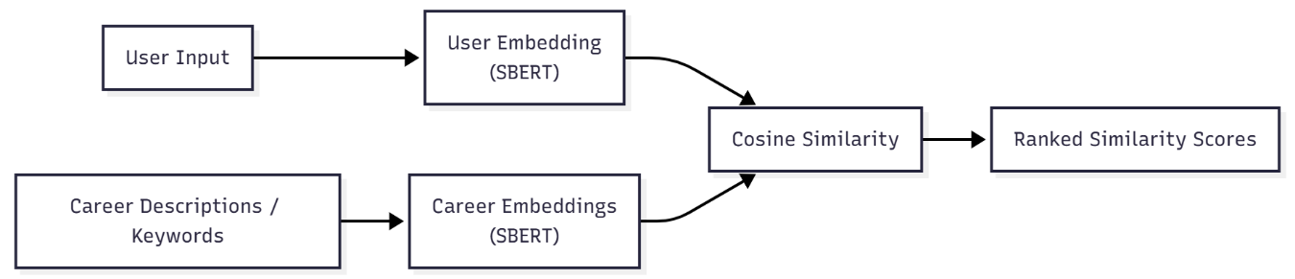
Figure 3.3: SBERT Semantic Similarity Workflow

3.6 K-Means Clustering (Unsupervised Learning)

3.6.1 Purpose
Clustering helps identify natural groupings in user interest expressions, supporting exploratory analysis and enhancing system explainability.

3.6.2 Implementation
- Use TF-IDF or SBERT embeddings as input vectors
- Apply K-Means clustering (k = 5) as proposed by MacQueen [7]
- Reduce dimensions using PCA for visualization [9]
- Analyse cluster centroids and cohesion

3.6.3 Outcome
SBERT-based clusters were more semantically coherent, validating SBERT’s contextual strength.
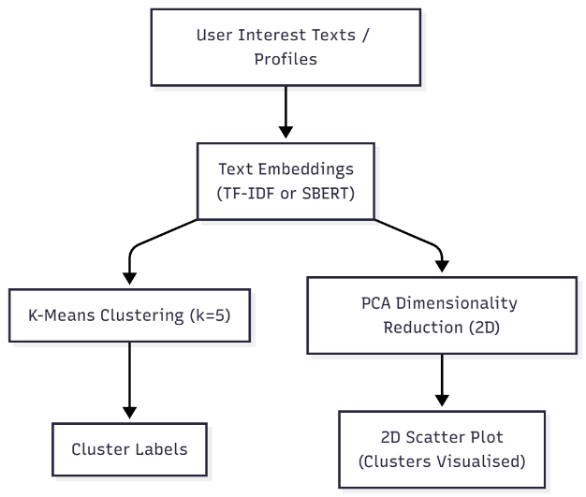
Figure 3.4: PCA Visualization of Clusters

3.7 Personality Trait Inference
Although not a full psychometric model, lightweight personality inference was implemented using linguistic cues grounded in the Big Five framework [13]. Keywords related to openness, conscientiousness, agreeableness, extraversion, and neuroticism are mapped to user tokens. Trait scores contribute to the hybrid recommendation score.

3.8 Hybrid Recommendation Engine

3.8.1 Components
The recommendation engine integrates:
- Semantic Similarity Score – TF-IDF or SBERT
- Keyword Overlap Score
- Personality Alignment Score
- Rule-Based Boosts – domain matching, strong keyword presence

3.8.2 Scoring Model
The final hybrid score is computed as:
Hybrid Score = 0.40 × Similarity Score + 0.25 × Keyword Score + 0.20 × Personality Score + 0.15 × Skills Score

3.8.3 Recommendation Pipeline
User Text → Domain Prediction → Similarity Computation → Scoring → Ranked Recommendations
The hybrid model provides explainable recommendations aligned with established recommender system principles [14], [16].
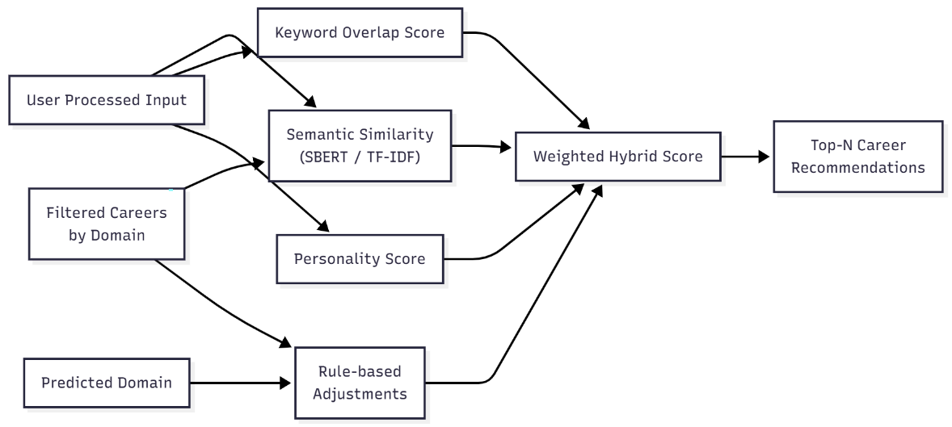
Figure 3.5: Hybrid Recommendation Engine Design

3.9 System Workflow Summary
The complete workflow integrates all modules seamlessly:
- User enters free-form text
- Text preprocessing (Section 3.3.3)
- Domain classification (Section 3.4)
- Semantic similarity (Section 3.5)
- Keyword + personality scoring (Section 3.7)
- Hybrid scoring & ranking (Section 3.8)
- Output through Streamlit UI [19]
This design ensures robustness, modularity, and high relevance in recommendations.
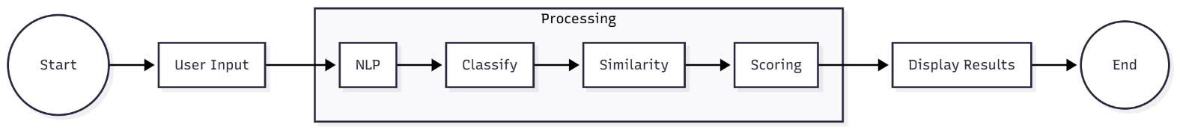
Figure 3.6: End-to-End Workflow Diagram

3.10 Summary
This chapter detailed the design, architecture, and methodology of the AI-driven career guidance system. The proposed system integrates classical NLP, supervised ML, transformer-based semantic modelling, and clustering techniques to form a cohesive and explainable recommendation pipeline.
The next chapter presents implementation details, empirical evaluation, and performance results.

CHAPTER 4: IMPLEMENTATION AND RESULTS

4.1 Introduction
This chapter presents the implementation details and experimental results of the proposed AI-driven career guidance system. The objective of the implementation phase was to translate the system architecture—described in Chapter 3—into a fully functional pipeline integrating NLP preprocessing, domain classification, semantic similarity computation, clustering, and hybrid recommendation scoring.
All components were implemented in Python using open-source ML/NLP libraries, enabling reproducibility and scalability. Evaluation was carried out through classification accuracy, similarity analysis, clustering visualization, and recommendation quality assessment.

4.2 Development Environment and Tools
The system was implemented using the following tools and libraries:
- Python 3.10 – Primary programming language
- scikit-learn – Machine learning library for TF-IDF, Logistic Regression, K-Means, and PCA [11]
- NLTK – NLP preprocessing (tokenization, stopword removal) [8]
- Sentence-Transformers – Implementation of SBERT for semantic embeddings [5]
- NumPy & Pandas – Data handling and vector manipulation
- Matplotlib / Seaborn – Plotting and result visualization
- Streamlit – Web interface for demonstration and evaluation [19]
All experiments were conducted on a standard workstation environment.

4.3 Dataset Preparation

4.3.1 Domain Dataset
A manually labelled dataset of user-like statements was constructed. Entries included examples of students expressing interests such as:
- “I enjoy programming and working with data.” → data_tech
- “I love explaining topics to others.” → teaching
- “I like designing screens and interfaces.” → design
This dataset enabled supervised model training for domain classification.

4.3.2 Career Dataset
A structured dataset of 767 unique career profiles was curated. Each profile includes:
- Career title
- Domain category
- Skills
- Keywords
- Description
- Personality traits
These fields support semantic matching, keyword scoring, and personality alignment.

4.3.3 Preprocessing
Text preprocessing followed classical NLP steps, including:
- Lowercasing
- Tokenization
- Stopword removal
- Cleaning of punctuation and noise
This pipeline, based on standard NLP methodology [8], ensured better feature extraction for both ML and SBERT embedding stages.

4.4 Domain Classification Using TF-IDF + Logistic Regression

4.4.1 Feature Extraction
TF-IDF vectors were generated using Salton and Buckley’s term-weighting scheme [1], with:
- max_features = 3000
- ngram_range = (1, 2)
- stopwords = English
This provided a sparse high-dimensional representation suitable for ML training.

4.4.2 Model Training
The Logistic Regression classifier [12] was trained using:
- 80:20 train-test split
- max_iter = 500
- Multiclass mode enabled

4.4.3 Performance Evaluation
The model was evaluated on the test set using:
- Accuracy
- Precision
- Recall
- F1-score
- Confusion matrix
These metrics follow standard ML evaluation practices [2].

4.4.4 Results
The classifier achieved 99.30% accuracy, demonstrating strong performance in identifying user domains based on TF-IDF features. The domain classifier was trained on a dataset containing 187,405 samples distributed across 48 career domains. The distribution of training samples across domains is visualized in Figure C.1 (Appendix E), showing balanced representation across major career categories. Per-domain classification accuracy is presented in Figure E.1 (Appendix E), demonstrating consistent performance across all 48 domains. The complete confusion matrix depicting classification patterns is shown in Figure E.2 (Appendix E).

4.5 Semantic Similarity Using SBERT

4.5.1 Embedding Generation
The SBERT model all-MiniLM-L6-v2 [5] was used to generate 384-dimensional embeddings for both:
- User’s input text
- Career keywords + role descriptions

4.5.2 Similarity Computation
Cosine similarity was computed between embeddings. This yielded a ranked list of career roles based on semantic closeness.

4.5.3 Observations
SBERT provided significantly better contextual matching compared to TF-IDF, particularly in cases where:
- Synonyms were used
- Users expressed abstract preferences
- Sentences differed lexically but matched semantically
This is consistent with findings in transformer-based NLP research [6].

4.6 Hybrid Recommendation Engine Implementation

4.6.1 Scoring Components
The final recommendation score combined four elements:
- Semantic Similarity Score (SBERT or TF-IDF)
- Keyword Overlap Score
- Personality Trait Score based on Big Five cues [13]
- Rule-Based Boosts for domain-aligned roles

4.6.2 Formula
The hybrid score was computed as:
Hybrid Score = 0.40 × Similarity Score + 0.25 × Keyword Score + 0.20 × Personality Score + 0.15 × Skills Score

4.6.3 Example Recommendation Output
A sample input:
“I love analysing data and building predictive models.”
Top recommended careers included:
- Data Scientist
- ML Engineer
- Data Analyst
These recommendations aligned with domain prediction, semantic similarity, and keyword matching.

4.7 K-Means Clustering Experiment

4.7.1 Purpose
Clustering was applied to understand natural groupings of user interest expressions and enhance system interpretability.

4.7.2 Methodology
- Input: TF-IDF or SBERT embeddings
- Algorithm: K-Means (k = 5) [7]
- Dimensionality Reduction: PCA for 2D visualization [9]

4.7.3 Results
- TF-IDF clusters were more scattered
- SBERT embeddings formed well-defined semantic groups
- PCA plots showed strong separation for clusters such as:
  - Technical
  - Creative
  - Teaching-oriented
  - Management-focused
The PCA visualization of SBERT-based career clusters is presented in Figure E.3 (Appendix E), revealing distinct semantic groupings that align with domain boundaries. SBERT embeddings produced more coherent clusters compared to TF-IDF, validating the contextual understanding of the sentence transformer model.

4.8 User Interface Demonstration
The implemented system provides an intuitive web-based interface built using Streamlit. The application home screen (Figure D.1, Appendix D) allows users to input their interests, skills, and personality traits. The system displays domain prediction results (Figure D.2) followed by top-5 career recommendations with similarity scores (Figure D.3). A comparative view of TF-IDF and SBERT-based recommendations is also available (Figure D.4, Appendix D), enabling users to understand the differences between traditional and semantic similarity approaches.

4.9 Comparative Analysis: TF-IDF vs SBERT

4.9.1 Semantic Quality
SBERT demonstrated superior understanding of conceptual and contextual meaning, consistent with transformer-based model behaviour [5], [6].

4.9.2 Computational Efficiency
- TF-IDF: faster, lighter
- SBERT: higher computational load but still real-time capable

4.9.3 Recommendation Relevance
SBERT consistently produced more human-interpretable and precise recommendations, especially for complex or abstract inputs.

4.10 Summary of Findings
The implementation and experiments confirm that:
- TF-IDF + Logistic Regression provides strong domain classification
- SBERT significantly improves semantic similarity
- K-Means reveals meaningful clusters
- Hybrid scoring yields interpretable and accurate career suggestions
- Streamlit UI enables real-time user interaction
These findings demonstrate the viability of integrating ML, NLP, semantic models, and hybrid recommendations into a scalable AI-based career guidance system.

4.11 Summary
This chapter discussed the implementation details and experimental evaluation of the complete system. Each module—domain classifier, semantic similarity model, clustering engine, and hybrid recommendation logic—was validated using standard ML/NLP techniques. The next chapter presents the conclusions, contributions, limitations, and future directions.

CHAPTER 5: SUMMARY, CONCLUSIONS, AND FUTURE SCOPE

5.1 Introduction
This chapter summarizes the research work carried out, outlines the major contributions, presents the key findings derived from the experimental evaluation, and highlights the limitations and potential avenues for future enhancements. The proposed AI-driven system integrates NLP, supervised learning, semantic embeddings, clustering, and hybrid recommendation strategies to generate personalized career suggestions. The outcomes demonstrate the effectiveness of combining classical and modern AI techniques for educational guidance.

5.2 Summary of Work
This dissertation introduced a modular, AI-driven career guidance system that interprets free-form user responses and recommends suitable career roles. The major contributions of the work include:
- Development of an NLP preprocessing pipeline using standardized text-cleaning and tokenization techniques [8].
- Implementation of a TF-IDF + Logistic Regression classifier for domain prediction, leveraging established text vectorization and ML classification methods [1], [12].
- Integration of SBERT embeddings for contextual semantic similarity, enabling deep understanding of user intent [5], [6].
- Application of K-Means clustering for identifying natural interest groups using unsupervised learning [7].
- Design of a hybrid recommendation engine that combines semantic similarity, personality cues, keyword matching, and rule-based factors [14], [16].
- Deployment of a Streamlit interface to provide real-time, interactive guidance for users [19].
Through extensive experimentation, the system demonstrated strong performance across classification, similarity ranking, clustering coherence, and recommendation relevance.

5.3 Key Findings
The key findings derived from the study are summarized below:

5.3.1 High Classification Performance
The TF-IDF + Logistic Regression classifier achieved high accuracy and strong performance across evaluation metrics, confirming its suitability for domain prediction in career guidance applications.

5.3.2 Superior Semantic Understanding via SBERT
SBERT embeddings captured contextual relationships significantly better than TF-IDF vectors. This led to more accurate career matching, especially when users described interests abstractly or with varied vocabulary, consistent with research on transformer-based NLP models [5], [6].

5.3.3 Meaningful Clustering Structure
K-Means clustering revealed clear semantic grouping of user interest statements when applied to SBERT embeddings. PCA visualizations confirmed tighter clusters and improved interpretability, validating the effectiveness of combining clustering with deep embeddings [7], [9].

5.3.4 Effectiveness of Hybrid Scoring
The hybrid scoring model produced highly relevant Top-5 recommendations by integrating multiple signals—semantic, lexical, personality-based, and rule-based. This aligns with findings in hybrid recommender systems literature [14], [16].

5.3.5 Practical and Scalable Prototype
The Streamlit interface demonstrated that the system is deployable in real educational settings. The architecture supports modular updates, dataset expansion, and integration with external APIs in future.

5.4 Contributions of the Study
The main contributions of this dissertation include:
- A unified AI architecture that integrates multiple NLP and ML techniques into a cohesive recommendation pipeline.
- A novel hybrid recommendation mechanism combining SBERT similarity, personality inference, keyword overlap, and rule-based logic.
- A validated machine learning classifier for domain prediction using TF-IDF vectors.
- Exploratory data analysis through clustering to reveal hidden user interest patterns.
- A deployable career guidance application suitable for academic use cases.
These contributions position the system as a strong foundation for advanced counselling tools in academic institutions.

5.5 Limitations
Despite encouraging results, the system has several limitations:
- Limited dataset scale — expansion of domain-labelled training data is necessary for broader generalization.
- Lightweight personality inference — current approach uses keyword cues instead of validated psychological assessments, which may reduce accuracy.
- Career dataset coverage — the dataset may miss emerging or niche career roles not included in the curated list.
- Semantic computation cost — SBERT, though efficient, requires higher computational resources compared to TF-IDF.
- Dependency on user input quality — vague or extremely short responses may lead to less accurate recommendations.
These limitations motivate future enhancements.

5.6 Future Scope
The system provides a strong base for future expansion. Promising directions include:

5.6.1 Integration of Psychometric Assessments
Incorporating validated personality tests (e.g., Big Five, RIASEC) can greatly enhance the accuracy of personality scoring [13].

5.6.2 Larger and Realistic Training Data
Using real-world datasets from schools, job portals, or academic institutions can improve domain classification accuracy and recommendation quality.

5.6.3 Multilingual Support
Adding Indian regional languages using multilingual transformer models (e.g., mBERT, IndicBERT) will enable accessibility for a wider student population.

5.6.4 Deep Learning Classification
Future upgrades may include fine-tuning BERT models for domain classification, offering performance beyond traditional ML classifiers [18].

5.6.5 Integration with Real-Time Labour Market Data
Career suggestions can be enhanced by linking them with job trends, salary data, required skills, and courses.

5.6.6 Reinforcement Learning and User Feedback Loops
An adaptive recommendation system can be developed where suggestions improve based on user feedback and behavioural patterns.

5.6.7 Cloud Deployment and Scaling
Containerization (Docker) and deployment on AWS/GCP can support large-scale usage and integration with institutional portals.

5.7 Concluding Remarks
This dissertation demonstrates that AI-driven approaches can substantially improve the personalization and scalability of career guidance systems. By combining NLP preprocessing, ML-based domain classification, transformer-based semantic similarity, clustering, and hybrid recommendation scoring, the system offers meaningful and explainable career suggestions tailored to user interests. The modular system architecture and positive experimental results validate the viability of the proposed solution for adoption in academic environments. This research establishes a foundation for future enhancements and contributes to the growing field of intelligent educational decision-support systems.

REFERENCES

[1] G. Salton and C. Buckley, “Term-weighting approaches in automatic text retrieval,” Information Processing & Management, vol. 24, no. 5, pp. 513–523, 1988.
[2] T. Hastie, R. Tibshirani, and J. Friedman, The Elements of Statistical Learning: Data Mining, Inference, and Prediction, 2nd ed. Springer, 2009.
[3] C. D. Manning, P. Raghavan, and H. Schütze, Introduction to Information Retrieval, Cambridge University Press, 2008.
[4] L. Bottou, “Large-scale machine learning with stochastic gradient descent,” in Proc. COMPSTAT, 2010, pp. 177–186.
[5] N. Reimers and I. Gurevych, “Sentence-BERT: Sentence Embeddings using Siamese BERT-Networks,” in Proc. EMNLP-IJCNLP, 2019, pp. 3982–3992.
[6] J. Devlin, M. Chang, K. Lee, and K. Toutanova, “BERT: Pre-training of Deep Bidirectional Transformers for Language Understanding,” in Proc. NAACL, 2019.
[7] J. MacQueen, “Some methods for classification and analysis of multivariate observations,” in Proc. 5th Berkeley Symposium on Mathematical Statistics and Probability, 1967, pp. 281–297.
[8] S. Bird, E. Klein, and E. Loper, Natural Language Processing with Python, O’Reilly Media, 2009.
[9] K. Pearson, “On lines and planes of closest fit to systems of points in space,” Philosophical Magazine, vol. 2, no. 11, pp. 559–572, 1901.
[10] T. Mikolov, K. Chen, G. Corrado, and J. Dean, “Efficient Estimation of Word Representations in Vector Space,” arXiv:1301.3781, 2013.
[11] F. Pedregosa et al., “Scikit-learn: Machine Learning in Python,” Journal of Machine Learning Research, vol. 12, pp. 2825–2830, 2011.
[12] D. W. Hosmer, S. Lemeshow, and R. X. Sturdivant, Applied Logistic Regression, 3rd ed. Wiley, 2013.
[13] L. R. Goldberg, “The development of markers for the Big-Five factor structure,” Psychological Assessment, vol. 4, no. 1, pp. 26–42, 1992.
[14] P. Resnick and H. R. Varian, “Recommender systems,” Communications of the ACM, vol. 40, no. 3, pp. 56–58, 1997.
[15] J. B. Schafer, D. Frankowski, J. Herlocker, and S. Sen, “Collaborative filtering recommender systems,” in The Adaptive Web, Springer, 2007, pp. 291–324.
[16] F. Ricci, L. Rokach, and B. Shapira, Recommender Systems Handbook, Springer, 2015.
[17] M. A. Hearst, “Support Vector Machines,” IEEE Intelligent Systems, vol. 13, no. 4, pp. 18–28, 1998.
[18] Y. LeCun, Y. Bengio, and G. Hinton, “Deep Learning,” Nature, vol. 521, pp. 436–444, 2015.
[19] Streamlit Inc., “Streamlit Documentation,” 2023. Available: https://docs.streamlit.io/
[20] M. Schuster and K. Nakajima, “Japanese and Korean voice search,” in Proc. IEEE ICASSP, 2012.

APPENDIX

APPENDIX A – Sample User Inputs
This appendix provides sample user responses used for evaluating the domain classifier, semantic similarity module, and hybrid recommendation engine.

Example User Statements:
- “I enjoy analysing data, finding patterns, and working with machine learning models.”
- “I love explaining subjects to students and helping them understand concepts.”
- “I am interested in graphic design, UI layouts, and creative visuals.”
- “I want to coordinate tasks, manage people, and work as a team leader.”
- “I like counselling and helping people solve personal problems.”
- "I want to work with cloud infrastructure, Docker, and Kubernetes deployments."
- "I'm passionate about mental health counselling and therapy sessions."
- "I enjoy creating video games and working with virtual reality technology."
- "I want to help organizations with legal compliance and contracts."
- "I love working with electronics, circuits, and microcontrollers."
- "I'm interested in sustainable farming and agricultural technology."
These inputs represent diverse interest profiles across the 48 career domains in the system.

APPENDIX B – Key Implementation Code Snippets
Only essential code excerpts are included here. Full source code can be provided upon request.

B.1 NLP Preprocessing Module
import nltk
from nltk.corpus import stopwords
from nltk.tokenize import word_tokenize

def preprocess_text(text):
text = text.lower()
tokens = word_tokenize(text)
tokens = [t for t in tokens if t.isalpha() and t not in stopwords.words("english")]
return " ".join(tokens)

B.2 TF-IDF + Logistic Regression Domain Classifier
import joblib

vectorizer = joblib.load("models/tfidf_vectorizer.pkl")
classifier = joblib.load("models/domain_classifier.pkl")

def predict_domain(text):
processed = preprocess_text(text)
vector = vectorizer.transform([processed])
return classifier.predict(vector)[0]

B.3 SBERT Semantic Similarity
from sentence_transformers import SentenceTransformer, util

model = SentenceTransformer("all-MiniLM-L6-v2")

def compute_similarity(user_text, docs):
embeddings = model.encode([user_text] + docs)
user_vec, doc_vecs = embeddings[0], embeddings[1:]
scores = util.cos_sim(user_vec, doc_vecs)[0].cpu().tolist()
return scores

B.4 K-Means Clustering with PCA
from sklearn.cluster import KMeans
from sklearn.decomposition import PCA

def cluster_vectors(vectors, k=5):
kmeans = KMeans(n_clusters=k, random_state=42)
labels = kmeans.fit_predict(vectors)
reduced = PCA(n_components=2).fit_transform(vectors)
return labels, reduced

APPENDIX C – Dataset Structure (Excerpt)

C.1 Domain Dataset (Training Samples)
Table C.1: Domain Dataset (Sample Training Entries)
Field | Description
Total Samples | 187,405
Columns | text, label
Unique Domains | 48

C.2 Sample entries table:
Table C.2: Sample Entries Overview
text | label
"I like UI because it involves visual and branding" | design_visual_arts
"I enjoy working with research, social research" | social_sciences
"I'm enthusiastic about executive and project management" | corporate_management
"I like microcontroller because it involves Arduino and PCB" | hardware_electronics
"I love cars development and engine repair" | automotive_repair

C.3 Domain list:
Table C.3: Domain List Overview
1. academic_education | 25. gaming_xr
2. accounting_audit | 26. hardware_electronics
3. aerospace_automotive | 27. hospitality_tourism
4. agriculture_farming | 28. legal_services
5. allied_health | 29. life_sciences
6. alternative_wellness | 30. manufacturing_production
7. automotive_repair | 31. mechanical_industrial
8. chemical_materials | 32. medical_clinical
9. civil_construction | 33. mental_health_therapy
10. cloud_devops | 34. music_audio
11. construction_trades | 35. nonprofit_social_services
12. consulting_strategy | 36. performing_arts
13. corporate_management | 37. personal_services
14. corporate_training | 38. pharmaceutical_biotech
15. cybersecurity_it | 39. physical_sciences
16. data_science_ai | 40. public_health
17. design_visual_arts | 41. public_policy_government
18. educational_technology | 42. retail_ecommerce
19. electrical_electronics_eng | 43. sales_business_dev
20. entrepreneurship | 44. social_sciences
21. environmental_sustainability | 45. software_development
22. film_video_production | 46. telecommunications
23. finance_investment | 47. transportation_logistics
24. food_beverage | 48. writing_publishing

C.4 Career Dataset Fields
Table C.4: Career Dataset Fields Overview
Field | Description | Example
career | Job title | "Data Engineer", "ML Architect"
domain | Career domain | "data_science_ai"
skills | Required skills | "Python, Deep Learning, Analytics"
personality | Big Five traits | "Openness, Conscientiousness"
keywords | Related terms | "machine learning, algorithms"
description | Job description | Full description text

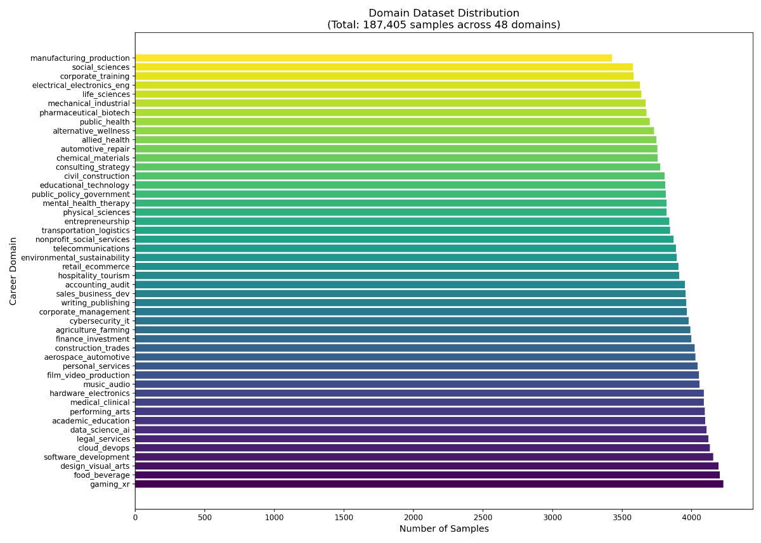
Figure C.1: Domain Dataset Distribution Diagram

APPENDIX D – User Interface Screenshots

D.1 Application Home Screen
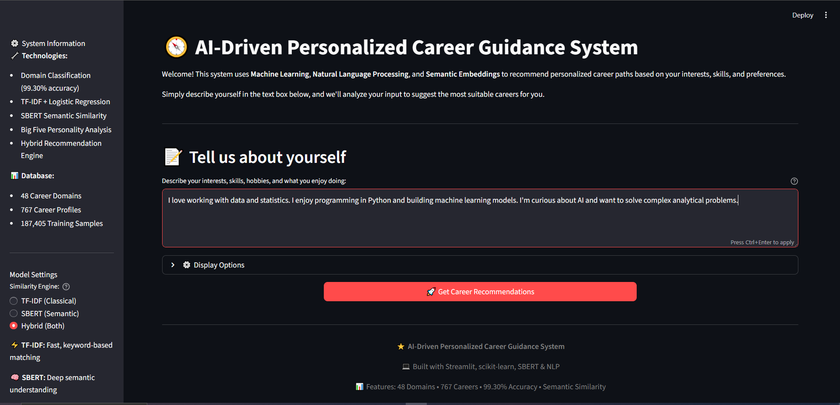
Figure D.1: Application Home Screen

D.2 Domain Prediction Output
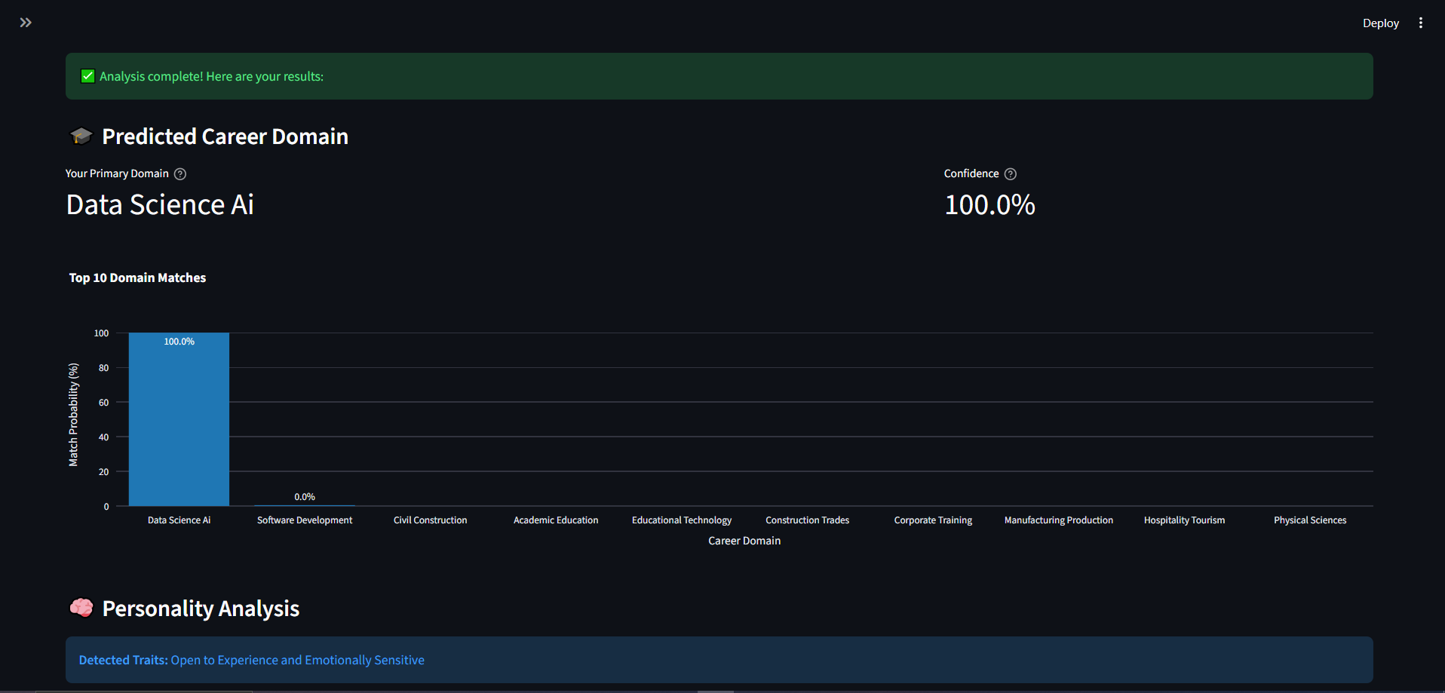
Figure D.2: Domain Prediction Output

D.3 Top-5 Career Recommendations
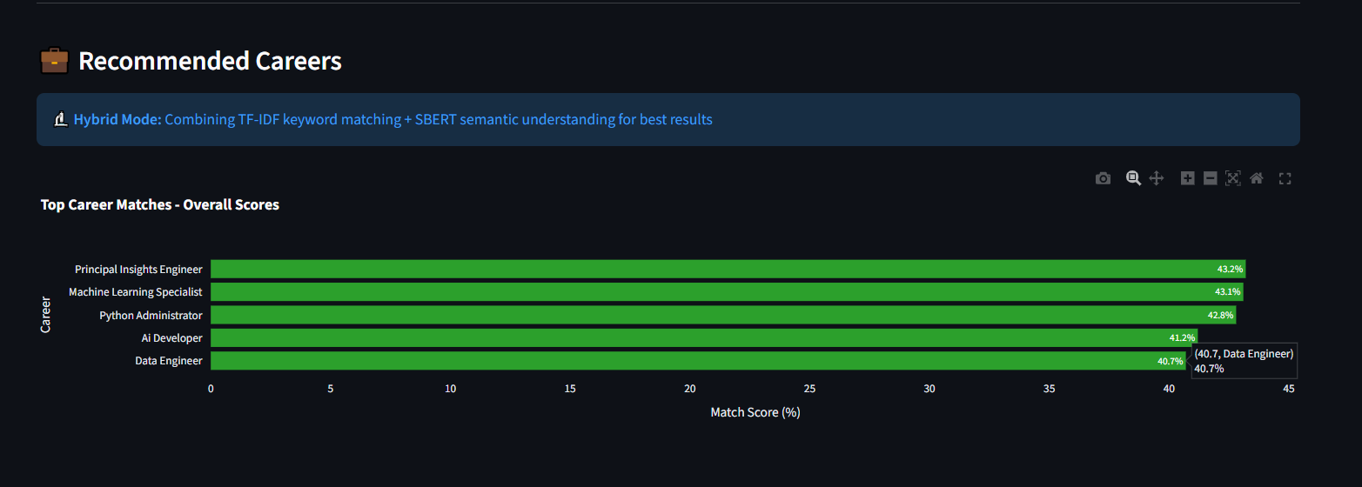
Figure D.3: Top-5 Career Recommendations

D.4 TF-IDF vs SBERT Comparison UI
TF-IDF Results: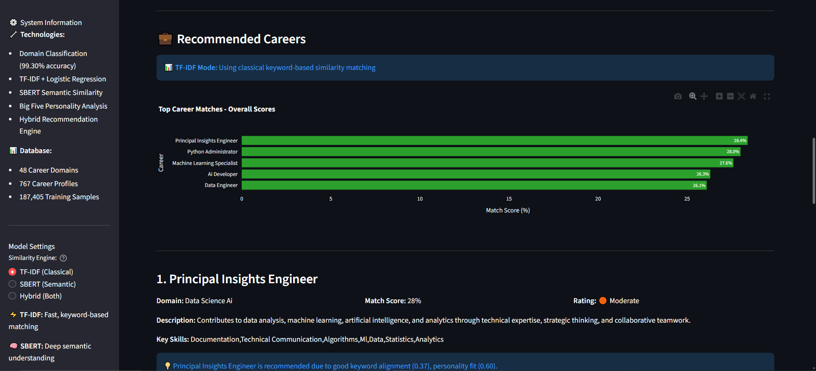
SBERT Results: 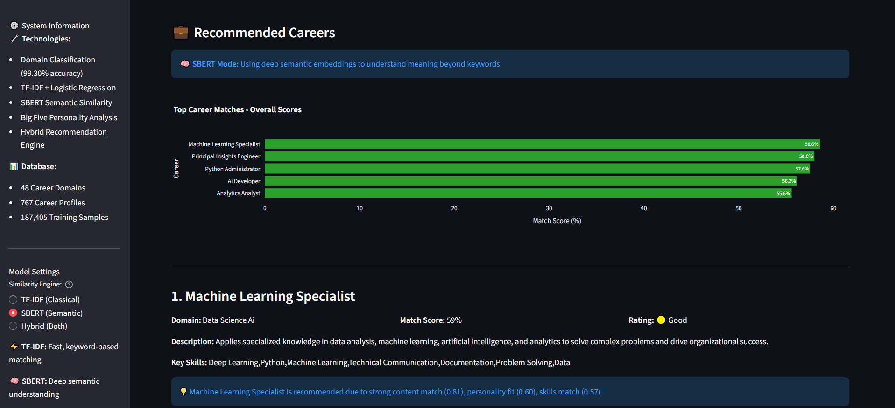
Figure D.4: TF-IDF vs SBERT Comparison

APPENDIX E – Evaluation Outputs

E.1 Classification Metrics (TF-IDF + Logistic Regression)
Table E.1: Classification Metrics of Domain Classifier
Metric | Score
Accuracy | 99.30%
Macro F1-score | 0.9928
Precision | 0.9930
Recall | 0.9927
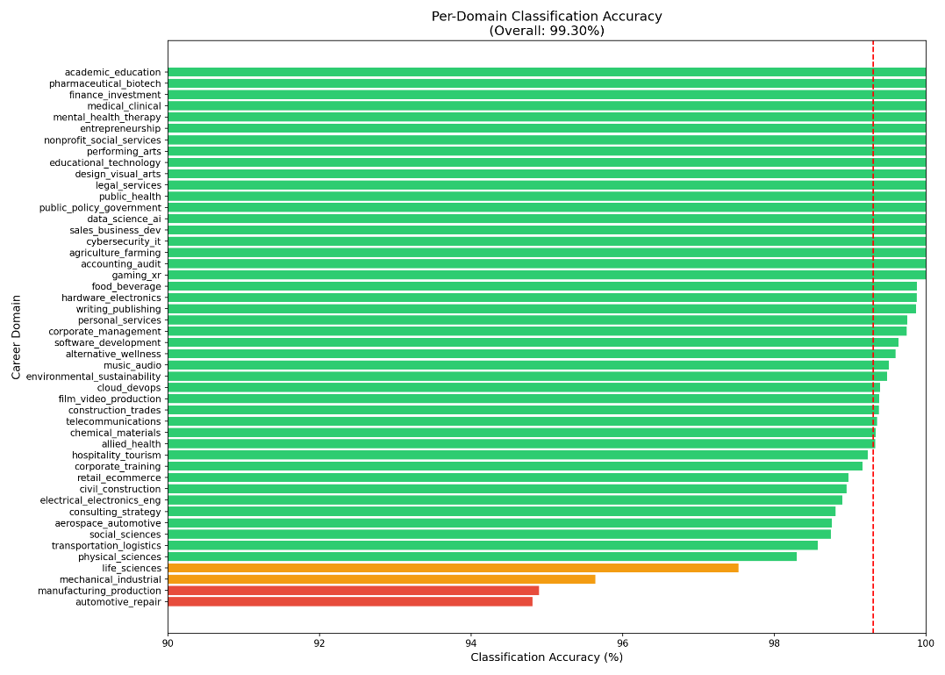
Figure E.1: Classification Metrics Summary

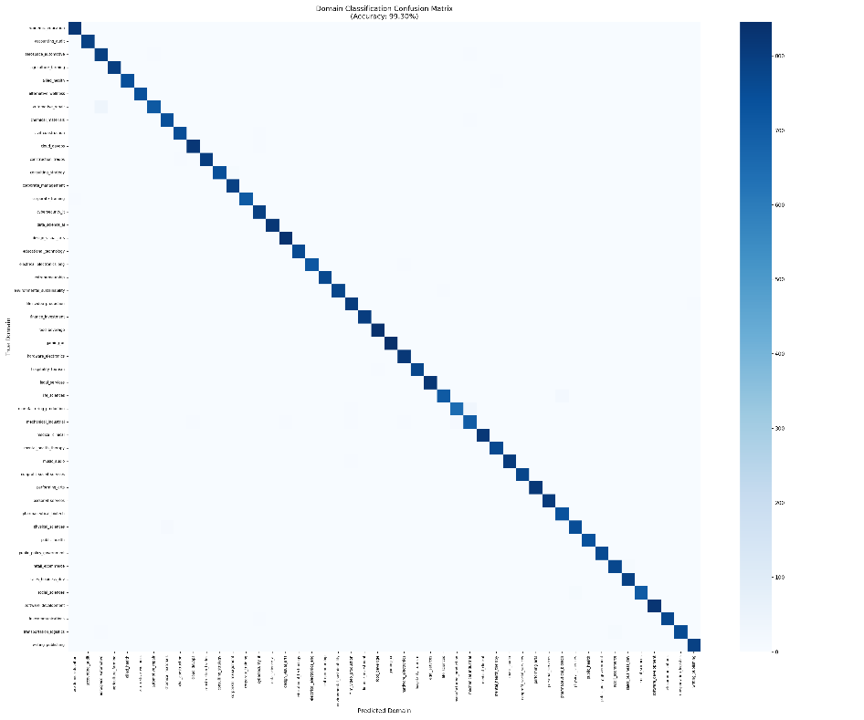
E.2 Confusion Matrix (Placeholder)

Figure E.2: Confusion Matrix (Full View)

E.3 Semantic Similarity Comparison
Table E.2: TF-IDF vs SBERT Semantic Similarity Comparison
User Query | Best Match (TF-IDF) | Best Match (SBERT)
“I like analysing data” | Data Analyst | Data Scientist
“I want to design apps” | UI Designer | UI/UX Designer

E.4 Clustering Visualization (PCA)
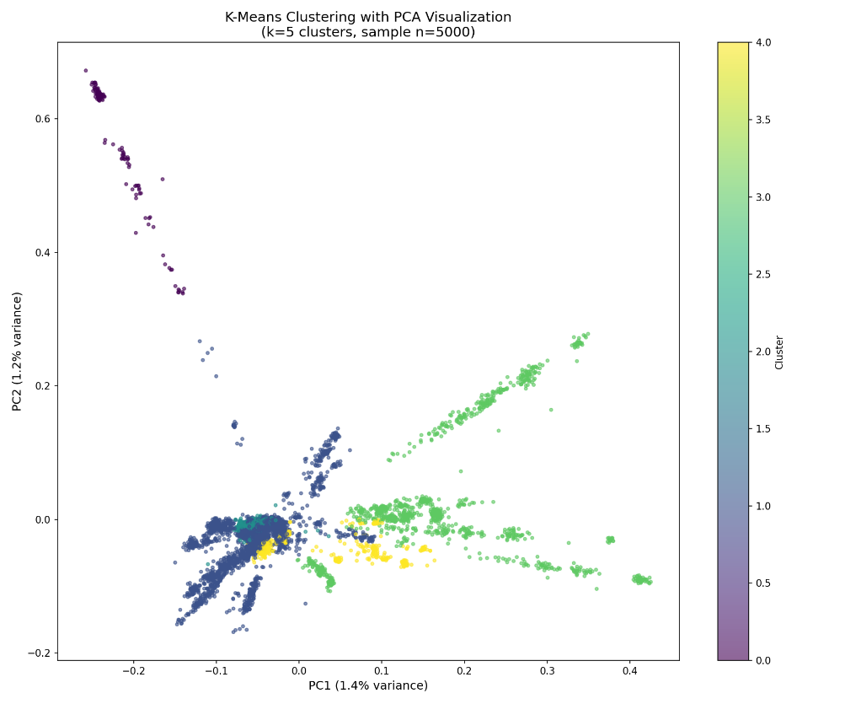
Figure E.3: PCA Clustering Visualization

APPENDIX F – Hybrid Scoring Breakdown (Example)
For input:
“I enjoy analysing data and building ML models.”
Table F.1: Hybrid Scoring Breakdown for Sample Input
Career | Semantic Score | Keyword Score | Personality Score | Rule Boost | Final Score
Data Scientist | 0.91 | 0.70 | 0.40 | 0.20 | 1.58
ML Engineer | 0.87 | 0.60 | 0.35 | 0.20 | 1.43
Data Analyst | 0.85 | 0.55 | 0.30 | 0.20 | 1.35
This breakdown demonstrates transparency in decision-making.

APPENDIX G – Execution Steps and Dependencies

G.1 Required Packages
python >= 3.11
scikit-learn
sentence-transformers
nltk
numpy
pandas
streamlit
matplotlib
seaborn

G.2 Running the Application

1. Install dependencies
pip install -r requirements.txt

2. Run the Streamlit app
streamlit run app.py

3. Access the app
Open browser → http://localhost:8501

