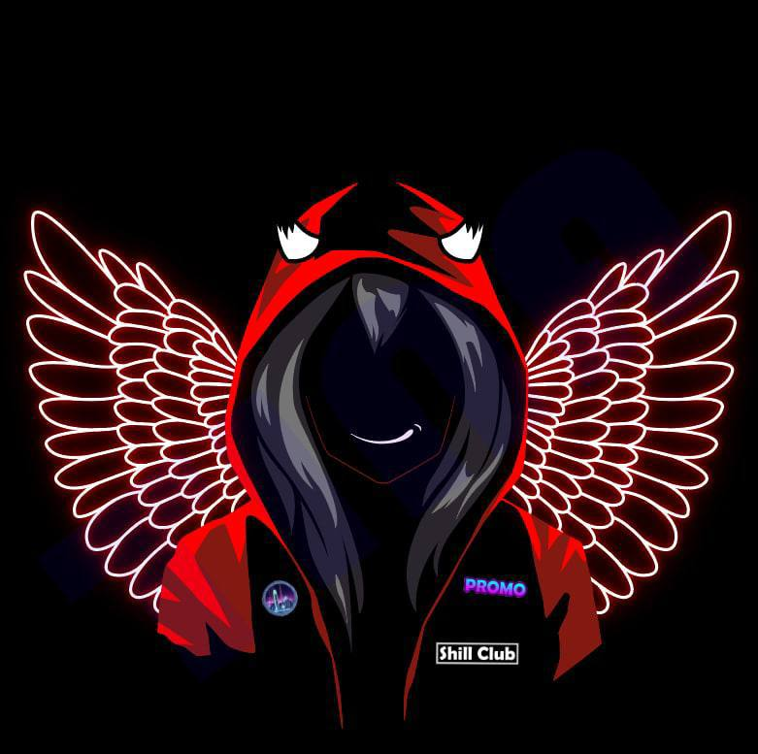

**SHILLCLUB**

**INTRODUCTION**

As it is commonly known, advertising is a form of communication, primarily, between a product and a consumer. It further aids consumers in learning about upcoming events and discovering new products or services. Modern market cannot exist without advertising. One cannot overestimate the value of a good quality advertisement. No matter how good a product might be, without the general public knowing about it its fate is bound to vanish.

Over the course of the last three decades the market of advertising has been steadily increasing using the potential of the Internet. Which made the process of advertising much easier, cost-effective and the most important it helps to target a globewide audience. Websites, news portals, even games both mobile and PC have the option to advertise a product.

In 2021 a global market of advertising reached a value of 590 billion $. Looking forward, the publisher expects the market to reach US$ 792.7 Billion by 2027, exhibiting a CAGR of 5.04% during 2021-2027.

By looking at these numbers a question arises: what might be the problem?

**PROBLEM**

Since 2017 cryptomarket has shown tremendous success in a way of increasing the number of participants, projects, ideas therefore capitalization. Protocols, DAOs, DeFis, NTF and so on. Furthermore, as numbers indicate, the cryptomarket will continually grow.

It means that more and more enthusiasts and pioneers with new ideas will join the world of crypto. In order for the world to hear them and see their ideas they need a means of communication. As it was mentioned, advertising is a right tool for it.

However, when one enters cryptoworld, it is not that easy to find the right way to advertise and those who will advertise. There are hundreds of Youtube channels, even more Telegram channels, whose main topic is cryptocurrency. It is not convenient to try and ask all of them if they could or could not advertise or promote your product.

In that case, everything should be taken into consideration: budget, expectation, audience, platform etc. Plus, there is no guarantee that everything will go as planned.

**SOLUTION**

It is our belief that the solution of the problem is to put together in one place everything one needs.

**Shillclub** is a brand new project which is aimed at simplifying the market of advertising.

Our main goal is to create a community of both ends: the one who looks for advertising and the one who can do it. Primarily, we believe that we can make the life of a new project much easier by offering a wide range of channels (Youtube, Telegram etc) which can help with promotion of your project.

By joining our project you will be able to find a proper place to promote your project using the following criterias:

* your budget;
* audience (can be sorted by language or country);
* duration of advertising;
* place (can be Youtube, Telegram, Instagram or all at once) etc.

**SHILLCLUB IS DAO**

We as a team are well aware that DAO is a future of a process of governing projects, however still in need of developing and perfecting.

We highly value our community that is why we are proud to say that Shillclub is based on a DAO. It means that our community will be a main part of a decision making process. Also it means that our members will be gaining income generated by Shillclub.

Usually, DAOs are governed through the ownership of a token. However, we take a step forward and Shillclub will be led through the NFT collection. Every piece of NTF will have a growing value provided by further success and development of our project.

We believe that having DAO based of NTF will solve of major problem that all DAOs have at this moment, such as:

* how to establish a fair voting system;
* how to encourage members to be an active part of a project;
* how to establish a reasonable and trustworthy financial system;
* how to fairly distribute an income between members of a project etc.

All DAO rules are open and transparent, and all decisions are open to the community. Fully transparent DAO governance is the most fundamental guarantee for increasing community consensus. Only when everything is transparent and open will it be fairer, better to gain the trust of the community, and to gather consensus among more communities.

Stay tuned.

**STRUCTURE OF PARTICIPATION**

**A project in a need of advertising**

In case you plan to start your own project - you are most welcome. Shillclub will provide you with proper counseling about what you might need and offer your (depending on your demands and possibilities) a list of possible channels that might help your project or community of your project to grow. Cooperating with us you will significantly save much of your time and efforts to find a good way of promotion.

**Advertiser**

If you have a social media and you are interested in providing services of promotion and advertising or you have been doing it for some time it is only beneficial for you to join our club. It does not require anything supernatural to be here. Join our club, give us information about your capabilities and links for your sources and wait for the offer. It is only up to you whether to accept it or not.

**Cooperation**

Interested in brokering a deal? Gain benefits by bringing in people who are interested in joining Shillclub. We are open to cooperate and we welcome everyone who supports us and our efforts. With every successful deal that you broker you will receive a 5% bonus on the transaction amount. Also, if you opt for cooperating with us you will be on our Whitelist to be the first one to buy our NFTs, which undoubtedly will give financial advantages.

It is very profitable to cooperate with us. Join us and find out by yourself.

**CONCLUSION**

Shillclub aims at simplifying and bringing together all parties concerned with advertising and we believe that together it will be way easier to achieve any goal we set. We believe that simplicity and unity is the key. By choosing Shillclub today you choose your success tomorrow.

**Partners:**

**Links**

Website - <https://shill.club>

Telegram - <https://t.me/ShilIClub>

Twitter - <https://twitter.com/Shill_Club>

**Have a question or suggestion?**

Contact us - [shillclub.dao@gmail.com](mailto:shillclub.dao@gmail.com)