**Create a Kubernetes cluster which runs a simple go hello world application**

Created a sample go application and containerized and pushed to docker registry.

* docker build -t kube-app.
* docker tag kube-app shilpagokul95/hello-app:1.0.0
* docker login
* docker push shilpagokul95/hello-app:1.0.0

Created a deployment file in Kubernetes to deploy the containerized application using following command

* kubectl apply -f <deployment.yml>

Exposed the deployment as a service with type as NodePort using following command

* Kubectl expose deployment –port=9090 –target-port=8080 –name=hello-app-service –type=NodePort

**How to make the service scalable?**

To manually scale the service, use the kubectl command or edit the deployment file as mentioned below. Horizontal pod autoscaling can also be enabled for autoscaling based on CPU consumptions

* Used kubectl scale command to scale the deployment to 4. “Kubectl scale –replicas=4 deployment/hello-app”
* The replicas can also be increased in the deployment file and reapplied which will in turn scale the number of pods to the mentioned count in deployment file

**What CI/CD pipeline to use?**

* Required files: main.go and main_test.go file, dockerfile, deployment.yml and service.yml
* Configure Jenkins user to connect to the cluster
* Check**'**Specify another hook url**'** for GitHub configuration in Jenkins and add the URL shown in the repo’s webhooks
* Create the Jenkins pipeline job and select GitHub hook trigger for git scm polling and provide repository URL and credentials
* Configure Jenkins Credentials for GitHub and Docker Hub
* In Jenkins following steps are performed
  + Build – Build go binary and ensure that nothing is wrong in the build process
  + Test – Validate that the application works as expected
  + Publish- Build docker image and push it to registry
  + Deploy- Deploys to Kubernetes

**How to store or deploy secrets?**

* Get the base64 encoded value of username
  + echo -n “shilpa” | base64
* Create a secret yaml and apply as shown below

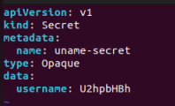

* Apply secrets and confirm if the secrets are created

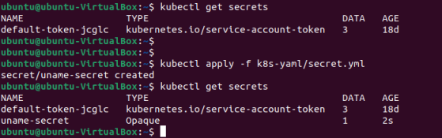

* Decode the secrets

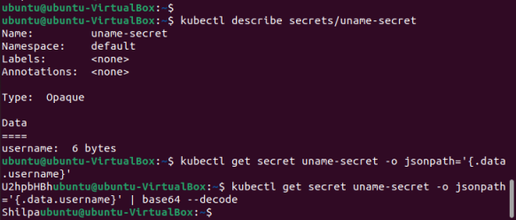

* There are three main ways for a Pod to use a Secret:
  + As [files](https://kubernetes.io/docs/concepts/configuration/secret/#using-secrets-as-files-from-a-pod) in a [volume](https://kubernetes.io/docs/concepts/storage/volumes/) mounted on one or more of its containers.
  + As [container environment variable](https://kubernetes.io/docs/concepts/configuration/secret/#using-secrets-as-environment-variables).
  + By the [kubelet when pulling images](https://kubernetes.io/docs/concepts/configuration/secret/#using-imagepullsecrets) for the Pod.
* Trying option 2- Add as container environment variable. Add the env variable in the deployment and reapply. Login to the container and check if the env value is set
  + Kubectl exec -it <pod name> sh
  + echo $SECRET_USERNAME

**How do you test how well your infrastructure scales? (When many requests come in)**

* Can perform load, endurance, and stress testing to ensure that the infrastructure scales properly
  + [Load test](https://www.techtarget.com/searchsoftwarequality/definition/load-testing)- To check how the system responds to a sudden increase in requests.
  + [Endurance test](https://www.techtarget.com/searchsoftwarequality/definition/Soak-testing)- To check how the system survives a constant, moderate load for longer duration of times. It can also be referred to as a soak test, referring to the long time the software spends under test.
  + [Stress test](https://www.techtarget.com/searchsoftwarequality/definition/stress-testing)- To check how the system responds under a heavy load, with an intent to find out the point at which system is stressed and ceases functioning.
* To avoid pod failures, can set memory and CPU limits in the deployment configuration or opt for Horizontal pod autoscaling which scales based on CPU consumption.

**How do you provide an SSL certificate to your service?**

* Create SSL certificate as secrets and mount it as volumes in the pod spec to access it from the containers.
  + Encode the SSL key and create secret
  + Specify the secret as volume mount in the pod spec to access the secrets
* To create a self-signed certificate for testing purposes, follow below steps
  + Generate a CA private key
    - *OpenSSL genrsa -out ca.key 2048*
  + Create a self-signed certificate, valid for 365 days.
    - *OpenSSL req -x509 -new -nodes -days 365 *

*-key ca.key \  
-out ca.crt \  
-subj "/CN=yourdomain.com"*

* + Create TLS secret using kubectl command
    - *kubectl create secret tls my-tls-secret \  
      --key ca.key \  
      --cert ca.crt*