MDM2 – Case Study: Intelligent Systems in Production
One‑Page Proposal

Team | FactoryDocs Assistant team
Members | Divi Teja Dimmiti(Team Lead ,RAG pipeline) , Shilpa Golla(LLM&Data & test set) , Vijay Boyapati(Evaluation & demo)
Project Title | FactoryDocs Assistant: A Retrieval-Augmented Chatbot for Production and Logistics Manuals
GitHub Repository URL | https://github.com/Shilpa-Golla/FactoryDocs-Assistant-A-Retrieval-Augmented-Chatbot-for-Production-and-Logistics-Manuals
Contact Email | divi.dimmiti@stud.th-deg.de
Industrial Application (target domain/use‑case) | Shop-floor knowledge access: operators and maintenance staff get short, page-cited answers from industrial robot manuals (production) and forklift/warehouse safety guidance (logistics).
Keywords (3–6) | Retrieval-Augmented Generation; Technical Language Processing; Hybrid Search; Local LLM; Industrial Manuals; Shop-Floor Safety
Submission Date (YYYY‑MM‑DD) | 2026-10-20
Gantt Chart (P1–P5 = course phases)
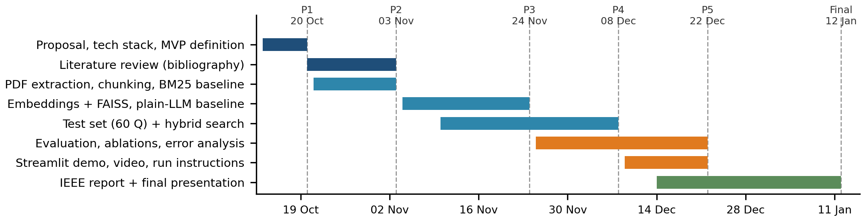

1) Problem Statement & Measurable Outcomes (3–4 sentences) | Problem: operators need quick answers (e.g., a robot’s maximum payload, how often forklift brakes must be checked), but these are buried in manuals of hundreds of pages; manual search is slow and general chatbots invent plausible but wrong answers, risking machine damage or injury. We build a chatbot that answers only from verified manuals and cites the source page.  KPIs (60-question test set): (1) retrieval hit rate@5 ≥ 80%; (2) answer accuracy ≥ 75%, beating BM25 and plain-LLM baselines; (3) correct “I don’t know” on ≥ 80% of unanswerable questions; (4) median response time ≤ 10 s on a laptop.
2) Motivation & Industrial Relevance (2–3 sentences) | Operators, maintenance technicians and safety officers: less time searching documentation shortens downtime, and cited answers reduce safety errors. Many factories cannot send internal documents to cloud AI (privacy, IP), so a local assistant is a practical way to bring LLMs to the shop floor now.
3) Related Work Snapshot (2–3 key references) | [1] P. Lewis et al., “Retrieval-Augmented Generation for Knowledge-Intensive NLP Tasks,” NeurIPS 2020. [2] Y. Gao et al., “Retrieval-Augmented Generation for Large Language Models: A Survey,” arXiv:2312.10997, 2023. [3] S. Es et al., “RAGAS: Automated Evaluation of Retrieval Augmented Generation,” EACL 2024 (Demos).  Gap: RAG is mostly evaluated on general text (Wikipedia, QA benchmarks); few studies test industrial manuals with specification tables, error codes and safety rules, or measure refusal on unanswerable shop-floor questions with a local model.
4) Method & Feasibility (≤6 sentences) | Data: 3–4 public PDFs – Universal Robots UR5e user manual, OSHA forklift (powered industrial truck) guidance, one conveyor or CNC manual (linked, not redistributed). Pipeline: pdfplumber extracts text and tables → page-tagged chunks → sentence-transformers embeddings in FAISS → local LLM (Ollama, e.g., Llama 3 8B) answers only from retrieved chunks with page citations, or refuses. Comparison: plain LLM (no retrieval) vs. BM25 RAG vs. dense RAG vs. hybrid (BM25 + dense), plus chunk-size and top-k ablations. Evaluation: 60 team-written questions in 5 types (fact, table value, procedure, safety rule, unanswerable), scored with a 3-level rubric by two members and cross-checked with RAGAS. Feasibility & artifacts: free tools on a laptop/Colab (≈ €0); GitHub repo with reproducible pipeline, test set and results, Streamlit demo + video, IEEE report.
5) Milestones & Timeline (short table/list) | P1 20 Oct: proposal, tech stack, MVP (chatbot over one manual with source page) · P2 03 Nov: literature review, PDF extraction, BM25 baseline, test plan  P3 24 Nov: embeddings + FAISS, first cited answers, plain-LLM baseline · P4 08 Dec: test set, hybrid search, comparison + error analysis  P5 22 Dec: Streamlit demo, video, run instructions, ablations · Final 12 Jan 2027: IEEE report and presentation
6) Risks & Ethics (1–2 sentences) | Manuals are linked and cited, not redistributed; no personal data is processed; the assistant is a decision aid that shows its source and refuses when unsure, never a replacement for official safety procedures. Feasibility risks: broken PDF table extraction (compare pdfplumber vs. PyMuPDF) and slow local inference (use a smaller quantized model).
Phase 1 rubric (15%): Team & GitHub (2%), On‑time (2%), Topic & Proposal (5%) — Industrial Application, Problem+Outcomes, Feasibility+Timeline; Presentation (6%).

