MDM2 – Case Study: Intelligent Systems in Production
One-Page Proposal

Team | FactoryDocs Assistant team
Members | Divi Teja Dimmiti (Team Lead – RAG pipeline & test set) · Shilpa Golla (PDF extraction & LLM integration) · Vijay Boyapati (evaluation & Streamlit demo)
Project Title | FactoryDocs Assistant: A Retrieval-Augmented Chatbot for Robot Error Diagnosis in Production
GitHub Repository URL | https://github.com/Shilpa-Golla/FactoryDocs-Assistant-A-Retrieval-Augmented-Chatbot-for-Production-and-Logistics-Manuals
Contact Email | divi.dimmiti@stud.th-deg.de
Industrial Application (target domain/use-case) | Robot error diagnosis in production: when a UR5e cobot (e.g., loading a CNC machine) triggers a protective stop, the operator types the error code or describes the problem and gets the cause, fix steps and source pages from the robot and gripper manuals.
Keywords (3–6) | Retrieval-Augmented Generation; Robot Error Diagnosis; Collaborative Robots; Hybrid Search; Local LLM; Downtime Reduction
Submission Date (YYYY-MM-DD) | 2026-10-20
Gantt Chart (P1–P5 = course phases)
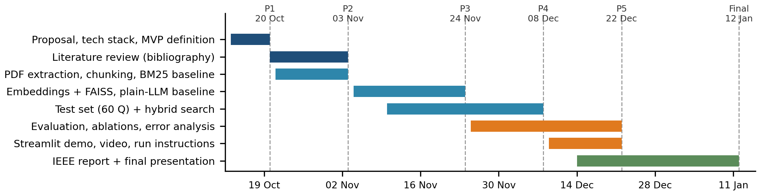

1) Problem Statement & Measurable Outcomes (3–4 sentences) | Problem: when a UR5e cobot triggers a protective stop (e.g., C153 position deviates from path, C157 collision detected by joint), the connected machine and material flow stop; UR requires the root cause to be reviewed before reset. Causes such as wrong payload, collisions or dragging cables, and their fixes, are spread over four long manuals; workers describe problems in their own words, which Ctrl+F cannot match, and general chatbots give unverified answers. We build a local chatbot that answers only from these manuals, with source pages.  KPIs (60-question test set): (1) retrieval hit rate@5 ≥ 80%; (2) answer accuracy ≥ 75%, beating BM25 and plain-LLM baselines; (3) correct “I don’t know” on ≥ 80% of unanswerable questions; (4) median response time ≤ 10 s on a laptop.
2) Motivation & Industrial Relevance (2–3 sentences) | Unplanned downtime costs the world’s 500 largest companies about $1.4 trillion per year (Siemens, 2024); finding the root cause faster shortens every robot stop. Operators and technicians benefit most when no expert is nearby; a local model keeps documents on site.
3) Related Work Snapshot (2–3 key references) | [1] P. Lewis et al., “Retrieval-Augmented Generation for Knowledge-Intensive NLP Tasks,” NeurIPS 2020. [2] Y. Gao et al., “Retrieval-Augmented Generation for Large Language Models: A Survey,” arXiv:2312.10997, 2023. [3] S. Es et al., “RAGAS: Automated Evaluation of Retrieval Augmented Generation,” EACL 2024 (Demos).  Gap: RAG is mostly evaluated on general text; few studies address robot error diagnosis where answers are spread over several manuals and queries mix exact error codes with free-text problem descriptions, or measure refusal with a local model.
4) Method & Feasibility (≤6 sentences) | Data: four public manuals – UR Error Codes Directory, UR5e User Manual, Robotiq 2F-85/2F-140 gripper manual (for UR), UR e-Series Service Handbook (linked, not redistributed). Pipeline: pdfplumber extracts text and tables → page-tagged chunks → sentence-transformers embeddings in FAISS + BM25 index → local LLM (Ollama, e.g., Llama 3 8B) gives meaning, cause and fix with source pages, or refuses. Comparison: plain LLM vs. BM25 RAG vs. dense RAG vs. hybrid RAG, plus chunk-size and top-k tests. Evaluation: 60 team-written questions in 5 types (error code, problem description, multi-document, procedure, unanswerable), scored with a 3-level rubric by two members and checked with RAGAS. Feasibility & artifacts: free tools, laptop/Colab (≈ €0); GitHub repo, Streamlit demo, video, IEEE report.
5) Milestones & Timeline (short table/list) | P1 20 Oct: proposal, tech stack, MVP (revised after feedback) · P2 03 Nov: literature review, PDF extraction, BM25 baseline, test plan  P3 24 Nov: embeddings + FAISS, first cited answers, plain-LLM baseline · P4 08 Dec: test set, hybrid search, comparison + error analysis  P5 22 Dec: Streamlit demo, demo video, run instructions · Final 12 Jan 2027: IEEE report and presentation
6) Risks & Ethics (1–2 sentences) | Decision aid only: UR requires trained personnel to review every protective stop, and the assistant supports this, never replaces it; manuals linked, no personal data. Risks: broken PDF table extraction (compare pdfplumber vs. PyMuPDF) and slow local inference (smaller quantized model).
Phase 1 rubric (15%): Team & GitHub (2%), On-time (2%), Topic & Proposal (5%) — Industrial Application, Problem+Outcomes, Feasibility+Timeline; Presentation (6%).

