

**Connecting ACE with Event Streams in CP4I Container**

**Submitted By**



DOCUMENT RELEASE NOTICE

**Document Details:**

|  |  |  |
| --- | --- | --- |
| Name | Version No. | Description |
| Connecting ACE with Event Streams in CP4I container | 1.0 | First version |

**Revision Details**

|  |  |  |  |
| --- | --- | --- | --- |
| Action taken  (Add / Del / Chg) | Preceding page no. | New page no. | Revision description |
|  |  |  |  |
|  |  |  |  |

Review:

|  |  |
| --- | --- |
| Reviewer | Date |
|  |  |
|  |  |

Approval:

|  |  |
| --- | --- |
| Approver | Date |
|  |  |
|  |  |

**Contents**

1 Introduction 5

1.1 Objective 5

1.2 List of nodes 5

2 IBM Tutorial reference website 6

3 Event Streams Configuration 7

3.1 Event Streams configuration 7

4 Configuring node in ACE toolkit 13

5 Download ACE config files 14

6 Deployment of Bar file into ACE instance 19

# Introduction

## Objective

This document describes the connectivity between ACE application and Event Streams instance deployed in same CP4I cluster.

The document mention about the properties to be considered in ACE application flow and Event Streams instance present in CP4I cluster

## List of nodes

List of nodes uses Kafka properties

1. Kafka Producer
2. Kafka Consumer
3. Kafka Read

# IBM Tutorial reference website

Refer the below link for end to end tutorial about the ACE to Event streams connectivity

<https://www.ibm.com/cloud/garage/dte/tutorial/integrate-kafka-business-applications-create-new-responsive-experiences-using-openshift-42>

The upcoming sections are having the similar steps in case any clarification needed based on the above tutorial link

# Event Streams Configuration

To make connection from ACE to Event Streams, the upcoming sections mention about the steps related to Event Streams configuration

## Event Streams configuration

After creating an event streams instance,

Step 1: Select the Event Streams instance (es2)

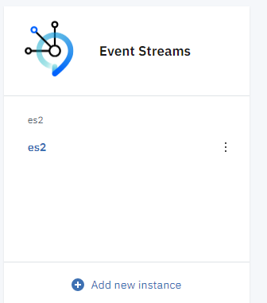

Step 2: Select Topics tab on the Event Stream page



Step 3: Select create Topic on the right hand side

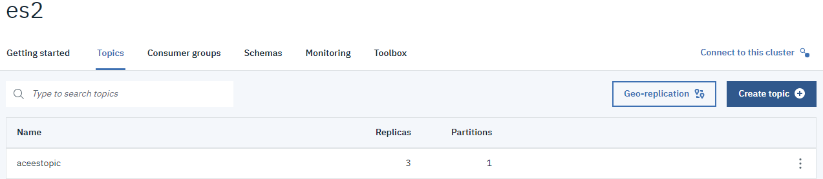

Step 4: Select Advanced option on left side and provide topic name, leave the rest of the values as default and select create topic on bottom of the page

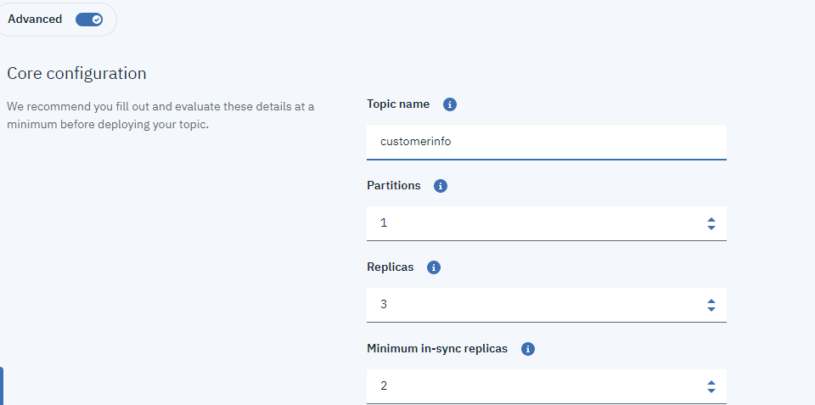

Step 5: The topic will be created and listed on the Topic tab

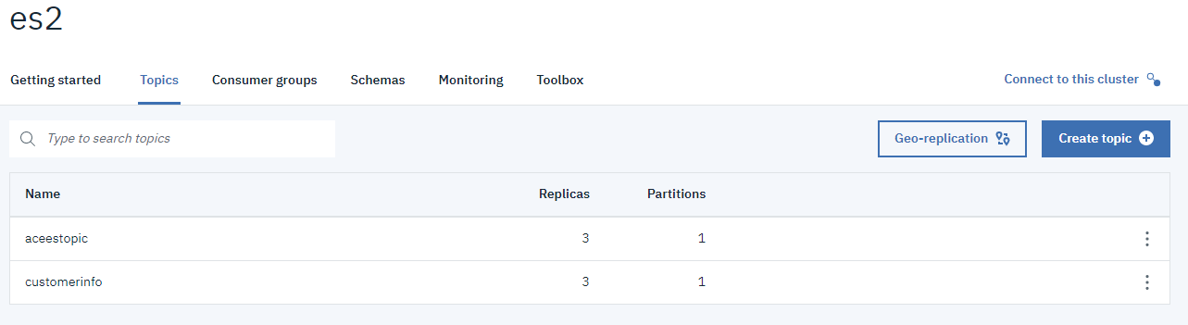

Step 6: Select Connect to this cluster option on right hand side

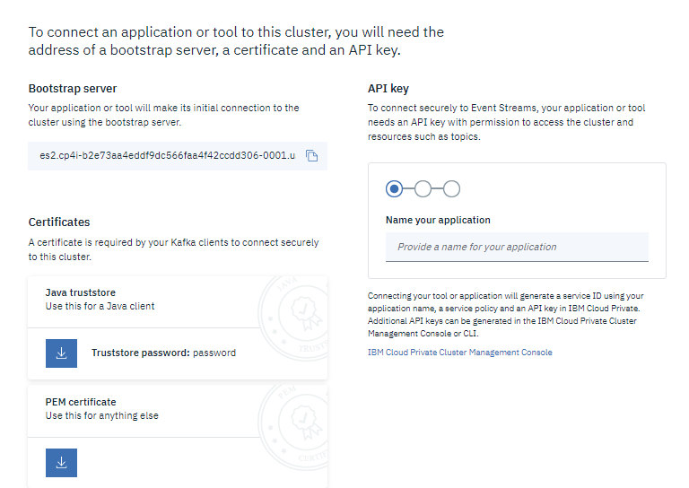

Step 7: To connect from ACE, we need Bootstrap server name, PEM Certificate and API key. The above image have bootstrap server name and download PEM certificate.

Step 8: To get API key, provide name of application and select produce and consume option

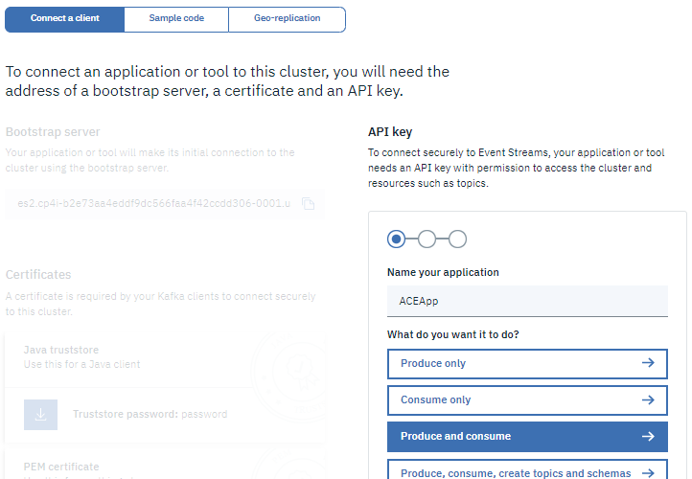

Step 9: Press Enter and provide topic name to connect (in this case its customerinfo)

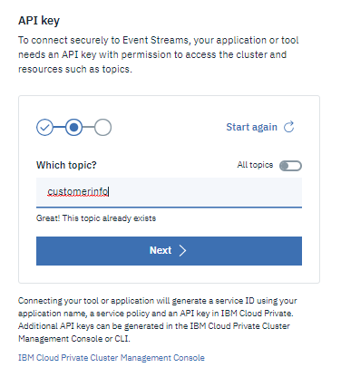

Step 10: Press enter and select Generate API key button

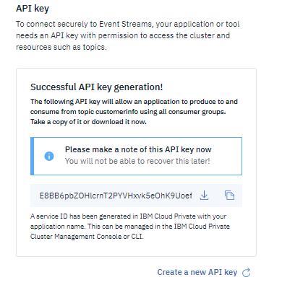

Step 11: Copy the API Key or download it as JSON

# Configuring node in ACE toolkit

After setting up the topic and getting the required info to connect to event streams using Section 2, open ACE toolkit on development environment and provide the configuration details in the Kafka Producer node

Step 1: provide topic name, Bootstrap server name in Basic properties

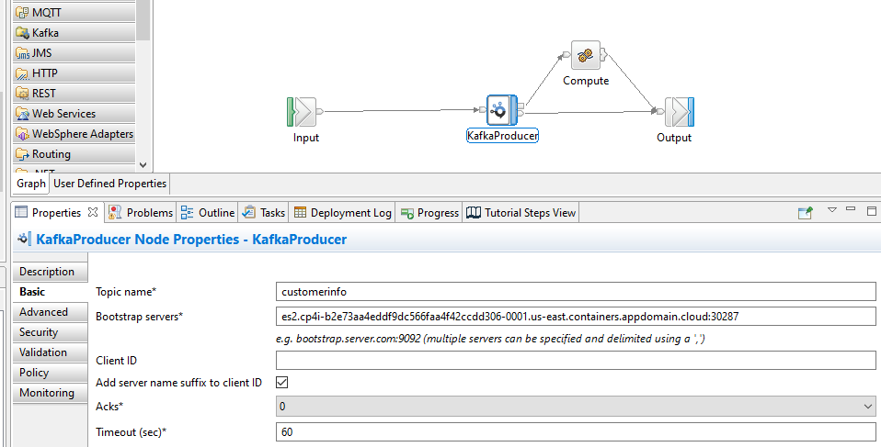

Step2: Select Security tab and select below properties

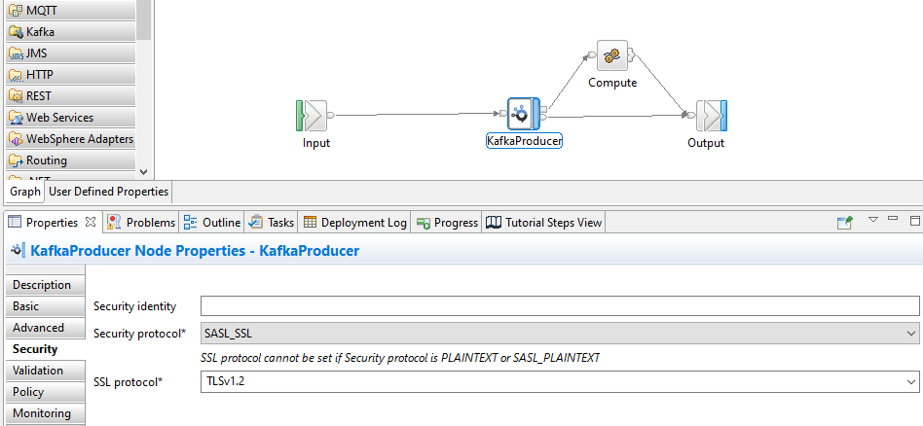

Step 3: Generate bar file and copy it in your local folder

# Download ACE config files

Step 1: Goto ACE instance in CP4I portal and select Add Server option

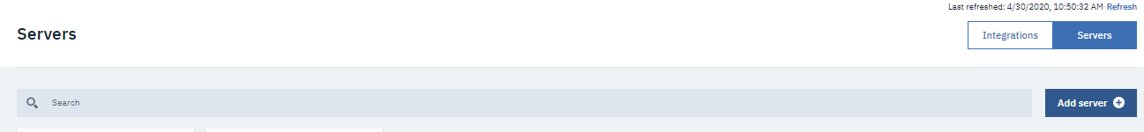

Step 2: Select Add a Bar file option and select the bar file for deployment and click Continue

Step 3: Select Download Configuration Package button

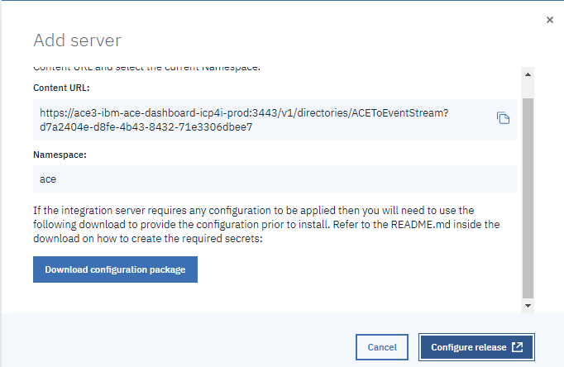

Step 4: it will download config zip files and extract the zip file into a folder

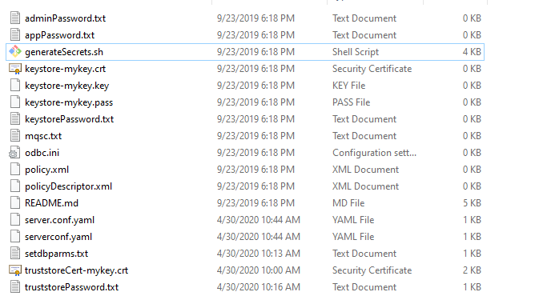

Step 5: Ensure if there are files called server.conf.yaml and serverconf.yaml. Please create a file if any one of these files are missing.

Step 6: The files server.conf.yaml, serverconf.yaml, setdbparms.txt, trusstoreCert-mykey.crt, truststorePassword.txt has to be updated with contents mentioned in the upcoming steps

**Note**: *The values mentioned in the upcoming steps are for reference only, you have to use your own values*

Step 7: Copy the API key generated as part of Section 2.1 Step 10. It will be available in the downloads folder as es-api-key.json file. Attached the file for reference



Sample content as: {"name":"customerinfoapp","api_key":"bd7ooGaCkP5eiKZ3umcywG1IYpiIO58Yys0KsNk2kevg"}

Step 8: Copy the API key from the downloaded es-api-key.json file and paste it in the setdbparms.txt file as below. Keep the rest of the values as it is (only API key is a variable value in the file)

kafka::KAFKA token bd7ooGaCkP5eiKZ3umcywG1IYpiIO58Yys0KsNk2kevg

setdbparms::truststore dummy password

Attaching the setdbparms.txt file for reference



Step 9: Copy the contents of PEM file download as part of section 2.1 step 8. The download file will be in the name of es-cert.pem. Open command prompt to copy content from PEM file to truststoreCert-mykey.crt file present in configuration folder



Attached the sample es-cert.pem and truststoreCet-mykey.crt files for reference



Step 10: Two CLI exe files are needed to update the config on ACE server. Download below two files on your system and run it

1. Kubectl for running Kubernetes command

Link: <https://kubernetes.io/docs/tasks/tools/install-kubectl/#install-kubectl-on-windows>

1. OC client tool

<https://www.okd.io/download.html>

If needed restart the system and run kubectl command and oc command in windows cmd prompt to verify the installation

Step 11: Goto OpenShift console on your CP4I cluster and select the ‘Copy login command’ from top right corner of the window

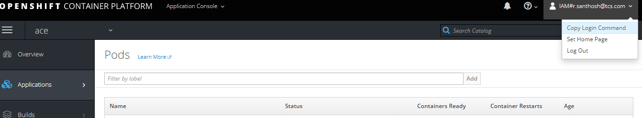

Step 12: Open command prompt and paste the copied command



Step 13: Click enter and type oc project ace, it will take to ace instance of CP4I



Step 14: Make sure you are currently in the folder which contains ace configuration files in your local system. Then run file ***generateSecrets.sh my-secret***

The above command will generate a secret in open shift console



It will run the generateSecrets.sh file and generate the secret in open shift

It can be verified from open shift console, by selecting Resources->Secrets

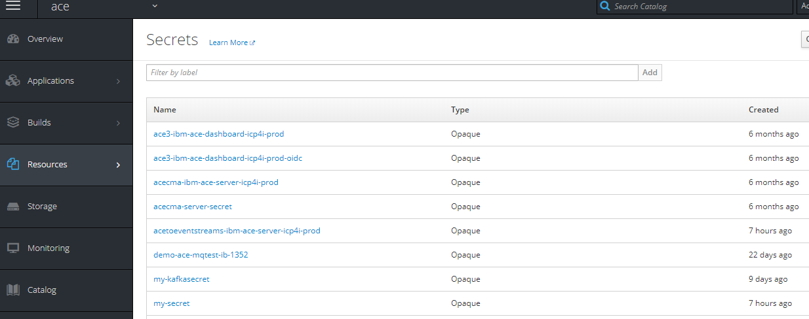

# Deployment of Bar file into ACE instance

Step 1: Select ACE instance and click Add Server option

Step 2: Select the bar file to deploy and click Configure

Step 3: In the configuration page, provide the below config values

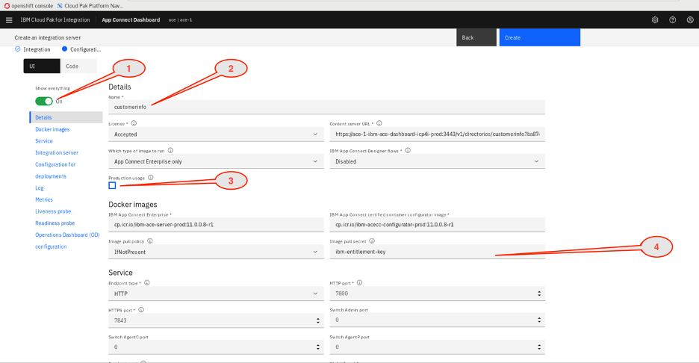

Step 4: Scroll and locate Integration Server parameters:

1. Enter my-secret as the Name of the secret that contains the server configuration.\
2. Enter  mykey as the List of certificate aliases for the the truststore.

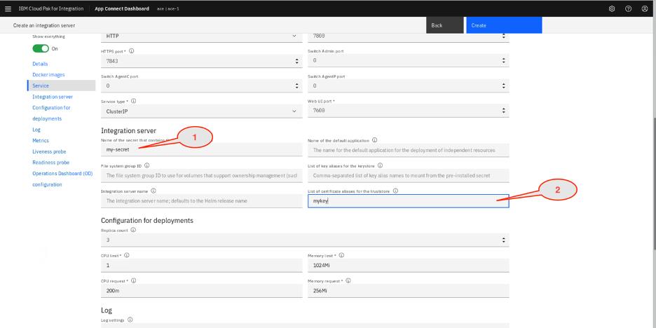

Leave rest of the fields as default or according to your default values and click Create

