

**Connecting ACE with MQ in CP4I Container**

**Submitted By**



DOCUMENT RELEASE NOTICE

**Document Details:**

|  |  |  |
| --- | --- | --- |
| Name | Version No. | Description |
| ACE and QM connectivity in CP4I container | 1.0 | First version |

**Revision Details**

|  |  |  |  |
| --- | --- | --- | --- |
| Action taken  (Add / Del / Chg) | Preceding page no. | New page no. | Revision description |
|  |  |  |  |
|  |  |  |  |

Review:

|  |  |
| --- | --- |
| Reviewer | Date |
|  |  |
|  |  |

Approval:

|  |  |
| --- | --- |
| Approver | Date |
|  |  |
|  |  |

**Contents**

1 Introduction 5

1.1 Objective 5

1.2 List of nodes 5

2 QM Configuration details 6

2.1 Queue manager configurations 6

3 ACE application MQ node configuration 12

# Introduction

## Objective

This document describes the connectivity between ACE application and MQ instance deployed in same CP4I cluster.

The document mention about the properties to be considered in ACE application flow to connect with a Queue Manager installed in the same CP4I cluster.

## List of nodes

List of nodes which needs MQ connection configuration properties

1. Publication Node
2. MQInput
3. MQOutput
4. MQGet
5. MQReply
6. MQHeader

# QM Configuration details

After creating the queue manager instance, few properties related to connection channel and QM properties needs to be updated. The connection properties are mentioned in the upcoming sections

## Queue manager configurations

After creating a queue manager instance QM will have default configurations.

Step 1: Click on queue manager and select properties.

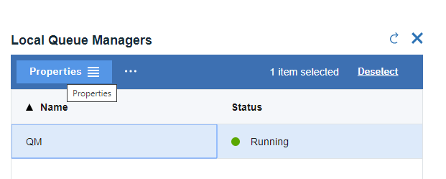

Step 2: Select Extended properties and remove entry from Connection authentication

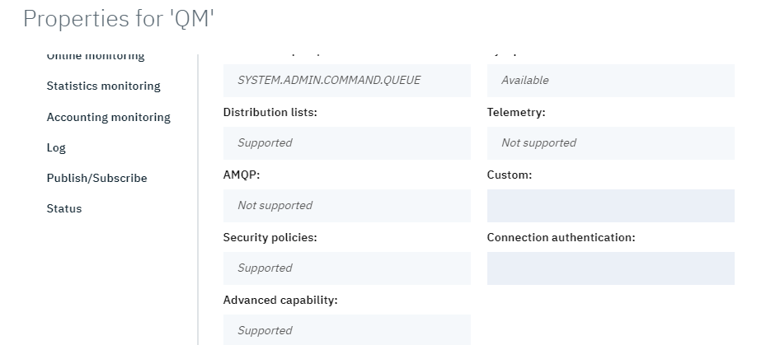

Step 3: Select communication properties and disable CHLAUTH records property

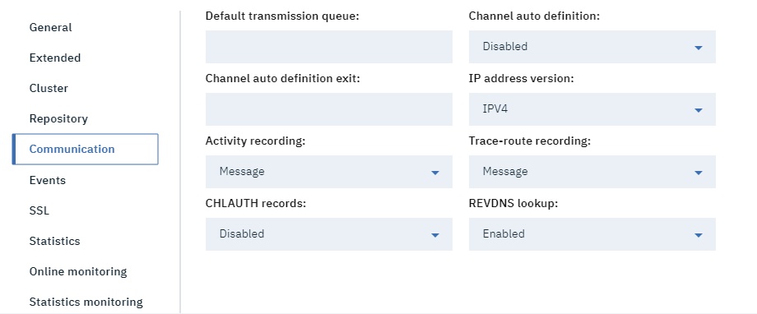

Step 4: Select SSL properties and enter Cert label as default

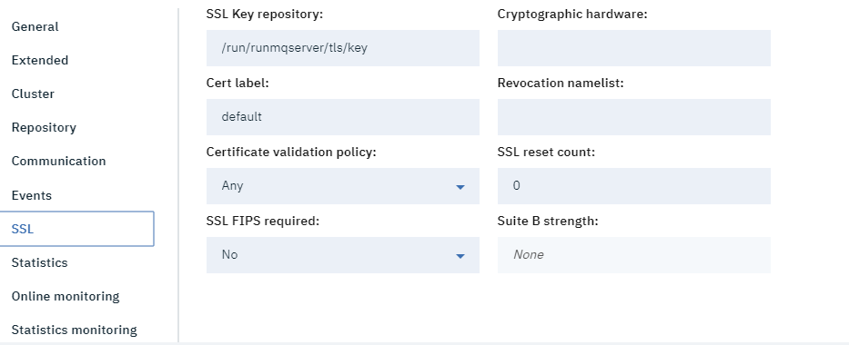

Step 5: Click save

Step 6: Refreshing security of QM. Select 3 dots near properties on QM

And select Refresh Security…

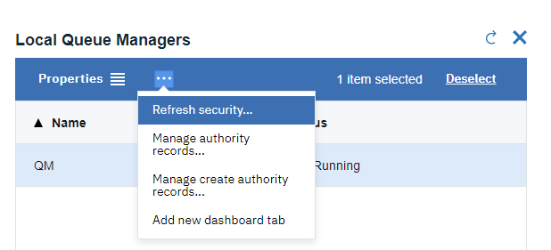

Step 7: Refresh the security by clicking on Authorization Service, Connection authentication, SSL

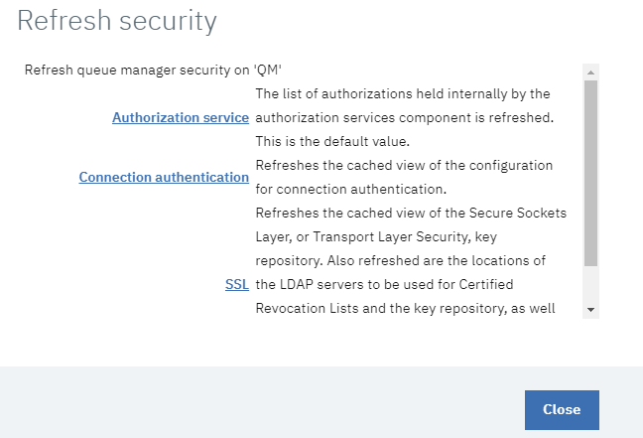

Step 8: Goto Channels on QM option and select SYSTEM.DEF.SVRCONN (Server-Connection) channel and select properties

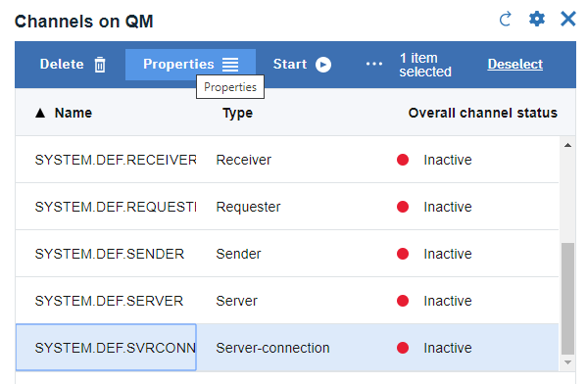

Step 9: Select MCA property of channel and enter mqm as the user ID

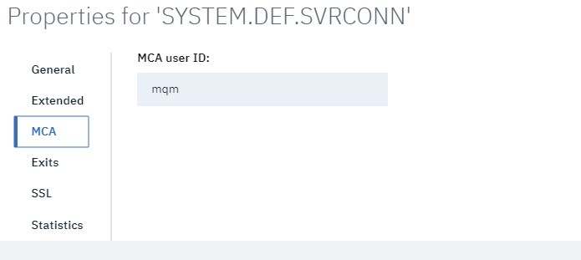

Step 10: Select SSL property and enter Cert label as default

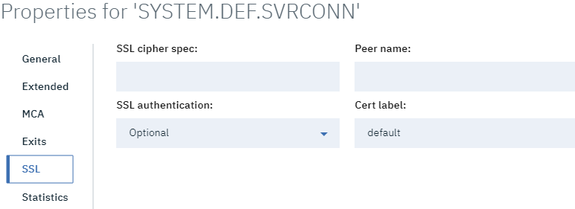

Step 11: Ensure the listener is running in QM

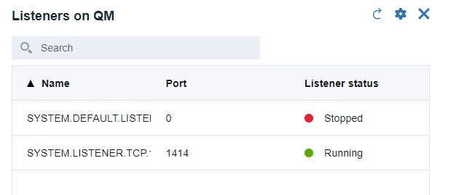

Step 12: Verification of host and port name for QM (needed to connect from ACE application)

Select 3 dots near MQ instance and click on release details

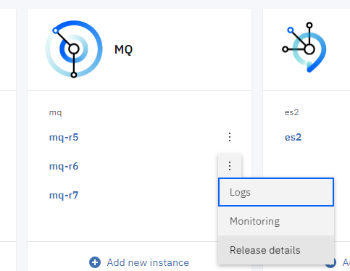

Step 13: Scroll down to Notes section to identify the host and port name

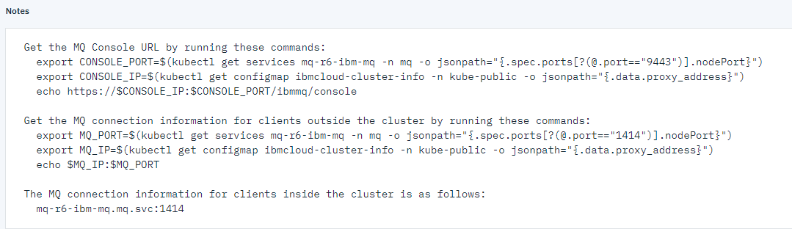

The above steps enables QM to connect with ACE application

# ACE application MQ node configuration

MQ connection properties to be defined on nodes such as MQInput, MQOutput , MQGet etc..

Step 1: Update MQ connection properties as below

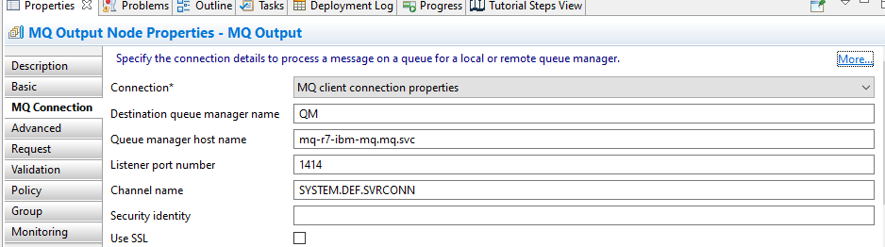

Step2: update the bar file and deploy into CP4I instance with the default ACE properties. (no need to mention queue manager details while adding integration server).

After creating bar file, config the CP4I instance as mentioned in Section 4

# ACE configuration on CP4I for bar file deployment

Similar to ACE on prem, applications/bar image deployed in Integration server for an ACE on CP4I cluster also need to associate with a local queue manager to support the nodes mentioned in section 1.2

Select the image mentioned in the below screenshot to allow ACE server to work with QM

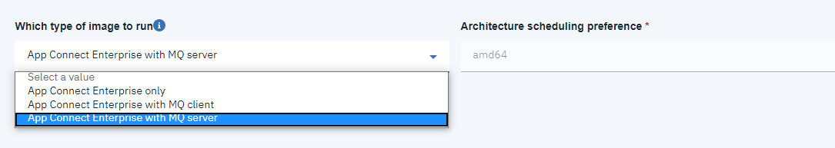

For MQInput, MQOutput, MQGet, MQReply, MQHeader nodes select the image as **App Connect Enterprise with MQClient**

To associate a queue manager for an Integration server in CP4I cluster the columns mentioned in screenshot below needs to be valued and selected.

Queue manager name and select the checkbox Initialize MQ Volume using root.

