

**Queue Manager dependency nodes related to ACE11 onprem/CP4I**

**Submitted By**



DOCUMENT RELEASE NOTICE

**Document Details:**

|  |  |  |
| --- | --- | --- |
| Name | Version No. | Description |
| Queue manager dependency nodes | 1.0 | First version |

**Revision Details**

|  |  |  |  |
| --- | --- | --- | --- |
| Action taken  (Add / Del / Chg) | Preceding page no. | New page no. | Revision description |
|  |  |  |  |
|  |  |  |  |

Review:

|  |  |
| --- | --- |
| Reviewer | Date |
|  |  |
|  |  |

Approval:

|  |  |
| --- | --- |
| Approver | Date |
|  |  |
|  |  |

**Contents**

1 Introduction 6

1.1 Objective 6

1.2 List of nodes 6

2 ACE On-Prem configuration 7

2.1 Command to create integration node 7

3 ACE on CP4I cluster 8

# Introduction

## Objective

This document captures the issue and solution related to nodes which need local queue manager dependency in ACE11 on prem and CP4I regions.

While migrating applications from IIBV10 to ACE11 on prem or CP4I region, some of the nodes need to access local system queues to store temporary data and hence while creating integration node on prem or adding server on CP4I ACE region, the developer/admin/architect need to assign a local queue manager.

This document describes the steps involved in assigning queue manager to integration node (for on prem) and integration server (for CP4I ACE instance)

## List of nodes

List of nodes have dependency on local queue manager to be assigned along with Integration node or integration server

1. Publication Node
2. AggregateControl
3. AggregateRequest
4. AggregateReply
5. Collector
6. Sequence
7. Requence
8. Timer Control
9. Timer Notification

# ACE On-Prem configuration

Similar to IIB V10 while creating an integration node for ACE On-Prem, a local queue manager needs to be assigned to the integration node. The system queue in the queue manager helps to handle the temporary details needed for the above mentioned nodes.

## Command to create integration node

Below is the command to create integration node for ACE on On-Prem. The –q is a mandatory parameter if an integration node needs to associate with a local queue manager.

*mqsicreatebroker <integrationNodeName> -q <queuemanagerName>*

The queue manager assigned will act as a default queue manager for the node and handle process related to the above mentioned nodes.

# ACE on CP4I cluster

Similar to ACE on prem, applications/bar image deployed in Integration server for an ACE on CP4I cluster also need to associate with a local queue manager to support the nodes mentioned in section 1.2

Select the image mentioned in the below screenshot to allow ACE server to work with QM

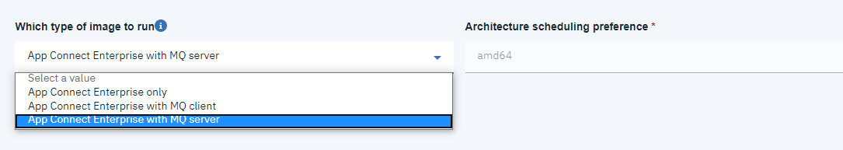

To associate a queue manager for an Integration server in CP4I cluster the columns mentioned in screenshot below needs to be valued and selected.

Queue manager name and select the checkbox Initialize MQ Volume using root.

