**Assignment-based Subjective Questions**

**1. From your analysis of the categorical variables from the dataset, what could you infer about their effect on the dependent variable? (3 marks)**

I have performed the categorical variables on the dependent data set, below are the few main points

• Fall season is having more booking than any other season, and 2019 is having more booking in this season.

• Booking in yr. 2019 is quite greater than 2018.

• In 2019 more booking seems in the month of May, June, July, Aug, Sep. but we compare same data with 2018 it is quite low.

• In clear weather more bikes are booked. Booking increase more in 2019.

• Friday and Saturday we observe more bike booked.

• Bikes are slightly more booked in working day.

**2. Why is it important to use drop_first=True during dummy variable creation? (2 mark)**

If drop_first is true it removes the first column which is created for the first unique value of a column. for eg: If there is a column which has 10 unique categorical values or labels, using pd.getdummies() we convert them into a binary vector which makes 10 columns, one column for each unique value of our original column and wherever this value is true for a row it is indicated as 1 else 0.

**3. Looking at the pair-plot among the numerical variables, which one has the highest correlation with the target variable? (1 mark)**

Temp is higher with target value.

**4. How did you validate the assumptions of Linear Regression after building the model on the training set? (3 marks)**

Using Linear Regression model following are the validation assumptions are used.

• Multicollinearity check

• Homoscedasticity

• Residual check.

**5. Based on the final model, which are the top 3 features contributing significantly towards explaining the demand of the shared bikes? (2 marks)**

3 features contributing towards shared bikes are

• Holiday

• Year

• Season

**General Subjective Questions**

**1. Explain the linear regression algorithm in detail. (4 marks)**

Linear Regression is a machine learning algorithm based on supervised

learning. It performs a regression task. Regression models a target

prediction value based on independent variables. It is mostly used for

finding out the relationship between variables and forecasting. Different

regression models differ based on – the kind of relationship between

dependent and independent variables, they are considering and the number of independent variables being used.

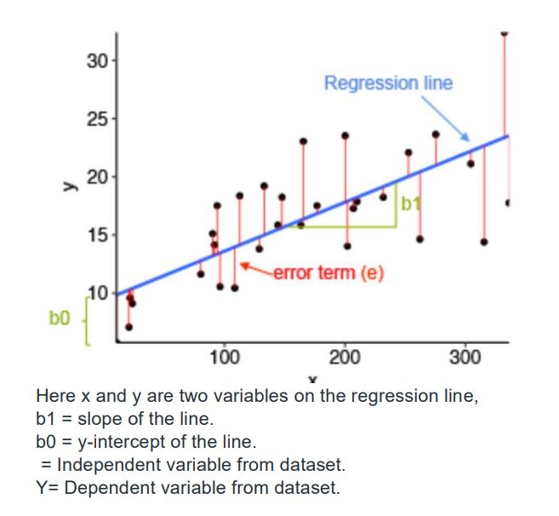

**2. Explain the Anscombe’s quartet in detail. (3 marks)**

Anscombe’s quartet comprises four datasets that have nearly identical simple statistical properties, yet appear very different when graphed. Each dataset consists of eleven (x,y) points. They were constructed in 1973 by the statistician Francis Anscombe to demonstrate both the importance of graphing data before analyzing it and the effect of outliers on statistical properties. Simple understanding: Once Francis John “Frank” Anscombe who was a statistician of great repute found 4 sets of 11 data-points in his dream and requested the council as his last wish to plot those points. Those 4 sets of 11 data-points are given below.

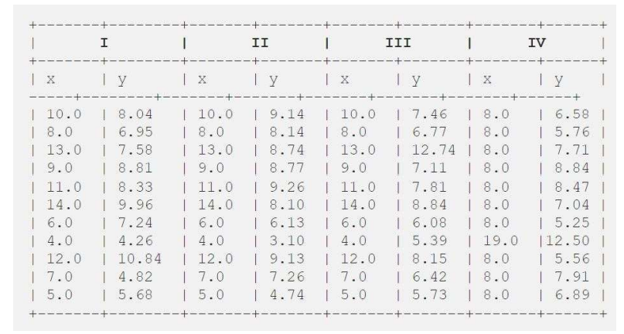

After that, the council analyzed them using only descriptive statistics and found the mean, standard deviation, and correlation between x and y.

**3. What is Pearson’s R? (3 marks)**

Pearson's r is a numerical summary of the strength of the linear association between the variables. If the variables tend to go up and down together, the correlation coefficient will be positive. If the variables tend to go up and down in opposition with low values of one variable associated with high values of the other, the correlation coefficient will be negative. The Pearson correlation coefficient, r, can take a range of values from +1 to -1. A value of 0 indicates that there is no association between the two variables. A value greater than 0 indicates a positive association; that is, as the value of one variable increases, so does the value of the other variable. A value less than 0 indicates a negative association; that is, as the value of one variable increases, the value of the other variable decreases. This is shown in the diagram below:

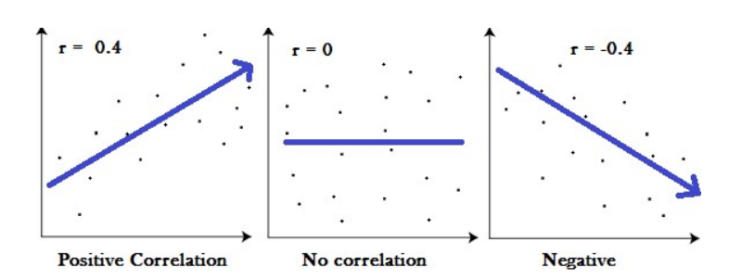

**4. What is scaling? Why is scaling performed? What is the difference between normalized scaling and standardized scaling? (3 marks)**

It is a step of data Pre-Processing which is applied to independent variables to normalize the data within a particular range. It also helps in speeding up the calculations in an algorithm.

Why is scaling performed?

Most of the times, collected data set contains features highly varying in magnitudes, units and range. If scaling is not done then algorithm only takes magnitude in account and not units hence incorrect modelling. To solve this issue, we have to do scaling to bring all the variables to the same level of magnitude. It is important to note that scaling just affects the coefficients and none of the other parameters like t-statistic, F-statistic, p-values, R-squared, etc.

**5. You might have observed that sometimes the value of VIF is infinite. Why does this happen? (3 marks)**

If there is perfect correlation, then VIF = infinity. A large value of VIF indicates that there is a correlation between the variables. If the VIF is 4, this means that the variance of the model coefficient is inflated by a factor of 4 due to the presence of multicollinearity. When the value of VIF is infinite it shows a perfect correlation between two independent variables. In the case of perfect correlation, we get R-squared (R2) =1, which lead to 1/ (1-R2) infinity. To solve this we need to drop one of the variables from the dataset which is causing this perfect multicollinearity

**6. What is a Q-Q plot? Explain the use and importance of a Q-Q plot in linear regression. (3 marks)**

If there is perfect correlation, then VIF = infinity. A large value of VIF indicates that there is a correlation between the variables. If the VIF is 4, this means that the variance of the model coefficient is inflated by a factor of 4 due to the presence of multicollinearity. When the value of VIF is infinite it shows a perfect correlation between two independent variables. In the case of perfect correlation, we get R-squared (R2) =1, which lead to 1/ (1-R2) infinity. To solve this we need to drop one of the variables from the dataset which is causing this perfect multicollinearity