**Database Systems (CSCI-526-01B)**

**Spring, 2023**

Project Title

**HOSPITAL MANAGEMENT SYSTEM**

Submitted by:

**Name:** Sai Shilpa Padmanabula, Rahul Gaddipati

**CWID:** 50327187,50324311

**Email:** [spadmanabul@leomail.tamuc.edu](mailto:spadmanabul@leomail.tamuc.edu) , rgaddipati@leomail.tamuc.edu

**Contact No:** +1 (430)-295-6034, +1 (480)-492-4567

Submitted to:

**Dr. Sang C. Suh**

Regents Professor, Computer Science Department

Texas A&M University - Commerce

**May 1st, 2023**

YouTube link: https://youtu.be/[ghvzvsQYQwM](https://youtu.be/ghvzvsQYQwM)

Contents

1. Introduction
2. Problem Statement
3. Operational Scenario’s
4. Entities & Attributes
5. Entity Relationship Diagram
6. Entity Relationship
7. ER to Relational Mapping
8. Normalization Rules on Tables
9. Create Tables
10. Insert Records/View Record
11. Future Scope
12. Conclusion
13. References

**Introduction to Hospital Management System**

A Hospital Management System (HMS) is a platform designed to simplify the administration and management of a hospital or healthcare facility. Patient registration, appointment scheduling, medical record administration, inventory management, billing, and reporting are common features of the system.

Doctors, nurses, administrative personnel, patients, and hospital administrators can all utilize the Hospital Management System. It aids in the reduction of manual workloads, the automation of administrative chores, the improvement of data accuracy, and the improvement of communication among healthcare practitioners.

Electronic health records, patient billing and insurance management, pharmacy and inventory management, appointment scheduling, and reporting and analytics are typical aspects of the Hospital Management System. Other healthcare systems, including as laboratory information systems, image archiving and communication systems, and electronic prescription systems, may also be integrated.

The major goal of setting up a Hospital Management System is to improve patient care quality, increase operational efficiency, and assure regulatory compliance. It can also assist healthcare practitioners make more informed decisions, streamline workflows, and deliver better patient care.

**Problem Statement**

The medical industry is facing several issues, including increased demand for healthcare services, the desire for greater patient care, and growing healthcare costs. Hospital Management Systems are designed to help solve some of these issues by reducing administrative operations, boosting communication among healthcare workers, and improving patient care.

As healthcare regulations become more complex and the need for compliance grows, hospitals must ensure that their management systems are up to date and capable of providing the necessary data and reporting for regulatory compliance. Failure to comply with regulatory regulations can result in financial penalties, legal consequences, and reputational harm to the institution.

As a result, Hospital Management Systems problem statement is to design and implement software platforms that can effectively address the challenges faced by healthcare providers, improve patient care, optimize operational efficiency, ensure regulatory compliance, and provide accurate and timely information to all stakeholders.

**Operational Scenario’s**

Some operational scenario’s that Hospital Management Systems (HMS) can manage are as follows:

* **Patient Registration:** The system should make it simple to register new patients. Basic patient information, contact information, and insurance information should all be recorded.
* **session Scheduling:** The system should allow healthcare professionals to plan patient appointments, assign doctors and resources for each session, and create reminders.
* **Management of Electronic Health Records (EHR):** The system should keep a detailed and secure electronic health record for each patient, including medical history, diagnosis, prescriptions, and lab test results.
* **Pharmacy and Inventory Management:** The system should assist healthcare practitioners in managing drugs, medical supplies, and equipment inventories. It should also keep track of medicinal products expiration dates and notify workers when supplies are running short.
* **Billing and Insurance Administration:** The system should create and manage bills, track payments, and handle insurance claims. It should also be able to connect to various payment channels and insurance companies.
* **Reporting and Analytics:** The system should provide real-time reporting and analytics on various metrics, including patient satisfaction, operational efficiency, and financial performance.
* **Telemedicine and Remote Patient Monitoring:** Remote consultations, virtual visits, and telemedicine services should be supported by the system. It should also allow for remote patient monitoring via wearables and other IoT devices.
* **Medical Imaging and Diagnostic Report Management:** The system should handle medical imaging and diagnostic reports, such as those from radiology, pathology, and cardiology. It should be able to communicate with various medical imaging systems and equipment.

These are a few examples of operational scenarios that Hospital Management Systems can handle. However, the scope of the system can vary depending on the specific needs of the hospital or healthcare facility.

**Entities & Attributes**

These are some of the entities and attributes that can be included in a Hospital Management System. The specific entities and attributes can vary depending on the requirements and needs of the hospital or healthcare facility.

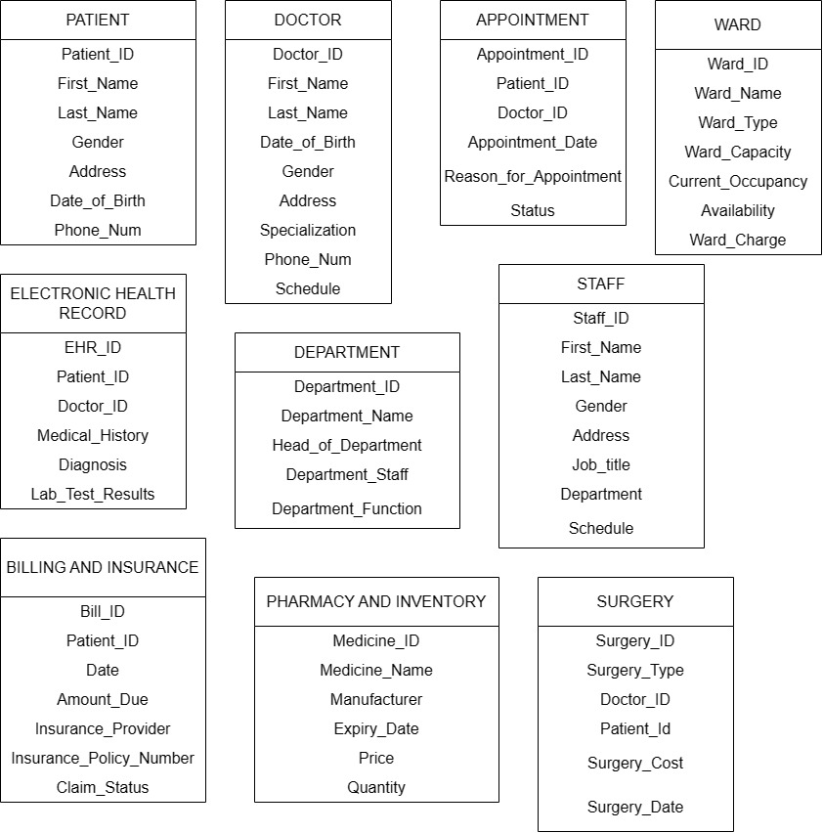

**Entity Relationship Diagram**

The ER Diagram for the Hospital Management System includes the following entities and their relationships: Patient, Doctor, Appointment, Ward, Electronic Health Record, Pharmacy and Inventory, Billing and Insurance, Department, Surgery, Staff.

The diagram includes the following symbols and conventions:

* Rectangles represent entities.
* Diamonds represent relationships.
* Lines connect the entities to relationships.

Overall, the ER Diagram for Hospital Management System depicts the relationships and dependencies among the entities and helps to understand the data flow and management within the hospital management system.

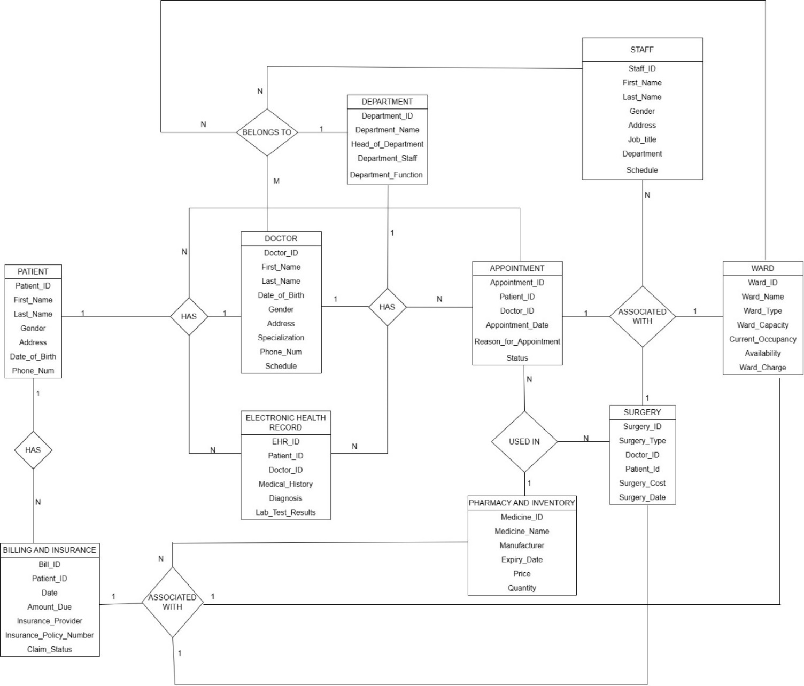

**Entity Relationships**

1. One-To-Many Binary Relationship

The below diagram represents the one-to-many relationship between PHARMACY AND INVENTORY and APPOINTMENT. The PHARMACY AND INVENTORY table has the attributes as Medicine_ID, Medicine_Name, Manufacturer, Expiry_Date, Price, Quantity and the APPOINTMENT table has the attributes as Appointment_ID, Patient_ID, Doctor_ID, Appointment_Date, Reason_for_Appointment, Status.

* One medicine from PHARMACY AND INVENTORY can be used in many APPOINTMENTS

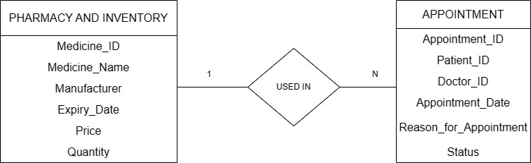

The below diagram represents the one-to-many relationship between PATIENT and BILLING AND INSURANCE. The PATIENT table has the attributes as Patient_ID, First_Name, Last_Name, Gender, Address, Date_of_Birth, Phone_Num and the BILLING AND INSURANCE table has the attributes as Bill_ID, Patient_ID, Date_, Amount_DUE, Insurance_Provider, Insurance_Policy_Number, Claim_Status.

* One patient with Patient_ID may have one or more bills and insurances.

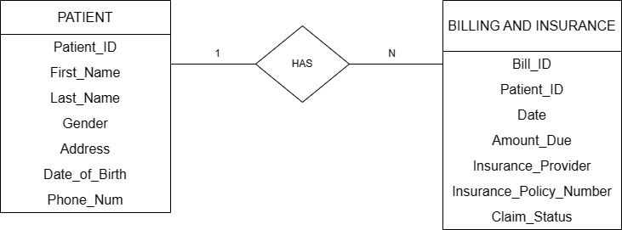

The below diagram represents the one-to-many relationship between PHARMACY AND INVENTORY and SURGERY. The PHARMACY AND INVENTORY table has the attributes as Medicine_ID, Medicine_Name, Manufacturer, Expiry_Date, Price, Quantity and the SURGERY table has the attributes as Surgery_ID, Surgery_Type, Doctor_ID, Patient_ID, Surgery_Cost, Surgery_Date.

* One medicine can be used in many surgeries that are performed on many patients.

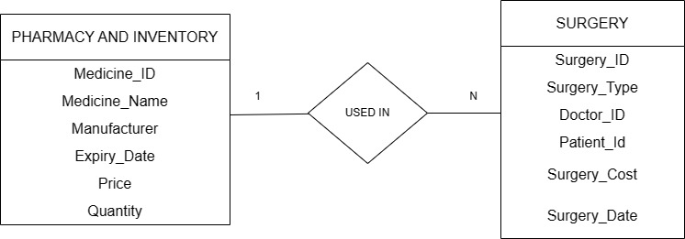

The below diagram represents the one-to-many relationship between SURGERY and STAFF. The SURGERY table has the attributes as Surgery_ID, Surgery_Type, Doctor_ID, Patient_ID, Surgery_Cost, Surgery_Date and the STAFF table has the attributes as Staff_ID, First_Name, Last_Name, Gender, Address, Job_Title, Department, Schedule.

* While performing one surgery on a patient many staff can be assisted.

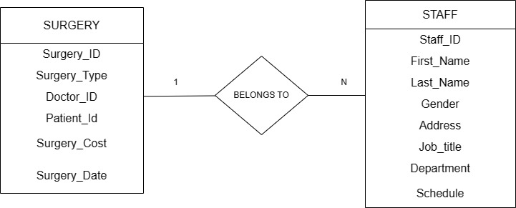

The below diagram represents the one-to-many relationship between PATIENT and ELECTRONIC HEALTH RECORD. The PATIENT table has the attributes as Patient_ID, First_Name, Last_Name, Gender, Address, Date_of_Birth, Phone_Num and the ELECTRONIC HEALTH RECORD table has the attributes as EHR_ID, Patient_ID, Doctor_ID, Medical_History, Diagnosis, Lab_Test_Results.

* One patient may have different electronic health record based on different diseases.

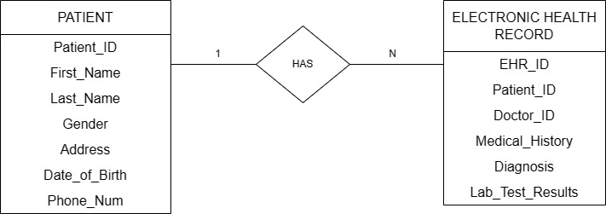

The below diagram represents the one-to-many relationship between PATIENT and APPOINTMENT. The PATIENT table has the attributes as Patient_ID, First_Name, Last_Name, Gender, Address, Date_of_Birth, Phone_Num and the APPOINTMENT table has the attributes as Appointment_ID, Patient_ID, Doctor_ID, Appointment_Date, Reason_for_Appointment, Status.

* One patient may have different appointments with different doctors based on the diseases he/she has.

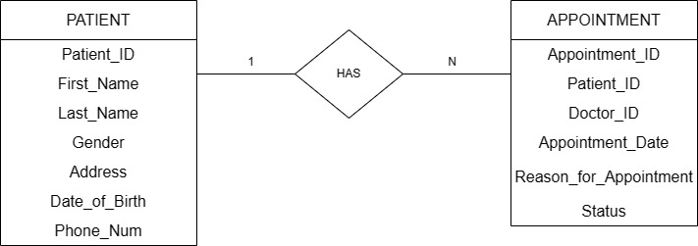

The below diagram represents the one-to-many relationship between DOCTOR and APPOINTMENT. The DOCTOR table has the attributes as Doctor_ID, First_Name, Last_Name, Date_of_Birth, Gender, Address, Specialization, Phone_Num, Schedule and the APPOINTMENT table has the attributes as Appointment_ID, Patient_ID, Doctor_ID, Appointment_Date, Reason_for_Appointment, Status.

* One doctor may have many appointments with many patients.

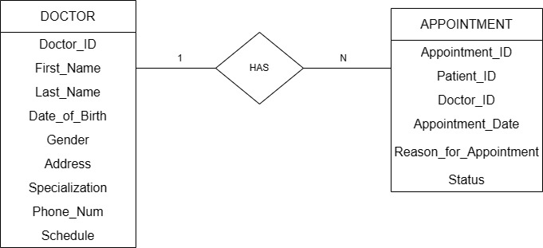

The below diagram represents the one-to-many relationship between DEPARTMENT and ELECTRONIC HEALTH RECORD. The DEPARTMENT table has the attributes as Department_ID, Department_Name, Head_of_Department, Department_Staff, Department_Function and the ELECTRONIC HEALTH RECORD table has the attributes as EHR_ID, Patient_ID, Doctor_ID, Medical_History, Diagnosis, Lab_Test_Results.

* One department may have different electronic health record based on different diseases.

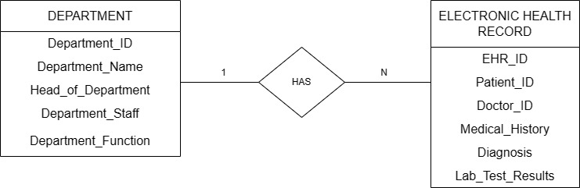

The below diagram represents the one-to-many relationship between DEPARTMENT and WARD. The DEPARTMENT table has the attributes as Department_ID, Department_Name, Head_of_Department, Department_Staff, Department_Function and the WARD table has the attributes as Ward_ID, Ward_Name, Ward_Type, Ward_Capacity, Current_Occupancy, Availability, Ward_Charge.

* One department may have different wardS based on different diseases.

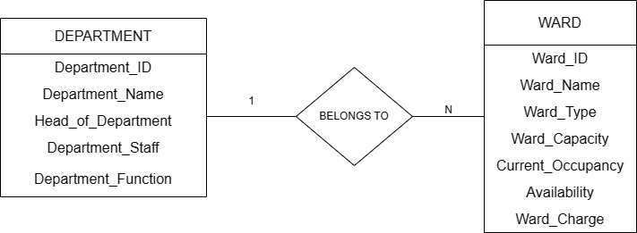

1. One-To-One Binary Relationship

The below diagram represents the one-to-one relationship between PATIENT and DOCTOR. The PATIENT table has the attributes as Patient_ID, First_Name, Last_Name, Gender, Address, Date_of_Birth, Phone_Num and the DOCTOR table has the attributes as Doctor_ID, First_Name, Last_Name, Date_of_Birth, Gender, Address, Specialization, Phone_Num, Schedule.

* One patient may consult only one doctor at the same time.

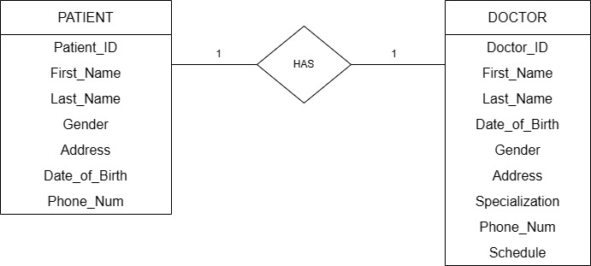

The below diagram represents the one-to-one relationship between APPOINTMENT and WARD. APPOINTMENT table has the attributes as Appointment_ID, Patient_ID, Doctor_ID, Appointment_Date, Reason_for_Appointment, Status. WARD table has the attributes as Ward_ID, Ward_Name, Ward_Type, Ward_Capacity, Current_Occupancy, Availability, Ward_Charge.

* One appointment may associate with one ward at the same time.

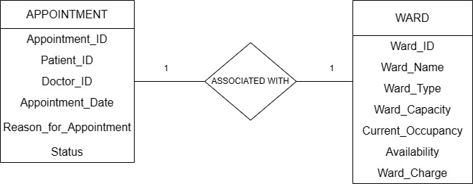

The below diagram represents the one-to-one relationship between APPOINTMENT and SURGERY. APPOINTMENT table has the attributes as Appointment_ID, Patient_ID, Doctor_ID, Appointment_Date, Reason_for_Appointment, Status. The SURGERY table has the attributes as Surgery_ID, Surgery_Type, Doctor_ID, Patient_ID, Surgery_Cost, Surgery_Date.

* One appointment may associate with one surgery at the same time.

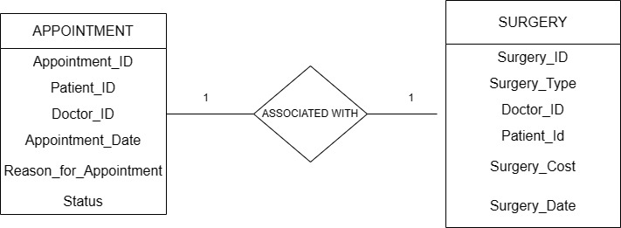

The below diagram represents the one-to-one relationship between BILLING AND INSURANCE and SURGERY. The BILLING AND INSURANCE table has the attributes as Bill_ID, Patient_ID, Date_, Amount_DUE, Insurance_Provider, Insurance_Policy_Number, Claim_Status.The SURGERY table has the attributes as Surgery_ID, Surgery_Type, Doctor_ID, Patient_ID, Surgery_Cost, Surgery_Date.

* One Billing and insurance may associate with one surgery at the same time.

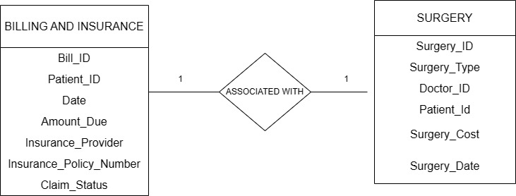

The below diagram represents the one-to-one relationship between BILLING AND INSURANCE and WARD. The BILLING AND INSURANCE table has the attributes as Bill_ID, Patient_ID, Date_, Amount_DUE, Insurance_Provider, Insurance_Policy_Number, Claim_Status. WARD table has the attributes as Ward_ID, Ward_Name, Ward_Type, Ward_Capacity, Current_Occupancy, Availability, Ward_Charge.

* One Billing and insurance may associate with one ward at the same time.

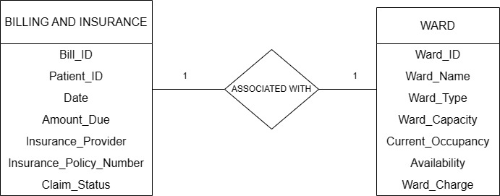

The below diagram represents the one-to-many relationship between DOCTOR and DEPARTMENT. The DOCTOR table has the attributes as Doctor_ID, First_Name, Last_Name, Date_of_Birth, Gender, Address, Specialization, Phone_Num, Schedule. The DEPARTMENT table has the attributes as Department_ID, Department_Name, Head_of_Department, Department_Staff, Department_Function.

* One Doctor is associated with one department at the same time.

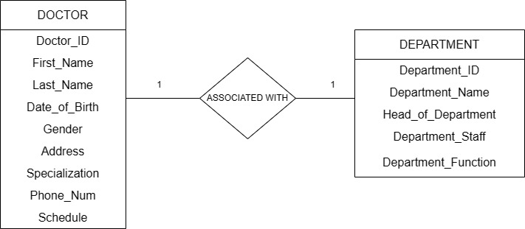

c).Many-to-many binary relationship

The below diagram represents the many-to-many relationship between ELECTRONIC HEALTH RECORD and APPOINTMENT. The ELECTRONIC HEALTH RECORD table has the attributes as EHR_ID, Patient_ID, Doctor_ID, Medical_History, Diagnosis, Lab_Test_Results and APPOINTMENT table has the attributes as Appointment_ID, Patient_ID, Doctor_ID, Appointment_Date, Reason_for_Appointment, Status.

* Many Electronic health records may be associated with many appointments with the same time.

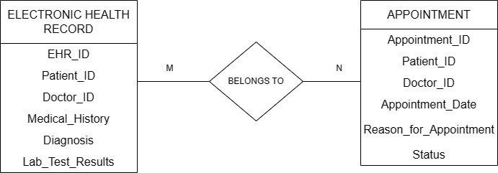

The below diagram represents the many-to-many relationship between DOCTOR and STAFF. The DOCTOR table has the attributes as Doctor_ID, First_Name, Last_Name, Date_of_Birth, Gender, Address, Specialization, Phone_Num, Schedule. The STAFF table has the attributes as Staff_ID, First_Name, Last_Name, Gender, Address, Job_Title, Department, Schedule.

* Many Doctors may be associated with many staff at the same time.

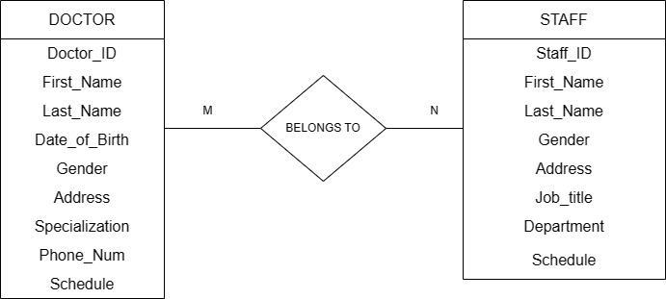

**ER to Relational Mapping**

PATIENT:

|  |  |  |  |  |  |  |
| --- | --- | --- | --- | --- | --- | --- |
| **Patient_ID** | First_Name | Last_Name | Gender | Address | Date_of_Birth | Phone_Num |

BILLING AND INSURANCE:

|  |  |  |  |  |  |  |
| --- | --- | --- | --- | --- | --- | --- |
| **Bill_ID** | Claim_Status | Date | Amount_Due | Insurance_Provider | Insurance_Policy_Number | **Patient_ID** |

|  |  |  |  |  |  |  |  |  |
| --- | --- | --- | --- | --- | --- | --- | --- | --- |
| **Doctor_ID** | First_Name | Last_Name | Date_of_Birth | Gender | Address | Specialization | Phone_Num | Schedule |

DOCTOR:

APPOINTMENT:

|  |  |  |  |  |  |
| --- | --- | --- | --- | --- | --- |
| **Appointment_ID** | Appointment_Date | Reason_for_Appointment | Status | **Patient_ID** | **Doctor_ID** |

ELECTRONIC HEALTH RECORD:

|  |  |  |  |  |  |
| --- | --- | --- | --- | --- | --- |
| **EHR_ID** | Medical_History | Diagnosis | Lab_Test_Results | **Patient_ID** | **Doctor_ID** |

SURGERY:

|  |  |  |  |  |  |
| --- | --- | --- | --- | --- | --- |
| **Surgery_ID** | Surgery_Type | Surgery_Cost | Surgery_Date | **Doctor_ID** | **Patient_ID** |

WARD:

|  |  |  |  |  |  |  |
| --- | --- | --- | --- | --- | --- | --- |
| **Ward_ID** | Ward_Name | Ward_Type | Ward_Capacity | Availability | Current_Occupancy | Ward_Charge |

DEPARTMENT:

|  |  |  |  |  |
| --- | --- | --- | --- | --- |
| **Department_ID** | Department_Name | Head_of_Departrment | Department_Staff | Department_Function |

STAFF:

|  |  |  |  |  |  |  |  |
| --- | --- | --- | --- | --- | --- | --- | --- |
| **Staff_ID** | First_Name | Last_Name | Gender | Address | Job_Title | Department | Schedule |

PHARMACY AND INVENTORY:

|  |  |  |  |  |  |
| --- | --- | --- | --- | --- | --- |
| **Medicine_ID** | Medicine_Name | Manufacturer | Expiry_Date | Price | Quantity |

**List of primary keys:** Patient_ID, Bill_ID, Doctor_ID, Appointment_ID, EHR_ID, Surgery_ID , Ward_ID, Department_ID, Staff_ID, Medicine_ID (highlighted in bold black font)

**List of foreign keys:** Patient_ID, Doctor_ID (highlighted in bold blue font)

**Normalization Rules on Tables**

Normalization is the process of organizing data in a database to reduce data redundancy and improve data integrity. It involves breaking down a large table into smaller, more manageable tables, which are then linked together through relationships. Normalization is an essential concept in database design as it helps to eliminate data redundancy and inconsistencies that may arise from data updates, deletions or insertions.

Generally, this normalization is divided into subcategories. They are:

1. 1st normalization form (1NF)
2. 2nd normalization form (2NF)
3. 3rd normalization form (3NF)

These normalization rules are being applied to the entities to check whether these are satisfying all the normalization rules.

**PATIENT:**

|  |  |  |  |  |  |  |
| --- | --- | --- | --- | --- | --- | --- |
| Patient_ID | First_Name | Last_Name | Gender | Address | Date_of_Birth | Phone_Num |

* **First Normal Form (1NF):** The given table appears to be in 1NF, as each attribute seems to contain atomic values.
* {Patient_ID} {First_Name, Last_Name, Gender, Address, Date_of_Birth, Phone_Num}
* **Second Normal Form (2NF):** The table should be in 1NF, and there should be no partial dependencies.To identify the partial dependencies, we need to determine the functional dependencies between the attributes. From the given table, we can assume that Patient ID is the primary key. Patient_ID -> First_Name, Last_Name, Gender, Address, Date_of_Birth, Phone_Num. There is no partial dependency, and each non-key attribute depends on the entire primary key. Hence, the table appears to be in 2NF.
* **Third Normal Form (3NF):** In the above relation there is no transitive dependency’s existing between non-prime attribute and primary key of relation, so it also satisfies 3NF.

|  |  |  |  |  |  |  |  |  |
| --- | --- | --- | --- | --- | --- | --- | --- | --- |
| Doctor_ID | First_Name | Last_Name | Gender | Address | Specialization | Phone_Num | Date_of_Birth | Schedule |

**DOCTOR:**

* **First Normal Form (1NF):** The given table appears to be in 1NF, as each attribute seems to contain atomic values.
* {Doctor_ID} { First_Name, Last_Name, Gender, Address, Specialization, Phone_Num, Date_of_Birth, Schedule}
* **Second Normal Form (2NF):** To identify the partial dependencies, we need to determine the functional dependencies between the attributes. From the given table, we can assume that Doctor ID is the primary key. Doctor_ID -> First_Name, Last_Name, Gender, Address, Specialization, Phone_Num, Date_of_Birth, Schedule. There is no partial dependency, and each non-key attribute depends on the entire primary key. Hence, the table appears to be in 2NF.
* **Third Normal Form (3NF):** In the above relation there is no transitive dependency’s existing between non-prime attribute and primary key of relation, so it also satisfies 3NF.

**APPOINTMENT:**

|  |  |  |  |  |  |
| --- | --- | --- | --- | --- | --- |
| Appointment_ID | Patient_ID | Doctor_ID | Appointment_Date | Reason_for_Appointment | Status |

* **First Normal Form (1NF):** The given table appears to be in 1NF, as each attribute seems to contain atomic values.
* **{**Appointment_ID} {Patient_ID, Doctor_ID, Appointment_Date, Reason_for_Appointment, Status}
* **Second Normal Form (2NF):** To identify the partial dependencies, we need to determine the functional dependencies between the attributes. From the given table, we can assume that Appointment ID is the primary key. Appointment_ID -> Patient_ID, Doctor_ID, Appointment_Date, Reason_for_Appointment, Status. There is no partial dependency, and each non-key attribute depends on the entire primary key. Hence, the table appears to be in 2NF.
* **Third Normal Form (3NF):** In the above relation there is no transitive dependency’s existing between non-prime attribute and primary key of relation, so it also satisfies 3NF.

**WARD:**

|  |  |  |  |  |  |  |
| --- | --- | --- | --- | --- | --- | --- |
| Ward_ID | Ward_Name | Ward_Type | Ward_Capacity | Availability | Current_Occupancy | Ward_Charge |

* **First Normal Form (1NF):** The given table appears to be in 1NF, as each attribute seems to contain atomic values.
* { Ward_ID } { Ward_Name, Ward_Type, Ward_Capacity, Availability, Current_Occupancy, Ward_Charge }
* **Second Normal Form (2NF):** To identify the partial dependencies, we need to determine the functional dependencies between the attributes. From the given table, we can assume that Ward ID is the primary key. Ward ID -> Ward_name, Ward_type, Ward_capacity, Availability, Current_occupancy, Ward_charge. There is no partial dependency, and each non-key attribute depends on the entire primary key. Hence, the table appears to be in 2NF.
* **Third Normal Form (3NF):** In the above relation there is no transitive dependency’s existing between non-prime attribute and primary key of relation, so it also satisfies 3NF.

**ELECTRONIC HEALTH RECORD:**

|  |  |  |  |  |  |
| --- | --- | --- | --- | --- | --- |
| EHR_ID | Patient_ID | Doctor_ID | Medical_History | Diagnosis | Lab_Test_Results |

* **First Normal Form (1NF):** The given table appears to be in 1NF, as each attribute seems to contain atomic values.
* { EHR_ID } { Patient_ID, Doctor_ID, Medical_History, Diagnosis, Lab_Test_Results }
* **Second Normal Form (2NF):** To identify the partial dependencies, we need to determine the functional dependencies between the attributes. From the given table, we can assume that EHR ID is the primary key. EHR_ID -> Patient_ID, Doctor_ID, Medical_History, Diagnosis, Lab_Test_Results. There is no partial dependency, and each non-key attribute depends on the entire primary key. Hence, the table appears to be in 2NF.
* **Third Normal Form (3NF):** In the above relation there is no transitive dependency’s existing between non-prime attribute and primary key of relation, so it also satisfies 3NF.

**DEPARTMENT:**

|  |  |  |  |  |
| --- | --- | --- | --- | --- |
| Department_ID | Department_Name | Head_of_Departrment | Department_Staff | Department_Function |

* **First Normal Form (1NF):** The given table appears to be in 1NF, as each attribute seems to contain atomic values.
* { Department_ID } { Department_Name, Head_of_Departrment, Department_Staff, Department_Function }
* **Second Normal Form (2NF):** To identify the partial dependencies, we need to determine the functional dependencies between the attributes. From the given table, we can assume that Department ID is the primary key. Department_ID -> Department_Name, Head_of_Departrment, Department_Staff, Department_Function. There is no partial dependency, and each non-key attribute depends on the entire primary key. Hence, the table appears to be in 2NF.
* **Third Normal Form (3NF):** In the above relation there is no transitive dependency’s existing between non-prime attribute and primary key of relation, so it also satisfies 3NF.

**STAFF:**

|  |  |  |  |  |  |  |  |
| --- | --- | --- | --- | --- | --- | --- | --- |
| Staff_ID | First_Name | Last_Name | Gender | Address | Job_Title | Department | Schedule |

* **First Normal Form (1NF):** The given table appears to be in 1NF, as each attribute seems to contain atomic values.
* { Staff_ID } { First_Name, Last_Name, Department_Staff, Gender , Address , Job_Title ,Department, Schedule }
* **Second Normal Form (2NF):** To identify the partial dependencies, we need to determine the functional dependencies between the attributes. From the given table, we can assume that Staff ID is the primary key. Staff_ID -> First_Name, Last_Name, Department_Staff, Gender , Address , Job_Title ,Department, Schedule. There is no partial dependency, and each non-key attribute depends on the entire primary key. Hence, the table appears to be in 2NF.
* **Third Normal Form (3NF):** In the above relation there is no transitive dependency’s existing between non-prime attribute and primary key of relation, so it also satisfies 3NF.

**BILLING AND INSURANCE:**

|  |  |  |  |  |  |  |
| --- | --- | --- | --- | --- | --- | --- |
| Bill_ID | Patient_ID | Date | Amount_Due | Insurance_Provider | Insurance_Policy_Number | Claim_Status |

* **First Normal Form (1NF):** The given table appears to be in 1NF, as each attribute seems to contain atomic values.
* { Bill_ID } { Patient_ID, Date, Amount_Due, Insurance_Provider, Insurance_Policy_Number, Claim_Status }
* **Second Normal Form (2NF):** To identify the partial dependencies, we need to determine the functional dependencies between the attributes. From the given table, we can assume that Bill ID is the primary key. Bill_ID -> Patient_ID, Date, Amount_Due, Insurance_Provider, Insurance_Policy_Number, Claim_Status. There is no partial dependency, and each non-key attribute depends on the entire primary key. Hence, the table appears to be in 2NF.
* **Third Normal Form (3NF):** In the above relation there is no transitive dependency’s existing between non-prime attribute and primary key of relation, so it also satisfies 3NF.

**PHARMACY AND INVENTORY:**

|  |  |  |  |  |  |
| --- | --- | --- | --- | --- | --- |
| Medicine_ID | Medicine_Name | Manufacturer | Expiry_Date | Price | Quantity |

* **First Normal Form (1NF):** The given table appears to be in 1NF, as each attribute seems to contain atomic values.
* { Medicine_ID } { Medicine_Name, Manufacturer, Expiry_Date, Price, Quantity }
* **Second Normal Form (2NF):** To identify the partial dependencies, we need to determine the functional dependencies between the attributes. From the given table, we can assume that Medicine ID is the primary key. Medicine_ID -> Medicine_Name, Manufacturer, Expiry_Date, Price, Quantity . There is no partial dependency, and each non-key attribute depends on the entire primary key. Hence, the table appears to be in 2NF.
* **Third Normal Form (3NF):** In the above relation there is no transitive dependency’s existing between non-prime attribute and primary key of relation, so it also satisfies 3NF.

**SURGERY:**

|  |  |  |  |  |  |
| --- | --- | --- | --- | --- | --- |
| Surgery_ID | Surgery_Type | Doctor_ID | Patient_ID | Surgery_Cost | Surgery_Date |

* **First Normal Form (1NF):** The given table appears to be in 1NF, as each attribute seems to contain atomic values.
* { Surgery_ID } { Surgery_Type, Doctor_ID, Patient_ID, Surgery_Cost, Surgery_Date }
* **Second Normal Form (2NF):** To identify the partial dependencies, we need to determine the functional dependencies between the attributes. From the given table, we can assume that Surgery ID is the primary key. Surgery_ID -> Surgery_Type, Doctor_ID, Patient_ID, Surgery_Cost, Surgery_Date. There is no partial dependency, and each non-key attribute depends on the entire primary key. Hence, the table appears to be in 2NF.
* **Third Normal Form (3NF):** In the above relation there is no transitive dependency’s existing between non-prime attribute and primary key of relation, so it also satisfies 3NF.

**Create Tables:**

In this project implementation, we are building the below tables with their respective attributes.

* **PATIENT** Patient_ID, First_Name, Last_Name, Gender, Address, Date_of_Birth, Phone_Num
* **DOCTOR** Doctor_ID, First_Name, Last_Name, Gender, Address, Specialization, Phone_Num, Date_of_Birth, Schedule
* **APPOINTMENT** Appointment_ID, Patient_ID, Doctor_ID, Appointment_Date, Reason_for_Appointment, Status
* **WARD** Ward_ID, Ward_Name, Ward_Type, Ward_Capacity, Availability, Current_Occupancy, Ward_Charge
* **ELECTRONIC HEALTH RECORD** EHR_ID, Patient_ID, Doctor_ID, Medical_History, Diagnosis, Lab_Test_Results
* **DEPARTMENT** Department_ID, Department_Name, Head_of_Departrment, Department_Staff, Department_Function
* **STAFF** Staff_ID, First_Name, Last_Name, Gender , Address , Job_Title ,Department, Schedule
* **BILLING AND INSURANCE** Bill_ID, Patient_ID, Date, Amount_Due, Insurance_Provider, Insurance_Policy_Number, Claim_Status
* **PHARMACY AND INVENTORY** Medicine_ID, Medicine_Name, Manufacturer, Expiry_Date, Price, Quantity
* **SURGERY** Surgery_ID, Surgery_Type, Doctor_ID, Patient_ID, Surgery_Cost, Surgery_Date

1. **PATIENT**

create table patient ( Patient_ID INT NOT NULL,

First_Name VARCHAR(50) NOT NULL,

Last_Name VARCHAR(50) NOT NULL,

Gender VARCHAR(10) NOT NULL,

Address VARCHAR(100) NOT NULL,

Date_of_Birth DATE NOT NULL,

Phone_Num VARCHAR(20) NOT NULL,

PRIMARY KEY (Patient_ID)

);

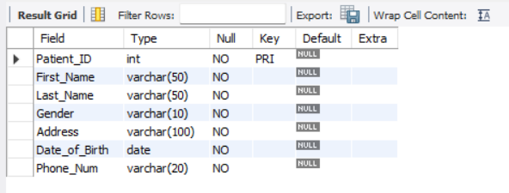

1. **DOCTOR**

CREATE TABLE doctor (

Doctor_ID INT PRIMARY KEY NOT NULL,

First_Name VARCHAR(50) NOT NULL,

Last_Name VARCHAR(50) NOT NULL,

Gender VARCHAR(10) NOT NULL,

Address VARCHAR(100) NOT NULL,

Specialization VARCHAR(50) NOT NULL,

Phone_Num VARCHAR(20) NOT NULL,

Date_of_Birth DATE NOT NULL,

Schedule VARCHAR(100) NOT NULL

);

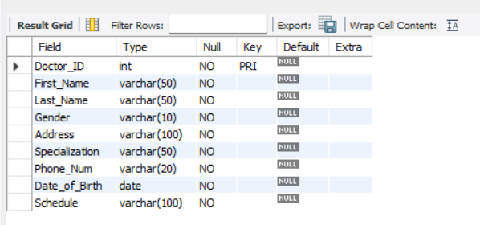

1. **APPOINTMENT**

CREATE TABLE appointment (

Appointment_ID INT PRIMARY KEY NOT NULL,

Patient_ID INT NOT NULL,

Doctor_ID INT NOT NULL,

Appointment_Date DATE NOT NULL,

Reason_for_Appointment VARCHAR(255) NOT NULL,

Status VARCHAR(20) NOT NULL,

FOREIGN KEY (Patient_ID) REFERENCES patient (Patient_ID),

FOREIGN KEY (Doctor_ID) REFERENCES doctor (Doctor_ID)

);

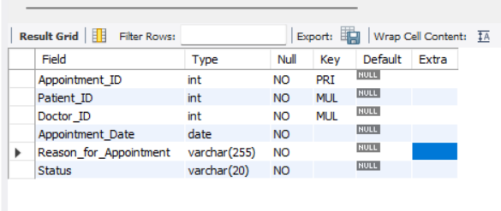

1. **WARD**

CREATE TABLE ward (

Ward_ID INT PRIMARY KEY NOT NULL,

Ward_Name VARCHAR(50) NOT NULL,

Ward_Type VARCHAR(50) NOT NULL,

Ward_Capacity INT NOT NULL,

Availability VARCHAR(20) NOT NULL,

Current_Occupancy INT NOT NULL,

Ward_Charge VARCHAR(20) NOT NULL

);

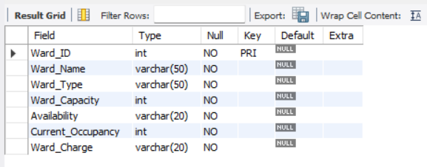

1. **ELECTRONIC HEALTH RECORD**

CREATE TABLE EHR (

EHR_ID INT NOT NULL,

Patient_ID INT NOT NULL,

Doctor_ID INT NOT NULL,

Medical_History VARCHAR(100) NOT NULL,

Diagnosis VARCHAR(100) NOT NULL,

Lab_Test_Results VARCHAR(100) NOT NULL,

PRIMARY KEY (EHR_ID),

FOREIGN KEY (Patient_ID) REFERENCES patient(Patient_ID),

FOREIGN KEY (Doctor_ID) REFERENCES doctor(Doctor_ID)

);

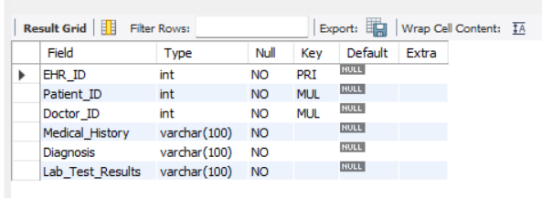

1. **DEPARTMENT**

CREATE TABLE department (

Department_ID INT PRIMARY KEY NOT NULL,

Department_Name VARCHAR(50) NOT NULL,

Head_of_Department VARCHAR(50) NOT NULL,

Department_Staff INT NOT NULL,

Department_Function VARCHAR(100) NOT NULL

);

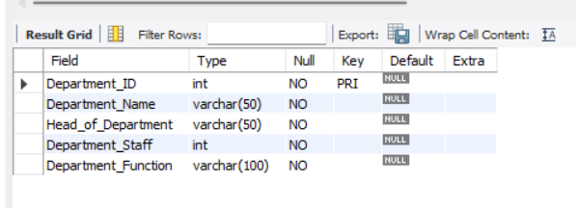

1. **STAFF**

CREATE TABLE staff (

Staff_ID INT PRIMARY KEY NOT NULL,

First_Name VARCHAR(50) NOT NULL,

Last_Name VARCHAR(50) NOT NULL,

Gender VARCHAR(10) NOT NULL,

Address VARCHAR(100) NOT NULL,

Job_Title VARCHAR(50) NOT NULL,

Department VARCHAR(50) NOT NULL,

Schedule VARCHAR(100) NOT NULL

);

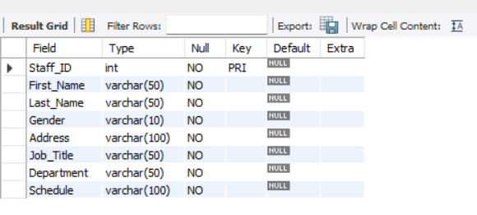

1. **BILLING AND INSURANCE**

CREATE TABLE billing_insurance (

Bill_ID INT NOT NULL PRIMARY KEY,

Patient_ID INT NOT NULL,

Date DATE NOT NULL,

Amount_Due VARCHAR(50) NOT NULL,

Insurance_Provider VARCHAR(50) NOT NULL,

Insurance_Policy_Number VARCHAR(50) NOT NULL,

Claim_Status VARCHAR(20) NOT NULL,

FOREIGN KEY (Patient_ID) REFERENCES patient(Patient_ID) );

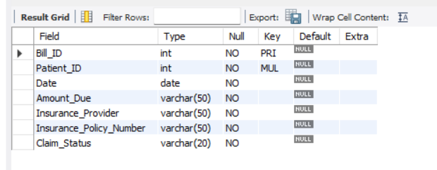

1. **PHARMACY AND INVENTORY**

CREATE TABLE pharmacy_inventory (

Medicine_ID INT PRIMARY KEY NOT NULL,

Medicine_Name VARCHAR(255) NOT NULL,

Manufacturer VARCHAR(255) NOT NULL,

Expiry_Date DATE NOT NULL,

Price DECIMAL(10,2) NOT NULL,

Quantity INT NOT NULL

);

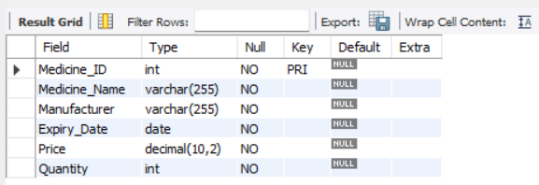

1. **SURGERY**

CREATE TABLE surgery (

Surgery_ID INT PRIMARY KEY NOT NULL,

Surgery_Type VARCHAR(255) NOT NULL,

Doctor_ID INT NOT NULL,

Patient_ID INT NOT NULL,

Surgery_Cost DECIMAL(10,2) NOT NULL,

Surgery_Date DATE NOT NULL,

FOREIGN KEY (Doctor_ID) REFERENCES doctor(Doctor_ID),

FOREIGN KEY (Patient_ID) REFERENCES patient(Patient_ID)

);

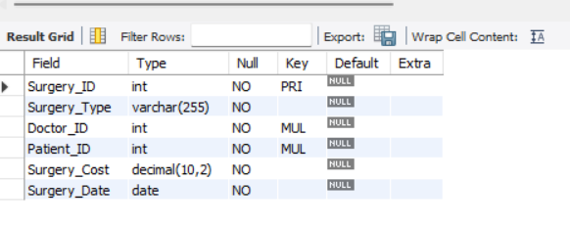

**Insert/View Records:**

1. **PATIENT**

INSERT INTO patient (Patient_ID, First_Name, Last_Name, Gender, Address, Date_of_Birth, Phone_Num) VALUES

(1, 'John', 'Doe', 'Male', '123 Main St', '1980-01-01', '123-456-7890'),

(2, 'Jane', 'Doe', 'Female', '456 Elm St', '1985-05-15', '555-555-5555'),

(3, 'Bob', 'Smith', 'Male', '789 Oak Ave', '1975-08-20', '444-444-4444'),

(4, 'Sara', 'Johnson', 'Female', '321 Maple Ln', '1990-02-10', '777-777-7777'),

(5, 'David', 'Lee', 'Male', '555 Pine St', '1988-12-25', '999-999-9999'),

(6, 'Jessica', 'Davis', 'Female', '888 Cherry Ave', '1970-07-12', '222-222-2222'),

(7, 'Michael', 'Brown', 'Male', '444 Oak St', '1995-03-05', '888-888-8888'),

(8, 'Rachel', 'Garcia', 'Female', '777 Willow Ave', '1982-06-30', '666-666-6666'),

(9, 'Kevin', 'Clark', 'Male', '222 Cedar St', '1978-04-22', '111-111-1111'),

(10, 'Amy', 'Lopez', 'Female', '999 Pine Ave', '1987-09-18', '333-333-3333'),

(11, 'Daniel', 'Chen', 'Male', '666 Elm St', '1992-11-08', '555-123-4567'),

(12, 'Emily', 'Wong', 'Female', '333 Maple Ave', '1984-12-31', '987-654-3210'),

(13, 'Alex', 'Taylor', 'Male', '111 Oak Ln', '1973-03-15', '321-654-0987'),

(14, 'Olivia', 'Nguyen', 'Female', '222 Pine St', '1994-07-20', '111-222-3333'),

(15, 'Jacob', 'Kim', 'Male', '333 Cherry Ave', '1981-05-12', '444-555-6666'),

(16, 'Grace', 'Gonzalez', 'Female', '777 Cedar St', '1993-08-02', '777-888-9999'),

(17, 'William', 'Liu', 'Male', '444 Oak Ave', '1976-09-23', '222-333-4444'),

(18, 'Ava', 'Patel', 'Female', '555 Willow Ln', '1989-04-14', '999-888-7777'),

(19, 'Mason', 'Singh', 'Male', '999 Elm Ave', '1983-11-26', '666-777-8888'),

(20, 'Sophia', 'Lee', 'Female', '888 Maple St', '1991-02-18', '123-456-7890');

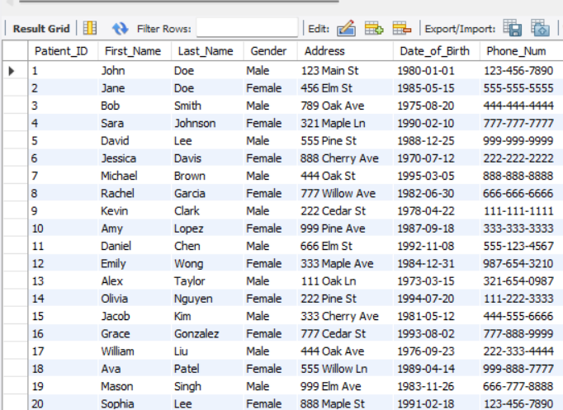

1. **DOCTOR**

INSERT INTO doctor (Doctor_ID, First_Name, Last_Name, Gender, Address, Specialization, Phone_Num, Date_of_Birth, Schedule)

VALUES

(1, 'Evelyn', 'Singh', 'Male', '123 Main St', 'Cardiology', '123-456-7890', '1980-01-01', 'Tuesday-Thursday 9am-5pm'),

(2, 'Lucas', 'Chen', 'Female', '456 Elm St', 'Pediatrics', '555-555-5555', '1985-05-15', 'Friday-Sunday 10am-6pm'),

(3, 'Charlotte', 'Wong', 'Male', '789 Oak Ave', 'Neurology', '444-444-4444', '1975-08-20', 'Saturday-Tuesday 8am-4pm'),

(4, 'Mason', 'Gupta', 'Female', '321 Maple Ln', 'Oncology', '777-777-7777', '1990-02-10', 'Wednesday-Saturday 12pm-8pm'),

(5, 'Amelia', 'Ali', 'Male', '555 Pine St', 'Dermatology', '999-999-9999', '1988-12-25', 'Monday-Wednesday 1pm-9pm'),

(6, 'Megan', 'Jones', 'Female', '888 Cherry Ave', 'Obstetrics and Gynecology', '222-222-2222', '1970-07-12', 'Friday 10am-6pm'),

(7, 'Anthony', 'Garcia', 'Male', '444 Oak St', 'Psychiatry', '888-888-8888', '1995-03-05', 'Monday 9am-5pm'),

(8, 'Katherine', 'Nguyen', 'Female', '777 Willow Ave', 'Endocrinology', '666-666-6666', '1982-06-30', 'Sunday 8am-4pm'),

(9, 'Kevin', 'Clark', 'Male', '222 Cedar St', 'Urology', '111-111-1111', '1978-04-22', 'Monday-Friday 12pm-8pm'),

(10, 'Daniel', 'Kim', 'Female', '999 Pine Ave', 'Rheumatology', '333-333-3333', '1987-09-18', 'Sunday-Thursday 1pm-9pm'),

(11, 'Samantha', 'Patel', 'Male', '666 Elm St', 'Ophthalmology', '555-123-4567', '1992-11-08', 'Tuesday-Saturday 10am-6pm'),

(12, 'William', 'Gonzalez', 'Female', '333 Maple Ave', 'Otolaryngology', '987-654-3210', '1984-12-31', 'Wednesday-Sunday 9am-5pm'),

(13, 'Emily', 'Collins', 'Male', '111 Oak Ln', 'Hematology', '321-654-0987', '1973-03-15', 'Thursday 8am-4pm'),

(14, 'Christopher', 'Lee', 'Female', '222 Pine St', 'Pulmonology', '111-222-3333', '1994-07-20', 'Saturday 12pm-8pm'),

(15, 'Jacob', 'Kim', 'Male', '333 Cherry Ave', 'Infectious Disease', '444-555-6666', '1981-05-12', 'Friday 1pm-9pm'),

(16, 'Ethan', 'Gupta', 'Male', '555 Oak Ave', 'Pediatrics', '111-222-3333', '1980-05-10', 'Monday-Friday 9am-5pm'),

(17, 'Isabella', 'Chang', 'Female', '222 Pine Ln', 'Cardiology', '444-555-6666', '1995-12-25', 'Monday-Wednesday 10am-2pm'),

(18, 'Logan', 'Shah', 'Male', '888 Cedar Ave', 'Oncology', '777-888-9999', '1987-08-16', 'Tuesday-Thursday 11am-3pm'),

(19, 'Avery', 'Kaur', 'Female', '777 Willow Ln', 'Psychiatry', '666-777-8888', '1990-02-28', 'Monday-Friday 1pm-7pm'),

(20, 'Liam', 'Hepburn', 'Male', '333 Oak St', 'Dermatology', '555-666-7777', '1978-06-20', 'Tuesday-Thursday 9am-12pm');

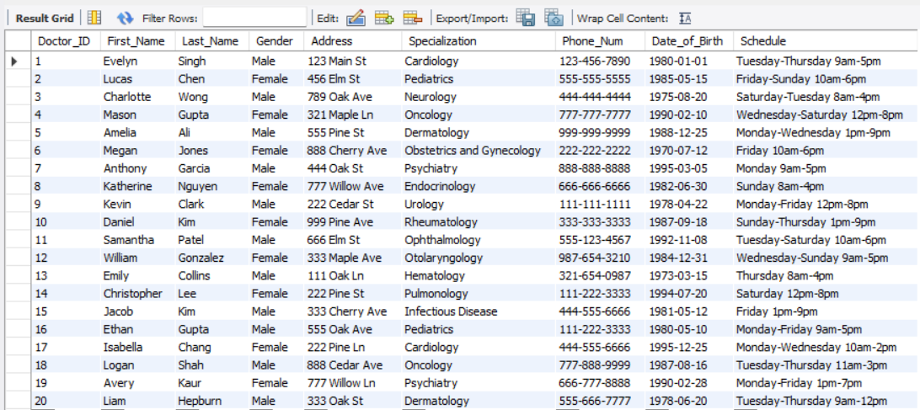

1. **APPOINTMENT**

INSERT INTO appointment (Appointment_ID, Patient_ID, Doctor_ID, Appointment_Date, Reason_for_Appointment, Status) VALUES

(1, 1, 3, '2023-05-10', 'Annual Checkup', 'Scheduled'),

(2, 2, 7, '2023-05-15', 'Flu Symptoms', 'Scheduled'),

(3, 3, 2, '2023-05-20', 'Headache', 'Scheduled'),

(4, 4, 4, '2023-05-25', 'Allergies', 'Scheduled'),

(5, 5, 8, '2023-05-30', 'Stomach Pain', 'Scheduled'),

(6, 6, 5, '2023-06-05', 'Back Pain', 'Scheduled'),

(7, 7, 9, '2023-06-10', 'Dizziness', 'Scheduled'),

(8, 8, 1, '2023-06-15', 'Fever', 'Scheduled'),

(9, 9, 10, '2023-06-20', 'Sore Throat', 'Scheduled'),

(10, 10, 6, '2023-06-25', 'Ear Infection', 'Scheduled'),

(11, 11, 3, '2023-07-01', 'Annual Checkup', 'Scheduled'),

(12, 12, 7, '2023-07-05', 'Flu Symptoms', 'Scheduled'),

(13, 13, 2, '2023-07-10', 'Headache', 'Scheduled'),

(14, 14, 4, '2023-07-15', 'Allergies', 'Scheduled'),

(15, 15, 8, '2023-07-20', 'Stomach Pain', 'Scheduled'),

(16, 16, 5, '2023-07-25', 'Back Pain', 'Scheduled'),

(17, 17, 9, '2023-07-30', 'Dizziness', 'Scheduled'),

(18, 18, 1, '2023-08-05', 'Fever', 'Scheduled'),

(19, 19, 10, '2023-08-10', 'Sore Throat', 'Scheduled'),

(20, 20, 6, '2023-08-15', 'Ear Infection', 'Scheduled');

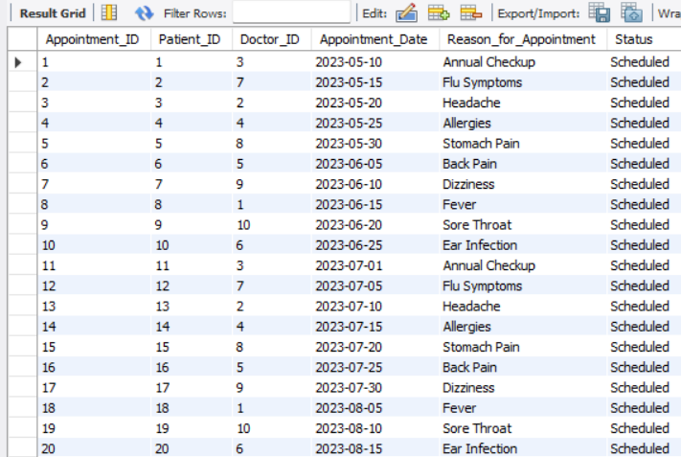

1. **WARD**

INSERT INTO ward (Ward_ID, Ward_Name, Ward_Type, Ward_Capacity, Availability, Current_Occupancy, Ward_Charge)

VALUES

(1, 'Cardiology Ward', 'Cardiology', 10, 'Available', 0, 'Olivia'),

(2, 'Oncology Ward', 'Oncology', 12, 'Available', 0, 'Benjamin'),

(3, 'Neurology Ward', 'Neurology', 8, 'Occupied', 8, 'Isabella'),

(4, 'Pediatrics Ward', 'Pediatrics', 15, 'Available', 0, 'Lucas'),

(5, 'Surgical Ward', 'Surgical', 20, 'Occupied', 15, 'Victoria'),

(6, 'Psychiatric Ward', 'Psychiatry', 6, 'Available', 0, 'Ethan'),

(7, 'Maternity Ward', 'Maternity', 10, 'Occupied', 7, 'Leah'),

(8, 'Orthopedic Ward', 'Orthopedic', 12, 'Available', 0, 'Alexander'),

(9, 'Intensive Care Unit', 'ICU', 5, 'Occupied', 5, 'Sofia'),

(10, 'Emergency Ward', 'Emergency', 10, 'Occupied', 9, 'Caleb'),

(11, 'Neonatal Intensive Care Unit', 'NICU', 8, 'Available', 0, 'Ava'),

(12, 'Gynecology Ward', 'Gynecology', 10, 'Occupied', 8, 'Wyatt'),

(13, 'Hematology Ward', 'Hematology', 6, 'Available', 0, 'Maya'),

(14, 'Endocrinology Ward', 'Endocrinology', 6, 'Available', 0, 'Levi'),

(15, 'Dermatology Ward', 'Dermatology', 8, 'Occupied', 6,'Naomi'),

(16, 'Gastroenterology Ward', 'Gastroenterology', 12, 'Occupied', 11, 'Owen'),

(17, 'Nephrology Ward', 'Nephrology', 10, 'Available', 0, 'Julia'),

(18, 'Radiology Ward', 'Radiology', 6, 'Available', 0, 'Nolan'),

(19, 'Pulmonology Ward', 'Pulmonology', 8, 'Occupied', 4, 'Audrey'),

(20, 'Urology Ward', 'Urology', 10, 'Available', 0, 'Sebastian');

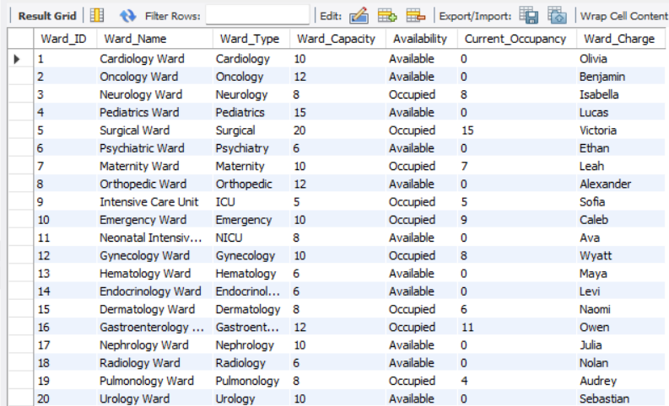

1. **ELECTRONIC HEALTH RECORD**

INSERT INTO EHR (EHR_ID, Patient_ID, Doctor_ID, Medical_History, Diagnosis, Lab_Test_Results)

VALUES

(101, 1,3, 'diabetes and high blood pressure', 'Type 2 diabetes and hypertension', 'Blood glucose level: 130 mg/dL'),

(102, 14, 7, 'asthma and allergies', 'Asthma and allergic rhinitis', 'Spirometry test: mild obstruction'),

(103, 7, 15,'heart disease and high cholesterol', 'Coronary artery disease and hypercholesterolemia', 'Cholesterol level: 240 mg/dL'),

(104, 6,20, 'depression and anxiety', 'Major depressive disorder and generalized anxiety disorder', 'PHQ-9 score: 16'),

(105, 8, 16,'migraines and seizures', 'Migraine headaches and epilepsy', 'EEG: focal slowing'),

(106, 15, 10,'back pain and arthritis', 'Chronic low back pain and osteoarthritis', 'MRI: degenerative changes'),

(107, 9, 17, 'gastrointestinal problems', 'Irritable bowel syndrome', 'Stool sample: negative for parasites'),

(108, 2,11, 'thyroid disorder and anemia', 'Hypothyroidism and iron-deficiency anemia', 'TSH level: 6.5 uIU/mL'),

(109, 11,10, 'sleep apnea and obesity', 'Obstructive sleep apnea and obesity', 'BMI: 35'),

(110, 19, 14,'skin problems and allergies', 'Atopic dermatitis and allergies', 'Patch test: positive for nickel allergy'),

(111, 16, 18,'kidney disease and hypertension', 'Chronic kidney disease and hypertension', 'Serum creatinine level: 2.0 mg/dL'),

(112, 12, 20, 'bipolar disorder and alcoholism', 'Bipolar disorder and alcohol use disorder', 'AUDIT-C score: 8'),

(113, 16, 1, 'multiple sclerosis and neuropathy', 'Multiple sclerosis and peripheral neuropathy', 'EMG: demyelinating neuropathy'),

(114, 13, 2,'asthma and COPD', 'Asthma and chronic obstructive pulmonary disease', 'Pulmonary function test: FEV1/FVC ratio <70%'),

(115, 15, 5,'osteoporosis and fractures', 'Osteoporosis and fragility fractures', 'DEXA scan: T-score -2.5 at hip'),

(116, 20, 7,'Crohn disease and ulcerative colitis', 'Inflammatory bowel disease', 'Colonoscopy: active inflammation'),

(117, 17, 19, 'hyperthyroidism and anxiety', 'Graves disease and generalized anxiety disorder', 'TSH level: <0.01 uIU/mL'),

(118, 18, 6,'No significant medical events in recent past', 'Diagnosed with acute bronchitis','inconclusive'),

(119, 3, 8, 'high blood pressure and high cholesterol', 'Diagnosed with hypertension', 'indicate high cholesterol.'),

(120, 4, 9, 'anxiety and depression', 'Diagnosed with major depressive disorder', 'No lab tests ordered.');

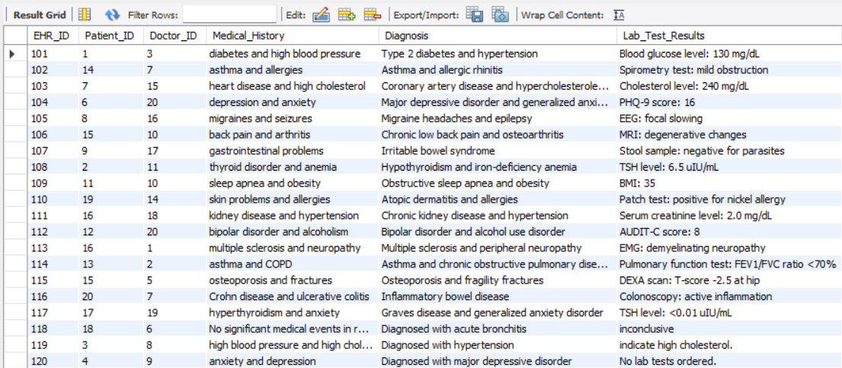

1. **DEPARTMENT**

INSERT INTO department (Department_ID, Department_Name, Head_of_Department, Department_Staff, Department_Function)

VALUES

(1, 'Cardiology', 'Dr. John Smith', 10, 'Diagnosis and treatment of heart diseases'),

(2, 'Neurology', 'Dr. Sarah Lee', 12, 'Diagnosis and treatment of nervous system disorders'),

(3, 'Oncology', 'Dr. Michael Johnson', 8, 'Diagnosis and treatment of cancer'),

(4, 'Dermatology', 'Dr. Emily Davis', 6, 'Diagnosis and treatment of skin conditions'),

(5, 'Orthopedics', 'Dr. James Brown', 9, 'Diagnosis and treatment of musculoskeletal disorders'),

(6, 'Gynecology', 'Dr. Ashley Garcia', 11, 'Diagnosis and treatment of women\'s reproductive health issues'),

(7, 'Pediatrics', 'Dr. Daniel Chen', 15, 'Diagnosis and treatment of children\'s health issues'),

(8, 'Psychiatry', 'Dr. Olivia Nguyen', 7, 'Diagnosis and treatment of mental health disorders'),

(9, 'Endocrinology', 'Dr. Mason Singh', 5, 'Diagnosis and treatment of endocrine system disorders'),

(10, 'Gastroenterology', 'Dr. Sophia Lee', 8, 'Diagnosis and treatment of digestive system disorders'),

(11, 'Pulmonology', 'Dr. William Liu', 6, 'Diagnosis and treatment of respiratory system disorders'),

(12, 'Rheumatology', 'Dr. Ava Patel', 4, 'Diagnosis and treatment of rheumatic diseases'),

(13, 'Ophthalmology', 'Dr. Jacob Kim', 7, 'Diagnosis and treatment of eye disorders'),

(14, 'Urology', 'Dr. Grace Gonzalez', 5, 'Diagnosis and treatment of urinary system disorders'),

(15, 'Hematology', 'Dr. Ethan Smith', 6, 'Diagnosis and treatment of blood disorders'),

(16, 'Infectious Diseases', 'Dr. Isabella Garcia', 8, 'Diagnosis and treatment of infectious diseases'),

(17, 'Nephrology', 'Dr. Elijah Wilson', 5, 'Diagnosis and treatment of kidney disorders'),

(18, 'Allergy and Immunology', 'Dr. Victoria Kim', 4, 'Diagnosis and treatment of allergies and immune system disorders'),

(19, 'Emergency Medicine', 'Dr. Ethan Chen', 10, 'Diagnosis and treatment of acute and urgent medical conditions'),

(20, 'Physical Therapy', 'Dr. Madison Davis', 7, 'Rehabilitation and recovery of physical function');

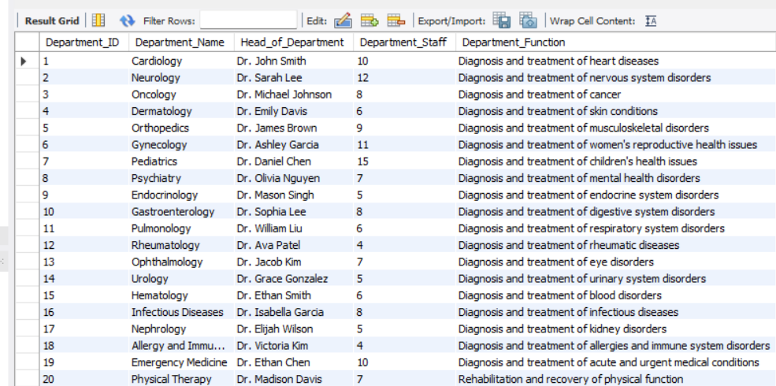

1. **STAFF**

INSERT INTO staff (Staff_ID, First_Name, Last_Name, Gender, Address, Job_Title, Department, Schedule)

VALUES

(1, 'Sarah', 'Johnson', 'Female', '123 Main St', 'Registered Nurse', 'Cardiology', 'Monday-Friday 9AM-5PM'),

(2, 'Daniel', 'Chen', 'Male', '456 Elm St', 'Cardiologist', 'Cardiology', 'Monday-Friday 8AM-4PM'),

(3, 'Emily', 'Wong', 'Female', '789 Oak Ave', 'Surgeon', 'Surgery', 'Tuesday-Saturday 10AM-6PM'),

(4, 'David', 'Lee', 'Male', '321 Maple Ln', 'Licensed Practical Nurse', 'Pediatrics', 'Monday-Friday 8AM-4PM'),

(5, 'Olivia', 'Nguyen', 'Female', '555 Pine St', 'Pediatrician', 'Pediatrics', 'Monday-Friday 9AM-5PM'),

(6, 'Grace', 'Gonzalez', 'Female', '888 Cherry Ave', 'Registered Nurse', 'Emergency Medicine', 'Saturday-Wednesday 11AM-7PM'),

(7, 'Ava', 'Patel', 'Female', '444 Oak St', 'Family Practitioner', 'Family Medicine', 'Monday-Friday 9AM-5PM'),

(8, 'William', 'Liu', 'Male', '777 Willow Ave', 'Neurologist', 'Neurology', 'Monday-Friday 8AM-4PM'),

(9, 'Sophia', 'Lee', 'Female', '222 Cedar St', 'Licensed Practical Nurse', 'Oncology', 'Thursday-Monday 12PM-8PM'),

(10, 'Mason', 'Singh', 'Male', '999 Pine Ave', 'Oncologist', 'Oncology', 'Monday-Friday 9AM-5PM'),

(11, 'Emma', 'Garcia', 'Female', '666 Elm St', 'Registered Nurse', 'Intensive Care Unit', 'Wednesday-Sunday 10AM-6PM'),

(12, 'James', 'Smith', 'Male', '333 Maple Ave', 'Intensivist', 'Intensive Care Unit', 'Monday-Friday 8AM-4PM'),

(13, 'Isabella', 'Brown', 'Female', '111 Oak Ln', 'Endocrinologist', 'Endocrinology', 'Tuesday-Saturday 9AM-5PM'),

(14, 'Noah', 'Taylor', 'Male', '222 Pine St', 'Licensed Practical Nurse', 'Psychiatry', 'Monday-Friday 8AM-4PM'),

(15, 'Sophie', 'Clark', 'Female', '333 Cherry Ave', 'Psychiatrist', 'Psychiatry', 'Monday-Friday 9AM-5PM'),

(16, 'Eva', 'Kim', 'Female', '888 Willow Ln', 'Registered Nurse', 'Nursing', 'Saturday-Wednesday 11AM-7PM'),

(17, 'Connor', 'Gonzalez', 'Male', '444 Pine St', 'Emergency Physician', 'Emergency', 'Wednesday-Sunday 10AM-6PM'),

(18, 'Leah', 'Chen', 'Female', '111 Willow Ave', 'Pediatrician', 'Pediatrics', 'Wednesday-Sunday 10AM-6PM'),

(19, 'Lucas', 'Patel', 'Male', '999 Cedar Ln', 'Surgeon', 'Surgery', 'Thursday-Monday 12PM-8PM'),

(20, 'Bella', 'Singh', 'Female', '777 Cherry St', 'Radiologist', 'Radiology', 'Tuesday-Saturday 9AM-5PM');

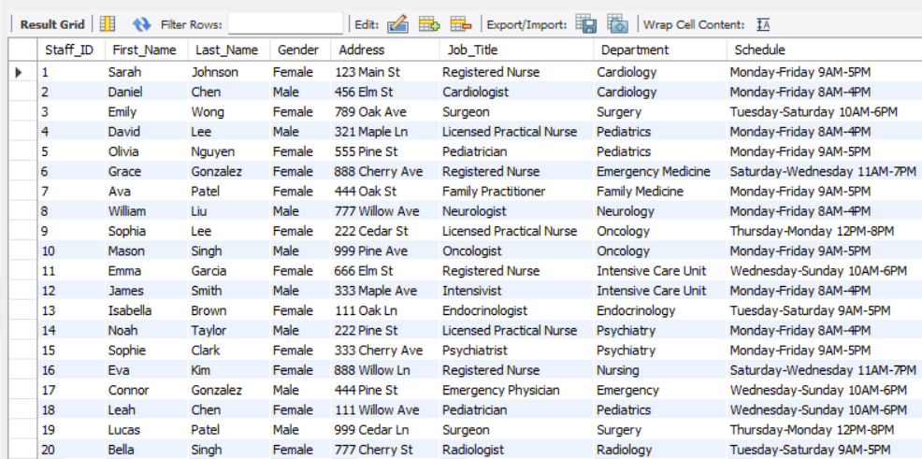

1. **BILLING AND INSURANCE**

INSERT INTO billing_insurance (Bill_ID, Patient_ID, Date, Amount_Due, Insurance_Provider, Insurance_Policy_Number, Claim_Status)

VALUES

(1, 11, '2023-05-01', 2000, 'ABC Insurance', '123456', 'Pending'),

(2, 20, '2023-05-02', 1500, 'XYZ Insurance', '789012', 'Approved'),

(3, 13, '2023-05-03', 1000, 'PQR Insurance', '345678', 'Rejected'),

(4, 19, '2023-05-04', 2500, 'LMN Insurance', '901234', 'Pending'),

(5, 15, '2023-05-05', 3000, 'ABC Insurance', '567890', 'Approved'),

(6, 7, '2023-05-06', 1800, 'XYZ Insurance', '123789', 'Rejected'),

(7, 16, '2023-05-07', 2200, 'PQR Insurance', '456789', 'Pending'),

(8, 18, '2023-05-08', 2800, 'LMN Insurance', '012345', 'Approved'),

(9, 19, '2023-05-09', 1200, 'ABC Insurance', '890123', 'Rejected'),

(10, 5, '2023-05-10', 1900, 'XYZ Insurance', '234567', 'Pending'),

(11, 1, '2023-05-11', 3500, 'PQR Insurance', '890123', 'Approved'),

(12, 2, '2023-05-12', 1400, 'LMN Insurance', '456789', 'Rejected'),

(13, 3, '2023-05-13', 1700, 'ABC Insurance', '012345', 'Pending'),

(14, 4, '2023-05-14', 2600, 'XYZ Insurance', '678901', 'Approved'),

(15, 6, '2023-05-15', 3200, 'PQR Insurance', '234567', 'Rejected'),

(16, 7, '2023-05-16', 2300, 'LMN Insurance', '890123', 'Pending'),

(17, 8, '2023-05-17', 2900, 'ABC Insurance', '456789', 'Approved'),

(18, 9, '2023-05-18', 2100, 'XYZ Insurance', '012345', 'Rejected'),

(19, 10, '2023-05-19', 1700, 'PQR Insurance', '678901', 'Pending'),

(20, 12, '2023-05-20', 1500, 'LMN Insurance', '234567', 'Approved');

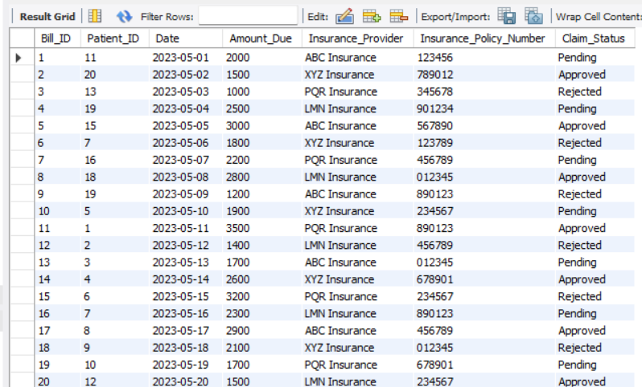

1. **PHARMACY AND INVENTORY**

INSERT INTO pharmacy_inventory (Medicine_ID, Medicine_Name, Manufacturer, Expiry_Date, Price, Quantity)

VALUES

(1, 'Aspirin', 'Bayer', '2024-06-01', 10.99, 50),

(2, 'Ibuprofen', 'Advil', '2023-09-01', 8.99, 70),

(3, 'Acetaminophen', 'Tylenol', '2024-12-01', 12.99, 30),

(4, 'Loratadine', 'Claritin', '2023-11-01', 14.99, 20),

(5, 'Diphenhydramine', 'Benadryl', '2023-08-01', 9.99, 40),

(6, 'Naproxen', 'Aleve', '2022-10-01', 11.99, 60),

(7, 'Cetirizine', 'Zyrtec', '2023-05-01', 15.99, 25),

(8, 'Lansoprazole', 'Prevacid', '2025-03-01', 19.99, 15),

(9, 'Omeprazole', 'Prilosec', '2024-07-01', 17.99, 35),

(10, 'Simvastatin', 'Zocor', '2024-09-01', 22.99, 10),

(11, 'Atorvastatin', 'Lipitor', '2023-12-01', 24.99, 5),

(12, 'Rosuvastatin', 'Crestor', '2022-08-01', 27.99, 8),

(13, 'Metformin', 'Glucophage', '2025-02-01', 7.99, 45),

(14, 'Lisinopril', 'Zestril', '2023-10-01', 5.99, 60),

(15, 'Losartan', 'Cozaar', '2024-01-01', 8.99, 30),

(16, 'Amlodipine', 'Norvasc', '2024-02-01', 6.99, 40),

(17, 'Metoprolol', 'Lopressor', '2022-11-01', 11.99, 20),

(18, 'Warfarin', 'Coumadin', '2023-06-01', 9.99, 50),

(19, 'Clopidogrel', 'Plavix', '2022-12-01', 18.99, 15),

(20, 'Ranitidine', 'Zantac', '2023-03-01', 7.99, 25);

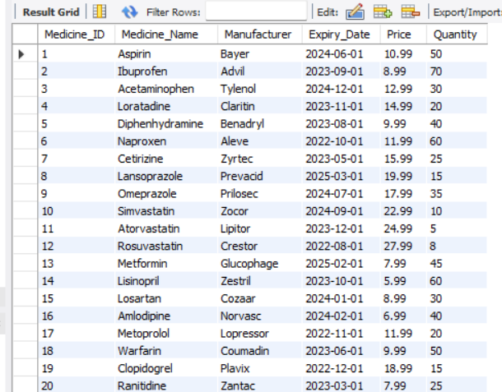

1. **SURGERY**

INSERT INTO surgery (Surgery_ID, Surgery_Type, Doctor_ID, Patient_ID, Surgery_Cost, Surgery_Date)

VALUES

(1, 'Appendectomy', 1, 20, 5000, '2023-05-05'),

(2, 'Knee Replacement', 2, 12, 10000, '2023-05-06'),

(3, 'Gallbladder Removal', 13, 3, 7000, '2023-05-07'),

(4, 'Cataract Surgery', 14, 2, 8000, '2023-05-08'),

(5, 'Hip Replacement', 5, 16, 12000, '2023-05-09'),

(6, 'Breast Biopsy', 16, 6, 4000, '2023-05-10'),

(7, 'Hysterectomy', 7, 17, 9000, '2023-05-11'),

(8, 'Colonoscopy', 18, 8, 3000, '2023-05-12'),

(9, 'Laminectomy', 19, 9, 11000, '2023-05-13'),

(10, 'Tonsillectomy', 10, 11, 6000, '2023-05-14'),

(11, 'Hernia Repair', 12, 1, 8000, '2023-05-15'),

(12, 'Coronary Angioplasty', 20, 14, 15000, '2023-05-16'),

(13, 'Prostatectomy', 13, 18, 10000, '2023-05-17'),

(14, 'Spinal Fusion', 15, 19, 12000, '2023-05-18'),

(15, 'Arthroscopy', 20, 15, 5000, '2023-05-19'),

(16, 'Mastectomy', 16, 4, 8000, '2023-05-20'),

(17, 'Tubal Ligation', 17, 5, 7000, '2023-05-21'),

(18, 'Gastric Bypass', 8, 7, 13000, '2023-05-22'),

(19, 'Laser Eye Surgery', 19, 17, 9000, '2023-05-23'),

(20, 'Liposuction', 12, 4, 10000, '2023-05-24');

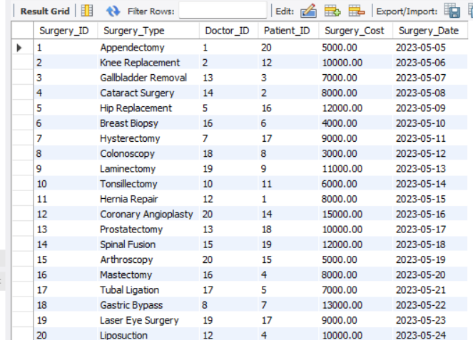

**Future Scope**

There are several potential future scopes for a hospital management system. Some possible ideas include:

* In future a GUI based application can be developed that connects the hospitals with the Customers.
* Incorporating artificial intelligence (AI) and machine learning (ML) algorithms to optimize patient care, such as predicting patient outcomes and recommending treatment plans.
* Integration with wearable health devices and mobile apps, allowing patients to easily access and share their health data with healthcare providers.
* Utilizing blockchain technology to securely store and share patient health records between healthcare providers, patients, and insurance companies.
* Adding telemedicine functionality, allowing patients to remotely consult with healthcare providers and receive virtual care.
* Developing a mobile app for patients to schedule appointments, view lab results, and communicate with healthcare providers.
* Implementing a patient feedback system to improve the overall patient experience and quality of care.
* Creating a patient portal for patients to access their health information and medical records, including test results and discharge instructions.

These are just a few potential ideas for future development of a hospital management system. The possibilities are endless, and the key is to continuously innovate and improve upon existing systems to provide the best possible care for patients.

**Conclusion**

In conclusion, the hospital management system is a comprehensive and efficient solution for managing various aspects of hospital operations, such as patient records, staff management, billing, pharmacy inventory, and surgical procedures.

By utilizing modern technology and database management techniques, this system offers several advantages such as improved accuracy, faster data processing, and better decision-making capabilities.

It also helps in reducing human errors, minimizing paperwork, and enhancing the overall efficiency of hospital operations.

Overall, the hospital management system can greatly benefit healthcare organizations by streamlining their operations and improving patient care.

**References**

1. <https://www.researchgate.net/publication/367460409_The_Hospital_Management_System>
2. <https://www.ijream.org/papers/INJRV01I11006.pdf>
3. <https://www.slideshare.net/nkniteen/hospital-management-system-project-report-184668959>
4. <https://www.academia.edu/36406675/Hospital_Management_System_Project_report>
5. <https://www.scribd.com/doc/49588162/Hospital-Management-System-abstract>
6. <https://www.ijcsmc.com/docs/papers/April2016/V5I4201602.pdf>
7. <https://www.slideshare.net/AbdulQadir441/hospital-database-management-system-project-report>
8. <https://m.mu.edu.sa/sites/default/files/content/2018/11/MAJD.pdf>
9. <https://www.angelfire.com/ny4/yjin/Healthcare/Healthcare-doc.pdf>
10. <https://www.cronj.com/blog/what-is-hospital-management-system-features-modules-uses-blog/>
11. <https://dspace.bracu.ac.bd/xmlui/bitstream/handle/10361/9038/07310069_CSE.pdf?sequence=1&isAllowed=y>
12. <https://itsourcecode.com/fyp/hospital-management-system-project-report-documentations-pdf/>
13. <https://sites.google.com/site/ignoubcafinalyearprojects/project-report/hospital-management-system-project-report>