# Homework 2

Your Name: _______________________

Student ID:________________________

**1. Normalization [20 points]**

The table shown below displays the details of the roles played by actors/actresses in films.

|  |  |  |  |  |  |  |  |
| --- | --- | --- | --- | --- | --- | --- | --- |
| **filmNo** | **fTitle** | **dirNo** | **director** | **actorNo** | **aName** | **role** | **timeOnScreen** |
| F1100 | Happy Days | D101 | Jim Alan | A1020 | Sheila Toner | Jean Simson | 15.45 |
|  |  | D101 | Jim Alan | A1222 | Peter Watt | Tom Kinder | 25.38 |
|  |  | D101 | Jim Alan | A1020 | Sheila Toner | Silvia Simpson | 22.56 |
| F1109 | Snake Bite | D076 | Sue Ramsay | A1567 | Steven McDonald | Tim Rosey | 19.56 |
|  |  | D076 | Sue Ramsay | A1222 | Peter Watt | Archie Bold | 10.44 |

(a) [5 points] Describe why the table shown below is not in first normal form and second normal form.

(b) [15 points] Re-design the tables to make them meet BCNF; you do not need to draw ERD, but you need to show the final design by drawing data tables in Word document, and explain why it meets BCNF. Just List the tables, attributes and keys. Use * to indicate Primary Key, use # to indicate foreign key.

Example: Student (StudentID *, Name, DeptID #)

**2. Identify issues in DB design [25 points]**

Assume that the primary key of this relation in the data below consists of two components: Author’s ID (AID) and book number (BNbr). The relation includes data regarding authors, books and publishers. In addition, it tells what an individual author’s per book royalty amount is in the case of multi-authored books

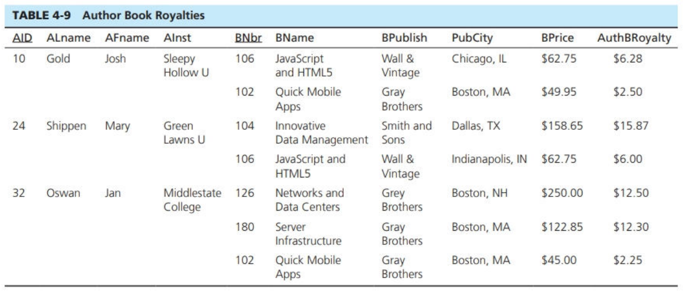

1). Identify the normal forms in the DB design above, and explain why [10 points]

3). Take actions (if necessary) to covert the relations into the 3rd normal form. Show your steps how did you fix the issues [15 points]

**3. Database Design [55 points]**

**Complete conceptual and logical DB design, and show your answers step by step**

**Note: do not need to draw ERD, just show tables, attributes, and keys**

**Example: Student (StudentID *, Name, DeptID #)**

Descriptions:

IIT wants to build a DB to collect faculties’ publications.

* Faculties may be from different departments
* A publication should have title, publication date, and publication venue (such as a conference or a journal). There are only two publication types: conference publications or Journal publications. A publication may have more than one authors
* A full-time faculty is expected to have at least 2 publications per year

1). Complete conceptual DB design, by listing entities and indicating their relationships [15]

2). Complete logical DB design by assigning attributes and PK/FK, use normalization to make sure your design meets at least 3NF [40]