SHILPA M
1NT20IS408
BIG DATA LAB

CREATING DB

> use Shipla-1NT20IS412
switched to db Shipla-1NT20IS412

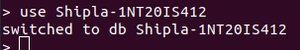

INSERT ONE COMMAND:

db.Shilpa.insertOne({name:"Shilpa",USN:"1NT20IS412",dept:"ISE"})
{
"acknowledged" : true,
"insertedId" : ObjectId("6291cc589d5b23e703e4c127")
}

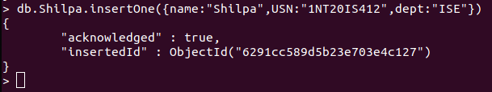

INSERT MANY COMMANDS:

> db.Shilpa.insertMany([{name:"Sushma",USN:"1NT20IS410",dept:"ISE"},
... {name:"Chandini",USN:"1NT20CS403",dept:"ISE"},
... {name:"Yashodha",USN:"1NT20CS416",dept:"ISE"}])
{
"acknowledged" : true,
"insertedIds" : [
ObjectId("6291cd559d5b23e703e4c128"),
ObjectId("6291cd559d5b23e703e4c129"),
ObjectId("6291cd559d5b23e703e4c12a")
]
}

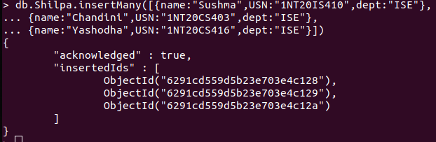

OUTPUT OF INSERTING COMMAND:

> db.Shilpa.find()
{ "_id" : ObjectId("6291cc589d5b23e703e4c127"), "name" : "Shilpa", "USN" : "1NT20IS412", "dept" : "ISE" }
{ "_id" : ObjectId("6291cd559d5b23e703e4c128"), "name" : "Sushma", "USN" : "1NT20IS410", "dept" : "ISE" }
{ "_id" : ObjectId("6291cd559d5b23e703e4c129"), "name" : "Chandini", "USN" : "1NT20CS403", "dept" : "ISE" }
{ "_id" : ObjectId("6291cd559d5b23e703e4c12a"), "name" : "Yashodha", "USN" : "1NT20CS416", "dept" : "ISE" }
>

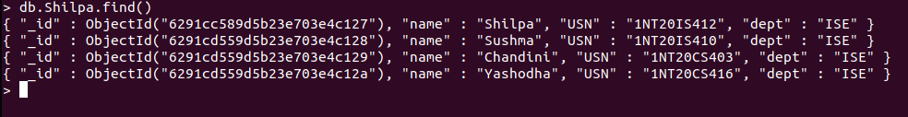

OUTPUT USING PRETTY COMMAND:

> db.Shilpa.find().pretty();
{
"_id" : ObjectId("6291cc589d5b23e703e4c127"),
"name" : "Shilpa",
"USN" : "1NT20IS412",
"dept" : "ISE"
}
{
"_id" : ObjectId("6291cd559d5b23e703e4c128"),
"name" : "Sushma",
"USN" : "1NT20IS410",
"dept" : "ISE"
}
{
"_id" : ObjectId("6291cd559d5b23e703e4c129"),
"name" : "Chandini",
"USN" : "1NT20CS403",
"dept" : "ISE"
}
{
"_id" : ObjectId("6291cd559d5b23e703e4c12a"),
"name" : "Yashodha",
"USN" : "1NT20CS416",
"dept" : "ISE"
}

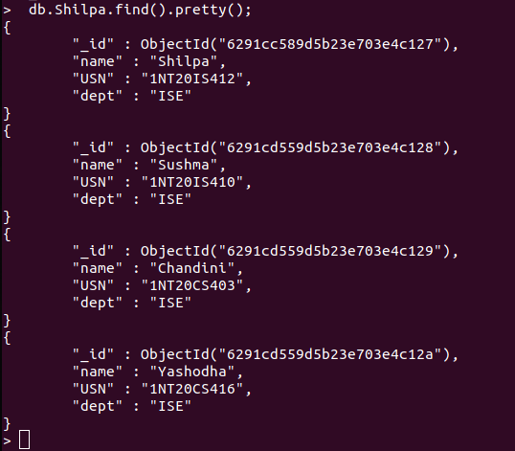

UPDATE ONE AND UPDATE MANY COMMAND:

db.Shilpa.updateOne({name:"Shilpa"},{$set:{name:"Puneeth"}})
{ "acknowledged" : true, "matchedCount" : 1, "modifiedCount" : 1 }

OUTPUT OF UPDATEONE

db.Shilpa.find();
{ "_id" : ObjectId("6291cc589d5b23e703e4c127"), "name" : "Puneeth", "USN" : "1NT20IS412", "dept" : "ISE" }
{ "_id" : ObjectId("6291cd559d5b23e703e4c128"), "name" : "Sushma", "USN" : "1NT20IS410", "dept" : "ISE" }
{ "_id" : ObjectId("6291cd559d5b23e703e4c129"), "name" : "Chandini", "USN" : "1NT20CS403", "dept" : "ISE" }
{ "_id" : ObjectId("6291cd559d5b23e703e4c12a"), "name" : "Yashodha", "USN" : "1NT20CS416", "dept" : "ISE" }

DELETE COMMAND:

db.Shilpa.deleteMany({name:"Puneeth"})
{ "acknowledged" : true, "deletedCount" : 1 }

OUTPUT OF DELETE COMMAND:

db.Shilpa.find();
{ "_id" : ObjectId("6291cd559d5b23e703e4c128"), "name" : "Sushma", "USN" : "1NT20IS410", "dept" : "ISE" }
{ "_id" : ObjectId("6291cd559d5b23e703e4c129"), "name" : "Chandini", "USN" : "1NT20CS403", "dept" : "ISE" }
{ "_id" : ObjectId("6291cd559d5b23e703e4c12a"), "name" : "Yashodha", "USN" : "1NT20CS416", "dept" : "ISE" }

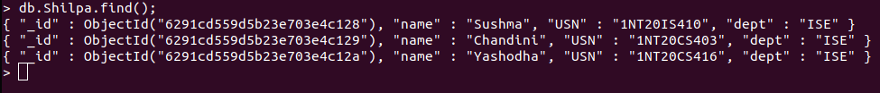

AGGREGATE COMANDS:

db.Shilpa.insertMany([{_id:0,name:"Pepperoni",size:"small",price:15,quantity:10,date:ISODate("2021-03-13T08:14:30Z")},
... {_id:1,name:"Pepperoni",size:"medium",price:20,quantity:20,date:ISODate("2021-03-13T09:13:24Z")},
... {_id:2,name:"Pepperoni",size:"large",price:21,quantity:30,date:ISODate("2021-03-17T09:22:12Z")},
... {_id:3,name:"Cheese",size:"small",price:12,quantity:15,date:ISODate("2021-03-13T11:21:39.736Z")},
... {_id:4,name:"Cheese",size:"medium",price:13,quantity:50,date:ISODate("2022-01-12T21:23:13.331Z")},
... {_id:5,name:"Cheese",size:"large",price:14,quantity:10,date:ISODate("2022-01-12T05:08:13Z")}])
{ "acknowledged" : true, "insertedIds" : [ 0, 1, 2, 3, 4, 5 ] }
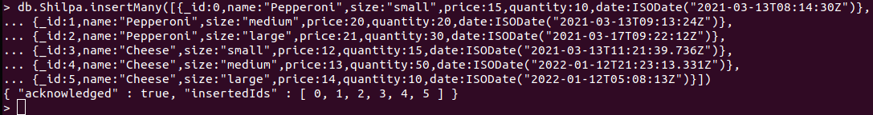

OUTPUT OF AGGREGARE:

db.Shilpa.aggregate([{$match:{size:"large"}},{$group:{_id:"$name",totalQuantity:{$sum:"$quantity"}}}])
{ "_id" : "Pepperoni", "totalQuantity" : 30 }
{ "_id" : "Cheese", "totalQuantity" : 10 }
>

