**SQL Exercise 2**

1. Display the Supplier table in the descending order of CITY.

🡪

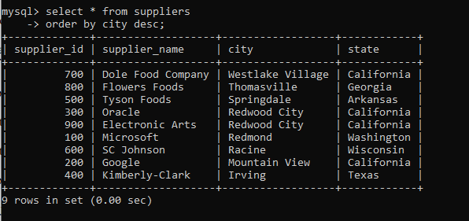

1. Display the Part Table in the ascending order of CITY and within the city in the ascending order of Part names.

🡪

1. Display all the Suppliers with a status between 10 and 20.

🡪

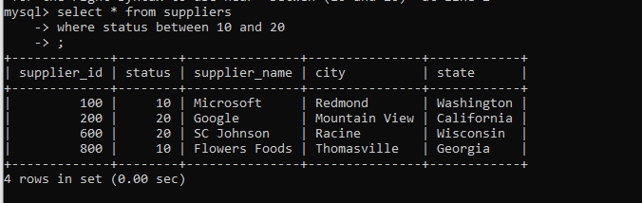

1. Display all the Parts and their Weight, which are not in the range of 10 and 15.

🡪

1. Display all the Part names starting with the letter ‘S’.

🡪

1. Display all the Suppliers, belonging to cities starting with the letter ‘L’.

🡪

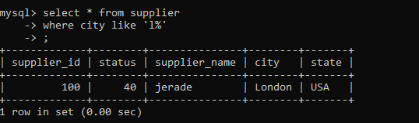

1. Display all the Projects, with the third letter in JNAME as ‘n’.

🡪