**SQL Exercise 4**

1. Display the minimum Status in the Supplier table.

🡪

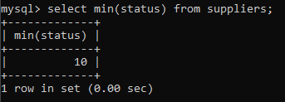

1. Display the maximum Weight in the Parts table.

🡪

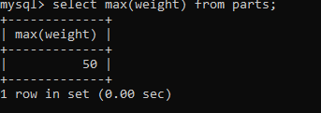

1. Display the average Weight of the Parts.

🡪

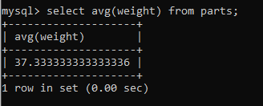

1. Display the total Quantity sold for part ‘P1’.

🡪

1. Display the total Quantity sold for each part.

🡪

1. Display the average Quantity sold for each part.

🡪

1. Display the maximum Quantity sold for each part, provided the maximum Quantity is greater than 800.

🡪

1. Display the Status and the count of Suppliers with that Status.

🡪

1. Display the count of Projects going on in different cities.

🡪

1. What is the difference between COUNT(Status) and COUNT(*) ?

🡪

1. Display the Status and the Count of Suppliers with that Status in the following format as shown below:-

**Status Count**

Ten 1

Twenty 2

Thirty 3

🡪