################################# Forecasting ############################

**#Objective: Forecast the CocaCola prices data set. Prepare a document for each model #explaining how many dummy variables you have created and RMSE value for each model. #Finally which model you will use for Forecasting.**

**#Data : CocaCola_Sales_Rawdata.csv**

###########################################################################

library(forecast)

install.packages("fpp")

library(fpp)

install.packages("smooth")

library(smooth) # forsmoothing and MAPE

install.packages("tseries")

library(tseries)

library(readxl)

CocaCola_Sales_Rawdata <- read_excel("D:\\Shilpa\\Datascience\\Assignments\\Forecasting\\CocaCola_Sales_Rawdata.xlsx")

View(CocaCola_Sales_Rawdata)

# Converting data into time series object

?ts

tssales<-ts(CocaCola_Sales_Rawdata$Sales,frequency = 4)

View(tssales)

# dividing entire data into training and testing data

train<-tssales[1:38]

train

test<-tssales[39:42] # Considering only 4 Quarters of data for testing because data itself is Quarterly

# seasonal data

# converting time series object

train<-ts(train,frequency = 4)

train

test<-ts(test,frequency = 4)

test

# Plotting time series data

plot(tssales)

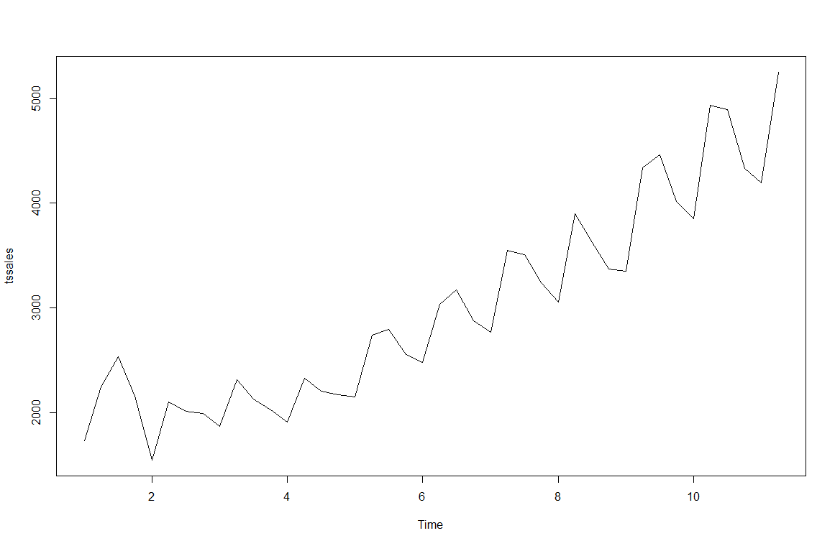

# Visualization shows that it has level, trend, seasonality => Additive seasonality

###################**USING HoltWinters function**#############################

**# Optimum values**

**# with alpha = 0.2 which is default value**

**# Assuming time series data has only level parameter**

hw_a<-HoltWinters(train,alpha = 0.2,beta = F,gamma = F)

hw_a

#Holt-Winters exponential smoothing without trend and without seasonal component.

#Call:

# HoltWinters(x = train, alpha = 0.2, beta = F, gamma = F)

#Smoothing parameters:

# alpha: 0.2

# beta : FALSE

# gamma: FALSE

#Coefficients:

# [,1]

#a 4020.406

hwa_pred<-data.frame(predict(hw_a,n.ahead=4))

# By looking at the plot the forecasted values are not showing any characters of train data

plot(forecast(hw_a,h=4))

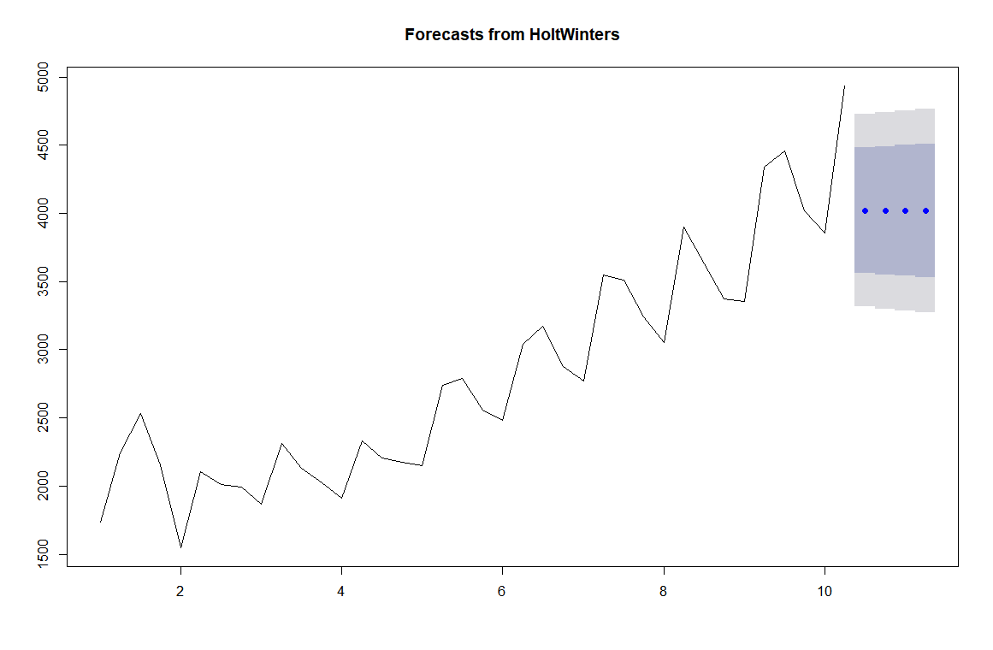

?forecast

hwa_mape<-MAPE(hwa_pred$fit,test)*100

hwa_mape #16.12634

#******************************************************************#

**# with alpha = 0.2, beta = 0.15**

**# Assuming time series data has level and trend parameter**

hw_ab<-HoltWinters(train,alpha = 0.2,beta = 0.15,gamma = F)

hw_ab

#Holt-Winters exponential smoothing with trend and without seasonal component.

#Call:

# HoltWinters(x = train, alpha = 0.2, beta = 0.15, gamma = F)

#Smoothing parameters:

# alpha: 0.2

#beta : 0.15

#gamma: FALSE

#Coefficients:

# [,1]

#a 4342.1529

#b 113.4152

hwab_pred<-data.frame(predict(hw_ab,n.ahead = 4))

# by looking at the plot the forecasted values are still missing some characters exhibited by train data

plot(forecast(hw_ab,h=4))

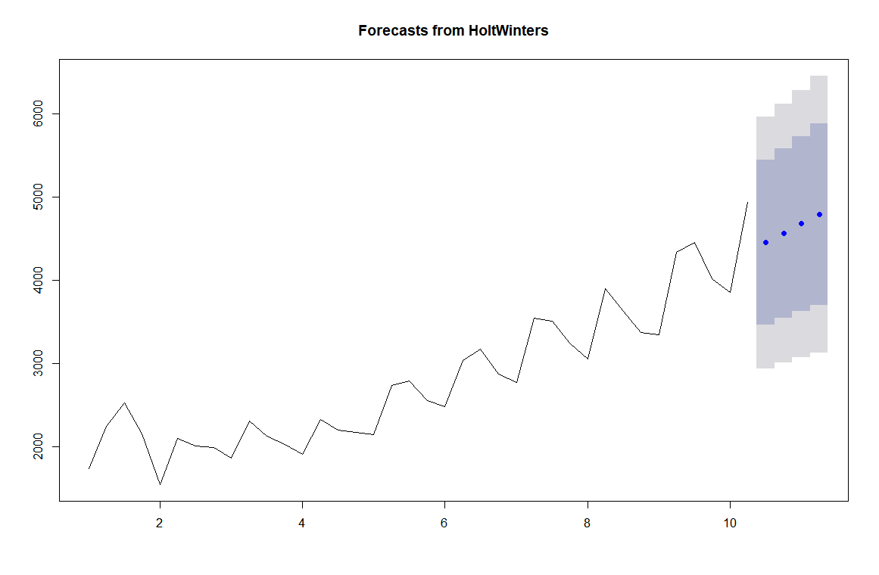

hwab_mape<-MAPE(hwab_pred$fit,test)*100

hwab_mape #[1] 8.747745

#**********************************************************************#

**# with alpha = 0.2, beta = 0.15, gamma = 0.05**

**# Assuming time series data has level,trend and seasonality**

hw_abg<-HoltWinters(train,alpha = 0.2,beta = 0.15,gamma = 0.05)

hw_abg

#Holt-Winters exponential smoothing with trend and additive seasonal component.

#Call:

# HoltWinters(x = train, alpha = 0.2, beta = 0.15, gamma = 0.05)

#Smoothing parameters:

# alpha: 0.2

#beta : 0.15

#gamma: 0.05

#Coefficients:

# [,1]

#a 4356.92555

#b 115.94078

#s1 350.06965

#s2 36.69702

#s3 -385.98882

#s4 248.32000

hwabg_pred<-data.frame(predict(hw_abg,n.ahead = 4))

# by looking at the plot the characters of forecasted values are closely following historical data

plot(forecast(hw_abg,h=4))

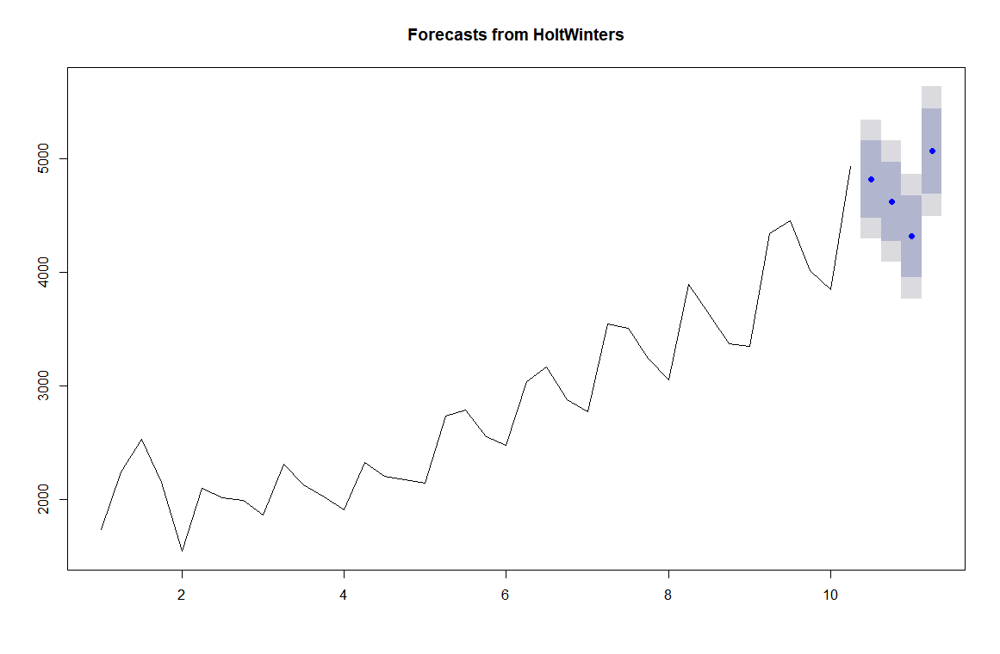

hwabg_mape<-MAPE(hwabg_pred$fit,test)*100

hwabg_mape #[1] 3.584105

###########################################################################

**# With out optimum values**

hw_na<-HoltWinters(train,beta = F,gamma = F)

hw_na

#Holt-Winters exponential smoothing without trend and without seasonal component.

#Call:

# HoltWinters(x = train, beta = F, gamma = F)

#Smoothing parameters:

# alpha: 0.502

#beta : FALSE

#gamma: FALSE

#Coefficients:

# [,1]

#a 4456.709

hwna_pred<-data.frame(predict(hw_na,n.ahead = 4))

hwna_pred

#fit

#1 4456.709

#2 4456.709

#3 4456.709

#4 4456.709

plot(forecast(hw_na,h=4))

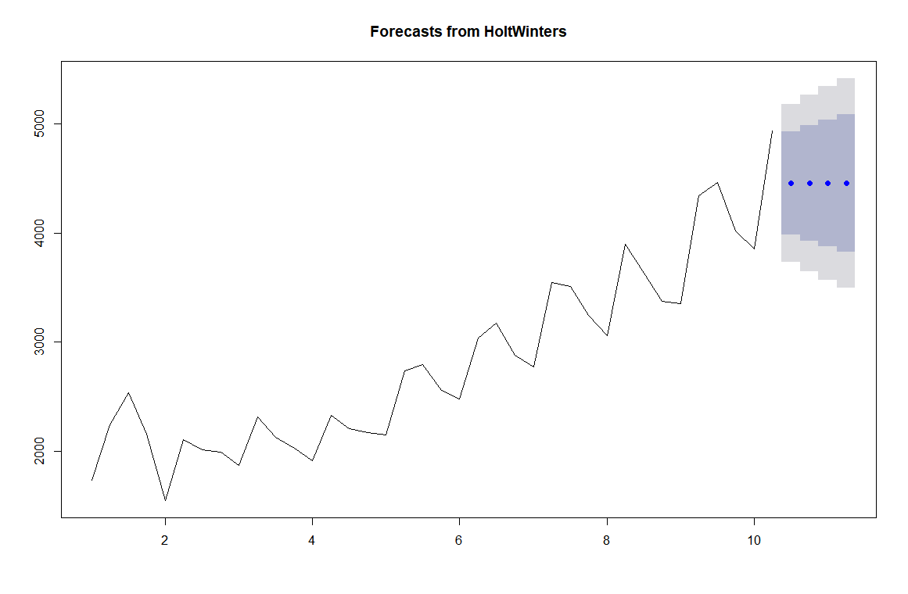

hwna_mape<-MAPE(hwna_pred$fit,test)*100

hwna_mape #9.093032

#************************************************************************#

hw_nab<-HoltWinters(train,gamma=F)

hw_nab

#Holt-Winters exponential smoothing with trend and without seasonal component.

#Call:

# HoltWinters(x = train, gamma = F)

#Smoothing parameters:

# alpha: 0.5747386

#beta : 0.3105725

#gamma: FALSE

#Coefficients:

# [,1]

#a 4581.1447

#b 182.7749

hwnab_pred<-data.frame(predict(hw_nab,n.ahead=4))

hwnab_pred

#fit

#1 4763.920

#2 4946.695

#3 5129.470

#4 5312.244

plot(forecast(hw_nab,h=4))

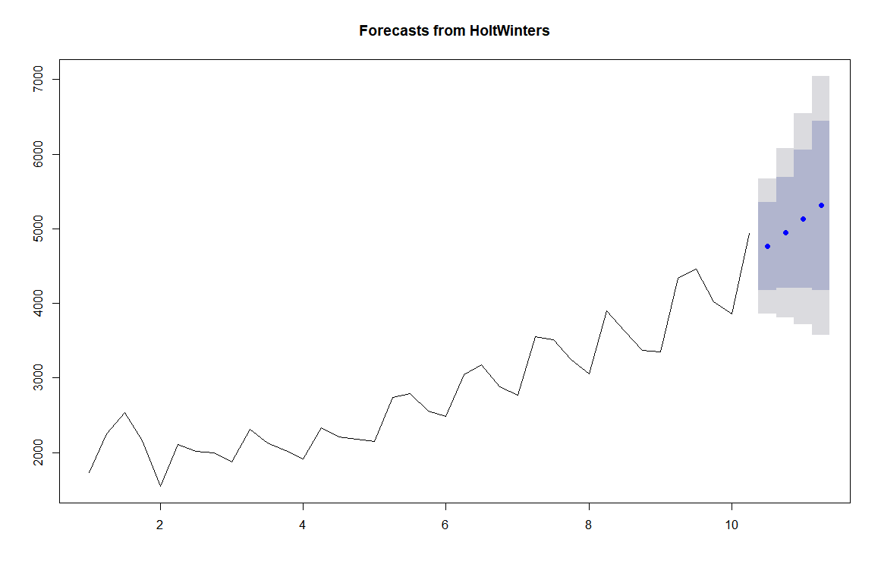

hwnab_mape<-MAPE(hwnab_pred$fit,test)*100

hwnab_mape # 8.62752

#******************************************************************#

hw_nabg<-HoltWinters(train)

hw_nabg

#Holt-Winters exponential smoothing with trend and additive seasonal component.

#Call:

# HoltWinters(x = train)

#Smoothing parameters:

# alpha: 0.3784328

#beta : 0.2526015

#gamma: 0.8897278

#Coefficients:

# [,1]

#a 4200.72210

#b 118.93562

#s1 556.79856

#s2 13.14018

#s3 -204.24618

#s4 732.44912

hwnabg_pred<-data.frame(predict(hw_nabg,n.ahead =4))

hwnabg_pred

#fit

#1 4876.456

#2 4451.734

#3 4353.283

#4 5408.914

plot(forecast(hw_nabg,h=4))

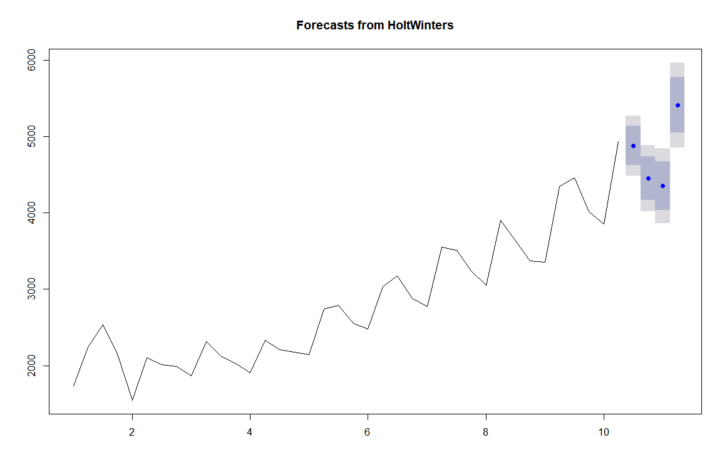

hwnabg_mape<-MAPE(hwnabg_pred$fit,test)*100

hwnabg_mape #2.397211

###########################################################################

df_mape<-data.frame(c("hwa_mape","hwab_mape","hwna_mape","hwnab_mape","hwnabg_mape"),c(hwa_mape,hwab_mape,hwna_mape,hwnab_mape,hwnabg_mape))

colnames(df_mape)<-c("MAPE","VALUES")

View(df_mape)

|  | **MAPE** | **VALUES** |
| --- | --- | --- |
|  |  |  |
| **1** | hwa_mape | 16.126335 |
| **2** | hwab_mape | 8.747745 |
| **3** | hwna_mape | 9.093032 |
| **4** | hwnab_mape | 8.627520 |
| **5** | hwnabg_mape | 2.397211 |

Showing 1 to 5 of 5 entries, 2 total columns

**# Based on the MAPE value we choose holts winter exponential technique which assumes the time series Data level, trend, seasonality characters with default values of alpha, beta and gamma**

new_model <- HoltWinters(tssales)

new_model

#Holt-Winters exponential smoothing with trend and additive seasonal component.

#Call:

# HoltWinters(x = tssales)

#Smoothing parameters:

# alpha: 0.3963858

#beta : 0.2321364

#gamma: 0.9921668

#Coefficients:

# [,1]

#a 4514.40200

#b 94.19669

#s1 606.55136

#s2 -30.22732

#s3 -240.73056

#s4 738.83022

plot(forecast(new_model,n.ahead=4))

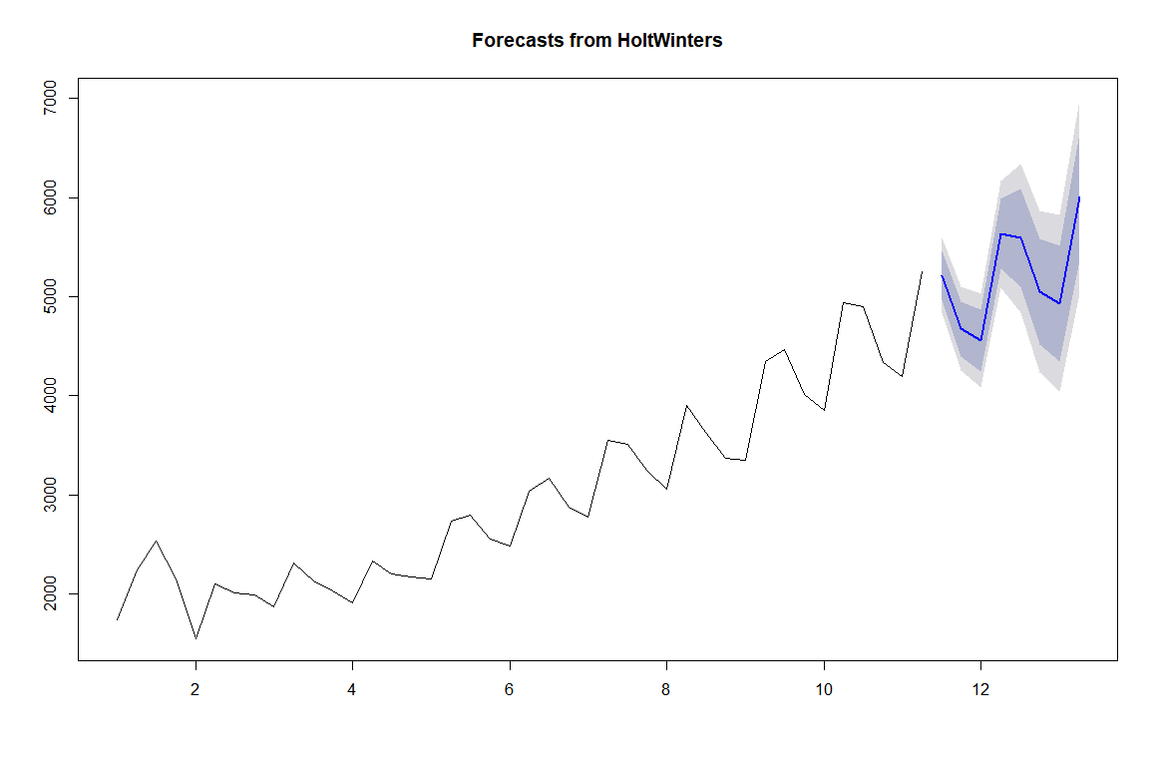

# Forecasted values for the next 4 quarters

forecast_new <- data.frame(predict(new_model,n.ahead=4))

forecast_new

#fit

#1 5215.150

#2 4672.568

#3 4556.262

#4 5630.019

########################################################################

############## **USING ses,holt,hw functions** ##########################

**# Optimum values**

**# with alpha = 0.2**

**# Simple Exponential smoothing**

ses_a<-ses(train,alpha = 0.2)

ses_a

#Point Forecast Lo 80 Hi 80 Lo 95 Hi 95

#10 Q3 4020.476 3420.807 4620.146 3103.361 4937.592

#10 Q4 4020.476 3408.931 4632.022 3085.198 4955.755

#11 Q1 4020.476 3397.281 4643.672 3067.382 4973.571

#11 Q2 4020.476 3385.845 4655.107 3049.892 4991.061

#11 Q3 4020.476 3374.612 4666.341 3032.712 5008.240

#11 Q4 4020.476 3363.571 4677.382 3015.826 5025.126

#12 Q1 4020.476 3352.712 4688.240 2999.219 5041.733

#12 Q2 4020.476 3342.027 4698.925 2982.878 5058.074

#12 Q3 4020.476 3331.508 4709.445 2966.790 5074.162

#12 Q4 4020.476 3321.147 4719.806 2950.945 5090.008

sesa_pred<-data.frame(predict(ses_a,h=4))

plot(forecast(ses_a,n.ahead=4))

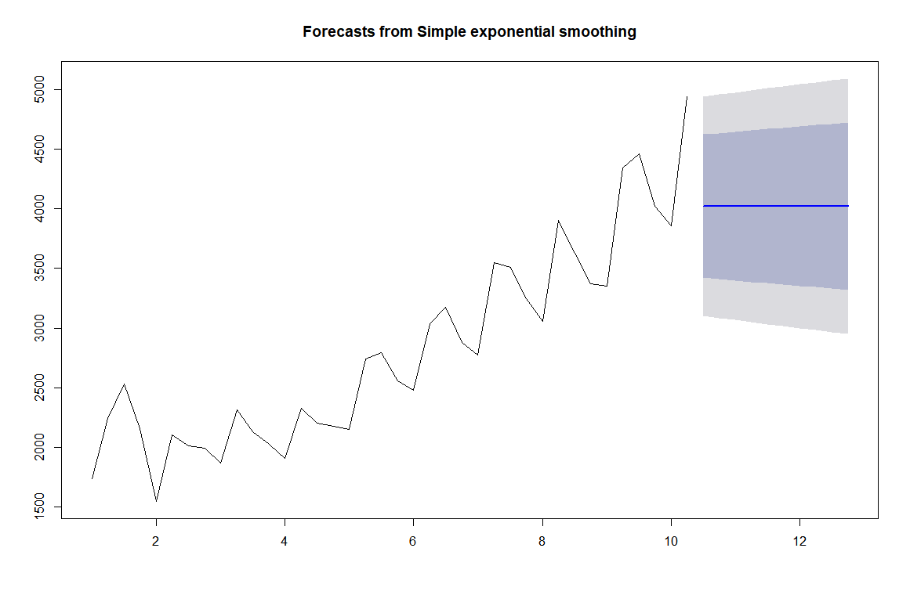

sesa_mape<-MAPE(sesa_pred$Point.Forecast,test)*100

sesa_mape # 16.1243

#**********************************************************************#

**# with alpha = 0.2, beta = 0.1**

holt_ab<-holt(train,alpha = 0.2,beta = 0.15)

holt_ab

#Point Forecast Lo 80 Hi 80 Lo 95 Hi 95

#10 Q3 4632.946 4166.028 5099.864 3918.856 5347.035

#10 Q4 4829.971 4335.280 5324.661 4073.406 5586.535

#11 Q1 5026.995 4479.983 5574.008 4190.413 5863.578

#11 Q2 5224.020 4598.455 5849.586 4267.300 6180.741

#11 Q3 5421.045 4692.443 6149.647 4306.745 6535.345

#11 Q4 5618.070 4765.065 6471.075 4313.512 6922.628

#12 Q1 5815.095 4819.398 6810.792 4292.308 7337.882

#12 Q2 6012.120 4857.972 7166.267 4247.003 7777.236

#12 Q3 6209.145 4882.736 7535.554 4180.577 8237.712

#12 Q4 6406.169 4895.164 7917.174 4095.287 8717.052

holtab_pred<-data.frame(predict(holt_ab,h=4))

plot(forecast(holt_ab,h=4))

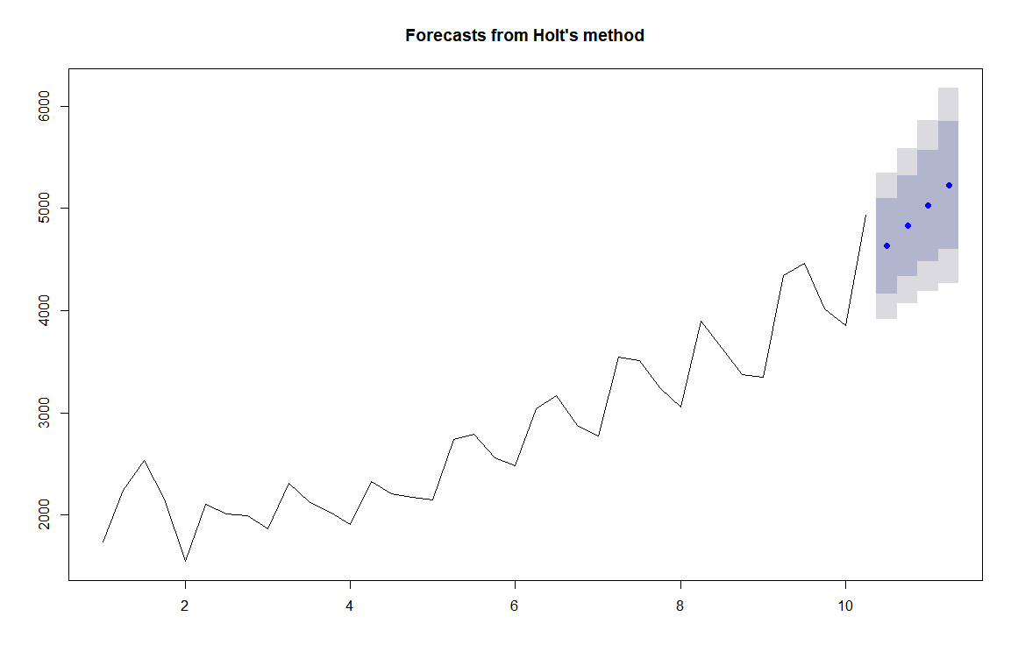

holtab_mape<-MAPE(holtab_pred$Point.Forecast,test)*100

holtab_mape #8.267703

#*********************************************************************#

**# with alpha = 0.2, beta = 0.1, gamma = 0.05**

hw_abg_new<-hw(train,alpha = 0.2,beta = 0.15,gamma = 0.05)

hw_abg_new

#Point Forecast Lo 80 Hi 80 Lo 95 Hi 95

#10 Q3 4826.538 4563.396 5089.681 4424.097 5228.980

#10 Q4 4725.159 4446.365 5003.953 4298.780 5151.538

#11 Q1 4685.764 4377.482 4994.045 4214.288 5157.239

#11 Q2 5493.996 5141.444 5846.547 4954.814 6033.177

#11 Q3 5581.440 5163.922 5998.959 4942.901 6219.979

#11 Q4 5480.061 4993.425 5966.696 4735.816 6224.305

#12 Q1 5440.665 4874.451 6006.880 4574.715 6306.616

#12 Q2 6248.897 5594.075 6903.720 5247.433 7250.362

hwabg_pred_new<-data.frame(predict(hw_abg_new,h = 4))

plot(forecast(hw_abg_new,h=4))

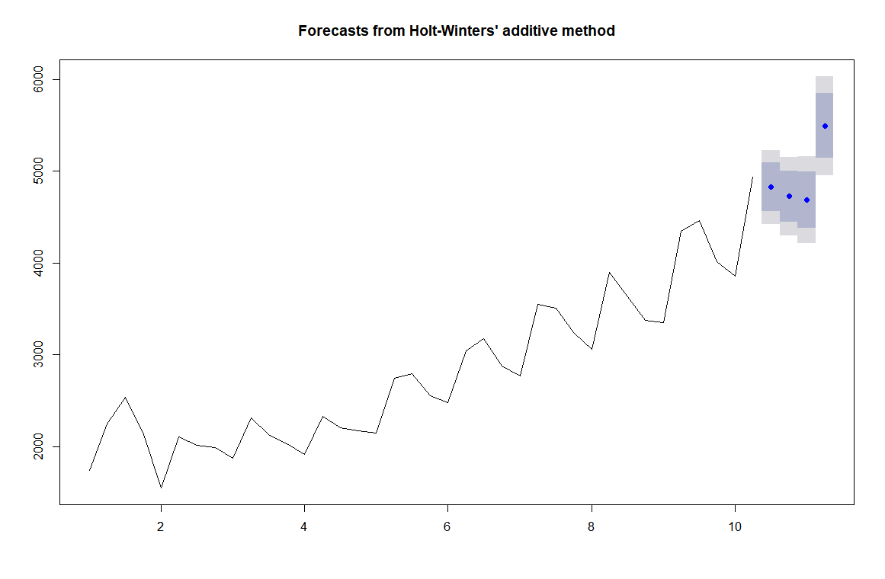

hwabg_mape_new<-MAPE(hwabg_pred_new$Point.Forecast,test)*100

hwabg_mape_new #6.149798

#*********************# **With out optimum values#**\*\*\*\*#

**# simple exponential method**

ses_na<-ses(train,alpha=NULL)

ses_na

**#Point Forecast Lo 80 Hi 80 Lo 95 Hi 95**

**#10 Q3 4437.383 3930.596 4944.170 3662.319 5212.447**

**#10 Q4 4437.383 3874.922 4999.844 3577.174 5297.593**

**#11 Q1 4437.383 3824.283 5050.483 3499.728 5375.038**

**#11 Q2 4437.383 3777.519 5097.247 3428.209 5446.558**

**#11 Q3 4437.383 3733.857 5140.909 3361.433 5513.334**

**#11 Q4 4437.383 3692.750 5182.016 3298.565 5576.201**

**#12 Q1 4437.383 3653.797 5220.969 3238.992 5635.774**

**#12 Q2 4437.383 3616.691 5258.075 3182.242 5692.524**

**#12 Q3 4437.383 3581.191 5293.575 3127.950 5746.816**

**#12 Q4 4437.383 3547.106 5327.661 3075.821 5798.945**

sesna_pred<-data.frame(predict(ses_na,h = 4))

sesna_pred

#Point.Forecast Lo.80 Hi.80 Lo.95 Hi.95

#10 Q3 4437.383 3930.596 4944.170 3662.319 5212.447

#10 Q4 4437.383 3874.922 4999.844 3577.174 5297.593

#11 Q1 4437.383 3824.283 5050.483 3499.728 5375.038

#11 Q2 4437.383 3777.519 5097.247 3428.209 5446.558

plot(forecast(ses_na,h=4))

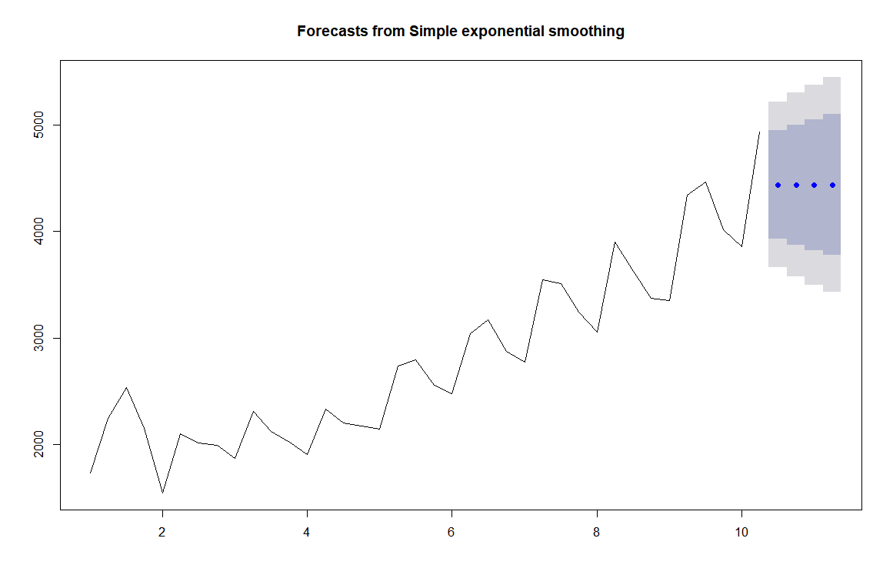

sesna_mape<-MAPE(sesna_pred$Point.Forecast,test)*100

sesna_mape #9.132635

#*******************************************************#

**# Holts winter method**

holt_nab<-holt(train,alpha = NULL,beta = NULL)

holt_nab

#Point Forecast Lo 80 Hi 80 Lo 95 Hi 95

#10 Q3 4358.812 3910.994 4806.629 3673.934 5043.689

#10 Q4 4475.703 4023.788 4927.618 3784.558 5166.848

#1 Q1 4592.595 4131.592 5053.597 3887.552 5297.637

#11 Q2 4709.486 4232.756 5186.215 3980.391 5438.581

#11 Q3 4826.377 4326.063 5326.692 4061.212 5591.542

#11 Q4 4943.269 4410.824 5475.714 4128.965 5757.573

#12 Q1 5060.160 4486.869 5633.452 4183.387 5936.934

#12 Q2 5177.052 4554.432 5799.671 4224.838 6129.266

#12 Q3 5293.943 4614.005 5973.881 4254.067 6333.819

#12 Q4 5410.834 4666.193 6155.476 4272.004 6549.665

holtnab_pred<-data.frame(predict(holt_nab,h=4))

holtnab_pred

#Point.Forecast Lo.80 Hi.80 Lo.95 Hi.95

#10 Q3 4358.812 3910.994 4806.629 3673.934 5043.689

#10 Q4 4475.703 4023.788 4927.618 3784.558 5166.848

#11 Q1 4592.595 4131.592 5053.597 3887.552 5297.637

#11 Q2 4709.486 4232.756 5186.215 3980.391 5438.581

plot(forecast(holt_nab,h=4))

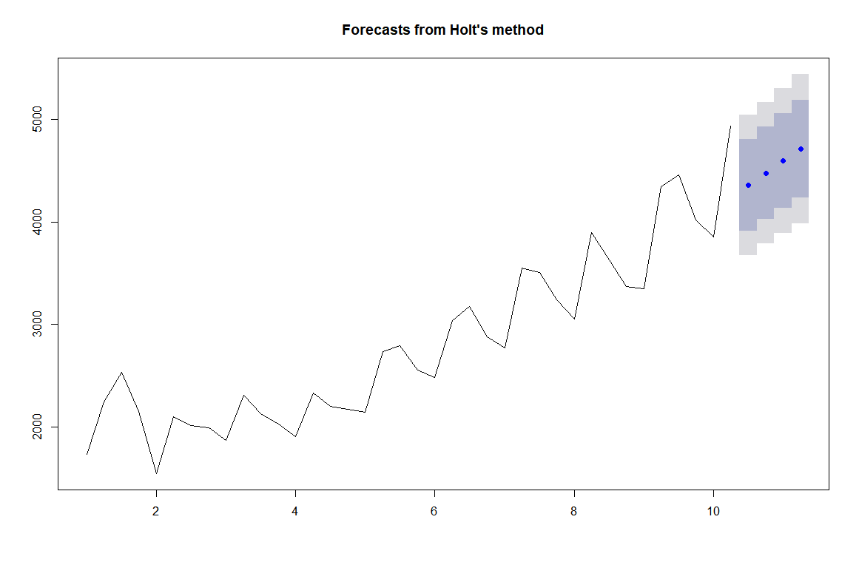

holtnab_mape<-MAPE(holtnab_pred$Point.Forecast,test)*100

holtnab_mape #8.927388

#*********************************************************#

**# Holts winter Exponential method**

hw_nabg_new<-hw(train,alpha=NULL,beta=NULL,gamma = NULL)

hw_nabg_new

#Point Forecast Lo 80 Hi 80 Lo 95 Hi 95

#10 Q3 4896.950 4643.712 5150.187 4509.656 5284.243

#10 Q4 4658.184 4300.150 5016.218 4110.618 5205.750

#11 Q1 4491.605 4053.130 4930.080 3821.015 5162.195

#11 Q2 5167.239 4660.933 5673.544 4392.911 5941.566

#11 Q3 5128.189 4562.039 5694.339 4262.337 5994.041

#11 Q4 4889.423 4269.233 5509.614 3940.923 5837.923

#12 Q1 4722.844 4052.949 5392.740 3698.328 5747.361

#12 Q2 5398.478 4682.311 6114.645 4303.194 6493.762

hwnabg_pred_new<-data.frame(predict(hw_nabg_new,h=4))

hwnabg_pred_new

#Point.Forecast Lo.80 Hi.80 Lo.95 Hi.95

#10 Q3 4896.950 4643.712 5150.187 4509.656 5284.243

#10 Q4 4658.184 4300.150 5016.218 4110.618 5205.750

#11 Q1 4491.605 4053.130 4930.080 3821.015 5162.195

#11 Q2 5167.239 4660.933 5673.544 4392.911 5941.566

plot(forecast(hw_nabg_new,h=4))

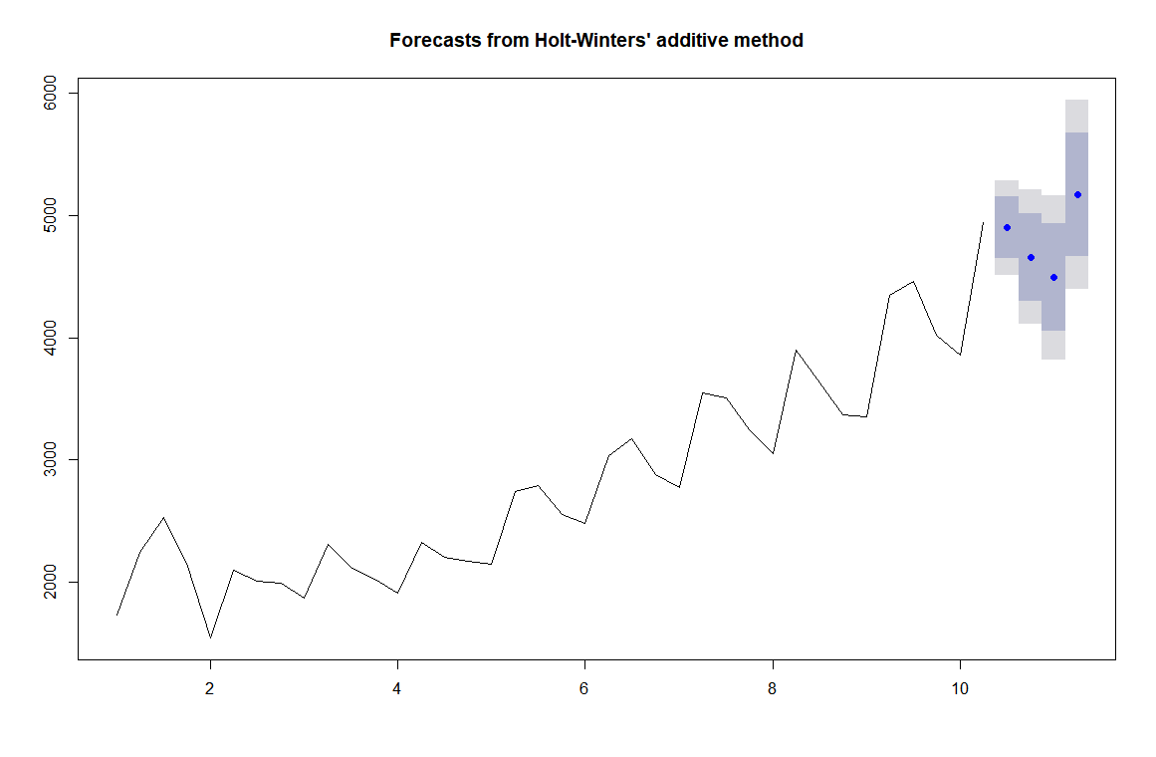

hwnabg_mape_new<-MAPE(hwnabg_pred_new$Point.Forecast,test)*100

hwnabg_mape # 2.397211

df_mapes_new<-data.frame(c("sesa_mape","holtab_mape","hwabg_mape_new","sesna_mape","holtnab_mape","hwnabg_mape_new"),c(sesa_mape,holtab_mape,hwabg_mape_new,sesna_mape,holtnab_mape,hwnabg_mape_new))

colnames(df_mapes_new)<-c("MAPE","VALUE")

View(df_mapes_new)

|  | **MAPE** | **VALUE** |
| --- | --- | --- |
|  |  |  |
| **1** | sesa_mape | 16.124299 |
| **2** | holtab_mape | 8.267703 |
| **3** | hwabg_mape_new | 6.149798 |
| **4** | sesna_mape | 9.132635 |
| **5** | holtnab_mape | 8.927388 |
| **6** | hwnabg_mape_new | 3.826562 |

Showing 1 to 6 of 6 entries, 2 total columns