Grafana

Dashboard

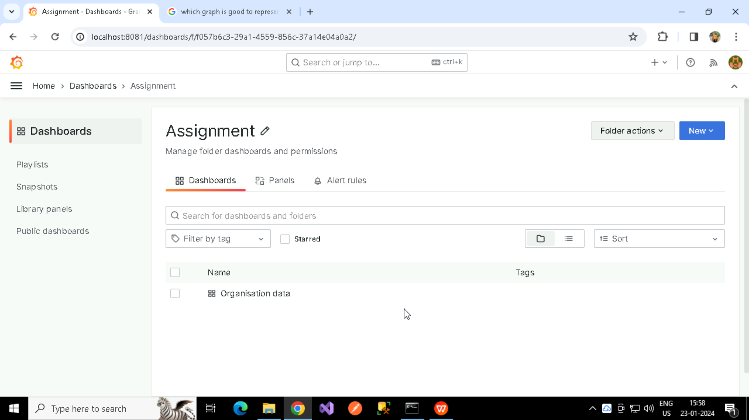

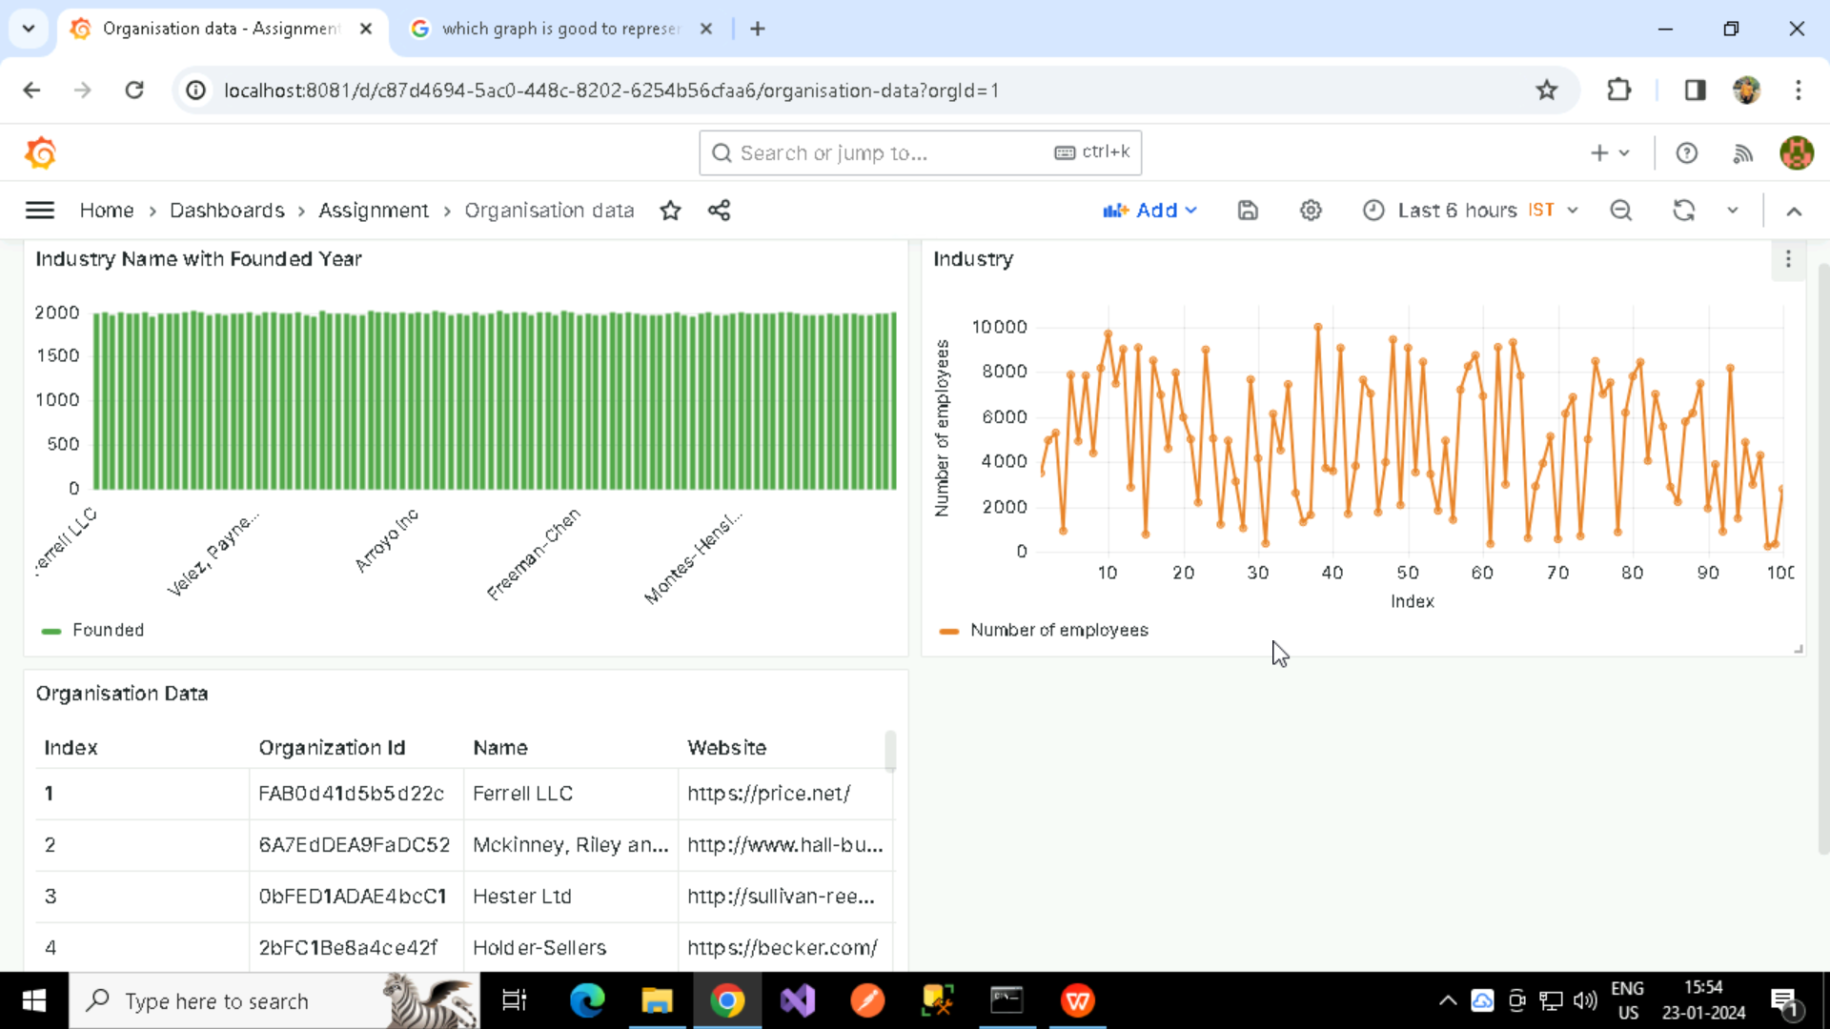

1. Table Panel – shows all the data in the CSV File
2. XY Panel – X axis showing Index Values and Y axis showing Number of employees.
3. Bar graph showing the Number of employees in the Organization.