**KPI’s**

1. **Total Loan Applications**

select count(id) as Total_Loan_Applications from Bank_loan_data



1. **MTD_Total_Loan_Applications**

select count(id) as MTD_Total_Loan_Applications from Bank_loan_data

Where issue_date betwe

en '2021-12-01' and '2021-12-31'

OR

select count(id) as MTD_Total_Loan_Applications from Bank_loan_data

Where Month(issue_date)=12 and Year(issue_date)=2021



1. **PMTD_Total_Loan_Applications**

select count(id) as PMTD_Total_Loan_Applications from Bank_loan_data

Where issue_date between '2021-11-01' and '2021-11-30'



1. **Month on month calculations**:

(MTD-PMTD)/(PMTD)

1. **Total_Funded_amount**

select sum(loan_amount) as Total_Funded_amount from Bank_loan_data



1. **MTD_Total_Funded_amount**

select sum(loan_amount) as MTD_Total_Funded_amount from Bank_loan_data

where month(issue_date)=12 and Year(issue_date)=2021



1. **PMTD_Total_Funded_amount**

select sum(loan_amount) as PMTD_Total_Funded_amount from Bank_loan_data

where month(issue_date)=11 and Year(issue_date)=2021



1. **Total_Amount_Received**

select sum(total_payment) as Total_Amount_Received from Bank_loan_data





1. **MTD_Total_Amount_Received**

select sum(total_payment) as MTD_Total_Amount_Received from Bank_loan_data

where MONTH(issue_date)= 12 and year(issue_date)=2021



1. **PMTD_Total_Amount_Received**

select sum(total_payment) as PMTD_Total_Amount_Received from Bank_loan_data

where MONTH(issue_date)= 11 and year(issue_date)=2021



**Average_interest_rate**

select round(AVG(int_rate),4)*100 as Average_interest_rate from Bank_loan_data 

**MTD_Average_interest_rate**

select round(AVG(int_rate),4)*100 as MTD_Average_interest_rate from Bank_loan_data



**PMTD_Average_interest_rate**

select round(AVG(int_rate),4)*100 as PMTD_Average_interest_rate from Bank_loan_data

where month(issue_date)=11 and year(issue_date)=2021



**MTD_Ave_DTI**

select round(AVG(dti),4)*100 as MTD_Ave_DTI from Bank_loan_data

where month(issue_date)=12 and year(issue_date)=2021



**PMTD_Ave_DTI**

select round(AVG(dti),4)*100 as MTD_Ave_DTI from Bank_loan_data

where month(issue_date)=11 and year(issue_date)=2021



**Good Loan**

**Good_Loan_percentage**

select (count(case when loan_status = 'Fully Paid' or loan_status = 'Current' then id end)*100) /

count(id) as Good_Loan_percentage from Bank_loan_data



**Good_Loan_Applications**

select count(id) as Good_Loan_Applications from Bank_loan_data

where loan_status = 'Fully Paid' or loan_status = 'Current'



**Good_Loan_Funded_Amt**

select sum(loan_amount) as Good_Loan_Funded_Amt from Bank_loan_data

where loan_status = 'Fully Paid' or loan_status = 'Current'



**Good_Loan_Amt_received**

select sum(total_payment) as Good_Loan_Amt_received from Bank_loan_data

where loan_status = 'Fully Paid' or loan_status = 'Current'

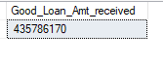

**BAD LOAN ISSUES**

**Bad_loan_Percentage**

Select (count(case when loan_status ='Charged off' then id end) *100.0)

/

count(id) as Bad_loan_Percentage from bank_loan_data



**Bad_loan_applications**

select count(id) as Bad_loan_applications from Bank_loan_data

where loan_status = 'Charged off'

**Bad_loan_Funded_Amt**

select sum(loan_amount) as Bad_loan_Funded_Amt from Bank_loan_data

where loan_status = 'Charged off'



**Bad_loan_Amt_received**

select sum(total_payment) as Bad_loan_Amt_received from Bank_loan_data

where loan_status = 'Charged off'



**LOAN STATUS**

select loan_status,

count(id) as TOTAL_LOAN_APPLICATIONS,

sum(Total_payment) as TOTAL_RECEIVED_AMT,

sum(loan_amount) as TOTAL_FUNDED_AMT,

avg(int_rate) * 100 as INTEREST_RATE,

avg(dti) * 100 as DTI

from Bank_loan_data

group by loan_status

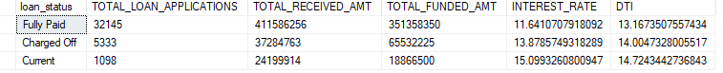

select loan_status,

count(id) as MTD_TOTAL_LOAN_APPLICATIONS,

sum(Total_payment) as MTD_TOTAL_RECEIVED_AMT,

sum(loan_amount) as MTD_TOTAL_FUNDED_AMT

from Bank_loan_data

WHERE MONTH(issue_date) = 12 and year(issue_date) = 2021

group by loan_status

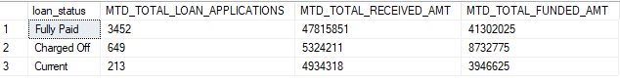

select

month(issue_date) as Month_No,

datename(month, issue_Date) as Month_Name,

count(id) as MTD_TOTAL_LOAN_APPLICATIONS,

sum(Total_payment) as MTD_TOTAL_RECEIVED_AMT,

sum(loan_amount) as MTD_TOTAL_FUNDED_AMT

from Bank_loan_data

group by month(issue_date), datename(month, issue_Date)

order by month(issue_date)

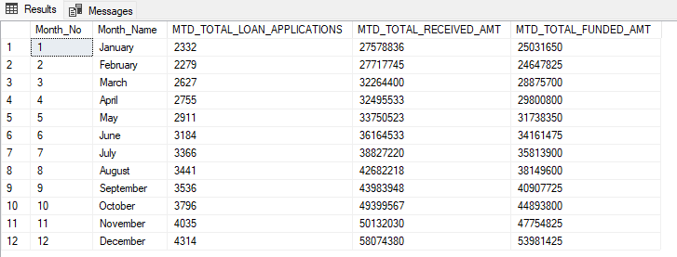

select

address_state as STATE,

count(id) as MTD_TOTAL_LOAN_APPLICATIONS,

sum(Total_payment) as MTD_TOTAL_RECEIVED_AMT,

sum(loan_amount) as MTD_TOTAL_FUNDED_AMT

from Bank_loan_data

group by address_state

order by count(id) desc

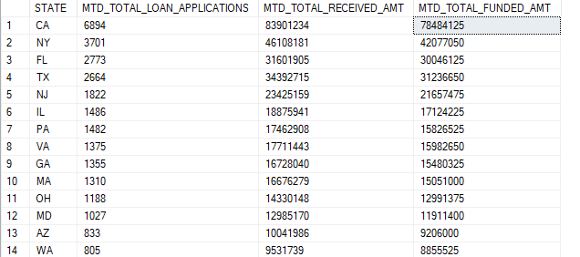

select

term as TERM,

count(id) as TOTAL_LOAN_APPLICATIONS,

sum(Total_payment) as TOTAL_RECEIVED_AMT,

sum(loan_amount) as TOTAL_FUNDED_AMT

from Bank_loan_data

group by term

order by term



select

emp_length,

count(id) as TOTAL_LOAN_APPLICATIONS,

sum(Total_payment) as TOTAL_RECEIVED_AMT,

sum(loan_amount) as TOTAL_FUNDED_AMT

from Bank_loan_data

group by emp_length

order by emp_length

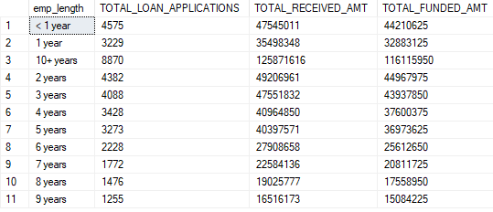

select

purpose,

count(id) as TOTAL_LOAN_APPLICATIONS,

sum(Total_payment) as TOTAL_RECEIVED_AMT,

sum(loan_amount) as TOTAL_FUNDED_AMT

from Bank_loan_data

group by purpose

order by count(id) desc

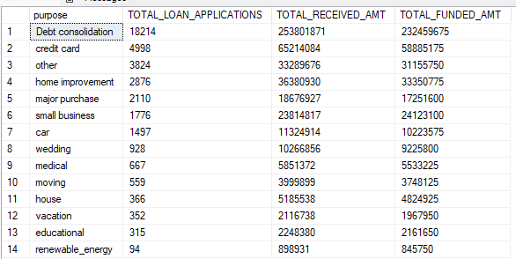

select

home_ownership,

count(id) as TOTAL_LOAN_APPLICATIONS,

sum(Total_payment) as TOTAL_RECEIVED_AMT,

sum(loan_amount) as TOTAL_FUNDED_AMT

from Bank_loan_data

group by home_ownership

order by count(id) desc

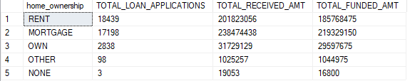

select

home_ownership,

count(id) as TOTAL_LOAN_APPLICATIONS,

sum(Total_payment) as TOTAL_RECEIVED_AMT,

sum(loan_amount) as TOTAL_FUNDED_AMT

from Bank_loan_data

where grade= 'A' and address_state= 'CA'

group by home_ownership

order by count(id) desc

