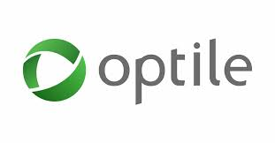

Test Plan

1. Introduction *
1.1. Test Plan Identifier 3
1.2. Introduction 3
1.3. References 3
2. Test Scope 3
3. Risk Issues 3
4. Plan 3
5. Test Data Generation 4
6. Test Environments *
6.1. Hardware Configuration 4
6.2. Software configuration 5
6.3. Test Tools 5
7. Environments Covered By Automation 5
8. Features *
8.1. Features to be tested 5
8.2. Features not to be tested 5
8.3. Features to be automated 6
9. Test Deliverables 6
10. Assumptions 6

- Test Plan Identifier :
Test Plan V 1.1 – optile-QA-Task-Dropbox.

- Introduction :
This document elaborates the automation plan, Test data generation approach for automation exection, Environments used, Execution plan and limitations of automation for Dropbox web application.

- References :
  - Requirements specifications
  - Dropbox Web Application.

- Test Scope :
- Automation Testing

- Software Risk Issues :
- Lack of availability of required hardware, software, data or tools.
- Complexities involved in testing the applications.
- Scalability of framework created.

- Plan :
The plan for automation testing for signup flow for a new user at Dropbox will be automated
Using Selenium with Java. The test scripts will cover all the Login/Logout Functionality, uploading a file, creating folder,, randomization of data along with detailed reports of all executed test cases. The framework to be used for this will be hybrid framework.

The hybrid framework, is one of the most basic type of automation framework. In this framework, a test scripts are written to match a functionality that represent modules of the application-under-test. These modules in turn are used in a hierarchical fashion to build large test cases.

The Framework is divided into 4 layers. The framework will be designed in such a way that it will be scalable any time and will support all the technologies in future. The framework will be capable of creating interactive reports using extent reports. The framework will also use Data Driven testing by taking input from excel sheet.

The Framework to be implemented should be as follows:

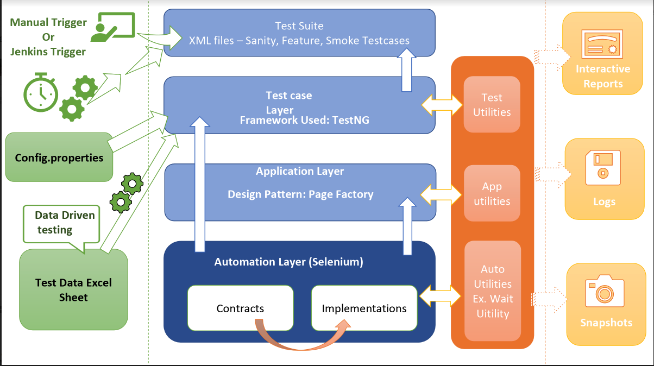

- Test Data Generation:
The test case specific data would be captured from excel sheet and some random data generator methods. Each time a script is run on execution environment, data will be automatically picked and detailed report of test metrics will be generated in html format.
Each time a test script will be failed the detailed analysis will be provided along with screenshot.

- Test Environment:
- Hardware Configuration :
  - Motherboard : Intel Chipset
  - Processor : Core i3
  - Hard disk Capacity : 160 GB
  - CD ROM : Not Available

- Software Configuration :
  - Operating System : Microsoft Windows 10/ Mac-Os
  - Web Browser : Chrome / Firefox
  - IDE : Eclipse.
  - Software : Java.

No special hardware is required for testing Dropbox automation test scripts.

- Test Tools :
- Selenium will be used for Automation Scripts.
- MS Excel will be used for Test Management process.

- Environments Covered By Automation:
The environment supported by Automation scripts is independent of operating system.
Currently it is supporting windows and mac-os. It will support cross browser testing also.
As of know it is supporting Chrome Browser and Firefox.
The scripts are scalable that they can be easily modified for supporting other operating system and different browsers also.

- Features To Be Tested:
- Login/Logout Functionality
- Creating a folder.
- Uploading file.
- Validations for Login.

- Features not to be Tested:
  - Not Applicable

- Features to be Automated:
  - All features to be tested will be done using Selenium using Java.

- Test Deliverables :

- Test Scripts.
- Execution Reports.
- Screenshots for Failed Test cases.

- Assumptions :
  - Application is functioning and ready to use.

